Victor Gregory Matos  
CSD310-J308  
Professor Sampson

7.2 Assignment

# Python Query #1

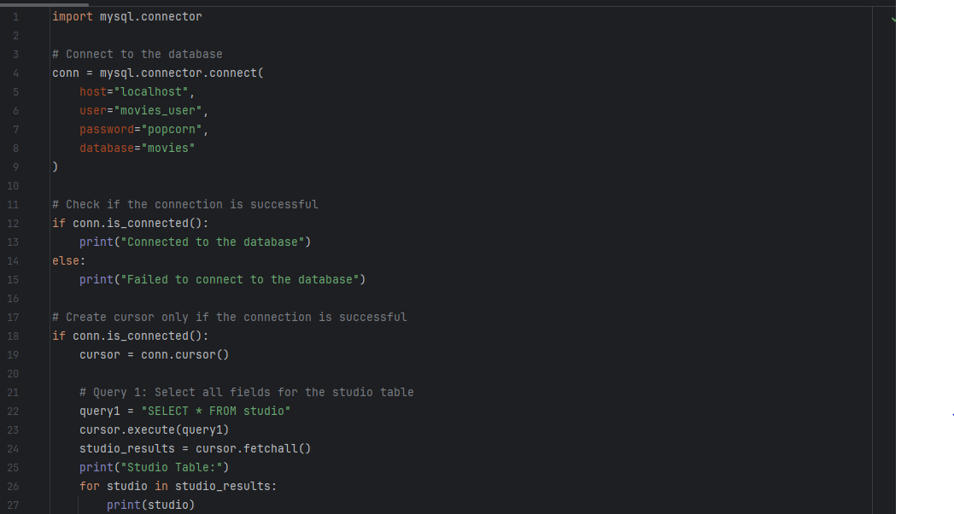

## Python Output #1

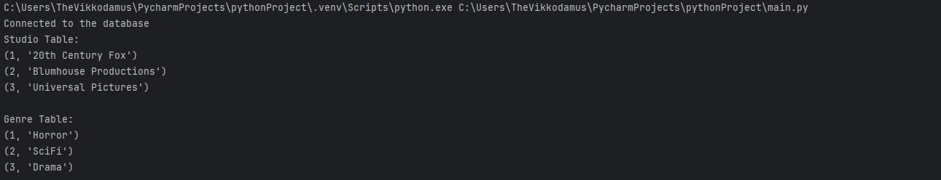

# Python Query #2

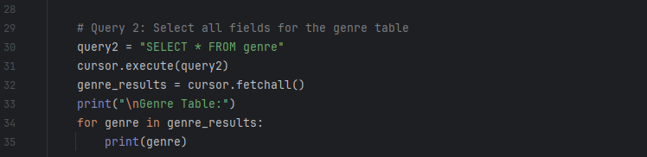

## Python Output #2

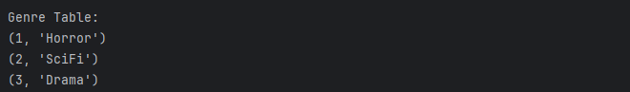

# Python Query #3

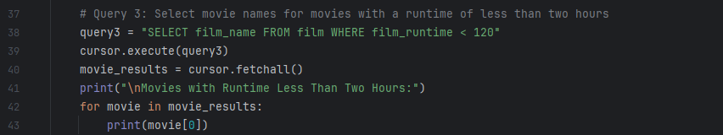

## Python Output #3

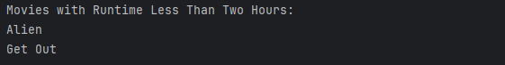

# Python Query #4

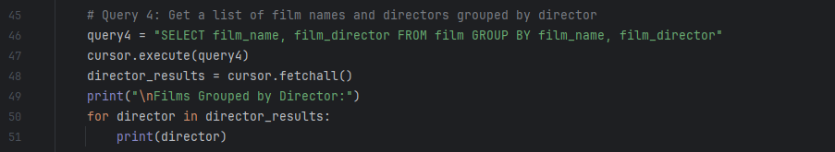

## Python Output #4

