SmartVault
Intelligent File & Document Management System
Complete System Blueprint — Version 2.0
Bare-Metal Install · Multi-Company · Multi-FY · Disaster Recovery
Prepared for | Version | Date | Status
Your Organisation | v2.0 | April 2025 | Ready for Development

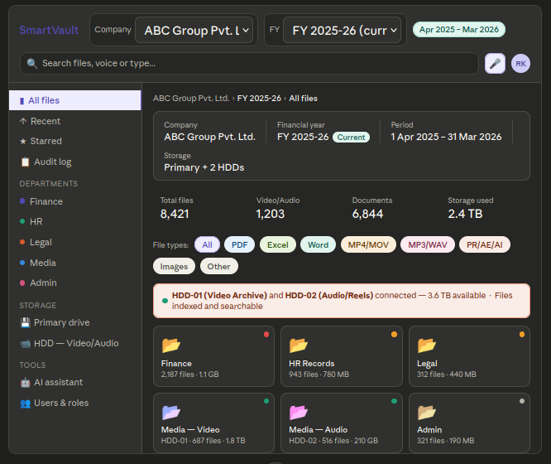

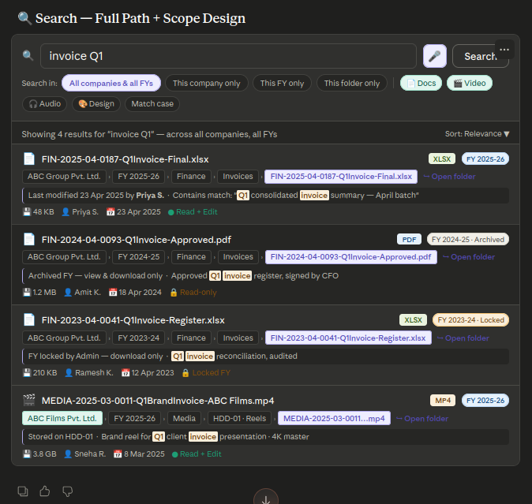

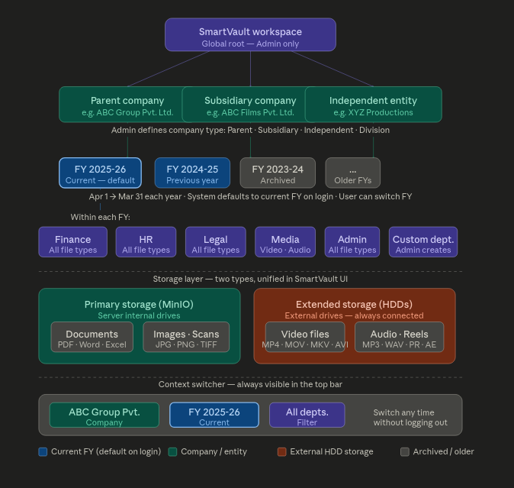
1. Executive Summary — What SmartVault is

SmartVault is a local-network, browser-based document and file management system for offices managing large volumes of documents across multiple companies, departments, and financial years. It runs entirely on your own dedicated server — no cloud, no Docker, no external dependencies — giving you complete data privacy and control.

All requirements including: bare-metal server installation, multi-company and multi-FY structure (April–March), full file extension support including video and audio on external HDDs, corrected FY lock and archive rules, full-path search results, disaster recovery plan, QR code thermal label printing, expiry and retention dates, duplicate file detection, Gmail email notifications, bulk operations, department dashboards, offline read-only mode, dark mode, and document retention policies.

2. Server & Storage Architecture

2.2 Storage layout
Two physical storage types — M.2 NVMe SSD for the system brain, large HDD for all file data:

What | Drive type | Mount path | Contents
Operating system | M.2 NVMe SSD | / (root) | Ubuntu 22 LTS
SmartVault app | M.2 NVMe SSD | /opt/smartvault/ | Node.js app, config files
PostgreSQL database | M.2 NVMe SSD | /var/lib/postgresql/ | Users, permissions, metadata, audit logs
Elasticsearch | M.2 NVMe SSD | /var/lib/elasticsearch/ | Search index for all files
Redis cache | M.2 NVMe SSD | /var/lib/redis/ | Session data, fast read cache
NGINX | M.2 NVMe SSD | /etc/nginx/ | Web gateway config
MinIO file storage | Large HDD | /mnt/storage/minio/ | All uploaded documents, images, Office files
External HDD-01 | External HDD | /mnt/hdd01/ | Video files — MP4, MOV, MKV, AE, PR etc.
External HDD-02 | External HDD | /mnt/hdd02/ | Audio files — MP3, WAV, FLAC, reels
Backup drive | Dedicated backup HDD | /mnt/backup/ | Daily automated snapshots

2.3 Server requirements (20–50 users)
Component | Minimum | Recommended | Notes
CPU | 4-core Intel i5 | 8-core Intel i7/i9 or Xeon | More cores = faster multi-user performance
RAM | 16 GB | 32 GB | Elasticsearch alone needs 4 GB minimum
M.2 NVMe SSD | 256 GB | 512 GB | OS + app + databases
File storage HDD | 2 TB | 4–8 TB RAID | All documents, office files
External HDDs | Per existing drives | Label and mount each | Video, audio, media files
Backup HDD | 4 TB | 8 TB | Dedicated — nothing else stored here
Network | 100 Mbps LAN | 1 Gbps Gigabit LAN | Gigabit switch recommended
OS | Ubuntu 22 LTS | Ubuntu 22 LTS | Free, best compatibility with the stack
UPS | Strongly recommended | Required | Prevents data loss during power cuts

2.4 How services start (systemd)
Every SmartVault service runs as a systemd unit — the standard Ubuntu way to manage background services. After installation, all services start automatically when the server boots and restart automatically if they crash.

Service | systemd unit name | What it does
Node.js app | smartvault-app.service | Main application server
PostgreSQL | postgresql.service | Database
Elasticsearch | elasticsearch.service | Search engine
Redis | redis-server.service | Cache and sessions
NGINX | nginx.service | Web gateway and HTTPS
MinIO | minio.service | File storage server
Backup scheduler | smartvault-backup.timer | Runs nightly backup at 2 AM
FY auto-create | smartvault-fy.timer | Creates new FY folder on 1 Apr each year

3. Company & Financial Year Structure — Multi-company, April–March FY

3.1 Company types
Admin creates and configures all companies from the Admin panel. Four company types are supported:

Type | Example | Behaviour
Parent company | ABC Group Pvt. Ltd. | Top-level entity. Can view all subsidiaries in one view if permitted.
Subsidiary | ABC Films Pvt. Ltd. | Linked to a parent. Separate files, separate users, own FY structure.
Division / branch | ABC North Branch | Shares parent company settings. Sub-entity of a parent.
Independent entity | XYZ Productions | Completely standalone. No link to any other company.

Each company has its own: departments, users, permission sets, FY folders, storage quota, and audit log. An Admin user can be granted access to multiple companies.

3.2 Financial year rules (April 1 – March 31)
Rule | Detail
FY format | April 1 to March 31 each year. Displayed as "FY 2025-26", "FY 2024-25" etc.
Default on login | System always opens the current active FY automatically on login.
FY switcher | Dropdown always visible in the top bar. User can switch FY without logging out.
Auto-creation | System creates a new FY folder structure on 1 April each year via scheduled task.
Manual creation | Admin can also create a new FY manually at any time (e.g. to prepare in advance).
Current FY badge | Current FY is marked with a green "Current" badge everywhere it appears.
Global search | The search system always searches ALL FYs and ALL companies simultaneously by default. User can narrow scope.

3.3 Archived FY rules (corrected)
RULE: When a FY ends on 31 March, it becomes "Archived" automatically. Archived FYs are read-only and downloadable by default. No user except Admin can upload, edit, or move files in an archived FY — unless Admin explicitly grants that permission.

State | Who can access | Upload / edit | Download | Admin can grant edit permission?
Active FY (current) | All users per normal permissions | Yes, per role | Yes | N/A — FY is active
Archived FY (closed) | All users who had access | No — read-only by default | Yes — always | Yes — Admin unlocks for specific user or role. Logged.
Locked FY (Admin-set) | All users | No — locked for everyone | Yes — always | Yes — Admin can grant specific user override. Requires reason. Logged.

The difference between Archived and Locked: Archived happens automatically at FY end — read-only but editable if Admin grants permission. Locked is a deliberate Admin action (e.g. after audit sign-off) — even stronger restriction. Both states require a logged reason when permission is granted to override them.

4. File Extension Support & Storage — All file types, all drives
SmartVault accepts and indexes every file extension with no restrictions. Files are categorised for display but there is no block list.

Category | Extensions | Preview in browser | Where stored
Documents | PDF, DOC, DOCX, XLS, XLSX, PPT, PPTX, TXT, CSV, ODT | Yes — built-in viewer | Primary HDD (MinIO)
Images | JPG, PNG, GIF, TIFF, BMP, WEBP, HEIC, RAW, SVG | Yes — image viewer | Primary HDD (MinIO)
Video | MP4, MOV, AVI, MKV, WMV, FLV, WebM, M4V, MPEG | Yes — browser player, streamed | External HDD-01
Audio | MP3, WAV, AAC, FLAC, OGG, M4A, AIFF, WMA | Yes — browser audio player | External HDD-02
Design / Edit | PSD, AI, INDD, XD, FIG, AEP (After Effects), PRPROJ (Premiere) | Thumbnail only | External HDD-01 or 02
3D / CAD | OBJ, FBX, DWG, STL, BLEND, DXF | Thumbnail only | Primary HDD or HDD-01
Archives | ZIP, RAR, 7Z, TAR, GZ | File list inside shown | Primary HDD (MinIO)
Code / Data | JS, PY, HTML, JSON, XML, SQL | Text preview | Primary HDD (MinIO)
Any other | All other extensions | Download only | Primary HDD (MinIO)

Video and audio files stored on external HDDs are streamed to the browser — the user never needs to download a 2 GB file to preview it. The file stays on the HDD at all times.

4.1 External HDD management
Scenario | How SmartVault handles it
HDD always connected | Mounted as named volumes at boot. Indexed and searchable like any folder.
New HDD added | Admin mounts it in Settings → Storage → Add drive. Assign name, department, and path.
HDD at 80% capacity | Admin receives email alert and dashboard warning.
HDD goes offline | Files on that drive show "Offline — drive unavailable" badge. Rest of system unaffected.
Re-indexing a drive | Admin runs "Re-index drive" from Settings. Picks up new files added outside SmartVault.

5. Search System — Full path · Scoped · Voice


5.1 Full path in every search result
Every search result shows the complete path from company root to filename. Every segment of the path is clickable — clicking any segment navigates directly to that folder. This means a user can find a file and immediately jump to its containing folder in one click.

Example path shown in result:
ABC Group Pvt. Ltd. › FY 2025-26 › Finance › Invoices › FIN-2025-04-0187-Q1Invoice.xlsx

Each segment (company, FY, department, subfolder, filename) is individually clickable. There is also an "Open folder" shortcut button on every result that jumps directly to the parent folder.

5.2 Search scope — where to search
Scope option | What it searches
All companies + all FYs (default) | Every file across every company, every FY, and every department the user has access to
This company only | All FYs within the currently selected company
This FY only | Only files within the currently selected company and FY
This folder only | Only files within the folder currently open — recursive (includes subfolders)
Custom scope | User selects one or more specific companies, FYs, or departments to search within

5.3 Search filters
Filter | How it works
File name | Partial or exact match. "invoice" finds "Q1Invoice", "InvoiceFinal", "invoice_copy" etc.
Match case | Toggle on to make search case-sensitive. Off by default.
Date range | From → to date picker. Also quick-select: Today, This week, This month, This FY, Custom range.
Year / month / day | Dedicated year, month, and day dropdowns for precise date filtering.
Department | Multi-select department filter. Tick one or more departments.
Company | Filter by one or more companies (for users with multi-company access).
FY | Filter by one or more financial years.
File type / extension | Category buttons (Docs, Video, Audio, Images, Design) or type a specific extension.
Text inside file | OCR-indexed content search. Finds text inside scanned PDFs and images.
Tags | Search by user-assigned or AI-assigned tags.
Voice search | Microphone button. Speak the query — converted to text automatically.
Uploaded by | Search files uploaded by a specific user.
FY status | Filter by Current, Archived, or Locked FY.
HDD location | Filter to show only files on a specific external drive.

5.4 Search result information
Each result card shows: file icon, file name (with search terms highlighted), full clickable path, FY badge (current / archived / locked), file extension badge, file size, last modified date, last modified by, user's permission on that file (Read-only / Read+Edit), and a content snippet with matching terms highlighted if the match was inside the file content.
6. Permission System — User · Role · Group · Department

6.1 Permission levels
Level | Set by | Applies to | Example
Individual user | Admin | One specific person | Priya can edit Finance/Invoices even though her role normally cannot
Role | Admin | All users with that role | All "Staff" users can upload but not move files
Group | Admin | All members of a named group | "Finance Team" group has access to Finance and shared HR folders
Department | Admin | All users in a department | Legal dept users can only see Legal and shared folders

Permissions stack in priority order: Individual overrides Role, Role overrides Group, Group overrides Department default. Admin sees a "Effective permissions" panel for any user showing exactly what their combined permissions are.

6.2 The no-delete rule
NO USER EXCEPT ADMIN CAN DELETE ANY FILE OR FOLDER — UNDER ANY CIRCUMSTANCE. This rule cannot be overridden by any permission setting, role, or group. Even Department Managers cannot delete. Only Admin users can permanently delete, and every deletion requires a typed reason which is stored forever in the audit log.

6.3 Built-in roles
Role | Upload | Edit | Move | Delete | View logs | Admin panel
Admin | Yes | Yes | Yes | Yes — with reason | All departments | Yes — full
Department Manager | Yes | Yes — own dept | Yes — own dept | No | Own dept only | No
Staff User | Yes | Own uploads only | No | No | No | No
Read-only / Guest | No | No | No | No | No | No
Custom role | Admin-set | Admin-set | Admin-set | No (always) | Admin-set | No

6.4 Archived and locked FY permissions
FY State | Default access | Admin override | Override is logged?
Archived | Read + download only | Admin grants edit permission to specific user or role | Yes — with mandatory reason
Locked | Download only | Admin grants override to specific user — even stronger than archived | Yes — with mandatory reason and expiry date for the override

7. Audit Log & Version Rollback — Full history · One-click restore
Every action in SmartVault is recorded permanently. Logs are never deleted — only Admin can export them. The rollback system works like Google Sheets version history: any action can be reversed with one click.

7.1 What is logged
Action type | What is recorded
Upload | User, filename, auto-name, department, company, FY, file size, timestamp, IP address
Edit / rename | User, old name, new name, full path, timestamp, what changed
Move | User, file/folder, old path (full), new path (full), timestamp
Download | User, filename, full path, timestamp — useful for audit compliance
Permission change | Admin, affected user/role/group, what permission changed, old value, new value
FY lock / unlock / archive | Admin, FY, action, reason, timestamp
Login / logout | User, timestamp, IP address, device/browser
Failed login | Username attempted, timestamp, IP — security monitoring
Delete | Admin only, filename, full path, reason typed by Admin, timestamp — never erasable
Bulk operation | Admin/user, list of all files affected, action, timestamp
Duplicate detected | User, filename, duplicate of (full path), action taken
Retention alert sent | File, recipient, alert type (90-day / 30-day / expired)
QR label printed | User, file/folder, timestamp

7.2 Rollback
- Admin opens Audit Log and filters by user, date, or file
- Selects any action and clicks "Rollback this action"
- System previews what will change before applying
- After confirmation, the rollback itself is logged as a new audit entry
- Rollback is available for: Move, Rename, Permission change, Edit, Bulk operation
- Rollback is NOT available for: Delete (deleted files are gone — backups are the recovery path), Login events

8. All Additional Features — 9 new features fully specified

8.1 QR Code Label Printing (Thermal — Dymo / Zebra)
Every file and folder in SmartVault has a unique QR code. Stick the printed label on the physical document — scanning it with any phone camera instantly opens the digital file.

Aspect | Design detail
QR content | Direct URL to the file: http://[server-ip]/file/FIN-2025-04-0187
Printer support | Dymo LabelWriter and Zebra ZD series via ZPL/DYMO XML. Printer model set once by Admin in Settings.
Label sizes | 25×25mm, 38×25mm, 57×32mm — configured by Admin. User selects size at print time.
Label content | QR code + short filename + department + FY + date — all on one small label.
Single print | Right-click any file or folder → Print QR label → one click.
Bulk print | Select multiple files → right-click → Print QR labels → all sent as one print job.
Folder QR | Folders also have QR codes. Scan opens the folder view in browser.
Reprint | Any label can be reprinted at any time from the file detail panel.
Printer setup | Admin adds printer IP address or USB port once in Settings → Printing. All users then print with one click.

8.3 Duplicate File Detection (SHA-256 hash, no AI required)
Uses SHA-256 hashing — a mathematical fingerprint of the file's exact content. Two files with identical content produce an identical hash, regardless of filename. This is 100% accurate and requires no AI.

Scenario | System behaviour
Upload identical file, different name | System detects hash match during upload, shows warning panel before saving.
Warning panel shows | Original filename, full path, upload date, uploaded by — user decides what to do.
User choices in warning panel | "Keep both", "Replace original", "Cancel upload", "View original first"
Initial duplicate scan | Background scan runs on first setup — finds all existing duplicates across all storage.
Ongoing scan | Background job runs weekly to detect any duplicates added outside SmartVault.
Duplicate report | Admin runs Duplicate Report: shows all pairs, storage wasted, recommended action.
Cross-company check | Optional setting — Admin enables cross-company duplicate detection if needed.
Performance | SHA-256 hash calculated server-side during upload. Adds less than 1 second for most files.

8.4 Email Notifications (Gmail / Google Workspace via SMTP)
Uses Gmail SMTP with an app password — setup takes 5 minutes in Admin settings, no third-party service needed, and no monthly cost.

Notification trigger | Who gets it | When
File uploaded to your department | Department manager | Instant or daily digest (user choice)
File you own was edited or moved | File owner + dept manager | Instant
File shared with you | You | Instant
HDD storage above 80% | Admin only | Once per threshold hit
Duplicate file detected during upload | Uploader | Instant
FY locked, unlocked, or archived | All department managers | Instant
New user account created | New user — welcome email with login instructions | On account creation
Login from new IP address | That user — security alert | Instant
Bulk operation affecting your files | File owners affected | Instant

Each user controls their own notification preferences via a Notifications panel in their profile — they can turn off any notification type or switch from instant to daily digest.

8.5 Bulk Rename and Move
Operation | How it works
Bulk move | Select any files/folders → right-click → Move to → browse destination → confirm. No limit on number.
Bulk rename | Select files → Rename → choose naming pattern: [DEPT]-[FY]-[SEQ]-[CUSTOM] or free text template.
Rename preview | Shows full before/after list of all file names before applying. User can adjust before confirming.
Bulk copy | Same as move but originals are kept. New copies indexed automatically.
Bulk tag | Add or remove tags from any number of files in one action.
Bulk set expiry | Apply the same retention date to all selected files at once.
Bulk print QR | Send QR label print jobs for all selected files in one batch.
Bulk download | Download selected files as a ZIP archive.
Undo | Every bulk operation is fully logged. Admin can rollback from Audit Log. User can undo within 5 minutes from a toast notification.
Scale | No hard limit. Tested for 1,000+ files in one operation.

8.6 Department Dashboards
Each department has a dedicated dashboard. Department managers see their department's full activity and storage at a glance. Admins see all department dashboards.

Dashboard widget | What it shows
Storage usage | Total files, total size, breakdown by drive (primary HDD vs external HDD-01/02), quota % used.
Recent activity | Last 20 actions in this department — who did what, when, to which file.
Expiry warnings | All files expiring in next 90 days, sorted by urgency. One-click to review each.
Top uploaders | Which users uploaded most this month — useful for tracking workload.
File type breakdown | Chart: how many PDFs vs Excel vs Word vs video vs audio in this department.
Pending reviews | Files in "Awaiting review" state (post-expiry). Action required from manager.
Duplicate alerts | Any duplicate files detected this week, awaiting resolution.
Cross-FY comparison | This FY vs last FY — file count and storage used side by side.
Quick actions | Buttons: Upload, New folder, Run duplicate scan, Export activity report.

8.7 Offline Mode (Read-only)
When a device loses connection to the office server — network outage, server maintenance, or working from outside the office — recently accessed files remain viewable without any special setup.

Aspect | How it works
Technology | Service Worker — built into modern browsers. Registers automatically on first login. Nothing to install.
What is cached | Last 50 viewed files and folder listings. Cached automatically in the background as user browses.
What works offline | View file metadata, read cached previews (PDFs, images, text documents), browse folder structure.
What does not work offline | Upload, edit, move, delete, search new content, print QR labels.
Offline indicator | Yellow banner at top: "Offline — showing cached content. Reconnecting…" with a spinner.
Reconnect | As soon as the server is reachable again, the banner disappears and full functionality returns automatically.
Cache size | Admin sets per-user cache limit in Settings. Default 500 MB. User can also clear their cache manually.
Mobile and tablet | Works identically on tablets and phones — same Service Worker technology.

8.8 Dark Mode
Aspect | Design detail
Toggle | Sun/moon icon in top right corner — always visible on every page.
Per user | Preference saved to user account. Persists across devices and login sessions.
System sync | Optional "Follow system setting" — auto-switches when OS switches between light and dark mode.
Coverage | All UI components: folder explorer, search, dashboards, admin panels, modals, QR print preview.
Folder colours | Importance colours (red/orange/green/grey) are adjusted slightly lighter in dark mode for visibility.
File icons | All file type icons have dark mode variants.

8.9 Document Retention Policy (System-level)
Admin defines retention rules that apply automatically to new files — no manual date-setting needed per file. Rules are evaluated in priority order.

Priority | Policy level | Example | Who sets it
1 (highest) | Manual override on individual file | This specific NDA: keep until 1 Jun 2030 | Any user with edit permission
2 | File type + department rule | All PDFs in Legal: keep 10 years | Admin
3 | Department default | All HR files: keep 10 years | Admin
4 | Company default | ABC Group: keep all files 5 years | Admin
5 (lowest) | Global default | All files: keep 3 years unless overridden | Admin

The policy engine walks from Priority 1 to Priority 5 and applies the first rule it finds. Admin sees a Policy Summary screen showing exactly which rule applies to every file type in every department, with a clear explanation of why.

9. Disaster Recovery Plan — Three-tier · RTO under 4 hours

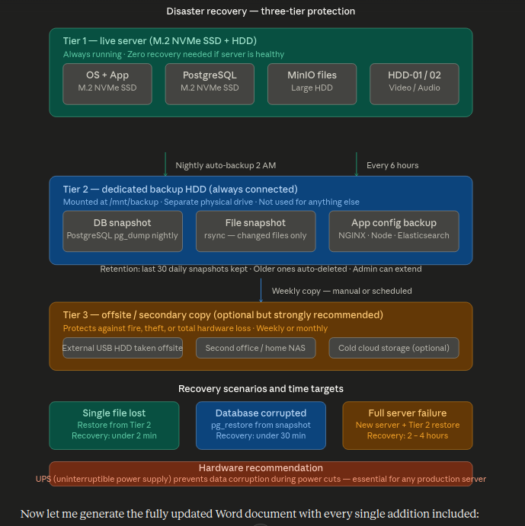
Disaster recovery means: if something goes wrong — accidental file deletion, database corruption, hard drive failure, power surge, fire, theft — how quickly can SmartVault be restored? This plan gives three tiers of protection.

9.1 Tier 1 — Live server (zero recovery time)
This is the running system. No recovery needed if the server is healthy. Protection at this tier comes from the OS and file system reliability:
- M.2 NVMe SSD for OS and databases — much more reliable than HDDs for read/write operations
- PostgreSQL write-ahead logging — database is crash-safe; no data loss even if power cuts mid-write
- MinIO file storage with checksums — detects and alerts on file corruption automatically
- UPS (uninterruptible power supply) — gives the server time to shut down cleanly during a power cut

9.2 Tier 2 — Dedicated backup HDD (recovery in 2–30 minutes)
A dedicated backup hard drive at /mnt/backup/ — a separate physical drive used for nothing else. Automated scripts run every night at 2 AM.

What is backed up | Method | Schedule | Retention
PostgreSQL database | pg_dump — full snapshot | Every night at 2 AM | Last 30 daily snapshots
All files (MinIO) | rsync — only changed files copied | Every night at 2 AM | Mirror of live storage
Video/audio (HDD-01/02) | rsync — changed files only | Every 6 hours | Mirror of live drives
App configuration | cp — full copy of /opt/smartvault and /etc/nginx | Every night at 2 AM | Last 7 copies
Elasticsearch index | Elasticsearch snapshot API | Every night at 3 AM | Last 7 snapshots

9.3 Tier 3 — Offsite copy (protection against physical disaster)
Protects against fire, theft, flooding, or total loss of the server room. Weekly or monthly copy of Tier 2 backup to an offsite location.
- Option A: External USB hard drive taken offsite by a trusted staff member weekly
- Option B: Copy to a second office or home NAS over a VPN connection
- Option C: Cold cloud storage (Backblaze B2 or similar) — very low cost for infrequent access

9.4 Recovery scenarios and time targets
Scenario | Cause | Recovery steps | Time to recover
Single file accidentally moved/renamed | User error | Rollback from Audit Log — one click | Under 2 minutes
Single file lost from storage | Disk error or accidental overwrite | Restore file from Tier 2 rsync mirror | Under 5 minutes
Database corrupted | Disk error, software bug, or power surge | pg_restore from last Tier 2 snapshot | Under 30 minutes
Elasticsearch index corrupted | Software failure | Restore from Elasticsearch snapshot or rebuild from PostgreSQL metadata | 30–60 minutes
Full HDD failure (file storage) | HDD dies | Replace HDD, restore files from Tier 2 rsync mirror | 2–4 hours depending on data size
Full server failure | Hardware failure, fire, theft | New server, install Ubuntu + stack, restore from Tier 2 backup | 2–6 hours
Total site loss (fire/flood) | Physical disaster | New server + restore from Tier 3 offsite copy | 4–12 hours

9.5 Backup monitoring
- Admin receives a daily email: "Last night's backup completed successfully. 14,832 files. DB: 2.1 GB."
- If backup fails, Admin receives an immediate alert email
- Admin dashboard shows last backup time, size, and status at all times
- Monthly: Admin reviews Tier 3 offsite copy and confirms it is current

10. Technology Stack — Bare-metal · All open source · No licence fees

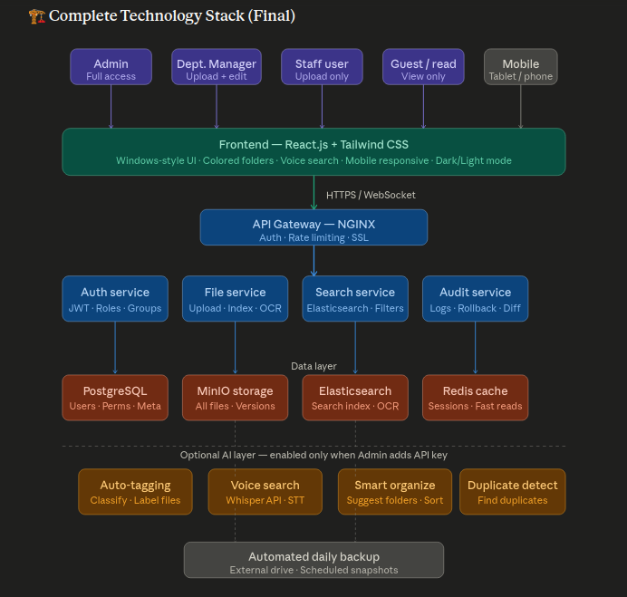
Technology | Installed as | Purpose | Why chosen
Ubuntu 22 LTS | OS on M.2 SSD | Operating system | Free, stable, 5-year support, best compatibility
Node.js + Express | npm + systemd service | Application server and API | Fast, handles 50 concurrent users easily
PostgreSQL | apt package + systemd | Main database | Stores users, permissions, metadata, audit logs. Free, rock-solid.
Elasticsearch | apt package + systemd | Search engine | Lightning-fast full-text and OCR search. Free open-source version.
Redis | apt package + systemd | Cache and sessions | Makes pages load instantly for repeated queries.
MinIO | Binary + systemd | File object storage | Like private Google Drive. Runs on your HDD. Free.
NGINX | apt package + systemd | Web gateway and HTTPS | Routes all browser traffic. Adds SSL encryption. Free.
Tesseract OCR | apt package | Text extraction from scans | Reads text inside scanned images and PDFs. Free.
React.js + Tailwind | Node build tool | Browser interface | Fast, works on all browsers, mobile, tablet. Free.
Web Speech API | Browser built-in | Voice search input | Built into Chrome/Edge/Safari. No cost or install.
Node-cron | npm package | Scheduled tasks (backup, FY creation) | Runs tasks on a schedule. Free.
Nodemailer + Gmail SMTP | npm package | Email notifications | Sends emails via your Gmail. Free.
node-qrcode + ZPL | npm packages | QR code generation and thermal printing | Creates QR codes, formats for Dymo/Zebra. Free.
Sharp | npm package | File thumbnails and previews | Generates preview images for all file types. Free.
OpenAI / Claude API | External API (optional) | AI features — tagging, voice, suggestions | Only active when Admin enters API key. Pay per use.

12. How to Get This Built — Hiring · Questions · Cost guide

12.1 What to look for in a developer
- Node.js and React.js — primary skills, non-negotiable
- PostgreSQL — database management, schema design
- Elasticsearch — setup, configuration, index management
- Ubuntu Linux server administration — systemd, NGINX, file permissions
- MinIO or similar object storage setup
- Bonus: experience with thermal label printing (ZPL/Dymo) and Gmail SMTP integratio

13. Security
- All data stays on your office server — nothing goes to internet or cloud
- HTTPS encryption on local network via NGINX + self-signed certificate
- Passwords stored with bcrypt hashing — never stored as plain text
- JWT session tokens expire after configurable inactivity period (default 8 hours)
- Every login attempt (success and failure) is logged with IP address
- Admin can remotely log out any user or suspend any account instantly
- File access checked on every API request — users cannot access files outside their permissions
- Daily automated backups to separate physical drive
- All file deletions require Admin login confirmation plus a typed reason
- Login from new IP address sends immediate email alert to that user

14. Glossary — Plain English for every technical term
Term | Plain English
Ubuntu 22 LTS | A free operating system for servers. LTS means Long Term Support — security updates for 5 years.
Bare-metal install | Installing software directly on the server hardware, not inside a container or virtual machine.
systemd | Ubuntu's built-in service manager. Starts SmartVault automatically when the server boots.
React.js | A tool for building modern web interfaces. Makes the UI fast and works on all browsers.
Node.js | The server-side engine. Handles all requests from users' browsers.
PostgreSQL | A database — like a very organised Excel sheet that stores all users, permissions, file metadata, and logs.
Elasticsearch | A super-fast search engine. Finds files in milliseconds even across hundreds of thousands of records.
MinIO | Your own private file storage — like Google Drive but running on your HDD, not the internet. Free.
Redis | A speed booster — remembers recently used data so pages load instantly on repeat visits.
NGINX | The doorman — manages all browser connections, adds HTTPS encryption, routes traffic to the right service.
OCR (Tesseract) | Optical Character Recognition — reads text from scanned images and PDFs so they become searchable.
SHA-256 hash | A mathematical fingerprint of a file's content. Identical content = identical fingerprint. Used for duplicate detection.
rsync | A backup tool that copies only files that have changed — fast and efficient for large file collections.
pg_dump / pg_restore | PostgreSQL's built-in backup and restore commands. Create a complete snapshot of the database.
Service Worker | A browser technology that caches content for offline use. Enables the offline read-only mode. Nothing to install.
ZPL | Zebra Programming Language — the file format used to send label designs to Zebra thermal printers.
JWT | A secure digital token — proves who you are when making requests to SmartVault. Expires automatically.
API key | A password that connects SmartVault to an AI service. Without it, all AI features stay disabled.
FY (Financial Year) | April 1 to March 31. SmartVault organises all files within FY folders. Current FY is the default view.
Audit log | A permanent record of every action — who did what, to which file, when, from which IP address.
Rollback | Reversing a logged action — returning a file, folder, or permission to exactly how it was before.
Retention policy | A rule that says how long a file must be kept before it can be considered for deletion or archiving.
UPS | Uninterruptible Power Supply — a battery backup that gives the server time to shut down safely during a power cut.

End of SmartVault Complete System Blueprint v2.0
This document may be shared freely with developers, vendors, or management.

