<https://download.csdn.net/download/qq_35231630/74358490>

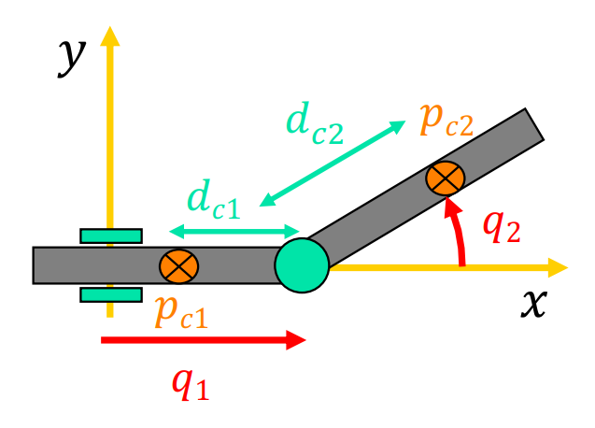

<https://github.com/giusenso/robot-manipulator-dynamics>

<https://github.com/Mansourt/Matlab_Euler-Lagrange_Library_for_Deriving_Equations_of_Dynamic_Systems>

[GitHub - sid19narayanan/3DOFRobotarm: The dynamics and control of a 3DOF robotic arm is presented. The robotic arm has 3 degrees of freedom and the Denavit-Hartenberg(DH) convention has been used to represent the link relationships to set up the forward and inverse kinematics of the manipulator. Lagrange's approach has been followed to establish the governing equations of motion. The trajectory of the robot has been constructed for the pick and place application discussed. Regulation control is implemented to check if the robot can hold its position. PD control techniques are implemented to track the desired trajectory. Robustness of the PD controller is demonstrated and a real time parameter updation technique is demonstrated using an adaptive controller to account for uncertainty in mass of the payload.](https://github.com/sid19narayanan/3DOFRobotarm)