**Version2**

**General Work flow**

1 Divide message1-message5 into 4 categories instead of 3.

2 Add causes of organization and Campaign

3. Test for normality, QQ plot

Kolmogorov-Smirnov test

Anderson

4. Change independent variables (model 1 model 2 and model 3)

'Org_causes' 'Cam_causes' are ignored? I add them in model 3

Model 1

1.            Campaign goal ( amount)

3.            Campaign Duration  ( number of days )

4.            Number of images used  ( can be 0 -5)

5.            Video use ( yes no )

7.            Number of words used in Description of campaign

8.            Number of words used in Description of NPO

Model 2

1. Campaign goal ( amount)
2. NPO Ipc Status For Tax Deductibility  ( yes no)
3. Campaign Duration  ( number of days )
4. Number of images used  ( can be 0 -5)
5. Video use ( yes no )
6. Impact message articulation ( 0-4)
7. Number of words used in Description of campaign
8. Number of words used in Description of NPO

Model 3

Many others variables.

['Actual_Donation_Amount', 'Campaign_Goal', 'NPO_Tax_Deductibility', 'duration_day', 'Campaign_Image_num', 'Campaign_Video', 'Msg1_category', 'Msg2_category', 'Msg3_category', 'Msg4_category','Msg5_category', 'Num_desc_cam', 'Num_desc_NPO', 'Org_causes', 'Cam_causes']

1. Descriptive statistics

Table1 Descriptive statistics and correlation

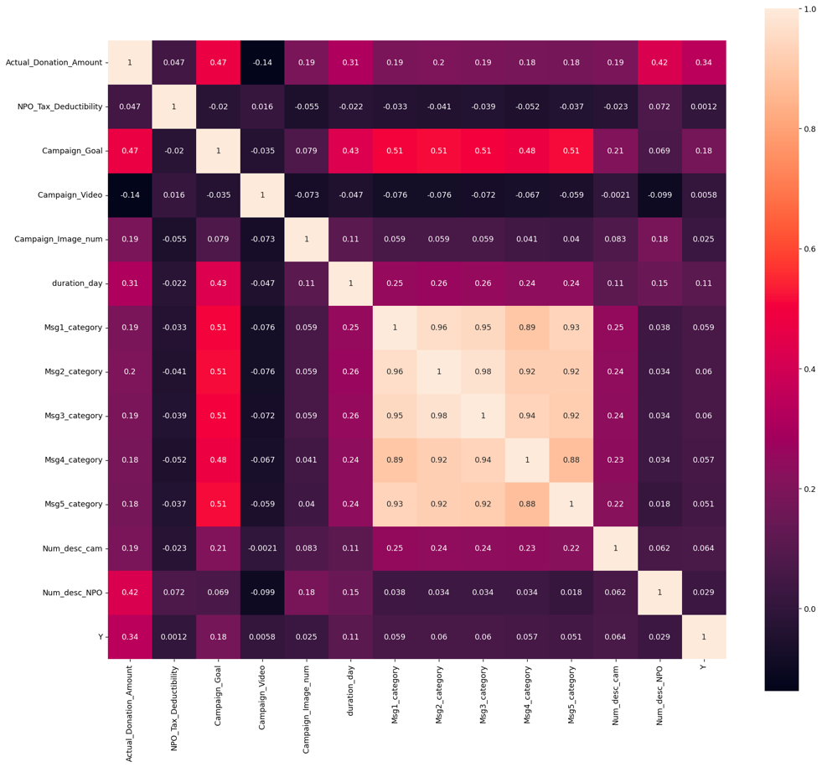

|  |  |  |  |  |
| --- | --- | --- | --- | --- |
|  | Mean | Variance | Max | Min |
| Actual_Donation_Amount | 9813 | 3966231020 | 3431670 |  |
| NPO_Tax_Deductibility |  |  |  |  |
| Campaign_Goal |  |  |  |  |
| Campaign_Video |  |  |  |  |
| Campaign_Image_num |  |  |  |  |
| duration_day |  |  |  |  |
| Msg1_category |  |  |  |  |
| Msg2_category |  |  |  |  |
| Msg3_category |  |  |  |  |
| Msg4_category |  |  |  |  |
| Msg5_category |  |  |  |  |
| Num_desc_cam |  |  |  |  |
| Num_desc_NPO |  |  |  |  |

Linear Regression Result

Model 1 The Result of selected independent variables

Model 2 The Result of selected

Model 3 The regression result

Model 4

