Relevant dataset

<https://github.com/linhandev/dataset>

Changed the environment

The easiest way to run fingerprint extraction, experiment planning and preprocessing is to use:

nnUNetv2_plan_and_preprocess -d DATASET_ID --verify_dataset_integrity

nnUNetv2_plan_and_preprocess -d 02 --verify_dataset_integrity

**Model training**

Training models is done with the nnUNetv2_train command. The general structure of the command is:

nnUNetv2_train DATASET_NAME_OR_ID UNET_CONFIGURATION FOLD [additional options, see -h]

nnUNetv2_train 201 2d 0 -device cpu

Use Google Colab to train nnUNet

Reference codes: <https://github.com/IML-DKFZ/nnunet-workshop>

Ubuntu system configuration process

机器编号：1023

ssh：220.168.146.21:51023 账号：wuyou 密码：wuyou@168

VMware installation

13960706814

机器编号：1023

TD：891 782 172 密码：755480

Download url: <https://customerconnect.vmware.com/downloads/get-download?downloadGroup=FUS-PUBTP-2021H1>

Account: [e0973856@u.nus.edu](mailto:e0973856@u.nus.edu) Password: same as email password

My VMware key: H4082-DA35Q-081QA-003K2-948M0

Ubuntu download:

<https://ubuntu.com/download/server/arm>

Configuration setting

reference link:

<https://juejin.cn/post/7086792624140451853>

Install desktop display

1.更新一下

sudo apt-get update

2.安装ubuntu桌面图形化显示

sudo apt-get install ubuntu-desktop

3.安装unity桌面系统

sudo apt-get install unity

4.安装lightdm显示管理器

sudo apt-get install lightdm

5.选择 lightdm或者gdm3都可以

sudo service gdm3 start

6.设置ubuntu开机的默认开启方式为图形化界面显示

sudo systemctl set-default graphical.target

7.重启系统

reboot

<https://github.com/search?q=Dimensionality+Reduction&type=repositories>

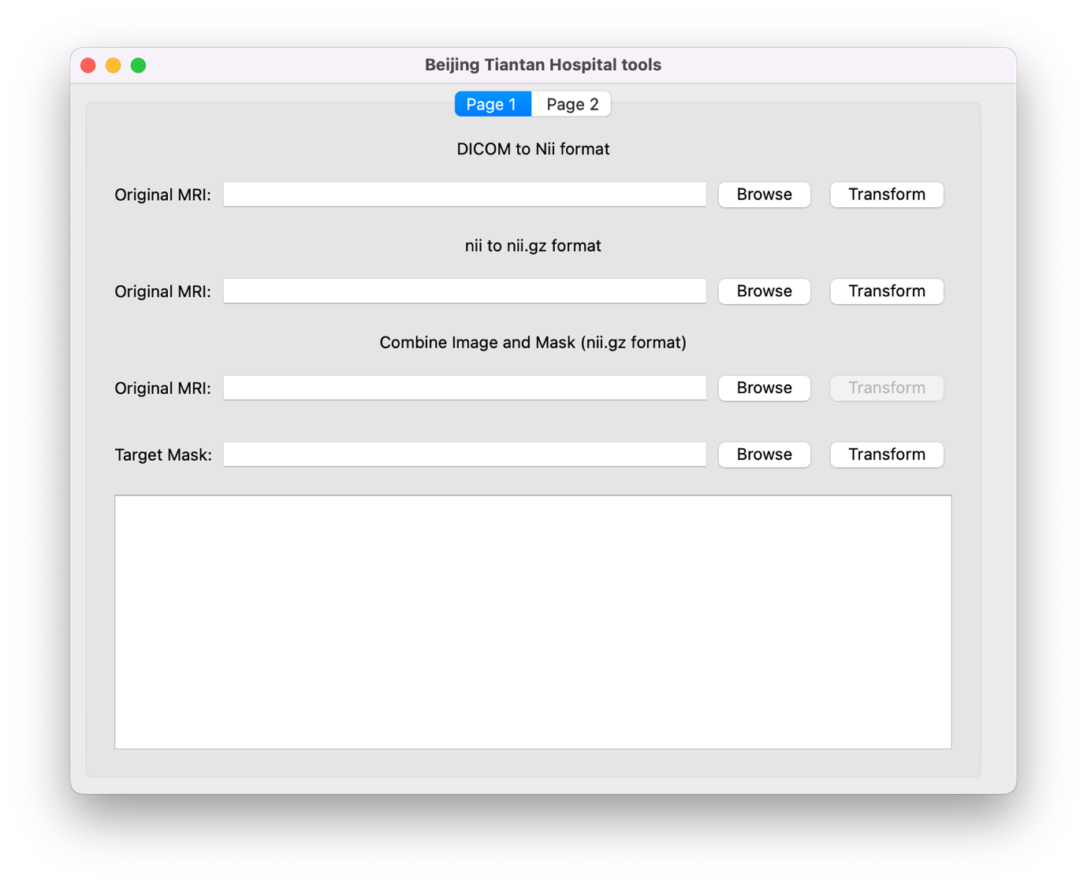

<https://www.youtube.com/watch?v=2EjrLpC4cE4>

打包成exe文件：

<https://www.youtube.com/watch?v=U4zlCx-emzc>