# Industry Grade Project 1:

Submission By : Vivek Gupta

Mail : vg52531@gmail.com

GitHub : <https://github.com/VGupta434/>

Project remote Repository: <https://github.com/VGupta434/Edureka-project-1.git>

## Task 1: Integrating Git

a. Copied the extracted code into working

b. Initialized the git repository(git init)

c. Committed the code for first time

d. Added an upstream 'master' branch.

e. Pushed the code to the remote repository(https://github.com/VGupta434/Edureka-project-1.git)

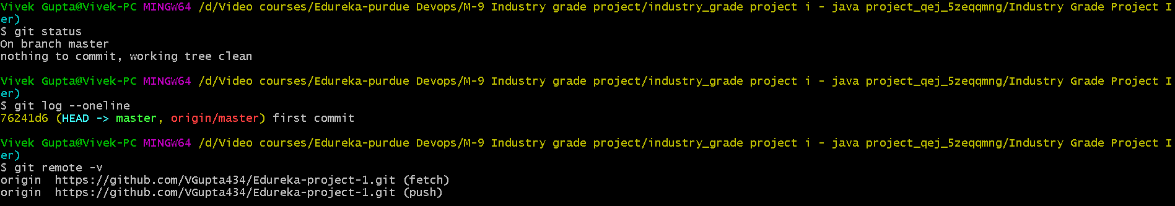

Img 1.1 : Setup local git repository

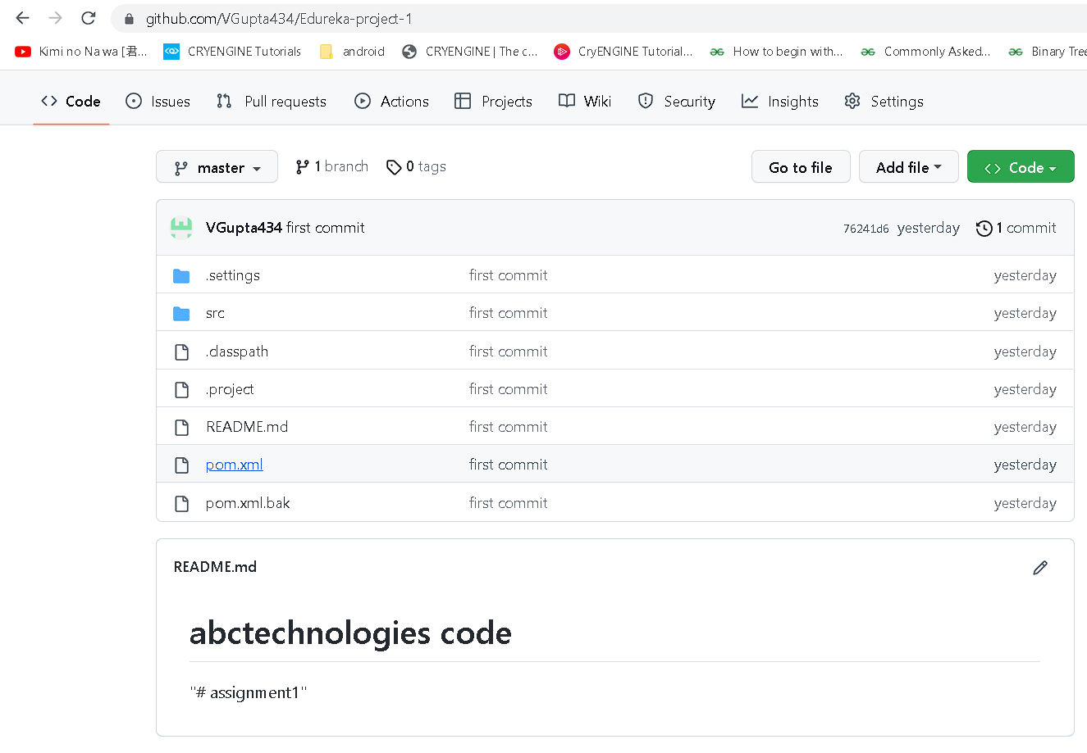

Img 1.2 : Setup remote git repository

## Task 2: Integrating with Jenkins

1. Installed Jenkins on Master node
2. Setup Jenkins on master node
3. Installed required plugins (jacoco, PMD, etc)
4. Setup a master slave architecture
5. Created scripted pipeline for CI using Jenkins

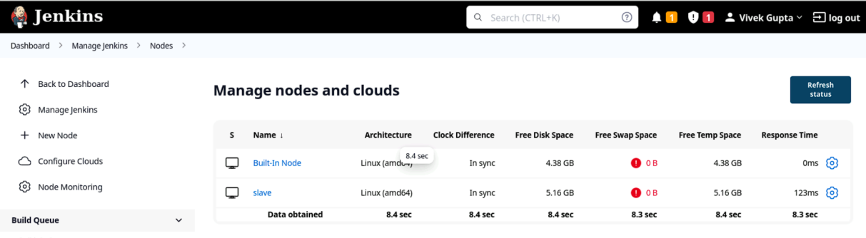

Img 2.1 : Setup master slave architecture on jenkins

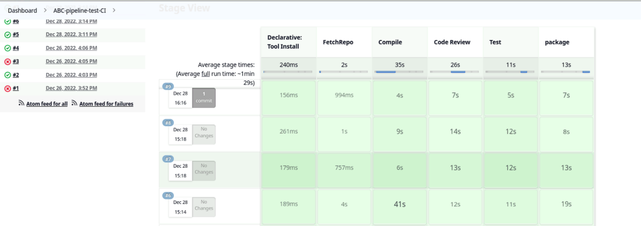

Img 2.2 : Created CI pipeline for code.

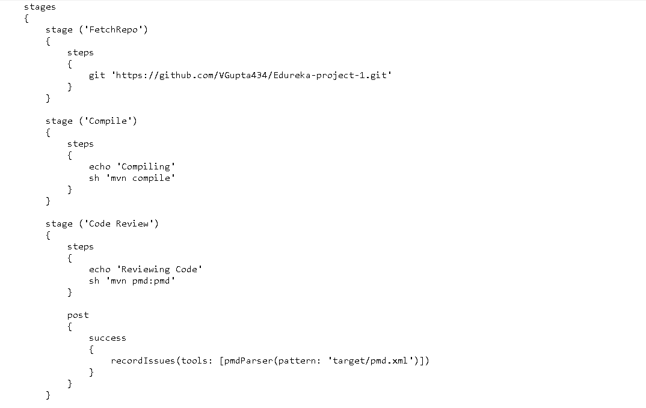

Img 2.3 : Pipeline code for Compiling & code review

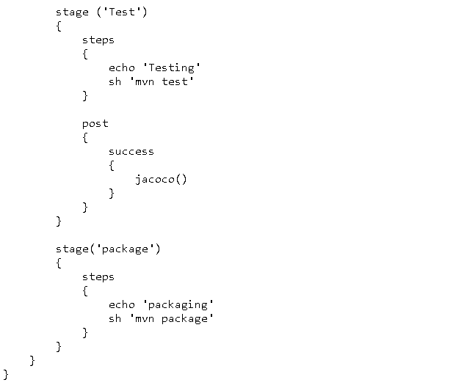

Img 2.4 : Pipeline code for Testing & Packaging

## Task 3 : Deployment with Docker

1. Created Dockerfile for the war file.
2. Created the jenkins pipeline to build docker image, Push image to docker repository, Build container.

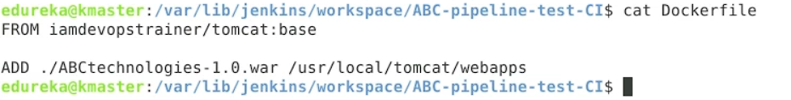

Img 3.1 : Dockerfile

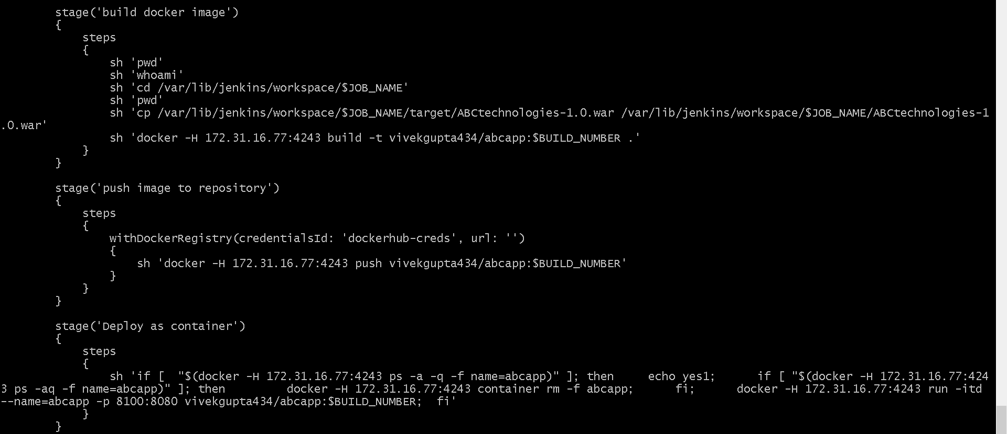

Img 3.2 : Jenkins pipeline stages to build,push docker image and deploy image as a container



Img 3.3 : Docker container created

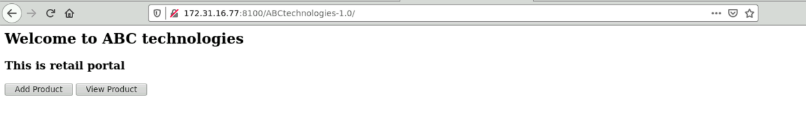

Img 3.4 : ABC-technologies Webpage

## Task 4: CD using Ansible, Docker & Kubernetes

1. Created ansible playbook for creating & pushing docker image
2. Created Kubernetes deployment manifest file
3. Created Kubernetes service manifest file
4. Created ansible playbook to deploy kubernetes resources
5. Created Jenkins pipeline to automate the execution of the playbooks to achieve continuous deployment

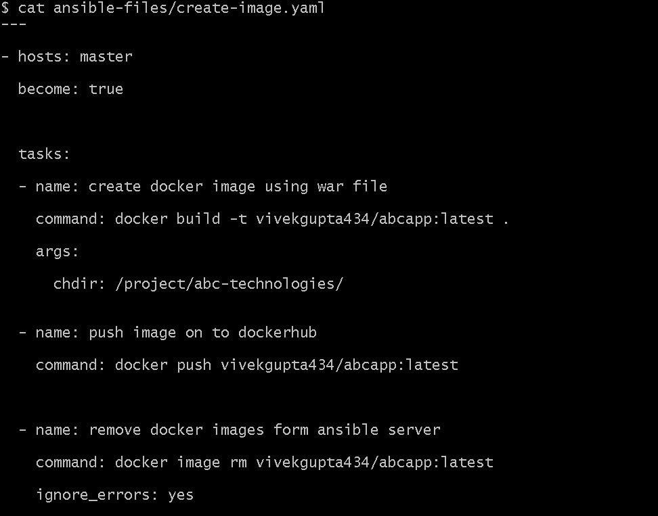

Img 4.1 : Ansible playbook for creating & pushing the docker image

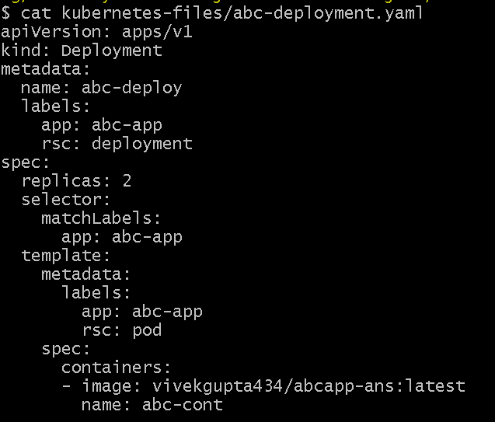

Img 4.2 : Kubernetes deployment manifest

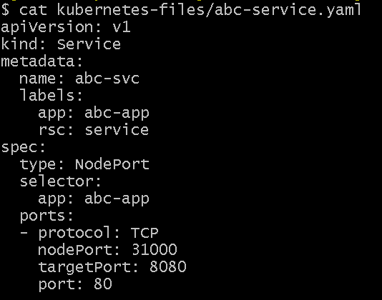

Img 4.3 : Kubernetes service manifest

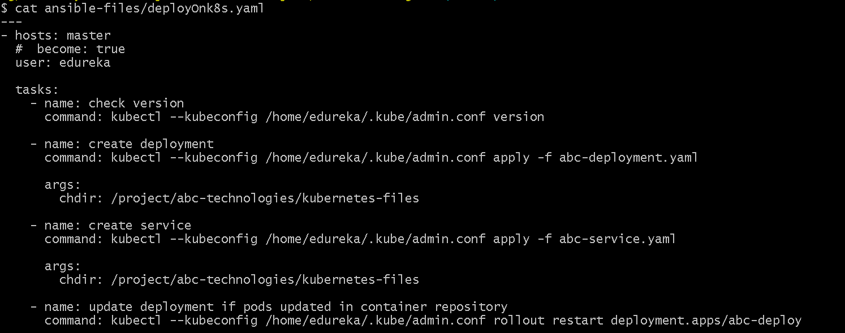

Img 4.4 : Ansible playbook to deploy kubernetes resources

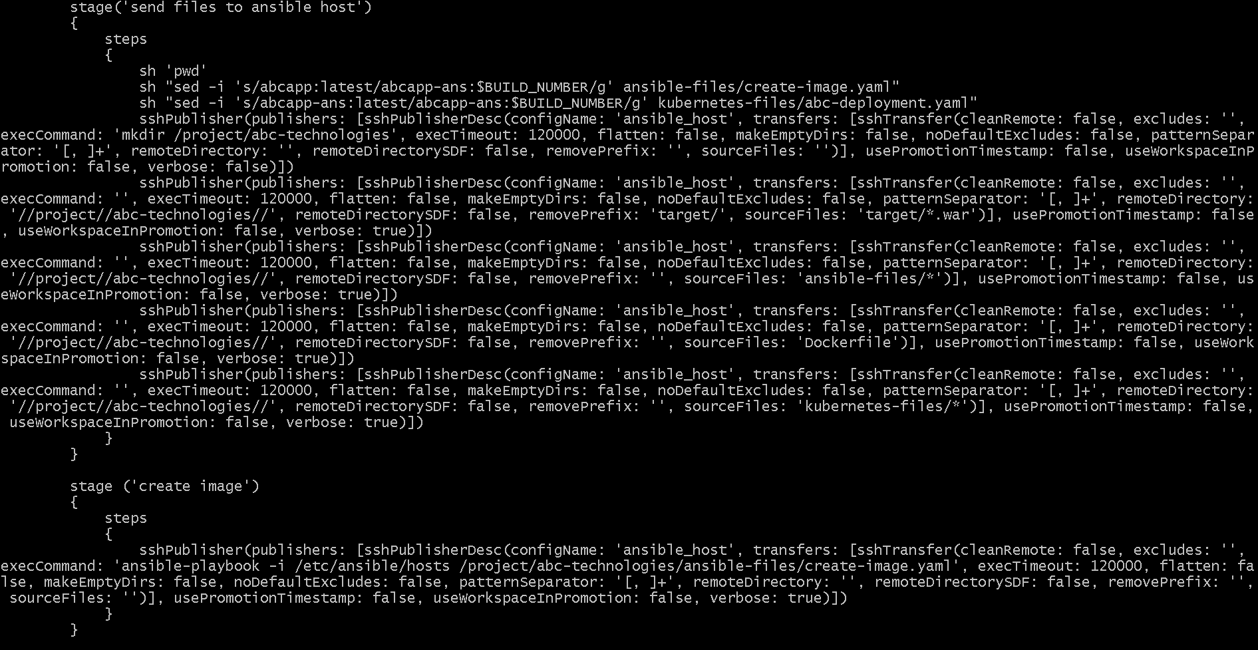

Img 4.5 : Jenkins pipeline code to send artifacts to ansible host & create & push docker image

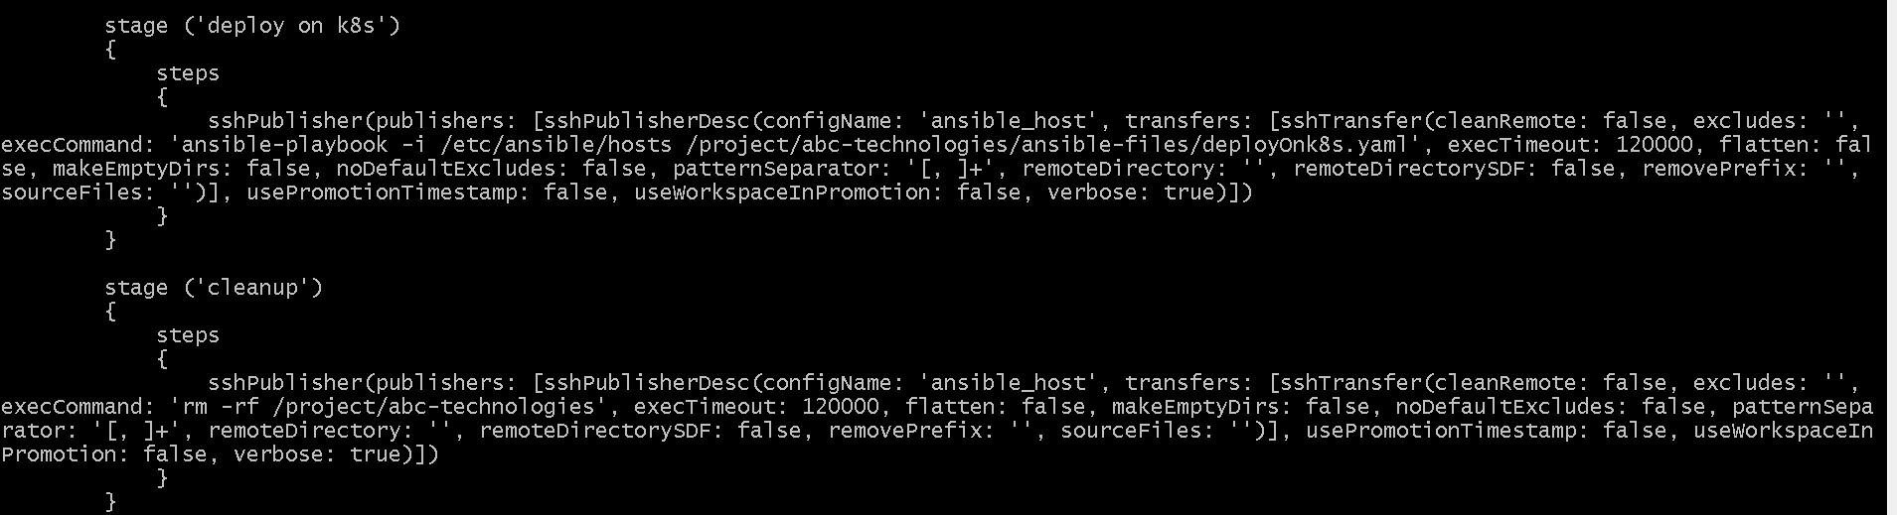

Img 4.6 : Jenkins pipeline code to deploy kuberneted resources & cleanup all extra files from ansible host after the deployment.

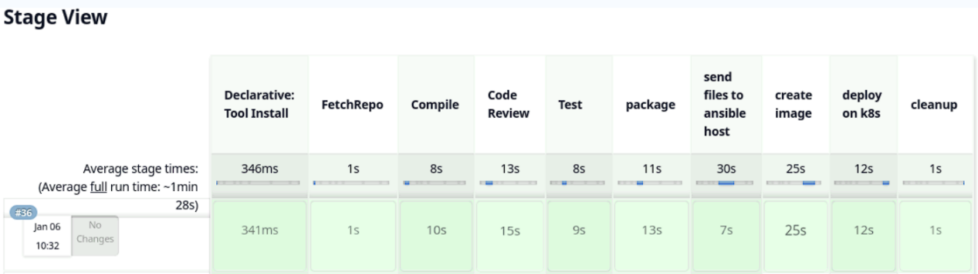

Img 4.7 : Jenkins pipeline successful

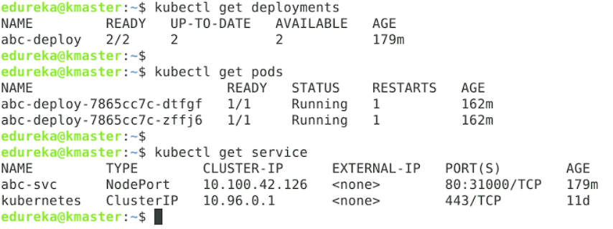

Img 4.8 : Kubernetes resources created

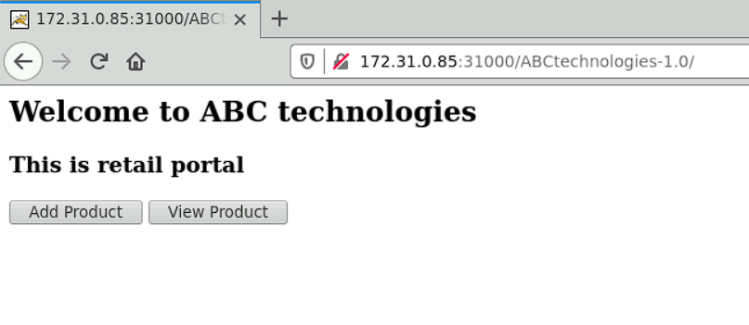

Img 4.8 : Deployed webpage accessed on another machine.

## Task 5: Monitoring using Prometheus and Grafana

1. Installed node exporter for linux from prometheus web page
2. Ran the node_exporter script
3. Added the node_exporter target to the prometheus.yaml file
4. Created grafana dashboard
5. Added the source as prometheus

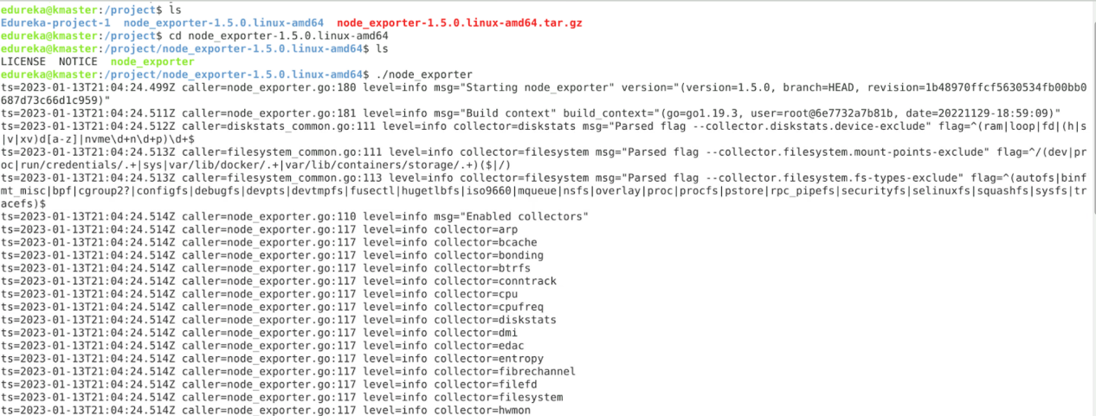

Img 5.1 : Downloaded the node_exporter and executed the script

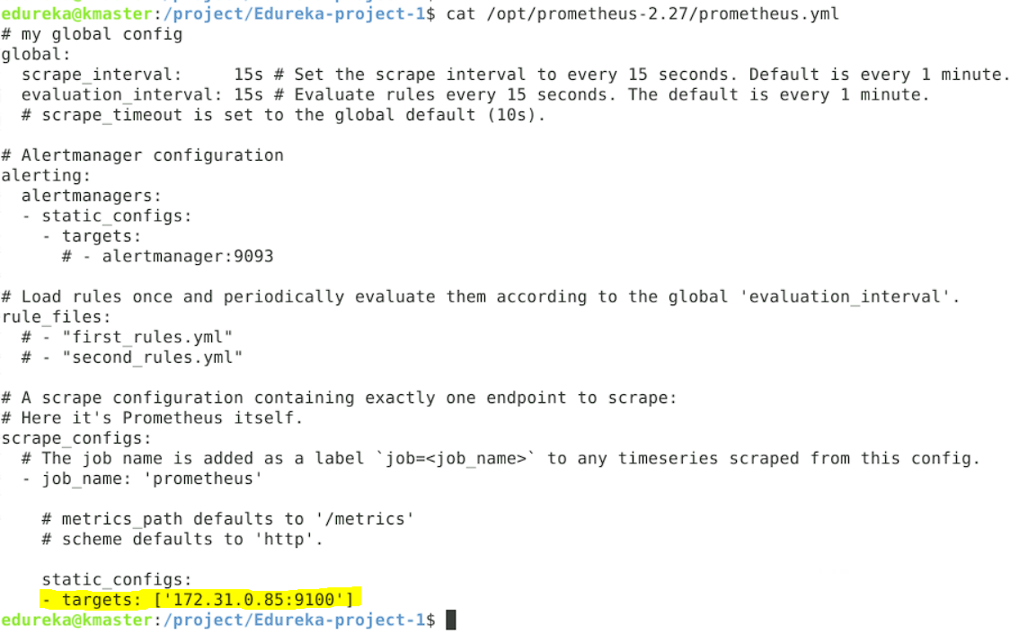

Img 5.2 : Added the node_exporter as target in prometheus.yml file

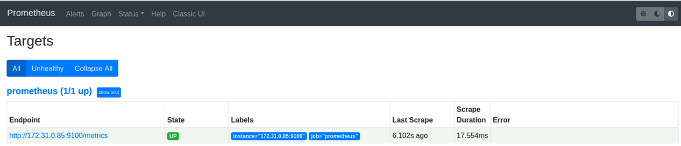

Img 5.3 : Prometheus targets

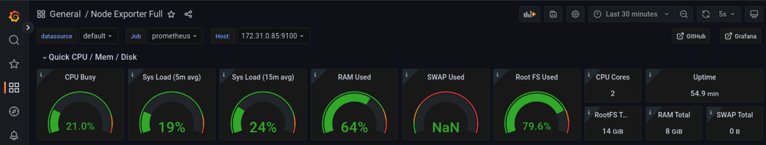

Img 5.4 : Grafana dashboard - 1

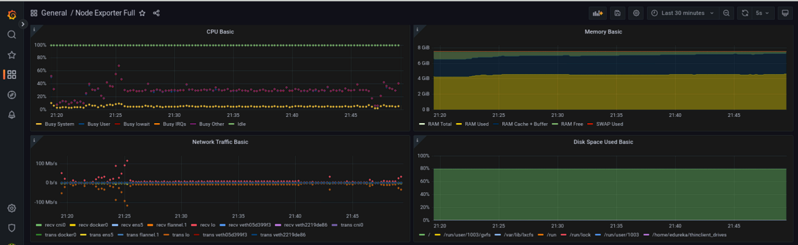

Img 5.5 : Grafana dashboard - 2