Department of Veterans Affairs

**Automated Surgical Risk Calculator (ASRC)**

User Guide



**July 2015**

Version 0.08

Revision History

| Date | Rev | Description | Author | Reviewer | Issue Date |
| --- | --- | --- | --- | --- | --- |
| 11/21/2014 | 0.01 | Creation  Tailored for ASRC and provided guidance for:  Login and system exit  Selecting surgical specialty  Manually entering gender  Manually entering age  Selecting a surgical procedure | B. Frey | S. Vetzel | 11/21/2015 |
| 12/17/2014 | 0.02 | Updated to include the following:  Pop-up list Variables (e.g., Procedure)  Manual Entry Variables (e.g., Age)  Checkbox Variables (e.g. DNR)  Radio Button Variables (e.g., Functional Status)  Custom Variables | B. Frey | S. Vetzel | 12/17/2014 |
| 02/23/2015 | 0.03 | Updated surgical procedure selection screenshot and added a description of the CPT code search feature.  Updated to include:  launching the ASRC application from the CPRS Tools Menu  Sharing Patient Context with CPRS  Model Calculation | B. Frey | S. Vetzel | 02/24/2015 |
| 03/23/2015 | 0.04 | Updated to include automatically retrieved values from VistA. | B. Frey | S. Ambrose | 03/23/2015 |
| 04/20/2015 | 0.05 | Updated to include re-run calculation with modified inputs and signing the risk calculation and saving the result as a TIU note | S. Ambrose | B. Frey | 04/21/2015 |
| 05/18/2015 | 0.06 | Updated Administrative functions. Added saving calculation results to SURGICAL RISK CALCULATIONS FILE (#136.1). | B. Frey | S. Ambrose | 05/18/2015 |
| 06/15/2015 | 0.07 | Updated to include new Procedure search functions and new administration features | B. Frey | S. Ambrose | 06/15/2015 |
| 7/14/2015 | 0.08 | Updated to include new administrator functions (e.g., adding/editing rules, updating procedures, and models, etc.) | B. Frey | S. Ambrose | 07/14/2015 |

**Table of Contents**

1. Introduction 1

1.1. Purpose 1

1.2. Overview 1

1.2.1. Major Functions 1

1.2.2. Characteristics 2

1.3. Project References 2

1.3.1. Contact Information 2

1.3.2. Help Desk 2

2. System Summary 2

2.1. System Diagram and Data Flows 2

2.2. User Access Levels 3

3. Getting Started 3

3.1. Logging On 3

3.1.1. CPRS Patient Context Sharing 4

3.2. Select Surgical Specialty Menu 4

3.3. Risk Variable Entry 5

3.3.1. Pop-up Selection List Variables 5

3.3.2. Manual Entry Variables 6

3.3.3. Check Box Variables 7

3.3.4. Radio Button Variables 8

3.3.5. Automatically Retrieved Variables 9

3.3.6. Running Risk Model Calculations 9

3.4. Re-run Calculation with Modified Inputs 11

3.5. Signing the Risk Calculation 11

3.5.1. Saving the Result as a TIU Note 12

3.5.2. Saving the Results as Discrete Data in VistA 12

3.6. ASRC Tool Administration 12

3.6.1. Accessing the Administration Function 12

3.6.2. Model Definitions 12

3.6.3. Variable Definitions 15

3.6.4. Rules 17

3.6.5. Procedures 21

3.7. Changing User ID and Password 23

3.8. Exit System 23

A. Appendix A – Acronym List 24

**List of Figures**

Figure 1 - ASRC System Diagram and Data Flow 3

Figure 2 - ASRC Login Screen 4

Figure 3 - Select Surgical Specialty 5

Figure 4 - Surgical Procedure Popup 6

Figure 5 - Manual Entry Variable 7

Figure 6 - Check Box Variable 8

Figure 7 - Radio Button Variable 9

Figure 8 - Run Calculation 10

Figure 9 - Results Page 11

Figure 10 - Administrator Login 12

Figure 11 - Model Definitions 13

Figure 12 - Edit Model Definition 13

Figure 13 - Model Definition CSV Example 14

Figure 14 - Variable Definition 15

Figure 15 - Adding new variables 16

Figure 16 - Edit Variable Page 17

Figure 17 - Rule Definition 17

Figure 18 - Add New Rule 18

Figure 19 - Edit Existing Rule 19

Figure 20 - Manage Procedures 22

Figure 21 - Update Procedures 22

Figure 22 - Procedure CSV File Example 23

**List of Tables**

Table 1 - Acronym List 24

# Introduction

## Purpose

The Automated Surgical Risk Calculator (ASRC) User Guide will provide a reference for users of the “ASRC Tool” being developed as a Department of Veterans Affairs (VA) Innovations program.

The purpose of this document is to provide clear and easy to follow instructions and associated screen shots to facilitate sufficient understanding to effectively use the ASRC tool. The User Guide will reflect updates as new functionality is developed and is accessible to system users.

## Overview

The tool is used at the time the patient is considered for surgical referral by a primary care provider, and when a surgeon is requesting a surgery. This Tool will support clinical decision-making regarding perioperative risk (includes preoperative, intraoperative, and postoperative). Providers will verify patient-specific data that is automatically pulled from available data sources, enter remaining fields, and be provided with a real-time individual risk calculation of perioperative surgical mortality based on historic Veterans Affairs Surgical Quality Improvement Program (VASQIP) data and current VASQIP risk-adjusted models that are specialty-specific. The data entered and the calculated results will be available for viewing in the Computerized Patient Record System (CPRS) as a progress note. The data will also transfer and store as discrete fields in Veterans Health Systems and Technology Architecture (VistA) and a Structured Query Language (SQL) database for use by the National Surgery Office (NSO).

### Major Functions

The ASRC Tool has the following Major Functions/Features

* Accessible through CPRS
* Automatic Patient and User Context (Not implemented) sharing with CPRS
* Selection of Surgical Specialties
* Pop-up list selection of Current Procedural Terminology (CPT) codes with long description and Relative Value Unit (RVU). Search for Procedure includes “All of these words”, “Any of these words”, and “CPT Search”
* Manual entry of variables such as Age and Body Mass Index (BMI)
* Check Box entry of variables such as Do Not Resuscitate (DNR)
* Radio Button selection of variables such as Functional Status
* Administrator access provided to add and modify surgical risk model variable names, help text, variable grouping, and VistA retrieval
* Automatic retrieval of values from VistA
* Text Integration Utility (TIU) Note saved with model calculation inputs and results available in CPRS
* Associated patient, CPT code, date and time of calculation, user, and actual outcome results from the calculation saved as discrete data in SURGICAL RISK CALCULATIONS FILE (#136.1)
* Model Input variable reuse through a button on the Results page

### Characteristics

The ASRC (under development in the VA’s Future Technology Lab (FTL)) is:

* A web-based application with a simple Graphical User Interface
* Integrated with VistA and CPRS
* A decision support system providing calculated surgical risk using NSO approved and validated risk models

## Project References

The reference document for the ASRC Tool is the VA’s Transformation Twenty-one Total Technology (T4), ASRC Performance Work Statement (PWS), executed out of the NSO and Dated, 08-31-2014 (TAC-14-16044).

### Contact Information

Primary development Team Point of Contact (POC),

* David Tombs, JAVA Developer, 321.608.0919, [David@libertyITS.com](mailto:David@libertyITS.com)
* Jeff Swesky, VistA Developer, 904.207.8560, [Jeff.Swesky@hp.com](mailto:Jeff.Swesky@hp.com)
* Bill Frey, Tester, 321.608.0924, E: [Bill.Frey@libertyITS.com](mailto:Bill.Frey@libertyITS.com)

### Help Desk

Although there is not a Help Desk established for the ASRC Innovations program, members of the development team may be contacted with system operation/function questions. The POC recommended for the initial call is Bill Frey (Tester).

# System Summary

## System Diagram and Data Flows

Figure 1 shows a simplified diagram of the ASRC system components and data flow. Whereas CPRS displays, please note that its integration is a future enhancement.

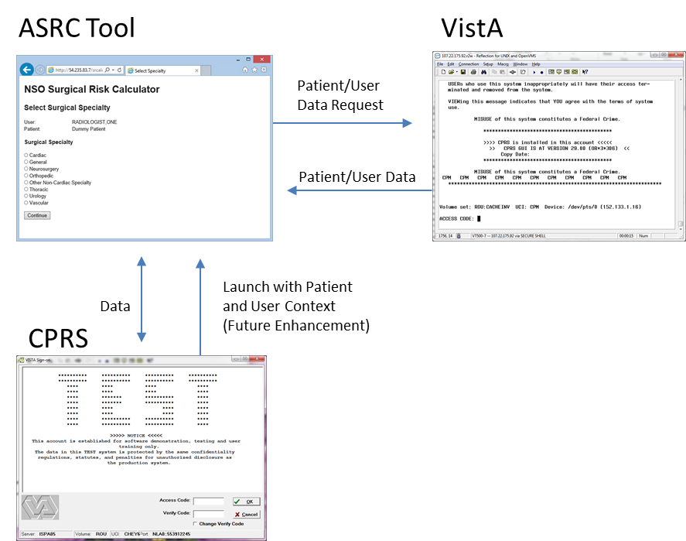

Figure 1 - ASRC System Diagram and Data Flow

## User Access Levels

There is no user access restrictions placed on the ASRC Tool during development. When the tool becomes operational, access will be limited to those that can access CPRS.

# Getting Started

## Logging On

To access the ASRC tool (also referred to as the ASRC application) login into CPRS (as of 2/23/2015 only available in the VA’s FTL) and launch ASRC from the CPRS Tools Menu. Access to the VA’s FTL is required. During the ASRC program development phase, please contact a representative of the development team as detailed in Section 1.3.1 of this manual.

On the ASRC login screen (Figure 2) enter a valid User Number (DUZ number) (Radiologist = 11716) in the User: field. This is a temporary login approach until User context sharing with CPRS is established.

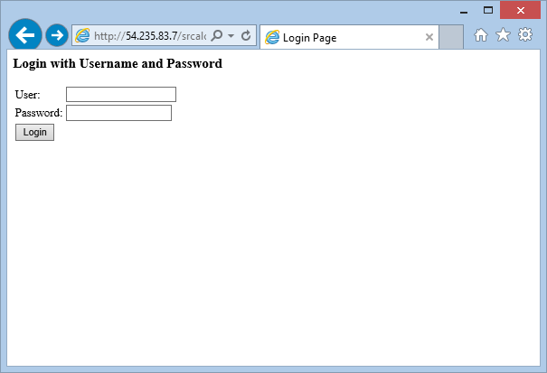

Figure 2 - ASRC Login Screen

### CPRS Patient Context Sharing

The patient selected, as part of the “Login” to CPRS, is automatically shared with the ASRC Application so that the user does not need to look up the patient from within the tool. The patient’s name selected in CPRS is shown as the “Patient” in ASRC and all data retrieved from VistA will be associated with this patient. If a new patient is selected in CPRS while the ASRC tool is already displaying another patient, the previously selected patient (and any already entered data) will be retained. However if ASRC is launched again after the selection of a new patient, that new patient will now be the active, displayed patient.

## Select Surgical Specialty Menu

Select a Surgical Specialty as shown in Figure 3 below. Please note that this screen may reflect updates as the program progresses but should still provide a good reference until the User Guide is updated to support the next version of the tool.

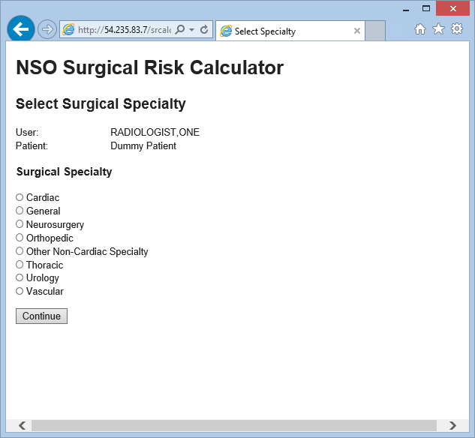

Figure 3 - Select Surgical Specialty

## Risk Variable Entry

In order to run risk calculations there are surgical specialty and risk model dependent variables that need to be entered. This section provides guidance for the different variable types that are available.

### Pop-up Selection List Variables

Currently only the surgical procedure is selectable from a pop-up list. Any future pop-up selection variables will work in the same manner.

#### Surgical Procedure Selection

To select a surgical procedure click on the Procedure “Select” Link (available only on the non-cardiac surgical specialties). The below pop-up window is displayed (Figure 4). Scroll through the available codes, select the CPT code by clicking the “Select” link located to the right of the desired code. The selected CPT code & short description will display on the surgical specialty screen.

#### Procedure Searching

Search for Procedures by using three different methods simultaneously or individually:

* “All of these words” - results include every word entered in the search box that is also in the CPT long description (they do not need to be in the exact order) (for example if “initial exam” was entered then results would include CPTs that had both “initial” AND “exam”)
* “Any of these words” - results include any word entered in the search box that is also in CPT long description (for example if “initial exam” was entered then results would include CPTs with either “initial” OR “exam”)
* “CPT Search” - results include and CPT that starts with the numbers entered up to 5 (5 digits entered would be an exact match)

When the Run Calculation executes, the selected code and long description will display on the results screen. An appropriate error message is displayed if Run Calculation is executed and a procedure is not selected (this is a required entry).

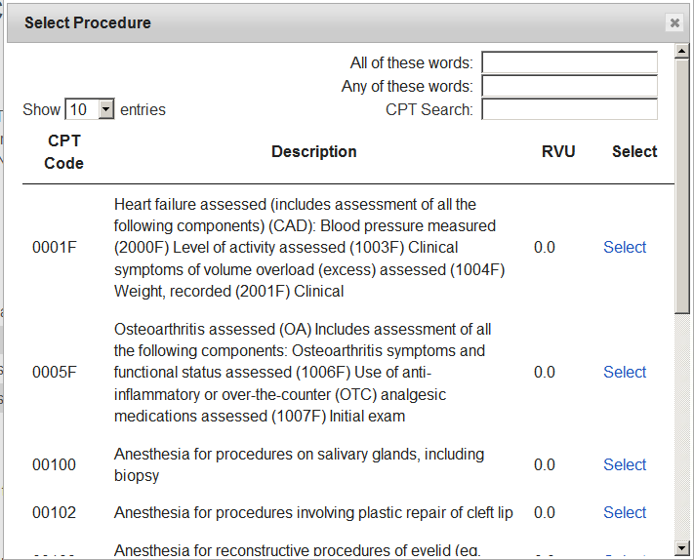

Figure 4 - Surgical Procedure Popup

### Manual Entry Variables

There are variables that are populated from VistA data or manually entered in cases where the data is not available in VistA or the user has information that is more recent. Examples of these variables are “Age:” and “BMI:” and they will all work in the same manner. An editable box will be displayed in which a user will manually enter the desired value (see Figure 5). Click in the entry box and enter the value. An appropriate error message will be displayed if the entry is not valid (e.g., an age of -1) or if a value is not entered. When Run Calculation executes, the entered value will display on the results screen.

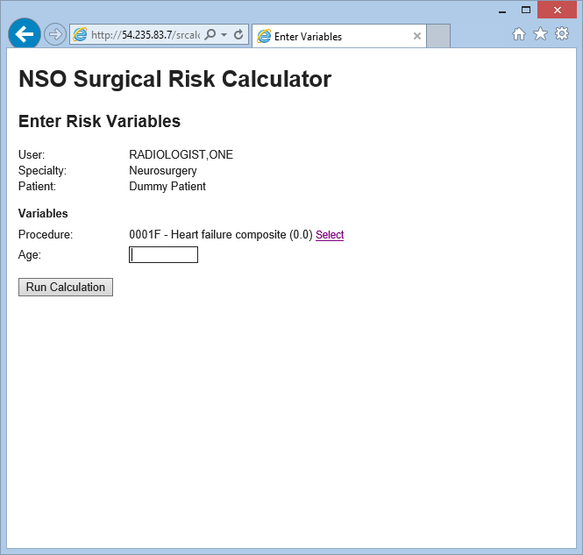

Figure 5 - Manual Entry Variable

### Check Box Variables

There are variables that can be selected by clicking a checkbox. Examples of these variables are “DNR” and “Preop Pneumonia” and they will all work in the same manner. These type of variables are shown as a small box on the display (see Figure 6) that can be left unchecked (indicating a “No” for that variable) or checked (indicating a “Yes” for that variable). When Run Calculation is executed, the corresponding value (“No” if unchecked, “Yes” if checked) will be displayed on the results screen.

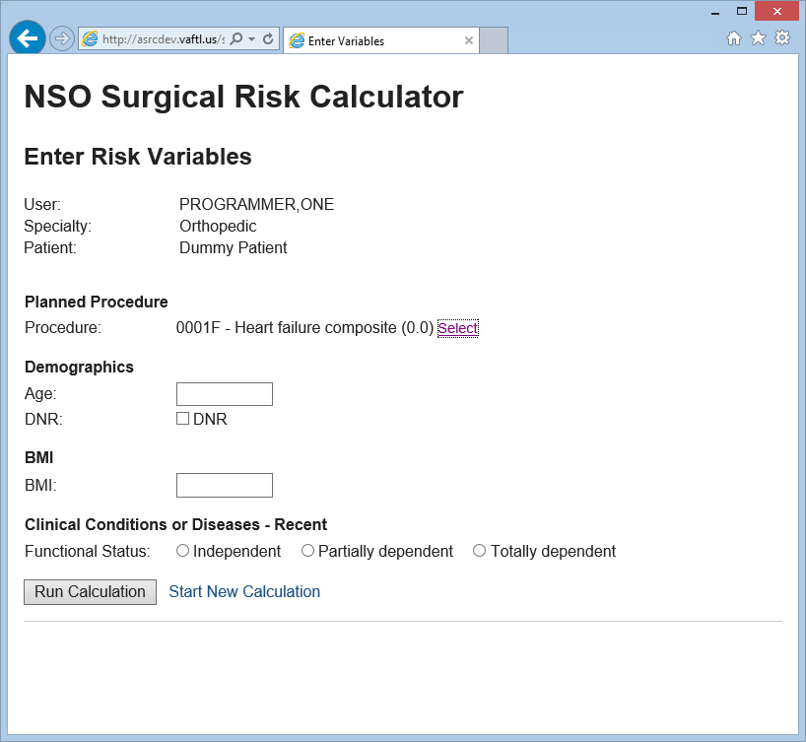

Figure 6 - Check Box Variable

### Radio Button Variables

There are variables that are selected by clicking a Radio Button. Examples of these variables are “American Society of Anesthesiology (ASA) Classification” and “Functional Status” and they will all work in the same manner. These types of variables are shown as a small circle next to a selection on the display (see Figure 7) that can be clicked to select (when clicked the circle will fill with black). If a radio button variable is not selected an appropriate error message will be displayed. When Run Calculation executes, the selected value will display on the results screen.

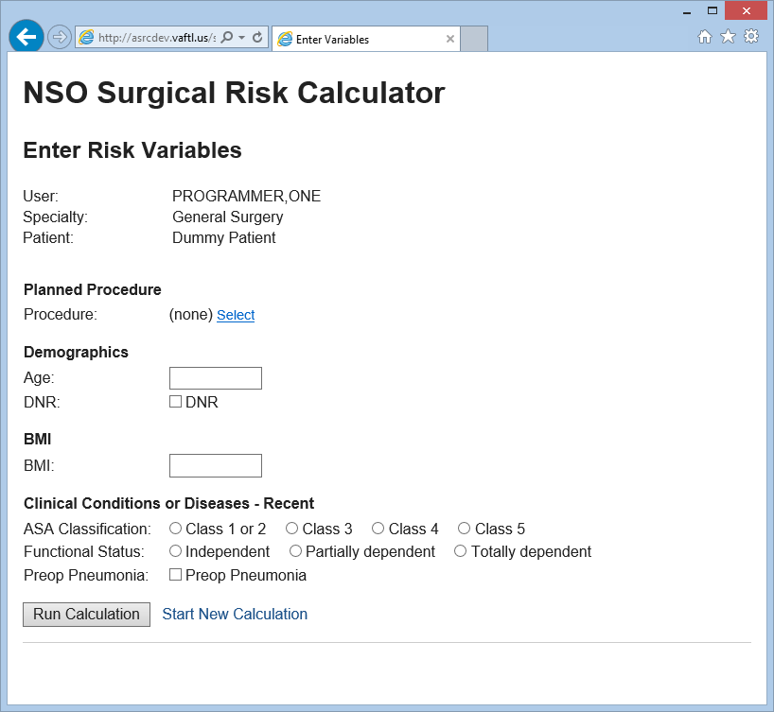

Figure 7 - Radio Button Variable

### Automatically Retrieved Variables

Some Variables’ values are automatically retrieved from VistA if they are available for the selected patient. Examples of these variables are Gender, Age, BMI, Weight, and Weight 6 months prior. The values retrieved from VistA are displayed as the default values. The ASRC user can overwrite any automatically retrieved values if necessary.

### Running Risk Model Calculations

To run a calculation for a specialty risk model, enter all information displayed for that specialty and click “Run Calculation” (Figure 11). The instructions for each variable type entry are in Section 3.3.1-3.3.5.

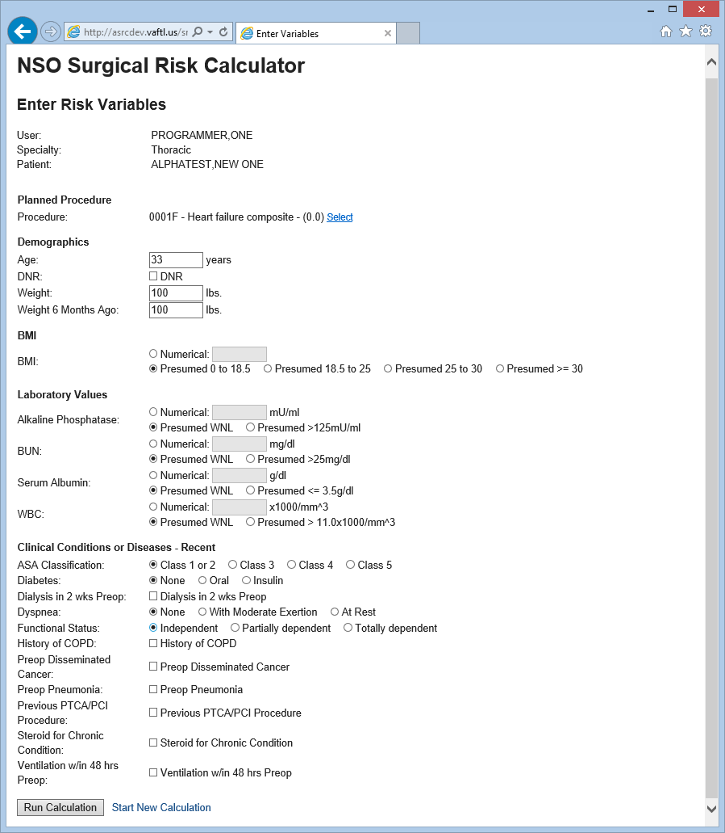

Figure 8 - Run Calculation

A results page (Figure 12) displays with all of the entered variables and the calculated risk shown as a percentage (%).

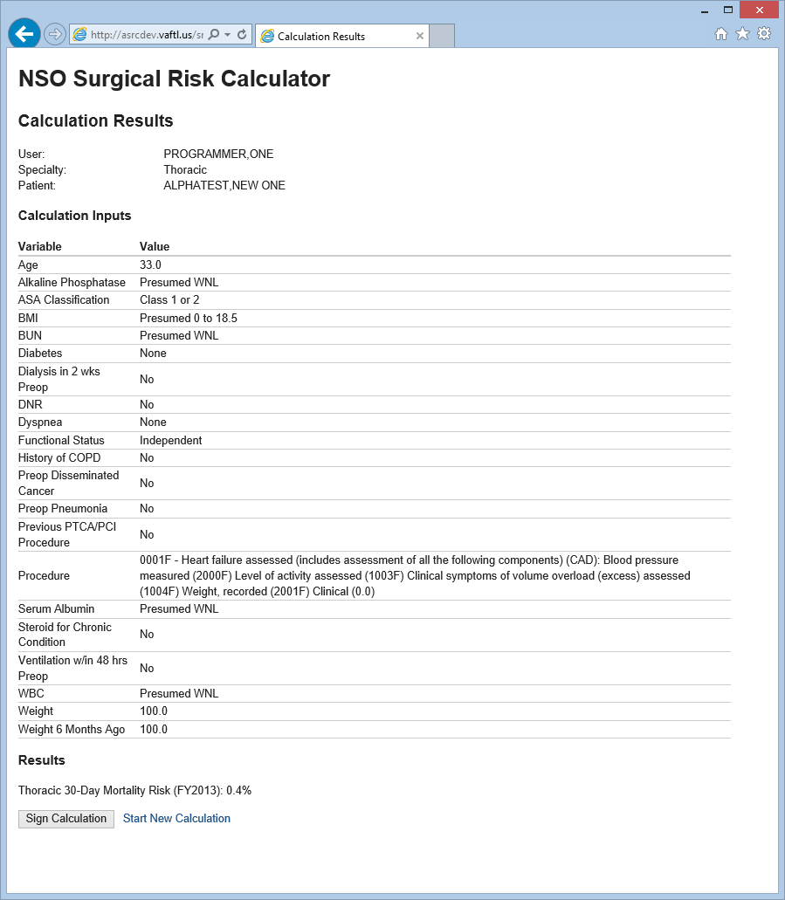

Figure 9 - Results Page

## Re-run Calculation with Modified Inputs

To re-run the calculation with modified inputs, click the “Return to Variable Input Form” button located on the results page. Clicking the back button does not display any inconsistent data to the user. The “Return to Variable Input Form” button returns to the variable input page, which preserves the current values.

## Signing the Risk Calculation

To sign the risk calculation for a specialty risk model, click the “Sign Calculation” button located on the results page (Figure 13). The tool will warn the user before signature that the data will be saved in Electronic Health Records (EHR). When signing the risk calculation the signature must be via the users electronic signature code. If the user signs the risk calculation with an invalid signature code, an appropriate error message will appear. When successfully signed, the tool brings the user to a success page indicating that the calculation has been saved as a note and they may close the browser window.

### Saving the Result as a TIU Note

After signing the risk calculation, the TIU Note with input values and outcomes is visible in the CPRS Notes tab. The calculation can easily be seen in the patient’s EHR. Once signed, a calculation may not be altered.

### Saving the Results as Discrete Data in VistA

After signing the risk calculation, the associated Patient, CPT code, date and time of calculation, user, and actual outcome results from the calculation are saved as discrete data to the SURGICAL RISK CALCULATIONS FILE (#136.1).

## ASRC Tool Administration

### Accessing the Administration Function

Use Internet Explorer to access the ASRC Administration function. During development of the Prototype, the administration function is available at http://asrcuat.vaftl.us/srcalc/admin. Administrator usernames and passwords are required.

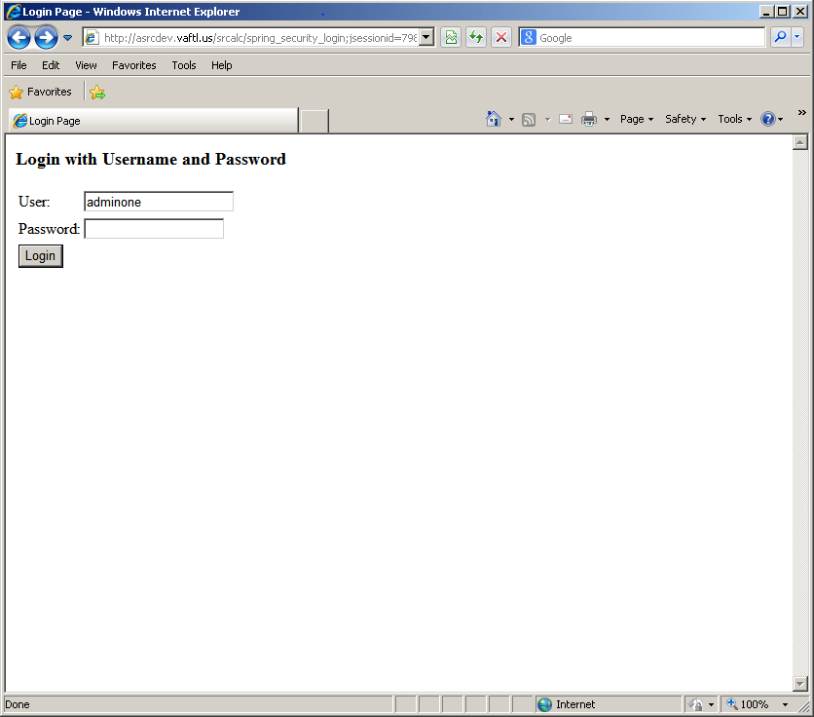

Figure 10 - Administrator Login

### Model Definitions

The ASRC administrator can “Edit” existing ASRC Risk Models. Figure 11 shows a Model Definition administration selection example.

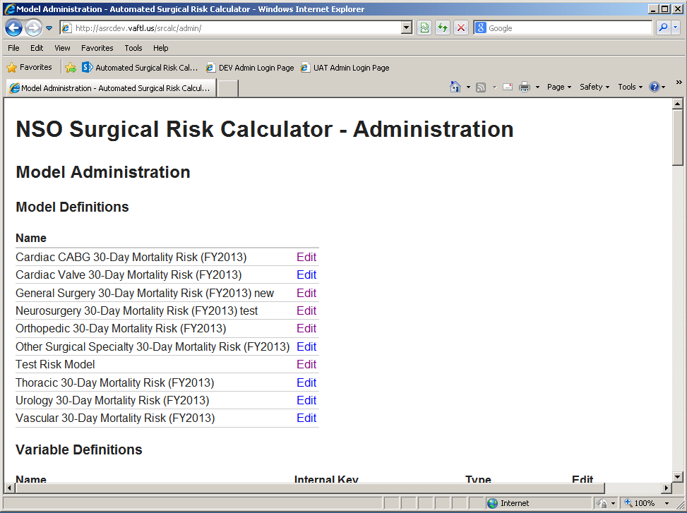

Figure 11 - Model Definitions

#### Model Definition – Edit

The ASRC Administrator uses the Edit Model Administration function (Figure 12) to

* See and Edit the Model name
* View the current model Terms, Term Type, and Coefficient
* Import a new model definition through a CSV (Comma Separated Values) file
* Save the changes

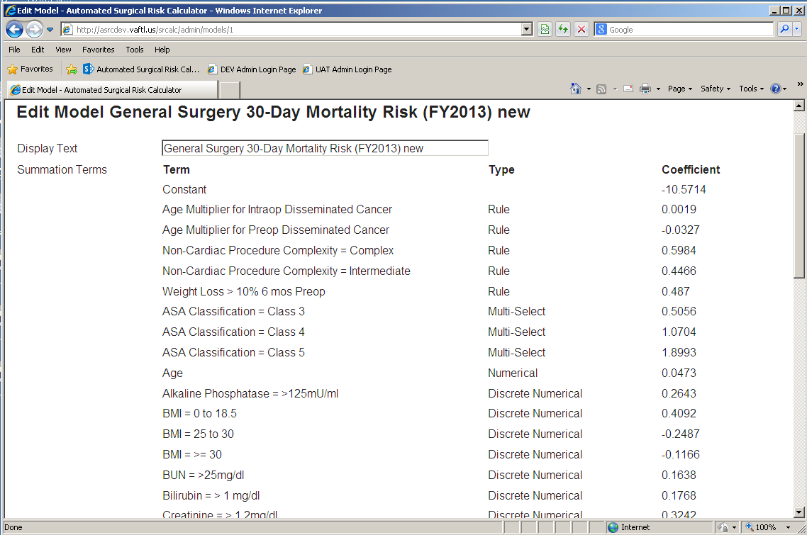

Figure 12 - Edit Model Definition

Figure 13 shows a sample of a correctly formatted model definition CSV file. ASRC validates the entries during the import process, displaying validation error messages to the Administrator. Changes are not made to the database until “Save Changes” is selected.

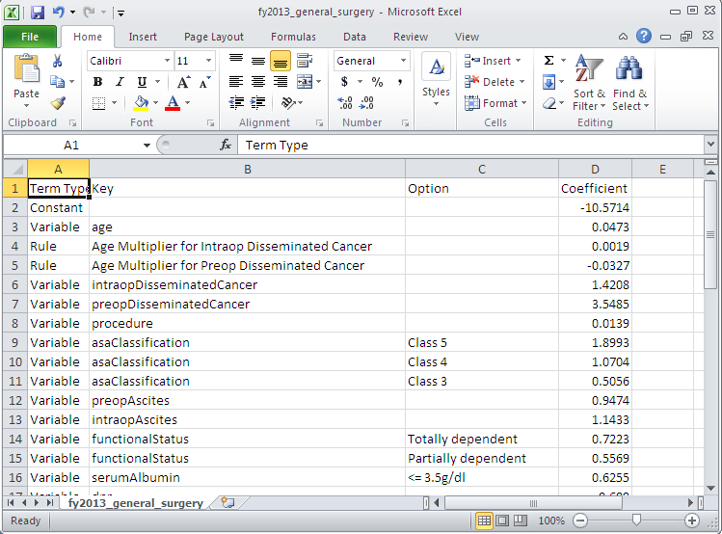

Figure 13 - Model Definition CSV Example

### Variable Definitions

The ASRC administrator can “Add” new variables or “Edit” existing ones. Figure 14 shows a Variable Definition administration selection example.

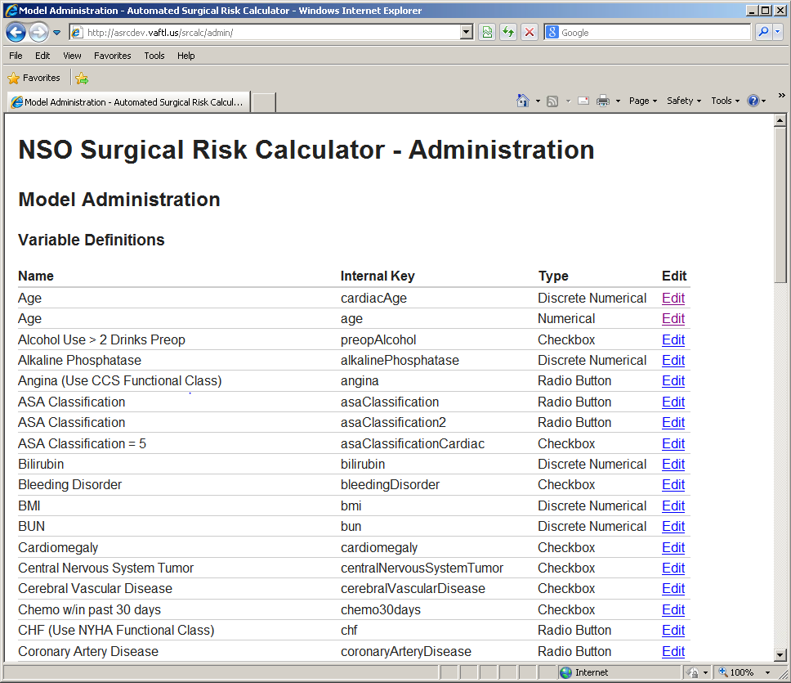

Figure 14 - Variable Definition

#### Variable Definition - Add

Add new variables by clicking the “Add New” button for the following variable types at the bottom of the ASRC Administration window (Figure 15):

* Checkbox variables
* Radio Button variables
* Discrete Numerical variables

After selecting the new variable type, the Administrative user enters the required information:

* Internal Key: Internal Database key for variable (This must be unique – the tool will validate on Save)
* Display Text: Name displayed on the Model input page. This name can be up to 80 characters in length.
* Help Text: Help text provided for the variable. The help text can be up to 4000 characters in length.
* Group: Select the variable group from the Group pick list.
* VistA Value: Indicate if the variable can be automatically loaded from VistA (if appropriate)
* Option: Option Name (Radio Button – up to 20)
* Units: Units in text (Discrete Numerical)
* Valid Range: Lower and upper bounds of the variable range (Discrete Numerical)
* Category: Category name (Discrete Numerical – up to 20)

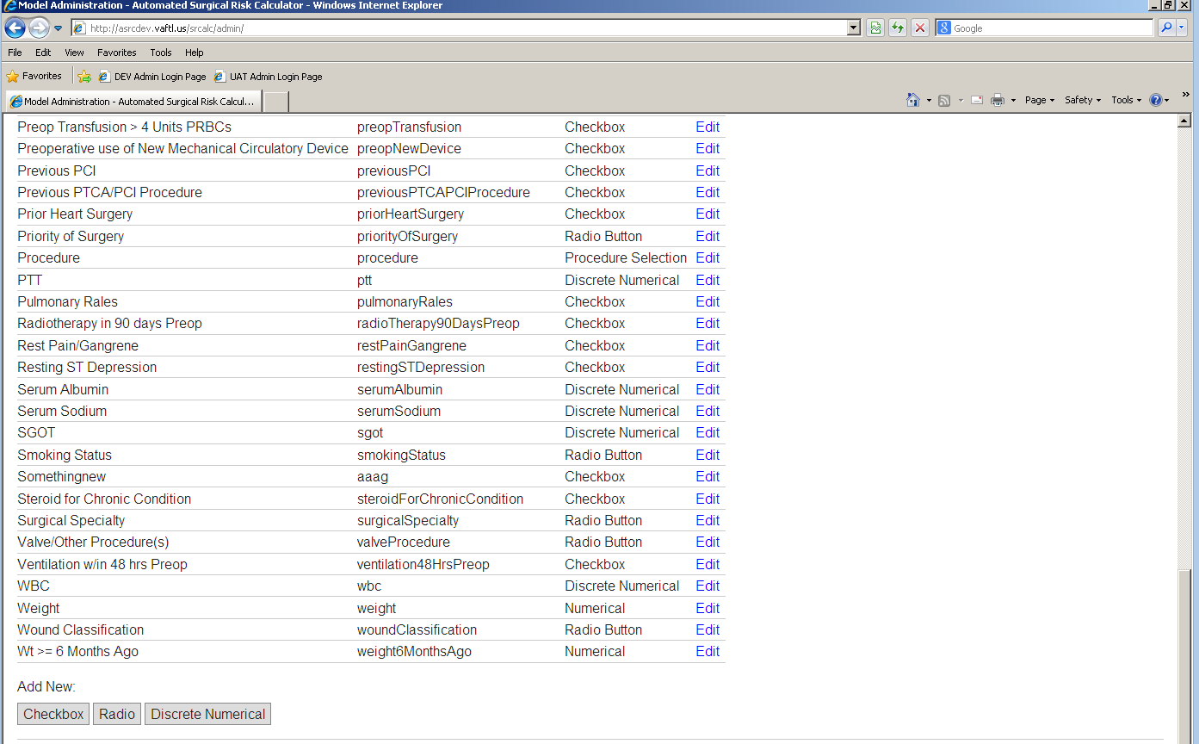

Figure 15 - Adding new variables

#### Variable Definition – Edit

In the ASRC Administration tool, Variable Definition section click on “Edit” (see Figure 16) to modify existing variables. The following characteristics are modifiable for each variable,

* Display Text: Name displayed on the Model input page. This name can be up to 80 characters in length.
* Help Text: Help text provided for the variable. The help text can be up to 4000 characters in length.
* Group: Select the variable group from the Group pick list.
* VistA Value: Indicate if the variable can be automatically loaded from VistA (if appropriate)
* Option: Option Name (Radio Button – up to 20)
* Units: Units in text (Discrete Numerical)
* Valid Range: Lower and upper bounds of the variable range (Discrete Numerical)
* Category: Category name (Discrete Numerical – up to 20)

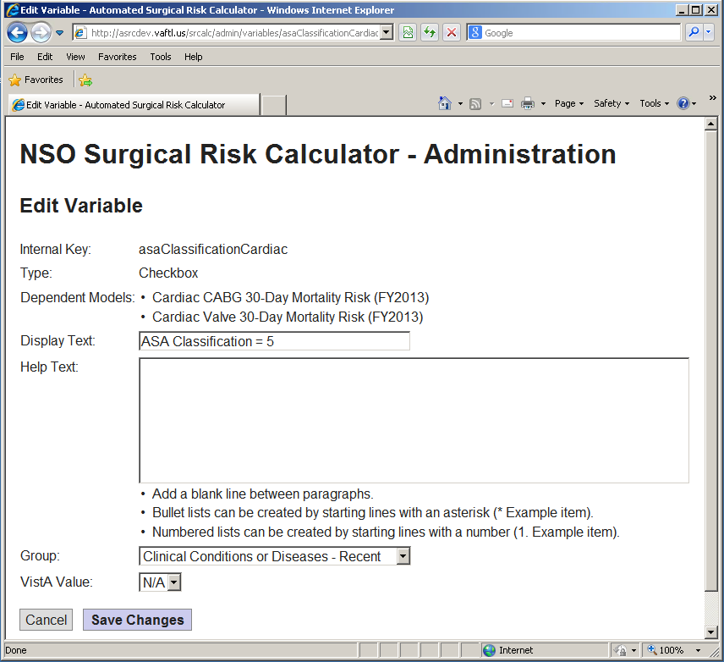

Figure 16 - Edit Variable Page

### Rules

The ASRC administrator can “Add” new rules or “Edit” existing ones. Figure 17 shows a Rule Definition administration selection example.

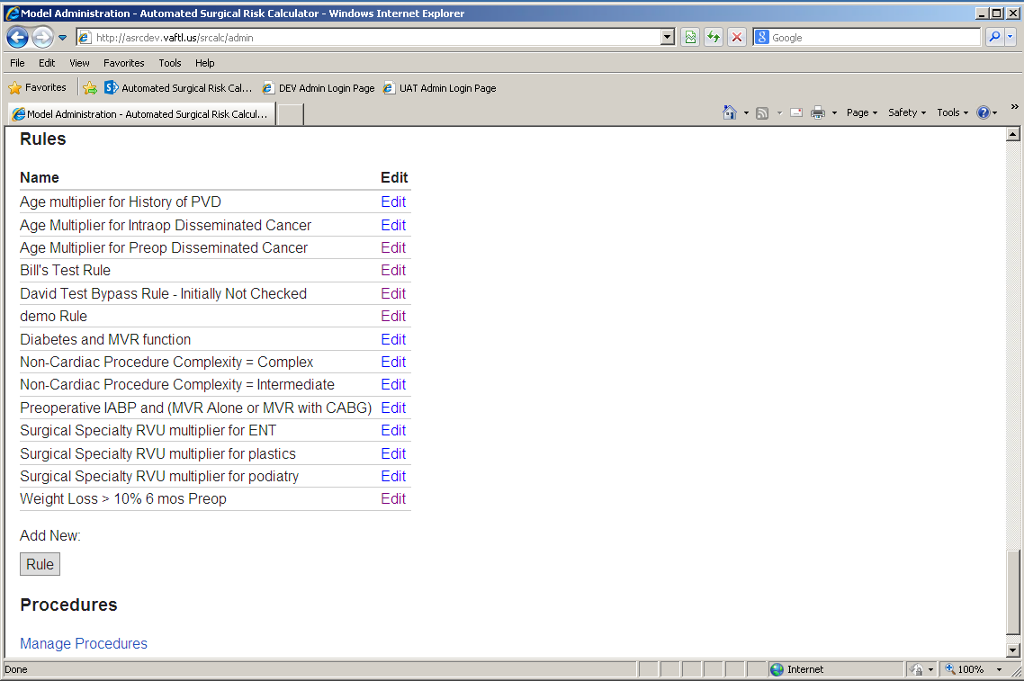

Figure 17 - Rule Definition

#### Rule Definition – Add

The ASRC Administrator can add a new rule by selecting Add New: Rule (Figure 17). The Administrator can then (see Figure 18)

* Create a Display name for the Rule (must be unique)
* Select is the Rule is bypassed if missing values by checking “Bypass rule if missing values”. See Rule Definition – Edit for an example of its usage.
* Create a Summand Expression (is applied to the model if all the variable expressions are true). For example, “#coefficient + 2” would add to the term’s coefficient if all of the evaluated expressions are true.
* Add variables from a drop down list
* For each variable, choose if that variable’s condition will be evaluated (check “Apply Condition to variable”. Entry in the Expression box requires selection of “Apply Condition to variable”.
* Up 10 ten variables can be added with a warning message generated if an 11th is attempted
* Reference variables by inserting a # in front of the variable name. For example, reference age as “#age”. The tool is case sensitive so enter the variable name exactly as shown in the Available Variable list.

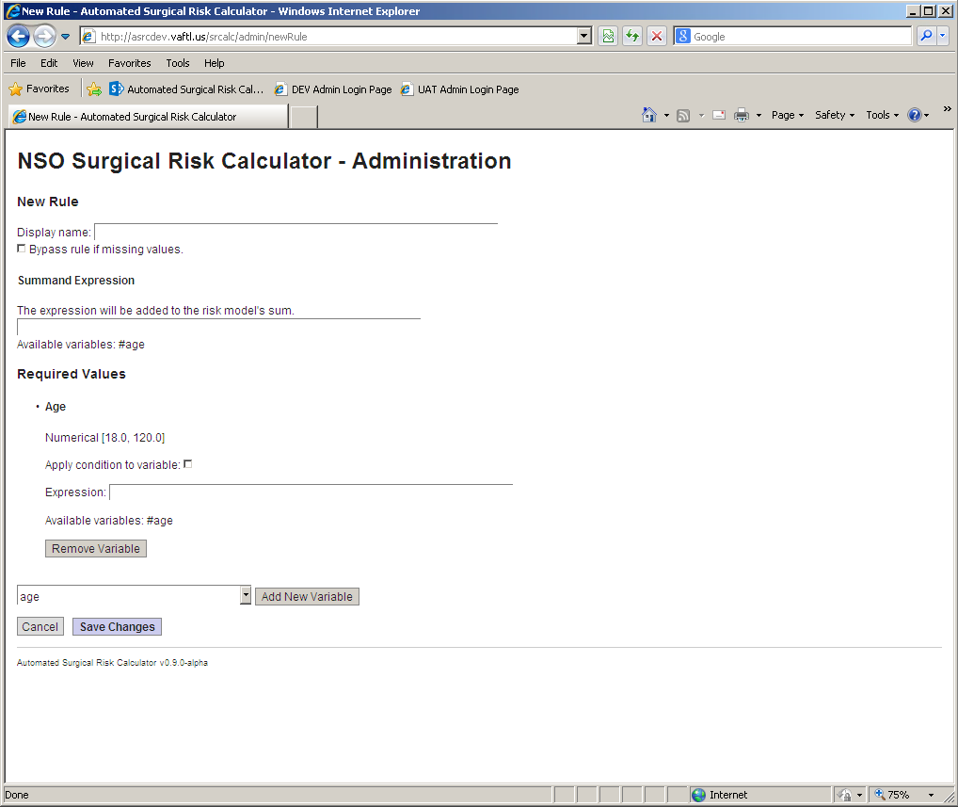

Figure 18 - Add New Rule

#### Rule Definition – Edit

The ASRC Administrator can add edit an existing rule by selecting Edit next to the rule name (see Figure 17). The Administrator can then

* (See Figure 19 for the below features)
* Modify the Display name for the Rule (must be unique)
* Select if numeric variables must have values (e.g., Weight and Weight 6 months ago would have the “Bypass rule if missing values” checked – see Figure 19)
* Modify the Summand Expression
* Add variables from a drop down list (up to 10)
* Remove variables by selecting “Remove Variable”
* For each variable, modify if that variable’s condition will be evaluated (check “Apply Condition to variable”

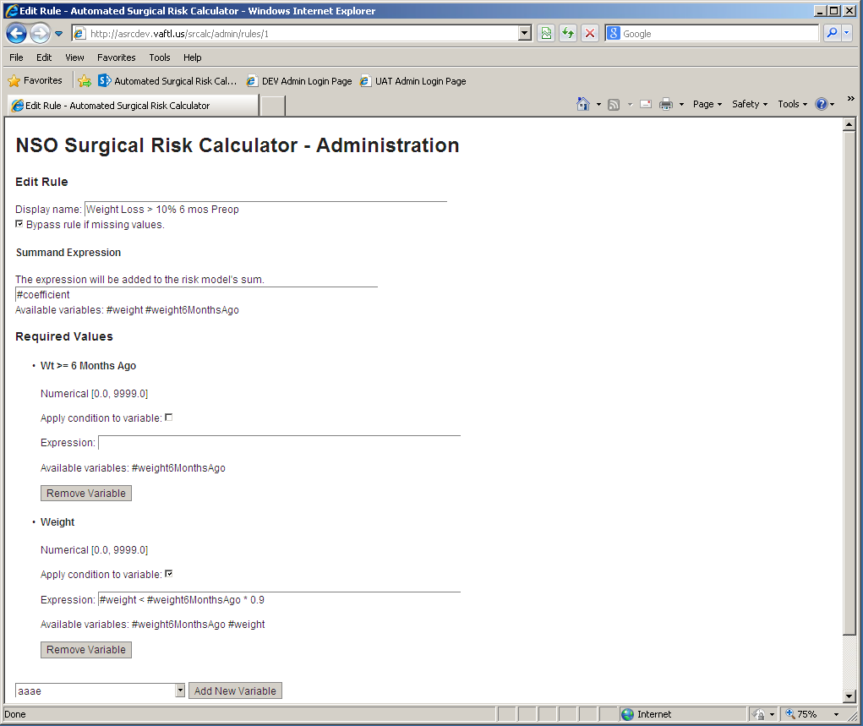

Figure 19 - Edit Existing Rule

#### Rule Definition Detailed Description

Much like typical math expressions, summand expressions must evaluate to a number and evaluate in a specified order of precedence. In this case, the summand expressions will follow this order of operations: operations inside of parentheses are evaluated first, then exponents, then multiplication and division going from left to right, then addition and subtraction going from left to right. If the expression “1+2-3*8^2/2/2” were evaluated, the answer would be -45.

Mathematical operators that are available in both the summand expressions and the Boolean (true or false) expressions are:

* Parentheses to specify order
* Exponents
* Scientific notation (i.e. 2E+3 is equal to 2000)
* Multiplication
* Division
* Modulus (used to find the remainder of division, i.e. 8 % 5 is equal to 3)
* Addition
* Subtraction

Referencing variables by utilizing the # sign and then the key of the variable. In order to reference a variable, however, the rule using the expression must have the variable in the rule’s “Required Variables” list. A referenced variable, but has no attached Boolean expression should have the “Apply condition to variable” box unchecked. The maximum amount of variables in a single rule is 10. It should be noted that referencing a variable incorrectly or referencing a variable that does not exist will allow the rule to be saved, but will cause the calculation to fail when the expressions are evaluated later.

Referencing a variable, such as “#age” will retrieve the value in that variable so that the user can use the value. In other words, if the age field was input as 55, then 55 replaces “#age” when evaluated. When using an explicit value do not use the # sign. For example, multiplying the coefficient by 10 would be done by using the expression “#coefficient * 10.0”. When referencing the procedure variable by using #procedure, there must also be a qualifying value. The available values for procedure are “#procedure.rvu” (the RVU code for the procedure), “#procedure.cptCode” (the assigned CPT code), “#procedure.complexity” (the complexity of the procedure). Currently the procedure variable is the only variable that has multiple attributes.

#### Rule Boolean Expressions

Boolean expressions will evaluate to true or false. One example would be 6 + 3 < 10. This would evaluate to true. However, 6 + 3 would not have a true or false value after evaluation because there is no Boolean expression to evaluate.

Boolean operators that are available only in the Boolean expressions are:

* Relational operators
  + < (less than)
  + (greater than)
  + <= (less than or equal to)
  + >= (greater than or equal to)
* Equality
  + == (the two operands are exactly equal to each other; the sign must be a double equal sign to test equality)
  + != (the two operands are NOT exactly equal)
* Logical operators
  + “and” (both of the operands need to be true for an “and” to be true)
  + “or” (one of the operands needs to be true for an “or” to be true)
  + Negate a Boolean result by using the exclamation point. For instance, “!true” would evaluate false and “!false” would evaluate true.

Putting a quote into an expression will denote a string of characters and will not be present in the final evaluation. As such, “#surgicalSpecialty == ‘ENT’” would mean that the value of the variable surgicalSpecialty evaluates to true if it equals “ENT”. This expression would evaluate to true if surgicalSpecialty was equal to “ENT”. This case would be equivalent to “’ENT’ == ‘ENT’”.

The values to which Boolean (checkbox) variables evaluate are always either true or false. Therefore, the expression “#dnr == true” is equivalent to “#dnr”.

#### Rule Examples

For the rule of 10% weight loss in the past 6 months, here is what we would expected to see in the expressions:

* Boolean expression for the variable Weight: “#weight < #weight6MoAgo * 0.9”. Reference both variables by their unique keys. Using the reference with the number sign grabs the actual value of that variable, so if the patient’s weight was 190 and the weight 6 months ago was 220, then the expression is “190 < 220 * 0.9” which would evaluate to true and would apply the summand expression.
* Summand expression would be “#coefficient” because we are only adding the coefficient tied to this rule if both of the Boolean expressions are true.

For the rule of an age multiplier when Preop Disseminated Cancer, there is no condition present for age, so the age variable is included, but disabled. Since we need to determine if the disseminated cancer has the value of “Preoperative” then we use the appropriate expression shown. The summand expression multiplies the aforementioned age variable by the coefficient if the cancer Boolean expression is true.

### Procedures

The ASRC Administrator selects “Manage Procedures” (see Figure 20) to

* (See Figure 21 for the below features)
* See the number of procedures in the database
* Import a new procedure definitions through a CSV file (file entries are validated with warning messages provided to the Administrator user) (see Figure 22 for CSV sample)
* Replace all of the Procedures
* Return Home to the Administration home page

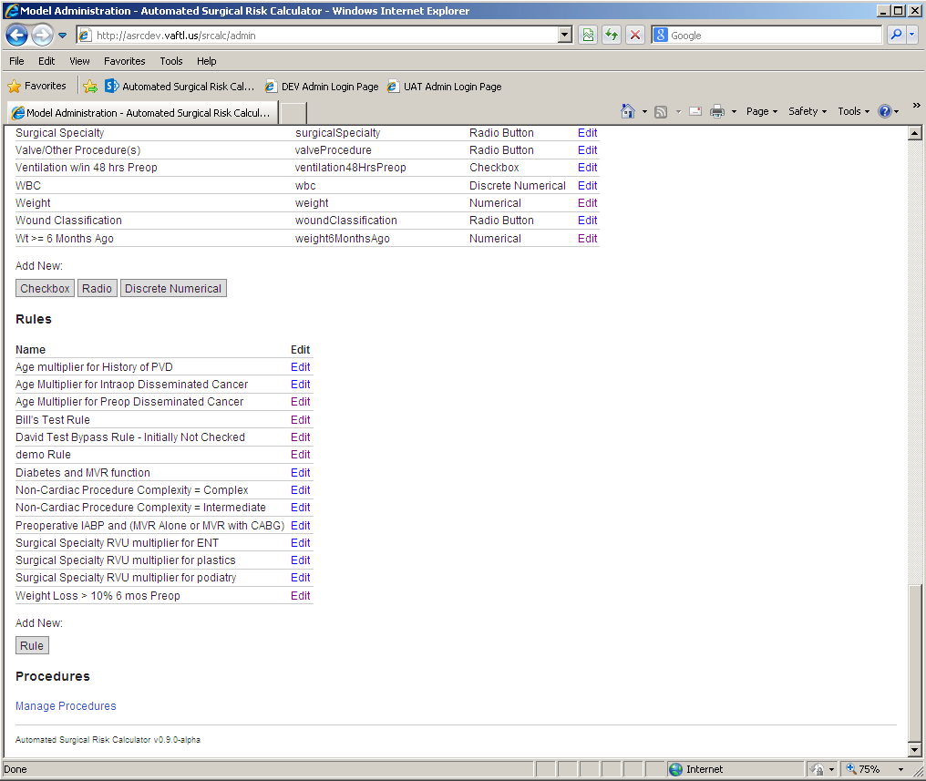

Figure 20 - Manage Procedures

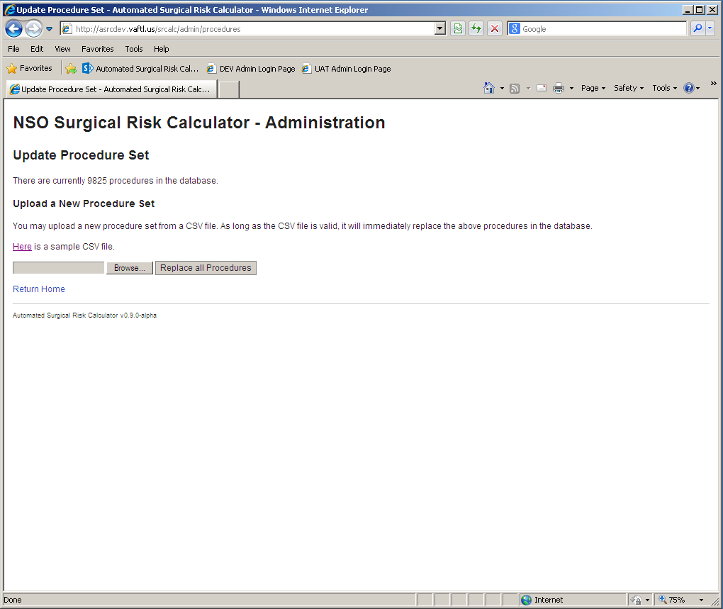

Figure 21 - Update Procedures

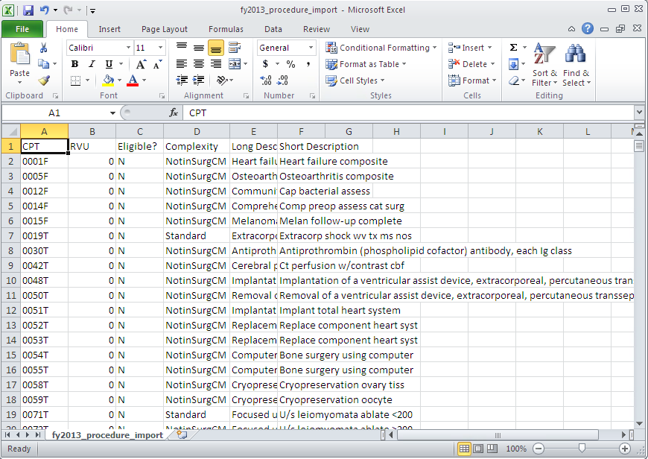

Figure 22 - Procedure CSV File Example

## Changing User ID and Password

There will be no need to change User ID and Password specifically for the ASRC Tool. Either a DUZ number will be used (provided in the login section) or will be accessible through CPRS with provided test accounts.

## Exit System

To exit the system, simply close the browser window.

1. Appendix A – Acronym List

Table 1 - Acronym List

| Term | Meaning |
| --- | --- |
| ASA | American Society of Anesthesiology |
| ASRC | Automated Surgical Risk Calculator |
| BMI | Body Mass Index |
| CPRS | Computerized Patient Record System |
| CPT | Current Procedural Terminology |
| CSV | Comma Separated Values |
| DNR | Do Not Resuscitate |
| DUZ | User Number |
| EHR | Electronic Health Records |
| FTL | Future Technology Lab |
| NSO | National Surgery Office |
| POC | Point of Contact |
| PWS | Performance Work Statement |
| RVU | Relative Value Unit |
| SQL | Structured Query Language |
| TIU | Text Integration Utility |
| VA | Department of Veterans Affairs |
| VASQIP | Veterans Affairs Surgical Quality Improvement Program |
| VistA | Veterans Health Systems and Technology Architecture |