Department of Veterans Affairs

Innovation #665 Hazardous Pharmaceuticals

**System Design Document**



Version 4.0

September 2013

This page intentionally left blank

Revision History

| Date | Version | Description | Author |
| --- | --- | --- | --- |
| 08/29/2013 | 4.0 | Tech Edit | John Owczarzak |
| 08/16/2013 | 3.1 | Added description of new PPSNSUPER security key for VistA. | John Castle |
| 08/08/2013 | 3.0 | August version technical writing edits | Bob Thomas |
| 08/07/2013 | 2.1 | Matching algorithms for drugs loaded from Hazard to Handle (NIOSH) and Hazard to Dispose (STERICYCLE) added | Alicia Ray |
| 07/02/2013 | 2.0 | July Version technical writing edits | Bob Thomas |
| 07/01/2013 | 1.4 | Updated BCMA screen captures | Bob Kaiser |
| 06/28/02013 | 1.3 | Updated VistA information – including updated routines | John Castle |
| 06/25/2013 | 1.2 | General technical writing edits | Bob Thomas |
| 06/14/2013 | 1.1 | Updated VistA information – including updated routines and menu options | John Castle |
| 05/20/2013 | 1.0 | Baseline Version   * 1.4.2 Pre-Populate Data Fields Table update * 2.2 Non-DBMS Files Table update | Yuki Olinger |
| 05/07/2013 | 0.2 | General technical writing edits. | Kiley Kapple |
| 04/30/13 | 0.1 | Initial Draft SDD | Bob Kaiser  Lalit Mathwani  John Castle  Alicia Ray |

This page intentionally left blank

Table of Contents

1. Introduction 1

1.1. Purpose 1

1.2. Identification 2

1.3. Scope 2

1.4. Assumptions 4

1.4.1. Database Information 4

2. Data Design 4

2.1. PPS-N Data Structure 4

2.2. PPS-N Initial Data Load: 6

2.3. Modify Database 7

2.4. DBMS Files 9

2.4.1. Pre-Populate Data Fields 9

3. Detailed Design 13

3.1. Software Detailed Design 13

3.1.1. Conceptual Design 14

3.1.1.1. Product Perspective 14

3.1.1.1.1. Software Interfaces 14

3.1.2. Specific Requirements 16

3.1.2.1. Routines 16

3.1.2.1.1. PSSHAZLD 16

3.1.2.1.2. PSSHAZLU 17

3.1.2.1.3. PSSHAZEE 17

3.1.2.1.4. PSSMIGRC 18

3.1.2.1.5. PSSMIGRD 19

3.1.2.1.6. PSSMIGRP 20

3.1.2.1.7. PSSMIGRR 21

3.1.2.1.8. PSJBCMA 22

3.1.2.1.9. PSJBCMA1 25

3.1.2.2. Options 28

3.1.2.2.1. PSS DRUG HAZARD LOAD 28

3.1.2.2.2. PSS DRUG HAZARD LOOKUP 29

3.1.2.2.3. PSS DRUG HAZARD ENTER/EDIT 30

3.1.2.2.4. PSS DRUG HAZARD MISMATCH 30

3.1.2.2.5. PSS DRUG HAZARD RESET 31

3.1.2.3. Remote Procedure Call (RPC) 32

3.1.2.3.1. PPS NDFMS SYNC 32

3.1.2.4. Variables Defined in Interface 33

3.1.2.4.1. Hazardous to Handle 33

3.1.2.4.2. Hazardous to Dispose 33

3.1.2.4.3. Primary EPA Code 34

3.1.2.4.4. Waste Sort Code 34

3.1.2.4.5. DOT Shipping Code 35

3.1.2.4.6. LOCAL HTD 36

3.1.2.4.7. LOCAL HTH 36

3.1.2.5. SECURITY KEY 37

3.1.2.5.1. PPSNSUPER 37

3.1.2.6. GUI 37

3.1.2.6.1. GUI Classes 37

3.1.2.6.2. Current Form 37

3.1.2.6.3. Modified Form 40

3.1.2.6.4. Components on Form 43

3.1.2.6.5. Events 43

3.1.2.6.6. Methods 43

3.1.2.6.7. Special References 43

3.1.2.6.8. Class Events 43

3.1.2.6.9. Class Methods 43

3.1.2.6.10. Class Properties 44

3.1.2.6.11. Uses Clause 44

3.1.2.6.12. Current Form 44

3.1.2.6.13. Modified Form 44

3.1.2.6.14. Components on Form 44

3.1.2.6.15. Events 44

3.1.2.6.16. Methods 44

3.1.2.6.17. Special References 44

3.1.2.6.18. Class Events 45

3.1.2.6.19. Class Methods 45

3.1.2.6.20. Class Properties 46

3.1.2.6.21. Uses Clause 47

3.1.2.6.22. Current Form 47

3.1.2.6.23. Modified Form 47

3.1.2.6.24. Components on Form 47

3.1.2.6.25. Events 47

3.1.2.6.26. Methods 47

3.1.2.6.27. Special References 47

3.1.2.6.28. Class Events 48

3.1.2.6.29. Class Methods 48

3.1.2.6.30. Class Properties 48

3.1.2.6.31. Uses Clause 49

3.1.2.6.32. Current Form 49

3.1.2.6.33. Modified Form 52

3.1.2.6.34. Components on Form 54

3.1.2.6.35. Events 54

3.1.2.6.36. Methods 54

3.1.2.6.37. Special References 55

3.1.2.6.38. Class Events 55

3.1.2.6.39. Class Methods 56

3.1.2.6.40. Class Properties 56

3.1.2.6.41. Uses Clause 56

3.1.2.6.42. Current Form 56

3.1.2.6.43. Modified Form 56

3.1.2.6.44. Components on Form 56

3.1.2.6.45. Events 56

3.1.2.6.46. Methods 56

3.1.2.6.47. Special References 57

3.1.2.6.48. Class Events 57

3.1.2.6.49. Class Methods 57

3.1.2.6.50. Class Properties 58

4. Acronyms and Definitions 60

**This page intentionally left blank**

# Introduction

The Hazardous Pharmaceuticals (Haz Pharm) project was developed from the Department of Veterans Administration (VA) Innovation Program. Through this initiative, prospective projects submitted by VA employees examine for benefit, funding, and development. Designated projects transition to the first of two innovation phases; a prototype phase, where the requested functionality is developed outside the VA Network in a virtual environment known as the VA Innovations Sandbox.

Every VA pharmacy in the country carries pharmaceuticals that present hazards for human exposure and environmental hazards upon disposal. Many VA pharmacies utilize automation. Hazardous pharmaceuticals should not be packaged or processed through automation allowing for cross contamination that would expose our Veteran population to risk unnecessarily. Nurses, in VA facilities across the country, administer medication utilizing the Bar Code Medication Administration (BCMA) system without knowing the potential for exposure hazards or the appropriate disposal methods. Facilities that improperly dispose of pharmaceuticals are subject to substantial Environmental Protection Agency (EPA) fines. This project has essential benefits for Veterans served by VA pharmacies, all VA staff who handle pharmaceuticals, the American taxpayer, and the environment.

## Purpose

The *Innovation #665 Hazardous Pharmaceuticals (Haz Pharm) System Design Document (SDD)* details the conceptual design necessary to enhance the functionality of the Pharmacy Product System – National (PPS-N), the local Veterans Health Information Systems and Technology Architecture (VistA) instance of the National Drug File (NDF), and the BCMA software applications. Components of each application modifications include changes necessary to identify, capture and/or flag for pharmaceuticals that would be hazardous to handle or hazardous to the environment upon disposal. The product will be a prototype solution viable for continued production development and delivery.

The prototype will incorporate data via scripting provided by two sources - National Institute of Occupational Safety and Health (NIOSH) and STERICYCLE Rx Waste Characterization. This data will be imported into the PPS-N application, where it will be matched with existing pharmaceutical (drug) data to determine if an entry is hazardous to handle, hazardous to dispose, neither or both. Should a drug be identified as hazardous, the source data supplied is stored in association to that drug entry in PPS-N. Hazardous data will be transferred from PPS-N to the VistA application via an RPC broker and similar data storage and flagging process will occur. VistA will also provide the means for the end-user to research if a drug is identified as hazardous and view associated specifics for the hazard. Finally, the BCMA application, which is used by nursing staff, will call the hazard data stored in VistA via another RPC broker; should the drug be identified as hazardous, the appropriate visual icon indicating the hazard will be displayed. In addition to the icon flag(s), BCMA will offer hover text spelling to alert the end-user of a potential hazard.

The SDD will be updated to reflect the product state as it is being constructed. The final version of the SDD will deliver the as-built design.

## Identification

The Haz Pharm projects requires the following versions (or higher) of VA software packages for proper implementation.

Table 1: Software Interfaces

|  |  |  |  |  |
| --- | --- | --- | --- | --- |
| **ID #** | **Title** | **Abbreviation** | **Version** | **Release** |
| 1 | Oracle | n/a | 11g | 11.0.1 |
| 2 | Java | n/a | 1.6.0 | 43 |
| 3 | Pharmacy Product System – National | PPS-N | 1.0 | (2013-01-16) |
| 4 | Microsoft Windows | Windows | XP SP3 |  |
| 5 | Veterans Health Information Systems and Technology Architecture | VistA |  |  |
| 6 | Delphi | n/a | 2007 |  |
| 7 | Bar Code Medication Administration | BCMA | 3.0 | PSB*3*68 (prototype based on current released version) |
| 8 | BEA Weblogic Server | BEA WLS | 10.3.5 |  |

## Scope

The scope for the HazPharm project will be limited to the modifications of the necessary fields, files in the PPS-N, VistA NDF, and BCMA applications for the purpose of creating an identification and alert mechanism associated to hazardous pharmaceuticals.

Hewlett Packard Enterprise Services (HPES) will create a fully functional and tested prototype within the Innovations Sandbox in which two (2) PPS-N drug file fields (Hazardous to Dispose field and Hazardous to Handle field) are added to hold the appropriate hazard data. Additionally, it will provide the functional interface between PPS-N and VistA, creating a pharmacy data look-up file for the hazard data and a functional interface with BCMA software. This will create flags/alerts activated by the bar code scan used by nursing while administering medications.

The design and development activities will be conducted and delivered within the confines of the VA Innovations Sandbox. Although the project addresses anticipated product integration into existing VA systems during the Close-out phase, it does not include an actual integration into VA production or test environments running on the VA network within this contract.

Table 2: Scope Inclusions

| Includes |
| --- |
| Oracle Installation using Virtual Machine provided by the Sandbox Team. |
| Extraction of Hazardous to Handle Data from National Institute of Occupational Safety and Health (NIOSH). |
| Initial Loading of NIOSH and STERICYCLE data into PPS-N (via database scripts). |
| Enhancing PPS-N for Drug Matching based on data provided from NIOSH and STERICYCLE sources. |
| Enhancing PPS-N for storage of NIOSH and STERICYCLE data. |
| Enhancing PPS-N for display of NIOSH and STERICYCLE data. |
| PPS-N to add call to VistA RPC (to push hazard data to VistA). |
| Modify VistA RPC to accept data from PPS-N. |
| Enhance VistA to create fields in the Local version of VistA NDF to store hazard data. |
| Create look-up for hazardous drugs. |
| Modify BCMA RPC to call data from VistA. |
| Enhance BCMA to add column and icon features for individual orderable component. |
| Enhance BCMA to add hover feature to icons. |
| Enhance BCMA to provide pop-up messages to include hazard data. |
| Referencing the **Task Order PWS Version Number: 1.6,** the following data fields need to be captured by the PPS_N web application for drugs that are Hazardous to Dispose:  Primary EPA Code, Waste Sort Code, DOT Shipping Name It is expected that these field values will populate directly from the latest STERICYCLE Rx WASTE CHARACTERIZATION spreadsheet for the drugs identified as being hazardous to dispose. |
| A flag needs to be captured for the drugs that are hazardous to handle per the latest NIOSH classification of Hazardous to Handle drugs. |
| These data elements should be displayed on the user interface of the application, and a PPS_N user with the right privileges should be allowed to override or specify these data elements via the PPS_N web application user interface. |
| These data elements need to be synchronized with the National Drug File (NDF) Local version. |

Table 3: Scope Exclusions

| Excludes |
| --- |
| Automated or semi-automated uploads/updates of NIOSH and STERICYCLE data into PPS-N (will be handled through scripting for the prototype). |
| Automated or semi-automated reconciliation of reclassified drugs from NIOSH Table 2 (will be handled manually in the prototype). |
| Physical scanning of barcode labels for input (barcode input will be manual for prototype). |
| Modifications to support the “Hazardous to the Patient” checkbox already deployed in the PPS-N application. |
| Additional data fields and data storage other than those outlined in the PWS. |
| Identification and incorporation of additional data sources other than NIOSH and STERICYCLE. |
| Distinction between dosage levels and/or pharmaceutical types, e.g., tablet vs. liquid, unless specifically identifiable in the NIOSH and/or STERICYCLE data sources. |
| The algorithm for handling multiple matches and/or no matches for both Hazardous to Handle and Hazardous to Dispose medications is found in PPS-N. |

## Assumptions

The PPS_N web application currently includes two checkboxes on the Administration Tab of a Product Item that allow the flagging of a Product Item as being Hazardous to Dispose or Hazardous to Handle. These flags are currently being persisted in the PPS-N EPL Database schema. However, these flags are not being synchronized with VistA.

Note that within PPS-N, Orderable Items and NDC Items currently do not store Hazardous to Handle and Hazardous to Dispose flags. Hence, in the innovation project, we will add the extra attributes for Hazardous to Dispose (Primary EPA Code, Waste Sort Code and DOT Shipping Name) to the Product Item.

### Database Information

Table 4: Database Inventory

| Database Name | Description | Type | Steward |
| --- | --- | --- | --- |
| PPSNEPL | PPS-N Oracle database | Modify | PBM |
|  | VistA Cache’/MUMPS database | Modify (add fields) | PBM |

# Data Design

## PPS-N Data Structure

PPS-N includes a generic/flattened data structure, referred to as a VA data field (VADF), to allow product item attributes to be stored and managed. Each VADF structure is designed to indicate the name of the VADF and its associated values. The generic VADF structure supports storing the following types of data:

1. Static single-select list of values (LOV)
2. A non-list, atomic value of type string, Boolean, number, or date
3. A non-list, non-atomic set of text values
4. Dynamically generated lists (not stored in the database except to indicate that there is such a dynamically generated list)

The following figure shows the physical implementation of the generic data structure supporting VADF storage.

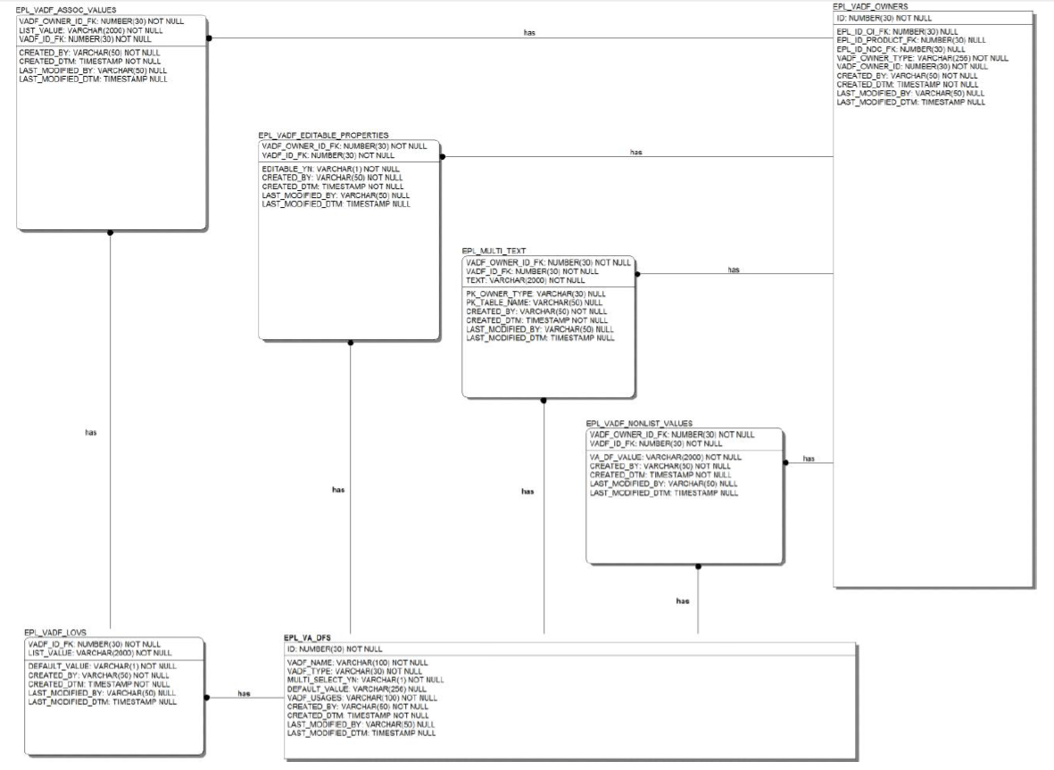

**Figure 1: VA Data Fields Storage**

As can be seen from Figure One, the focal table is (EPL_VA_DFS), which includes columns that specify the following data for each VADF:

* Name (VADF_NAME)
* Type (VADF_TYPE)
* Default (DEFAULT_VALUE), when needed

If the VADF is a static LOV, the values are stored in EPL_VADF_LOVS with exactly one entry for a given VADF being marked as the default. When a user selects a value from a static LOV, the association record in EPL_VADF_ASSOC_VALUES indicates the value selected.  
If the VADF is a non-list, atomic value, the value is stored in EPL_VADF_NONLIST_VALUES in a character-string representation that the PPS code can parse.

If the VADF is a non-list, non-atomic set of text values, the multiple values are stored in EPL_MULTI_TEXT.

The PPS code also allows a PNM to control whether other users can edit a given VADF. The table EPL_VADF_EDITABLE_PROPERTIES supports that functionality.

The EPL_VADF_OWNERS table links the stored values in the EPL_MULTI_TEXT, EPL_VADF_NONLIST_VALUES and EDF_VADF_ASSOC_VALUES with the product item, NDC item or Orderable item to which the stored value applies.

Currently there are two field definitions already stored in the EPL_VA_DFS for attributes: “hazardous.to.handle” and “hazardous.to.dispose”. These are non-list atomic values of type BOOLEAN and have a default value of false.

For the HazPharm innovation project, three additional non list atomic values of type “STRING” will be added to the EPL_VA_DFS table. These three fields are: “primary.epa.code”, “waste.sort.code”, and “dot.shipping.name”. These three fields will be marked as editable in the PL_VADF_EDITABLE_PROPERTIES table.

The addition of these three field definitions in the EPL_VA_DFS table will be the only change currently needed to the Database configuration. No Database schema changes are anticipated to support persistence of these three additional fields.

## PPS-N Initial Data Load:

The initial data load of Hazardous Pharmaceutical data into the PPS-N schema involves two high-level tasks:

* Modify Database: Preparing the database to capture and store the new data elements
* Pre-Populate data fields: Processing the raw data for inclusion in the database

The first task, Modify Database, will result in the development of Data Definition Language (DDL)/Data Modification Language (DML) statements to define the database objects required for this task. The second task, Pre-Populate data fields, will result in the development of stored procedure(s) to encapsulate the logic needed to develop a comprehensive data migration process to extract, cleanse, and map the data elements from the authenticated source for inclusion in the PPS-N database.

Table 5 shows the activities needed to perform this tasking for both data sources. Database scripts will be developed to perform the parsing, mapping, and loading of the data as well as the exception reporting. Stored procedures will be utilized to provide the structured logic constructs needed to perform the parsing, product lookup, evaluation, and required database actions.

|  |  |
| --- | --- |
| Table 5: PPS-N Prototype Initial Data  Load - Development Tasks and Activities | |
| **Modify Database** | |
| **ActivityID** | **Activity Description** |
| 1 | Analyze data structure, apply normalization if needed |
| 2 | Develop DDL to modify the database tables |
| 3 | Apply modifications to the PPS-N database schema |
| **Pre-populate Data Fields** | |
| **ActivityID** | **Activity Description** |
| 1 | Develop a data migration process to extract, cleanse, and map the data elements from the authenticated source for inclusion in the PPS-N database |
| 2 | Include options in the migration strategy for identification of candidate drugs by product name or National Drug Code (NDC) number to match PPS-N product by Synonym or NDC |
| 3 | Evaluate and authenticate source of the hazard data |
| 4 | Develop a process to report the results of the data migration effort noting exceptions in the process and possible mitigation strategies for any exceptions identified |

## Modify Database

The database structures in PPS-N include a generic/flattened data structure, referred to as a VA data field (VADF), to allow product item attributes to be defined, stored, and managed within the schema. Each product attribute is defined as an entry in the EPL_VA_DFS table.

Table 6: EPL_VA_DFS

|  |  |  |  |  |  |
| --- | --- | --- | --- | --- | --- |
| **Column Name** | **ID** | **PK** | **Pos** | **Null** | **Data Type** |
| ID | 1 | 1 | 1 | N | NUMBER (30) |
| VADF_NAME | 2 |  |  | N | VARCHAR2 (100 Byte) |
| VADF_TYPE | 3 |  |  | N | VARCHAR2 (30 Byte) |
| MULTI_SELECT_YN | 4 |  |  | N | VARCHAR2 (1 Byte) |
| DEFAULT_VALUE | 5 |  |  | Y | VARCHAR2 (256 Byte) |
| VADF_USAGES | 6 |  |  | N | VARCHAR2 (100 Byte) |
| CREATED_BY | 7 |  |  | N | VARCHAR2 (50 Byte) |
| CREATED_DTM | 8 |  |  | N | TIMESTAMP(6) |
| LAST_MODIFIED_BY | 9 |  |  | Y | VARCHAR2 (50 Byte) |
| LAST_MODIFIED_DTM | 10 |  |  | Y | TIMESTAMP(6) |

To define a new product attribute for the PPS-N database, insert a new entry into the EPL_VA_DFS table. Table 7 shows the attributes currently defined in the EPL_VA_DFS table.

Table 7: Attributes in EPL_VA_DFS

**VADF_NAME VADF_TYPE**

**action.profile.message STRING**

**application.package.use LIST**

**approved.for.splitting LIST**

**ar.ws.amis.category LIST**

**ar.ws.amis.conversion.number NUMBER**

**conjunction STRING**

**corresponding.inpatient.drug PKEY**

**corresponding.outpatient.drug PKEY**

**current.inventory NUMBER**

**daw.code LIST**

**day.nd.or.dose.nl.limit STRING**

**dea.schedule LIST**

**default.mail.service STRING**

**dispense.days.supply.limit NUMBER**

**dispense.limit.for.order STRING**

**dispense.limit.for.schedule STRING**

**dispense.override STRING**

**dispense.override.reason STRING**

**dispense.quantity.limit.dose NUMBER**

**dispense.quantity.limit.time NUMBER**

**dispense.quantity.override STRING**

**dispense.quantity.override.reason STRING**

**do.not.handle.if.pregnant BOOLEAN**

**do.not.mail BOOLEAN**

**follow.up.time BOOLEAN**

**formulary LIST**

**formulary.alternative PKEY**

**fsn STRING**

**hazardous.to.dispose BOOLEAN**

**hazardous.to.handle BOOLEAN**

**hazardous.to.patient BOOLEAN**

**high.risk BOOLEAN**

**high.risk.followup BOOLEAN**

**high.risk.followup.time.period STRING**

**inpatient.medication.expired.order.max.time STRING**

**inpatient.medication.expired.order.min.time STRING**

**inpatient.pharm.locations STRING**

**lab.monitor.mark BOOLEAN**

**lifetime.cumulative.dosage BOOLEAN**

**local.non.formulary BOOLEAN**

**local.special.handling STRING**

**long.term.out.of.stock BOOLEAN**

**low.safety.margin BOOLEAN**

**max.dispense.limit STRING**

**message STRING**

**monitor.max.days NUMBER**

**monitor.routine STRING**

**ncpdp.dispense.unit LIST**

**ncpdp.quantity.multiplier NUMBER**

**ndc.price.per.dispense.unit NUMBER**

**ndc.price.per.order.unit NUMBER**

**non.renewable BOOLEAN**

**normal.amount.to.order NUMBER**

**number.of.doses NUMBER**

**oi.iv.flag BOOLEAN**

**op.external.dispense BOOLEAN**

**orderable.item.synonym STRING**

**other.language.instructions STRING**

**other.language.preposition STRING**

**other.language.verb STRING**

**override.reason.enterer STRING**

**patient.instructions STRING**

**patient.specific.label BOOLEAN**

**preposition STRING**

**previous.ndc STRING**

**previous.upc.upn STRING**

**product.dispense.unit.per.ord NUMBER**

**product.number STRING**

**product.price.per.dispense.unit NUMBER**

**product.price.per.order.unit NUMBER**

**proposed.inactivation.date DATE**

**protect.from.light BOOLEAN**

**quantity.dispense.message STRING**

**recall.level LIST**

**refrigeration LIST**

**reorder.level NUMBER**

**scored LIST**

**special.handlings PKEY**

**total.dispense.quantity STRING**

**transmit.to.cmop BOOLEAN**

**unit.dose.schedule STRING**

**unit.dose.schedule.type LIST**

**unit.price NUMBER**

**verb STRING**

**witness.to.administration BOOLEAN**

**85 rows selected.**

Two field definitions are currently stored in the EPL_VA_DFS for the attributes “hazardous.to.handle” and “hazardous.to.dispose”. These are non-list atomic values of type BOOLEAN and have a default value of “false.” For the Hazardous Pharmaceuticals innovation project, these two fields will be retained. Three additional non-list atomic value fields of type “STRING” will be added to the EPL_VA_DFS table to define the additional data to be captured and stored: “primary.epa.code”, “waste.sort.code”, and “dot.shipping.name”.

**Table 8: Additional Non List Atomic Value Fields**

|  |  |  |
| --- | --- | --- |
| **EPL_VA_DFS Action** | **VADF_NAME** | **VADF_TYPE** |
| Insert new record | primary.epa.code | STRING |
| Insert new record | waste.sort.code | STRING |
| Insert new record | dot.shipping.name | STRING |

## DBMS Files

### Pre-Populate Data Fields

For the Hazardous Pharmaceuticals innovation project, two data sources, shown in Table 9, will be used to populate the hazardous pharmaceutical fields.

**Table 9: Data Sources**

|  |  |  |  |  |
| --- | --- | --- | --- | --- |
| **Data Source** | **Data Source Title** | **Data Source Format** | **Lookup Approach** | **Lookup Approach Tables** |
| Hazardous to Handle | NIOSH List of Antineoplastic and Other Hazardous Drugs In Healthcare Settings 2012 - Table 1. Sample List of Drugs that Should be Handled as Hazardous | PDF document | See matching algorithm description for Hazardous to Handle - NIOSH data below. | ppsnepl.epl_products |
| Hazardous to Dispose | STERICYCLE Rx WASTE CHARACTERIZATION (Attachment A), Report Subtitle: All Characterized Pharmaceuticals, EPA Hazardous tab | Excel spreadsheet | See matching algorithm description for Hazard to Dispose - STERICYCLE data below. | ppsnepl.epl_ndcs  ppsnepl.epl_products |

* + - * Matching algorithm for drugs loaded from Hazard to Handle – NIOSH PDF input file:
        + The system shall perform a primary search for a drug Trade Name from the NIOSH PDF using a “contains” search on Synonym in the PPS-N Enterprise Product List (EPL) database.
        + If the Synonym search yields resulting matches to drug(s) in the PPS-N EPL database, then for all resulting matches, the system shall set the value of the Hazardous to Handle field to True (checked) at the Product level.
        + The system shall perform a secondary for the same drug Trade Name from the NIOSH PDF using a “contains” search on VA Product Name.
        + If the VA Product name search yields resulting matches to drug(s) in the PPS-N EPL database, then for all resulting matches, the system shall set the value of the Hazardous to Handle field to True (checked) at the Product level.
        + When a drug (Trade Name) loaded from the NIOSH PDF does NOT match any drug at the PPS-N Product level either by primary or secondary search, the system will log the drug in an Output Exception Report file for manual inspection by the system administrator.
      * Matching algorithm for drugs loaded from Hazard to Dispose – STERICYCLE spreadsheet input file:
        + The system shall perform a primary search for a drug NDC code from the STERICYCLE input file using an NDC search in the PPS-N EPL database.
        + If the search on NDC yields an exact match to an NDC code in the PPS‑N EPL database, the system shall set the value of the Hazardous to Dispose field to True (checked) at the Product level, populate the corresponding Primary EPA Code, Waste Sort Code and DOT Shipping Name fields, and identify the Generic Name for the product.
        + The system shall perform a secondary “contains” search for the drug Generic Name in the PPS-N EPL database.
        + If the Generic Name search yields resulting matches to drug(s) in the PPS-N EPL database, then for all resulting matches, the system shall set the value of the Hazardous to Dispose field to True (checked) at the Product level, populate the corresponding Primary EPA Code, Waste Sort Code and DOT Shipping Name fields, and identify the Synonym for each product found.
        + The system shall perform a tertiary “contains” search on Synonym in the PPS-N EPL database for each product identified.
        + If the Synonym search yields resulting matches to drug(s) in the PPS-N EPL database, then for all resulting matches, the system shall set the value of the Hazardous to Dispose field to True (checked) at the Product level, and populate the corresponding Primary EPA Code, Waste Sort Code and DOT Shipping Name fields.
        + If the primary search for an NDC code yields NO exact match to an NDC code in the PPS-N EPL database, the system will perform a secondary search for the drug’s Product name from the STERICYCLE input file using a “contains” search on Synonym in the PPS-N EPL database.
        + If the Synonym search yields resulting matches to drug(s) in the PPS-N EPL database, then for all resulting matches, the system shall set the value of the Hazardous to Dispose field to True (checked) at the Product level, populate the corresponding Primary EPA Code, Waste Sort Code and DOT Shipping Name fields, and identify the Generic Name for each product found.
        + The system shall perform a tertiary “contains” search on Generic Name in the PPS-N EPL database for each Generic Name identified.
        + If the Generic Name search yields resulting matches to drug(s) in the PPS-N EPL database, then for all resulting matches, the system shall set the value of the Hazardous to Dispose field to True (checked) at the Product level, and populate the corresponding Primary EPA Code, Waste Sort Code and DOT Shipping Name fields.
        + When a drug NDC or Product Name loaded from the STERICYLE input file does NOT match any drug in the target PPS-N EPL database, the system will log the NDC, Product Name, Primary EPA Code, Waste Sort Code and DOT Shipping Name in an Output Exception Report file for manual inspection by the system administrator.

Each source will be used as provided. Efforts to match the contents to PPS-N product entries will follow the methods stated in the Performance Work Statement (PWS) and matching algorithms described above. Each record contained in the data sources will be used to perform a lookup against the data in the PPS-N database. When algorithm matches are found, the appropriate hazardous pharmaceutical fields will be populated for the corresponding products. Discrepancies will be reported in an Exceptions Report and provided to the Stakeholders for review at the conclusion of this tasking.

The EPL_PRODUCTS, EPL_NDCS, EPL_SYNONYMS, and EPL_VA_GEN_NAMES tables will be used for the lookup searches by NDC. EPL_PRODUCTS, EPL_SYNONYMS, and EPL_VA_GEN_NAMES will be utilized for product name lookups.

Once a match is found, entries will be created in the EPL_VADF_NONLIST_VALUES table to represent the hazardous field attributes associated to the PPS-N product entries:

Table 10: EPL_VADF_NONLIST_VALUES

|  |  |  |  |  |  |
| --- | --- | --- | --- | --- | --- |
| **Column Name** | **ID** | **PK** | **Pos** | **Null** | **Data Type** |
| VADF_OWNER_ID_FK | 1 | 1 | 1 | N | NUMBER (30) |
| VADF_ID_FK | 2 | 2 | 2 | N | NUMBER (30) |
| VA_DF_VALUE | 3 |  |  | N | VARCHAR2 (2000 Byte) |
| CREATED_BY | 4 |  |  | N | VARCHAR2 (50 Byte) |
| CREATED_DTM | 5 |  |  | N | TIMESTAMP(6) |
| LAST_MODIFIED_BY | 6 |  |  | Y | VARCHAR2 (50 Byte) |
| LAST_MODIFIED_DTM | 7 |  |  | Y | TIMESTAMP(6) |

There are a few scenarios that will need special handling due to the nature of the relationships between the data. The relationship between NDC code and Product is one of many, i.e., a Product can have many associated NDCs. An NDC is associated with one and only one Product. Since the recommended approach is to use NDC lookup as the authenticated source lookup, there will be a one-to-one match if found. However, since a product name can be associated to several NDCs, this approach may result in a record being updated multiple times and the last update taking precedence as shown in Table 11.

Table 11: Example Product with Multiple NDCs

| **Hazardous To Dispose** | | | | |
| --- | --- | --- | --- | --- |
| **NDC Number** | **Product Name** | **Primary EPA Code** | **Waste Sort Code** | **DOT Shipping Name**  **Initial** |
| 60429078401 | WARFARIN | U248 | BKC | Toxic Liquids, Organic, n.o.s. |
| 60429078501 | WARFARIN | P001 | PBKC | Toxic Liquids, Organic, n.o.s. |
| 60429078610 | WARFARIN | P001 | PBKC | Toxic Liquids, Organic, n.o.s. |
| 60429078701 | WARFARIN | P001 | PBKC | Toxic Liquids, Organic, n.o.s. |
| 60429078801 | WARFARIN | P001 | PBKC | Toxic Liquids, Organic, n.o.s. |
| 60429078910 | WARFARIN | P001 | PBKC | Toxic Liquids, Organic, n.o.s. |
| 60429079010 | WARFARIN | P001 | PBKC | Toxic Liquids, Organic, n.o.s. |
| 60429079101 | WARFARIN | P001 | PBKC | Toxic Liquids, Organic, n.o.s.  **Latest** |
| 60429079201 | WARFARIN | P001 | PBKC | Toxic Liquids, Organic, n.o.s. |

Each NDC number listed in table 11 is linked to the Product Name, “WARFARIN.” As a result, a lookup for each NDC number in this example may result in the PPS-N Hazardous to Dispose fields (Primary EPA Code, Waste Sort Code, and DOT Shipping Name) being set to the last NDC entry for that product if each of the entries is found using the lookup algorithms described above. Although that may be valid, the fact that one of the entries has different codes needs to be highlighted in an Exceptions Report so that the Stakeholders can determine whether the correct values have been retained.

An example query of an existing PPS-N database instance also highlights the case that common names, i.e., WARFARIN, may not be found with an exact Product Name lookup method. Therefore, the lookup algorithms have been modified to use “contains” clause in the search to yield better results. Any exceptions will be reported in the Exceptions Report.

Table 12: Example Query

|  |  |  |  |
| --- | --- | --- | --- |
| **VA_PRODUCT_NAME** | **PRODUCT_NDC** | **NATIONAL_FORMULARY_NAME** | **NDF_PRODUCT_IEN** |
| WARFARIN NA (GOLDEN STATE) 10MG TAB |  | WARFARIN TAB | 21207 |
| WARFARIN NA (GOLDEN STATE) 1MG TAB |  | WARFARIN TAB | 21209 |
| WARFARIN NA (GOLDEN STATE) 2.5MG TAB |  | WARFARIN TAB | 21210 |
| WARFARIN NA (GOLDEN STATE) 2MG TAB |  | WARFARIN TAB | 21212 |
| WARFARIN NA (GOLDEN STATE) 3MG TAB |  | WARFARIN TAB | 21214 |
| WARFARIN NA (GOLDEN STATE) 4MG TAB |  | WARFARIN TAB | 21215 |
| WARFARIN NA (GOLDEN STATE) 5MG TAB |  | WARFARIN TAB | 21213 |
| WARFARIN NA (GOLDEN STATE) 6MG TAB |  | WARFARIN TAB | 21211 |
| WARFARIN NA (GOLDEN STATE) 7.5MG TAB |  | WARFARIN TAB | 21208 |
| WARFARIN NA 10MG TAB |  | WARFARIN TAB | 4654 |
| WARFARIN NA 10MG TAB,UD |  | WARFARIN TAB | 13679 |
| WARFARIN NA 1MG TAB |  | WARFARIN TAB | 4656 |
| WARFARIN NA 1MG TAB,UD |  | WARFARIN TAB | 13674 |
| WARFARIN NA 2.5MG TAB |  | WARFARIN TAB | 4651 |
| WARFARIN NA 2.5MG TAB,UD |  | WARFARIN TAB | 13675 |
| WARFARIN NA 2MG TAB |  | WARFARIN TAB | 4650 |
| WARFARIN NA 2MG TAB,UD |  | WARFARIN TAB | 13624 |
| WARFARIN NA 3MG TAB |  | WARFARIN TAB | 4659 |
| WARFARIN NA 3MG TAB,UD |  | WARFARIN TAB | 13676 |
| WARFARIN NA 4MG TAB |  | WARFARIN TAB | 4657 |
| WARFARIN NA 4MG TAB,UD |  | WARFARIN TAB | 19109 |
| WARFARIN NA 50MG/VIL INJ |  | WARFARIN INJ,CONC, W/BUF | 4655 |
| WARFARIN NA 5MG TAB |  | WARFARIN TAB | 4652 |
| WARFARIN NA 5MG TAB,UD |  | WARFARIN TAB | 13625 |
| WARFARIN NA 5MG/VIL INJ |  | WARFARIN INJ | 4658 |
| WARFARIN NA 6MG TAB |  | WARFARIN TAB | 4660 |
| WARFARIN NA 6MG TAB,UD |  | WARFARIN TAB | 13677 |
| WARFARIN NA 7.5MG TAB |  | WARFARIN TAB | 4653 |
| WARFARIN NA 7.5MG TAB,UD |  | WARFARIN TAB | 13678 |

# Detailed Design

## Software Detailed Design

**PPS-N changes to implement persistence of the added fields**

A reference will be added to the three new data fields in the administrationdata.jsp so that the three additional fields display on the User Interface as editable text fields. (Note: These may be changed into select drop downs or other types of fields based on feedback from stakeholders.)

The three new fields will also be defined in the gov.va.med.pharmacy.peps.common.vo.FieldKey<T> class. The field labels will be defined for the fields in the FieldKey.properties file.

There should be no need to change any of the hibernate mappings, Managed Item or Request Domain objects, nor DAOs to handle persistence of these fields. The persistence of these fields will be handled by the existing mechanism for persisting other VA Data field values.

There are special requirements from the RSD for displaying the Primary EPA Code, Waste Sort Code, and DOT Shipping Name fields and for synchronizing these with Vista:

**When the Hazard to Dispose check box is “False” (unchecked) on the PPS-N web application interface:**

* The system shall allow any existing data to remain in the Primary EPA, Waste Sort Code, and DOT Shipping Name fields and gray out the fields to disable editing.
* Upon synchronization, the system shall send NULL values to VistA for Primary EPA, Waste Sort Code, and DOT Shipping Name fields.

**When the Hazard to Dispose check box is marked “True” (rechecked) after being “False” (unchecked) on the PPS-N web application interface:**

* The system shall leave any existing values in the Primary EPA, Waste Sort Code, and DOT Shipping Name fields and re-enable the fields for editing.
* Upon synchronization, the system shall send any data populated in the Primary EPA, Waste Sort Code, and DOT Shipping Name fields to VistA.

To implement these special rules, a javascript on Change event handler function will be created for the “Hazardous to Dispose” check box. Inside this function, the graying out of the three fields will be handled based on the value for the checkbox.

Additionally, the VistA synchronization call will look at the current value for the “Hazardous to Dispose” checkbox. If the current value is “false”, NULLS will be passed for the three fields. If the current value is “true”, the present value for the three fields will be passed to VistA (Note: In the latter scenario, the earlier value does not matter in terms of the synchronization with VistA.)

### Conceptual Design

#### Product Perspective

##### Software Interfaces

**Synchronization with VistA – changes needed to the Synchronization Data object XML Schema:**

**Synchronization with VistA for the product attributes is currently handled via the MUMPS RPC “PPS NDFMS SYNC.”**

An XML document that includes all the Product Item attributes that need to be synchronized to the NDF file is passed as an argument to this RPC.

To pass on the five attributes referenced above, the element definitions shown in Table 13 will be added to the vaProductSyncRequest element’s XML Schema definition.

Table 13: Element Definitions

<xsd:element name="vaProductSyncRequest">

<xsd:complexType>

<xsd:sequence>  
……………………………… existing elements …………………………………  
………………………………… new elements added for HazPharma initiative …………………………..

<xsd:element

name="hazardToDispose"

type="xsd:boolean"

minOccurs="0"

maxOccurs="1" />

<xsd:element

name="primaryEpaCode"

type="xsd:string"

minOccurs="0"

maxOccurs="1" />

<xsd:element

name="wasteSortCode"

type="xsd:string"

minOccurs="0"

maxOccurs="1" />

<xsd:element

name="dotShippingName"

type="xsd:string"

minOccurs="0"

maxOccurs="1" />

<xsd:element

name="hazardToHandle"

type="xsd:boolean"

minOccurs="0"

maxOccurs="1" />

</xsd:sequence>

..

These additional attributes will be passed to the RPC (PPS NDFMS SYNC) in the body of the XML document attribute.

**Synchronization with VistA – changes needed to the Application:**

We anticipate that these five fields must be exposed in the value object that holds attributes for the Product Item, i.e., gov.va.med.pharmacy.peps.common.vo.ProductVO. Conversion utilities that convert the ProductVO into the VAProductSyncRequest (the auto-generated class that maps to the synchronization request XSD) will need to be modified to allow passage of these five fields to the body of the MUMPS RPC.

### Specific Requirements

#### Routines

##### PSSHAZLD

| Routines | Activities | | | |
| --- | --- | --- | --- | --- |
| **Routine Name** | PSSHAZLD | | | |
| **Enhancement Category** | New | Modify | Delete | No Change |
| **RTM** |  | | | |
| **Related Options** | PSS DRUG HAZARD LOAD | | | |

| Related Routines | Routines “Called By” | Routines “Called” |
| --- | --- | --- |
|  | N/A | N/A |

| Routines | Activities | | | | |
| --- | --- | --- | --- | --- | --- |
| **Data Dictionary (DD) References** | VA PRODUCT File (#50.68) | | | | |
| **Related Protocols** | N/A | | | | |
| **Related Integration Control Registrations (ICRs)** | N/A | | | | |
| **Data Passing** | Input | Output Reference | Both | Global Reference | Local |
| **Input Attribute Name and Definition** | Name:  Definition: | | | | |
| **Output Attribute Name and Definition** | Name:  Definition: | | | | |

| Current Logic |
| --- |
| N/A |

| Modified Logic (Changes are in bold) |
| --- |
| **This new routine reads a flat file at the default directory and attempts to insert the data into the hazardous pharmaceutical fields in the VA PRODUCT File (#50.68). The file is a result of an SQL query performed by PPS-N, which is then FTP’d to the VistA server. It also creates a Mismatch Report that can be viewed. If the VA PRODUCT IEN from PPS-N and the VA PRODUCT IEN in VistA do not match, an entry is put into the Mismatch Report. Also, this routine holds functionality to clear the local modification flags.** |

##### PSSHAZLU

| Routines | Activities | | | |
| --- | --- | --- | --- | --- |
| **Routine Name** | PSSHAZLU | | | |
| **Enhancement Category** | New | Modify | Delete | No Change |
| **RTM** |  | | | |
| **Related Options** | PSS DRUG HAZARD LOOKUP | | | |

| Related Routines | Routines “Called By” | Routines “Called” |
| --- | --- | --- |
|  | N/A | N/A |

| Routines | Activities | | | | |
| --- | --- | --- | --- | --- | --- |
| **Data Dictionary (DD) References** | VA PRODUCT File (#50.68)  DRUG File (#50) | | | | |
| **Related Protocols** | N/A | | | | |
| **Related Integration Control Registrations (ICRs)** | N/A | | | | |
| **Data Passing** | Input | Output Reference | Both | Global Reference | Local |
| **Input Attribute Name and Definition** | Name:  Definition: | | | | |
| **Output Attribute Name and Definition** | Name:  Definition: | | | | |

| Current Logic |
| --- |
| N/A |

| Modified Logic (Changes are in bold) |
| --- |
| **This new routine performs a lookup on drug hazards. The user can enter the NDC, Drug Name, Synonym, or bar code IEN. The output is the display of any hazards associated with the entered drug.** |

##### PSSHAZEE

| Routines | Activities | | | |
| --- | --- | --- | --- | --- |
| **Routine Name** | PSSHAZEE | | | |
| **Enhancement Category** | New | Modify | Delete | No Change |
| **RTM** |  | | | |
| **Related Options** | PSS DRUG HAZARD ENTER/EDIT | | | |

| Related Routines | Routines “Called By” | Routines “Called” |
| --- | --- | --- |
|  | N/A |  |

|  |  |
| --- | --- |
| **Data Dictionary (DD) References** | VA PRODUCT File (#50.68)  DRUG File (#50) |

|  |  |  |  |  |  |
| --- | --- | --- | --- | --- | --- |
| **Related Protocols** | N/A | | | | |
| **Related Integration Control Registrations (ICRs)** | N/A | | | | |
| **Data Passing** | Input | Output Reference | Both | Global Reference | Local |
| **Input Attribute Name and Definition** | Name:  Definition: | | | | |
| **Output Attribute Name and Definition** | Name:  Definition: | | | | |

| Current Logic |
| --- |
| N/A |

| Modified Logic (Changes are in bold) |
| --- |
| **This new routine performs entry and edit on drug hazards. The user can enter the NDC, Drug Name, Synonym, or bar code IEN. The updated hazard information is stored in the VA PRODUCT File (#50.68).** |

##### PSSMIGRC

| Routines | Activities | | | |
| --- | --- | --- | --- | --- |
| **Routine Name** | PSSMIGRC | | | |
| **Enhancement Category** | New | Modify | Delete | No Change |
| **RTM** |  | | | |
| **Related Options** | Called via RPC from VistaLink | | | |

| Related Routines | Routines “Called By” | Routines “Called” |
| --- | --- | --- |
|  | N/A | PSSMIGRD  PSSMIGRP  MXMLDOM |

|  |  |  |  |  |  |
| --- | --- | --- | --- | --- | --- |
| **Data Dictionary (DD) References** | VA PRODUCT File (#50.68)  DRUG File (#50) | | | | |
| **Related Protocols** | N/A | | | | |
| **Related Integration Control Registrations (ICRs)** | N/A | | | | |
| **Data Passing** | Input | Output Reference | Both | Global Reference | Local |
| **Input Attribute Name and Definition** | Name: XML  Definition: Reference to an XML file | | | | |
| **Output Attribute Name and Definition** | Name:  Definition: | | | | |

| Current Logic |
| --- |
| Initial parser routine for inbound XML messages from VistaLink. |

| Modified Logic (Changes are in bold) |
| --- |
| **This new routine adds logic to parse new nodes in XML message from PPS-N. New nodes will be hazardous.to.handle, hazardous.to.dispose, primary.epa.code, waste.sort.code, and DOT.shipping.code.** |

##### PSSMIGRD

| Routines | Activities | | | | | | | | |
| --- | --- | --- | --- | --- | --- | --- | --- | --- | --- |
| **Routine Name** | PSSMIGRD | | | | | | | | |
| **Enhancement Category** | New | | Modify | Delete | | | No Change | | |
| **RTM** |  | | | | | | | | |
| **Related Options** | N/A | | | | | | | | |
| Related Routines | Routines “Called By” | | | | | Routines “Called” | | | |
|  | PSSMIGRC | | | | | PSSMIGRE  PSSMIGRR  PSSMIGRC | | | |
| **Data Dictionary (DD) References** | VA PRODUCT File (#50.68)  DRUG File (#50)  DRUG UNIT File (#50.607)  DRUG INGREDIENTS File (#50.416)  VA DRUG CLASS File (#50.605)  DOSAGE FORM File (#50.606)  VA GENERIC NAME File (#50.6)  VA DISPENSE UNIT File (#50.64)  MANUFACTURER File (#55.95)  PACKAGE TYPE File (#50.608)  NDC File (#50.67) | | | | | | | | |
| **Related Protocols** | N/A | | | | | | | | |
| **Related Integration Control Registrations (ICRs)** | N/A | | | | | | | | |
| **Data Passing** | Input | Output Reference | | | Both | | | Global Reference | Local |
| **Input Attribute Name and Definition** | Name:  Definition: | | | | | | | | |
| **Output Attribute Name and Definition** | Name:  Definition: | | | | | | | | |

| Current Logic |
| --- |
| Inserts data parsed by PSSMIGRC into the appropriate data dictionary. |

| Modified Logic (Changes are in bold) |
| --- |
| **This new routine adds logic to enter data into the new fields mentioned in PSSMIGRC description into the VA PRODUCT File (#50.68).** |

##### PSSMIGRP

| Routines | Activities | | | | | | | | |
| --- | --- | --- | --- | --- | --- | --- | --- | --- | --- |
| **Routine Name** | PSSMIGRP | | | | | | | | |
| **Enhancement Category** | New | | Modify | Delete | | | No Change | | |
| **RTM** |  | | | | | | | | |
| **Related Options** | Called via RPC from VistaLink | | | | | | | | |
| Related Routines | Routines “Called By” | | | | | Routines “Called” | | | |
|  | PSSMIGRC | | | | | PSSMIGRC  MXMLDOM | | | |
| **Data Dictionary (DD) References** | VA PRODUCT File (#50.68)  DRUG File (#50) | | | | | | | | |
| **Related Protocols** | N/A | | | | | | | | |
| **Related Integration Control Registrations (ICRs)** | N/A | | | | | | | | |
| **Data Passing** | Input | Output Reference | | | Both | | | Global Reference | Local |
| **Input Attribute Name and Definition** | Name: XML  Definition: Reference to an XML file | | | | | | | | |
| **Output Attribute Name and Definition** | Name:  Definition: | | | | | | | | |

| Current Logic |
| --- |
| Parses XML message for VA Product updates |

| Modified Logic (Changes are in bold) |
| --- |
| **This new routine adds logic to parse new nodes in XML message from PPS-N. New nodes will be hazardous.to.handle, hazardous.to.dispose, primary.epa.code, waste.sort.code, and DOT.shipping.code** |

##### PSSMIGRR

| Routines | Activities | | | | | | | | |
| --- | --- | --- | --- | --- | --- | --- | --- | --- | --- |
| **Routine Name** | PSSMIGRR | | | | | | | | |
| **Enhancement Category** | New | | Modify | Delete | | | No Change | | |
| **RTM** |  | | | | | | | | |
| **Related Options** | Called via RPC from VistaLink | | | | | | | | |
| Related Routines | Routines “Called By” | | | | | Routines “Called” | | | |
|  | PSSMIGRD | | | | | PSSMIGRC  MXMLDOM | | | |
| **Data Dictionary (DD) References** | VA PRODUCT File (#50.68) | | | | | | | | |
| **Related Protocols** | N/A | | | | | | | | |
| **Related Integration Control Registrations (ICRs)** | N/A | | | | | | | | |
| **Data Passing** | Input | Output Reference | | | Both | | | Global Reference | Local |
| **Input Attribute Name and Definition** | Name: XML  Definition: Reference to an XML file | | | | | | | | |
| **Output Attribute Name and Definition** | Name:  Definition: | | | | | | | | |

| Current Logic |
| --- |
| Enters parsed XML data into the VA PRODUCT File (#50.68) |

| Modified Logic (Changes are in bold) |
| --- |
| **This routine enters the new data fields for the hazardous pharmaceuticals into the VA PRODUCT File (#50.68) using Fileman calls. NOTE – If the local modification flags LOCAL HTD (#106) or LOCAL HTH (#107) are set, the data is not entered into the VA PRODUCT File (#50.68).** |

##### PSJBCMA

| Routines | Activities | | | | |
| --- | --- | --- | --- | --- | --- |
| **Routine Name** | PSJBCMA | | | | |
| **Enhancement Category** | New | Modify | Delete | | No Change |
| **RTM** |  | | | | |
| **Related Options** | N/A | | | | |
| Related Routines | Routines “Called By” | | | Routines “Called” | |
|  | PSBCSUTL  PSBMLEN  PSBMLTS  PSBO  PSBODL  PSBOMH  PSBOMH2  PSBOMM  PSBOMT  PSBOPE  PSBOWA  PSBVDLIV  PSBVDLTB  PSBVDLU3  PSGAPIV  PSGCAPIV  PSGDL  PSGMIV  PSGMMIV  PSGMMIVC  PSGPLO  PSGSO  PSIVCAL  PSIVLBL1  PSIVUDL  PSIVUTL  PSIVUTL1  PSIVWL  PSJBCMA1  PSJBCMA4  PSJCOM1  PSJH1  PSJLMPRI  PSJLMUT1  PSJMIV  PSJO1  PSJORMA2 | | | PSJBCMA3 | |

|  |  |  |  |  |  |
| --- | --- | --- | --- | --- | --- |
| **Data Dictionary (DD) References** | PHARMACY ORDERABLE ITEM File (#50.7)  MEDICATION ROUTES File (#51.2)  IV ADDITIVES File (#52.6)  IV SOLUTIONS File (#52.7)  PHARMACY PATIENT File (#55)  DRUG File (#50) VA PRODUCT File (#50.68) | | | | |
| **Related Protocols** | N/A | | | | |
| **Related Integration Control Registrations (ICRs)** | 1231, 2056, 2173, 2178, 2180, 2191, 2192, 2829, 10006 | | | | |
| **Data Passing** | Input | Output Reference | Both | Global Reference | Local |
| **Input Attribute Name and Definition** | Name:  Definition: | | | | |
| **Output Attribute Name and Definition** | Name:  Definition: | | | | |

| Current Logic |
| --- |
| Creates ^TMP global to send medication information to BCMA. |
| Modified Logic (Changes are in bold) |
| **UDVAR**  **+68 . D HAZARDS(+PSJDD)**  **+69 .** S ^TMP("PSJ",$J,PSJINX,700,CNT,0)=+PSJDD_U_$P($G(^PSDRUG(+PSJDD,0  )),U)_U_$S((FON["U")&($P(PSJDD,U,2)=""):1,(FON["U")&($E($P(PSJDD,U,2))=".  "):"0"_$P(PSJDD,U,2),1:$P(PSJDD,U,2))_U_$P(PSJDD,U,3)_**U_U_HAZTOHAN_U_HAZT**  **ODIS_U_EPACODE_","_WASTESRT_","_DOTSHIP**  **IVVAR**  **+104 . D HAZARDS($P(DN,"^",2))**  **+105** . S CNT=CNT+1,^TMP("PSJ",$J,PSJINX,850,CNT,0)=+ND_U_$P(DN,U)_U_$P(N  D,U,2)_U_$P(ND,U,3)_**U_U_HAZTOHAN_U_HAZTODIS_U_EPACODE_","_WASTESRT_","_DO**  **TSHIP**  **+227 HAZARDS(HAZIEN) ;**  **+228 N VAPROD,PSNDF**  **+229 S PSNDF=$P($G(^PSDRUG(HAZIEN,"ND")),"^",3)**  **+230 D GETS^DIQ(50.68,PSNDF,"**","IE","VAPROD")**  **+231 S HAZTOHAN=$G(VAPROD(50.68,PSNDF_",",101,"I"))**  **+232 S HAZTODIS=$G(VAPROD(50.68,PSNDF_",",102,"I"))**  **+233 S EPACODE=$G(VAPROD(50.68,PSNDF_",",103,"E"))**  **+234 S WASTESRT=$G(VAPROD(50.68,PSNDF_",",104,"E"))**  **+235 S DOTSHIP=$G(VAPROD(50.68,PSNDF_",",105,"E"))**  **+236 Q** |

##### PSJBCMA1

| Routines | Activities | | | |
| --- | --- | --- | --- | --- |
| **Routine Name** | PSJBCMA1 | | | |
| **Enhancement Category** | New | Modify | Delete | No Change |
| **RTM** |  | | | |
| **Related Options** | N/A | | | |

| Related Routines | Routines “Called By” | | | Routines “Called” | | |
| --- | --- | --- | --- | --- | --- | --- |
|  | PSBCHKIV  PSBCSUTY  PSBINJEC  PSBMLLKU  PSBMLTS  PSBOPM  PSBVDLIV  PSBVDLU1  PSBVDLU2  PSBVDLU3  PSBVT  PSIVVW1  PSJBCMA2  PSJBCMA5  PSJLIACT  PSJOEA2  PSJUTL3 | | | PSJBCMA  PSJLMUT1 | | |
| **Data Dictionary (DD) References** | PHARMACY ORDERABLE ITEM File (#50.7)  MEDICATION ROUTES File (#51.2)  IV ADDITIVES File (#52.6)  IV SOLUTIONS File (#52.7)  PHARMACY PATIENT File (#55)  DRUG File (#50) VA PRODUCT File (#50.68) | | | | | |
| **Related Protocols** | N/A | | | | | |
| **Related Integration Control Registrations (ICRs)** | 1231, 2056, 2173, 2178, 2180, 2191, 2192, 2829, 10006 | | | | | |
| **Data Passing** | Input | Output Reference | Both | | Global Reference | Local |
| **Input Attribute Name and Definition** | Name:  Definition: | | | | | |
| **Output Attribute Name and Definition** | Name:  Definition: | | | | | |

| Current Logic |
| --- |
| Creates ^TMP global to send medication information to BCMA. |

| Modified Logic (Changes are in bold) |
| --- |
| **UDVAR**  **+34 . D HAZARDS(+PSJDD)**  **+**35 . S ^TMP(PSJTMP,$J,700,CNT,0)=+PSJDD_U_$P($G(^PSDRUG(+PSJDD,0)),U)_  U_$S((ON["U")&($P(PSJDD,U,2)=""):1,(ON["U")&($E($P(PSJDD,U,2))="."):"0"_$  P(PSJDD,U,2),1:$P(PSJDD,U,2))_U_$P(PSJDD,U,3)_**U_U_HAZTOHAN_U_HAZTODIS_U_E**  **PACODE_","_WASTESRT_","_DOTSHIP**  **...................**  **IVVAR**  +76 . D HAZARDS($P(DN,"^",2))  +77 . ;S CNT=CNT+1,^TMP(PSJTMP,$J,850,CNT,0)=+ND_U_$P(DN,U)_U_$P(ND,U,2  )_U_$P(ND,U,3) ;_U_U_$P(DN,U,11)_U_AOINAME_U_AOIDF  +78 . S CNT=CNT+1,^TMP(PSJTMP,$J,850,CNT,0)=+ND_U_$P(DN,U)_U_$P(ND,U,2)  _U_$P(ND,U,3)_**U_U_HAZTOHAN_U_HAZTODIS_U_EPACODE_","_WASTESRT_","_DOTSHIP**  **+82 . D HAZARDS($P(DN,"^",2))**  **+83** . ;S CNT=CNT+1,^TMP(PSJTMP,$J,950,CNT,0)=+ND_U_$P(DN,U)_U_$P(ND,U,2  )_U_$P(DN,U,4) ;_U_U_$P(DN,U,11)_U_SOINAME_U_SOIDF  +84 . S CNT=CNT+1,^TMP(PSJTMP,$J,950,CNT,0)=+ND_U_$P(DN,U)_U_$P(ND,U,2)  _U_$P(DN,U,4**)_U_U_HAZTOHAN_U_HAZTODIS_U_EPACODE_","_WASTESRT_","_DOTSHIP**  **+215 HAZARDS(HAZIEN) ;**  **+216 N VAPROD,PSNDF**  **+217 S PSNDF=$P($G(^PSDRUG(HAZIEN,"ND")),"^",3)**  **+218 D GETS^DIQ(50.68,PSNDF,"**","IE","VAPROD")**  **+219 S HAZTOHAN=$G(VAPROD(50.68,PSNDF_",",101,"I"))**  **+220 S HAZTODIS=$G(VAPROD(50.68,PSNDF_",",102,"I"))**  **+221 S EPACODE=$G(VAPROD(50.68,PSNDF_",",103,"E"))**  **+222 S WASTESRT=$G(VAPROD(50.68,PSNDF_",",104,"E"))**  **+223 S DOTSHIP=$G(VAPROD(50.68,PSNDF_",",105,"E"))**  **+224 Q** |

#### Options

##### PSS DRUG HAZARD LOAD

| Options | Activities | | | | | | | | | | |
| --- | --- | --- | --- | --- | --- | --- | --- | --- | --- | --- | --- |
| **Option Name** | PSS DRUG HAZARD LOAD | | | | | | | | | | |
| **Enhancement Category** | New | Modify | | | | Delete | | | No Change | | |
| **Associated Menu Options that will invoke this reference** | N/A | | | | | | | | | | |
| **Data Passing** | Input | | Output | | Both | | | Global Reference | | | Local Reference |
| **Menu Text Description** | This option will load hazardous pharmaceutical data from a flat file created by PPS-N to keep the systems in synch upon initial loading of the data in PPS-N. | | | | | | | | | | |
| **Option Type** | Edit | | | Print | | | Menu | | | Inquire | |
| Action | | | Run Routine | | | Other | | |  | |
| **Associated Routine** | PSSHAZLD | | | | | | | | | | |
| **Option Definition** | This option will load hazardous pharmaceutical data from a flat file created by PPS-N to keep the systems in synch upon initial loading of the data in PPS-N. | | | | | | | | | | |
| Current Entry Action Logic | | | | | | | | | | | |
| N/A | | | | | | | | | | | |
| Modified Entry Action Logic (Changes are in bold) | | | | | | | | | | | |
| **Run linetag EN^PSSHAZLD** | | | | | | | | | | | |

| Current Exit Action Logic |
| --- |
| N/A |

| Modified Exit Action Logic (Changes are in bold) |
| --- |
| N/A |

##### PSS DRUG HAZARD LOOKUP

| Options | Activities | | | | | | | | | | |
| --- | --- | --- | --- | --- | --- | --- | --- | --- | --- | --- | --- |
| **Option Name** | PSS DRUG HAZARD LOOKUP | | | | | | | | | | |
| **Enhancement Category** | New | Modify | | | | Delete | | | No Change | | |
| **Associated Menu Options that will invoke this reference** | N/A | | | | | | | | | | |
| **Data Passing** | Input | | Output | | Both | | | Global Reference | | | Local Reference |
| **Menu Text Description** | This option will run a report to display any hazards associated with the input drug, NDC code, barcode, synonym or IEN. | | | | | | | | | | |
| **Option Type** | Edit | | | Print | | | Menu | | | Inquire | |
| Action | | | Run Routine | | | Other | | |  | |
| **Associated Routine** | PSSHAZLU | | | | | | | | | | |
| **Option Definition** | This option will run a report to display any hazards associated with the input drug, NDC code, barcode, synonym or IEN. | | | | | | | | | | |
| Current Entry Action Logic | | | | | | | | | | | |
| N/A | | | | | | | | | | | |
| Modified Entry Action Logic (Changes are in bold) | | | | | | | | | | | |
| **Run linetag START^PSSHAZLU** | | | | | | | | | | | |

| Current Exit Action Logic |
| --- |
| N/A |

| Modified Exit Action Logic (Changes are in bold) |
| --- |
| N/A |

##### PSS DRUG HAZARD ENTER/EDIT

| Options | Activities | | | | | | | | | | |
| --- | --- | --- | --- | --- | --- | --- | --- | --- | --- | --- | --- |
| **Option Name** | PSS DRUG HAZARD ENTER/EDIT | | | | | | | | | | |
| **Enhancement Category** | New | Modify | | | | Delete | | | No Change | | |
| **Associated Menu Options that will invoke this reference** | N/A | | | | | | | | | | |
| **Data Passing** | Input | | Output | | Both | | | Global Reference | | | Local Reference |
| **Menu Text Description** | This option will allow the user to enter/edit hazards for a given drug. The drug entry can be by drug name, NDC code, synonym, barcode, or IEN. | | | | | | | | | | |
| **Option Type** | Edit | | | Print | | | Menu | | | Inquire | |
| Action | | | Run Routine | | | Other | | |  | |
| **Associated Routine** | PSSHAZEE | | | | | | | | | | |
| **Option Definition** | This option will allow the user to enter/edit hazards for a given drug. The drug entry can be by drug name, NDC code, synonym, barcode, or IEN. | | | | | | | | | | |
| Current Entry Action Logic | | | | | | | | | | | |
| N/A | | | | | | | | | | | |
| Modified Entry Action Logic (Changes are in bold) | | | | | | | | | | | |
| **Run linetag START^PSSHAZEE** | | | | | | | | | | | |

| Current Exit Action Logic |
| --- |
| N/A |

| Modified Exit Action Logic (Changes are in bold) |
| --- |
| N/A |

##### PSS DRUG HAZARD MISMATCH

| Options | Activities | | | | | | | | | | |
| --- | --- | --- | --- | --- | --- | --- | --- | --- | --- | --- | --- |
| **Option Name** | PSS DRUG HAZARD MISMATCH | | | | | | | | | | |
| **Enhancement Category** | New | Modify | | | | Delete | | | No Change | | |
| **Associated Menu Options that will invoke this reference** | N/A | | | | | | | | | | |
| **Data Passing** | Input | | Output | | Both | | | Global Reference | | | Local Reference |
| **Menu Text Description** | This option will ask the user for the name of the Mismatch Report file, and will read the contents of the file, and display it to the screen. | | | | | | | | | | |
| **Option Type** | Edit | | | Print | | | Menu | | | Inquire | |
| Action | | | Run Routine | | | Other | | |  | |
| **Associated Routine** | PSSHAZLD | | | | | | | | | | |
| **Option Definition** | This option will ask the user for the name of the Mismatch Report file, and will read the contents of the file, and display it to the screen. | | | | | | | | | | |
| Current Entry Action Logic | | | | | | | | | | | |
| N/A | | | | | | | | | | | |
| Modified Entry Action Logic (Changes are in bold) | | | | | | | | | | | |
| **Run line tag RUNREPT^PSSHAZLD** | | | | | | | | | | | |

| Current Exit Action Logic |
| --- |
| N/A |

| Modified Exit Action Logic (Changes are in bold) |
| --- |
| N/A |

##### PSS DRUG HAZARD RESET

| Options | Activities | | | | | | | | | | |
| --- | --- | --- | --- | --- | --- | --- | --- | --- | --- | --- | --- |
| **Option Name** | PSS DRUG HAZARD RESET | | | | | | | | | | |
| **Enhancement Category** | New | Modify | | | | Delete | | | No Change | | |
| **Associated Menu Options that will invoke this reference** | N/A | | | | | | | | | | |
| **Data Passing** | Input | | Output | | Both | | | Global Reference | | | Local Reference |
| **Menu Text Description** | This option will clear local modification flags if they are set. | | | | | | | | | | |
| **Option Type** | Edit | | | Print | | | Menu | | | Inquire | |
| Action | | | Run Routine | | | Other | | |  | |
| **Associated Routine** | PSSHAZLD | | | | | | | | | | |
| **Option Definition** | This option will clear local modification flags if they are set. | | | | | | | | | | |
| Current Entry Action Logic | | | | | | | | | | | |
| N/A | | | | | | | | | | | |
| Modified Entry Action Logic (Changes are in bold) | | | | | | | | | | | |
| **Run linetag CLEAR^PSSHAZLD** | | | | | | | | | | | |

| Current Exit Action Logic |
| --- |
| N/A |

| Modified Exit Action Logic (Changes are in bold) |
| --- |
| N/A |

#### Remote Procedure Call (RPC)

##### PPS NDFMS SYNC

| RPCs | Activities | | |
| --- | --- | --- | --- |
| **Name** | PPS NDFMS SYNC | | |
| **TAG^RTN** | SYNC^PSSMIGRC | | |
| **Input Parameters** | XML | | |
| **Results Array** | Single Value | Array | Word Processing |
| Global Array | Global Instance |  |
| **Description** | This RPC accepts a reference to XML-formatted data and parses it into MUMPS-readable form. When an update is made in the PPS-N system, this RPC is invoked by VistaLink. The resulting data is put into the appropriate fields in the VA PRODUCT File (#50.68) and the DRUG File (#50). | | |
| **Name** |  | | |
| **TAG^RTN** |  | | |
| **Input Parameters** |  | | |
| **Results Array** | Single Value | Array | Word Processing |
| Global Array | Global Instance |  |
| **Description** |  | | |

#### Variables Defined in Interface

##### Hazardous to Handle

|  |  |  |  |  |  |  |
| --- | --- | --- | --- | --- | --- | --- |
| Field Name | Hazardous to Handle | | | | | |
| Field Description | Boolean Value – is this drug hazardous to handle? | | | | | |
| Field # | 101 | | | | | |
| Node # | ^PSNDF50.68,IEN,”HAZTOHAN”) | | | | | |
| Piece # | 1 | | | | | |
| New Field | Yes | | No | | | |
| Data Type | Date/Time | | Numeric | | Set of Codes | Free Text |
|  | Pointer to a File | | | | Variable-Pointer | |
| Identifier | Yes | | No | | | |
| Uneditable Field | Yes | | No | | | |
| Mandatory Field | Yes | | No | | | |
| Field Documentation or Help Changes Necessary | Yes | | No | | | |
| Field Definition | 0 = NO, 1 = YES | | | | | |
| Input/Output Transform | N/A | | | | | |
| Cross-Reference (ID and type) | Regular | Kwic | | Mnemonic | | Mumps |
|  | Soundex | Trigger | | Bulletin | |  |

##### Hazardous to Dispose

|  |  |  |  |  |  |  |
| --- | --- | --- | --- | --- | --- | --- |
| Field Name | Hazardous to Dispose | | | | | |
| Field Description | Boolean Value – is this drug hazardous to dispose? | | | | | |
| Field # | 102 | | | | | |
| Node # | ^PSNDF(50.68,IEN,”HAZTODIS”,0) | | | | | |
| Piece # | 1 | | | | | |
| New Field | Yes | | Yes | | | |
| Data Type | Date/Time | | Numeric | | Set of Codes | Free Text |
| Pointer to a File | | | | Variable-Pointer | |
| Identifier | Yes | | No | | | |
| Uneditable Field | Yes | | No | | | |
| Mandatory Field | Yes | | No | | | |
| Field Documentation or Help Changes Necessary | Yes | | No | | | |
| Field Definition | 0 = NO, 1 = YES | | | | | |
| Input/Output Transform | N/A | | | | | |
| Cross-Reference (ID and type) | Regular | Regular | | Regular | | Regular |
| Soundex | Soundex | | Soundex | | Soundex |

##### Primary EPA Code

|  |  |  |  |  |  |  |
| --- | --- | --- | --- | --- | --- | --- |
| Field Name | PRIMARY EPA CODE | | | | | |
| Field Description | This is the primary EPA code associated with the disposal of this drug. | | | | | |
| Field # | 103 | | | | | |
| Node # | ^PSNDF(50.68,IEN,”HAZTODIS”,0) | | | | | |
| Piece # | 2 | | | | | |
| New Field | Yes | | No | | | |
| Data Type | Date/Time | | Numeric | | Set of Codes | Free Text |
| Pointer to a File | | | | Variable-Pointer | |
| Identifier | Yes | | No | | | |
| Uneditable Field | Yes | | No | | | |
| Mandatory Field | Yes | | No | | | |
| Field Documentation or Help Changes Necessary | Yes | | No | | | |
| Field Definition | Free text code of up to 50 characters | | | | | |
| Input/Output Transform | $L(X) < 51 | | | | | |
| Cross-Reference (ID and type) | Regular | Kwic | | Mnemonic | | Mumps |
| Soundex | Trigger | | Bulletin | |  |

##### Waste Sort Code

|  |  |  |  |  |  |  |
| --- | --- | --- | --- | --- | --- | --- |
| Field Name | WASTE SORT CODE | | | | | |
| Field Description | This is the waste sort code associated with the disposal of this drug. | | | | | |
| Field # | 104 | | | | | |
| Node # | ^PSNDF(50.68,IEN,”HAZTODIS”,0) | | | | | |
| Piece # | 3 | | | | | |
| New Field | Yes | | No | | | |
| Data Type | Date/Time | | Numeric | | Set of Codes | Free Text |
| Pointer to a File | | | | Variable-Pointer | |
| Identifier | Yes | | No | | | |
| Uneditable Field | Yes | | No | | | |
| Mandatory Field | Yes | | No | | | |
| Field Documentation or Help Changes Necessary | Yes | | No | | | |
| Field Definition | Free text code of up to 50 characters | | | | | |
| Input/Output Transform | $L(X) < 51 | | | | | |
| Cross-Reference (ID and type) | Regular | Kwic | | Mnemonic | | Mumps |
| Soundex | Trigger | | Bulletin | |  |

##### DOT Shipping Code

|  |  |  |  |  |  |  |
| --- | --- | --- | --- | --- | --- | --- |
| Field Name | DOT SHIPPING CODE | | | | | |
| Field Description | This is the DOT shipping code associated with the disposal of this drug. | | | | | |
| Field # | 105 | | | | | |
| Node # | ^PSNDF(50.68,IEN,”HAZTODIS”,0) | | | | | |
| Piece # | 4 | | | | | |
| New Field | Yes | | No | | | |
| Data Type | Date/Time | | Numeric | | Set of Codes | Free Text |
| Pointer to a File | | | | Variable-Pointer | |
| Identifier | Yes | | No | | | |
| Uneditable Field | Yes | | No | | | |
| Mandatory Field | Yes | | No | | | |
| Field Documentation or Help Changes Necessary | Yes | | No | | | |
| Field Definition | Free text code of up to 50 characters. | | | | | |
| Input/Output Transform | $L(X) < 51 | | | | | |
| Cross-Reference (ID and type) | Regular | Kwic | | Mnemonic | | Mumps |
| Soundex | Trigger | | Bulletin | |  |

##### LOCAL HTD

|  |  |  |  |  |  |  |
| --- | --- | --- | --- | --- | --- | --- |
| Field Name | LOCAL HTD | | | | | |
| Field Description | Boolean value – Is this a local modification to the Hazardous to Dispose data? | | | | | |
| Field # | 106 | | | | | |
| Node # | ^PSNDF(50.68,IEN,”HAZTODIS”,0) | | | | | |
| Piece # | 5 | | | | | |
| New Field | Yes | | No | | | |
| Data Type | Date/Time | | Numeric | | Set of Codes | Free Text |
| Pointer to a File | | | | Variable-Pointer | |
| Identifier | Yes | | No | | | |
| Uneditable Field | Yes | | No | | | |
| Mandatory Field | Yes | | No | | | |
| Field Documentation or Help Changes Necessary | Yes | | No | | | |
| Field Definition | Boolean value. 0=”NO” 1=”YES” | | | | | |
| Input/Output Transform | n/a | | | | | |
| Cross-Reference (ID and type) | Regular | Kwic | | Mnemonic | | Mumps |
| Soundex | Trigger | | Bulletin | |  |

##### LOCAL HTH

|  |  |  |  |  |  |  |
| --- | --- | --- | --- | --- | --- | --- |
| Field Name | LOCAL HTH | | | | | |
| Field Description | Boolean value – Is this a local modification to the Hazardous to Handle data? | | | | | |
| Field # | 107 | | | | | |
| Node # | ^PSNDF(50.68,IEN,”HAZTOHAN”,0) | | | | | |
| Piece # | 2 | | | | | |
| New Field | Yes | | No | | | |
| Data Type | Date/Time | | Numeric | | Set of Codes | Free Text |
| Pointer to a File | | | | Variable-Pointer | |
| Identifier | Yes | | No | | | |
| Uneditable Field | Yes | | No | | | |
| Mandatory Field | Yes | | No | | | |
| Field Documentation or Help Changes Necessary | Yes | | No | | | |
| Field Definition | Boolean value. 0=”NO”, 1=”YES” | | | | | |
| Input/Output Transform | n/a | | | | | |
| Cross-Reference (ID and type) | Regular | Kwic | | Mnemonic | | Mumps |
| Soundex | Trigger | | Bulletin | |  |

#### SECURITY KEY

##### PPSNSUPER

NUMBER: 668 NAME: PPSNSUPER

DESCRIPTIVE NAME: PPS-N Supervisor Key

PERSON LOOKUP: LOOKUP

#### GUI

NA

##### GUI Classes

Table 14: GUI Classes

| GUI Classes | BCMA_Main |
| --- | --- |
| **Class Name** | TFrmMain |
| **Derived From Class** | **TForm** |
| **Purpose** | Main form |

##### Current Form

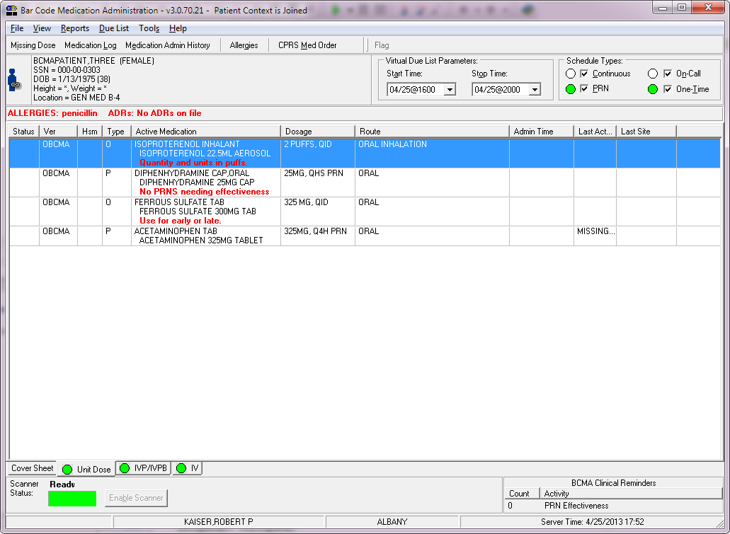

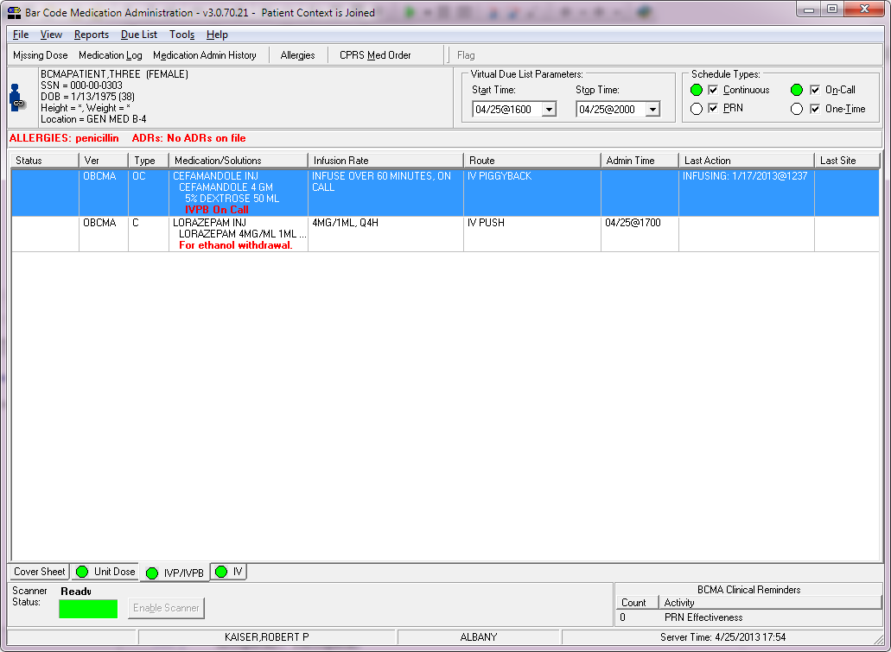

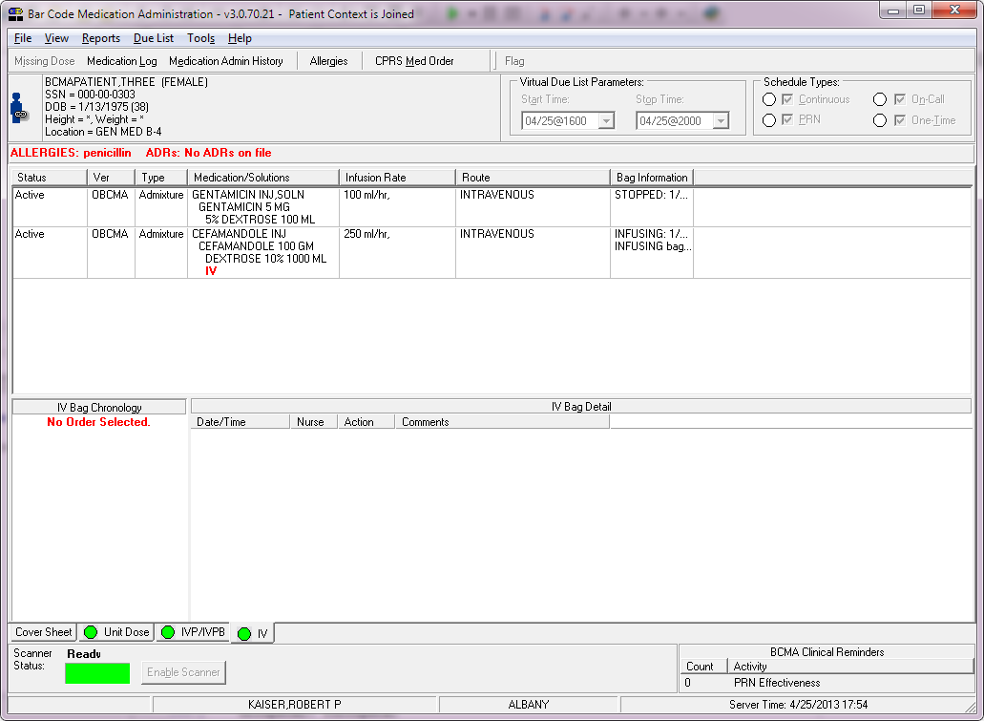

##### Modified Form

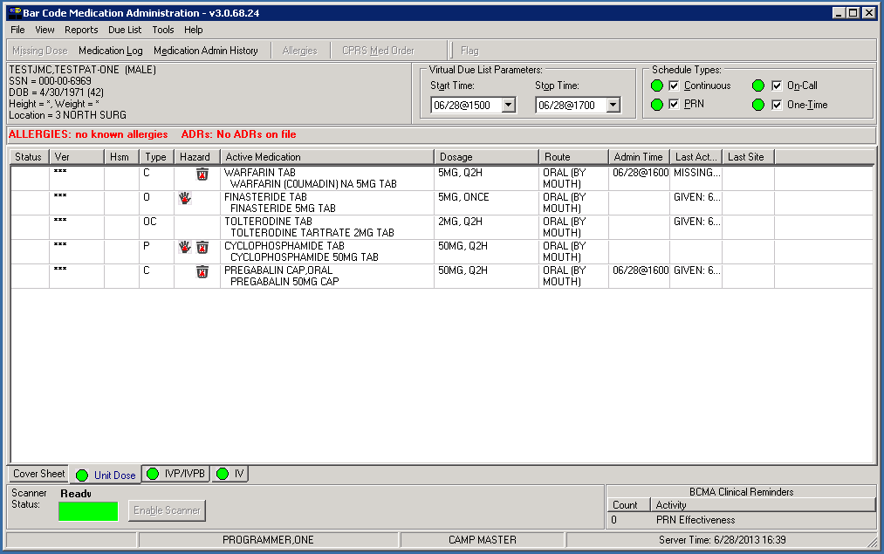

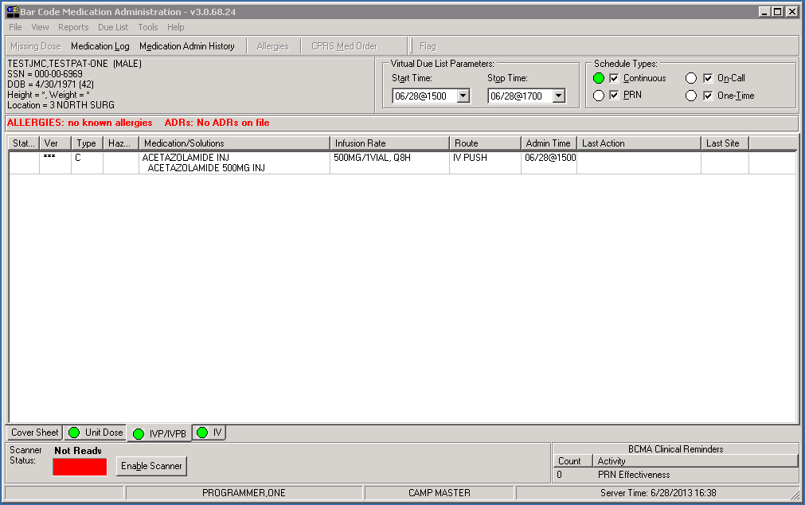

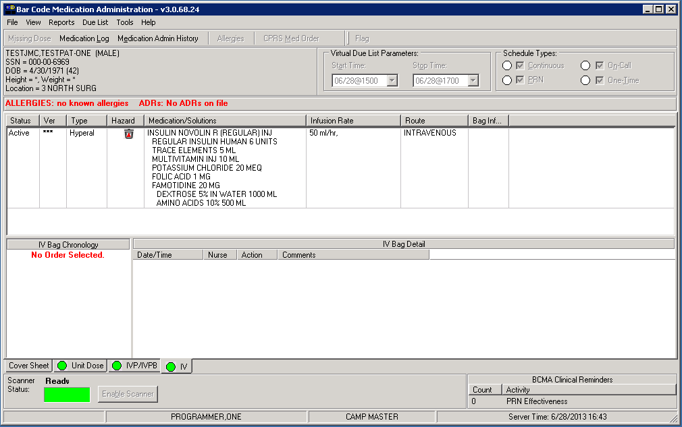

##### Components on Form

Table 15: Components on Form

| Name | Type | Description |
| --- | --- | --- |
| ImageList1 | TImageList | Added Hazardous to Handle icon (hand) index 3.  Added Hazardous to Dispose icon (trash can) index 4. |

##### Events

NA

##### Methods

Table 16: Methods

| Method Name | Procedure/Function | Description |
| --- | --- | --- |
| MedListCompare | Function | Added ability to sort on hazardous pharmaceutical column. Uses combined Hazardous to Handle and Hazardous to Dispose flags for sort comparison. |

##### Special References

NA

##### Class Events

NA

##### Class Methods

Table 17: Class Methods

| Name | Procedure/Function | Description |
| --- | --- | --- |
| lstUnitDoseDrawItem | Procedure | Added functionality to display hazardous to handle and hazardous to dispose icons as appropriate for an order. |

|  |  |  |
| --- | --- | --- |
| actionSortByActiveMedExecute | Procedure | Added functionality to sort by hazardous pharmaceutical column. |
| lstUnitDoseMouseMove | Procedure | Added functionality to display “Hazardous to Handle” and/or “Hazardous to Dispose” hover hint over Hazard column as appropriate. |

##### Class Properties

NA

##### Uses Clause

Table 18: GUI Classes

| GUI Classes | BCMA_Objects |
| --- | --- |
| **Class Name** | TBCMA_MedOrder, TBCMA_Patient |
| **Derived From Class** | **TObject** |
| **Purpose** | Encapsulate medication order, patient information |

##### Current Form

N/A

##### Modified Form

N/A

##### Components on Form

NA

##### Events

NA

##### Methods

NA

##### Special References

Table 19: Special References

| Special Reference Name | Type | Description |
| --- | --- | --- |
| stHazPharm | TSortMnuTagTypes | Added to sort enumerated type |
| ctHazPharm | TVDLColumnTypes | Added to unit dose enumerated type |
| pbHazPharm | lstPBColumnTypes | Added to IVP/IVPB enumerated type |
| ivHazPharm | lstIVColumnTypes | Added to IV enumerated type |
| HAZHANDLE_IDX | Const | HAZHANDLE_IDX = 3. Index of hand in ImageList1 |
| HAZDISPOSE_IDX | Const | HAZDISPOSE_IDX = 4. Index of trashcan in ImageList1 |

##### Class Events

NA

##### Class Methods

Table 20: Class Methods

| Name | Procedure/Function | Description |
| --- | --- | --- |
| TBCMA_MedOrder.AddHazPharm | Procedure | AddHazPharm(innamestr, inhandlestr, indisposestr: string);  Add non-null inhandlestr to FHazHandle with innamestr and set FHaveHazHandle to ‘1’. Add non-null indisposestr to FHazDispose with innamestr and set FHaveHazDispose to ‘1’. |
| TBCMA_MedOrder.ShowHazPharm | Function | ShowHazPharm(): Boolean;  Display FHazHandle stringlist and FHazDispose stringlist in message dialog. |

|  |  |  |
| --- | --- | --- |
| TBCMA_MedOrder.Create | Constructor | Create(RPCBroker: TBCMA_Broker);  Added create for FHazHandle and FHazDispose. |
| TBCMA_MedOrder.Clear | Procedure | Clear;  Added clear on FHazHandle and FHazDispose. Set FHaveHazHandle and FHaveHazDispose to ‘0’. |
| TBCMA_MedOrder.Destroy | Destructor | Destroy;  Added FreeAndNil on FHazHandle and FHazDispose. |
| TBCMA_Patient.LoadMedOrders | Procedure | LoadMedOrders;  Added functionality which parses hazardous to handle and hazardous to dispose data from detailed DD, ADD, SOL rows in results returned by PSB GETORDERTAB and calls AddHazPharm to add the data to the respective stringlists. |

##### Class Properties

Table 21: Class Properties

| Class Properties Name | Type | Visibility | Description |
| --- | --- | --- | --- |
| TBCMA_MedOrder.FHaveHazHandle | String | Private | Flag indicating presence (‘1’) or absence (‘0’) of FHazHandle strings |
| TBCMA_MedOrder.FHaveHazDispose | String | Private | Flag indicating presence (‘1’) or absence (‘0’) of FHazDispose strings |
| TBCMA_MedOrder.FHazHandle | TStringList | Private | Contains list of dispensed drug names and hazardous to handle text |
| TBCMA_MedOrder.FHazDispose | TStringList | Private | Contains list of dispensed drug names and hazardous to dispose text |

|  |  |  |  |
| --- | --- | --- | --- |
| TBCMA_MedOrder.HaveHazHandle | String | Public | FHaveHazHandle read access |
| TBCMA_MedOrder.HaveHazDispose | String | Public | FHaveHazDispose read access |
| TBCMA_MedOrder.HazHandle | TStringList | Public | FHazHandle read / write access |
| TBCMA_MedOrder.HazDispose | TStringList | Public | FHazDispose read / write access |

##### Uses Clause

Table 22: GUI Classes

| GUI Classes | BCMA_Common |
| --- | --- |
| **Class Name** |  |
| **Derived From Class** |  |
| **Purpose** |  |

##### Current Form

N/A

##### Modified Form

N/A

##### Components on Form

NA

##### Events

NA

##### Methods

Table 23: Methods

| Method Name | Procedure/Function | Description |
| --- | --- | --- |
| ReAdjustHdr | Procedure | ReadjustHdr(HdrControl: THeaderControl);  Added functionality to maintain minimum width on Hazard column |

##### Special References

NA

##### Class Events

NA

##### Class Methods

NA

##### Class Properties

Table 24: Class Properties

| Class Properties Name | Type | Visibility | Description |
| --- | --- | --- | --- |
| VDLColumnTitles | Const array[TVDLColumnTypes] of string | Global | Added ‘Hazard’ column title on unit dose tab |
| VDLColumnWidths | Const array[TVDLColumnTypes] of integer | Global | Added column width for hazard column on unit dose tab |
| lstPBColumnTitles | Const array[lstPBColumnTypes] of string | Global | Added ‘Hazard’ column title on IVP/IVPB tab |
| lstPBColumnWidths | Const array[lstPBColumnTypes] of integer | Global | Added column width for hazard column on IVP/IVPB tab |
| lstIVColumnTitles | Const array[lstIVColumnTypes] of string | Global | Added ‘Hazard’ column on IV tab |
| lstIVColumnWidths | Const array[lstIVColumnTypes] of integer | Global | Added column width for hazard column on IV tab |
| lstValidUDSortColumns | array[TVDLColumnTypes] of integer | Global | Added ord(stHazPharm) |
| lstValidPBSortColumns | array[lstPBColumnTypes] of integer | Global | Added ord(stHazPharm) |
| lstValidIVSortColumns | array[lstIVColumnTypes] of integer | Global | Added ord(stHazPharm) |

##### Uses Clause

Table 25: GUI Classes

| GUI Classes | fCoverSheet |
| --- | --- |
| **Class Name** | TfrmCoverSheet |
| **Derived From Class** | **TForm** |
| **Purpose** | Display summary of administration information |

##### Current Form

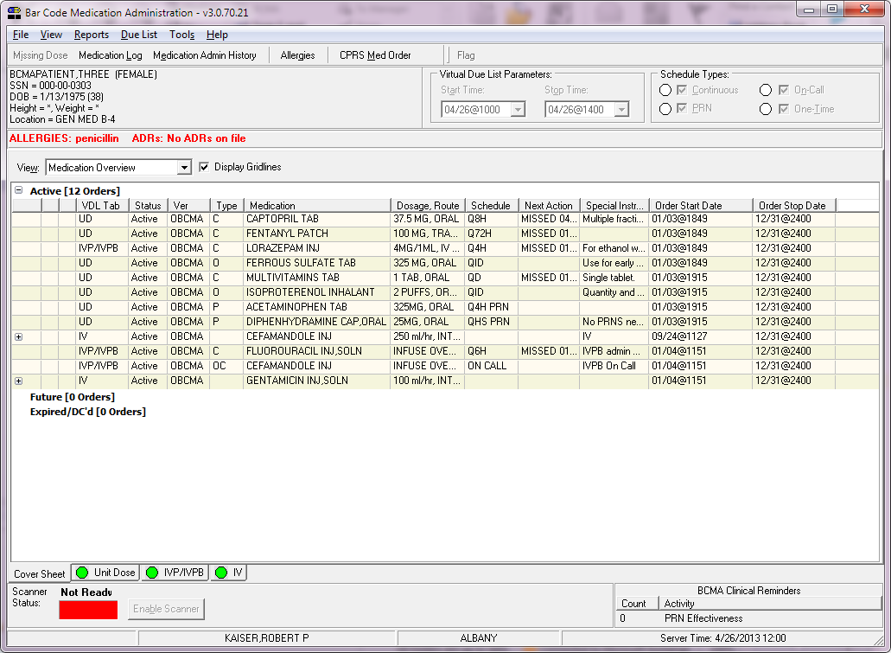

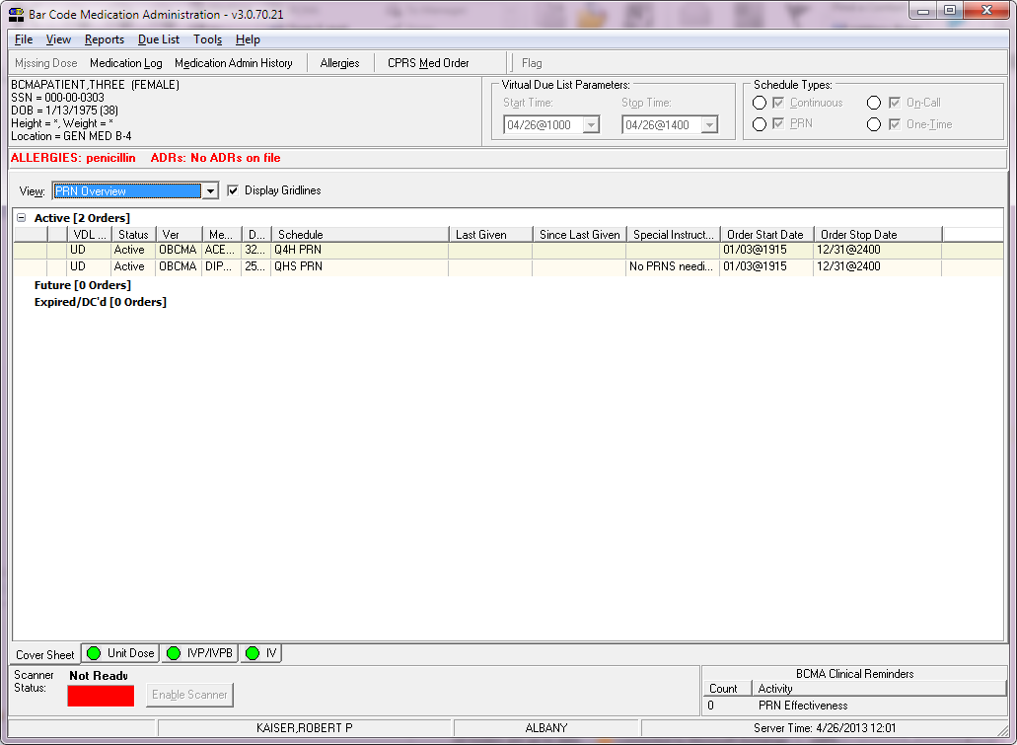

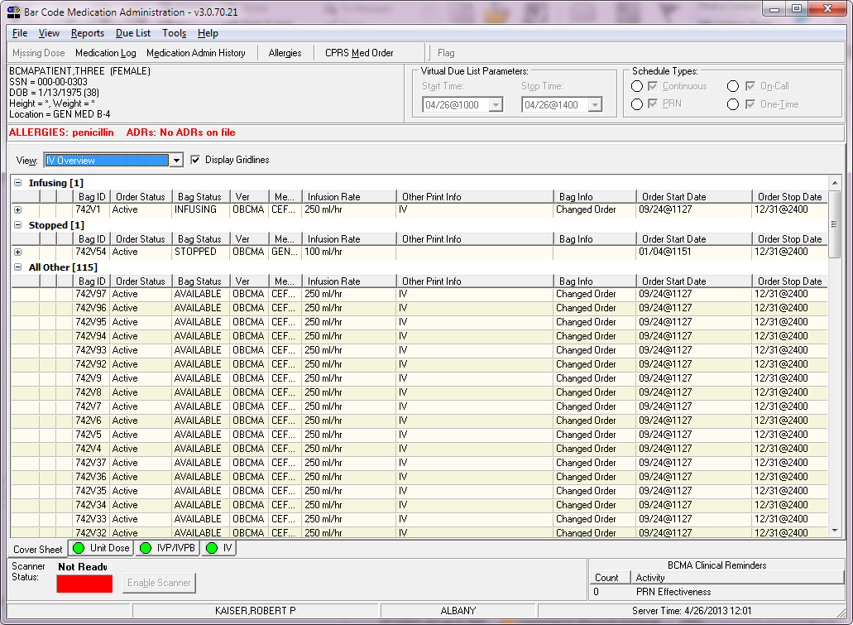

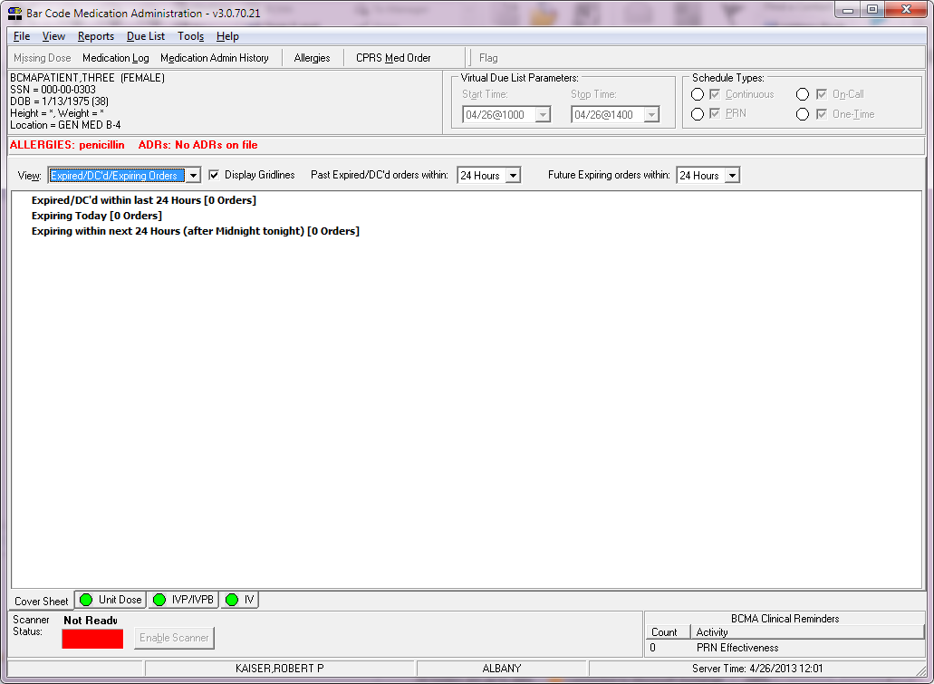

##### Modified Form

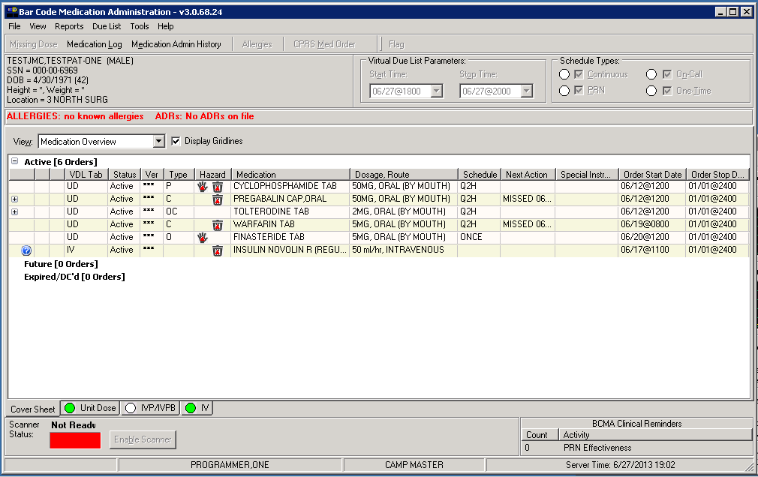

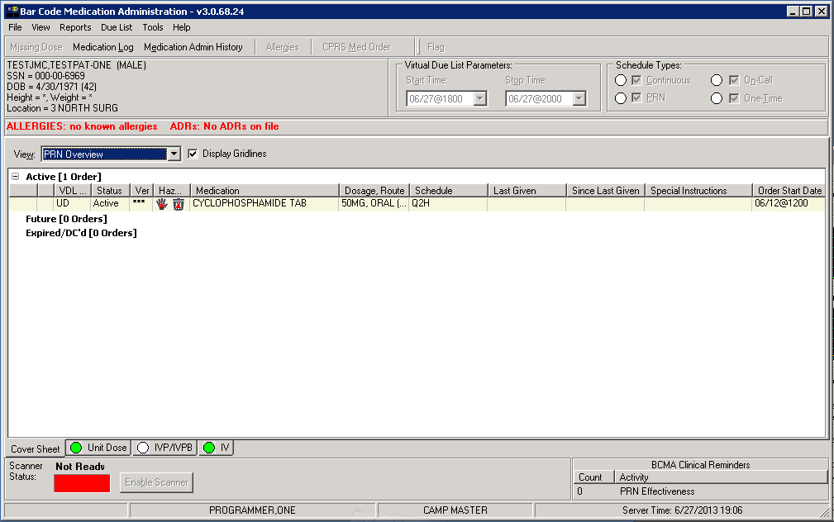

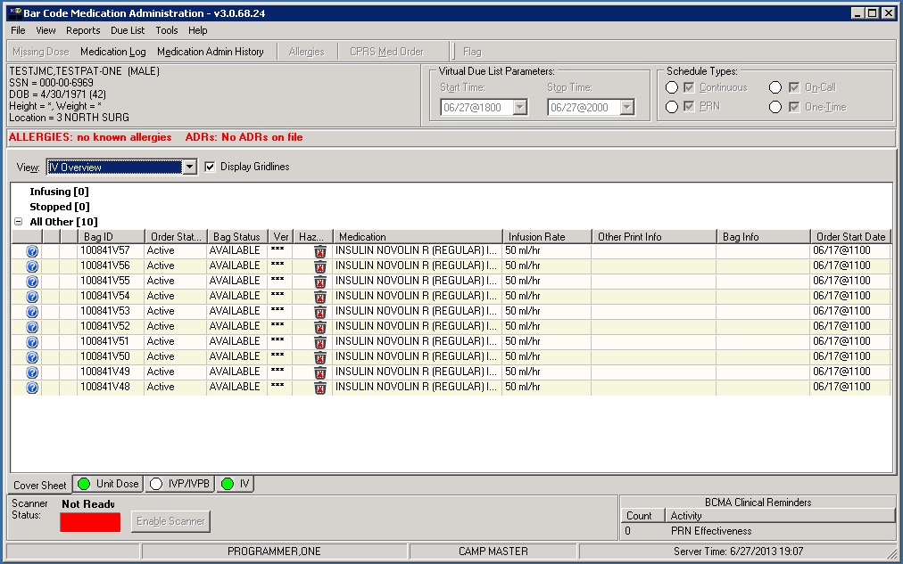

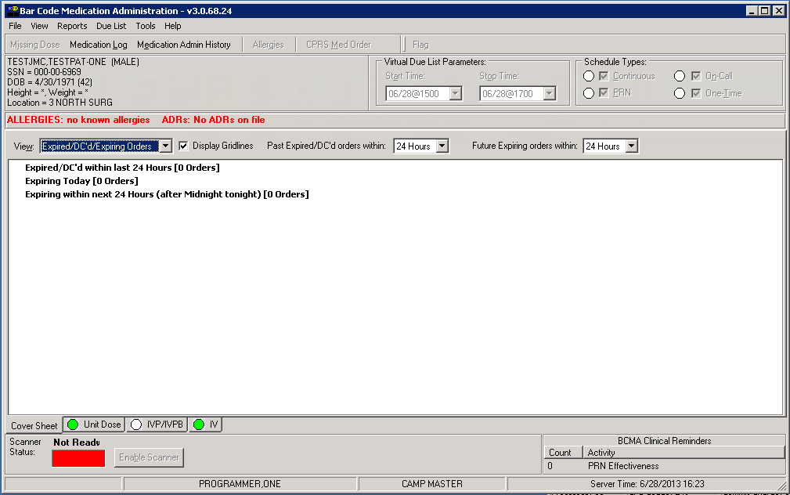

##### Components on Form

Table 26: Components on Form

| Name | Type | Description |
| --- | --- | --- |
| ImageList1 | TImageList | Added Hazardous to Handle icon (hand) index 5.  Added Hazardous to Dispose icon (trash can) index 6. |

##### Events

NA

##### Methods

Table 27: Methods

| Method Name | Procedure/Function | Description |
| --- | --- | --- |
| SortCoverSheet | Function | SortCoverSheet(Item1, Item2: pointer): Integer;  Added functionality to sort on Hazard column for each of the four views. |
| lstMOGroupBoxesDoseDrawItem | Procedure | lstMOGroupBoxesDoseDrawItem(Control: TWinControl;  Index: Integer; Rect: TRect; State: TOwnerDrawState);  Added functionality to display Hazard to Handle and/or Hazardous to Dispose icons as appropriate. Includes display of matching hover hint text as appropriate. |
| lstPRNGroupBoxesDoseDrawItem | Procedure | lstPRNGroupBoxesDoseDrawItem(Control: TWinControl;  Index: Integer; Rect: TRect; State: TOwnerDrawState);  Added functionality to display Hazard to Handle and/or Hazardous to Dispose icons as appropriate. Includes display of matching hover hint text as appropriate. |
| lstIVGroupBoxesDoseDrawItem | Procedure | lstIVGroupBoxesDoseDrawItem(Control: TWinControl;  Index: Integer; Rect: TRect; State: TOwnerDrawState);  Added functionality to display Hazard to Handle and/or Hazardous to Dispose icons as appropriate. Includes display of matching hover hint text as appropriate. |
| lstExGroupBoxesDoseDrawItem | Procedure | lstExGroupBoxesDoseDrawItem(Control: TWinControl;  Index: Integer; Rect: TRect; State: TOwnerDrawState);  Added functionality to display Hazard to Handle and/or Hazardous to Dispose icons as appropriate. Includes display of matching hover hint text as appropriate. |

##### Special References

Table 28: Special References

| Special Reference Name | Type | Description |
| --- | --- | --- |
| CSMouseOverTextHazHandle | Const string | 'Hazardous to Handle' text displayed in hover hint over Hazard column |
| CSMouseOverTextHazDispose | Const string | 'Hazardous to Dispose' text displayed in hover hint over Hazard column |

##### Class Events

NA

##### Class Methods

Table 29: Class Methods

| Name | Procedure/Function | Description |
| --- | --- | --- |
| TfrmCoverSheet.SetHeaderMaxWidth | Procedure | SetHeaderMaxWidth(tempHeaderControl: THeaderControl);  Added functionality to set minimum width for Hazard column |

##### Class Properties

NA

##### Uses Clause

Table 30: GUI Classes

| GUI Classes | oCoverSheet Unit |
| --- | --- |
| **Class Name** | TCoverSheet, TCoverSheet_Order |
| **Derived From Class** | **TObject** |
| **Purpose** | Encapsulate medication order information |

##### Current Form

N/A

##### Modified Form

N/A

##### Components on Form

NA

##### Events

NA

##### Methods

Table 31: Methods

| Method Name | Procedure/Function | Description |
| --- | --- | --- |
| LoadCoverSheetOrders | Function | LoadCoverSheetOrders(PIEN: string; Hours: string): string;  Added functionality which parses hazardous to handle and hazardous to dispose data from detailed DD, ADD, SOL rows in results returned by PSB COVERSHEET1 and calls AddHazPharm to add the data to the respective stringlists. |

##### Special References

Table 32: Special References

| Special Reference Name | Type | Description |
| --- | --- | --- |
| cHazPharm | TMedOverviewColTypes | Added to Med Overview enumerated type |
| ctPRNHazPharm | TPRNColTypes | Added to PRN view enumerated type |
| ctIVHazPharm | TIVColTypes | Added to IV view enumerated type |
| ctExHazPharm | TExpiredColTypes | Added to Expired view enumerated types |
| CSHAZHANDLE | Const | CSHAZHANDLE = 5. Index of hand in ImageList1 |
| CSHAZDISPOSE | Const | CSHAZDISPOSE = 6. Index of trashcan in ImageList1 |

##### Class Events

NA

##### Class Methods

Table 33: Class Methods

| Name | Procedure/Function | Description |
| --- | --- | --- |
| TCoverSheet_Order.AddHazPharm | Function | AddHazPharm(innamestr, inhandlestr, indisposestr: string);  Add non-null inhandlestr to FHazHandle with innamestr and set FHaveHazHandle to ‘1’. Add non-null indisposestr to FHazDispose with innamestr and set FHaveHazDispose to ‘1’. |
| TCoverSheet_Order.Create | Constructor | Create(RPCBroker: TBCMA_Broker);  Added create for FHazHandle and FHazDispose. |
| TCoverSheet_Order.Clear | Procedure | Clear;  Added clear on FHazHandle and FHazDispose. Set FHaveHazHandle and FHaveHazDispose to ‘0’. |
| TCoverSheet_Order.Destroy | Destructor | Destroy;  Added FreeAndNil on FHazHandle and FHazDispose. |

##### Class Properties

Table 34: Class Properties

| Class Properties Name | Type | Visibility | Description |
| --- | --- | --- | --- |
| TCoverSheet_Order.FHaveHazHandle | String | Private | Flag indicating presence (‘1’) or absence (‘0’) of FHazHandle strings |
| TCoverSheet_Order.FHaveHazDispose | String | Private | Flag indicating presence (‘1’) or absence (‘0’) of FHazDispose strings |

|  |  |  |  |
| --- | --- | --- | --- |
| TCoverSheet_Order.FHazHandle | TStringList | Private | Contains list of dispensed drug names and hazardous to handle text |
| TCoverSheet_Order.FHazDispose | TStringList | Private | Contains list of dispensed drug names and hazardous to dispose text |
| TCoverSheet_Order.HaveHazHandle | String | Public | FHaveHazHandle read access |
| TCoverSheet_Order.HaveHazDispose | String | Public | FHaveHazDispose read access |
| TCoverSheet_Order.HazHandle | TStringList | Public | FHazHandle read / write access |
| TCoverSheet_Order.HazDispose | TStringList | Public | FHazDispose read / write access |

# Acronyms and Definitions

| Term | Definition |
| --- | --- |
| BCMA | Bar Code Medication Administration |
| DDL | Data Definition Language |
| DIF | Drug Information Framework |
| DML | Data Modification Language |
| EPA | Environmental Protection Agency |
| EPL | Enterprise Product List |
| FSS | Federal Supply Schedule |
| Haz Pharm | Hazardous Pharmaceuticals |
| GFE | Government Furnished Equipment |
| HPES | Hewlett Packard Enterprise Services |
| IPT | Integrated Project Team |
| J2EE | Java 2 Enterprise Edition |
| JDK | Java Developer’s Kit |
| LOV | List of Values |
| NDF | National Drug File |
| NIOSH | The National Institute of Occupational Safety and Health |
| OSEHRA | Open Source Electronic Health Record Agent |
| PPS-N | Pharmacy Product System – National |
| PWS | Performance Work Statement |
| SDD | System Design Document |
| SME | Subject Matter Expert |
| SQA | Software Quality Assurance |
| TAC | Technical Assistance Contract |
| VA | Department of Veterans Administration |
| VADF | VA Data Field |
| VAMC | VA Medical Center |
| VistA | Veterans Health Information Systems and Technology Architecture |
| VM | Virtual Machine |