Department of Veterans Affairs
Operations and Maintenance (O&M) Plan
Innovation # 665 Hazardous Pharmaceuticals



Version 1.0

September 2013

Revision History
Date | Version | Description | Author
September 2013 | 1.0 | Operations and Maintenance Plan for #665 Hazardous Pharmaceuticals | Bob Thomas

(This page included for two-sided copying.)

Table of Contents
1. System Business and Operational Description 1
1.1 Project Overview 1
1.2 Operational Priority and Service Level 1
1.3 Logical System Description 2
2. Application Administration 2
2.1 Database Load 2
2.2 PPS-N 2
2.2.1 Hazardous to Handle 2
2.2.2 Hazardous to Dispose 3
2.2.3 Hazardous to Handle and Hazardous to Dispose 4
2.3 VistA 5
2.3.1 VistA Menu Options 5
2.3.2 PPSNSUPER Security Key for Haz Pharm Administrator Access 7
2.4 BCMA 20
2.4.1 New Visual Indicators on BCMA GUI 20
2.4.2 Administering Medications that are flagged as Hazardous Pharmaceuticals 23
2.4.3 Maintenance of BCMA 29
3. Acronyms 29
4. Database Administration 31
4.1 PPS-N 31
5. Troubleshooting 36
5.1 Initial Data Load Summary Report 36
5.1.1 Matching Algorithms 38
5.2 Hazardous Drug Mismatch Report 41

(This page included for two-sided copying.)

System Business and Operational Description
The Contractor Project Management Plan (CPMP) provides the approach, expected schedule, and tools to be used in managing the deliverables of the Hazardous Pharmaceuticals (Haz Pharm) innovation contract from beginning to end of the contract cycle.

Project Overview
The Innovation #665 Hazardous Pharmaceuticals (Haz Pharm) project was born from the Veterans Health Administration (VHA) Office of Health Information (OHI) Innovation Program. Through this initiative, prospective projects submitted by VA employees scrutinize for benefit, funding, and development. Selected projects move to the first of two innovation phases, a prototype phase, where the requested functionality is developed outside the VA Network in a virtual environment known as the VA Innovations Sandbox.

Every VA pharmacy in the country carries pharmaceuticals that present hazards for human exposure and environmental hazards upon disposal. Many VA pharmacies utilize automation. Hazardous pharmaceuticals should not be packaged or processed through automation allowing for cross contamination that would expose our Veteran population to risk unnecessarily. Nurses in VA facilities across the country administer medication utilizing the Bar Code Medication Administration (BCMA) system without knowing the potential for exposure hazards or the appropriate disposal methods. Facilities that improperly dispose of pharmaceuticals are subject to substantial Environmental Protection Agency (EPA) fines. This project has intrinsic benefits to Veterans served by VA pharmacies, all VA staff who handle pharmaceuticals, the American taxpayer, and the environment.

The Haz Pharm Innovations project will enhance the functionality of the Pharmacy Product System – National (PPS-N) and modify the local National Drug File (NDF) in Veterans Health Information Systems and Technology Architecture (VistA). These applications will be updated to identify and create flags for pharmaceuticals that would be hazardous to handle or hazardous to the environment upon disposal. Bar Code Medication Administration (BCMA) software will also require development to pull and flag data warning nursing of hazard before medication administration to patients. These improvements will be provided in a prototype system and demonstrated solely within the VA Sandbox to the stakeholders.

Operational Priority and Service Level
The Innovation #665 Hazardous Pharmaceuticals (Haz Pharm) project was born from the Veterans Health Administration (VHA) Office of Health Information (OHI) Innovation Program. Through this initiative, prospective projects submitted by VA employees scrutinize for benefit, funding, and development. Selected projects move to the first of two innovation phases, a prototype phase, where the requested functionality is developed outside the VA Network in a virtual environment known as the VA Innovations Sandbox.

Every VA pharmacy in the country carries pharmaceuticals that present hazards for human exposure and environmental hazards upon disposal. Many VA pharmacies utilize automation. Hazardous pharmaceuticals should not be packaged or processed through automation allowing for cross contamination that would expose our Veteran population to risk unnecessarily. Nurses in VA facilities across the country administer medication utilizing the Bar Code Medication Administration (BCMA) system without knowing the potential for exposure hazards or the appropriate disposal methods. Facilities that improperly dispose of pharmaceuticals are subject to substantial Environmental Protection Agency (EPA) fines. This project has intrinsic benefits to Veterans served by VA pharmacies, all VA staff who handle pharmaceuticals, the American taxpayer, and the environment.

Logical System Description
The Haz Pharm Innovations project will enhance the functionality of the Pharmacy Product System – National (PPS-N) and modify the local National Drug File (NDF) in Veterans Health Information Systems and Technology Architecture (VistA). These applications will be updated to identify and create flags for pharmaceuticals that would be hazardous to handle or hazardous to the environment upon disposal. Bar Code Medication Administration (BCMA) software will also require development to pull and flag data warning nursing of hazard before medication administration to patients. These improvements will be provided in a prototype system and demonstrated solely within the VA Sandbox to the stakeholders.

Application Administration
Application Administration schedules application tasks, develops backup schedules, monitors operations of the applications/software, and troubleshoots the application/software when a problem occurs. In addition, Application Administration participates in tuning the application to resolve performance issues. Coordinate with System Administrators to manage changes.

Database Load
Full details regarding the Database load are provided within the Haz Pharm Installation Guide document. Refer to Section 1 of the Haz Pharm Installation Guide for installation details.

PPS-N
The PPS-N source code being used for the Haz Pharm project was downloaded from a VA accessible website specifically used for PPS-N software development.

Hazardous to Handle
After initial data load from the NIOSH data source into PPS-N, the drug will be successfully checked as Hazardous to Handle at the Product level on the Administration Data tab.

Example: Hazardous to Handle
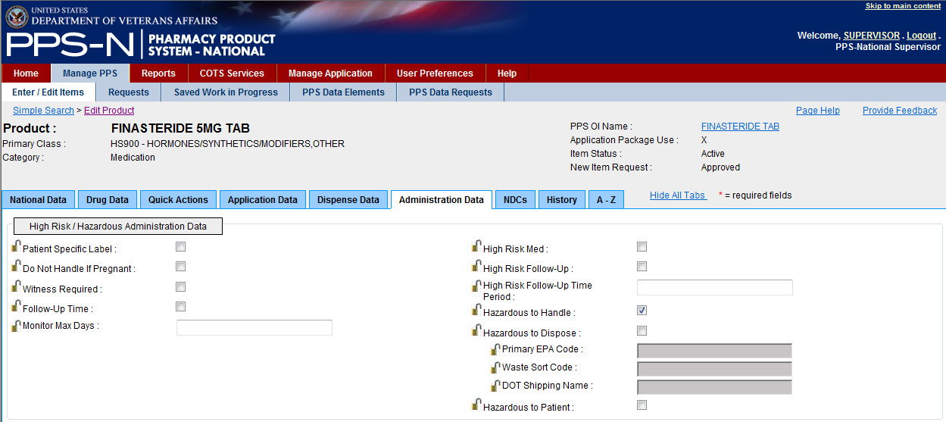

Hazardous to Dispose
After initial data load from the Stericycle data source into PPS-N, the drug will be successfully checked as Hazardous to Dispose at the Product level on the Administration Data tab. Additional Hazardous to Dispose data fields (Primary EPA Code, Waste Sort Code, DOT Shipping Name) will be populated below the checkbox, as applicable. The Warfarin example below has all Hazardous to Dispose fields populated, while the Pregabalin example below only has a Waste Sort Code populated.

Example: Hazardous to Dispose (Warfarin)
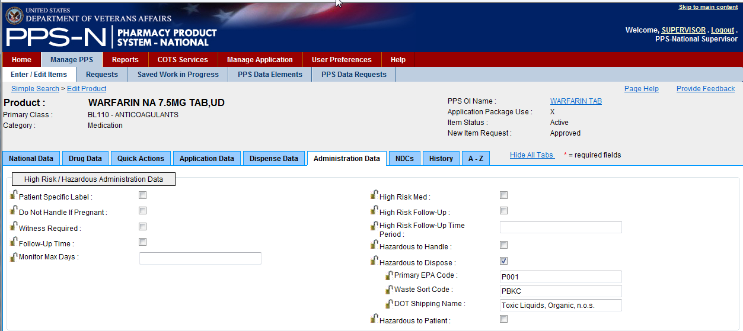

Example: Hazardous to Dispose (Pregabalin)
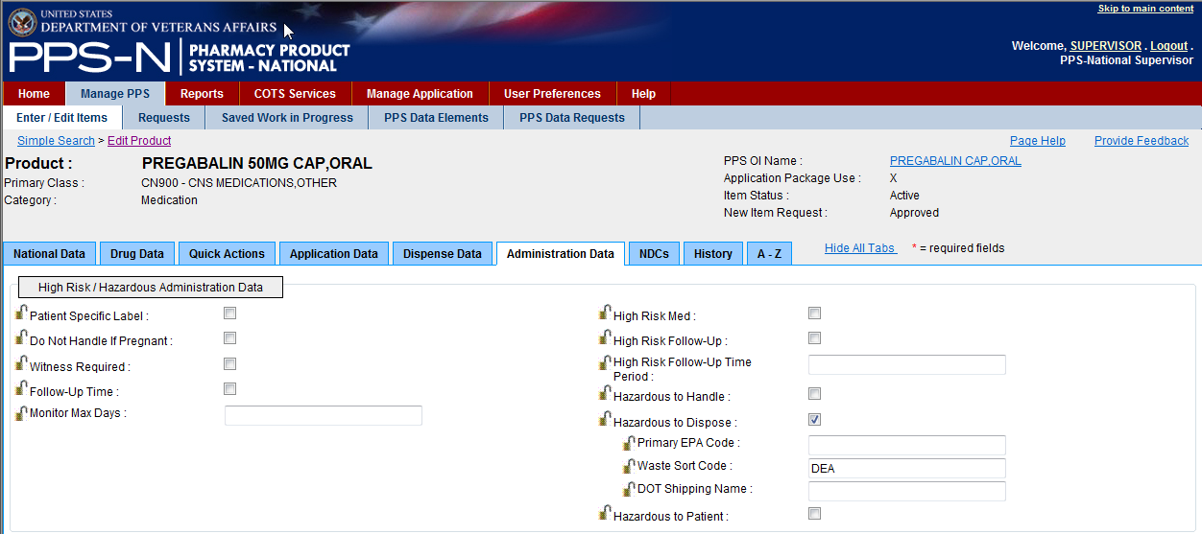

Hazardous to Handle and Hazardous to Dispose
After initial data loads from both the NIOSH and STERICYLCE data sources into PPS-N, the drug will be successfully checked as both Hazardous to Handle and Hazardous to Dispose at the Product level on the Administration Data tab. Additional Hazardous to Dispose data fields (Primary EPA Code, Waste Sort Code, and DOT Shipping Name) will be populated below the checkbox, as applicable. The Cyclophosphamide below shows that it is both Hazardous to Handle and Hazardous to Dispose.

Example: Hazardous to Handle and Hazardous to Dispose
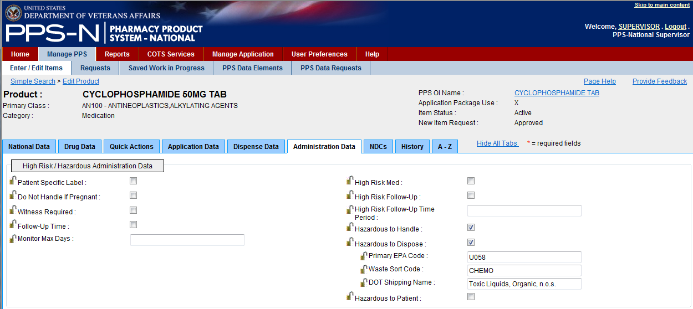

After the initial data load of NIOSH and STERICYLE data into the PPS-N database is completed, the system creates a delimited flat file containing all drugs marked as Hazardous to Handle and/or Hazardous to Dispose along with the three additional fields of information for Hazardous to Dispose drugs.
Complete details for each installation step for all applications associated with the Haz Pharm project, are provided within the Haz Pharm Installation Guide document. Refer to Section 1 of the Haz Pharm Installation Guide for installation details including data load steps needed to ensure that the database updates are reflected in VistA.
Local modifications to accommodate sources other than NIOSH and Stericyle should be performed in VistA and not in PPS-N.

VistA
There are specific VistA patches to apply to local VistA instances and this will be handled by the Regional Application Service Line (ASL) supporting the specific Medical Center VistA images.
There is no workstation specific software required; Hazardous Pharmaceuticals Innovation 665 fully integrates with existing Veterans Health Information Systems and Technology Architecture (VistA).
The ASL is responsible for the configuration and installation of application specific processes and parameters. The ASL provides T2 support for problem trouble shooting, and interfaces with higher tiers of support via established escalation procedures such as REMEDY, Automate Notification Reporting (ANR), local incident response systems, and change management systems.
The ASL works closely with the Business Systems Service Line (BSSL) to assure that hardware issues pertaining to VistA and application communications systems such as VistaLink are configured and work correctly. The ASL will work with the Infrastructure Service Line (ISL) to assure that network based communication to/from VistA and PPS-N servers are configured and working correctly.
It is the responsibility of the local site to allocate the PPSNSUPER security key to the appropriate individual(s) who is/are responsible for maintaining the Hazardous Pharmaceutical data. The holder(s) of this key will be responsible for running the initial data load of the Hazardous Pharmaceutical data, running a Hazardous Drug Mismatch Report, if applicable, for file reconciliation, and making any local modifications to the Hazardous Pharmaceutical data that may be required. They will also be responsible for removing the flagging that denotes a local modification in the file structure, should it be necessary.

VistA Menu Options
This section outlines the new hazardous pharmaceuticals menu options in VistA created for this project.

Option | Option Name | Description
PSS DRUG HAZARD ENTER/EDIT | Hazardous Drug Enter/Edit | Allows local modifications of VistA VA PRODUCT File (#50.68)  Administrator function – Requires PPSNSUPER security key.
PSS DRUG HAZARD LOAD | Hazardous Drug Data Load | Flat file from PPS-N extract gets FTP'd to VistA Server. Load option prompts for filename. Option to see updates scroll on the screen as they are being made; otherwise, the process runs unseen, and notifies the user when completed.  Administrator function – Requires PPSNSUPER security key.
PSS DRUG HAZARD LOOKUP | Hazardous Drug Lookup | Provided drug lookup by DRUG IEN, GENERIC name, VA PRODUCT name NAME, NDC, SYNONYM, or DRUG CLASS.
PSS DRUG HAZARD MISMATCH | Hazardous Drug Mismatch Report | Runs Mismatch report that is created after data load. To see file name, type “!” at VistA prompt, then “DIR” to view filenames in directory list. Type “Quit” to return to VistA. Enter Mismatch filename at prompt.  Administrator function – Requires PPSNSUPER security key.
PSS DRUG HAZARD RESET | Hazardous Drug Local Mod Flag Reset | Resets local modification flag for a specific drug, such that future PPS-N updates (manual or via data loading) can occur.  Administrator function – Requires PPSNSUPER security key.

The VistA Hazardous Pharmaceuticals menu can be accessed by typing PSS HAZARDOUS PHARMACEUTICALS.

Example: VistA Hazardous Pharmaceuticals Main Menu
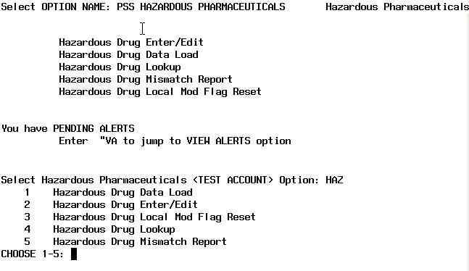

PPSNSUPER Security Key for Haz Pharm Administrator Access
A new security key, PPSNSUPER, has been introduced to limit access to administrator functions for hazardous pharmaceuticals in the VA PRODUCT File (#50.68). Pharmacy users who administer and maintain hazardous pharmaceutical attributes in VistA will require this security key in order to execute options 1, 2, 3, and 5 listed above.
Basic pharmacy users, who not do not have the security key, PPSNSUPER, will only be allowed to perform the Hazardous Drug Lookup, option 4, above.
The following screen captures display what basic pharmacy users (who do not hold the PPSNSUPER security key) see when selecting Hazardous Pharmaceutical menu options.

Example: User without PPSNSUPER security key
attempts to run Hazardous Drug Data Load option (Disallowed)
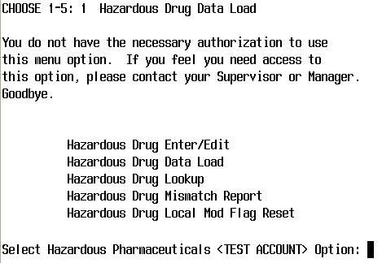

Example: User without PPSNSUPER security key
attempts to run Hazardous Drug Enter/Edit option (Disallowed)
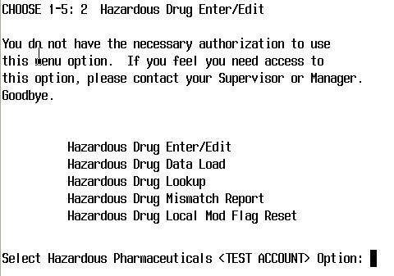

Example: User without PPSNSUPER security key
attempts to run Hazardous Drug Local Mod Flag Reset option (Disallowed)
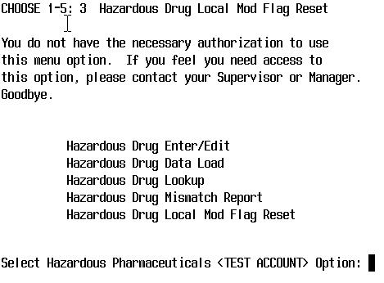

Example: User without PPSNSUPER security key
attempts to run Hazardous Drug Lookup option (Allowed)
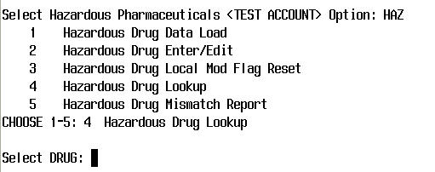

Example: User without PPSNSUPER security key
attempts to run Hazardous Drug Mismatch Report option (Disallowed)

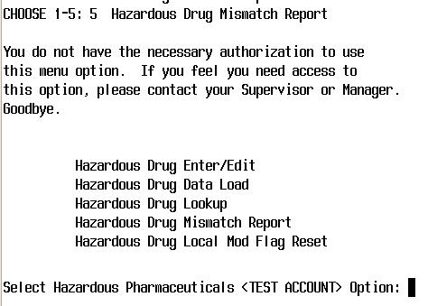
The following screen shots display what administrator pharmacy users (who hold the PPSNSUPER security key) see when selecting Hazardous Pharmaceutical menu options. Users who hold the PPSNSUPER security key are allowed to execute all options on the Hazardous Pharmaceuticals menu.
When performing a data load, the administrator must know the name of the data input file. This file was created after the initial data load into PPS-N, then FTP’d to the VistA server into a specific default directory. For this innovation project, the default directory was “d:\intersystems\cache\manager\dev1”. You can exit to the operating system in order to view the files listed in the default directory, then Quit back to VistA to type in the correct file name at the prompt. The screen shot below shows an example filename “PPSN_Extract_07312013_1.txt”.
Example: User with PPSNSUPER security key
runs Hazardous Drug Data Load option (Allowed)
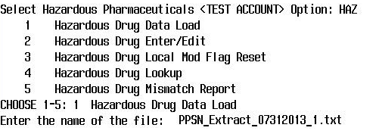

The Drug Enter/Edit option allows the administrator to make changes to the hazardous to handle and hazardous to dispose fields in the local VA PRODUCT File (#50.68). When selecting the Drug Enter/Edit option, the administrator sees a warning message that local modifications to the local VA PRODUCT File (#50.68) will cause the file to deviate from the PPS-N national database. If changes are made to either hazard to handle or hazardous to dispose data, the record will be flagged with local modifications. Once the record is flagged as having local modifications, all changes made to the corresponding product in PPS-N (either via data loading or manual edits in PPS-N) will not be reflected in VistA. To resume synchronization between PPS-N updates and the VA PRODUCT File (#50.68) for a specific product, the administrator must use the Hazardous Drug Local Mod Flag Reset option, and select a specific drug for which to clear the local modification flag.
If the administrator selects the Hazardous Drug Enter/Edit option, then presses Return after each entry without making changes, or types in exactly what was there before, the record will not be flagged as being locally modified.

Example: User with PPSNSUPER security key
runs Hazardous Drug Enter/Edit option
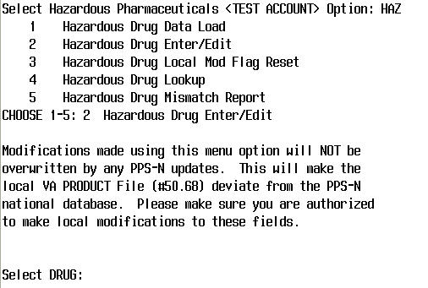

Example: User with PPSNSUPER security key
runs Hazardous Drug Enter/Edit option
for Hazardous to Handle Drug
FINASTERIDE 5 MG TAB
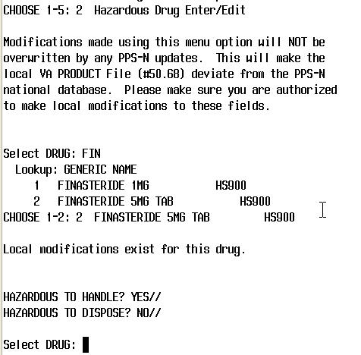

Example: User with PPSNSUPER security key
runs Hazardous Drug Enter/Edit option
for Hazardous to Dispose Drug
WARFARIN 7.5 MG TAB
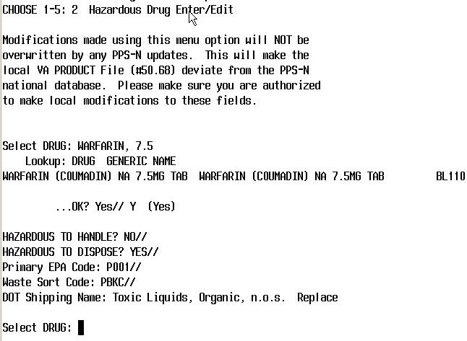

Example: User with PPSNSUPER security key
runs Hazardous Drug Enter/Edit option for
Hazardous to Handle and Hazardous to Dispose Drug
CYCLOPHOSPHAMIDE 50 MG TAB
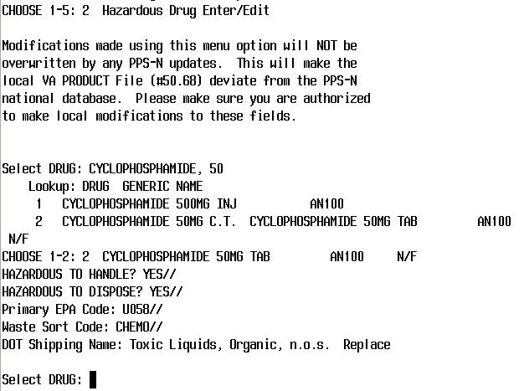

Example: User with PPSNSUPER security key
runs Hazardous Drug Lookup option
for Hazardous to Handle Drug
Showing Entry Has Been Locally Modified
FINASTERIDE 5MG TAB
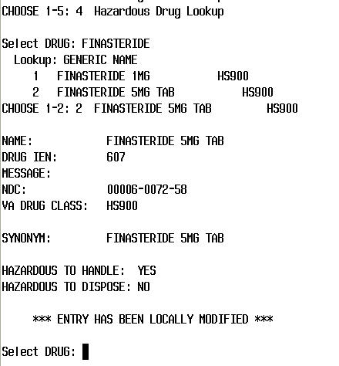
Example: User with PPSNSUPER security key
runs Hazardous Drug Lookup option
for Hazardous to Dispose Drug
for a drug that has not been locally modified
WARFARIN 7.5MG TAB
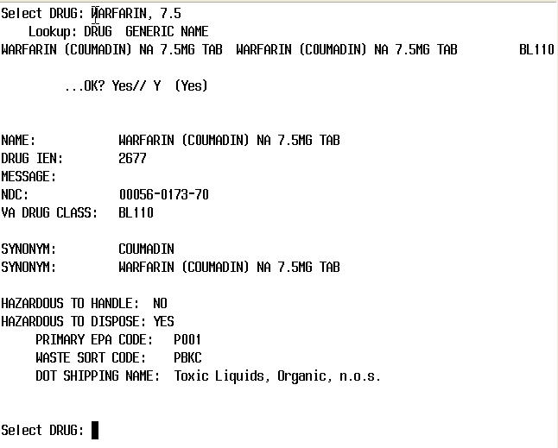

Example: User with PPSNSUPER security key
runs Hazardous Drug Local Mod Flag Reset option
for Hazardous to Handle Drug
FINASTERIDE 5MG TAB
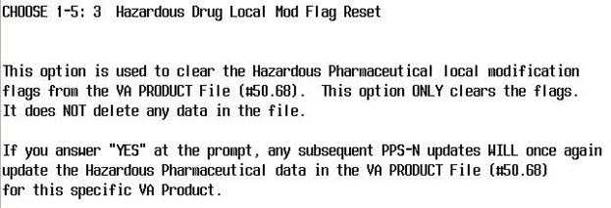
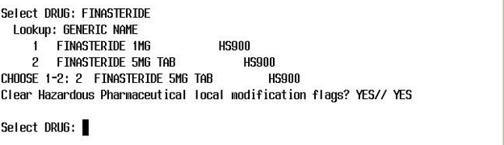

Example: User with PPSNSUPER security key
runs Hazardous Drug Lookup option
for Hazardous to Handle Drug
After Clearing Hazardous Pharmaceutical Local Mod Flag
FINASTERIDE 5MG TAB
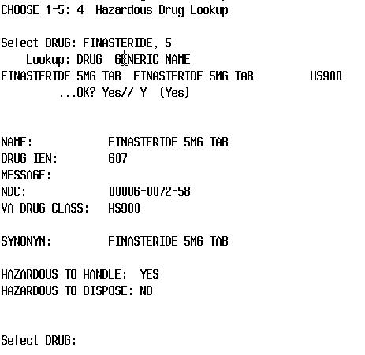

Example: User with PPSNSUPER security key
runs Hazardous Drug Mismatch Report
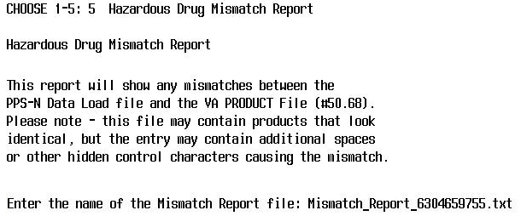
The following shows sample output for the Hazardous Drug Mismatch Report.
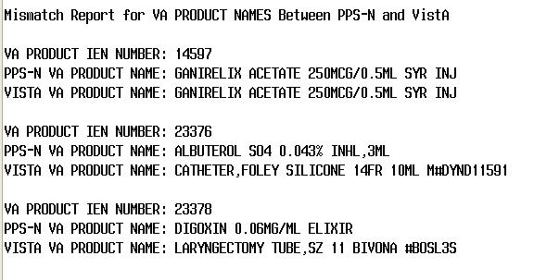

BCMA

New Visual Indicators on BCMA GUI
This project introduces two new icons that display on the BCMA GUI to indicate when a medication order contains one or more drugs that are flagged as Hazardous to Handle and/or Hazardous to Dispose. When applicable to a medication order, these icons display in a new column entitled “Hazard” on the Cover Sheet, Unit Dose, IVP/IVPB, and IV tabs in BCMA.

If a medication order contains one or more drugs that are flagged as Hazardous to Handle, this icon (hand with a red triangle) will display to the left side of the Hazard column.
If a medication order contains one or more drugs that are flagged as Hazardous to Dispose, this icon (trash can with a red triangle) will display to the right side of the Hazard column.

When processing and displaying administration data in BCMA, the system looks up hazard flags in the Drug (#50.68) file for all the dispense drugs, additives, and solutions contained in each order, and then determines which of the following icons to display based on the attributes of the order as a whole. The following table shows the four possible combinations found in the Hazard column, and what it means for the medication order.

Hazard Column Icons | Signifies that the medication order contains the following attributes:
 | Both Hazardous to Handle and Hazardous to Dispose
 | Hazardous to Handle only
 | Hazardous to Dispose only
 | Neither Hazardous to Handle or Hazardous to Dispose

The Hazard column can be sorted by clicking on the “Hazard” title at the top of the column. Click once to sort administrations in Ascending order by Hazard (no hazard icons at top), and click again to sort administrations in Descending order by Hazard (both hazard icons at top). The Hazard column can be sorted on the Cover Sheet, Unit Dose, IVP/IVPB, and IV tabs.
Hover text, indicating the hazard attributes of the order, is displayed for three seconds whenever the mouse pointer hovers over an icon in the Hazard column. There are three possible hover text messages: “Hazardous to Handle,” “Hazardous to Dispose,” or “Hazardous to Handle/Hazardous to Dispose.”

Example: Unit Dose Tab sorted by Hazard Column in Ascending Order
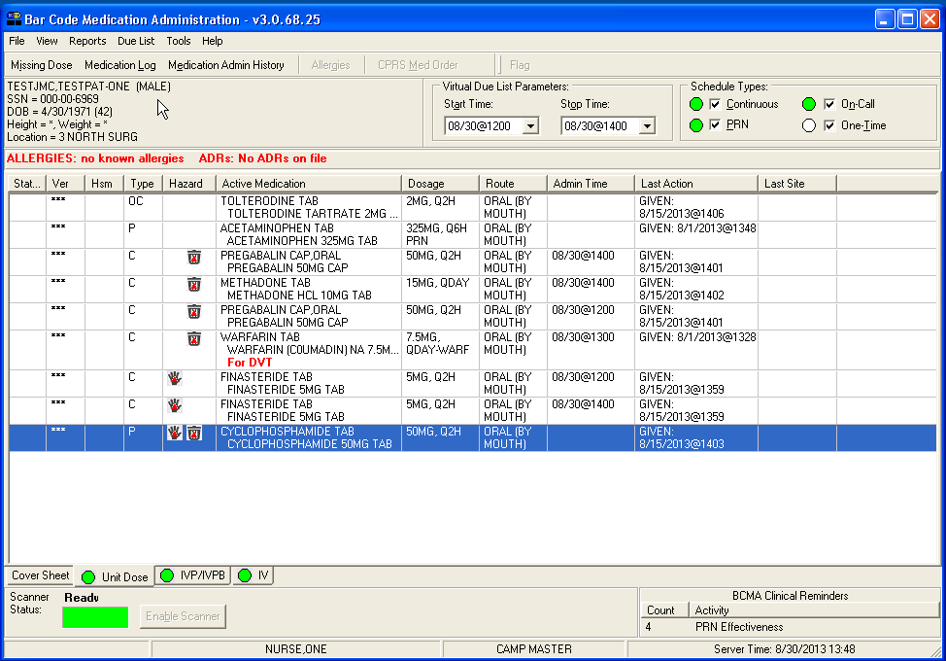
Example: Unit Dose Tab sorted by Hazard Column in Descending Order
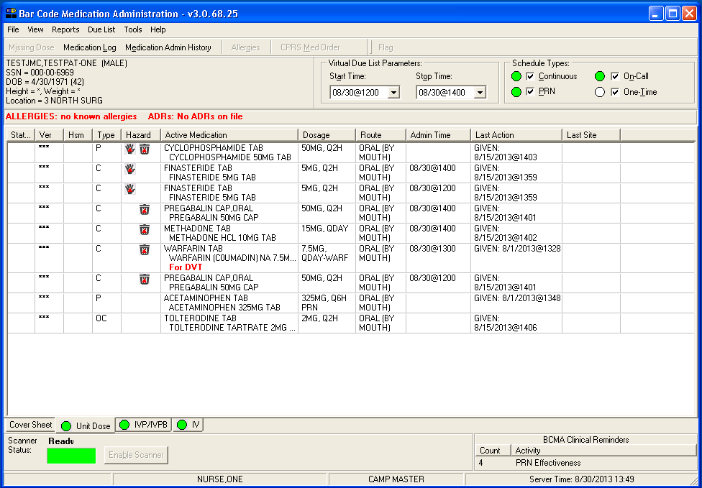

Example: Cover Sheet showing Hazard Column with Orders sorted
Alphabetically by Medication
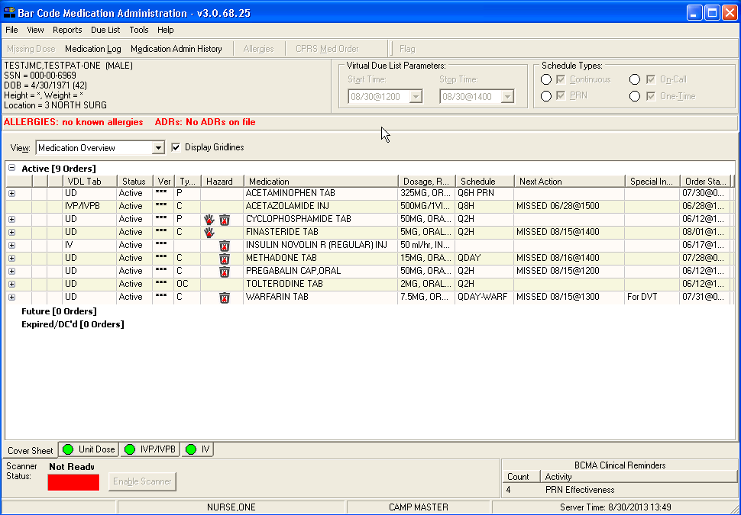
Example: IV Tab showing IV order with Hazardous to Dispose Icon
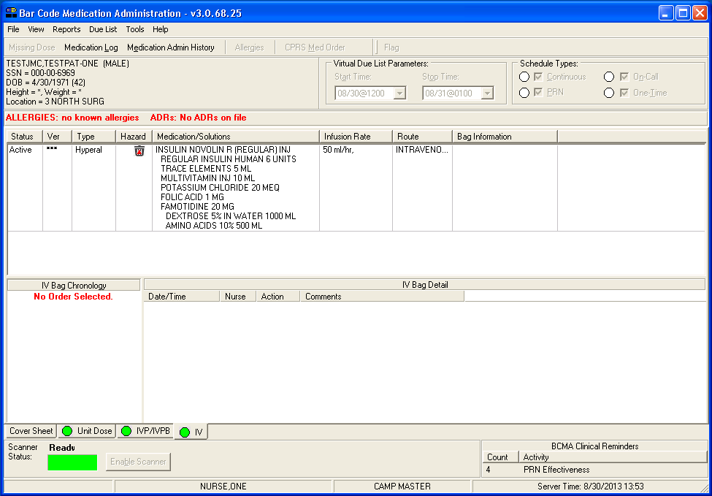

Example: Hazard Column and Icons are also included
in Multiple Orders for Scanned Drug Dialog
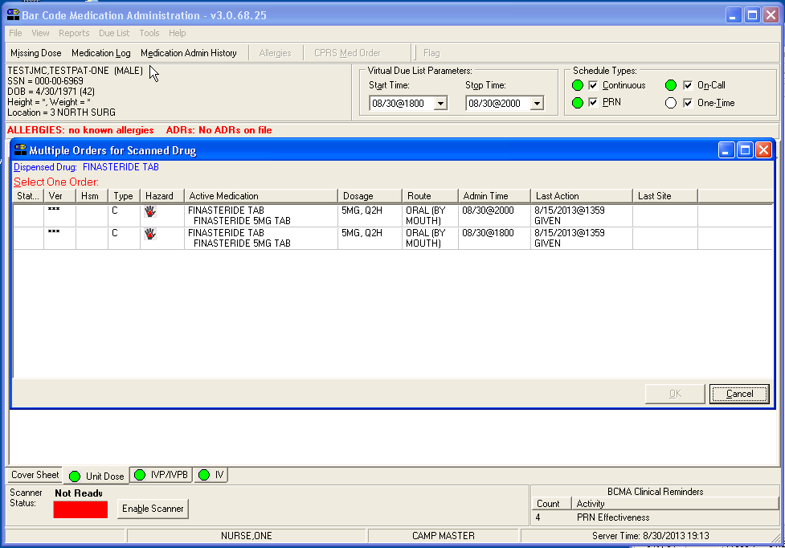

Administering Medications that are flagged as Hazardous Pharmaceuticals
Whenever Hazardous to Handle and/or Hazardous to Dispose data updates are made to the Drug (#50.68) file in VistA by either loading data from PPS-N, or by local modifications, the changes are immediately reflected in BCMA. The user should utilize the Refresh feature (F5) to refresh the data on the Virtual Due List (VDL), which will update the Hazard icons, and display the appropriate Hazard pop-ups during medication administration.
When administering Unit Dose, IV Push, IV Piggyback, and large volume IV medications in BCMA, if hazard attributes are found, the Hazardous Pharmaceutical warning pop-up displays first in the administration workflow, listing the drug(s) that are flagged, and any corresponding hazard data found in the Drug (#50.68) file. Other important points that impact administration include:
- A single drug can be listed as both Hazardous to Handle and Hazardous to Dispose.
- One medication order can contain multiple drugs with similar or different hazard attributes.
- Orders that are Fractional or Multiple Dose will only display the Hazardous Pharmaceutical pop-up once per administration.
- Hazardous Pharmaceutical warnings work with Unable to Scan functionality by displaying the pop-up after the medications are validated.
- Hazardous Pharmaceutical warnings work with large volume IV orders by displaying the pop-up when initially infusing an available IV bag, or upon infusing a bag after completing a previously infusing IV bag.
The following examples illustrate various Hazardous Pharmaceutical pop-up displays for different types of administrations.
Example: Administering a Medication that is Hazardous to Handle, Only
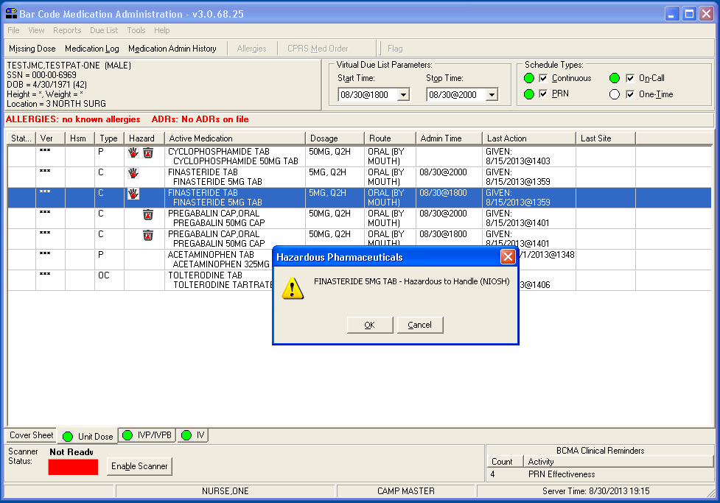

2.4.2.1. Administering a Medication that is Hazardous to Dispose (all data populated)
The following example shows the administration of a medication that is Hazardous to Dispose only, where all Hazardous to Dispose data is populated. Primary EPA Code, Waste Sort Code, and DOT Shipping Name fields are displayed, separated by commas.
Example: Administering a Medication that is Hazardous to Dispose, Only
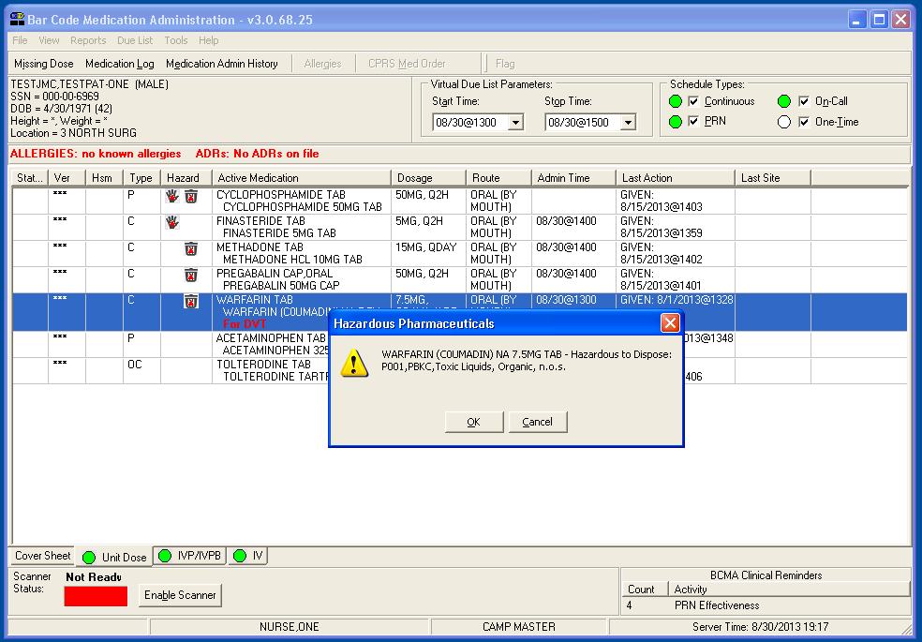

2.4.2.2. Administering a Medication that is Hazardous to Dispose (Waste Sort Code only)
The following example shows the administration of a medication that is Hazardous to Dispose only, where only the Waste Sort Code field is populated, and commas are shown as placeholders for the Primary EPA Code and DOT Shipping Name fields.
Example: Administering a Medication that is Hazardous
to Dispose (Waste Sort Code Only)
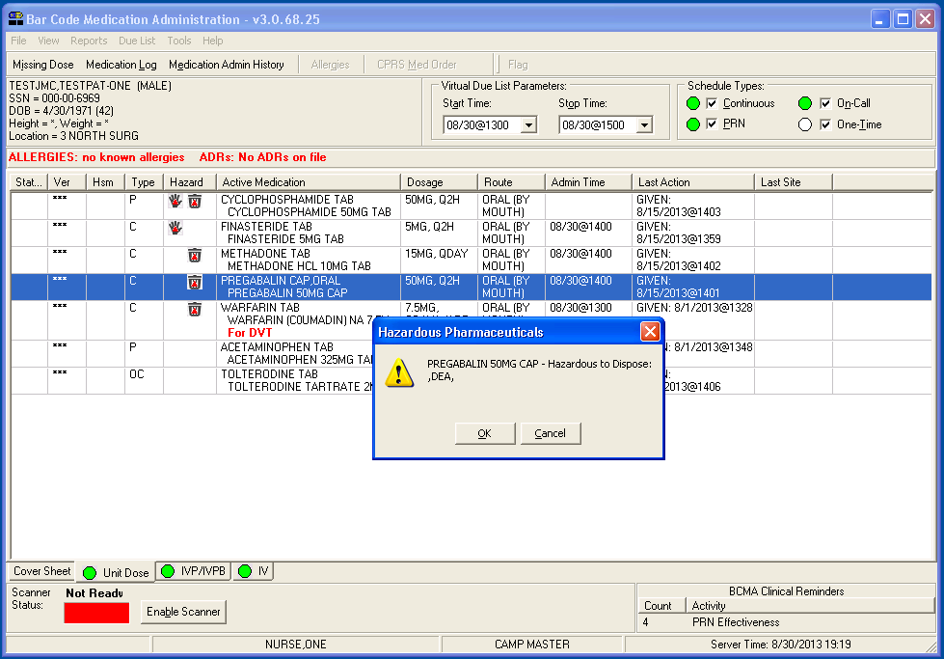

2.4.2.3. Administering a Multiple/Fractional Dose Order that is Hazardous to Dispose
For this multiple/fractional dose order, the Hazardous Pharmaceutical pop-up displays only once, at the start of the administration workflow. It is followed by other pop-ups that may be applicable to the administration (such as Nurse Verify and Medication Log early/late), then the Multiple/Fractional Dose dialog. When the second tablet is scanned, no duplicate hazard pop-up displays.
Example: Administering a Multiple/Fractional Dose order
that is Hazardous to Dispose
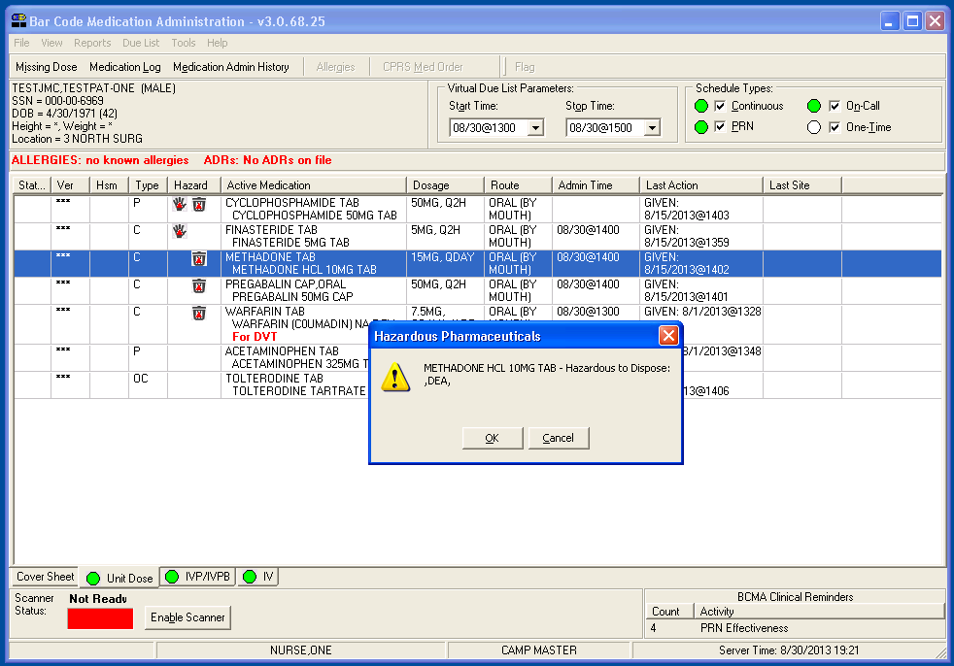

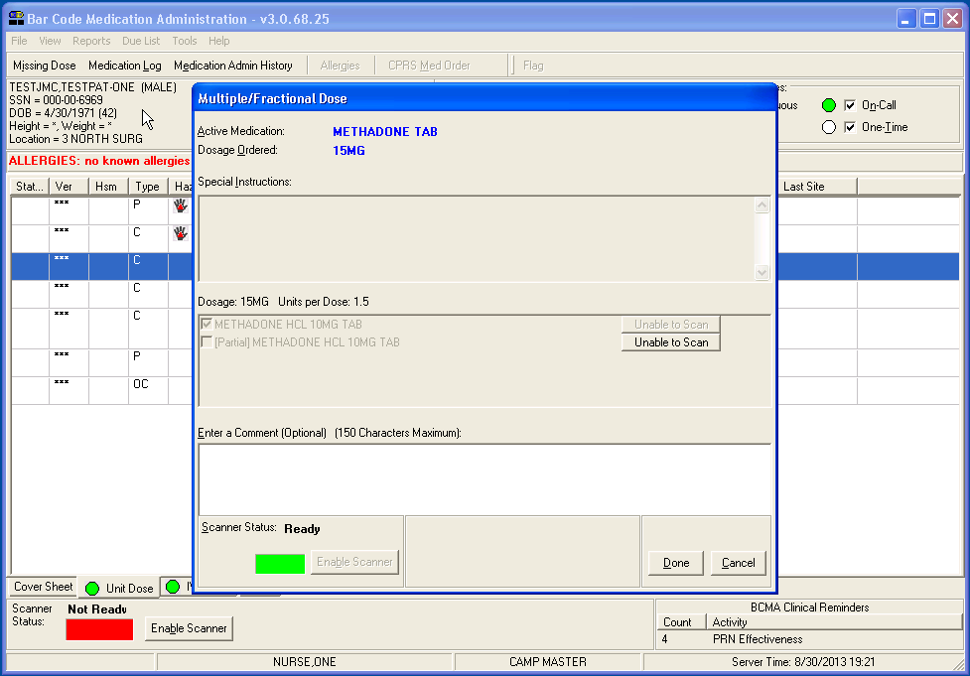

2.4.2.4. Administering a medication that is both Hazardous to Handle and Hazardous to Dispose
In this example, a single drug contains both Hazardous to Handle and Hazardous to Dispose attributes.
Example: Administering a Medication that is both Hazardous
to Handle and Hazardous to Dispose
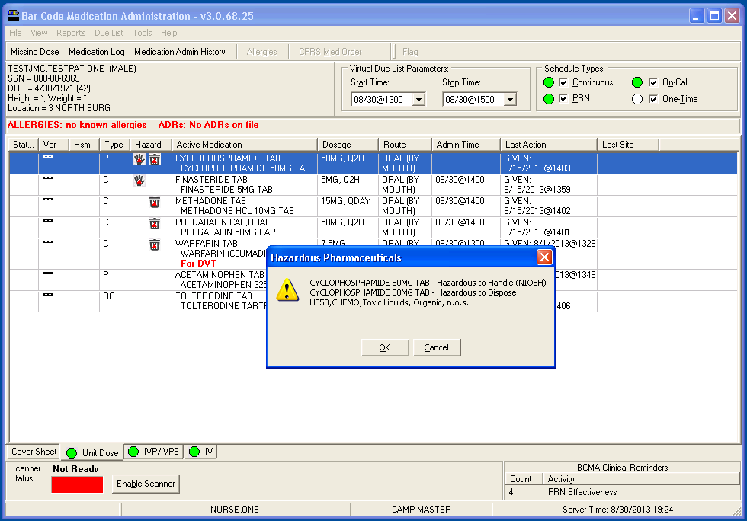

2.4.2.5. Administering an IV medication that has two different medications with Hazard attributes.
Example: Administering an IV Medication that has Two Different
Medications with Hazard Attributes
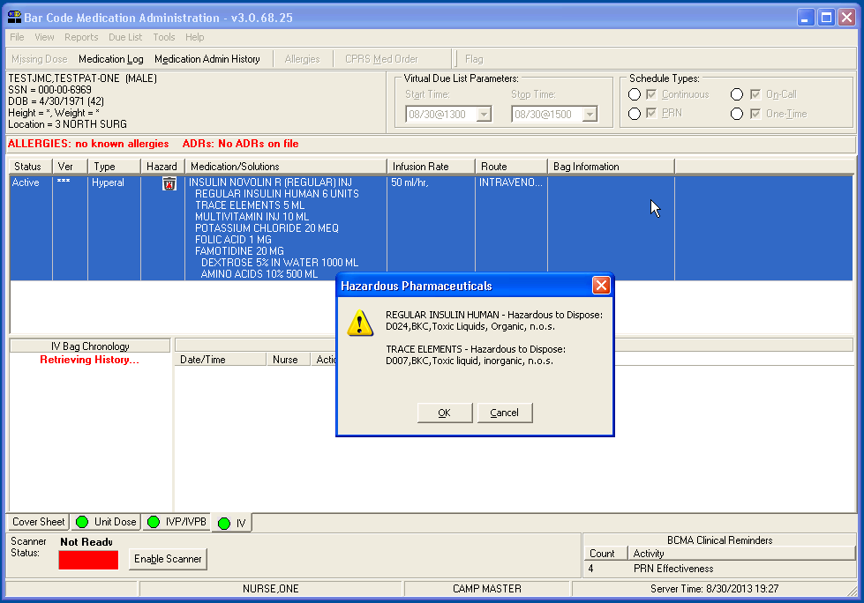

Maintenance of BCMA
Once the BCMA application is installed, there are maintenance operations which need to be performed initially or periodically.
The BCMA Parameters program is used to set site-specific parameters. The BCMA Managers User Manual details the parameters and their default values. Information Resource Management (IRM), Clinical Application Coordinator (CAC), Applications Package Coordinator (ADPAC), or BCMA Coordinator would perform this function.
The BCMA Technical Manual/Security Guide describes several functions including Implementation and Maintenance, Exported Options, Archiving and Purging, Security Features, and Internal and External Relations. These functions are normally performed by Information Resource Management (IRM). Security Features include assignment of role-based menu options and security keys to individuals as they are given access to the BCMA system.

Acronyms
Term | Definition
API | Application Programming Interface
BCMA | Bar Code Medication Administration
CDC | Centers for Disease Control and Prevention
COTS | Commercial-Off-The-Shelf
DIF | Drug Information Framework
EPA | Environmental Protection Agency
EPL | Enterprise Product List
FDB | First DataBank
FFP | Firm-Fixed-Price
FSS | Federal Supply Schedule
GFE | Government Furnished Equipment
HPES | Hewlett Packard Enterprise Services
IPT | Integrated Project Team
J2EE | Java 2 Enterprise Edition
JDK | Java Developer’s Kit
NDF | National Drug File
NIOSH | The National Institute of Occupational Safety and Health
OSEHRA | Open Source Electronic Health Record Agent
PM | Project Manager
PMBOK® | Project Management Body of Knowledge
PMI | Project Management Institute
PMP | Project Management Professional
PPS-N | Pharmacy Product System – National
PWS | Performance Work Statement
SME | Subject Matter Expert
SQA | Software Quality Assurance
TAC | Technical Assistance Contract
VAMC | VA Medical Center
VistA | Veterans Health Information Systems and Technology Architecture
VM | Virtual Machine

Database Administration
Database administration involves the design, security, administration, and problem resolution for all database functionality.

PPS-N
The Data base administrator will be required to load NIOSH and Stericycle and ensure the information is correctly reflected within PPS-N.
The Hazardous Pharmaceuticals Innovation project added the functionality to PPS-N to allow for the “Hazardous to Handle” and “Hazardous to Dispose” flags – currently recorded on the “Administration Data” tab of the VA product details as checkboxes– to be synchronized with the National Product File on Vista. Changes to these checkbox settings are saved to the Enterprise Product List (EPL) Database and are synchronized with Vista.

Additionally, the “Administration Data” tab for the VA product has been enhanced for the Hazardous Pharmaceuticals Innovation project to include 3 additional text fields – “Primary EPA Code,” “Waste Sort Code,” and “DOT Shipping Name.” These text fields reside as sub-fields that are activated when the “Hazardous to Dispose” checkbox is selected to mark a drug as Hazardous to Dispose.
See the below example for a view of the “Administration Data” tab after implementation of the Hazardous Pharmaceuticals Innovation project.
Example: Administration Data Tab
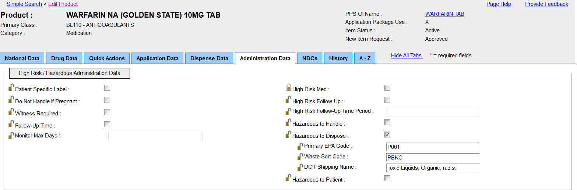
A PPS-N administrator with the appropriate “Supervisor,” “Manager,” or “Second Approver” roles (modeled as Vista Security keys – refer to the PPS-N User Manual) may access this screen with a simple or advanced search for a VA Product. Once the search result is displayed, the “Show All Tabs” link may be selected to access the “Administration Data” tab.
When the “Hazardous to Dispose” checkbox is unchecked, the 3 sub-fields become grayed out and disabled. They do retain the original values entered. See the example below. When submitted, the grayed out values still stored in the 3 sub-fields continue to be stored in the PPS_N EPL Database but are not synchronized with the Vista Product file. In other words, the Vista Product file will have null values stored against the 3 sub-fields in this scenario.

Example: Administration Data Tab
Hazardous to Dispose Checkbox Unchecked
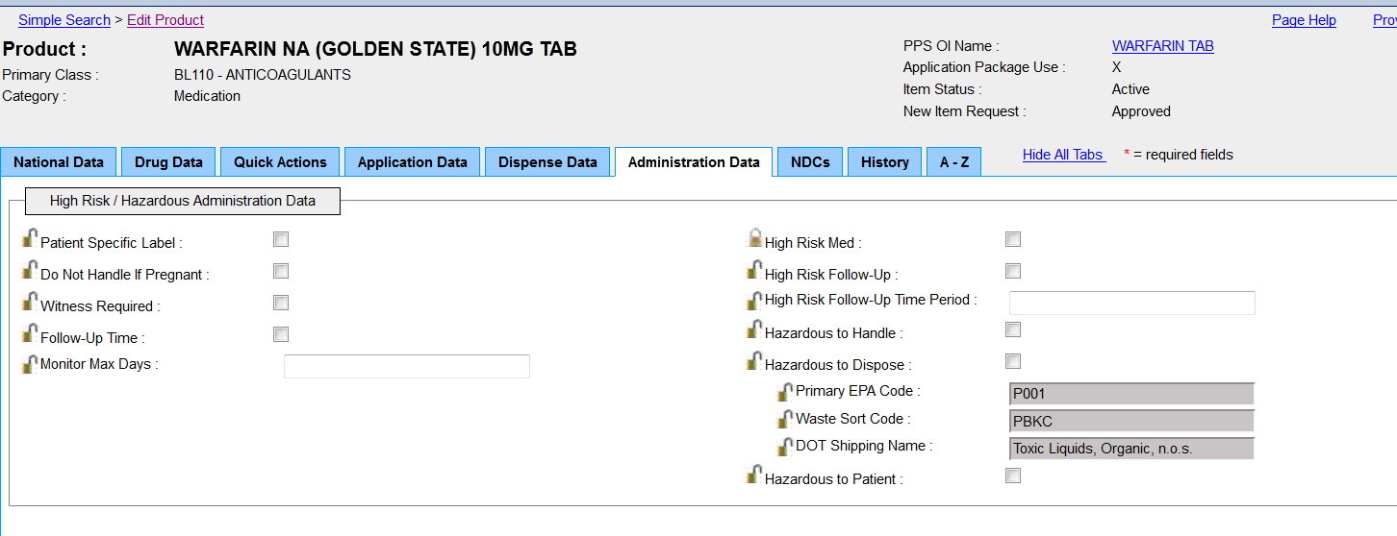

Note that the scope for the Hazardous Pharmaceutical Innovation project included the developoment of a loading process for the NIOSH and Stericycle data sources. Therefore, it is expected that most of the drugs classified as Hazardous to Handle by NIOSH and Hazardous to Dispose by Stericycle will have been marked as such in the PPS-N system.

There might still be a need to change these settings on a as-needed basis, for example, to handle ‘re-classifications’ that may occur in a NIOSH or Stericycle data source released in any year. These re-classifications are not currently handled by the load process.
As an example, alemtuzumab was a drug that was reclassified as not being hazardous to handle in the 2012 NIOSH drug list.

Example: Drugs Reclassified
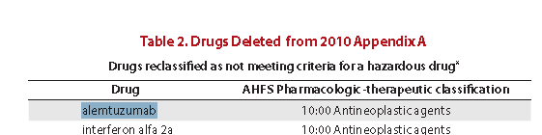

In PPS-N, alemtuzumab would have been marked as “Hazardous to Handle” – but would now need to be re-classified as not being hazardous to handle after the NIOSH 2012 list was released.
Before re-classification, all VA products that would have matched up during the NIOSH data load with the alemtuzumab product would have shown up with Administration Data settings as shown below.

Example: Administration Data Tab
Hazardous to Handle and Hazardous to Dispose Checked
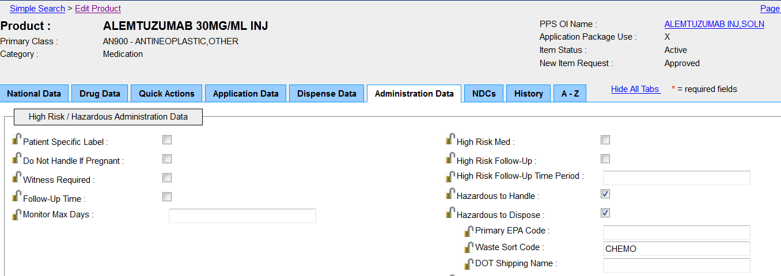

To reclassify this product, the “Hazardous to Handle” checkbox would have to be unchecked as shown below, and the “Submit” button would have to be clicked.

Example: Administration Data Tab
Hazardous to Handle Unchecked/Submit button Clicked
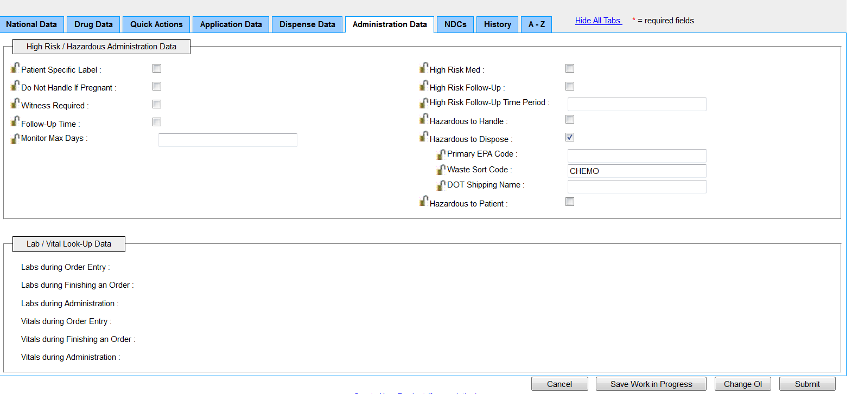

PPS-N will display a list of fields changed with the before and after values. For each field that has been changed, an optional “Reason” can be specified. Click on the “Accept Changes” button.

Example: PPS-N Fields Changed
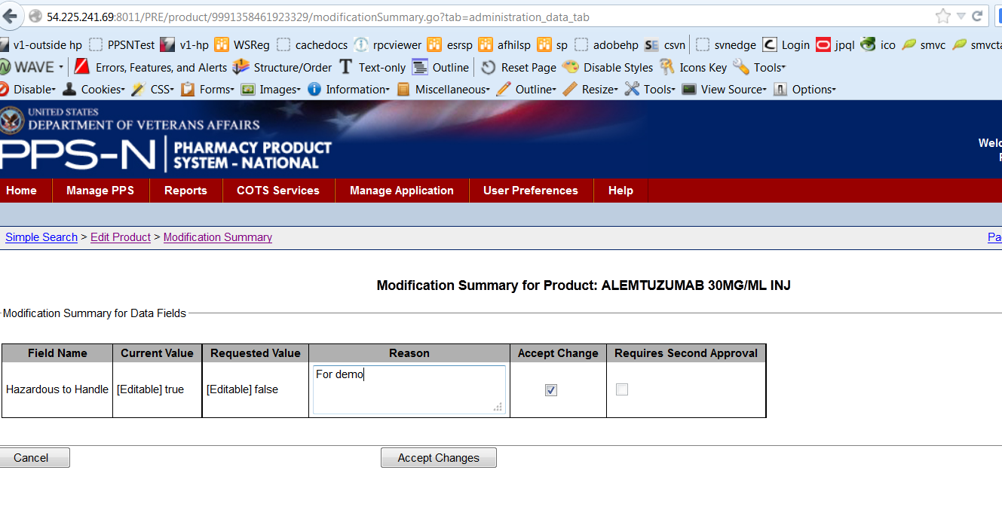

This will result in the changes being saved in the EPL Database and synchronized with Vista. If the Database save and Vista synchronization are successful, the following message will be generated from the PPS-N UI:
Example: PPS-N Modifications Confirmed
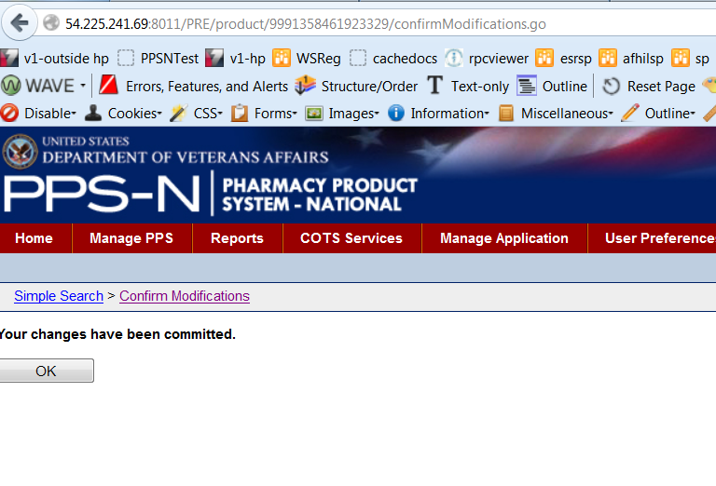

Troubleshooting
The Initial Data Load Summary Report and the Hazardous Drug Mismatch report in VistA aid the user in troubleshooting the application.

Initial Data Load Summary Report
The output produced by the initial data load of the HAZMAT data into PPS-N provides a detailed accounting and a summary of actions performed during the load. Each data type has a separate output file, but the format for each is similar. The header will identify the data type for the load. See example below.

Hazard to Dispose Excerpt from Initial Load Summary Report - Header:

EPA STERICYCLE Rx WASTE CHARACTERIZATION - Hazard to Dispose - Initial Load
Load Start: 08-12-2013 14:38:15

Hazard to Handle Excerpt from Initial Load Summary Report - Header:

NIOSH List of Hazardous Drugs - Hazard to HANDLE - Initial Load
Load Start: 08-12-2013 14:35:48

Following the header will be a detailed description of the actions performed for each record processed. The resulting action from each record processed will fall into one of several load status categories:

For Hazard to Dispose, these categories are:
- NDC Not Found, no Product match updates found
- NDC Not Found, Product match update applied
- NDC Found, Product Name match update applied

For Hazard to Handle, these categories are:
- Initial Load Successful by Synonym match
- Initial Load Successful by VA Product name match
- Product Not Found
- Initial Load Successful by Synonym/VA Product name match

For each category, information about the product lookup is provided for further review. An excerpt for each data type is provided below.

Hazard to Dispose Excerpt from Initial Load Summary Report - Detail:
Dispose Product -- NDC, PRODUCT, EPA, WASTE_CODE, DOT SHIPPING_NAME: 2036302, DARVOCET-N 100, , , DEA.

Product not found for NDC, PRODUCT, EPA, WASTE_CODE, DOT SHIPPING_NAME: 2036302, DARVOCET-N 100, , , DEA.
---alternative product match updated using synonym search (VA Product, Synonym): PROPOXYPHENE N 100MG/ACETAMINOPHEN 650MG TAB, DARVOCET-N 100
---additional product match updated using generic search (VA Product, Generic): PROPOXYPHENE N 100MG/ACETAMINOPHEN 650MG TAB, ACETAMINOPHEN/PROPOXYPHENE
---additional product match updated using generic search (VA Product, Generic): PROPOXYPHENE HCL 65MG/ACETAMINOPHEN 650MG TAB, ACETAMINOPHEN/PROPOXYPHENE
---additional product match updated using generic search (VA Product, Generic): PROPOXYPHENE HCL 65MG/ACETAMINOPHEN 325MG CAP, ACETAMINOPHEN/PROPOXYPHENE
---additional product match updated using generic search (VA Product, Generic): PROPOXYPHENE N 50MG/ACETAMINOPHEN 325MG TAB, ACETAMINOPHEN/PROPOXYPHENE
---additional product match updated using generic search (VA Product, Generic): PROPOXYPHENE N 100MG/ACETAMINOPHEN 650MG CAP, ACETAMINOPHEN/PROPOXYPHENE
---additional product match updated using generic search (VA Product, Generic): PROPOXYPHENE N 100MG/ACETAMINOPHEN 650MG TAB,UD, ACETAMINOPHEN/PROPOXYPHENE
---additional product match updated using generic search (VA Product, Generic): PROPOXYPHENE N 100MG/ACETAMINOPHEN 325MG TAB, ACETAMINOPHEN/PROPOXYPHENE
---additional product match updated using generic search (VA Product, Generic): PROPOXYPHENE N 100MG/ACETAMINOPHEN 500MG TAB, ACETAMINOPHEN/PROPOXYPHENE

Dispose Product -- NDC, PRODUCT, EPA, WASTE_CODE, DOT SHIPPING_NAME: 2416502, EVISTA, , , CHEMO.
---additional product match updated using synonym search (VA Product, Synonym): RALOXIFENE HCL 60MG TAB, EVISTA

Dispose Product -- NDC, PRODUCT, EPA, WASTE_CODE, DOT SHIPPING_NAME: 2721510, AMYTAL SOD, , , DEA.

Product not found for NDC, PRODUCT, EPA, WASTE_CODE, DOT SHIPPING_NAME: 2721510, AMYTAL SOD, , , DEA.
---no product name alternative name found using synonym search

Hazard to Handle Excerpt from Initial Load Summary Report - Detail:

Product not found with synonym lookup : Acitretin, .
---alternative product match for VA Product Name updated: ACITRETIN 10MG CAP
---alternative product match for VA Product Name updated: ACITRETIN 25MG CAP
---alternative product match for VA Product Name updated: ACITRETIN 17.5MG CAP
---alternative product match for VA Product Name updated: ACITRETIN 25MG CAP,30/VERSA FOAM KIT
---alternative product match for VA Product Name updated: ACITRETIN 10MG CAP,30/VERSA FOAM KIT

Product not found with synonym lookup : Bacillus Calmette-Guerin (BCG), AZATHIOPRINE.
---no alternative product name match found.

Product not found with synonym lookup : Bendamustine HCl, AZATHIOPRINE.
---alternative product match for VA Product Name updated: BENDAMUSTINE HCL 100MG/VIL INJ
---alternative product match for VA Product Name updated: BENDAMUSTINE HCL 25MG/VIL INJ

Product not found with synonym lookup : Plerixafor, PENTOSTATIN.
---alternative product match for VA Product Name updated: PLERIXAFOR 20MG/ML INJ

Product found for Synonym Lookup (input product_name, va product name, synonym_name):Podofilox, PODOFILOX 0.5% SOLN,TOP, PODOFILOX.
---alternative product match for VA Product Name updated: PODOFILOX 0.5% SOLN,TOP
---alternative product match for VA Product Name updated: PODOFILOX 0.5% GEL,TOP

Product found for Synonym Lookup (input product_name, va product name, synonym_name):Podophyllum resin, PODOPHYLLIN PWDR, PODOPHYLLUM RESIN.
---no additional alternative product name match found.

The report is concluded with a summary of all actions performed.

After each load has concluded and the Initial Load Summary reports have been distributed, anomalies may surface that need further investigation. These reports can be used to facilitate troubleshooting as they provide detailed accounting of the actions performed during the load. See the below example for each category type.

Hazard to Dispose Excerpt from Initial Load Summary Report - Footer:
EPA STERICYCLE Rx WASTE CHARACTERIZATION - Hazard to Dispose - Load Results Summary

Total STERICYCLE Input Count: 646.
Total PPSN NDC Lookup Match: 537.
Total PPSN VA Product Updated using NDC/GENERIC name lookup: 11276.
Total PPSN VA Product Updated using NDC/GENERIC/Synonym name lookup: 28020.
Total PPSN VA Product Updated using SYNONYM Match to STERICYCLE Name lookup: 269.
Total PPSN VA Product Updated using SYNONYM/GENERIC name lookup: 6951.
Total STERICYCLE Input Not Found in PPSN: 37.
Load End: 08-12-2013 17:56:44

Hazard to Handle Excerpt from Initial Load Summary Report - Footer:
NIOSH List of Hazardous Drugs - Hazard to HANDLE - Load Results Summary

Total NIOSH Input Count: 167.
Total PPSN Products Updated using Synonym Lookup: 226.
Total PPSN Products Updated using additional VA Product Name Lookup: 2913.
Total NIOSH Input Not Found in PPSN: 10.
Load End: 08-12-2013 14:36:20

Following is a description of the matching algorithms or logic used to identify records in the PPSNEPL database for update. Understanding this logic coupled with the detailed output will provide the tools needed to troubleshoot any actions performed or omitted during the load process.

Matching Algorithms
The following tables outline the matching algorithms used for loading Hazardous to Handle and Hazardous to Dispose drugs from the NIOSH and Stericycle data sources, respectively.
Example: Hazardous to Handle (H2H) - Matching Algorithm
for Drugs loaded from NIOSH PDF Input File
 | Step
Primary search | 1 | Search for drug Trade Name from NIOSH using a “contains” search on Synonym in the PPS_N EPL DB.
 | 2 | Set H2H flag for the Product(s) in result set.
Secondary search | 3 | Search for the same drug Trade Name from NIOSH using a “contains” search on VA Product Name in the PPS_N EPL DB.

Example: Hazardous to Dispose (H2D) - Matching Algorithms
for Drugs loaded from Stericycle Input File
(NDC Found)
 | Step
Primary search | 1 | Search for NDC code from the Stericycle input file using an NDC search in the PPS_N EPL DB.
 | 2 | If NDC is FOUND (exact match):  1) Set H2D flag for the Product  2) Populate corresponding H2D fields (Primary EPA Code, Waste Sort Code, DOT Shipping Name)  3) Identify the Generic Name for the product

Secondary search | 3 | Search for Generic Name using “contains” search on Generic Name in PPS_N EPL DB.
 | 4 | For all resulting Generic Name search matches:  1) Set H2D flag for the Product  2) Populate the corresponding H2D fields (Primary EPA Code, Waste Sort Code, DOT Shipping Name)  3) Identify the Synonym for each product found.
Tertiary search | 5 | Search for Synonym using “contains” search on Synonym in the PPS_N EPL DB for each product identified.
 | 6 | For all resulting Synonym search matches:  1) Set H2D flag for Product  2) Populate the corresponding H2D fields (Primary EPA Code, Waste Sort Code, DOT Shipping Name)
Example: Hazardous to Dispose (H2D) - Matching Algorithms
for Drugs loaded from Stericycle Input File
(NDC Not Found)
 | Step
Primary search | 1 | Search for NDC code from the Stericycle input file using an NDC search in the PPS_N EPL DB.
Secondary search | 2 | If NDC is NOT FOUND (no match):  Search for the drug’s Product name from the Stericycle input file using a “contains” search on Synonym in the PPS_N EPL DB.
 | 3 | For all resulting Synonym search matches:  1) Set H2D flag for Product  2) Populate corresponding H2D fields (Primary EPA Code, Waste Sort Code, DOT Shipping Name)  3) Identify the Generic Name for each product found
Tertiary search | 4 | Search for Generic Name using a “contains” search on Generic Name in the PPS_N EPL DB for each Generic Name identified.
 | 5 | For all resulting Generic Name search matches:  1) Set H2D flag for Product  2) Populate the corresponding H2D fields (Primary EPA Code, Waste Sort Code, DOT Shipping Name)

The following excerpts show examples of matching logic results documented in the individual Initial Database Load Summary Reports for Hazardous to Handle drugs loaded from the NIOSH PDF and Hazardous to Dispose drugs loaded from the Stericycle spreadsheet – as they are being matched to products in PPS-N, using matching algorithms listed above.
Example: Hazardous to Handle Output
from Initial Database Load Summary Report
Finasteride|1,3,5|92:08 5-alpha reductase inhibitors
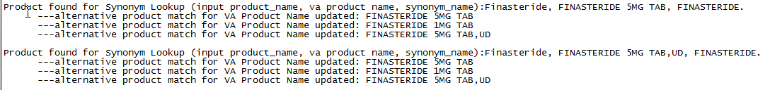

Ambrisentan|7|24:12.92 Vasodilating agents, miscellaneous
Amsacrine|3,5|Not in AHFS (antineoplastic agent)
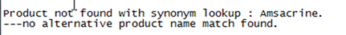

Example: Hazardous to Dispose example output
from Initial Database Load Summary Report
00071101968|LYRICA||DEA|
EXCERPT...
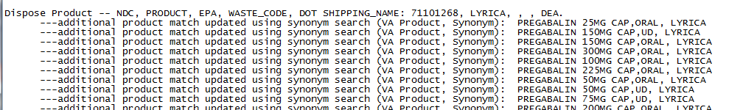

10019015868|MEPERIDINE HCL||DEA|
|NDC Not Found, Product match update applied.|7/16/2013 12:45:24.000000 PM
EXCERPT...
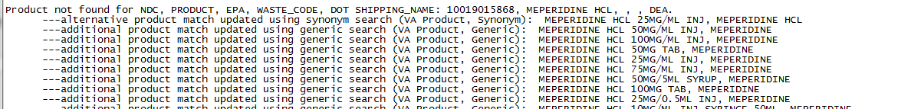

00482018410|DECONAMINE||DEA|

Hazardous Drug Mismatch Report
During the initial data load process, the system creates a Hazardous Drug Mismatch Report file in VistA logging instances when the VA PRODUCT NAME from the flat file of the PPS-N data does not match the VA PRODUCT NAME in the VA PRODUCT File (#50.68) in VistA. The system captures the VA PRODUCT IEN, the VA PRODUCT NAME from PPS-N, and the VA PROUDCT NAME from VistA in the Hazardous Drug Mismatch Report file. A new menu option in VistA (PSS DRUG HAZARD MISMATCH) prompts the user to enter the name of the Hazardous Drug Mismatch Report file, in order to display/print any data contained in the file.
If the PPS-N VA PRODCUT NAME for a given VA PRODUCT IEN does not match the VA PRODUCT NAME in Vista, an entry is made into the Hazardous Drug Mismatch Report. When the user runs the menu option, any entries display in the report. Sites must determine how they want to handle the discrepancy. If the discrepancy is because the VA PRODUCT is completely different, the best course of action is to inactivate both the entry in PPS-N and the entry in VistA, and create a new entry for both systems. If the discrepancy is simply a misspelled word, or an extra space or something in the VA PRODUCT NAME, the user can access VistA and update the VA PRODUCT NAME to make it consistent with PPS-N.

