**Perceptive Reach**

**Integrated Reach Database System**

**(IRDS)**

**Release Notes**



**Department of Veterans Affairs**

**February 2016**

Version 1.6

Revision History

| Date | Version | Description | Author |
| --- | --- | --- | --- |
| 2/18/2016 | 1.6 | Updated section ‘2.3.1. Attempt Prediction Chart Widget’ | Kaitlin Reskovac |
| 2/16/2016 | 1.5 | Updated title page to reflect correct version number  Updated items in sections “2.1. Defects Fixed Since Last Release” and “2.2. Remaining Defects” | Kaitlin Reskovac |
| 1/25/2016 | 1.4 | Updated section “Defects Fixed Since Last Release”  Removed sections “2.4.3. 508 Compliance – Resizing Widgets”, “2.4.4. 508 Compliance – Moving Widgets” and “2.1 Remaining Tasks” | Kaitlin Reskovac |
| 1/20/2016 | 1.3 | Updated sections “2.2 Defects Fixed Since Last Release” and “2.3 Remaining Defects”  Added sections “2.4.2. Data Entry Widget” and “2.4.4. 508 Compliance – Moving Widgets” | Kaitlin Reskovac |
| 12/15/2015 | 1.2 | Added sections “2.4 New Features”, “2.4.1 Facility Surveillance Widget”, and “2.4.2 508 Compliance – Resizing Widgets” | Kaitlin Reskovac |
| 12/10/2015 | 1.1 | December 2015 update and review for new features | Kaitlin Reskovac |
| 9/15/2015 | 1.0 | Final Review | Paul Bradley/Monica Mohler |
| 9/13/2015 | .3 | Additional issue added | Matthew Robinson |
| 9/11/2015 | .2 | Formatting update and peer review | Matthew Robinson / Kaitlin Reskovac |
| 9/11/2015 | .1 | Initial Draft | Jaya Rao |

**Table of Contents**

**1. Introduction 3**

**1.1 Purpose 3**

**1.2 Scope 3**

**1.3 Related Documents 3**

**1.4 Acronyms and Definitions 3**

**2. Technical Release Notes 4**

**2.1 Defects Fixed Since Last Release 4**

**2.2 Remaining Defects 7**

**2.3 New Features 8**

**2.3.1. Attempt Prediction Chart Widget 8**

**2.3.2. Data Entry Widget 9**

**Appendix A. Priority Definitions 10**

## 1. Introduction

The Perceptive Reach Integrated Reach Database System (IRDS) innovation project proposes to combine technology, outreach, and clinical support to realize a clinically based data-driven early intervention and treatment solution aimed at Veteran suicide prevention.

This release corresponds to the first release of the Perceptive Reach Integrated Reach Database System option year and associated functionalities.

## Purpose

The purpose of this document is to identify and describe the remaining bugs or known behaviors in the Perceptive Reach IRDS software. It summarizes the defects remaining as of December 2015. Reference the documents listed in Section 1.3 for a full summary of the features and functionality included in this release.

## Scope

The scope of this release includes the initial development effort of the Perceptive Reach option year, which spans Atlassian JIRA tickets from requirements and conceptualizing through 508 compliance remediation and release.

## Related Documents

The documentation for the Department of Veterans Affairs (VA) Perceptive Reach Integrated Reach Database System includes:

* **Perceptive Reach Installation Guide**: Provides detailed instructions for setting up, installing, and configuring Perceptive Reach on VA servers. Its intended audience includes server administrators and AngularJS application developers.
* **Perceptive Reach System Design Document**: Contains detailed information on the design considerations as well as architecture for VA Perceptive Reach and related applications.
* **Perceptive Reach Developer Guide**: Contains detailed information about workstation setup, authentication, continuous integration, JIRA, Structured Query Language (SQL) Server, and code base details.
* **Perceptive Reach User Manual**: Describes all end user-facing features of the application and underlying functionality.
* **Perceptive Reach Release Notes** (this document):Contains detailed information about the scope of this release and remaining defects slated for resolution in the next release.

## **Acronyms and Definitions**

**Table 1: Acronyms and Definitions**

|  |  |
| --- | --- |
| Acronym | Description |
| CDW | Corporate Data Warehouse |
| EUT | End User Testing |
| IRDS | Integrated Reach Database System |
| SPC | Suicide Prevention Coordinator |
| SQL | Structured Query Language |
| VA | Department of Veterans Affairs |
| VAMC | VA Medical Center |
| VHA | Veterans Health Administration |
| VistA | Veterans Health Information Systems and Technology Architecture |

## 2. Technical Release Notes

At the close of the Perceptive Reach IRDS software development, select tasks were left for the next release. While there were no defects considered “critical” to functioning of the system left at the close of development, defects discovered after the close of the code freeze during testing or those considered “non-critical” are documented below as known defects.

## 2.1 Defects Fixed Since Last Release

This table is updated to describe defects resolved as part of the release.

**Table 2: Defects Fixed**

| **Key** | **Summary** | **Description** |
| --- | --- | --- |
| PR-3099 | Appointment Type Does Not Appear in Appointment Widget | Previously, the appointment type was not displayed in the appointment widget.  The appointment type now appears in the widget. It will also indicate the reason for the appointment. For example, the widget will display if the Veteran’s appointment is related to: primary care, psychological care, surgery, specialty care, etc. |
| PR-3086 | Unable to sort the Outreach Status column on the Patient Roster by VAMC widget | Previously, the user was unable to sort the "Outreach Status" column on the Patient Roster by VAMC widget.  The “Outreach Status” column in this widget can now be sorted by selecting the “Outreach Status” title in the Patient Roster by VAMC widget. |
| PR-3318 | Outreach Status Null Value | Previously when the outreach status field loaded, statuses with no selections would load as “null” and an error was thrown to the background. This error prevented the “Outreach Status” column from sorting correctly.  Now, outreach statuses with no selection do not appear as a “null” value and the “Outreach Status” column can sort correctly. |
| PR-3010 | Refreshing Page deletes Recent Changes made | Previously when the user added new widgets to a dashboard, saved their changes, and then refreshed the page, the recently saved changes were deleted.  Now when the user saves their dashboard changes, these changes remain after the page is refreshed. |
| PR-3333 | 508 Compliance- Widget Resize: Handle keyboard arrow events for widget resizing. | Previously, the user was not able to resize widgets in the Dashboard using only their keyboard.  Users now have the ability to resize all widgets solely by using the tab and arrow keys on the keyboard. |
| PR-3337 | 508 Compliance- Moving Widgets - Use keyboard to move widgets. | Previously, the user was not able to move widgets in the Dashboard using only their keyboard.  Users now have the ability to move all widgets solely by using the tab and other keys on the keyboard. |
| PR-2176 | Resizing table widgets creates unused white space in the widget area. | Previously, the data inside a widget would not expand or resize when a user resized the height and/or width of a widget. This resulted in unused white space in the widget area.  Now, when a user resizes a widget, the data inside the widget also resizes and expands. This resizing minimizes unused white space in the widget area. |
| PR-3461 | Column Content and Header Alignment | Previously when a user expanded the width of a widget, the column headers spread out faster than the data in the column itself, causing the headers and the data to appear misaligned visually.  Now the column headers are aligned to the column content when widgets are resized. |
| PR-3002 | Adding the Same Widget Multiple Times | Users were previously able to add multiple instances of the same widget, which could be confusing from a user experience perspective.  This functionality has now been removed and the user is not able to add the same widget multiple times to the Dashboard. |
| PR-3531 | Add VAMC Name (Instead of Number) | Currently, the Dashboard shows the VAMC "number" when a user puts a VAMC into view, instead of the VAMC name.   The VAMC name and number now display on the IRDS Dashboard when a VAMC is selected. This change has been applied to all relevant Dashboard views (Individual view and Surveillance view). |
| PR-3530 | No "X" In the Top Right of Widgets | Currently, widgets do not display an "X" in the upper right corner of each widget.  The “X” icons are now displayed in the upper right corner of each widget. |
| PR-3095 | The user is unable to select the VAMC and VISN under the Surveillance View on the VISN roster as well as Facility roster widget with tab key (IE11). | Previously, the user was unable to select a VAMC and VISN in the Surveillance view using the tab key on the keyboard.  This functionality is now available to users. Users can select a VAMC or VISN in the Surveillance view using the tab key. |
| PR-3092 | On Initial Load, the "Outreach Status" column loads data for the entire data set and not just the SPC user | Previously when a user logged in to the system, the Outreach Status widget would display data for the entire dataset, not just for the facility the user was assigned to.  Now when a user logs in to the system, the Outreach Status widget only displays data for the facility that user is assigned to. |

## 2.2 Remaining Defects

**Table 3: Remaining Defects**

| **Key** | **Summary** | **Description** | **Priority** |
| --- | --- | --- | --- |
| PR-3049 | Focused fields have a blue box around them. | When a user clicks on a container on certain pages, a blue box appears around it. Only specific fields need to have blue boxes around them. | Trivial |
| PR-2973 | Clinical Decision Support Widget shows TOP and MIDDLE info for two seconds and then only shows MIDDLE info. | The Clinical Decision Support widget at first shows both TOP and MIDDLE info for 1-2 seconds before showing only MIDDLE info. | Trivial |
| PR-3068 | Surveillance View Bug Remediation | When the user selects a VISN/Facility in the Surveillance view, then switches to the Facility View their selections in the Surveillance view are not saved and the Facility/VISN rosters do not properly display the user’s selections. | Major |
| PR-3225 | Blue Widget Titles are not readable | When a widget is resized, the blue widget titles do not fit in the allotted space and the title is cut off, making it unreadable. | Minor |
| PR-2185 | Widget title repeats in a header style text and also a bold/bubble text | The widget titles on the Dashboard repeat in a header style text and also a bold/bubble text. | Trivial |

## 2.3 New Features

The tables and content below describe new features incorporated in this release.

### 2.3.1. Attempt Prediction Chart Widget

The Attempt Prediction Chart widget displayed below has been added to the IRDS dashboard since the last release. The Attempt Prediction Chart widget is located on the Surveillance view and is only available to users with elevated access permissions. This widget introduces a reporting and analytics component to the IRDS Dashboard allowing users to view data over a period of time and discern patient-related trends. The Attempt Prediction Chart widget displays monthly patient attempt data for a selected facility in line graph format and provides users with longitudinal trends of monthly reportable incidents for the previous 17 months. The user has the ability to hover their mouse over the dots on the line graph to view actual data along with upper limit, lower limit, and the line of best fit metrics.

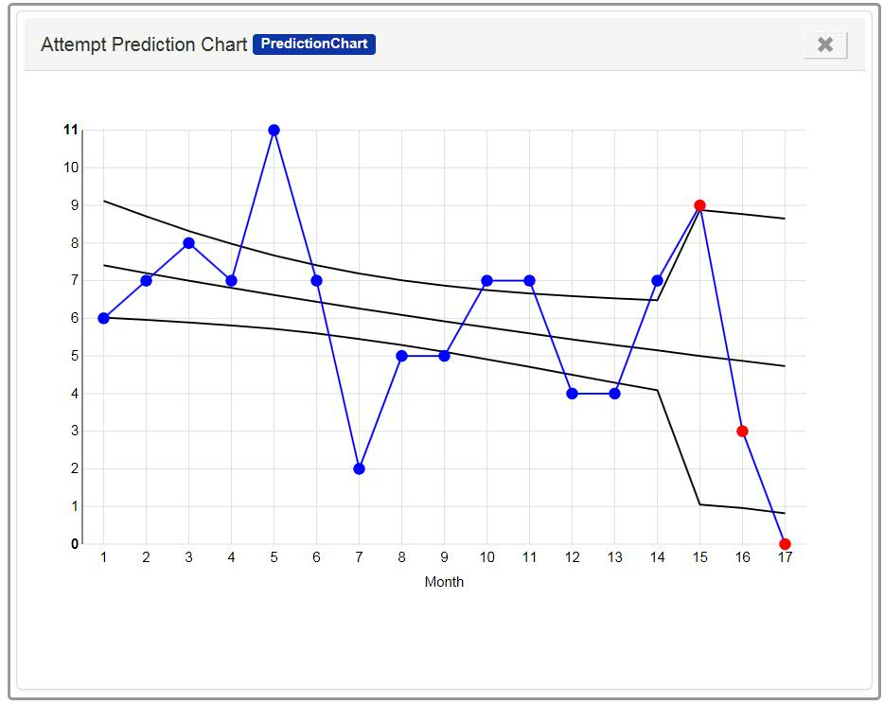

**Figure 1: Attempt Prediction Chart Widget**

### 2.3.2. Data Entry Widget

The Data Entry widget displayed below has been added to the IRDS dashboard since the last release. The Data Entry widget is located on the Individual view and is available to all users. This widget introduces an informal reporting component to the IRDS Dashboard allowing users to enter and save patient-related information in the IRDS Database. The Data Entry widget displays information entered by the user and official information from the systems of record. System of record data in this widget is updated on a monthly basis.

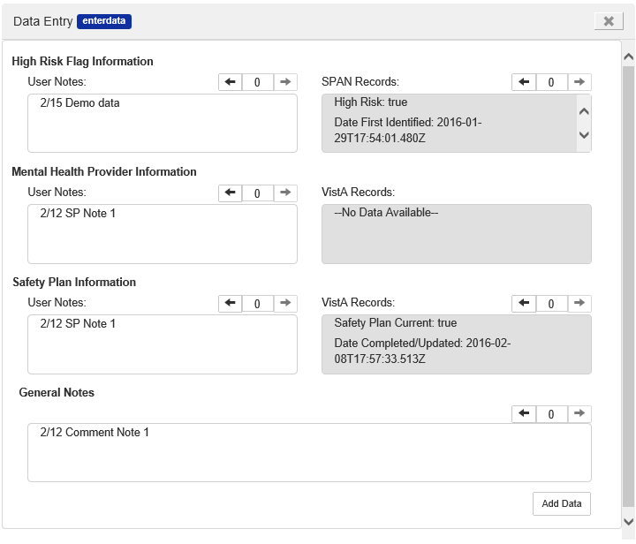

**Figure 2: Data Entry Widget**

## Appendix A. Priority Definitions

The table below defines the criteria used in the defect descriptions in this document.

**Table 4: Priority Definitions**

|  |  |
| --- | --- |
| **Priority Level** | **Description** |
| Blocker | Critical functionality not implemented correctly; user cannot meet the business objectives; a work-around (temporary fix) is ***NOT*** available |
| Critical | Errors found which result in the user not being able to meet the business objectives; a work-around (temporary fix) is available |
| Major | This is a moderate defect, which can cause some deviations from the requirements; deviation is not serious and does not require a work around |
| Minor | Minor defect, which causes the user some inconvenience but does not alter functionality (e.g. spelling error, user interface [UI] issue, aesthetics, or other minor issues) |
| Trivial | Cosmetic problem like misspelled words or misaligned text |