Perceptive Reach

Integrated Reach Database System

(IRDS)

Dashboard Design Document



Department of Veterans Affairs

**December 2014**

Version .01

Revision History

| Date | Version | Description | Author |
| --- | --- | --- | --- |
| 11/18/2014 | .01 | Initial Version | Matthew Robinson and Radina Ivanova |
|  |  |  |  |

Artifact Rationale

The Dashboard Design Document is a dual-use document that provides the conceptual design as well as the as-built design of the IRDS dashboard. This document will be updated as the product is built, to reflect the as-built product. Wireframes are to be considered “proof of concept” drawings that may differ from the finalized design in the application.

Table of Contents

1. About this document 1

2. Introduction 1

2.1. Purpose of the Dashboard Design Document 1

2.2. Identification 1

2.3. Scope 2

2.4. Constraining Policies, Directives and Procedures 2

2.5. User Characteristics 2

2.6. Relationship to Other Documents and Plans 3

2.7. Acronyms and Abbreviations 3

3. Background 4

3.1. Overview of the Business Benefits 4

3.2. Assumptions and Constraints 5

3.2.1. Design Assumptions 5

3.2.2. Design Constraints 5

3.2.3. Design Trade-offs 6

4. Conceptual Dashboard Design 6

4.1. Navigation Hierarchy 6

4.1.1. Individual Veteran View 7

4.1.2. Facility Service Area View 8

4.1.3. State / VISN View 9

4.1.4. Regional View 10

4.1.5. National View 10

4.1.6. Reporting and Research Interface 11

Attachment A – Approval Signatures 12

# About this document

This document is a “work in progress.” The dashboard will be designed through a series of mockups and iterative development sprint cycles in collaboration with VA stakeholders and users. The document will be populated with content as the design evolves with each sprint, including all potential data options, configurability rules and options. The early versions of the document will focus on the conceptual dashboard design, key business requirements, and the primary user stories related to the design of the dashboard. The detailed dashboard design will follow.

# Introduction

VA is seeking to expand suicide prevention to include upstream approaches designed to reduce initiation or escalation of a risk factor. Upstream suicide interventions target individuals or groups who exhibit biological, psychological, or social risk factors that are more prominent among high-risk groups than among the larger population. Understanding the unique needs of our nation’s Veterans and the military culture as it relates to stigma and mental health is important for early intervention. The goal of the Integrated Reach Database System (IRDS) innovation is to promote the general health of the Veteran population and effectively intervene in issues before they escalate in crisis.

The IRDS innovation will serve to bolster the three major components of VHA’s Strategic Plan for Suicide Prevention: surveillance, risk and protective factors, and prevention interventions. The IRDS innovation will target antecedent events specific to Veteran populations prior to the onset of risk to mitigate the development of risk.

The “dashboard” component is a key feature of the IRDS solution. Within the dashboard, end users such as frontline outreach and intervention specialists, VA leadership, clinicians, and other staff with an interest in suicide outreach and intervention will be able to see data visualizations related to individual at-risk Veterans in addition to groups of Veterans within the overall Veteran population. The solution will provide visual screen elements that will provide quick, intuitive “at a glance” type information, in addition to visual screen elements that will allow users to “deep dive” into the data and create more customized views of the data depending on user preference.

## Purpose of the Dashboard Design Document

The purpose of this document is to describe how the proposed dashboard will be designed. The Dashboard Design Document translates requirement specifications into a document from which the developers can create the actual system. A related document, the System Design Document (SDD), translates requirement specifications into a document from which the developers can create the actual system from a technical and architectural perspective.

## Identification

The following document describes the dashboard design for the IRDS Innovation as developed within the VA Center for Innovations (VACI).

## Scope

The tables below describe what features of the system are considered within and outside the scope of the dashboard design and Dashboard Design Document.

Table 1: Scope Inclusions

| Includes |
| --- |
| The visual and functional design of a surveillance dashboard consisting of custom visualization tools that depict the results of analyses conducted by the IRDS, including data trends, events and performance metrics, Veteran demographics, Veteran medical history, etc. |
| Data visualizations to include Charts, Tables, Maps, Animations, Other graphics and visual technology. |
| Dashboard configurability, providing different user groups distinct views that meet their business needs. |
| Support for interactive viewing and formatting. |
| Consideration of user interface (UI) and user experience (UX) matters that will enable the dashboard to present data in a manner that is accessible to a broad range of users |

Table 2: Scope Exclusion

| Excludes |
| --- |
| Detailed end-user research (included in the User Research Report deliverable) |
| Detailed descriptions of the IRDS architecture or technical capabilities (included in the System Design Document deliverable) |
| Detailed functional requirements or user stories (included in the Requirements Traceability Matrix and Jira) |
| Functionality related to the case management or clinical care of high risk Veterans |

## Constraining Policies, Directives and Procedures

## User Characteristics

There are five user interaction scenarios envisioned for the IRDS: upstream at-risk notification, surveillance, research, reporting, and system sustainment.

1. Surveillance – The primary users in this model shall include VA leadership, VA Center of Excellence for Suicide Prevention staff, VA Mental Health leaders, and VA Suicide Prevention Coordinators. The surveillance dashboard will be available through a standard web browser that will be updated in near real-time (minimum weekly) with results produced from the continuous monitoring and processing of linked data sources.
2. Research – The users in this usage model are researchers and statisticians looking to leverage the tools and data available through Reach data analytics platform. The solution will provide a framework for these users to utilize the interfaces provided by the assembled tools to perform required research functions.
3. Reporting – This model shall include both direct and indirect users. The direct users are the individuals required to assemble reports. The indirect users are the consumers or target audience of the reports. The direct users will utilize the interfaces provided by the assembled tools to assemble reports. The report generation process shall be automated.
4. Sustainment - The Contractor shall provide the capability for users to edit and add to the IRDS Risk Stratification Model, permit creation to new models and mapping to interfaces.

User interaction with the dashboard is broadly described in the “surveillance” interaction scenario above, however it is conceivable that users will access the dashboard in parallel or in conjunction with other interaction scenarios during the course of a regular work day. More detailed user research and characteristics are included in the User Research Report.

## Relationship to Other Documents and Plans

The following IRDS documents may be referenced in tandem with the information recorded here:

* IRDS Requirements Specification Document (RSD)
* IRDS System Design Document (SDD)
* IRDS Requirements Traceability Matrix (RTM)
* IRDS User Research Report

## Acronyms and Abbreviations

Table 1: Acronyms and Abbreviations

| Acronym | Term |
| --- | --- |
| GUI | Graphical User Interface |
| HHS | U.S. Department of Health and Human Services |
| ICD | International Statistical Classification of Diseases and Related Health Problems |
| IPT | Integrated Project Team |
| IRDS | Integrated Reach Database System |
| IT | Information Technology |
| RSD | Requirements Specification Document |
| RTM | Requirements Traceability Matrix |
| SDD | System Design Document |
| SPC | Suicide Prevention Coordinator |
| TRM | Technical Reference Model |
| UI | User Interface |
| UX | User Experience |
| VA | Department of Veterans Affairs |
| VACI | VA Center for Innovation |
| VHA | Veterans Health Administration |
| VISN | Veteran Service Area Network |

# Background

## Overview of the Business Benefits

Surveillance, identification of risk and protective factors, and interventions are three components of a holistic suicide prevention program. IRDS aims to implement and test this approach using data, technology and clinical expertise to establish a systematic approach, automating the data collection, data analysis/predictive modelling, identification of risk factors and Veterans at risk, notification, reporting, and continuous monitoring processes.

The IRDS concept will address two major elements of suicide intervention; information and time.

* Can information on Veterans both under and outside VHA care be aggregated to produce a useful prediction of suicide risk?
* Can effective interventions be developed and deployed in time to avoid problems from escalating into crises?

We contend that the proposed model will realize a real-time surveillance and intervention solution that will answer both questions in the affirmative.

|  |
| --- |
|  |
| **Source:** CRS analysis of major components of U.S. Department of Health and Human Services (HHS) Office of the Surgeon General and National Action Alliance for Suicide Prevention, 2012 National Strategy for Suicide Prevention: Goals and Objectives for Action, Washington DC: HHS, September 2012 |

Figure 1: Surveillance Process Model

|  |
| --- |
| Impact |
| * The IRDS innovation will dramatically change the manner in which VA plans, funds, manages, and assesses suicide intervention and prevention programs. * IRDS will provide a cost effective framework from which health data can be studied, hypotheses tested, and where proven analytic methods can be automated, including the automation of report and notification messages. * As risk factors change over time, and as new risk factors are identified, new analytical models and new data sources can be incorporated into IRDS and the method of identification, notification, and intervention can be re-applied. * Through near real time analysis, and a surveillance dashboard, IRDS will allow VA to respond to regional and temporal events and trends with more agility and precision, while also providing a means to monitor and measure the results from specific initiatives. * Likewise, the precision provided in the system will reduce program expenditures as more focused funding can be applied, and ineffective programs can be assessed and terminated. |
| Benefits |
| * The most significant benefit of the IRDS innovation will be the reduction in attempted and completed suicides through early identification, effective intervention, and early treatment. * Due to the early identification and treatment for a broad range of clinical, socioeconomic, and environmental conditions, outreach and intervention programs leveraging IRDS will promote wellness and are therefore likely to decrease the probability of more serious health conditions in the future. * The IRDS solution is aimed at identifying individuals and populations with characteristics that may, if left untreated, increase the probability of future suicidal crises. That is, we are looking for early warning signs, and the application of preventative care that will reduce suffering, suicides and treatment expenses. * The organization and visualization of near real time information will simplify VA business processes, minimizing or eliminating the costs of producing static reports, and eliminating the costs of actions taken on stale data. * Program funding and resources can be optimized and tailored to specific regional needs, preventing waste. * The IRDS innovation will highlight the need for policies and governance surrounding the use of public and non-public data to manage both population and individual health outcomes. |

Figure 2: System Benefits

## Assumptions and Constraints

### Design Assumptions

No design assumptions have been identified at this time. In accordance with industry standard Agile best practices, the design team will present the design of the dashboard to project stakeholders regularly to garner feedback and better-inform future iterations of the design. As assumptions are identified this section will be updated.

### Design Constraints

* System designers have attempted to utilize open source tools wherever possible. This design of the user interface / front end presentation layer of the system, testing tools, and statistical / analytics tools.
* System designers used VA tools approved for use in the VA Technical Reference Model (TRM) or have requested a waiver for any tools not included in the TRM
* The design team will comply with VA-recommend UI/UX best practices as defined in the project’s RSD

### Design Trade-offs

No design trade-offs have been identified at this time.

# Conceptual Dashboard Design

## Navigation Hierarchy

The diagram below describes the navigational hierarchy of the proposed dashboard solution. Users will access the dashboard through a standard log-in procedure. Once the application has verified a user’s credentials, he or she will be presented with their default “home screen” view. For example, a Suicide Prevention Coordinator will most likely want to see the Facility Service Area View first, to see the latest data that is directly relevant to his or her work day. An executive level user may want to start with the National View. This setting will be configurable by users.

Users will have the ability to navigate “up” and “down” through the views. The views at the lowest level of the diagram have the lowest level of data aggregation; that is, the Individual Veteran View will only display data relevant to the specific Veteran selected, but as a user moves up the navigational hierarchy, data aggregation will increase to show data relevant to larger and larger geographical boundaries.



Figure 3: Navigation Hierarchy

Note that State and Veteran Service Area Network (VISN) are depicted at the same level in the diagram. This is because some VISNs overlap state border lines, while some states, such as Texas, encompass multiple VISNs. Therefore, there is no logical hierarchy between the State and VISN level within the navigation. The design team is currently exploring options for how to best lead users through navigation hierarchy at this level and will finalize the design in a future sprint.

### Individual Veteran View

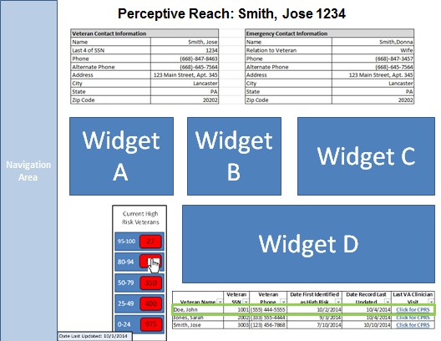

Figure 4: Individual Veteran View

The Individual Veteran View allows an outreach provider, such as a Suicide Prevention Coordinator (SPC), the ability to view details associated with an individual Veteran’s risk profile. The top third of the screen will display the Veteran’s contact information in addition to his or her emergency contact information. Displaying this information clearly and prominently is a key feature, as an outreach provider will want to frequently access Veteran contact information (especially phone number) during the course of their regular work.

The middle third will feature details related to the Veterans risk profile. **Figure 4** shows the ability for users to view a Veteran’s risk profile based on 6 aggregated “metrics” based on data in the IRDS. Users are then able to view the Veteran’s summary risk profile or “snapshot” graphically (in this case as a radar chart). The Graphical User Interface (GUI) will also allow for users to “drill down” into the snapshot to view a more detailed view of a Veteran’s associated data to potentially include

* Demographics
  + Age
  + Gender
  + Ethnicity
* Geography
  + Veteran Street Address
  + City
  + State
  + Zip Code
  + Local Medical Center Service Area
  + Veteran Service Area Network (VISN)
  + Urban vs. Rural location
* Suicide Risk and Protective Factors
  + Medical History
  + Military Service History
  + Financial Factors (employment status, income, etc.)
  + Social and Familial Factors (education level, dependents, marriage status, etc.)

The bottom third of the GUI will include screen elements to allow users to either view a different Veteran in their facility service area, or view a list or “roster” of Veterans stratified by risk level within the risk model’s results. The user will then be able to navigate to view a different individual Veteran in the roster or navigate up to the Facility Service Area View.

### Facility Service Area View

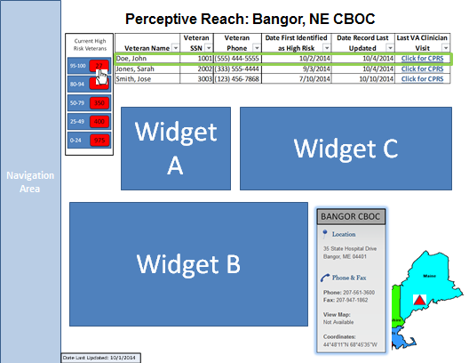

**Figure 5: Facility Service Area View**

The Facility Service Area View allows an outreach provider, such as an SPC, the ability to view summary data of Veterans who are within the catchment of a specific facility. The bottom third of the screen, shown in **Figure 5** will include screen elements to allow users to either view a different Veteran in their facility service area, or view a list or “roster” of Veterans stratified by risk level within the risk model’s results. Displaying this information clearly and prominently is a key feature, as an outreach provider will want to frequently view the details for an individual Veteran in their Facilities Service Area. Users will also be able to navigate up a level to the State / VISN View.

The rest of the GUI in **Figure 5** features details related to the current Veterans with the facility’s service area. Widgets could include (as customized by the user) a summary of prominent Veteran risk factors, a cause of death chart for completed suicides (based on ICD-10 codes associated with a Veterans death in the underlying database), and suicide rate by month, quarter, or other time constraint depicted as a line chart. The facility’s contact information will also be presented in the view. All of these widgets have the ability to be moved around the screen and organized by the user.

### State / VISN View

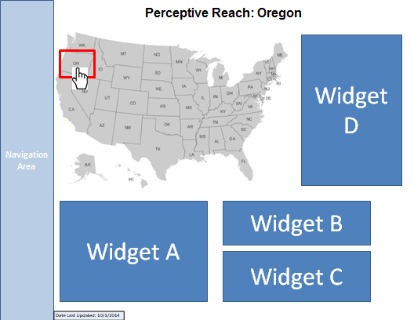

**Figure 6: State/VISN View**

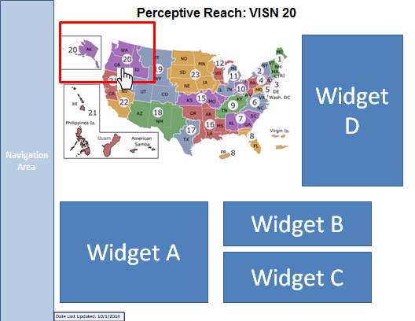

Figure 7: VISN 20

The State/VISN View allows an outreach provider, such as an SPC, the ability to view visualizations of data related to Veteran suicide within a specific VISN or state. From this screen, users will be able to customize their screens by selecting and rearranging widgets in the same manner as described in the Facility Service Area View. Widgets could include (as customized by the user) a summary of prominent veteran risk factors, a cause of death chart for completed suicides, and suicide rate by month, quarter, or other time constraint depicted as a line chart.

Both the State and VISN views will offer similar if not identical functionality, but data will be aggregated across all of the zip codes of a state or zip codes of a VISN, respectively.

### Regional View

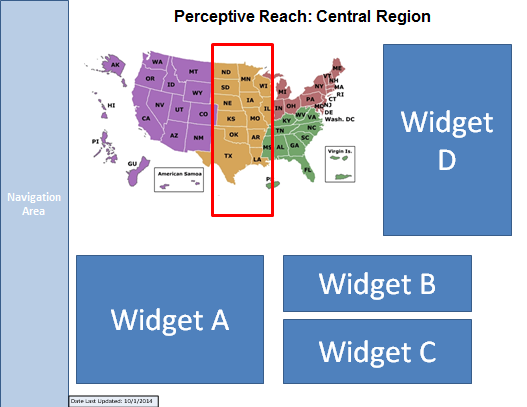

The Regional View allows an outreach provider, such as an SPC, the ability to view visualizations of data related to Veteran suicide within one of VA’s four regions across the country (Western, Eastern, Southern, Central). Users will be able to navigate “up” to the National View or “down” to the State / VISN view. Otherwise, functionality and widget-selection will be similar to that at the State / VISN view, only with data aggregated to regional levels.

### National View

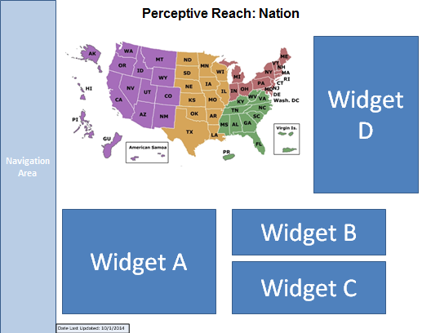

Figure 8: National View

The State/VISN View allows an outreach provider, such as an SPC, the ability to view visualizations of data related to Veteran suicide within one of VA’s four regions across the country (Western, Eastern, Southern, Central). Users will be able to navigate “up” to the National View or “down” to the State / VISN view. Otherwise, functionality and widget-selection will be similar to that at the State / VISN view, only with data aggregated to regional levels.

## Widget Design

A primary feature of the dashboard design is the ability for users to choose what features they want to see on the screen as “widgets,” while also being able to change the widgets’ size and position on the screen. The following widgets are either in development or under consideration for development in future sprints.

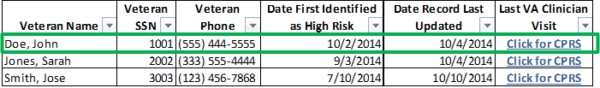

Figure 9: Veteran Roster

The Veteran roster allows a user to view a list of Veterans within a specific area (service area, state, etc.). It includes a visual indicator to highlight Veterans who have are new to the roster – in this case, a green box. The last column represents a tentative user story that allows the user to click a direct hyperlink into the Veteran’s electronic health record. Another future phase story may even include the ability to pull information directly from the health record into the dashboard for a specific Veteran.

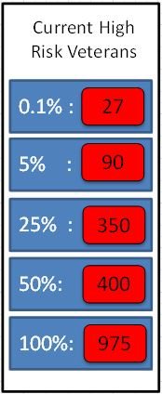

Figure 10: Stratification Widget

The stratification widget allows a user to see how many Veterans within a particular area (state, VISN, etc.) are within a specific risk stratification. In this example, 27 Veterans are in the top .1% of the risk model. Users can click the stratification to view a roster of the Veterans included.

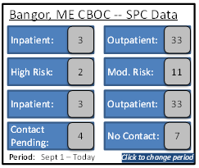

Figure 11: Attributes Summary Widget

The attributes summary widget provides a list of summary data about Veterans within a specific are (in this case, within the Bangor, ME’s service area). This widget could be customizable by user to show various summary data attributes related Veteran demographics, location, social and familiar factors, etc.

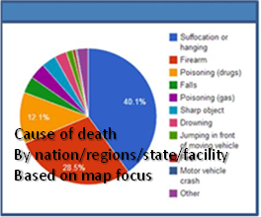

Figure 12: Means Chart

The means chart shows what percent of suicides were completed by a certain means (firearm, poisoning, etc.) These means are associated with an ICD-9 code in the underlying database. Users would be able to see this information in a specific geographic area such as state or VISN.

Figure 13: Suicide Rate Chart

The suicide rate chart shows the trend of suicide rates over time. Users will be able to make this chart specific to a geographic area, and also be able to specify the time frame displayed.

Figure 14: Suicide Risk Chart

The suicide risk chart shows the trend in how many Veterans are within certain risk stratification. Users will also be able to specify the time frame and geographic area to define charts of interest to them.

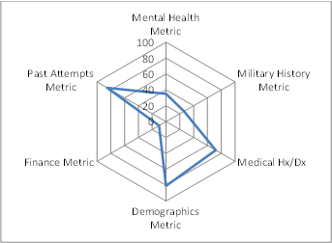

Figure 15: Risk Snapshot

The risk “snapshot” applies to an individual Veteran. This is a “proof of concept” design, presented as a radar chart that shows a Veteran’s relative risk according to several risk categories. The project’s analytics team is working closely with VA leadership to determine if it is feasible to present visualized summaries of risk factors such as this one in a way that is statistically valid and appropriate for frontline providers to view. As these conversations continue this design may be updated, or an alternative design created.

Attachment A – Approval Signatures

This section is used to document the approval of the Dashboard Design Document. The review should be conducted face to face where signatures can be obtained ‘live’ during the review. If unable to conduct a face-to-face meeting then it should be held via LiveMeeting and concurrence captured during the meeting. The Scribe should add /es/name by each position cited. Example provided below.

The Chair of the governing Integrated Project Team (IPT), Business Sponsor, IT Program Manager, and Project Manager are required to sign.

______________________________________________________________________________

Signed: Date:

< Integrated Project Team (IPT) Chair >

______________________________________________________________________________

Signed: Date:

< Business Sponsor >

______________________________________________________________________________

Signed: Date:

< IT Program Manager >

______________________________________________________________________________

Signed: Date:

< Project Manager >