Perceptive Reach

Integrated Reach Database System

(IRDS)

Dashboard Design Document



Department of Veterans Affairs

**April 2015**

Version 2.0

Revision History

| Date | Version | Description | Author |
| --- | --- | --- | --- |
|  | 2.0 | Final Review | Monica Mohler/Paul Bradley |
| 4/1/2015 | 1.9 | Peer Review | Radina Ivanova |
| 3/31/2015 | 1.8 | April 2015 update with additional content added related Veteran outreach status and widget content | Matthew Robinson |
| 3/11/2015 | 1.7 | Final Review | Monica Mohler/Paul Bradley |
| 3/6/2015 | 1.6 | Peer Review | Radina Ivanova |
| 3/6/2015 | 1.5 | March 2015 update with additional content added related to clinical and administrative widget design | Matthew Robinson |
| 2/13/2015 | 1.4 | Final Review | Paul Bradley and Monica Mohler |
| 2/12/2015 | 1.3 | Peer Review | Radina Ivanova |
| 2/13/2015 | 1.2 | February 2015 update with additional content added related to patient information and widget design | Matthew Robinson |
| 1/6/2014 | 1.1 | January 2015 update with revisions to content and focus on patient care | Matthew Robinson |
| 12/10/2014 | 1.0 | Final review | Paul Bradley and Monica Mohler |
| 12/5/2014 | .02 | Peer Review | Radina Ivanova |
| 11/18/2014 | .01 | Initial Version | Matthew Robinson and Radina Ivanova |

Artifact Rationale

The Dashboard Design Document is a dual-use document that provides the conceptual design as well as the as-built design of the IRDS Dashboard. The development team will update this document as new requirements are identified, interface design details are refined, and new features are implemented. Wireframes are to be considered “proof of concept” drawings that may differ from the finalized design in the application.

Table of Contents

1. About this document 4

2. Introduction 4

2.1. Purpose 5

2.2. Scope 5

2.3. User Scenarios 5

2.4. Relationship to Other Documents and Plans 6

2.5. Acronyms and Abbreviations 6

3. Background 7

3.1. Assumptions and Constraints 7

3.1.1. Design Assumptions 7

3.1.2. Design Constraints 8

3.1.3. Design Trade-offs 8

4. Conceptual Dashboard Design 8

4.1. Primary View: Individual Veteran 10

4.2. Other Views 12

4.3. Widget Design 13

# About this document

This document is a “work in progress.” The Dashboard will be designed through a series of mockups and iterative development sprint cycles in collaboration with VA stakeholders and users. The document will be populated with content as the design evolves with each sprint, including all potential data options, configurability rules, and options. The early versions of the document will focus on the conceptual Dashboard design, key business requirements, and the primary end-user features related to the design of the Dashboard. Future versions will add additional detail as it becomes available.

# Introduction

VA is seeking to expand suicide prevention to include upstream approaches designed to reduce initiation or escalation of a risk factor. Upstream suicide interventions target individuals or groups who exhibit biological, psychological, or social risk factors that are more prominent among high-risk groups than among the larger population. Understanding the unique needs of our nation’s Veterans and the military culture as it relates to stigma and mental health is important for early intervention. The goal of the Integrated Reach Database System (IRDS) innovation is to promote the general health of the Veteran population and effectively intervene in issues before they escalate in crisis.

The IRDS innovation will serve to bolster the three major components of the Veteran Health Administration’s (VHA) Strategic Plan for Suicide Prevention: surveillance, risk and protective factors, and prevention interventions. The IRDS innovation will target antecedent events specific to Veteran populations prior to the onset of risk to mitigate the development of risk.

The Dashboard component is a key feature of the IRDS solution. Within the Dashboard, end users such as frontline outreach and intervention specialists, VA leadership, clinicians, and other staff with an interest in suicide outreach and intervention will be able to see data visualizations related to individual at-risk Veterans. The solution will provide visual screen elements that will provide quick, intuitive “at a glance” type information, in addition to visual screen elements that will allow users to “deep dive” into the data and create more customized views of the data depending on user preference.

The Dashboard’s design is informed by Human Centered Design (HCD) principles and techniques. HCD is a discipline in which “the needs, behaviors, and experiences of an organization's customers (or users) drive product, service, and/or technology outputs.[1]” In the case of IRDS, researchers and designers have used qualitative research techniques, primarily interviewing and document review, to understand how VA users currently do their work today and what they desire from the IRDS, including the Dashboard. To that end, the Dashboard’s design emphasizes display of information that is directly relevant to the target end user groups’ goals and desired outcomes in their work in a way that is both easy to access and understand.

## Purpose

The purpose of this document is to describe how the proposed Dashboard will be designed. The Dashboard Design Document translates requirement specifications into a document from which the developers can create the actual system. A related document, the System Design Document (SDD), translates requirement specifications into a document from which the developers can create the actual system from a technical and architectural perspective. For more information, please refer to the [SDD](https://internal.vacloud.us/wiki/pages/81X0Z7X5/Perceptive_Reach_Deliverables.html)*.*

## Scope

The lists below describe what content is considered inside and outside the scope of the Dashboard Design Document.

In scope:

* The visual and functional design of a surveillance Dashboard consisting of custom visualization tools that depict the results of analyses conducted by the IRDS, including data trends, events and performance metrics, Veteran demographics, Veteran medical history, clinical care support, outreach and intervention resources and guidelines, links to other tools and resources, etc.
* Data visualizations to include charts, tables, maps, animations, other graphics and visual technology.
* Dashboard configurability, providing different user groups distinct views that meet their business needs.
* Support for interactive viewing and formatting.
* Consideration of user interface (UI) and user experience (UX) practices that will enable the Dashboard to present data in a manner that is accessible to a broad range of users.

Out of scope:

* End-user profiles and characteristic research (to be included in the [User Research Report](https://internal.vacloud.us/wiki/pages/81X0Z7X5/Perceptive_Reach_Deliverables.html))
* Descriptions of the IRDS architecture or technical capabilities (to be included in the [System Design Document](https://internal.vacloud.us/wiki/pages/81X0Z7X5/Perceptive_Reach_Deliverables.html))

## User Scenarios

There are five user interaction scenarios envisioned for the IRDS: upstream at-risk notification, surveillance, research, reporting, and system sustainment.

1. Upstream At-Risk Notification – The primary users in this usage model are the VA outreach and intervention teams. The system will provide secure notification via a Direct Message of at-risk populations and at-risk individuals to these teams.
2. Surveillance – The primary users in this model shall include VA leadership, VA Center of Excellence for Suicide Prevention staff, VA Mental Health leaders, and VA Suicide Prevention Coordinators. The surveillance Dashboard will be available through a standard web browser that will be updated in near real-time (minimum weekly) with results produced from the continuous monitoring and processing of linked data sources.
3. Research – The users in this usage model are researchers and statisticians looking to leverage the tools and data available through Reach data analytics platform. The solution will provide a framework for these users to utilize the interfaces provided by the assembled tools to perform required research functions.
4. Reporting – This model shall include both direct and indirect users. The direct users are the individuals required to assemble reports. The indirect users are the consumers or target audience of the reports. The direct users will utilize the interfaces provided by the assembled tools to assemble reports. The report generation process shall be automated.
5. Sustainment - The Contractor shall provide the capability for users to edit and add to the IRDS Risk Stratification Model, permit creation to new models and mapping to interfaces.

User interaction with the Dashboard is broadly described in the “Surveillance” scenario above, however it is conceivable that users will access the Dashboard in parallel or in conjunction with other interaction scenarios during the course of a regular workday. Additional user research and characteristics are included in the User Research Report.

## Relationship to Other Documents and Plans

The following IRDS documents may be referenced in tandem with the information recorded here:

* [IRDS Requirements Specification Document (RSD)](https://internal.vacloud.us/wiki/pages/81X0Z7X5/Perceptive_Reach_Deliverables.html)
* [IRDS System Design Document (SDD)](https://internal.vacloud.us/wiki/pages/81X0Z7X5/Perceptive_Reach_Deliverables.html)
* [IRDS Requirements Traceability Matrix (RTM)](https://internal.vacloud.us/wiki/pages/81X0Z7X5/Perceptive_Reach_Deliverables.html)
* [IRDS User Research Report](https://internal.vacloud.us/wiki/pages/81X0Z7X5/Perceptive_Reach_Deliverables.html)

## Acronyms and Abbreviations

Table : Acronyms and Abbreviations

| Acronym | Term |
| --- | --- |
| EHR | Electronic Health Record |
| DoD | Department of Defense |
| GUI | Graphical User Interface |
| HCD | Human Centered Design |
| HHS | U.S. Department of Health and Human Services |
| ICD | International Statistical Classification of Diseases and Related Health Problems |
| IPT | Integrated Project Team |
| IRDS | Integrated Reach Database System |
| IT | Information Technology |
| MDD | Major Depressive Disorder |
| PWS | Performance Work Statement |
| RSD | Requirements Specification Document |
| RTM | Requirements Traceability Matrix |
| SDD | System Design Document |
| SPC | Suicide Prevention Coordinator |
| TRM | Technical Reference Model |
| UI | User Interface |
| UX | User Experience |
| VA | Department of Veterans Affairs |
| VACI | VA Center for Innovation |
| VHA | Veterans Health Administration |
| VISN | Veterans Service Area Network |

# Background

## Assumptions and Constraints

### Design Assumptions

The primary user goals and objectives related to Dashboard functionality are related to providing effective, timely, and well-informed outreach, intervention, and clinical care services to at-risk Veteran patients. Data visualizations related to Veteran populations at the state, Veteran Integrated Service Network (VISN), region, or national levels are of lower priority for development. The ability to view data aggregated at these levels will be limited to users in leadership positions within VA who have appropriate system access.

In accordance with industry standard Agile best practices, the design team will present the design of the Dashboard to project stakeholders regularly to garner feedback and better-inform future iterations of the design. As more assumptions are identified, this section will be updated.

### Design Constraints

* System designers have attempted to utilize open source tools wherever possible. This includes design of the user interface / front end presentation layer of the system, testing tools, and statistical / analytics tools.
* System designers utilized VA tools approved for use in the VA Technical Reference Model (TRM) or have requested a waiver for any tools not included in the TRM.
* The design team will comply with VA-recommend UI/UX best practices as defined in the project’s RSD.
* The design of the Dashboard is both driven and constrained by the data available within the IRDS. As new datasets are incorporated into the IRDS or when new statistical techniques and models are applied to the data, new design features or data visualizations may be feasible.
* The Dashboard must operate within VA-approved web browsers.

### Design Trade-offs

The Dashboard’s design must be created using open source tools meaning that adoption of a design based on non-open source or commercial tools is not feasible. In addition, access to the Dashboard must be web-based and accessible by VA supported/approved browsers. Therefore, design features must be readable for viewers using standard 1024×768, 1366×768, and 1280×800 screen resolutions. Lastly, given the diverse set of target end users of the Dashboard, the design will emphasize configurable features and data visualizations to enhance user ability to customize Dashboard views to their own unique needs.

# Conceptual Dashboard Design

At the highest level, a Dashboard is “a visual display of the most important information needed to achieve one or more objectives, consolidated and arranged on a single screen so the information can be monitored at a glance.[2]”

In the case of the IRDS Dashboard, the “most important information needed” will be information directly related to Veteran patient outreach, intervention, and clinical care. This information includes:

* Veteran contact information
* Veteran demographics
* Veteran medical history
* Care recommendations, guidelines, resources, and other supplemental information

The Veteran’s demographics and key insights into the Veteran’s medical record will provide users with information that can help guide development of an outreach approach. The application will provide this information coupled with guidance and resources related to the Veteran’s specific information. For example, if a Veteran’s health record indicates a previous diagnosis of Major Depressive Disorder (MDD), the application will use logic-based business rules to then display clinical care guidelines, evaluation tools, and resources at local VA facilities that are relevant to outreach and care for patients with MDD. The Dashboard will also feature administrative functions related to the management of this content so that users can add new resources, updated care guidelines, and care recommendations as they are developed and identified. These features will help care providers identify at-risk Veterans, understand the Veteran’s circumstances, and devise targeted outreach and intervention strategies, custom-tailored to each Veteran’s needs.

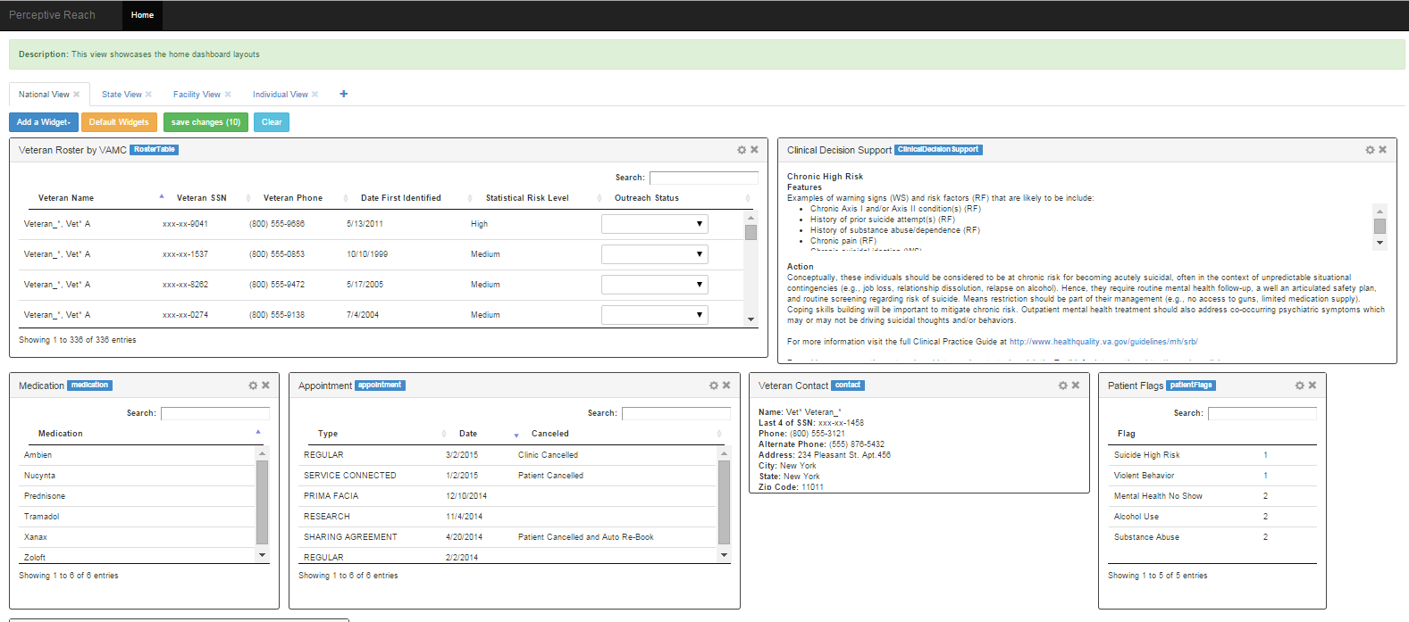

Figure : Screen Capture of Current Dashboard Development Framework

The visual features of the Dashboard will be primarily displayed as “widgets” within the Dashboard’s Graphical User Interface (GUI). Widgets are small, modular displays of Dashboard information, with limited scope and functionality within the widget’s window. The primary benefit of adopting a widget-driven design is to provide end-users with the ability to pick and choose which widgets they most want to see, while also providing the ability to resize and move widgets according to user preference. Technical aspects of the Dashboard and its widget-driven development are described in Section 5.2.1.2 of the SDD: <https://internal.vacloud.us/wiki/pages/81X0Z7X5/Perceptive_Reach_Deliverables.html>.

The following sections describe the specific screen features of the Dashboard in further detail.

## Primary View: Individual Veteran

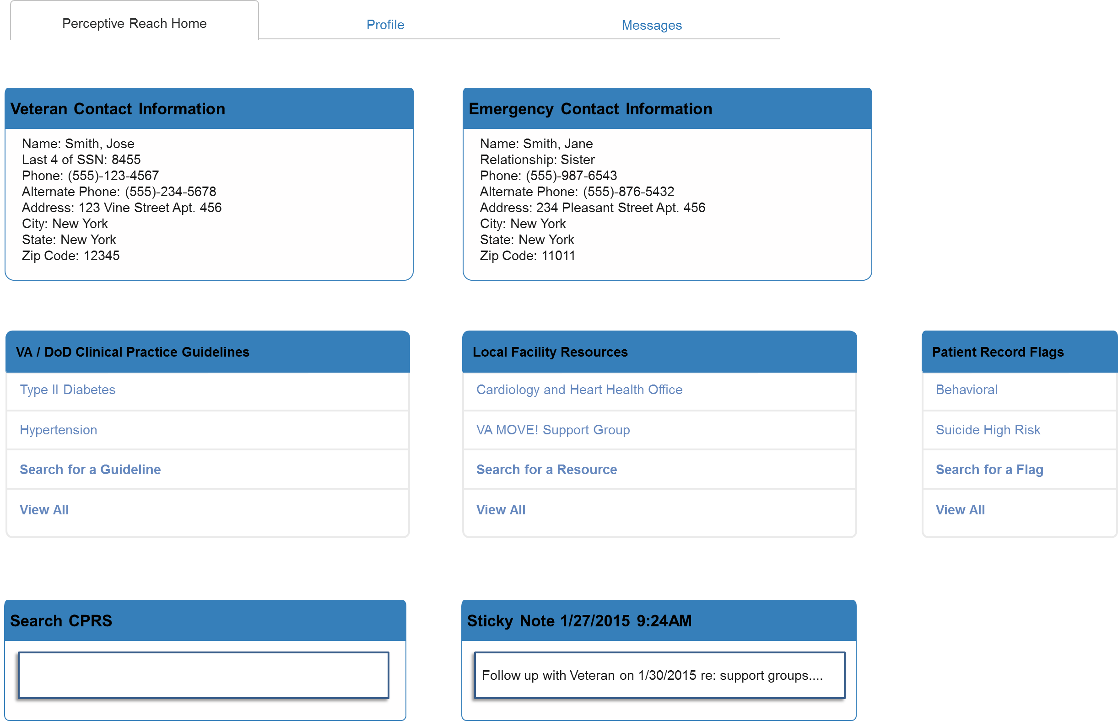

Figure : Individual Veteran View

The Individual Veteran View allows an outreach provider, such as a Suicide Prevention Coordinator (SPC), the ability to view details associated with an individual Veteran’s health factors and contact information. Figure 2: Individual Veteran View above shows some of the widget display options available to users. The view will display the Veteran’s contact information in addition to his or her emergency contact information. Displaying this information clearly and prominently is a key feature, as an outreach provider will want to frequently access Veteran contact information (especially phone number) during the course of their regular work.

The view also features widgets with data pulled from the Veteran’s electronic health record (EHR). The data points for these widgets have been selected from those displayed in the EHR’s Cover Sheet tab as those directly related to suicide outreach, intervention, and overall mental health. The Cover Sheet fields to be pulled include:

* Current Patient Record Flags
* Medical Diagnoses
* Active Medications
* Appointments, Visits, and Admissions

The Dashboard must feature easy to read, easy to consume “at a glance”-style content. Therefore, widgets will provide the most recent flags, diagnoses, medications, and appointments. If the user wishes to see either more details or information from further in the past, the user will be able to search within or launch the health record directly from within the Dashboard.

The view will provide additional informational widgets to users based on the Veteran’s previous problems and diagnoses. By activating the “Local Facility Resources” widget, users will be able to view programs, groups, tools, and applications available at their facility directly related to Veteran’s condition. For example, if a Veteran has been diagnosed with Type II Diabetes, the application will display information about local resources such as the local VA endocrinology clinic, Veteran support groups, and VA’s MOVE! weight loss program. The VA / Department of Defense (DoD) Clinical Practice Guidelines option will provide links to the complete clinical guideline for relevant conditions. Other administrative-oriented widgets will include ability to search a Veteran’s health record or find and select another Veteran from a roster.

## Other Views

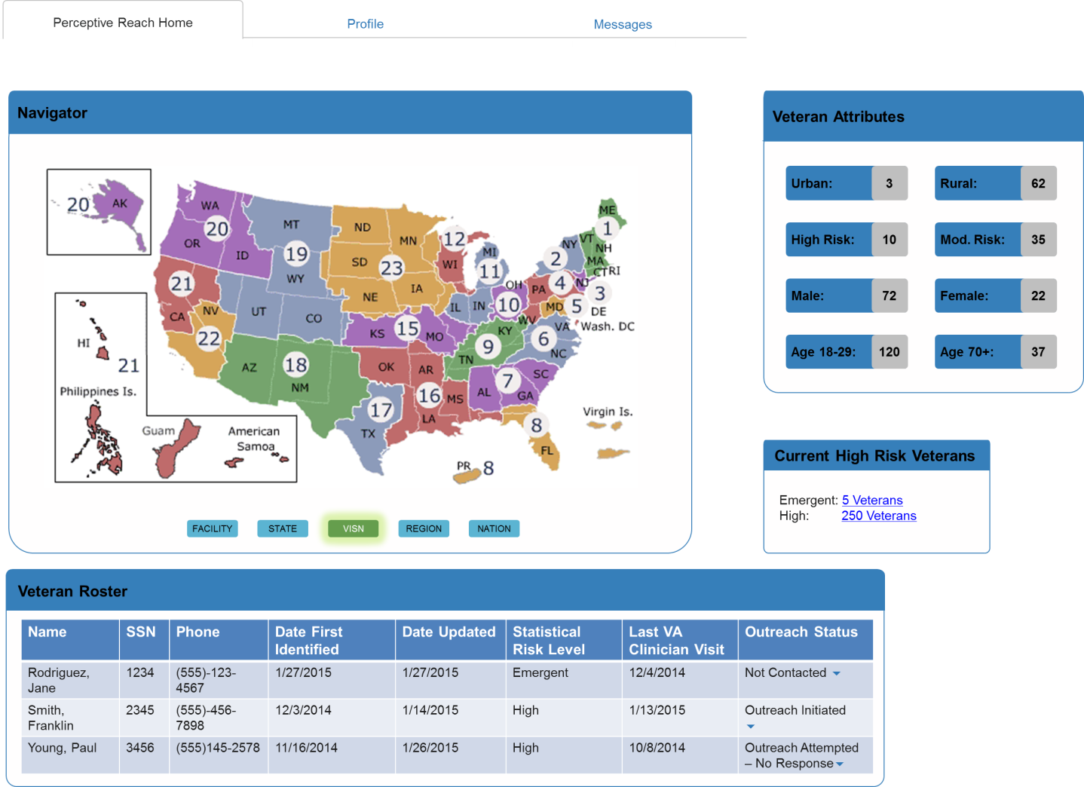

Figure : VISN Level

The primary view for IRDS users will be the Individual Veteran View. Other views will give users the ability to view visualizations of data related to Veterans and / or Veteran suicide within a specific geographic area, to include Facility Service Area, State, VISN, Region, or Nation. In Figure 3: VISN Level above, data provided is aggregated at the VISN level, meaning that users will be able to see summary statistics related to Veteran incidence across individual VISNs. Users will have the ability to then navigate to other levels of aggregation using a screen menu. These views are lower in priority for development compared to the Individual Veteran View and will only be accessible to users in leadership positions with appropriate access. The view will feature a navigational menu to allow users to change the data aggregation level as desired.

As with the Individual Veteran View, users will be able to customize these views by selecting and rearranging the widgets visually on the screen (Described in Section 4.3). According to stakeholders, the most desirable data points to summarize in these views include:

* Number of Veterans in each statistical risk group
* Outreach Status
* Location
* Presence of a Suicide Risk Flag

Lower priority data points include:

* Age Group
* Military Branch
* Gender
* Combat Era

As development continues, these data points will continue to be further refined.

## Widget Design

The Dashboard design will be “widget” based, meaning that information will be visually grouped together in generally small, discrete areas of the screen, each with a specific, useful purpose and function. t. This will allow users to move and arrange widgets spatially within the Dashboard to their own preferences, and in some cases select what widgets they do and do not desire to be displayed on the screen. The following widgets are either in development or under consideration for development in future sprints.

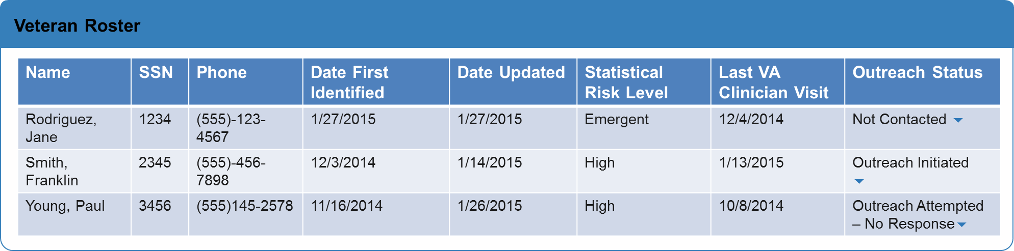

Figure : Veteran Roster

The Veteran Roster allows a user to view a list of Veterans within a specific area (service area, state, etc.). It includes a visual indicator to highlight Veterans who have been recently identified – in this case, a green box. The last column represents a user story that allows the user to click a direct hyperlink into the Veteran’s EHR, bypassing the Individual Veteran View and going straight to the medical record. Users will also be able to select a Veteran’s outreach status from a drop down menu. Note: the categories in the “Statistical Risk Level” column are a notional feature. Clinical experts have discussed how best to categorize or label Veterans according to the individual Veteran’s risk level, however consensus has not yet been reached. For illustration purposes, the figure above proposes a label of “Emergent” for Veterans in the top .1% and “High” for Veterans in the top 5%.The actual schema to be used in the application will be finalized and described in future versions of this document. As of the end of Sprint 12, stake holders have suggest “High” vs. “Medium” or “Top” vs. “Middle,” for the categorical labels, however consensus has not yet been reached.

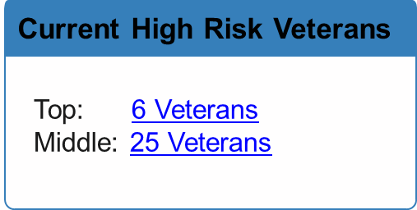

Figure : Stratification Widget

The Stratification Widget allows a user to see how many Veterans within a particular area (state, VISN, etc.) are within a specific risk stratification. In this example, 6 Veterans are in the top .1% (with the “Top” categorical label) and 25 are in the top 5% (with the “Middle” categorical label). Users can click the stratification to view a roster of the Veterans included.

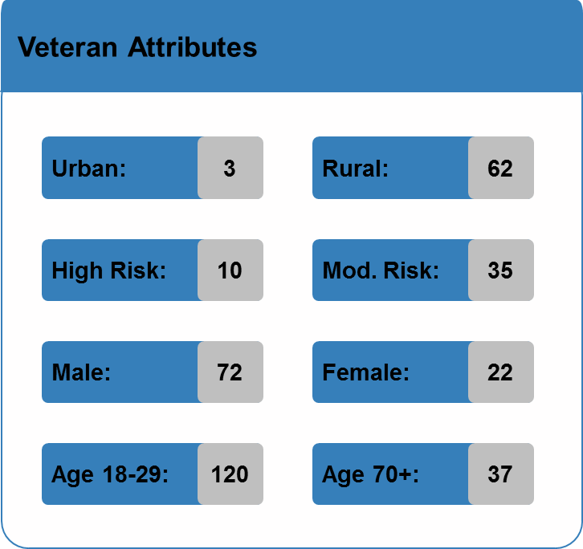

Figure : Attributes Summary Widget

The Attributes Summary Widget provides a list of summary data about Veterans within a specific area. This widget is customizable by user to show various summary data attributes related Veteran demographics, location, social and familiar factors, etc.

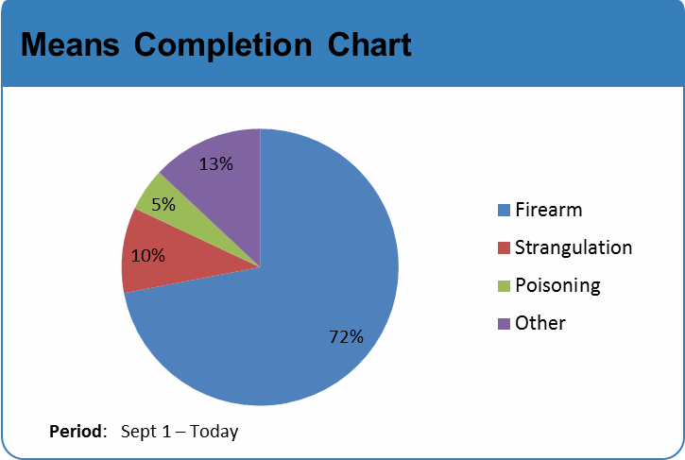

Figure : Means Completion Chart

The Means Completion Widget shows what percent of suicides were completed by a certain mean (firearm, poisoning, etc.). These means are associated with an International Statistical Classification of Diseases and Related Health Problems (ICD) code in the underlying database. Users will be able to see this information for a specific geographic area such as state or VISN. The development team will be able to re-use this widget framework as needed to display nominal or proportional data that is most easily read and understood as a circle chart.

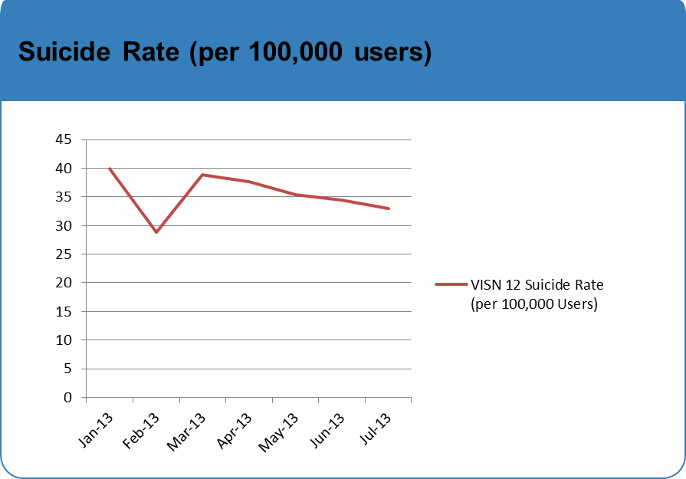

Figure : Suicide Rate Chart

The Suicide Rate Chart Widget shows the trend of suicide rates over time. Users will be able to make this chart specific to a geographic area, and be able to specify the time frame displayed.

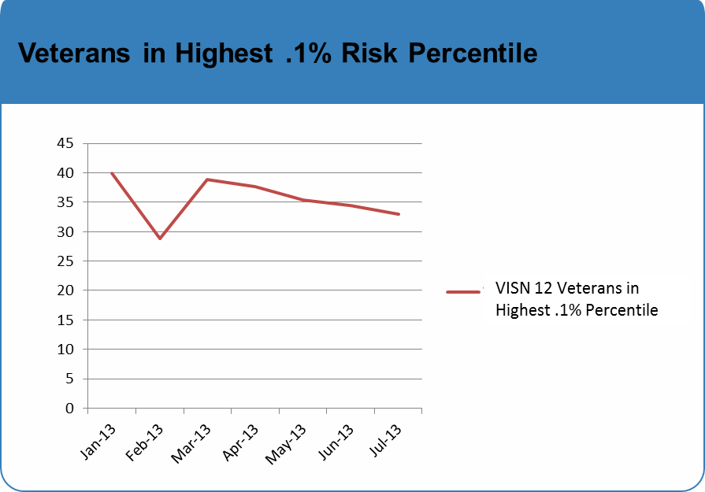

Figure : Veterans in Highest .1% Risk Percentile

The Suicide Risk Chart shows the trend for how many Veterans are within certain risk stratification. Users will also be able to specify the time frame, risk stratification, and geographic area to define charts of interest to them. The development team will be able to re-use this widget framework as needed to illustrate changes in data over time that are most easily read and understood in a line chart.

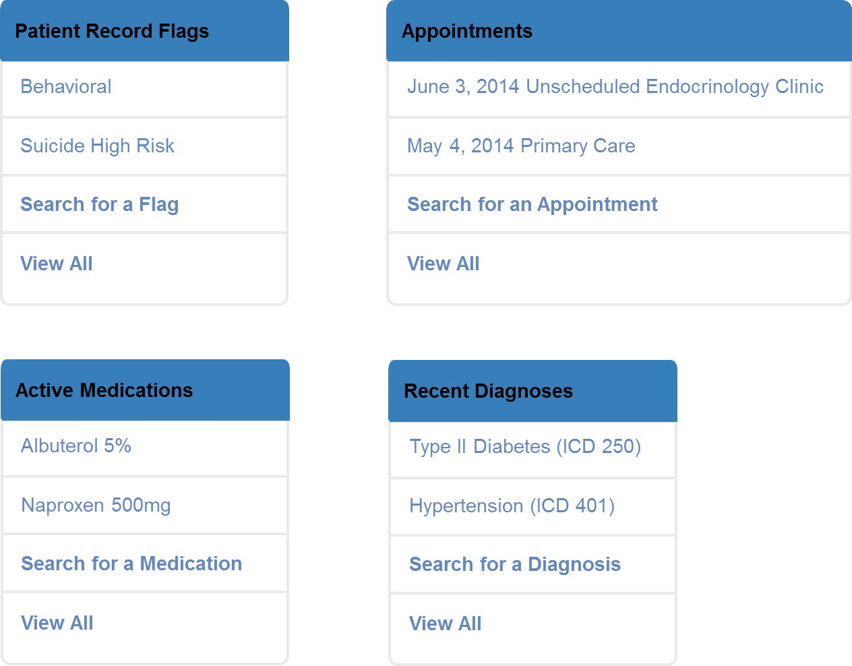

Figure : Medical Cover Sheet Widgets

The Medical Cover Sheet Widgets pull relevant information from the Veteran’s health record and consolidates it into an easy to read view. Data pulled will include recent Patient Record Flags, recently identified diagnoses, active medications, and recent appointments, procedures, and patient / provider encounters (summarized as Appointments). Another proposed user feature is providing access to a search widget which gives the ability to search for keywords in a Veteran’s health record and returns a list of relevant results. This way, users will not have to search through information scattered across multiple tabs and screens to find key information they are interested in.

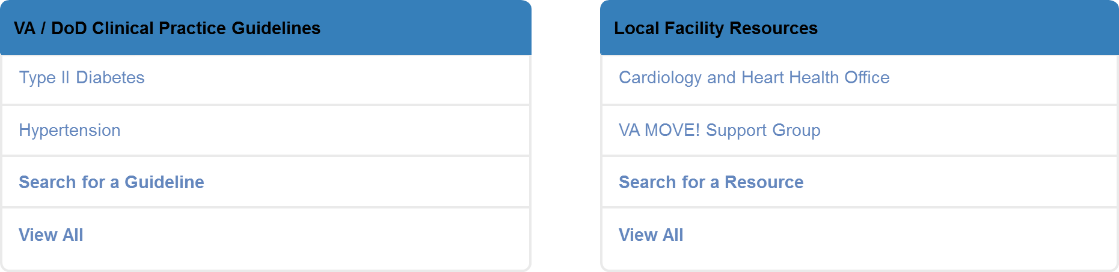

Figure : Clinical Practice Guidelines and Local Facility Resource Widgets

The widgets above provide contextual decision support information to the user. Each widget offers information based on logical business rules and information from the medical record. For example, if a Veteran has been diagnosed with Type II Diabetes, the widgets could show recently completed assessments related to diabetes management, clinical practice guideline recommendations diabetes care, and local resources for diabetes such as support groups, mobile apps, clinical care, etc. As of the end of Sprint 12, the Dashboard has the ability to display links to the VA / DoD Clinical Practice Guideline documents for patients at risk for suicide. The Dashboard also provides supplemental information based on the individual Veteran’s statistical risk level. As the project continues, the content of this widget will be further refined as new resources are developed and identified for inclusion in the Dashboard.

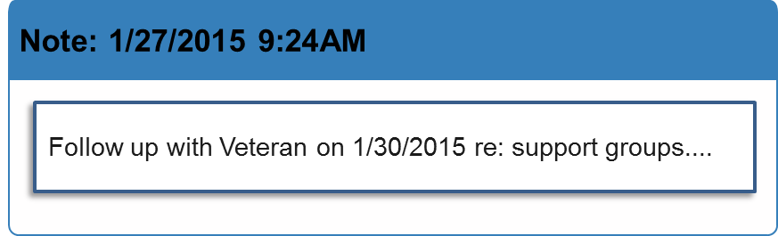

Figure : Note Widget

The Note Widget allows users to enter and save a note in the Dashboard as desired. Users will be able to save, edit, and remove notes within the Dashboard’s UI. This functionality does not replace contact notes required in various VA tools of official record such as the EHR or suicide prevention case management tools.

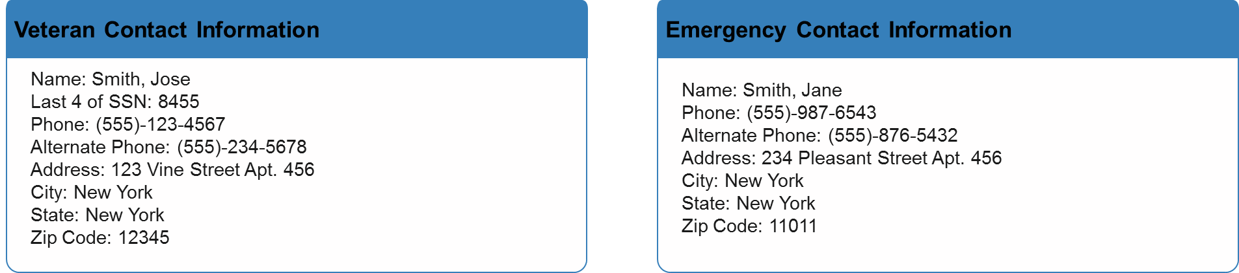

Figure : Contact Widgets

The Contact Widgets (also described in Section 4.1) allows users to quickly view a Veteran’s recorded contact information and emergency contact information. Users will be able to use the information displayed to contact a Veteran via phone (the primary mode of communication for initial contact) and mail.

1. PWS for VA Contract No. VA118-14-C-0046
2. Stephen Few (March 20, 2004) “Dashboard Confusion” *Intelligent Enterprise.* 