Perceptive Reach

Integrated Reach Database System

(IRDS)

Developers Guide



Department of Veterans Affairs

**May 2016**

Version 1.8

Revision History

| Date | Version | Description | Author |
| --- | --- | --- | --- |
| 5/23/2016 | 1.8 | Management Review | Matthew Robinson |
| 5/23/2016 | 1.7.1 | Updated content in section “7.1.1. Process” | Kaitlin Reskovac |
| 5/9/2016 | 1.7 | Updated the title page, page headers, and page footers to reflect the correct month | Kaitlin Reskovac |
| 4/6/2016 | 1.6 | Updated the title page, page headers, and page footers to reflect the correct month | Kaitlin Reskovac |
| 3/28/2016 | 1.5 | Updated the title page, page headers, and page footers to reflect the correct month | Kaitlin Reskovac |
| 2/16/2016 | 1.4 | Updated page headers and footers to reflect the current month | Kaitlin Reskovac |
| 1/25/2016 | 1.3 | Updated headers to reflect the current month and year. Updated section “10.1 Dashboard.” | Kaitlin Reskovac |
| 115/2015 | 1.2 | Peer Review | Kaitlin Reskovac and Matthew Robinson |
| 11/3/2015 | 1.1 | Added database/SSIS content | Bill Balshem |
| 9/14/2015 | 1.0 | Final Review | Monica Mohler / Paul Bradley |
| 9/13/2015 | .6 | Minor formatting updates | Matthew Robinson |
| 9/11/2015 | .5 | Contract Compliance and Quality Assurance Review | Matthew Robinson / Kaitlin Reskovac / Radina Ivanova |
| 9/10/2015 | .4 | Technical updates to Deployment Process section | Robert Snelling |
| 9/9/2015 | .3 | Formatting and minor content updates | Matthew Robinson / Kaitlin Reskovac |
| 9/1/2015 | .2 | Miscellaneous updated throughout | Robert Snelling |
| 6/1/2015 | 0.1 | Initial Draft | Jaya Rao |

**Table of Contents**

[1. About the Developers Guide 5](#_Toc434396585)

[2. Introduction 5](#_Toc434396586)

[3. Technology Stack 5](#_Toc434396587)

[4. Developer Workstation Setup 6](#_Toc434396588)

[4.1. Application Development Tools 6](#_Toc434396589)

[**4.1.1. GitHub Tools 6**](#_Toc434396590)

[**4.1.2. JavaScript (Node.js) editor 8**](#_Toc434396592)

[4.2. SSIS Database Development Tools 9](#_Toc434396594)

[4.3. Application Environment Installation 11](#_Toc434396595)

[5. Source Repository 12](#_Toc434396596)

[5.1. Initializing GitHub 12](#_Toc434396597)

[**5.1.1. Git Bash 12**](#_Toc434396598)

[**5.1.2. SourceTree 13**](#_Toc434396599)

[5.2. Branching Strategy 15](#_Toc434396600)

[**5.2.1. Main branches 15**](#_Toc434396601)

[**5.2.2. Supporting branches 15**](#_Toc434396602)

[5.3. GitHub Working with Feature Branches 16](#_Toc434396603)

[**5.3.1. Creating a feature branch 16**](#_Toc434396604)

[**5.3.2. Incorporating a finished feature on dev 16**](#_Toc434396605)

[5.4. Committing and Pushing Source Code Changes 16](#_Toc434396606)

[**5.4.1. Git Bash 17**](#_Toc434396607)

[**5.4.2. SourceTree 17**](#_Toc434396608)

[**5.4.3. Database Changes 19**](#_Toc434396609)

[5.5. Working with Hotfix Branches 19](#_Toc434396610)

[**5.5.1. Creating a hotfix branch 19**](#_Toc434396611)

[**5.5.2. Incorporating a hotfix to stable 19**](#_Toc434396612)

[**5.5.3. Finishing a hotfix branch 19**](#_Toc434396613)

[5.6. Finishing out the Sprint 20](#_Toc434396614)

[5.7. Git Stash 20](#_Toc434396615)

[6. Code Compilation 21](#_Toc434396616)

[6.1. Grunt and Node.js 22](#_Toc434396617)

[6.2. SQL Server 2012 22](#_Toc434396618)

[**6.2.1. SQL Server Installation 22**](#_Toc434396619)

[**6.2.2. Reach Database 33**](#_Toc434396621)

[6.3. Configuration Files 37](#_Toc434396622)

[**6.3.1. .env 37**](#_Toc434396623)

[7. Deployment Packaging 38](#_Toc434396624)

[**7.1.1. Process 38**](#_Toc434396625)

[8. Development Cycle 40](#_Toc434396626)

[9. Test Driven Development 41](#_Toc434396628)

[10. VA Cloud Server Deployments of Perceptive Reach 41](#_Toc434396629)

[10.1. Dashboard 41](#_Toc434396630)

[10.2. Databases 41](#_Toc434396631)

[11. Atlassian JIRA 42](#_Toc434396632)

[11.1. Epics, User Stories, and Tasks 42](#_Toc434396633)

[11.2. JIRA Guidelines 43](#_Toc434396634)

[**11.2.1. Linking epics, user stories, and tasks 43**](#_Toc434396635)

[**11.2.2. Adding blockers 44**](#_Toc434396636)

[**11.2.3. Smart Commits 45**](#_Toc434396637)

[12. Jenkins Continuous Integration 45](#_Toc434396638)

[13. Build Process 46](#_Toc434396639)

[13.1. Build Overview 46](#_Toc434396640)

[13.2. Build Manual Steps 46](#_Toc434396641)

[14. Additional Resources 46](#_Toc434396642)

[14.1. Documentation 46](#_Toc434396645)

[14.2. VA Perceptive Reach Innovation Site 47](#_Toc434396646)

[15. Acronyms & Abbreviations 47](#_Toc434396647)

# About the Developers Guide

This Developers Guide details the context and steps for development on the VA Perceptive Reach project and is a live document to be consulted in conjunction with the VA Perceptive Reach System Design Document and VA Perceptive Reach web application. In accordance with Human Centered Design (HCD) principles and Agile software methodology, the team will update this document continuously and deliver a revised version monthly or as new information and key insights are gathered.

The intended audience for this document is all key stakeholders who participate in development, testing, or sustainment of the system. The primary stakeholder for this document will possess a technical background and understanding of web applications, continuous integration (CI), databases, and Agile methodology.

The following symbols appear throughout the documentation to alert the reader to special information or conditions.

|  |  |
| --- | --- |
| **Symbol** | **Description** |
| Note | Used to inform the reader of general information and references to additional reading material, including online information. |
| Caution | **Used to caution the reader to take special notice of critical information.** |

# Introduction

The Perceptive Reach Integrated Reach Database System (IRDS) innovation project proposes to combine technology, outreach, and clinical support to realize a clinically based data-driven early intervention and treatment solution aimed at Veteran suicide prevention.

The target users for the Perceptive Reach IRDS include a diverse set of Department of Veterans Affairs (VA) staff including frontline Veteran suicide outreach and intervention providers, mental health clinical care providers, researchers, and statisticians, in addition to other VA staff in leadership or administrative positions.

# Technology Stack

The technology used in the development environment includes the following:

* Node.js – Software platform built on JavaScript runtime (<https://nodejs.org/>)
* ExpressJS – Web framework for Node.js (<http://expressjs.com/>)
* AngularJS – JavaScript (JS) framework (<https://angularjs.org/>)
* Bootstrap – HyperText Markup Language (HTML), Cascading Style Sheets (CSS), and JS framework (<http://getbootstrap.com/>)
* Bower - Package manager for the web (<http://bower.io/>)
* Grunt – JavaScript task runner (<http://gruntjs.com/>)
* SQL Server – Database (<http://www.microsoft.com/en-us/server-cloud/products/sql-server/>)

# Developer Workstation Setup

## Application Development Tools

The application development process is JavaScript centric and is driven by the GitHub code repository and a JavaScript (Node.js) editor.

### GitHub Tools

The Perceptive Reach code base is housed on a public Git repository on the Github.com domain. Proceed to install the GitHub client Git Bash and SourceTree, a Graphic User Interface (GUI)-enhanced tool for interacting with GitHub. These two items can be downloaded then installed from the following:

#### Git Bash

1. Download the latest release at <http://git-scm.com/downloads>

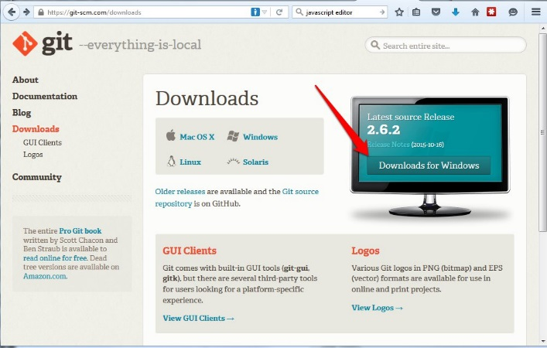

1. Install the program (Accept the defaults except on the 6th screen)

|  |  |  |
| --- | --- | --- |
| Screen 1: Next | Screen 2: Next | Screen 3: Next |
| Screen 4: Next | Screen 5: Next | C:\Users\rsnelling037\AppData\Local\Skitch\Screenshot_103115_111336_AM.jpgScreen 6: Second Option |
| Screen 7: Next | Screen 8: Next | Screen 9: Next – Final Screen |

**SourceTree** - (Preferred Tool for Everyday Use)

1. Download the latest release at <http://www.sourcetreeapp.com/>

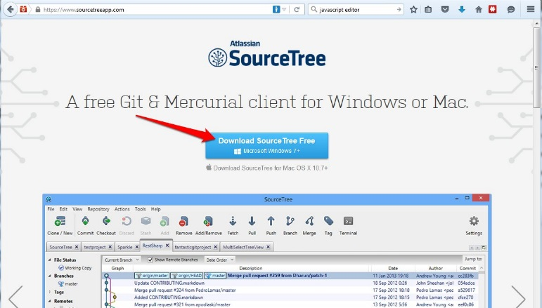

1. Install the program (Accept the defaults)

|  |  |  |
| --- | --- | --- |
| C:\Users\rsnelling037\AppData\Local\Skitch\Screenshot_103115_114134_AM.jpgScreen 1: Next | C:\Users\rsnelling037\AppData\Local\Skitch\Screenshot_103115_114019_AM.jpgScreen 2: Next | C:\Users\rsnelling037\AppData\Local\Skitch\Screenshot_103115_114212_AM.jpgScreen 3: Install – Final Screen |

### JavaScript (Node.js) editor

The development process for node.js requires a text editor for the development environment. Two options for development are Sublime Text and Brackets.

**Sublime Text 2**

1. Download the latest release at <http://www.sublimetext.com/2>

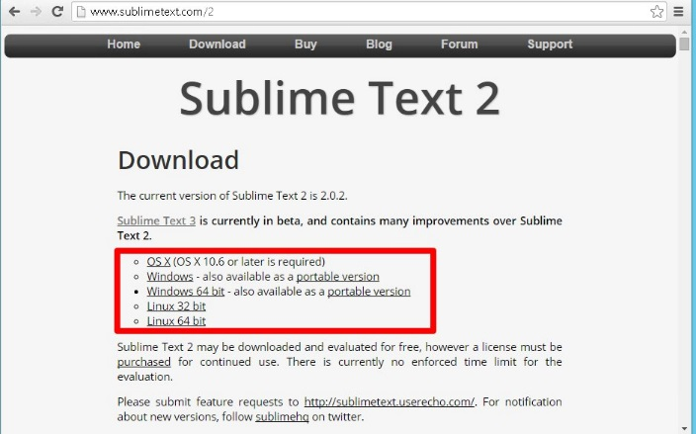

1. Install the program (Accept the defaults)

|  |  |  |
| --- | --- | --- |
| C:\Users\rsnelling037\AppData\Local\Skitch\Screenshot_103115_023113_PM.jpgScreen 1: Next | C:\Users\rsnelling037\AppData\Local\Skitch\Screenshot_103115_023213_PM.jpgScreen 2: Next | C:\Users\rsnelling037\AppData\Local\Skitch\Screenshot_103115_023301_PM.jpgScreen 3: Next |
| Screen 4: Install – Final Screen C:\Users\rsnelling037\AppData\Local\Skitch\Screenshot_103115_023400_PM.jpg |  |  |

**Brackets**

1. Download the latest release at <http://brackets.io/>

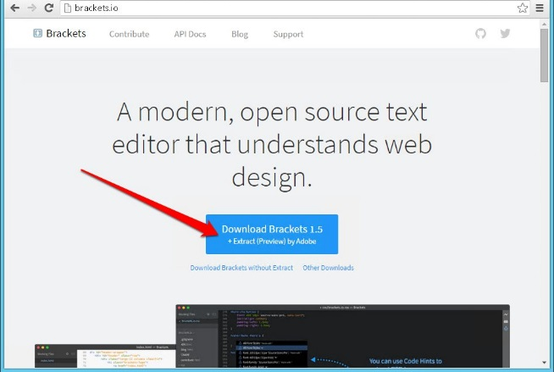

1. Install the program (Accept the defaults)

|  |  |  |
| --- | --- | --- |
| C:\Users\rsnelling037\AppData\Local\Skitch\Screenshot_103115_023949_PM.jpgScreen 1: Next | C:\Users\rsnelling037\AppData\Local\Skitch\Screenshot_103115_024027_PM.jpgScreen 2: Install – Final Screen |  |

## SSIS Database Development Tools

Microsoft SQL Server Integration Services (SSIS) is a platform for building high performance data integration solutions, including extraction, transformation, and load (ETL) packages for data warehousing.

**Microsoft SQL Server Management Studio**

1. Download the Microsoft® SQL Server® 2012 Express at <http://www.microsoft.com/en-us/download/details.aspx?id=29062>

**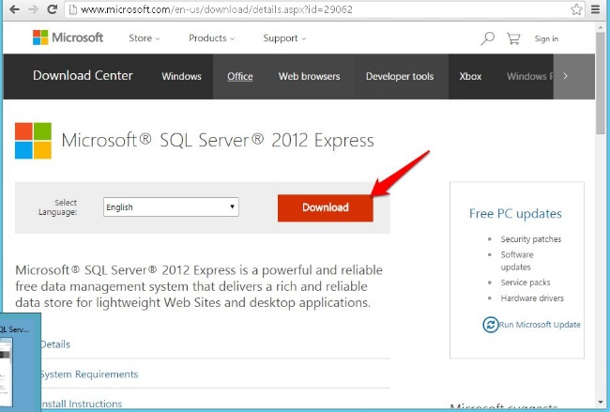**

**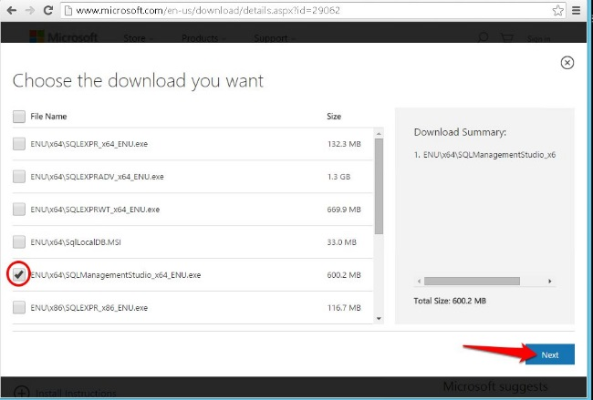**

1. Install the program (Accept the defaults)

|  |  |  |
| --- | --- | --- |
| Screen 1: New SQL Server | Screen 2: Accept License - Next | Screen 3: Install |
| Screen 4: Close – Final Screen |  |  |

NOTE: Most SSIS processes developed for the IRDS involve importing patient health information and/or referencing proprietary VA components such as elements of the suicide risk model. Therefore SSIS solutions are developed in an environment behind the VA firewall. The VA has given the IRDS database team a database and ETL development environment. For more detail, please refer to the IRDS Database/ETL developers’ guide.

## Application Environment Installation

The Application Environment is centered on Node.js®, a platform built on Chrome's JavaScript runtime to easily build fast, scalable network applications. Node.js uses an event-driven, non-blocking I/O model that makes it lightweight and efficient, perfect for data-intensive real-time applications that run across distributed devices.

**Node.js**

1. **Download the 0.12.4 version of node.js at** <http://nodejs.org/dist/v0.12.4/x64/node-v0.12.4-x64.msi>
2. Install the program (Accept the defaults)

|  |  |  |
| --- | --- | --- |
| Screen 1: Next | Screen 2: Next | Screen 3: Next |
| Screen 4: Install – Final Screen | C:\Users\rsnelling037\AppData\Local\Skitch\Screenshot_103115_032133_PM.jpgSelect “Node.js command prompt” to use Node.js | Use the “Node.js command prompt” for running the application locally C:\Users\rsnelling037\AppData\Local\Skitch\Screenshot_103115_032453_PM.jpg |

# Source Repository

## Initializing GitHub

### Git Bash

After installing the above tools, clone the Perceptive Reach GitHub repository to the local machine or development environment by going to the GitHub Bash console, changing to your working directory using the **cd** command, then typing

git clone <https://github.com/VHAINNOVATIONS/PerceptiveReach>

A sample working directory appropriate for development could be

**/root/path/to/cloned/PerceptiveReach/**

Once the repository has successfully been cloned, change directories using the **cd** command then switch to the relevant branch to work on the project by entering

git checkout –b <branch\_name>

The correct branch can be determined from reading section **4.2 Branching Strategy**, but for development the command is almost always

git checkout –b dev

### SourceTree

To work with the SourceTree desktop application, the steps are the GUI-interface equivalent of the Git Bash commands, but they are issued differently as follows.

Navigate to the SourceTree application then click Clone/New and add the SourcePath URL as [**https://github.com/VHAINNOVATIONS/PerceptiveReach**](https://github.com/VHAINNOVATIONS/PerceptiveReach) as shown in Figure 1.

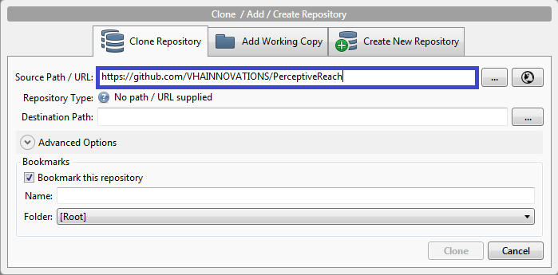

**Figure 1: SourceTree Cloning Operation**

Clone the Perceptive Reach GitHub Repository:

<https://github.com/VHAINNOVATIONS/PerceptiveReach>.

Then the correct branch can be checked out by selecting the correct branch from the **Remotes** menu in SourceTree then right-clicking the branch\_name and selecting **Checkout <branch\_name>**.

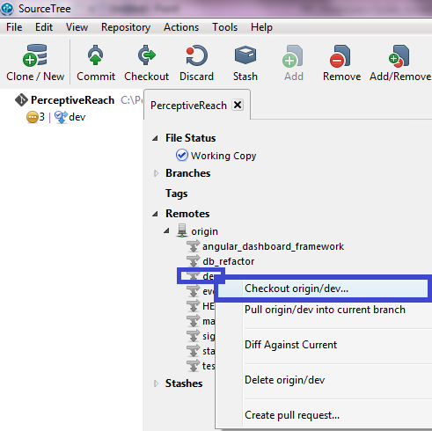

**Figure 2: Checking out dev from SourceTree**

All source code changes will happen in one of three branches, *dev* branch, a feature branch, or a hotfix branch. It is imperative for a developer to confirm what branch is active/checked-out before committing source code changes to GitHub. This can be done by reviewing the branch that is **bolded** under the “Branches” tree in the SourceTree Client or by running the following command in Git Bash: “git status”.

## Branching Strategy

The Perceptive Reach Repository incorporates a branching strategy in order to provide a structure to the repository for successful development, testing, and promotion of source code.

### Main branches

The main branches used in GitHub for VA Perceptive Reach are detailed below:

***master branch***

The *master* branch is the project deliverable branch and as such no development should occur against this branch. Source code is only merged from other branches, primarily *stable*.

***stable branch***

The *stable* branch will act as an integration/staging branch. It will contain production ready code that has passed all the continuous integrating testing scenarios. Source code will be manually merged from the *test* branch to the *stable* branch by the testing team. The *stable* branch will be merged into the *master* for delivery to the client.

***test branch***

The *test* branch will consist of all source code that has passed the developer unit test and is ready for continuous integration testing. Jenkins will provide an auto merge from the *dev* branch to the *test* branch. If the code passes, it will be merged into the *stable* branch, however if it fails, the code will be rolled-back to the *dev* branch.

***dev branch***

The *dev* branch is where the ongoing software development takes place. With the exception of hot fixes, all software code changes should be done against the *dev* branch. This means a developer will spend most of their time checked out against the *dev* branch.

### Supporting branches

Supporting branches are used to aid parallel development between team members and to assist in quickly fixing production problems. Unlike the main branches, these branches always have a limited lifetime, since they will always be removed eventually.

***Feature branches***

Feature branches are used to develop new features that are not ready for inclusion to the *dev* branch. This would be appropriated for development that is related to one specific feature that spans more than one Sprint. The essence of a feature branch is that it exists as long as the feature is in development, but will eventually be merged back into the *dev* branch or possibly discarded. Feature branches may branch off from *dev* and must be merge back into *dev*.

***Hotfix branches***

Hotfix branches are very much like feature branches in that they are short lived but are meant to fix a production release bug. When a critical bug in a production version must be resolved immediately, a hotfix branch may be branched off from the corresponding tag on the master branch that marks the production version. The essence is that work of team members (on the *dev* branch) can continue, while another person is preparing a quick production fix. Hotfix branches may branch off from the stable branch and must be merged back into *dev*, *test*, and *stable* branches. The naming convention should be hotfix-issue#, where issue# is the GitHub issue task number.

## GitHub Working with Feature Branches

### Creating a feature branch

When starting work on a new feature, branch off from the develop branch using the following commands:

$ git checkout -b myfeature *dev*

*Switched to a new branch "myfeature"*

A “Feature Branch” will be built against the Dev Branch. The “Feature Branch” will be created for one feature at a time. The “Feature Branch” will be tested and merged after completion.

### Incorporating a finished feature on dev

Finished features may be merged into the *dev* branch using the following commands:

$ git checkout *dev*

*Switched to branch 'develop'*

$ git merge --no-ff myfeature

*Updating… (Summary of changes)*

$ git branch -d myfeature

*Deleted branch myfeature*

$ git push origin *dev*

## Committing and Pushing Source Code Changes

Much like the GitHub initialization steps, source code change steps can be committed to GitHub with either Git Bash or SourceTree.

### Git Bash

To commit changes using the Git Bash console, navigate to the directory where Perceptive Reach has been cloned during initialization using the **cd** command to change directory.

For example, if the repository is in root\path\to\cloned\PerceptiveReach\directory, the developer would type:

cd /root/path/to/cloned/PerceptiveReach/directory

Then after the correct directory path is achieved, type the git command to commit the changes.

git commit -a -m ' PR-XXXX Put your work comment/description of the changes'

 This commit command is specific to VA Perceptive Reach because it has been integrated with JIRA to update the developers’ tickets denoted by the ‘PR-XXXX’ with the developers’ GitHub commits. The specific format of the letters ‘PR’ followed by a hyphen and four numbers corresponding to the JIRA ticket number is imperative or the code and ticket will not connect to one another when the ticket is pushed.

After the commit step has been completed, if a developer wishes to push changes to GitHub, he/she would issue the Git command to push, which is:

git push

### SourceTree

The SourceTree client will recognize any files that have not been committed in the **Unstaged Files** area and allow you to select then commit them. The process is as follows:

* + Navigate to the **File Status** tab.
  + Select all files to be committed to GitHub. This part of the process stages the files.
  + Provide a Commit Message – “PR-XXXX Was able to finish the proof of concept….” This step is where the “Smart Commit” connecting JIRA and GitHub takes place. If Smart Commit is being used, an optional time spent working on the task can be entered such as “PR-XXXX #2h” to reflect the developer spent 2 hours working on the task. Time can be populated manually as well directly in JIRA, so it is not imperative that the time tag is added. However, it is imperative that the task number is added.
  + Click “Commit”. This step results in the commit being added to a Jira task, and if the changes checked to immediately push the changed, then the changes also push during this step, which is unadvised unless the developer pulled the latest code just before committing.

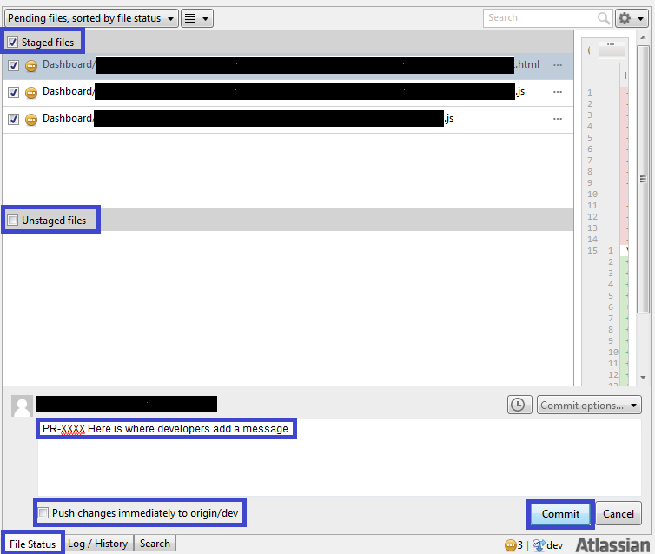

**Figure 3: Commit files from SourceTree to GitHub**

From this point if a developer wishes to **Push** the committed changes to GitHub, he or she would look at the **Pull** icon at the top of the application to see if any other developers checked in any new changes. If there are no changes to pull, the developer can click **Push** to push the changes to the dev branch.



**Figure 4: Pull and push buttons in SourceTree**

### Database Changes

Because some of the components of the Reach database contains items that are proprietary to the VA, the version control repository is located on a server behind the VA firewall in the VA Config File. For more detail please refer to the IRDS Database/ETL developers’ guide. When changes are made to the Reach database (database objects or reference data). Use the following steps:

1. Create a script that accomplishes exact changes to the database such as

* Add/remove a table
* Add/remove column to/from a table
* Add/remove records from a reference table
* Create/update a view or stored procedure

1. The script should include the schema that the object is a part of, except if the object is in the .dbo schema. This is set as the default schema in the reach database. This is necessary because the IRDS database development environment in the VA environment does not allow the .dbo schema and will be rejected.
2. Pass this script to the IRDS DBA to be added to the VA Config file.

## Working with Hotfix Branches

### Creating a hotfix branch

Hotfix branches are created from the master branch in order to fix a production problem. The branch can be checked out using the following commands.

$ git checkout -b hotfix-PR-XXX X *stable*

*Switched to a new branch "hotfix- PR-XXXX "*

A “Hot Fix” will be developed against the Stable branch. Only one branch will be created per “Hot Fix” branch. After successful testing, the “Hot Fix” branch will be merged with the Stable, Test, and Dev branches to close out the process.

### Incorporating a hotfix to stable

Once the bug is fixed, commit the fix in one or more separate commits as shown below.

$ git commit -m "Put your comment/description of the changes along with the GitHub Task Number”

*[hotfix-PR-XXX] Fixed severe production problem*

*5 files changed, 32 insertions(+), 17 deletions(-)*

### Finishing a hotfix branch

When finished, the bugfix needs to be merged back into *stable*, but also needs to be merged back into *dev* and *test* in order to safeguard that the bugfix is included in the next release as well.

First, update *stable* and tag the release.

$ git checkout *stable*

*Switched to branch 'stable'*

$ git merge --no-ff hotfix-PR-XXX

*Merge made by recursive.*

*(Summary of changes)*

Next, include the bugfix in *dev* and *test*, too (Repeat for each branch):

$ git checkout *dev*

*Switched to branch 'dev'*

$ git merge --no-ff hotfix-PR-XXX

*Merge made by recursive.*

*(Summary of changes)*

Finally, remove the temporary branch:

$ git branch -d hotfix-PR-XXX

*Deleted branch hotfix- PR-XXX*

## Finishing out the Sprint

Developers provide manual merges from the test branch to the stable branch and from the stable branch to the master branch at the end of a Sprint. The following commands can be used to accomplish this task as follows:

$ git checkout *stable* (or *master*)

*Switched to branch 'stable'*

$ git merge --no-ff *test* (or *stable*)

*Updating…(Summary of changes)*

$ git push origin *stable* (or *master*)

## Git Stash

If a developer would like to switch branches but does not want to commit what he or she has been working on yet, the following steps can be used to mitigate the situation.

Pushing a new stash onto the local stack will stage the uncommitted files until the developer is ready to work with them again in *dev*. He or she can use the git stash command as shown.

$ git stash

The working directory will now be clean. To verify use the following command:

$ git status

*# On branch master*

*nothing to commit, working directory clean*

At this point, any developer can easily switch branches and do work elsewhere. Changes are stored on the local stack. To see which stashes have been stored, use the git stash list command.

The following commands are used in the context of an example.

$ git stash list

*stash@{0}: WIP on master: 049d078 added the index file*

*stash@{1}: WIP on master: c264051 Revert "added file\_size"*

*stash@{2}: WIP on master: 21d80a5 added number to log*

In the above example, two stashes were created previously, so the developer has access to three different stashed works. Developers can reapply the code recently stashed by using the following commands:

$ git stash apply

*Applies the most recent stash*

$ git stash apply stash@{2}

Applies a specific one if there are more

# Code Compilation

A few configurable settings and commands must be run on a freshly cloned code base to make it compile and run successfully. When the application has run once successfully from a clean pull of the code base, these commands do not need to be issued to run the application unless the entire code base is wiped away and replaced with a fresh Git clone. The configuration steps need to take place before the application is run.

## Grunt and Node.js

The Dashboard Application, client and server, build process is managed by Grunt, The JavaScript Task Runner. This enables the build process to be consistent and automates tasks like minification, compilation, unit testing, linting, etc. Grunt and Grunt plugins are installed and managed via npm, the Node.js package manager. Therefore a few steps need to take place to install Grunt and Node.js components before running the application.

The compilation process utilizes the Node.js command prompt which can be found on the start menu under the Node.js folder.

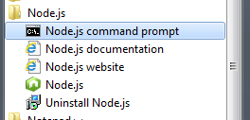

Compile the code by first going to the PerceptiveReach\Dashboard\PRDash-ADF directory then running the following in sequential order at the Node.js command prompt:

cd \PerceptiveReach\Dashboard\PRDash-ADF

npm install –g grunt-cli

npm install –g bower

npm install

bower install

Once they have successfully run, the developer can run the program by typing in **grunt serve.**

This command will deploy the project locally on port 9000 (<http://localhost:9000>)

### NPM Install Troubleshooting steps :

If there are errors (in red) in console window after executing “npm install” command then follow the troubleshooting steps below:

1. Confirm the errors are related to Node-Gyp module by reading the error text.
2. Install node-gyp module by following steps mentioned in this [link](https://github.com/nodejs/node-gyp) and then run “npm install” to confirm errors are resolved.
3. If the error still exists (After step 1 &2) install “Node Version manager” by following steps mentioned in this [link](https://github.com/creationix/nvm).
   1. Install 32 bit version of node (Choose the same version for 32 bit as 64 bit).
   2. Switch node version using “nvm use” command.
   3. Run “npm install” command and verify the errors have been resolved.

## SQL Server 2012

The Perceptive Reach web application points to a SQL Server database backend. For developers to run the application locally on their own machine or within a Virtual Machine (VM)/development environment, they must have a functional copy of SQL Server 2012 running and configured properly.

### SQL Server Installation

To install an instance of SQL Server:

1. Go to wherever on the machine the installation files are located and double click the SQL Server ‘setup.exe’ file.

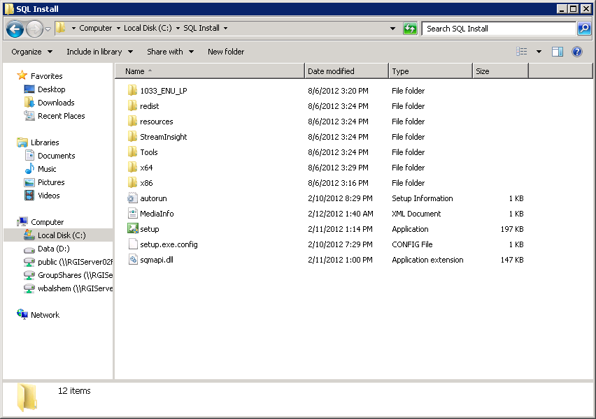

1. On the left panel select ‘Installation’.

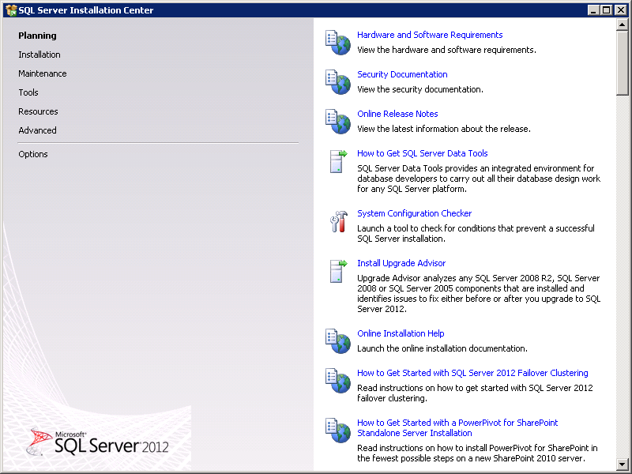

1. Select ‘New SQL Server stand-alone installation’

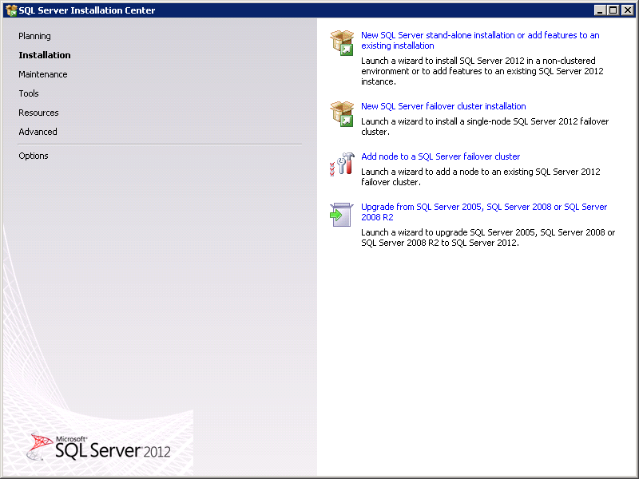

1. 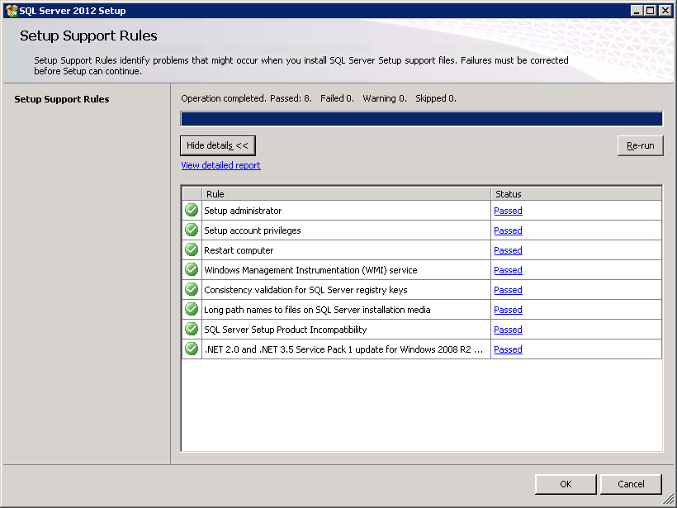Ensure all setup support rules have passed and click ‘OK’. If SQL Server lists any errors or warnings, address them on an individual basis.
2. Make sure the product key radio button is selected and press ‘Next’.

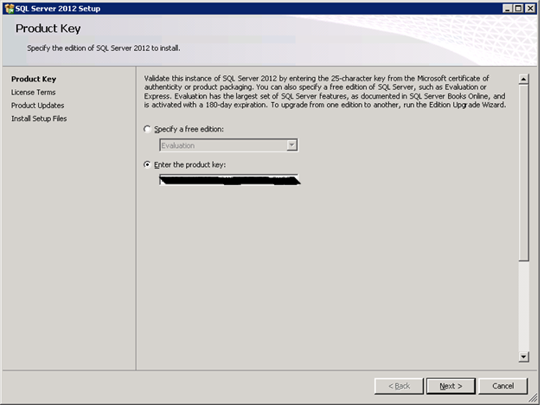

1. Accept the terms and click ‘Next’.

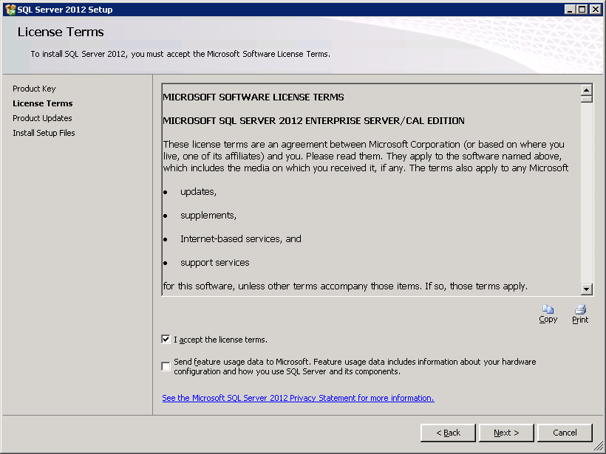

1. Confirm all setup support rules have passed and click ‘Next’. If SQL Server lists any errors or warnings, address them.

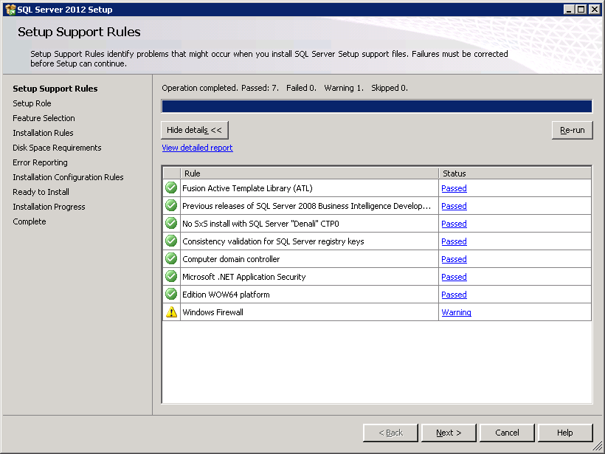

1. For Setup Role, select ‘All features with defaults’. Click ‘Next’.

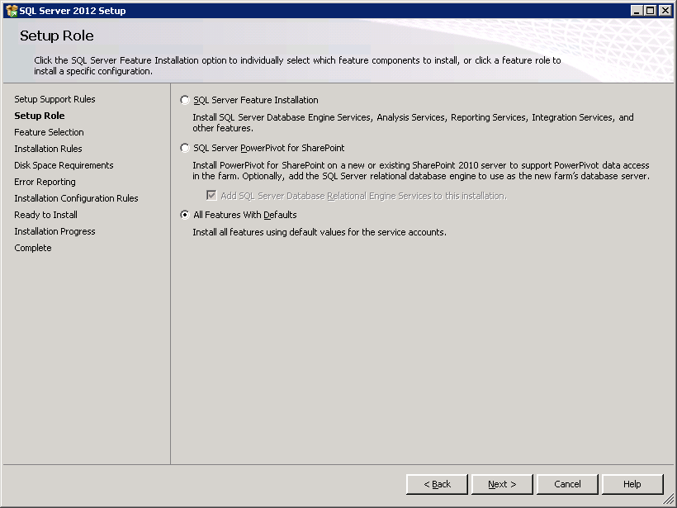

1. On the Feature Selection page, unselect Analysis Services and Reporting Services – Native. Keep the default Shared feature directories and click ‘Next’.

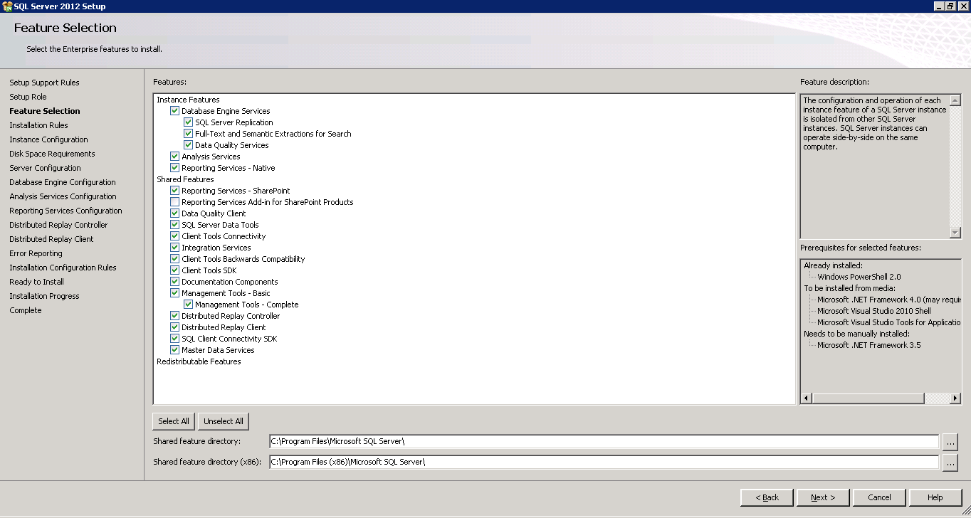

1. Verify all installation rules have passed and click ‘Next’. If SQL Server lists any errors or warnings, address them.

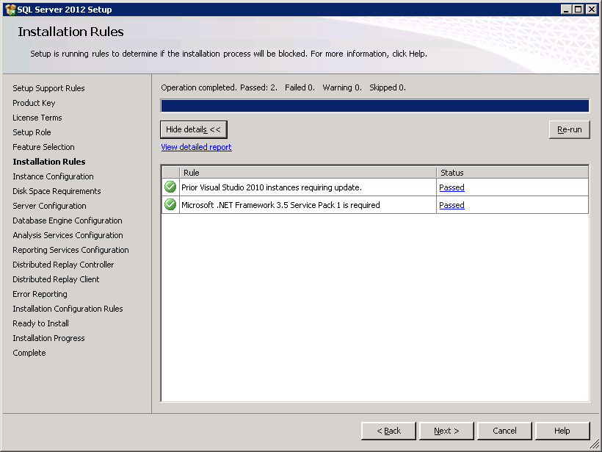

1. For Instance Configuration, leave all default instance settings and click ‘Next’.

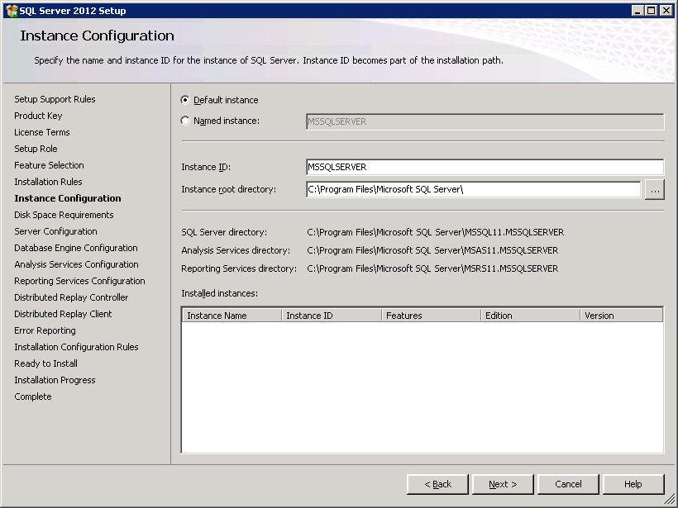

1. Review Disk Space Requirements and click ‘Next’. Address any issues if necessary.

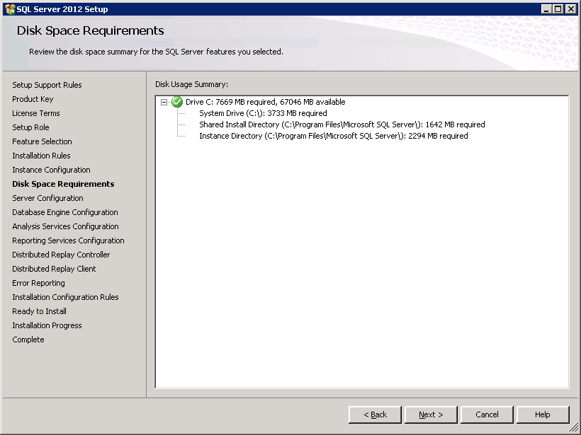

1. For server Configuration leave all defaults and click ‘Next’.

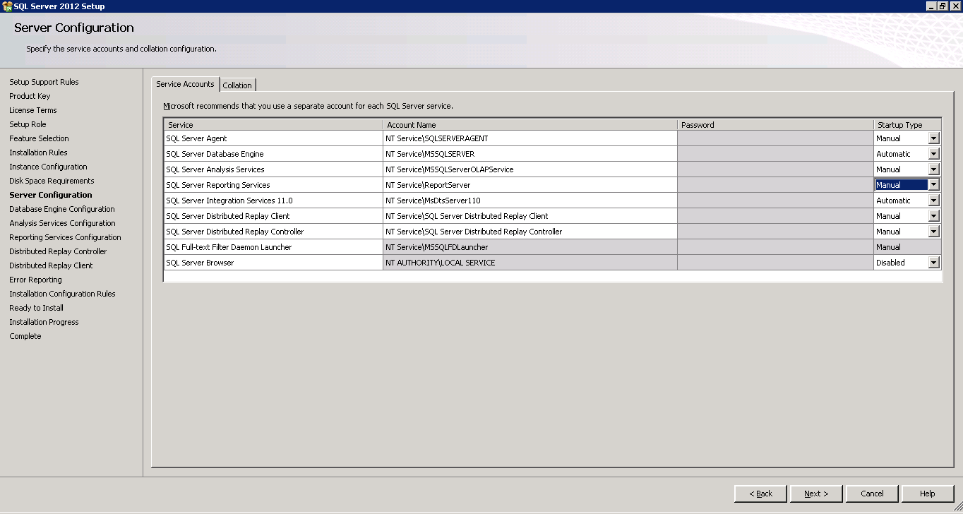

1. For the Database Engine Configuration section, make sure Windows authentication mode is selected. In the Server Configuration tab, add the Current User as Administrator.

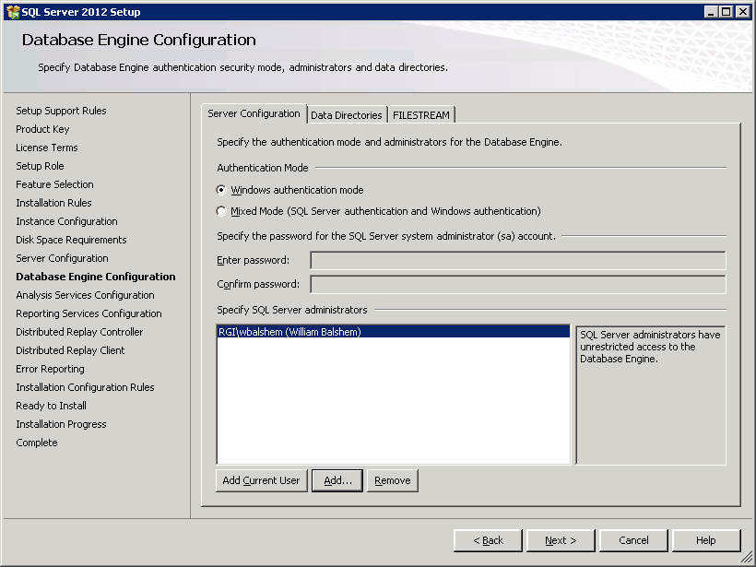

1. Select the Data Directories tab set the Data root directory to ‘C’, if this is a developers laptop, ‘D’ or ‘E’ if this is a server (whichever drive has been designated as the data drive for that server). This will change all other directories to subfolders below the root of the drive selected. Leave all other defaults. Click ‘Next’.

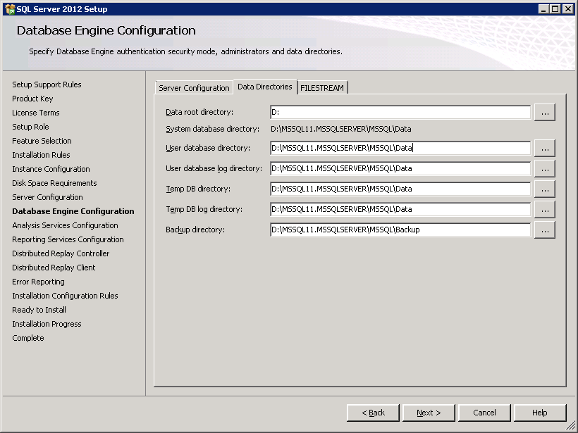

1. On the Distributed Replay Controller screen, add Current User as administrator.

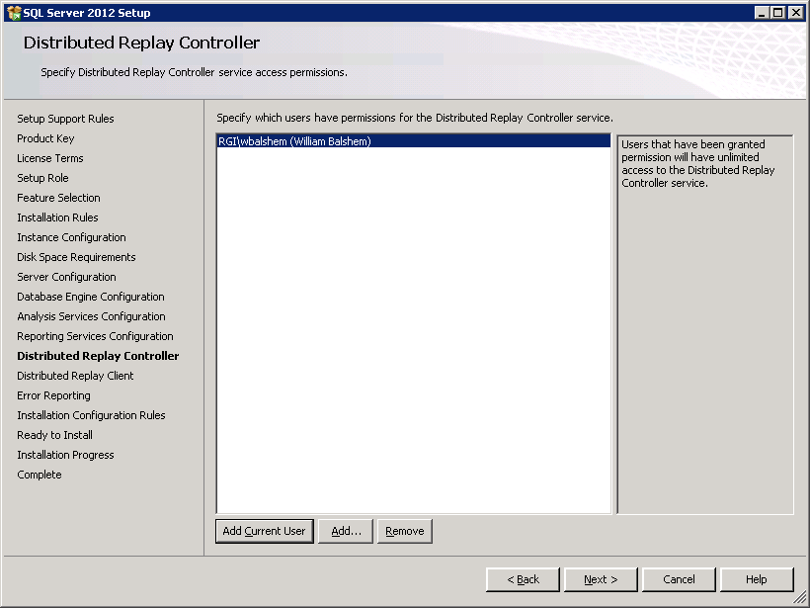

1. On the Distributed Replay Client screen, leave all defaults and click ‘Next’.

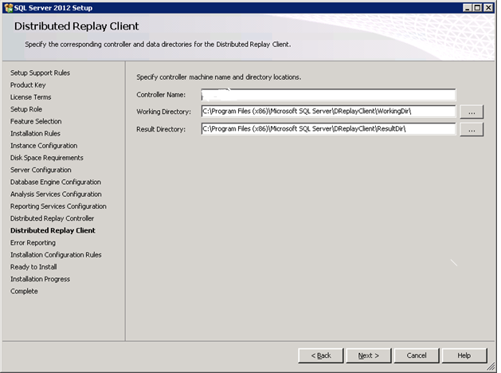

1. In the Error Reporting section, leave ‘Send Windows and SQL Server Error Reports…’ unchecked. Click ‘Next’.

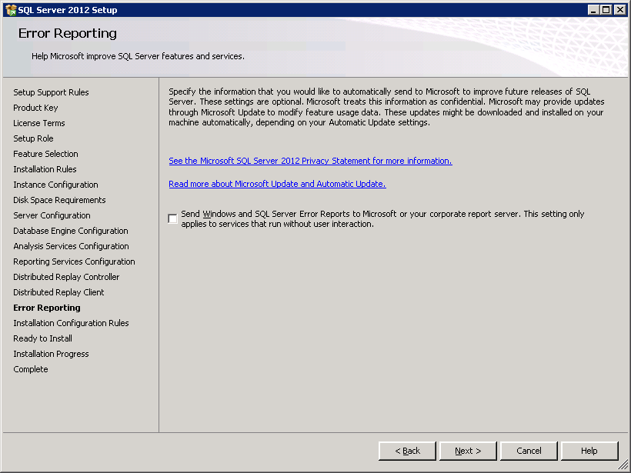

1. Make sure all Installation Configuration rules have passed and click ‘Next’. If SQL Server lists any errors or warnings, address them.

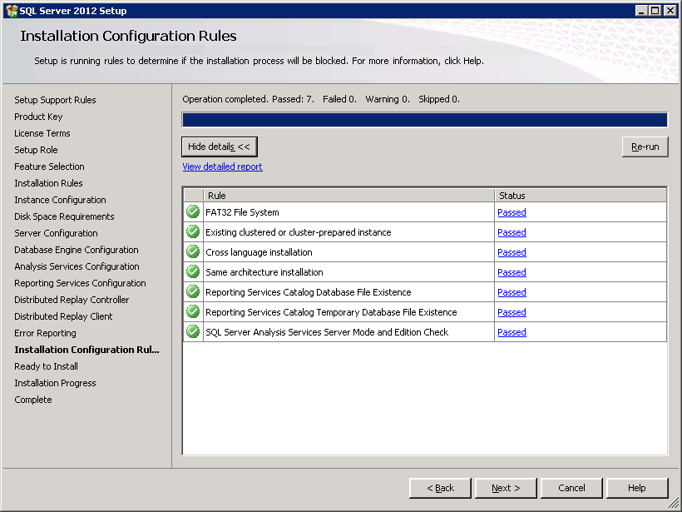

1. Review all Installation settings and click ‘Install’.

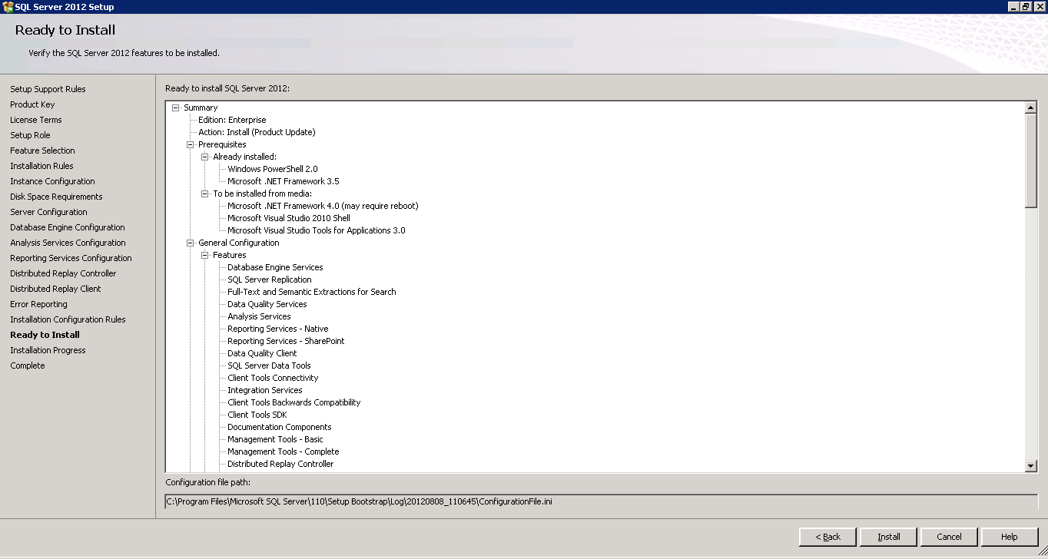

1. The installation process will begin and a process screen will show the updates as they occur. The installation will take a while to complete. The progress screen will display as ‘Complete’ when it is finished. Review installation results and click ‘OK’.

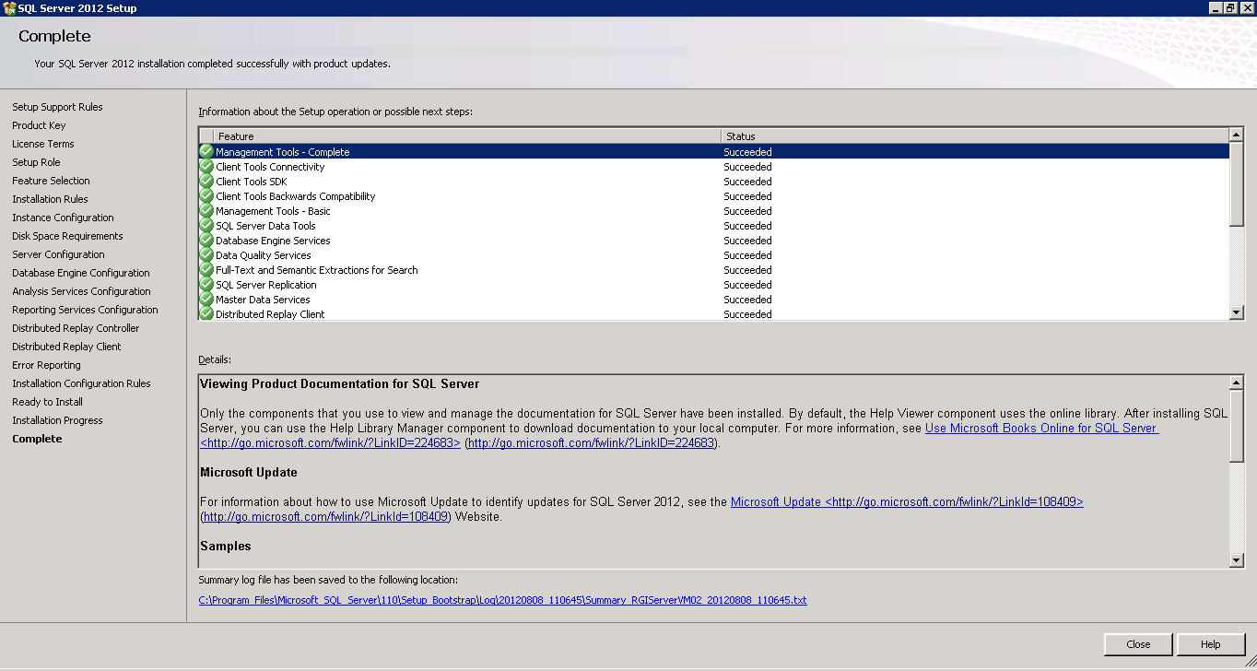

### Reach Database

To install a copy of the latest Reach database to your SQL Server instance:

1. From the cloud server go to D:\MSSQL11.MSSQLSERVER\MSSQL\Backup. A nightly process creates a compressed back up (.bak) of the Reach\_Dev database to this folder. Copy the latest backup to the machine where the new SQL Server Installation is. The date of the backup is included in the file naming convention. EX: Reach\_Dev\_Nov\_1\_2015.bak.
2. From SSMS, In the Object Explorer, right click on Databases and select Restore Files and Filegroups...

The Restore Files and Filegroups dialog appears. In the “To database” drop down type ‘Reach\_Dev’.

Select the From Device radio button and click the … ellipse.

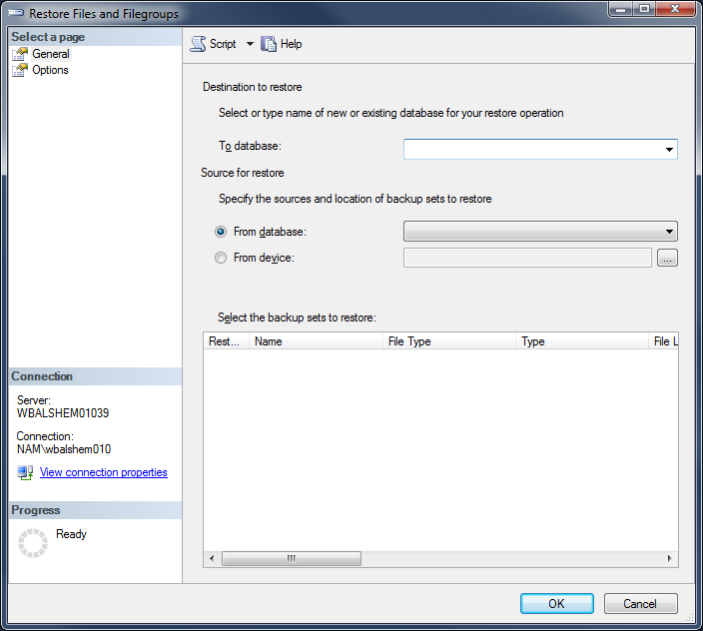

1. The Select backup devices dialog appears. Click the ‘Add’ button.

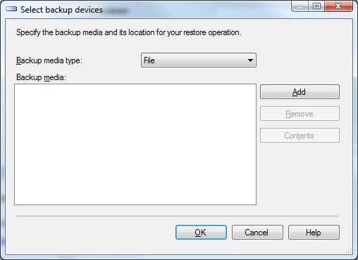

1. The Locate Backup File appears. Navigate to the folder where the .bak file was placed on select it. Click ‘OK’. Then click ‘OK’ on the Select backup devices dialog.

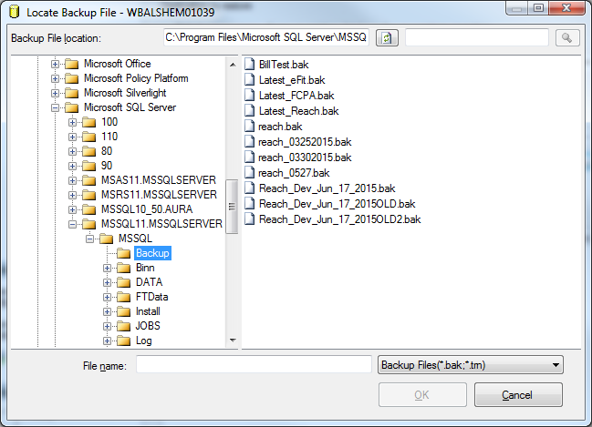

1. In the Restore Files and Filegroups dialog, an item has been added to the “Select the backup sets to restore” list box. Click the ‘Restore’ checkbox for that item and click ‘OK’.

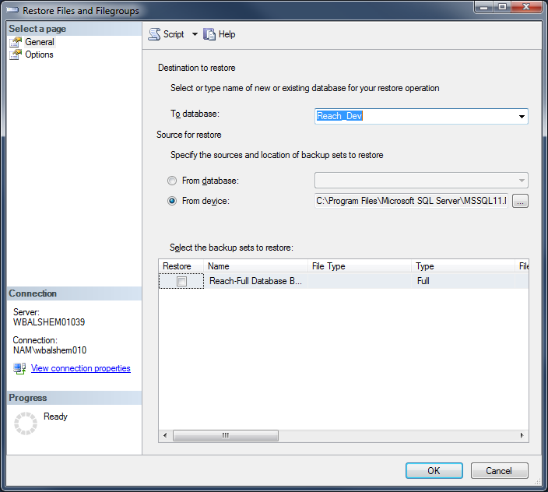

## Configuration Files

### .env

The .env file located under PerceptiveReach\Dashboard\PRDash-ADF\ must have the correct values for the Perceptive Reach database the developer would like to use. To configure the database settings, open .env in the development environment, and add the appropriate values as shown. The actual values for the db user, pass, and host will need to come from the development manager as the values may be dynamic in nature. The APP\_PATH variable should reflect the absolute path of the PRDash-ADF\client folder in the development environment.

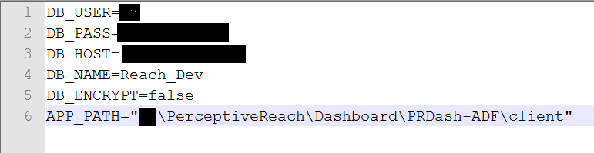

**Figure 5: Database .env file configuration**

# Deployment Packaging

The deployment of the Perceptive Reach Dashboard and Direct applications requires the same process for packaging. The deployment packages do not need to contain all of the development dependency files but rather only what is necessary for a production deployment. Once the deployment file is completed then it can be transferred to the production server for installation.

### Process

The packaging process begins with merging code in GitHub from the TEST to STABLE branch. This can be done by selecting the “New Pull Request” button in GitHub. Follow the additional steps below for merging the code in GitHub and checking out the STABLE branch.

1. In the pull request, ensure that the STABLE branch is the ‘base’ and the TEST branch is the ‘compare’

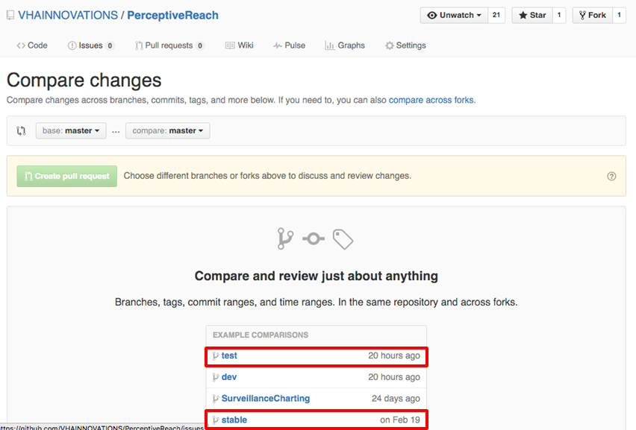

**Figure 6: GitHub Pull Request**

1. If the branches are in good shape, the ‘Able to Merge’ message will appear

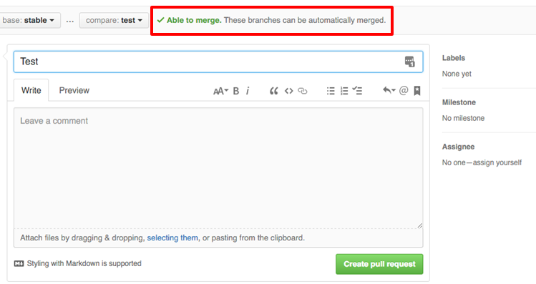

**Figure 7: GitHub Able to Merge Message**

1. Select the ‘Create Pull Request’ button
2. After selecting the ‘Create Pull Request’ button, you will see a summary of all the activity in the Pull Request and at the bottom the “Merge Pull Request” button should appear.

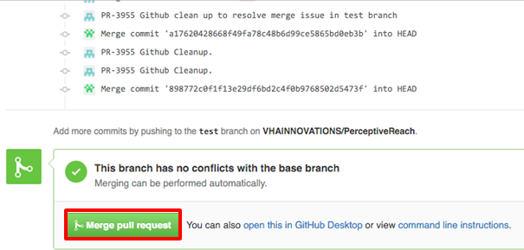

**Figure 8: GitHub Merge Pull Request**

* 1. **NOTE**: You never want to “Delete” the Branch

The packaging process will utilize the Node.js command prompt and an archiving tool, such as Winzip or Windows Send-to Compressed Folder. After checking out the “Stable” Branch from GitHub, follow the steps below:

1. Navigate to the root of the application:
   1. Cd C:\PerceptiveReach\Dashboard\PRDash-ADF
2. If the “node\_modules” folder exists, then delete it with the following command:
   1. rmdir node\_modules /S /Q

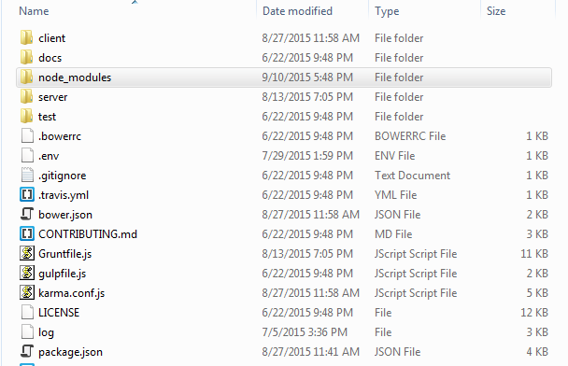

* 1. On occasion, Windows will prevent some of the contents of the node\_modules folder from being deleted, when this occurs delete the folder and all of its contents manually.

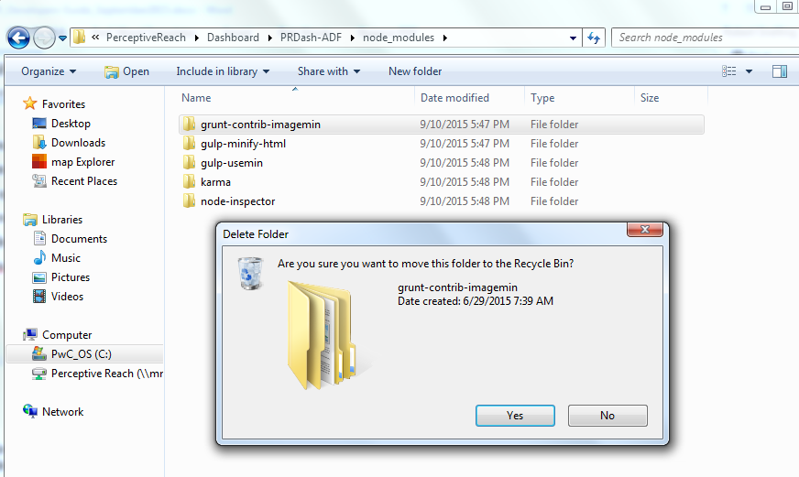

**Figure 9: Delete Folder Manually**

* 1. If the “docs” and test” folders exist, delete these manually.

1. Run the following commands in succession:

npm install ––production (2 “–“ dashes)

npm dedupe

bower install

1. Create a compressed archive (Zip) of the contents of the PRDash-ADF folder. Do this by highlighting all of the folders and files, then right click and select “Send to”, “Compressed (zipped) folder”.

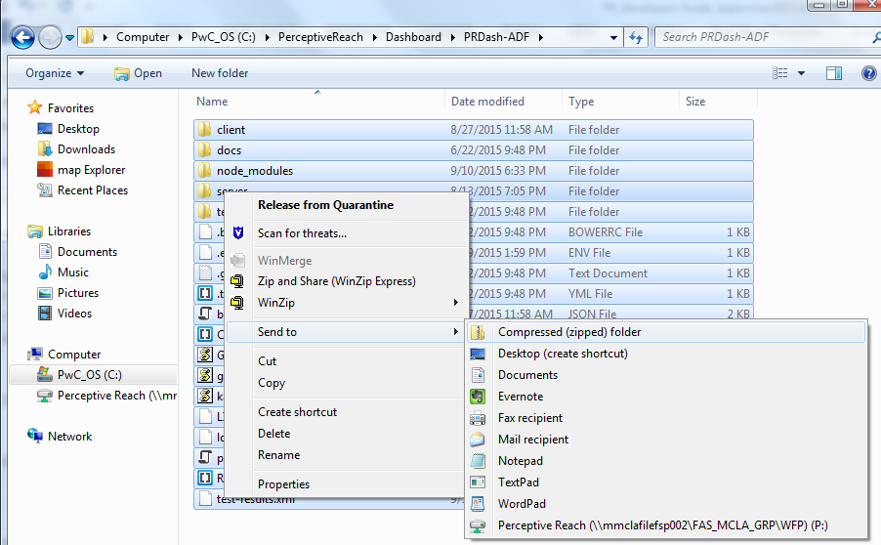

**Figure 10: Zip the PRDash-ADF Folder**

1. Rename the Zip file to match the release deployment, ie. PR\_Dashboard\_Release 2.zip.

# Development Cycle

Each development cycle typically takes on a standard pattern of events as follows.

* Developers use the **dev** branch to make changes, enhancements, and updates
* Developers create unit tests for recently developed code and verify that they pass when run
* Developer commits code to GitHub **dev** branch which is tested via Jenkins
* Jenkins compiles, deploys, and tests the **dev** branch
* The **dev** branch build process successfully completes then triggers the **test** branch to update
* The **test** branch is merged with the dev branch and triggers a build process
* The **test** branch is built and tested via Jenkins
* Upon failure the CI pipeline sends emails out to prompt action
* Upon completion of Sprint and testing succeeding the code is promoted to the **stable** branch.
* The **stable** code is pushed to the **master** branch

# Test Driven Development

Test-driven development relies on the repetition of a very short development cycle. The developers usually write a test case and then write the minimum amount of code to illicit an expected test outcome. The typical steps for this sort of development form a pattern, and for Perceptive Reach they take on the following steps.

* Requirements become a user story
* The user story becomes test plan task, executed by the test team in Cucumber
* The entire team engages to refine a requirement as needed
* The development team works in Jasmine to turn the test plan into a unit test then subsequently a function or feature
* The entire team engages again to refine the requirement as needed
* The development and test team work through continuous integration
* Unit testing succeeds
* Functional/Usability testing succeeds
* The build succeeds and is promoted to the **stable** environment

# VA Cloud Server Deployments of Perceptive Reach

## Dashboard

The Perceptive Reach Dashboard is running on the VA Cloud Server running via Internet Information Services (IIS). There are three environments running from three different ports, differentiating dev from test and stable versions of the dashboard.

|  |  |
| --- | --- |
| VA Perceptive Reach Dashboard Environments | |
| Development, Dev DB | http://irdsdev.vaftl.us:7001 |
| Test, Test DB | http://irdsdev.vaftl.us:7003 |
| Stable, Stable DB | http://irdsdev.vaftl.us:7005 |
| Feature View | http://irdsdev.vaftl.us:7007 |

**Table 1: VA Perceptive Reach dashboard environments**

## Databases

There are currently three separate Perceptive Reach databases. The developers use Reach\_Dev for all development activity, and testers follow suit using Reach\_Test.

Reach is the production database and runs stable code. It is backed up after each Sprint, and major changes or enhancements are all stored in scripted format for use in future release guides.

|  |  |
| --- | --- |
| VA Perceptive Reach Databases | |
| Reach\_Dev | Development database built ad-hoc to produce scripts and guides for future use |
| Reach\_Test | Test database built using scripts and deployment guides |
| Reach (master database, stable) | Master database with stable code |

**Table 2: VA Perceptive Reach databases**

# Atlassian JIRA

Jira is the Sprint management tool being used for Perceptive Reach. It can be downloaded from the internet at <https://opensourceehr.atlassian.net>.

JIRA makes use of Epics, User Stories, and Tasks to track code base development and issue resolution.

## Epics, User Stories, and Tasks

**EPICS**

* Captures a large body of work
* It is essentially a large [user story](https://confluence.atlassian.com/display/AGILE/Story) that can be broken down into a number of smaller stories
* It may take several [Sprints](https://confluence.atlassian.com/display/AGILE/Sprint) to complete an epic.
* *Example: As a member of VA leadership, VA Center of Excellence for Suicide Prevention staff, VA Mental Health leaders, and VA Suicide Prevention Coordinators (hereby indicated as a "Suicide Prevention Staff Member") I want to view a surveillance dashboard with results produced from the continuous monitoring and processing of linked data sources so I can monitor and understand Suicide Outreach outcomes.*

**USER STORIES**

* A *story* or *user story* is a software system requirement that is expressed in a few short sentences, ideally using non-technical language.
* User oriented language
* *Example: As a Dashboard User, I want to view newly identified at-risk Veterans during a specific time frame.*

**TASKS**

* A *task* is a unit of work contained within a [story](https://confluence.atlassian.com/display/AGILE/Story).
* *Example: Create Database/API Components for Clinical Practice Guidelines (PR-996)*
* When writing a Task it HAS to contain an action word such as: create, implement, research, enable, etc.

## JIRA Guidelines

There are several best practices in place to ensure the Agile methodology is optimized for use on this project. These guidelines govern the way the development team behaves with each other as well as the code base.

### Linking epics, user stories, and tasks

When using JIRA to document work, each epic has to be linked to one or more user stories in JIRA. When a ticket is being created, the user can link it to an epic through use of the interface.

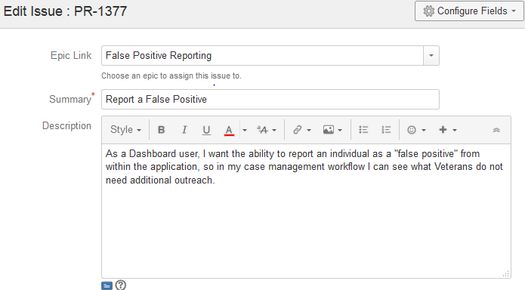

**Figure 11: Linking an epic to a user story in JIRA**

Additionally, each task must be linked to its user story.

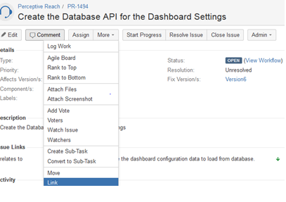

**Figure 12: Linking a user story to a task in JIRA**

### Adding blockers

A blocker in the context of JIRA is any story, task, or issue that prevents a developer from moving forward with others. How to add a blocker or change the priority of the story, task, or issue in Jira is shown below.

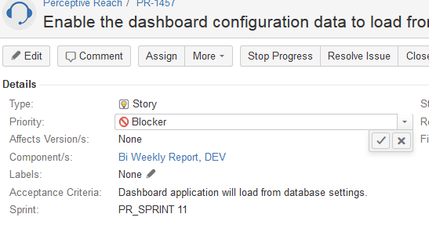

**Figure 13: Adding a blocker in JIRA**

### Smart Commits

Smart Commits link GitHub submissions to JIRA tasks and tickets to enhance traceability.

Each git commit must be accompanied by relevant Smart Commit tags for a task or issue number, time spent, and comments. Three of these four tags can be used as follows in the commit message of a Git code submission:

Task number: PR-XXXX

Time spent: #time Xh Ym Zs

Comments: #comment ‘here is a comment’

Transition: **do not use**

# Jenkins Continuous Integration

Jenkins Continuous Integration tool is used to build and deploy code and third party source to multiple environments in a continuous fashion. Changes flow from development to test to stable based on gateway criteria for each environment. To honor the quality benchmarks set for the code base, the Perceptive Reach cycles code through the following environments:

|  |  |
| --- | --- |
| **Environment** | **Details** |
| **PR\_DEV** | Development branch of Perceptive Reach. Once build occurs successfully, this environment script triggers a push to PR\_DEV\_TEST. |
| **PR\_FEATURE** | New feature branch of Perceptive Reach. Once the new feature is tested and ready, the code is pushed on to DEV branch. |
| **PR\_DEV\_TEST** | This environment runs development unit tests. Upon successful completion it triggers a push to PR\_TEST. |
| **PR\_TEST** | This environment is test for Perceptive Reach. Upon successful build and test it merges the dev branch with the test branch then triggers a push to PR\_TEST\_TEST. |
| **PR\_TEST\_TEST** | This environment is where Cucumber functional tests are run, and its results represent coverage of the functional requirements. |
| **PR\_STABLE** | This environment is a merge of test after the successful build and test of PR\_TEST\_TEST. It represents the completion of the Sprint, and it is the demo environment. |

**Table 3: Jenkins Continuous Integration Environments**

# Dev Server Build Process

## Build Overview

## Build Manual Steps

To prepare for the build process the following tasks must be completed.

* Install Node.js (v) + IISNode (v) + IIS redirect addon
* Compile the code by first going to the PerceptiveReach\Dashboard\PRDash-ADF directory then running the following in sequential order:
  + npm install –g grunt-cli
  + npm install –g bower
  + npm install
  + bower install
* Configure: IIS
* Create a new site then point site to the directory where the compiled code.
* A web.config file must be present with a redirect to the correct file.js.
* Database: SQL Server 2012
* CI: Jenkins (v)
* Configure: install add-ons for Git, NodeJS
* Testing: Cucumber (v)
* Configure Cucumber using the following commands:
  + gem install cucumber
  + gem install selenium-webdriver
  + gem install gherkin
  + gem install capybara
  + gem install rspec

# Additional Resources

Additional resources for the VA Perceptive Reach innovation project are available in the form of companion documents to this Developers Guide and online.

## Documentation

Relevant documentation for the VA Perceptive Reach Integrated Reach Database System includes:

* *Perceptive Reach Installation Guide*: Provides detailed instructions for setting up, installing, and configuring Perceptive Reach on VA servers. Its intended audience includes server administrators, Information Rights Management IT specialists, and AngularJS application developers.
* *Perceptive Reach System Design Document*: Contains detailed information on the design considerations as well as high and low level architecture for VA Perceptive Reach.
* *Perceptive Reach Developer Guide* (this document):Contains detailed information about workstation setup, authentication, continuous integration, JIRA, SQL Server, and code base details.

## VA Perceptive Reach Innovation Site

Additional web-based information about the VA Perceptive Reach project is available on the VA Cloud at <http://vacloud.us/groups/558/>.

# Acronyms & Abbreviations

|  |  |
| --- | --- |
| **Acronym** | **Term** |
| CI | Continuous Integration |
| CSS | Cascading Style Sheets |
| GUI | Graphic User Interface |
| HCD | Human Centered Design |
| HTML | HyperText Markup Language |
| IDE | Integrated Development Environment |
| IIS | Internet Information Services |
| IRDS | Integrated Reach Database System |
| JS | JavaScript |
| SQL | Structured Query Language |
| VA | Department of Veterans Affairs |
| VM | Virtual Machine |

**Table 4: Acronyms and Definitions**