Perceptive Reach

Integrated Reach Database System

(IRDS)

User Guide



Department of Veterans Affairs

May 2015

Version 0.1

Revision History

Note: The revision history cycle begins once changes or enhancements are requested after the Requirements Specification Document has been baselined.

| Date | Version | Description | Author |
| --- | --- | --- | --- |
| 5/01/2015 | 0.1 | First Draft | Radina Ivanova/Matthew Robinson |
|  |  |  |  |
|  |  |  |  |
|  |  |  |  |

**Table** **of Contents**

1. About this document 1-4

2. Introduction 2-4

2.1. Purpose 2-4

2.2. Scope 2-4

3. General Information 3-4

3.1. Project References 3-5

3.2. Authorized Use Permission 3-5

3.3. Points of Contact 3-6

3.3.1. Information 3-6

3.3.2. Coordination 3-6

3.3.3. Help Desk 3-6

3.4. Organization of the Manual 3-6

3.5. Acronyms and Abbreviations 3-6

4. System Summary 4-10

4.1. System Overview 4-10

4.1.1. SDR Database Background 4-11

4.2. Data Flows 4-12

4.3. User Access Levels 4-12

4.4. Contingencies and Alternate Modes of Operation 4-12

5. Getting Started 5-1

5.1. Logging On 5-1

5.2. System Menu 5-1

5.2.1. [System Function Name] 5-1

5.3. Changing User ID and Password 5-1

5.4. Exit System 5-1

6. Using the System (Online) 6-1

6.1. [System Function Name] 6-1

6.1.1. [System Sub-Function Name] 6-2

6.2. Special Instructions for Error Correction 6-2

6.3. Caveats and Exceptions 6-2

7. Using the System (batch) 7-2

7.1. [System Function Name] 7-2

7.1.1. [System Sub-Function Name] 7-2

7.2. Special Instructions for Error Correction 7-3

7.3. Caveats and Exceptions 7-3

7.4. Input Procedures and Expected Output 7-3

8. Querying 8-3

8.1. Query Capabilities 8-3

8.2. Query Procedures 8-4

9. Reporting 9-4

9.1. Report Capabilities 9-4

9.2. Report Procedures 9-4

# About this document

This document is a “work in progress.” In accordance with industry-standard Agile best practices, this document will be populated with content as the design evolves with each sprint.

# Introduction

This User Manual is developed for the Perceptive Reach Integrated Reach Database System (IRDS) project for the Department of Veterans Affairs (VA). VA is seeking to expand suicide prevention to include upstream approaches designed to reduce initiation or escalation of a suicide risk factor. Upstream suicide interventions target individuals or groups who exhibit biological, psychological, or social risk factors that are more prominent among high-risk groups than among the larger population. Understanding the unique needs of our nation’s Veterans and the military culture as it relates to stigma and mental health is important for early intervention. The goal of the IRDS innovation is to promote the general health of the Veteran population and effectively intervene in issues before they escalate into crisis.

The IRDS solution will harness the power of large and diverse data stores to aggregate, analyze and identify risk onset as well as reveal previously unidentified at-risk individuals and populations as a holistic and integrated approach. The IRDS innovation will serve to bolster the three major components of Veterans Health Administration’s (VHA) Strategic Plan for Suicide Prevention: surveillance, risk and protective factors, and prevention interventions. The IRDS innovation will target antecedent events specific to Veteran populations prior to the onset of risk to mitigate the development of risk.

## Purpose

This User Manual was developed to help internal and external users become better acclimated to using and navigating the IRDS as it may apply to their responsibilities.

## Scope

The User Manual contains a description of the functions and capabilities, step-by-step procedures for access and use, and additional essential information for users to make full use of the specified system or system element.

# General Information

The IRDS innovation, a pilot program under VHA’s VA Center for Innovation (VACI), serves to bolster the three major components of VHA’s Strategic Plan for Suicide Prevention: surveillance, risk and protective factors, and prevention interventions. The IRDS innovation targets antecedent events specific to Veteran populations prior to the onset of risk to mitigate the development of risk.

The Integrated Reach Database System (IRDS) is an integrated data analytic and predictive modeling database system that also includes direct messaging. This system utilizes predictive analysis to provide early intervention and treatment solution to prevent Veteran suicide. This solution integrates clinical data sources, integrated data analytics, a surveillance dashboard and secure messaging into one system.

Use of this User Guide applies to the Perspective Reach application features as they exist in the application’s pilot phase. A future version of this document will serve as the User Guide for the nationwide production version of the application.

## Project References

The documents below also contain relevant information related to the use, design, technical features of Perceptive Reach.

* Suicide Outreach and Intervention Toolkit <link>
* Installation Guide <link>
* System Admin Guide <link>
* Technical Manual <link>
* Developer Guide <link>
* Latest Release Notes <link>

## Authorized Use Permission

Authentication and permission determine the identity of a user, server, or client and the settings that define who or what is allowed to use it and what they are allowed to do with it. Refer to Section 4.3 for User Access Levels. Unauthorized use of this system could subject users to penalties as described in VA Handbook 6500[1] and any other relevant VA policy documents or US law.

## Points of Contact

|  |  |
| --- | --- |
| **Name** | **Contact Information** |
|  |  |
|  |  |
|  |  |

### Information

All user requests for information, help, trouble shooting, documentation, or instructions should be directed to the Perceptive Reach Help Desk contacts listed in Section 3.3.3.

### Coordination

Provide a list of organizations that require coordination between the project and its specific support function (e.g., installation coordination, security, etc.). Include a schedule for coordination activities.

### Help Desk

All user requests for information, help, trouble shooting, documentation, or instructions should be directed to the Perceptive Reach Help Desk at <link>.

## Organization of the Manual

Provide a list of the major sections of the User’s Manual (1.0, 2.0, 3.0, etc.) and a brief description of what is contained in each section.

## Acronyms and Abbreviations

Table 1: Acronyms and Abbreviations

| Acronym | Term |
| --- | --- |
| Army STARRS | Army Study to Assess Risk and Resilience in Service members |
| API | Application Program Interface |
| CDC | Center for Disease Control |
| CDW | Corporate Data Warehouse |
| CI | Continuous Integration |
| DB | Database |
| DoD | Department of Defense |
| EA | Enterprise Architecture |
| ETL | Extract, Transform, Load |
| FMQL | FileMan Query Language |
| GB | Gigabyte |
| HMAC | Hash-based Message Authentication Code |
| HTTPS | Hypertext Transfer Protocol Secure |
| ICD | International Classification of Diseases |
| IRDS | Integrated Reach Database System |
| IT | Information and Technology |
| JDBC | Java Database Connectivity |
| JSON | JavaScript Object Notation |
| NDI | National Death Index |
| ODBC | Open Database Connectivity |
| PMP | Project Management Plan |
| REST | RESTful |
| RPC | Remote Procedure Call |
| RSD | Requirements Specification Document |
| RTM | Requirements Traceability Matrix |
| SAS | Statistical Analysis System |
| SDCD | State Death Certificate Data |
| SDR | Suicide Data Repository |
| SPA | Single Page Application |
| SPAN | Suicide Prevention Applications Network |
| SQL | Structured Query Language |
| SSIS | SQL Server Integration Services |
| SSN | Social Security Number |
| TBD | To Be Determined |
| TRM | Technical Reference Manual |
| UBHC | University Behavioral Health Care |
| UI | User Interface |
| VA | Department of Veterans Affairs |
| VAMC | VA Medical Center |
| VCL | Veterans Crisis Line |
| VHA | Veterans Health Administration |
| VISN | Veterans Integrated Service Networks |
| VistA | Veterans Health Information Systems and Technology Architecture |
| VLER | Virtual Lifetime Electronic Record |
| VSO | Veterans Service Organizations |
| PMAS | Project Management Accountability System |
| SDD | System Design Document |
| DBMS | Database Management System |
| HHS | U.S. Department of Health and Human Services |
| CRS | Congressional Research Service |
| PR | Perceptive Reach |
| KNIME | Konstanz Information Miner |
| BIRT | Business Intelligence and Reporting Tools |
| DOB | Date of Birth |
| ID | Identification |
| MUMPS | Massachusetts General Hospital Utility Multi-Programming System |
| CPU | Central Processing Unit |
| LAN | Local Area Network |
| WAN | Wide Area Network |
| MVC | Model View Controller |
| PII | Personally identifiable information |
| PHI | Protected health information |
| PACER | Public Access to Court Electronic Records |
| TBI | Traumatic Brain Injury |
| VR&E | Vocational Rehabilitation and Employment |
| VBA | Veterans Benefit Administration |
| PTSD | Post-Traumatic Stress Disorder |
| US | United States |

# System Summary

## System Overview

The Perceptive Reach application combines technology outreach and clinical support to realize a clinically based data-driven early intervention and treatment solution aimed at suicide prevention. The application includes capability for analyzing multiple and integrated data sets with cutting-edge data analytic techniques and visualizations to identify at-risk individuals and populations and provide proactive and secure notifications of these results to Veteran support services.

As shown in **Figure 1**, IRDS is an integrated system comprised of the following:

* **Reach Database.** A SQL database used to aggregate new data sources and relevant data from VHA’s Suicide Data Repository (SDR).
* **Data Analytics Platform and Dashboard.** An integrated collection of analytics and visualization tools, including a surveillance dashboard aimed at identifying at-risk individuals and populations.
* **Direct Messaging.** A method to construct and transmit a secure message to authorized outreach and intervention service providers.
* **Outreach and Intervention.** A pilot workflow that includes the process by which outreach and intervention resources are notified and act upon the data provided.

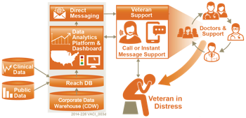

Figure 1: IRDS System Overview

### SDR Database Background

VHA’s SDR is a centralized SQL Server database, which currently consolidates multiple sources of data containing suicide and mortality data of Veterans. The SDR is one of the primary data sources for the IRDS innovation. Data from the sources below are periodically imported into the SDR. Sources include:

* National Death Index (NDI) based on DoD and VA NDI search criteria
* State Death Certificate Data (SDCD)
* Suicide Prevention Applications Network (SPAN)
* Veterans Crisis Line (VCL)

The SDR provides a means for VA to quantify and monitor the scope of Veteran suicide by analyzing SDR data using analytics to identify characteristics associated with higher or lower risk of suicide, and track changes in the suicide rate over time to evaluate the effectiveness of suicide prevention interventions.

Importantly, the SDR provides a view into the unique characteristics of Veterans pertaining to mortality, suicide ideations, suicide attempts, crisis line communications, and mental healthcare. The data contained within the SDR combined with additional real time clinical data sources represents an opportunity to more accurately identify at-risk Veterans.

## Data Flows

The figure below describes the major data inputs and outputs for the application.

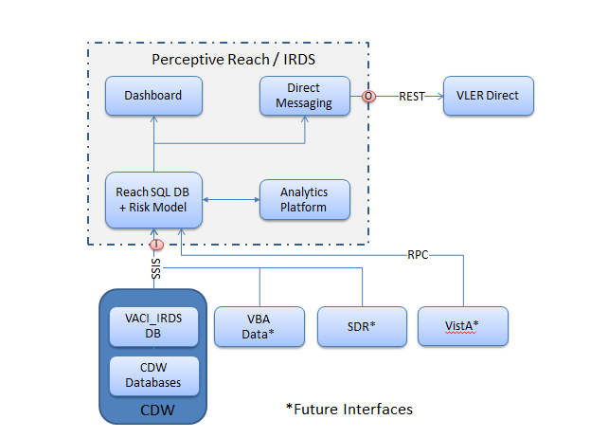

Figure 2: Data Flow

## User Access Levels

**Table 2** describes the various user access levels for the IRDS application.

Table 2: User Access Levels

|  |  |  |  |  |  |
| --- | --- | --- | --- | --- | --- |
|  | Clinical Care Team Members[2] | Supervisors | Researchers | Reporters | System Administrators |
| Individual Veteran View Widgets | X | X |  | X | X |
| Facility View Widgets | X[3] | X |  | X | X |
| VISN / State / Region / Nation View Widgets |  | X |  | X | X |
| R / KNIME / MySQL Database Access |  |  | X | X | X |
| System Administration Tools |  |  |  |  | X |

## Contingencies and Alternate Modes of Operation

Matters related to operations in the event of an emergency, disaster, or accident are described in the IRDS Disaster Recovery Plan at <link>. To report a performance issue or outage, please refer to Section 3.3.3. of this User Guide to contact the Help Desk.

# Getting Started

## Logging On

To log on to the Perceptive Reach Dashboard, follow these steps:

1. Open a web browser and navigate to <hyperlink>.
2. Enter your username into the “Username” field.
3. Enter your password into the “Password” field. Your username should be the same you use to access other VA systems such as email and the Computerized Patient Record System (CPRS).
4. Click the “Login” button below the username and password fields. The system will then display your default Perceptive Reach Dashboard view.

*If you do not enter a valid username and password combination or do not have one in the system, the application will not permit you to log on.*

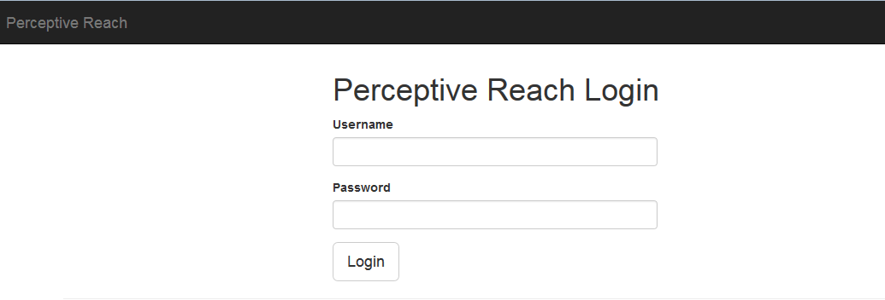

Figure 3: Login

To log on to VLER Direct to access Direct Messages, follow these steps:

1. If you are an existing Perceptive Reach user and are receiving VLER notifications in your VA Outlook email inbox, navigate to a Perceptive Reach notification and click the link to VLER in the body of the message.
2. If you are not automatically logged on to the VLER application, enter your username in the “Username” field.
3. Enter your password into the “Password” field.
4. Click the “Login” button to enter the application.
5. To set up a new account, follow the below steps:

* Open Internet Explorer (8+). Alternatively, Mozilla Firefox may be used.
* Go to the webpage, https://direct.va.gov, on a PIV enabled workstation.
* Click on Register with Direct account and you will be prompted to select your certificate again.
* Once the page loads, Direct Secure Messaging will pull identification information from PIV, Organization, Department, Phone, and Job Title may be completed but are not required (**Figure 5**).
* When the **New User Registration** web form is complete, review the information and click **Submit Request** to notify Direct Secure Messaging Application Administrators of the request for an account.

When an account request is submitted, the Application Administrator will login to the API Admin Panel, confirm that the user is authorized to use Direct Secure Messaging, and approve the account.

A notification email will be sent out to inform that the Direct Secure Messaging Account may be used and the user will be notified they need to wait for their account to be approved (**Figure 4**).

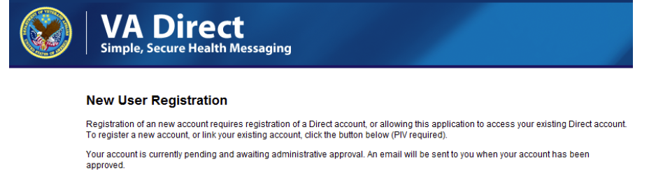

Figure 4: Direct Secure Messaging User Registration Submitted

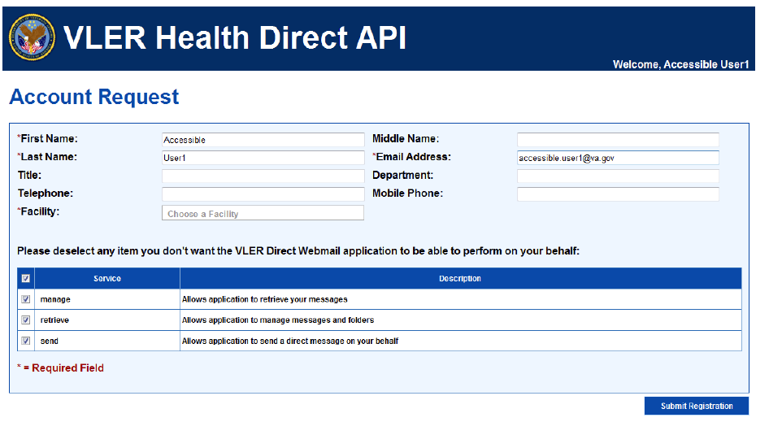

Figure 5: VLER Health Direct API

For detailed instructions for how to log on and access Reporting and Research capabilities for the IRDS, contact system administrators via the Help Desk.

If you are not able to access the system or need further instruction, contact the Help Desk.

## System Menu

### Dashboard System Menu Options

The sections below detail system menu options specific to uses accessing the Perceptive Reach Dashboard.

#### Dashboard Views

From this area of the Dashboard, users can access various views on the Dashboard organized by geographic area. For users who are members of frontline clinical care teams (the majority of users), access will be limited to viewing the:

* **Individual Veteran View**, providing information related to outreach, intervention, and care for a specific Veteran within the system
* **Facility Level View**, providing information and data about at-risk Veterans who are associated with the user’s home facility

Additional views provide the ability to see information and data related to at-risk Veterans within a specific, state, VISN, region, or nationally. Access to these views is limited to users with “Supervisory” level access.

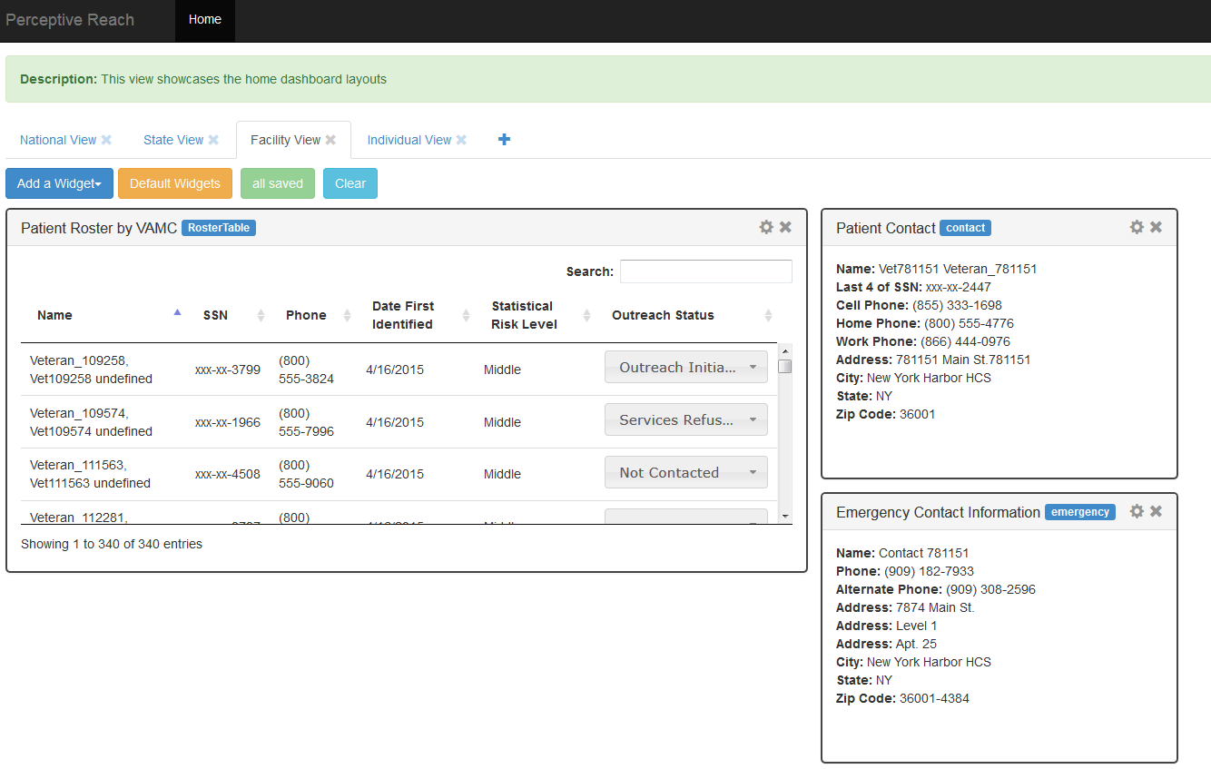Figure 6: Individual and Facility View

#### Widget Selector

The widget selection menu provides the ability to choose which widgets you do and do not want to see on the Dashboard. To add a widget to the Dashboard, click the widget’s name from within the selector dropdown menu. To remove a widget from the Dashboard, click the “X” shape in the far upper right corner of the widget. Note that the option to remove some widgets from the Dashboard, such as the Veteran Roster Widget, is not available.

Users also have the ability to “restore” their Dashboard view to just show the default set of widgets for a particular view, and also save any customizations of their Dashboard view for future use.

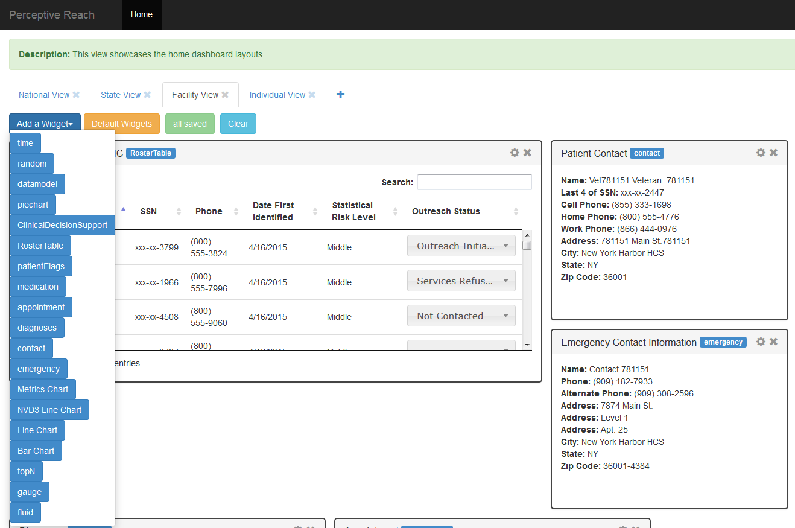

Figure 7: Widget Selector

#### Dashboard Widgets

The Dashboard features several default and non-default widgets. Some widgets are relatively static, while others feature customization options and / or the ability to click items within the widget to see additional information. A detailed description of how to use the widgets is available in Section 6 of this document.

#### Help Desk

Select the “Help Desk” option to view a menu of options for how to contact Help Desk staff for questions, troubleshooting, and general assistance.

### VLER Direct Menu Options

For a description of VLER Direct menu options, consult the VLER Direct User Guide at <link>.

### Research and Reporting Menu Options

The IRDS has been built for access with several ancillary applications, including BIRT, KNIME, MySQL, and R, for research and reporting purposes. Each application has its own unique set of system menus and options. For more information, please refer to the user guide for each application, and / or contact the Perceptive Reach Help Desk.

## Changing User ID and Password

Usernames and passwords for the application are tied directly to VA Active Directory login credentials. To change your username and / or password, contact your local IT Help Desk or the National Help Desk, as appropriate.

## Exit System

To exit the system, select the “Log Off” button in the upper right area of the Dashboard. To access the system again, you will be asked to provide your username and password.

# Using the System

The sections below provide detailed descriptions of all functionality available to Perceptive Reach users.

## Direct Messaging

### Generation of Direct Messages

The Perceptive Reach application automatically runs a predictive analytics “risk model” late every evening. During this process, the application analyzes the health data of Veterans in the VHA health system and calculates a relative risk score for all Veterans who have updated data in their VHA health record since the last time the model was run.

The application then sends users in the Clinical Team Member user category a Direct Message in the following conditions:

* A Veteran is in the “Middle” risk category. These Veterans are in roughly the top 5% of the risk scores for all Veterans in the system.
* A Veteran is in the “Top” risk category. These Veterans are in the roughly the top .1% of the risk scores for all Veterans in the system.

Once the first message about a Veteran has been sent, the system will not send another message about that Veteran unless the following conditions have been met:

1. The last Direct Message was sent more than 90 days ago, and the Veteran’s Outreach Status in the Roster Widget has not been updated (see Section 6.2.5 for more details).
2. The Veteran has moved up from the “Middle” to “Top” risk category.

Users only receive messages for Veterans within the user’s facility’s service area. For example, an SPC in Puget Sound, WA would only receive Veterans who receive services at the Bay Pines VA Medical Center (VAMC).

If more than one Veteran is identified since the last time the risk model was run, all Veteran information will be summarized into a single message. For more information, see Section 6.1.3.

### Access Direct Messages

To access Direct Messages, users have two options.

* First, users may directly log on to their VLER Direct accounts at <link>.
* Second, users may set up their VLER Direct account to send alerts to their VA Outlook inbox. These alert messages will also include a direct link to VLER Direct.

Once inside their VLER inbox, users may read, forward, and delete messages, similar to web-based email. For more details on all of the functionality available to VLER Direct users, refer to the VLER Direct User Guide at <link>.

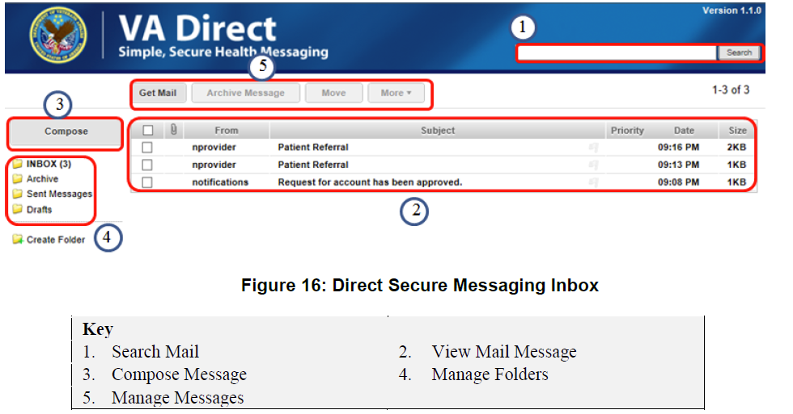

Figure 8: Direct Secure Messaging Inbox

### Review Direct Messages

Direct Messages from the Perceptive Reach contain the Veteran Details Table. The table contains

* Veteran Name
* Last four digits of the Veteran’s SSN
* Veteran Phone Number
* Veteran Risk Category (Middle or Top)

If more than one Veteran has been identified since the last time the automated risk model was run, each row in the table will list a different Veteran’s details. Each newly identified Veteran will also appear in the Perceptive Reach Dashboard.

In addition, each message contains a direct link to the Perceptive Reach Dashboard, and a link to the Perceptive Reach Help Desk.

Users are expected to review the details and manage care of each Veteran in accordance with the guidance in the Outreach and Intervention Toolkit at <link>.

## Perceptive Reach Dashboard Views

### Navigate Dashboard Views

Once logged in to the Dashboard, users have the ability to view information related to individual Veterans or groups of Veterans associated with a specific VAMC. To navigate between these views, users can select between them on the navigation tool bar.

Users with Supervisory level access can also see data summarized at the VISN, State, or National Level, and navigate between them using the same navigation tool bar.

### Customize Dashboard Layout

#### Add a Widget

The Dashboard has a set of default widgets that all users see on initial log on. Users also have the ability to remove and add some (but not all) widgets from the Dashboard view.

To add a widget, select the “Widget Selector” button from the toolbar. You will be presented with a list of available widgets. Click the widget you wish to add, and it will appear on the Dashboard.

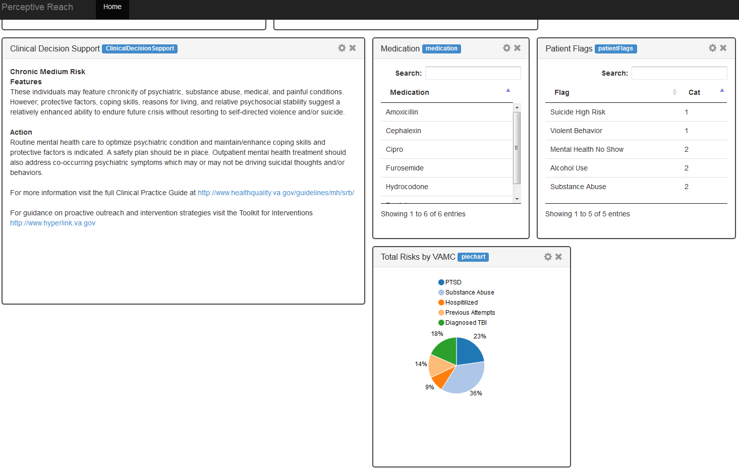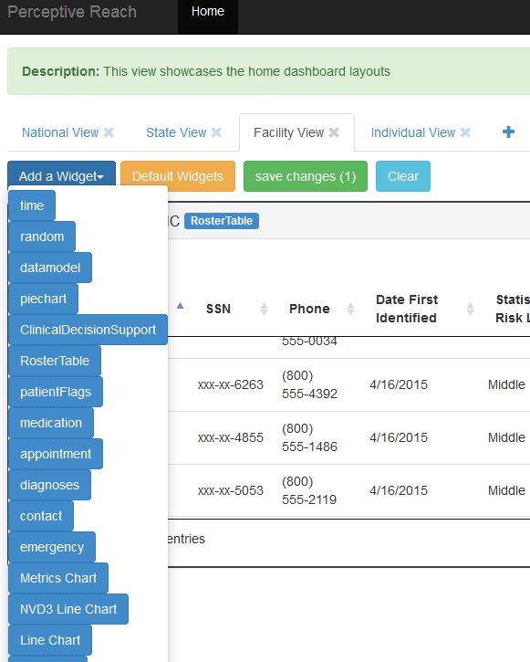

Figure 9: Addition of a Widget: Pie Chart example

#### Remove a Widget

To remove a widget, navigate to the widget you wish to no longer see on the Dashboard. Then, click the “X” shape in the upper right corner of the widget’s frame. The widget will disappear from the Dashboard. The widget will then be available to be added back to the Dashboard from the Widget Selector option.

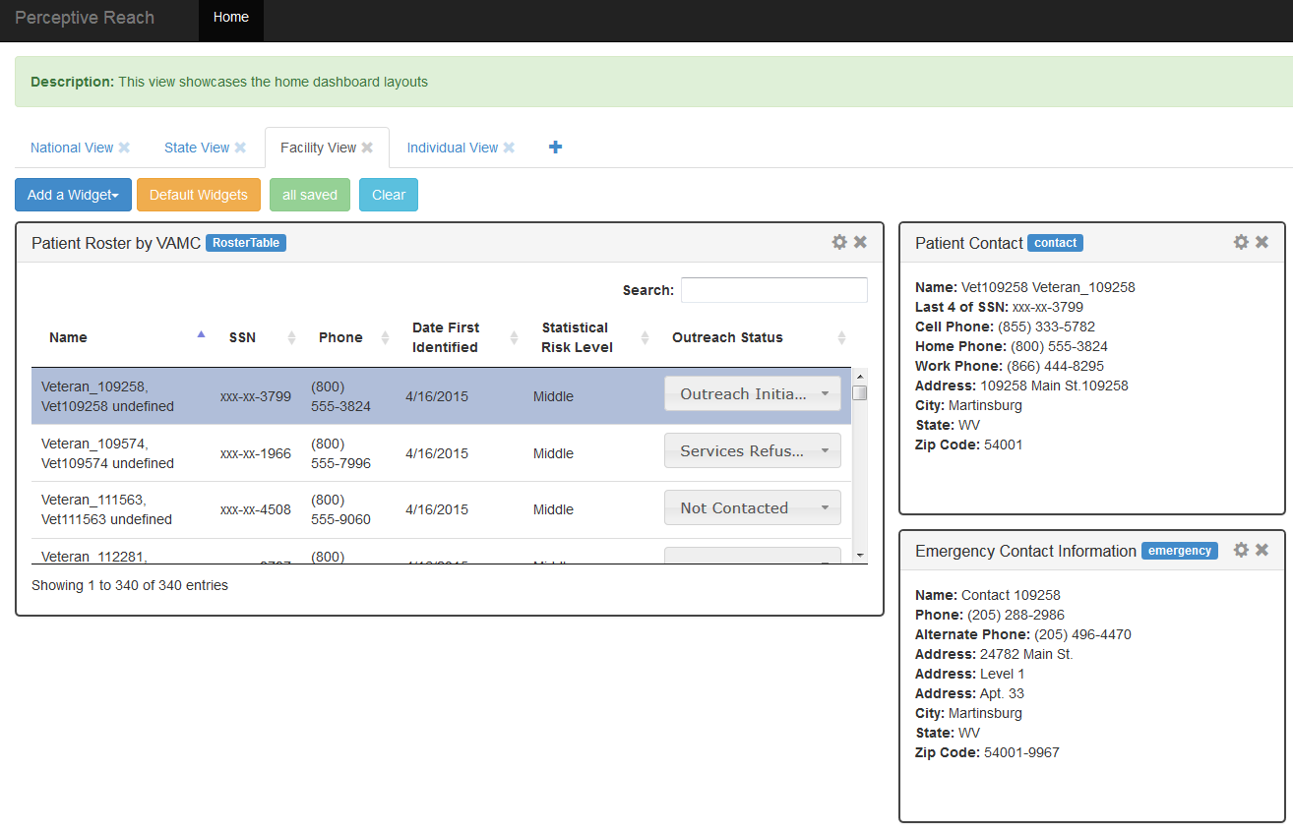

Figure 10: Remove a Widget

#### Move Widgets

To move a widget, click the bar at the top of the widget, and drag the widget to your desired location on the screen. Other widgets should move automatically if you have placed a widget in an area of the screen other widgets were covering.

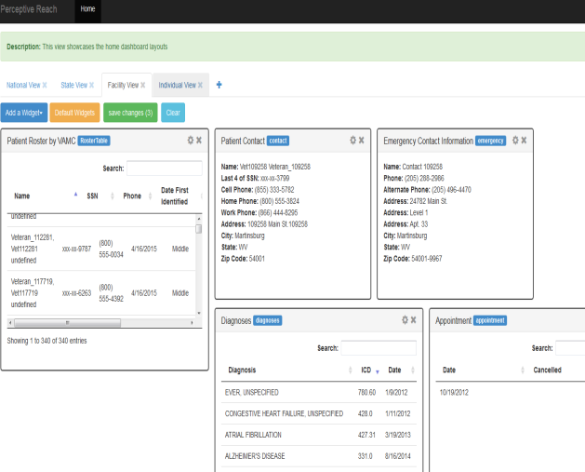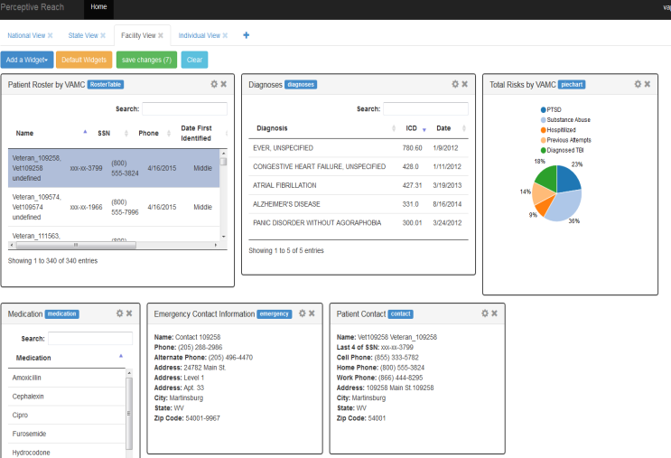

Figure 11: Widgets Movement

#### Resize Widgets

To resize a widget, click the edge of the widget and drag the edge of the widget until the frame is the desired size.

### Select New Veteran

The primary method for viewing information related to an individual Veteran is via the Roster Widget.

On the Individual Veteran View, click a Veteran in the Roster Widget updates the Dashboard to show information related to the Veteran you selected. Selecting a different Veteran updates the Dashboard to show information to the Veteran you just selected, and so on.

Clicking a Veteran in the Roster Widget from any other view automatically navigates the user back to the Individual Veteran View to see the information relevant to that specific Veteran.



Figure 12: Roster Widget and Veteran Selection

### View Clinical Support Information

Clicking on an individual Veteran prompts the Dashboard to display several types of useful information about the specific Veteran. Clinical users, such as SPCs, nurses, doctors, psychologists, care team leaders, etc. should use this information to guide decisions related to possible outreach and intervention strategies. Details of how to develop and carry out these strategies are including the Outreach and Intervention Toolkit at <link>.

#### Contact Information

The Veteran Contact and Emergency Contact widgets provide contact information for the Veteran including address and phone number.

#### Medical History Information

Several widgets provide information about the Veteran’s care and medical history.

* The High Risk Flags Widget shows if a Veteran has or has had a high risk flag recorded in the Suicide Prevention Applications Network (SPAN).
* The Appointments Widget shows recent medical visits, appointments, and clinical encounters the Veteran has had at VA facilities. The widget also shows if an encounter was missed or cancelled (by VA or the Veteran).
* The Medications Widget shows active medication orders.
* The Diagnoses Widget shows recent diagnoses.

It is expected that these widgets will provide a quick, “at a glance”-style view of information in the Veteran’s health record that may provide clues for the best choices and methods for an outreach and intervention strategy. These widgets are not intended to replace the clinical users’ ability to view Veterans’ full health records in VistA / CPRS. Those systems should be reviewed before making any clinical decision per standard VA policy.

#### Outreach and Intervention Guidance

Some additional widgets provide links to guidance related to development of outreach and intervention strategies. Currently, the Clinical Decision Support Widget provides a link to the VA/DoD Clinical Practice Guidelines, the Outreach and Intervention Toolkit, and brief guidance related to development of a strategy. This brief guidance is tailored to the categorical risk level of the Veteran, either “Top” or “Middle.”

### Update Veteran Outreach Status

Within the Roster Widget, users have the ability to update the “Outreach Status” of a Veteran using a drop down menu. Frontline clinical users of the application are expected to update this status accordingly:

* Not Contacted: The Veteran requires contact per the SPC guidelines for intervention and outreach. Contact has not yet been initiated. The Veteran will be contacted in the future.
* Outreach Initiated: The Veterans has been contacted. The Veteran is engaged in outreach and intervention activities and / or clinical care.
* Outreach Attempted – No Response: VA outreach and intervention staff have attempted to contact the Veteran. The Veteran has not responded, or is not available to respond. The Veteran will continue to be contacted in the future.
* Services Refused: The Veteran has been contacted. The Veteran has refused services from VA staff.
* No Additional Outreach Required: The Veteran is not available for further outreach.

The status can be updated as frequently as appropriate. Data from this feature is recorded in the application’s underlying database, so users are encouraged and expected to update the status in a timely, accurate fashion to avoid reporting problems.

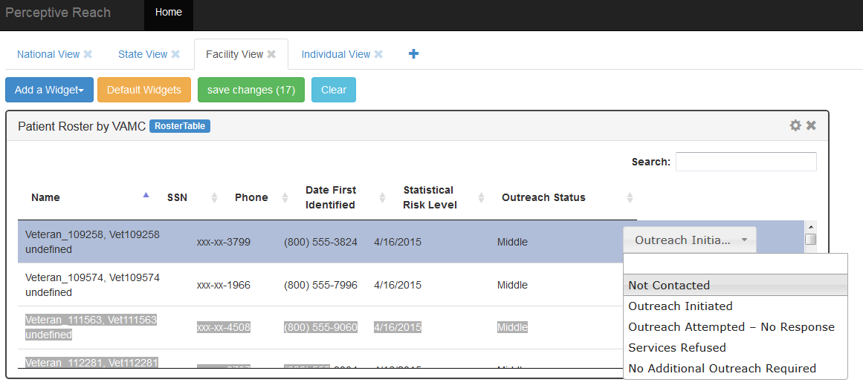

Figure 13: Veteran Outreach Status

### Report Incorrect Veteran Location

The application’s underlying database uses logical business rules to associate a Veteran to a VAMC.

There are times when the Veteran assignment to a VAMC may not be accurate. This could result from a technical error, a Veteran moving, a Veteran getting care at multiple facilities, or a clerical error in the system.

If you receive a Direct Message and / or see a Veteran on the Dashboard that you think has been incorrectly assigned to your facility, follow these steps:

1. Navigate to the Veteran in question on the Individual Veteran View.
2. Click the “Incorrect Facility Assignment” link in the Dashboard.
3. Enter text briefly describing why you think the Veteran has been incorrectly assigned.
4. Hit “Send”

The application will send a notification to a System Administrator who will investigate the issue.

### Other Dashboard Views

The Dashboard also provides the ability to view data aggregated at the state, VISN, and national levels. Only users with Supervisory access are granted the ability to access these views by default.

These views feature additional widgets that show information in the following categories:

* **Veteran Outreach Status**: Data includes presence of High Risk Flags in SPAN, outreach status from the Dashboard’s Roster Widget, and Safety Plan status.
* **Demographics**: Data includes categorical risk level (Top vs. Middle), gender, location, military history, and age group.
* **Public Health**: Data includes incidence of suicide, suicide attempts, suicide means, and other information about Veteran population health.

### Request Help

All requests for help, instructions, troubleshooting, and bug / issue reporting should be directed toward the Perceptive Reach Help Desk at <link>.

## Reporting

Reporting functions beyond those available on the Perceptive Reach Dashboard is handled via several add on tools including BIRT, KNIME, and R. Users with appropriate access can also export certain data for manipulation and report generation in other VA approved tools.

## Research

Research functions beyond those available on the Perceptive Reach Dashboard is handled via several add on tools including BIRT, KNIME, and R. Users with appropriate access can also export certain data for manipulation and research in other VA approved tools. Research access to the underlying database is approved and granted on a case by case basis by the owners of the system.

## Special Instructions for Error Correction

Describe all recovery and error correction procedures, including error conditions that may be generated and corrective actions that may need to be taken.

## Caveats and Exceptions

If there are special actions the user must take to insure that data is properly saved or that some other function executes properly, describe those actions here. Include screen captures and descriptive narratives, if applicable.

Approval Signatures

This section is used to document the initial approval of the IRDS System Maintenance Manual.

All members of the governing IRDS Management Team are required to sign:

__________________________________________________________

Signed: Date:

*xxx, System Owner*

__________________________________________________________

Signed: Date:

*xxxx, Contracting Officer’s Representative*

__________________________________________________________

Signed: Date:

*xxxx VA VHA Program Manager*

1. Department of Veterans Affairs (VA) Directive 6500, Information Security Program <http://www.va.gov/vapubs/viewPublication.asp?Pub_ID=56>
2. Clinical Care Team is a catch-all term for a staff member who provides outreach and intervention services to at-risk patients. Users in this category may include Suicide Prevention Coordinators, social workers, care managers, and other clinicians such as primary care physicians, psychologists, nurses, etc.
3. Clinical Care Team Members will have access to the Facility View for their home facility only by default.