Perceptive Reach

Integrated Reach Database System

(IRDS)

User Manual



Department of Veterans Affairs

September 2015

Version 2.0

Revision History

| Date | Version | Description | Author |
| --- | --- | --- | --- |
| 9/14/2015 | 2.0 | Final Review | Monica Mohler / Paul Bradley |
| 9/14/2015 | 1.7 | Reorganization of Getting Started section and minor formatting updates. | Matthew Robinson |
| 9/5/2015 | 1.6 | Contract Compliance and Quality Assurance Review | Jesse Rogers / Radina Ivanova / Kaitlin Reskovac |
| 9/5/2015 | 1.5 | Minor content updates throughout. Keyboard navigation instructions added. | Matthew Robinson |
| 9/1/2015 | 1.4 | Updated content related to Surveillance Level views | Matthew Robinson |
| 8/26/15 | 1.3 | Updated table of contents and miscellaneous updates | Kaitlin Reskovac |
| 8/24/15 | 1.2 | Updated screen shots, helpdesk information, and research / reporting information. | Jesse Rogers |
| 8/12/2015 | 1.1 | Updated information related to VLER business rules, analytic tools, and dashboard features | Matthew Robinson |
| 7/15/2015 | 1.0 | Updated document with new screen captures and login information | Matthew Robinson |
| 6/11/2015 | .2 | Additional content and details added | Matthew Robinson |
| 5/01/2015 | 0.1 | First Draft | Radina Ivanova/Matthew Robinson |

Table of Contents

1. Introduction 1-5

1.1. Purpose & Scope 1-5

2. General Information 2-5

2.1. Authorized User Permission 2-6

2.2. Points of Contact 2-6

2.2.1. Information 2-6

2.2.2. Coordination 2-6

2.2.3. Help Desk 2-6

2.3. Organization of the Manual 2-6

2.4. System Overview 2-7

2.5. Key Components and Interfaces 2-7

2.6. User Access Levels 2-8

2.7. Contingencies and Alternate Modes of Operation 2-9

3. Getting Started 3-9

3.1. Dashboard User Registration 3-9

3.2. Logging In - Dashboard 3-9

3.3. Direct Messaging User Registration 3-10

3.4. Logging In – Direct Messages 3-11

3.5. System Menu 3-12

3.5.1. Dashboard System Menu Options 3-12

3.5.2. VLER Direct Menu Options 3-14

3.5.3. Research and Reporting Menu Options 3-14

3.6. Changing User ID and Password 3-15

3.7. Exit System 3-15

3.8. Keyboard Navigation 3-15

4. Using the System 4-16

4.1. Direct Messaging 4-16

4.1.1. Generation of Direct Messages 4-16

4.1.2. Access Direct Messages 4-17

4.1.3. Review Direct Messages 4-18

4.2. Perceptive Reach Dashboard Views 4-19

4.2.1. Navigate Dashboard Views 4-19

4.2.2. Customize Dashboard Layout 4-19

4.2.3. Individual View – Select New Veteran 4-22

4.2.4. Individual View - View Clinical Support Information 4-23

4.2.5. Individual View - Update Veteran Outreach Status 4-24

4.2.6. Facility Level View 4-25

4.2.7. Surveillance Level View 4-26

4.2.8. Request Help 4-27

4.3. Reporting 4-27

4.4. Research 4-29

4.5. Special Instructions for Error Correction 4-30

6.0 Acronyms and Abbreviations 4-30

# Introduction

This User Manual is developed for the Perceptive Reach Integrated Reach Database System (IRDS) project for the Department of Veterans Affairs (VA). VA is seeking to expand suicide prevention to include upstream approaches designed to reduce initiation or escalation of a suicide risk factor. Upstream suicide interventions target individuals or groups who exhibit biological, psychological, or social risk factors that are more prominent among high-risk groups than among the larger population. Understanding the unique needs of our nation’s Veterans and the military culture as it relates to stigma and mental health is important for early intervention. The goal of the IRDS innovation is to promote the general health of the Veteran population and effectively intervene in issues before they escalate into crisis.

The IRDS solution will harness the power of large and diverse data stores to aggregate, analyze and identify risk onset as well as reveal previously unidentified at-risk individuals and populations as a holistic and integrated approach. The IRDS innovation will serve to bolster the three major components of Veterans Health Administration’s (VHA) Strategic Plan for Suicide Prevention: surveillance, risk and protective factors, and prevention interventions. The IRDS innovation will target antecedent events specific to Veteran populations prior to the onset of risk to mitigate the development of risk.

## Purpose & Scope

This User Manual was developed to help users become better acclimated to using and navigating the IRDS as it applies to their responsibilities.

The User Manual contains a description of the functions and capabilities, step-by-step procedures for access and use, and additional essential information for users to make full use of the application and its various components.

# General Information

The IRDS innovation, a pilot program under VHA’s VA Center for Innovation (VACI), serves to bolster the three major components of VHA’s Strategic Plan for Suicide Prevention: surveillance, risk and protective factors, and prevention interventions. The overall project in which the IRDS innovation has been developed is call Perceptive Reach. The IRDS innovation targets antecedent events specific to Veteran populations prior to the onset of risk to mitigate the development of risk.

The IRDS is an integrated data analytic and predictive modeling database system that also includes direct messaging. This system utilizes predictive analysis to provide early intervention and treatment solution to prevent Veteran suicide. This solution integrates clinical data sources, integrated data analytics, a surveillance dashboard and secure messaging into one system.

Use of this User Manual applies to use of IRDS application features as they exist in the application’s pilot phase. A future version of this document will serve as the User Manual for the nationwide production version of the application after the program’s pilot is complete.

## Authorized User Permission

Authentication and permission determine the identity of a user, server, or client and the settings that define who or what is allowed to use it and what they are allowed to do with it. Refer to Section 4.3 for User Access Levels. Unauthorized use of this system could subject users to penalties as described in VA Handbook 6500[1] and any other relevant VA policy documents or US law.

## Points of Contact

## 

Table 1: Points of Contact

|  |  |  |
| --- | --- | --- |
| **Name** | **Role** | **Contact Information** |
| Dr. Robert Bossarte | Primary VA Business Owner | Robert.bossarte@va.gov |
| Perceptive Reach Help Desk | Technical Support for All Users | [VAPerceptiveReachSupport@va.gov](mailto:VAPerceptiveReachSupport@va.gov) |

### Information

All user requests for information, help, trouble shooting, documentation, or instructions should be directed to the Perceptive Reach Help Desk contact listed in Section 2.2.

### Coordination

Coordination activities for purposes of the IT Pilot and Field Pilot should be coordinated via Dr. Robert Bossarte, the project’s primary Business Owner, and / or the technical development team which can be reached via the Help Desk as listed in Section 2.2.

### Help Desk

All user requests for information, help, trouble shooting, documentation, or instructions should be directed to the Perceptive Reach Help Desk: [VAPerceptiveReachSupport@va.gov](mailto:VAPerceptiveReachSupport@va.gov)

## Organization of the Manual

This User Manual features the following major sections:

* **1.0 Introduction:** Containing description of the IRDS application, along with the scope and purpose of this document and related documents
* **2.0 General Information**: Containing administrative details, additional background, and notes on how this document is to be used and referenced.
* **3.0 Getting Started**: Containing a more detailed overview of how users can get access to the systems components and understand the menu options available to them.
* **4.0 Using the System**: Containing a detailed description of all major functions and features of the application.
* **5.0 Acronyms and Abbreviations**: Containing a list of all acronyms and abbreviations used in this document along with their respective definitions.

## System Overview

The Perceptive Reach application combines technology, outreach, and clinical support to realize a clinically based data-driven early intervention and treatment solution aimed at suicide prevention. The application includes capability for analyzing multiple and integrated data sets with cutting-edge data analytic techniques and visualizations to identify at-risk individuals and populations and provide proactive and secure notifications of these results to Veteran support services.

As shown in**Figure 1**, IRDS is an integrated system comprised of the following:

* **Reach Database.** A (Structured Query Language) SQL database used to aggregate new data sources and relevant data from VHA’s Suicide Data Repository (SDR) and Corporate Data Warehouse (CDW).
* **Data Analytics Platform and Dashboard.** An integrated collection of analytics and visualization tools, including a surveillance dashboard aimed at identifying at-risk individuals and populations.
* **Direct Messaging.** A method to construct and transmit a secure message to authorized outreach and intervention service providers.
* **Outreach and Intervention.** A pilot workflow that includes the process by which outreach and intervention resources are notified and act upon the data provided.

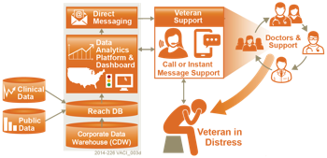

Figure 1: IRDS System Overview

## Key Components and Interfaces

The figure below illustrates the major data inputs and outputs for the system.

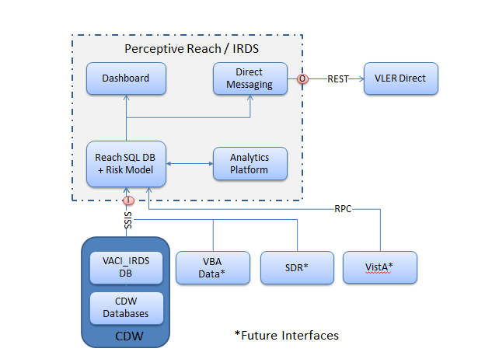

Figure 2: Key Components and Interfaces

## User Access Levels

**Table 2** describes the various user access levels for the IRDS application.

Table 2: User Access Levels

|  |  |  |  |  |  |
| --- | --- | --- | --- | --- | --- |
|  | **Clinical Care Team Members[2]** | **Supervisors** | **Researchers** | **Reporters** | **System Administrators** |
| Individual Veteran View Widgets | X | X |  | X | X |
| Facility View Widgets | X[3] | X |  | X | X |
| Surveillance View Widgets |  | X |  | X | X |
| R / BIRT / MySQL Database Access |  |  | X | X | X |
| System Administration Tools |  |  |  |  | X |

## Contingencies and Alternate Modes of Operation

Matters related to operations in the event of an emergency, disaster, or accident are described in the IRDS Disaster Recovery Plan. To report a performance issue or outage, please contact the Help Desk: [VAPerceptiveReachSupport@va.gov](mailto:VAPerceptiveReachSupport@va.gov)

# Getting Started

## Dashboard User Registration

All users must complete a Perceptive Reach User Access form, which then must be signed and approved by the application’s Information Security Officer and Contracting Officer before they will be permitted to access the system. Contact the Help Desk at [VAPerceptiveReachSupport@va.gov](mailto:VAPerceptiveReachSupport@va.gov) for more information about user registration.

## Logging In - Dashboard

To log in to the Perceptive Reach Dashboard, follow these steps:

1. Open your web browser on an internet-connected computer and navigate to the URL you were provided upon registration. Your screen will display the application’s login screen as shown in **Error! Reference source not found.** below.
2. Enter your username into the “Username” field.
3. Enter your password into the “Password” field. Your username should be the same you use to access other VA systems such as email and the Computerized Patient Record System (CPRS). You do not need to enter your VA domain name.
4. Click the checkbox to accept the terms and conditions, and then click the “Login” button below the username and password fields. The system will then display your default Perceptive Reach Dashboard view. An incorrect username and password entry will cause an error message to appear. More than three failed login attempts will require you to contact the help desk to unlock your account before being able to attempt login again.

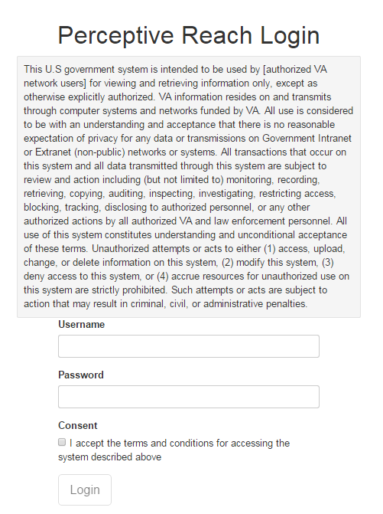

Figure 3: Login Screen

## Direct Messaging User Registration

To set up a new account for the Virtual Lifetime Electronic Record (VLER) Direct Message application, follow these steps:

1. Open Internet Explorer.
2. Go to the webpage <https://direct.va.gov> on a Personal Identity Verification (PIV) enabled workstation.
3. Click on Register with Direct account and you will be prompted to select your certificate again.
4. Once the page loads, Direct Secure Messaging will pull identification information from your PIV card. Organization, Department, Phone, and Job Title may be completed but are not required as seen in Figure 4.
5. When the New User Registration web form is complete, review the information and click Submit Request to notify Direct Secure Messaging Application Administrators of the request for an account.

When an account request is submitted, the Application Administrator will login to the API Admin Panel, confirm that the user is authorized to use Direct Secure Messaging, and approve the account.

Figure 4: VLER Health Direct Account Request

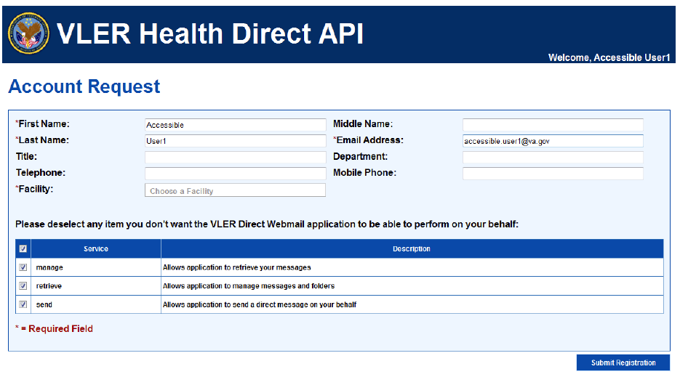

Upon approval, a notification email will be sent out to inform the registrant that the Direct Secure Messaging Account may be access and used.

For detailed instructions for how to log on and access Reporting and Research capabilities for the IRDS, see Sections 5.3 and 5.4 respectively.

If you are not able to access the system or need further instruction, contact the Help Desk: [VAPerceptiveReachSupport@va.gov](mailto:VAPerceptiveReachSupport@va.gov).

## Logging In – Direct Messages

To log on to VLER Direct to access Direct Messages, follow these steps:

1. Open Internet Explorer.
2. Navigate to <https://direct.va.gov>. Alternatively, you can also access your VLER inbox by clicking <https://direct.va.gov> from within any automated notices from VLER that appear in your Outlook Inbox.
3. If you are automatically logged on, then begin to use the application.
4. If you are not automatically logged on to the VLER application, enter your username in the “Username” field.
5. Enter your password into the “Password” field.
6. Click the “Login” button to enter the application.

## System Menu

The following section details various menus and menu options available within the application.

### Dashboard System Menu Options

The sections below detail system menu options specific to users accessing the Perceptive Reach Dashboard.

#### Dashboard Views

Users can access various views on the Dashboard organized by geographic area. For users who are members of frontline clinical care teams (the majority of users), access will be limited to viewing:

* **Individual Veteran View**, providing information related to outreach, intervention, and care for a specific Veteran within the system
* **Facility Level View**, providing information and data about at-risk Veterans who are associated with the user’s home facility

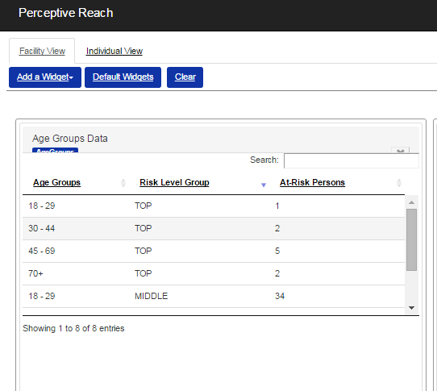

Figure 5: Individual and Facility View Selection

An additional view, the Surveillance View, provides the ability to see information and data related to at-risk Veterans within a specific VISN or nationally. Additionally, the Facility View, described above, has the additional ability for users to see data from all facilities in the VA system, not just the users’ home facility. Access to these views is limited to users with “Supervisory” level access.

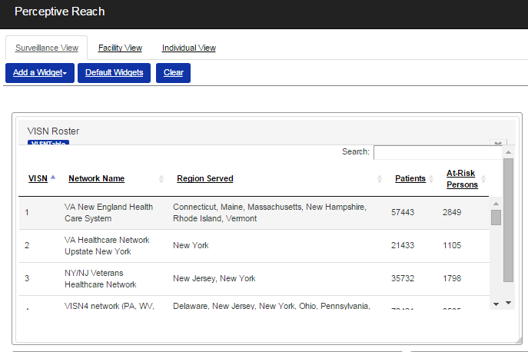

Figure 6: Selecting the Surveillance Level View

#### Dashboard Customization

The Add a Widget selection menu provides the ability to choose which widgets you do and do not want to see on the Dashboard. To add a widget to the Dashboard, click the widget’s name from within the selector dropdown menu. To remove a widget from the Dashboard, click the “X” shape in the far upper right corner of the widget. Note that the option to remove some widgets from the Dashboard, such as the Veteran Roster Widget, is not available. Users can drag and drop widgets to move widgets to other areas of the screen, and also resize widgets by clicking and dragging the edge of the widget window.

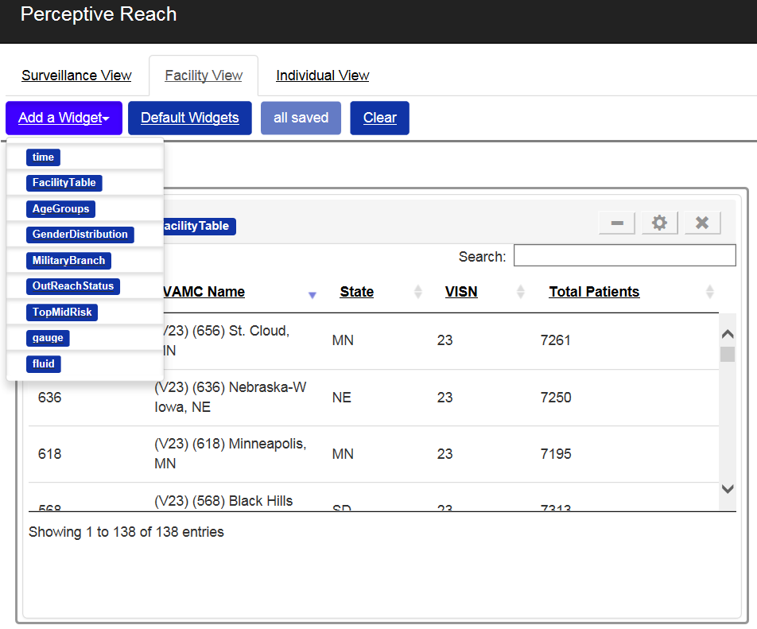

Figure 7: Add a Widget and Remove a Widget

The Dashboard will automatically save any changes to the Dashboard a user has made. This way, users will Users also have the ability to “restore” their Dashboard view to just show the default set of widgets for a particular view.

### VLER Direct Menu Options

For a description of VLER Direct menu options, consult the VLER Direct User Manual.

### Research and Reporting Menu Options

The IRDS has been built for access with several ancillary applications, including Business Intelligence Reporting Tools (BIRT), MySQL, and R, for research and reporting purposes. Each application has its own unique set of system menus and options. For more information, please refer to the user guide for each application, and / or contact the Perceptive Reach Help Desk: [VAPerceptiveReachSupport@va.gov](mailto:VAPerceptiveReachSupport@va.gov).

## Changing User ID and Password

Usernames and passwords for the application are tied directly to VA Active Directory login credentials. To change your username and / or password, first contact [VAPerceptiveReachSupport@va.gov](mailto:VAPerceptiveReachSupport@va.gov) for further instructions.

## Exit System

To exit the system, select the “Log Off” button in the upper right area of the Dashboard. To access the system again, you will be asked to provide your username and password.

## Keyboard Navigation

Users have the option to navigate the application’s features using a mouse and / or keyboard[4]. To navigate the application without a mouse, the following keys can be used to navigate exclusively through use of a standard keyboard.

Table 3: Keyboard Navigation

|  |  |
| --- | --- |
| **IF you want to...** | **THEN select** |
| Move forward from link to link or to controls | Tab |
| Move backward from link to link or to controls | Shift + Tab |
| Select rows for VISN or Facility Roster widgets | Spacebar |
| Traverse rows for VISN or Facility Roster widgets | Down and Up arrows |
| Exit table rows and return to widget navigation for VISN and Facility | Tab |
| Select rows for Patient Roster widgets | Enter |
| Traverse rows for Patient Roster widgets | Tab |
| Exit table rows and return to widget navigation for Patient Roster | Esc |
| Select/deselect boxes | Spacebar |
| Close a List Box | ALT + Up arrow |
| Open a List Box | ALT + Down arrow |
| Read the prior screen | CTRL + Page Up |
| Read the next screen | CTRL + Page Down |
| Go to the top of the page | CTRL + Home |
| Go to the bottom of the page | CTRL + End |
| Close the current window (in Internet Explorer) | CTRL + W |
| Refresh the screen | F5 or Ctrl + R |
| Go back a page | ALT + Left Arrow |
| Go forward a page | ALT + Right Arrow |
| Navigate to & select the text in the browser address combo box | ALT + D |
| Navigate to & access the browser home button | ALT + Home |
| Navigate to & access the browser favorites button | ALT + C |
| Navigate to & access the browser tools button | ALT + X |

# Using the System

The sections below provide detailed descriptions of all functionality available to Perceptive Reach users.

## Direct Messaging

Direct Messaging via the VLER web application enables members of clinical care teams to receive messages about at-risk Veterans who may candidates for outreach and / or intervention activities. These features are described in detail below.

### Generation of Direct Messages

The Perceptive Reach application automatically runs a predictive analytics “risk model” on a regular basis. During this process, the application analyzes the health data of Veterans in the VHA health system and calculates a relative risk score for all Veterans who have updated data in their VHA health record since the last time the model was run.

The application then sends users in the Clinical Team Member user category a Direct Message in the following conditions:

* A Veteran is in the “Middle” risk category. These Veterans are in roughly the top 5% of the risk scores for all Veterans in the system.
* A Veteran is in the “Top” risk category. These Veterans are in the roughly the top .1% of the risk scores for all Veterans in the system.

Once the first message about a Veteran has been sent, the system will not send another message about that Veteran unless the following conditions have been met:

1. The last Direct Message was sent more than 90 days ago, and the Veteran’s Outreach Status in the Roster Widget has not been updated (see Section 5.2.5 for more details).
2. The Veteran has moved up from the “Middle” to “Top” risk category.

If more than one Veteran is identified since the last time the risk model was run, all Veteran information will be summarized into a single message. For more information, see Section 5.1.3.

Users only receive messages for Veterans within the user’s facility’s service area. For example, a Suicide Prevention Coordinator (SPC) in Puget Sound, WA would only receive messages for Veterans who get services in Puget Sound. The exception is if a Veteran has received care at multiple facilities that are not associated with the same VA Medical Center in the past 6 months, **the direct message will indicate that the Veteran receives care at multiple sites.**

In this case, users are expected to the call or email the SPCs or care teams at the other sites, and coordinate which site will be the “lead” care site. The lead care site will then update the status of the Veteran using the “Outreach Status” feature of the Veteran Roster on the Dashboard. This will indicate in the system which site is the “lead.”

### Access Direct Messages

To access Direct Messages, users have two options.

* First, users may directly log on to their VLER Direct accounts via <https://direct.va.gov>.
* Second, users may set up their VLER Direct account to send alerts to their VA Outlook inbox. These alert messages will also include a direct link to VLER Direct.

Once inside their VLER inbox, users may read, forward, and delete messages, similar to web-based email. For more details on all of the functionality available to VLER Direct users, refer to the VLER Direct User Manual.

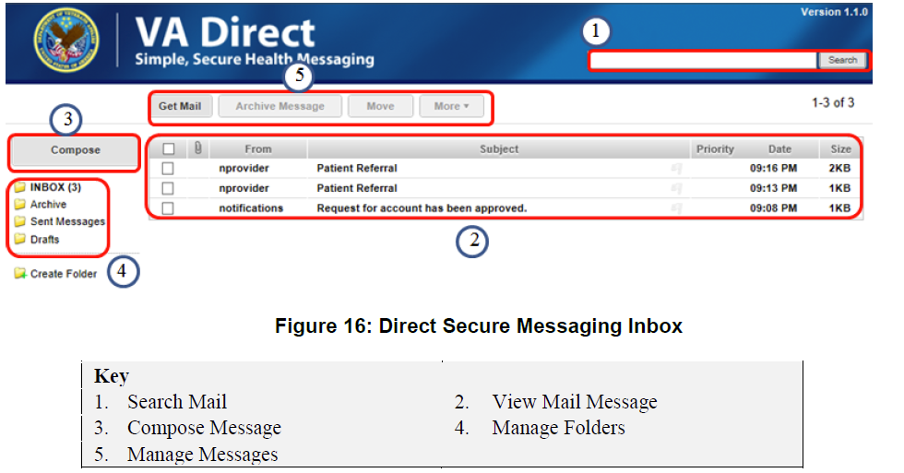

Figure 8: Direct Secure Messaging Inbox

### Review Direct Messages

Direct Messages from the Perceptive Reach contain the Veteran Details Table. The table contains.

* Veteran Name
* Last four digits of the Veteran’s Social Security Number (SSN)
* Veteran Phone Number
* Risk Level (TOP or MIDDLE)
* Other Care Locations
* If the Veteran has been newly identified (NEW), if the message was triggered as a reminder because the Veteran’s outreach status has not been updated in the 90 days since the first message was sent (NOT CONTACTED), or if the Veteran has moved from the Middle to Top category (TRANSITION TO TOP).

If more than one Veteran has been identified since the last time the automated risk model was run, each row in the table will list a different Veteran’s details. Each newly identified Veteran will also appear in the Perceptive Reach Dashboard. If a Veteran receives care at multiple locations (as indicated in the direct message), then all recipients are expected to discuss via email or phone which site should “lead” care for the Veteran in question. An update to this Veteran’s outreach status on the Dashboard indicates in the application which site will serve as “lead.”

In addition, each message contains a direct link to the Perceptive Reach Dashboard.

Users are expected to review the details and manage care of each Veteran in accordance with the guidance in the Outreach and Intervention Toolkit.

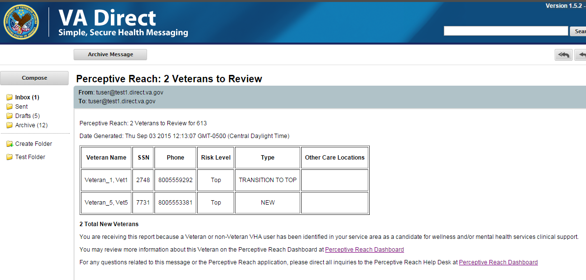

Figure 9: VLER Direct Message Content

## Perceptive Reach Dashboard Views

### Navigate Dashboard Views

Once logged in to the Dashboard, users have the ability to view information related to individual Veterans or groups of Veterans associated with a specific facility. To navigate between these views, users can select between them on the navigation tool bar.

Users with Supervisory level access can also see data summarized at the Surveillance Level View, and navigate between them using the same navigation tool bar.

### Customize Dashboard Layout

#### Add a Widget

The Dashboard has a set of default widgets that all users see on initial log on. Users also have the ability to remove and add some (but not all) widgets from the Dashboard view.

To add a widget, select the “Add a Widget” button from the toolbar. You will be presented with a list of available widgets. Click the widget you wish to add, and it will appear on the Dashboard.

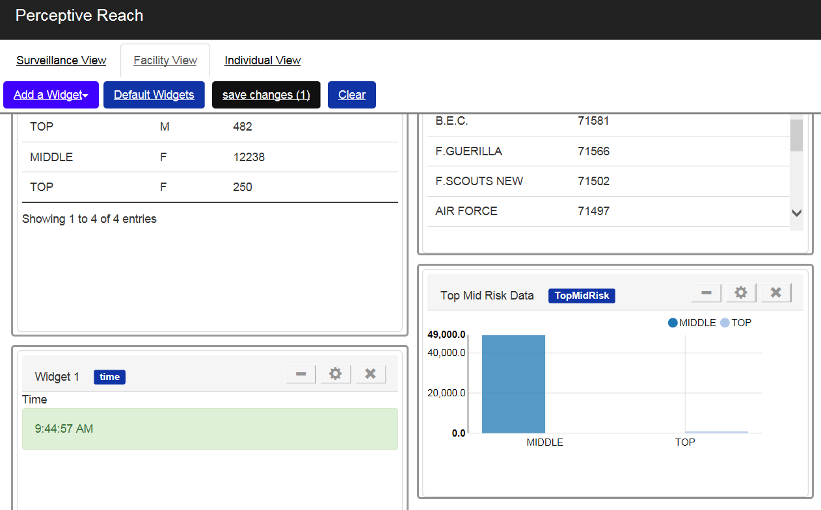

Figure 10: Addition of a Widget - Top Mid Risk example

#### Remove a Widget

To remove a widget, navigate to the widget you wish to no longer see on the Dashboard. Then, click the “X” shape in the upper right corner of the widget’s frame. The widget will disappear from the Dashboard. The widget will then be available to be added back to the Dashboard from the Widget Selector option. Users are not able to remove certain widgets, such as roster-type widgets, from the Dashboard because the presence of these widgets is required for the application’s functionality.

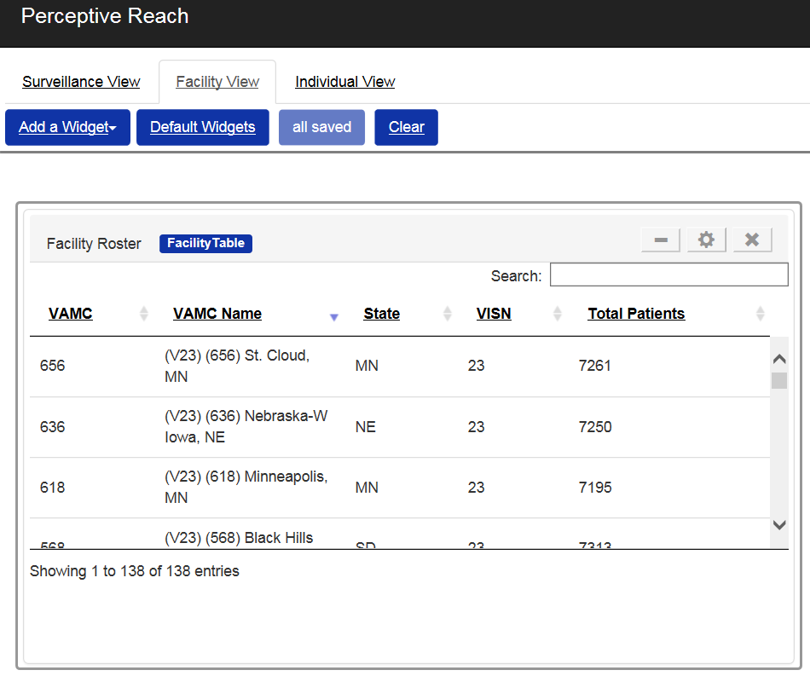

Figure 11: Remove a Widget

#### Move Widgets

To move a widget, click the bar at the top of the widget, and drag the widget to your desired location on the screen. Other widgets should move automatically if you have placed a widget in an area of the screen other widgets were covering.

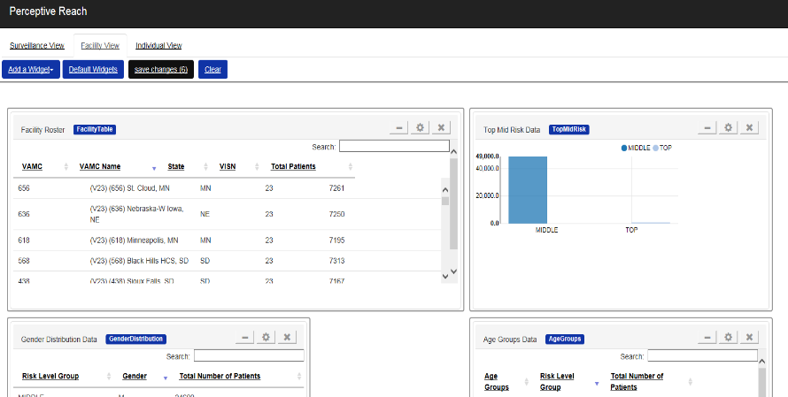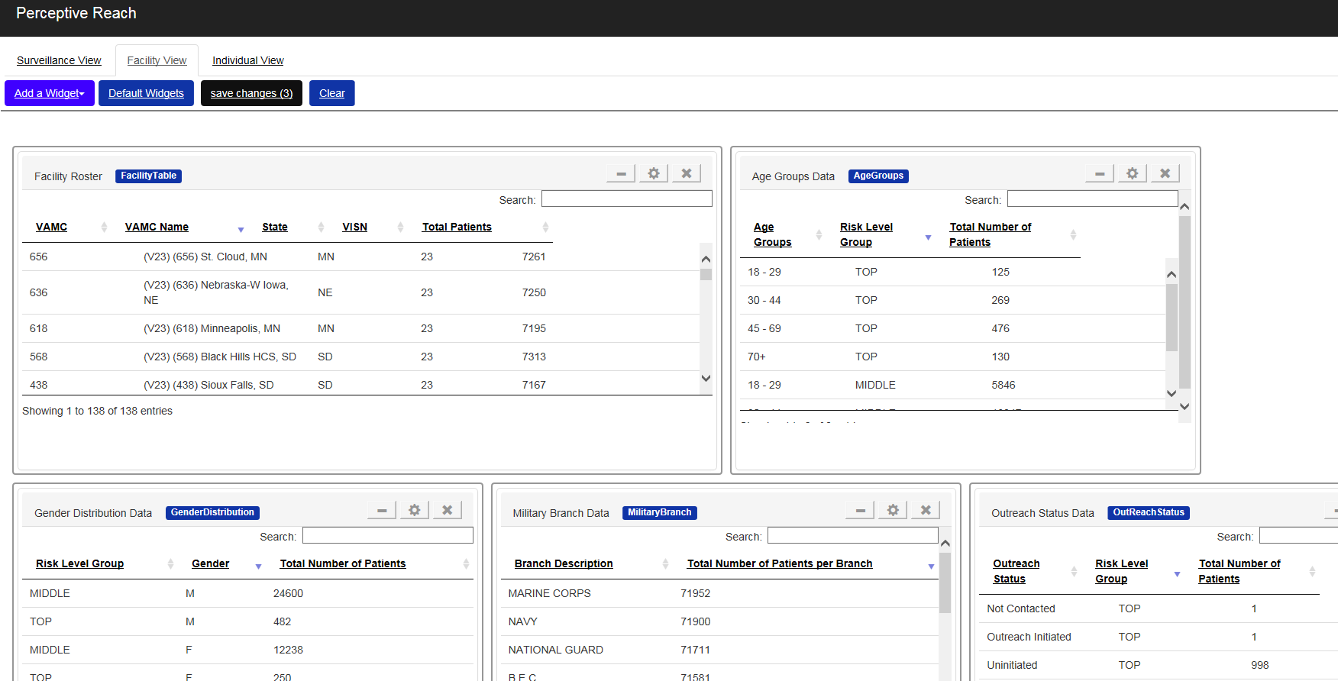

Figure 12: Move Widgets

#### Resize Widgets

To resize a widget, click the edge of the widget and drag the edge of the widget until the frame is the desired size.

#### Save Customizations

The Dashboard will automatically save any customizations (adding or removing widgets, moving widgets, resizing widgets, etc.) a user has made. When a user logs out, the customizations will still appear when the user logs back in.

#### Remove Customizations

To remove any customizations to the Dashboard, click the “Restore Defaults” button to return to the default settings for widgets and widget configuration.

### Individual View – Select New Veteran

The primary method for viewing information related to an individual Veteran is via the Roster Widget.

On the Individual Veteran view, clicking a Veteran in the Roster Widget updates the Dashboard to show information related to the Veteran you selected. Selecting a different Veteran updates the Dashboard to show information about the Veteran just selected, and so on.

Clicking a Veteran in the Roster Widget from any other view automatically navigates the user back to the Individual Veteran View to see the information relevant to that specific Veteran. Users will also be able to see a Veteran’s phone number, last four digits of the Veteran’s Social Security Number, and date first identified as at-risk.

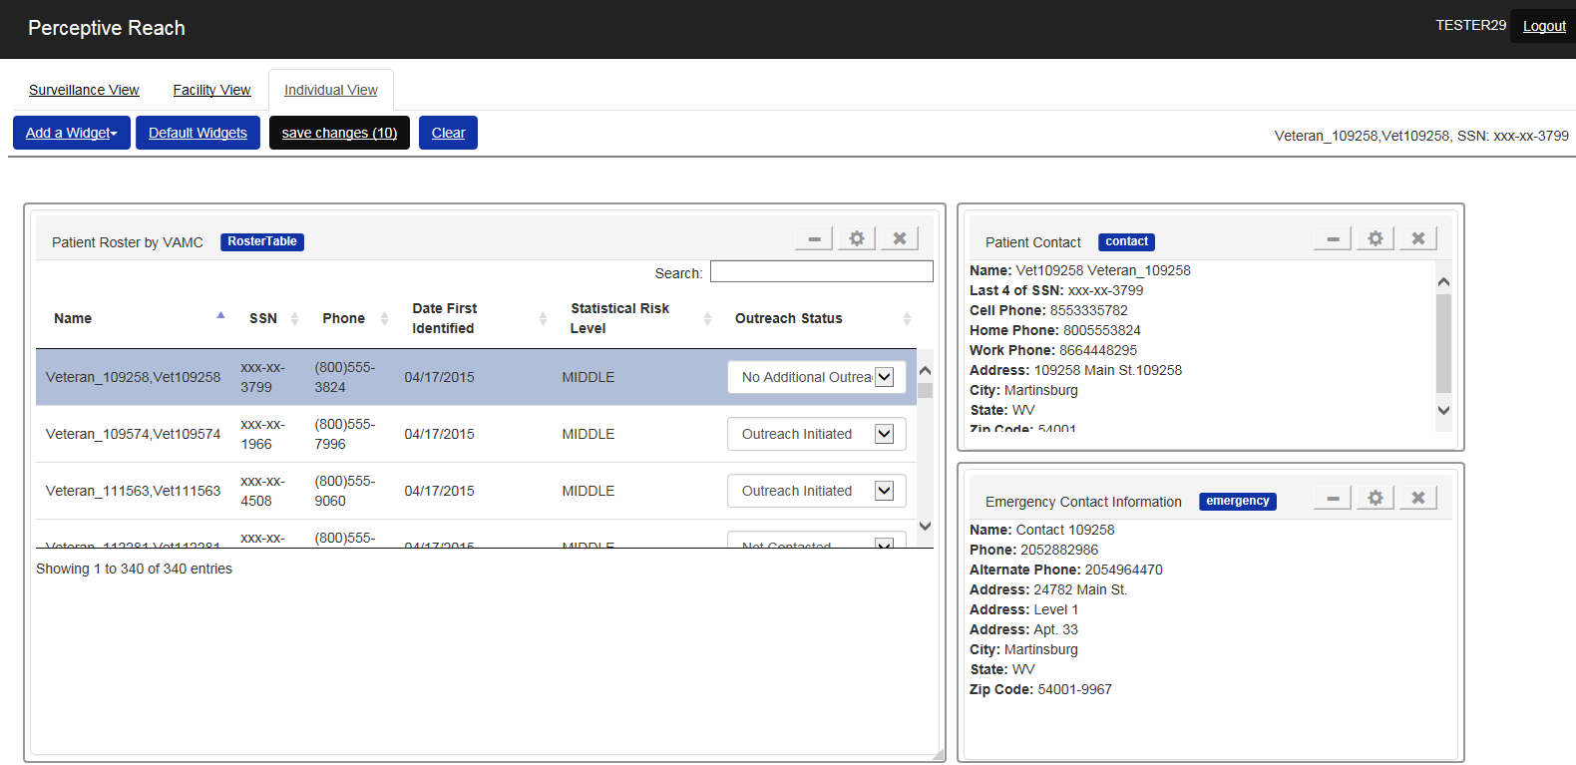

Figure 13: Roster Widget and Veteran Selection

### Individual View - View Clinical Support Information

Clicking on an individual Veteran prompts the Dashboard to display several types of useful information about the specific Veteran. Clinical users, such as SPCs, nurses, doctors, psychologists, care team leaders, etc. should use this information to guide decisions related to possible outreach and intervention strategies. Details of how to develop and carry out these strategies are included in the Outreach and Intervention Toolkit.

#### Contact Information

The Veteran Contact and Emergency Contact widgets provide contact information for the Veteran including address and phone number.

#### Medical History Information

Several widgets provide information about the Veteran’s care and medical history.

* The Appointments Widget shows recent medical visits, appointments, and clinical encounters the Veteran has had at VA facilities. The widget also shows if an encounter was missed or cancelled (by VA or the Veteran).
* The Medications Widget shows active medication orders.
* The Diagnoses Widget shows recent diagnoses.

It is expected that these widgets will provide a quick, “at a glance”-style view of information in the Veteran’s health record that may provide clues for the best choices and methods for an outreach and intervention strategy. These widgets are not intended to replace the clinical users’ ability to view Veterans’ full health records in the Veterans Health Information Systems and Technology Architecture (VistA) / CPRS. Those systems should be reviewed before making any clinical decision per standard VA policy.

#### Outreach and Intervention Guidance

Some additional widgets provide links to guidance related to development of outreach and intervention strategies. Currently, the Clinical Decision Support Widget provides a link to the VA/ Department of Defense (DoD) Clinical Practice Guidelines, the Outreach and Intervention Toolkit, and brief guidance related to development of a strategy. This brief guidance is tailored to the categorical risk level of the Veteran, either “Top” or “Middle.”

### Individual View - Update Veteran Outreach Status

Within the Roster Widget, users have the ability to update the “Outreach Status” of a Veteran using a drop down menu. Frontline clinical users of the application are expected to update this status accordingly:

* Not Contacted: The Veteran requires contact per the SPC guidelines for intervention and outreach. Contact has not yet been initiated. The Veteran will be contacted in the future.
* Outreach Initiated: The Veteran has been contacted. The Veteran is engaged in outreach and intervention activities and / or clinical care.
* Outreach Attempted – No Response: VA outreach and intervention staff have attempted to contact the Veteran. The Veteran has not responded, or is not available to respond. The Veteran will continue to be contacted in the future.
* Services Refused: The Veteran has been contacted. The Veteran has refused services from VA staff.
* No Additional Outreach Required: The Veteran is not available for further outreach.

The status can be updated as frequently as appropriate. Data from this feature is recorded in the application’s underlying database, so users are encouraged and expected to update the status in a timely, accurate fashion to avoid reporting problems.

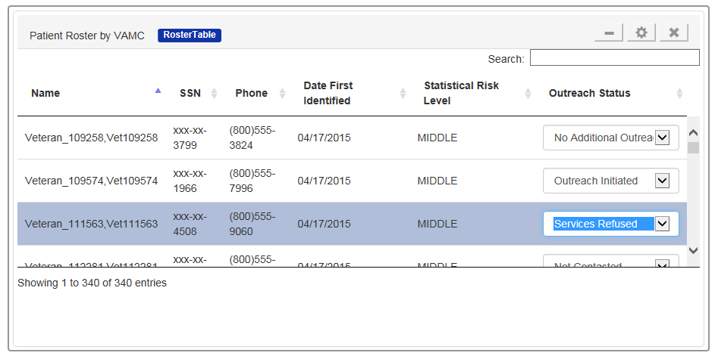

Figure 14: Veteran Outreach Status

### Facility Level View

The Dashboard also provides the ability to view data aggregated at the facility level. Users with both Supervisory and standard Clinical Care Team Member access will have access to this view. Users with Clinical Care Team Member access will only be able to see data from their “home” facility by default. Users with supervisory-level access will be able to toggle through the various facilities in the system using the Facility Roster widget, similar to other rosters found throughout the Dashboard.

The view features additional widgets that show information in the following categories:

* Veteran Outreach Status
* Categorical Risk Level (Top vs. Middle),
* Gender
* Military Service Branch
* Age Group

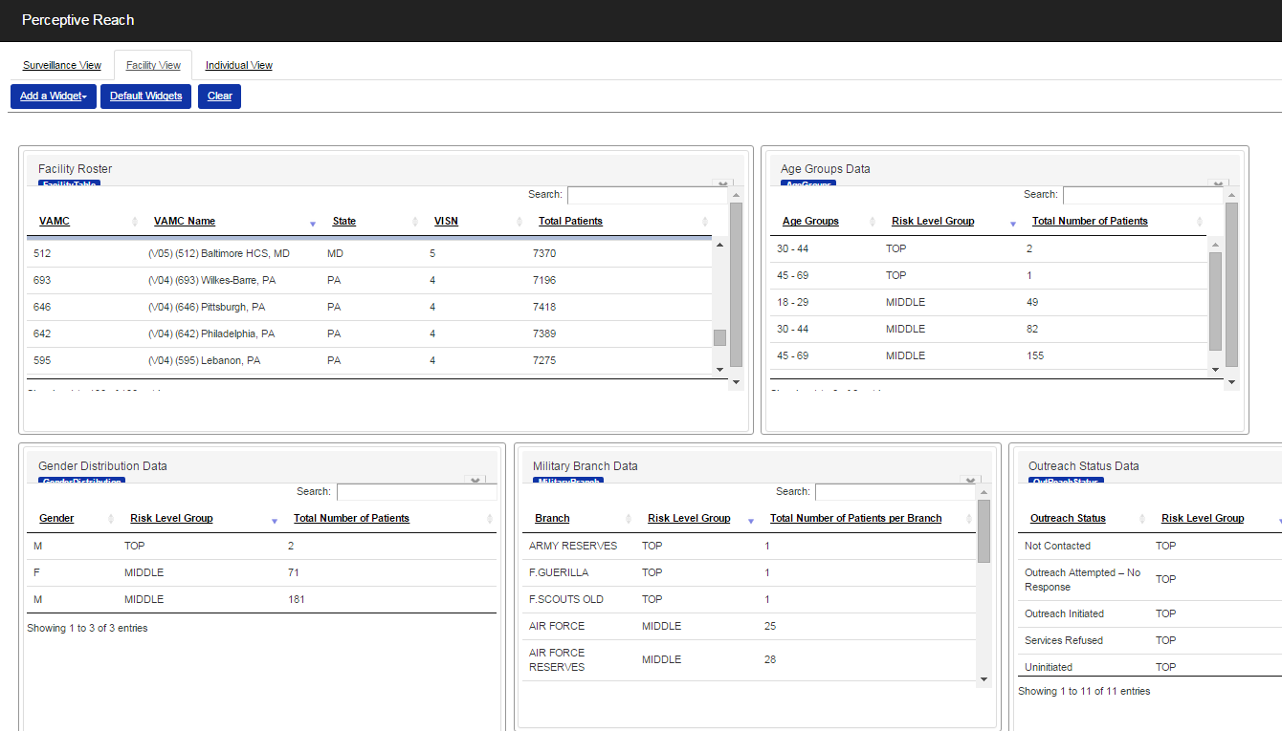

Figure 15: Facility View – Supervisor Level Access

### Surveillance Level View

The Dashboard also provides the ability to view data aggregated at the National and VISN levels. Only users with Supervisory access are granted the ability to access these views by default.

These views feature additional widgets that show information including summaries of categorical risk level (Top vs. Middle), gender, location, military history, age group, and outreach status.

To navigate to a desired VISN and / or facility, use the VISN Roster and Facility Roster on the surveillance level view:

* Select a VISN from the VISN Roster. The Dashboard will update to show data related to that VISN. To view data for a different VISN, simply select another VISN from the rows contained in the widget.
* To view data associated with a facility, select a facility from the Facility Roster. Only facilities within the selected VISN will be available. For example, when VISN 4 is selected in the VISN Roster, only facilities within VISN 4 will be available for selection.
* To go back to viewing just VISN data, de-select the current facility by clicking it again in the Facility Roster. The screen will return to displaying VISN-level data.

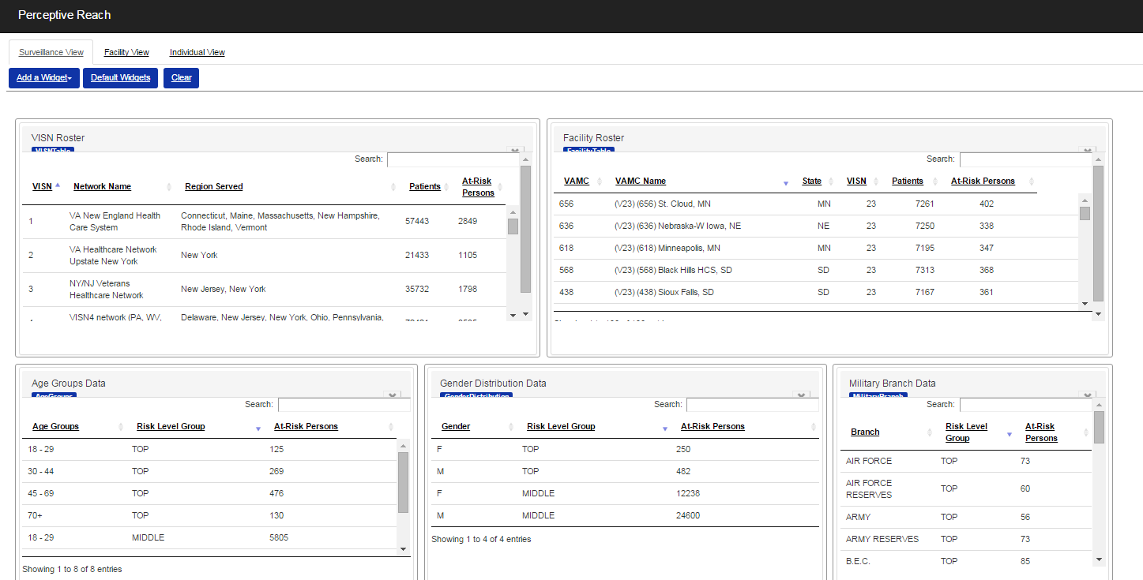

Figure 16: Surveillance View

The Surveillance view also offers, if activated, a Health Indicators widget with data pulled from an external data source: HealthIndicators.gov. The data set provided in the widget includes population-level risk factors for suicide in context of the overall Surveillance View.

### Request Help

All requests for help, instructions, troubleshooting, and bug / issue reporting should be directed toward the Perceptive Reach Help Desk at [VAPerceptiveReachSupport@va.gov](mailto:VAPerceptiveReachSupport@va.gov).

## Reporting

Reporting functions beyond those available on the Perceptive Reach Dashboard are handled via several add on tools including BIRT, SQL Server Management Studio (SSMS), and R. These tools are available via the Remote Desktop on the IRDS Application Server. Using the R tool, users are able to export files in the format: .xlsx (tab delimited, comma separated, and XML). Using the SSMS application, users are able to open new query pages, enter new queries, and view query results. The BIRT application allows users to export various report files to: DOC, DOCX, HTML, PDF, PPT, XLS. Users can also export certain data for manipulation and report generation in other VA approved tools with prior approval. Please contact [VAPerceptiveReachSupport@VA.gov](mailto:VAPerceptiveReachSupport@VA.gov) for more information.

**BIRT**

To login and access the BIRT follow the steps below:

1. Initiate gaining access to the tool by contacting the Perceptive Reach help desk and indicating you need access: [VAPerceptiveReachSupport@VA.gov](mailto:VAPerceptiveReachSupport@VA.gov)
2. Contact the system administrator to start process for gaining access to the server per Help Desk instructions. Once you have access to the server, BIRT should appear on the remote desktop as an icon.
3. Navigate to the Remote Desktop on the App Server.
4. Navigate to and open the BIRT tool / application on the desktop; once clicked, the Eclipse tool application will open with BIRT libraries.
5. On the BIRT application, choose the ‘Open Perspective.’
6. Choose the ‘Report Design’ option.
7. To create a new project in BIRT choose: ‘File’, ‘New’, ‘Project’; once selected, the project dashboard/dialogue should appear.
8. Type in a name for the report (i.e. ‘Report XX’).
9. Click ‘Finish’, a new report should be appear in the workspace.
10. In the tree view, choose the project recently created and enter in the desired field names.
11. Click ‘Next’ and a report should appear.
12. You may also utilize the DataSource to create a report.
13. Export report files into various formats: DOC, DOCX, HTML, PDF, PPT, XLS.

**R**

To login and access the R tool research functions follow the steps below:

1. Initiate gaining access to the tool by contacting the Perceptive Reach help desk and indicating you need access: [VAPerceptiveReachSupport@VA.gov](mailto:VAPerceptiveReachSupport@VA.gov)
2. Contact the system administrator to start process for gaining access to the server. Once you have access to the server, R should appear on the remote desktop as an icon.
3. Login to the Remote Desktop on App Server using your VA credentials.
4. Navigate to and open the R tool / application; once clicked, the R tool application will open.

**SQL / SSMS**

To login and access the SQL / SSMS research functions follow the steps below:

1. Initiate gaining access to the tool by contacting the Perceptive Reach help desk and indicating you need access: [VAPerceptiveReachSupport@VA.gov](mailto:VAPerceptiveReachSupport@VA.gov)
2. Contact the system administrator to start process for gaining access to the server. Once you have access to the server, BIRT should appear on the remote desktop as an icon.
3. Access the IRDS Application Server via Remote Desktop; Server Name = [APServerName].
4. Navigate to and open Microsoft SQL SSMS and verify the connection to the server. ServerName = [DBServerName].
5. IRDS data and tables will be available by Expand the Reach Database.
6. Click on New Query button to open a new query page.
7. Enter the desired query into the Editor window.
8. SQL SSMS will allow you to create new queries and return results from these queries.

## Research

Research functions beyond those available on the Perceptive Reach Dashboard are handled via several add on tools including BIRT, R, and SSMS. Research access to the underlying database is approved and granted on a case by case basis by the owners of the system.

**BIRT**

To login and access the BIRT tool’s research functions follow the steps below:

1. Initiate gaining access to the tool by contacting the Perceptive Reach help desk and indicating you need access: [VAPerceptiveReachSupport@VA.gov](mailto:VAPerceptiveReachSupport@VA.gov)
2. Contact the system administrator to start the process for gaining access to the server.
3. Go to the Remote Desktop on the App Server
4. Navigate to and open the BIRT tool / application on the desktop; once clicked, the Eclipse tool application will open with BIRT libraries.
5. On the BIRT application, choose the ‘Open Perspective’
6. Choose the ‘Report Design’ option
7. To create a new project in BIRT choose: ‘File’, ‘New’, ‘Project’; once selected, the project dashboard/dialogue should appear
8. Type in a name for the report (i.e. ‘Report XX’)
9. Click ‘Finish.’ A new report should be appear in the workspace
10. In the tree view, choose the project recently created and enter in the desired field names
11. Click ‘Next’ and a report should appear
12. You may also utilize the DataSource to create a report
13. Export report files into various formats: DOC, DOCX, HTML, PDF, PPT, XLS

**R**

To login and access the R tool research functions follow the steps below:

1. Initiate gaining access to the tool by contacting the Perceptive Reach help desk and indicating you need access: [VAPerceptiveReachSupport@VA.gov](mailto:VAPerceptiveReachSupport@VA.gov)
2. Contact the system administrator to start the process for gaining access to the server.
3. Login to the Remote Desktop on App Server using your VA credentials.
4. Navigate to and open the R tool / application; once clicked, the R tool application will open.

**SQL / SSMS**

To login and access the SQL / SSMS research functions follow the steps below:

1. Initiate gaining access to the tool by contacting the Perceptive Reach help desk and indicating you need access: [VAPerceptiveReachSupport@VA.gov](mailto:VAPerceptiveReachSupport@VA.gov)
2. Contact the system administrator to start process for gaining access to the server.
3. Once you have access to the server, BIRT should appear on the remote desktop as an icon.
4. Access the IRDS Application Server via Remote Desktop; Server Name = [APServerName].
5. Navigate to and open Microsoft SQL SSMS and verify the connection to the server. ServerName = [DBServerName].
6. IRDS data and tables will be available by Expand the Reach Database.
7. Click on New Query button to open a new query page.
8. Enter the desired query into the Editor window.
9. SQL SSMS will allow you to create new queries and return results from these queries.

## Special Instructions for Error Correction

No special instructions for errors have been identified at this time. When and if special instructions are defined, this document will be updated.

## 6.0 Acronyms and Abbreviations

Table 4: Acronyms and Abbreviations

| Acronym | Term |
| --- | --- |
| API | Application Program Interface |
| BIRT | Business Intelligence Reporting Tool |
| CDW | Corporate Data Warehouse |
| CPRS | Computerized Patient Record System |
| DoD | Department of Defense |
| IRDS | Integrated Reach Database System |
| IT | Information and Technology |
| NDI | National Death Index |
| PIV | Personal Identity Verification |
| PR | Perceptive Reach |
| SDR | Suicide Data Repository |
| SMSS | SQL Server Management Studio |
| SPAN | Suicide Prevention Applications Network |
| SPC | Suicide Prevention Coordinator |
| SQL | Structured Query Language |
| SSN | Social Security Number |
| UI | User Interface |
| VA | Department of Veterans Affairs |
| VACI | VA Center for Innovation |
| VAMC | VA Medical Center |
| VHA | Veterans Health Administration |
| VISN | Veterans Integrated Service Networks |
| VistA | Veterans Health Information Systems and Technology Architecture |
| VLER | Virtual Lifetime Electronic Record |

1. Department of Veterans Affairs (VA) Directive 6500, Information Security Program <http://www.va.gov/vapubs/viewPublication.asp?Pub_ID=56>
2. Clinical Care Team is a catch-all term for a staff member who provides outreach and intervention services to at-risk patients. Users in this category may include Suicide Prevention Coordinators, social workers, care managers, and other clinicians such as primary care physicians, psychologists, nurses, etc.
3. Clinical Care Team Members will have access to the Facility View for their home facility only by default.
4. Keyboard navigation features apply to core features of the application such as the Perceptive Reach Dashboard. For details on keyboard navigation for related applications such as VLER Direct, BIRT, R, please see the user manual for those applications.