RAPTOR Charts Tech Guide

Last updated 20140315

Contents

Overview 2

Charts 2

Temperature Thumbnail Chart 2

X Axis 2

Y Axis 2

eGFR Chart 2

X Axis 2

Y Axis 3

Vitals Chart 3

X Axis 3

Y Axis 3

Special Point Plotting Notes 3

Revision History 4

**Tables**

Table 1 – Charts 2

# Overview

The RAPTOR application has three charts as shown in Table 1. Plan is to use the d3 opensource library to produce them.

Table 1 – Charts

| Name | Description |
| --- | --- |
| Temperature Thumbnail Chart | Small chart with temperature on Y axis and Dates on the X axis. |
| eGFR Chart | Normal chart with eGFR values on the Y axis and Dates on the X axis. |
| Vitals Chart | Has two Y axis, one X axis. |

# Charts

Data will be passed to charting function for display on existing HTML pages.

## Temperature Thumbnail Chart



Figure 1 - Thumbnail Chart Example

Data for the chart will be array with rows of following values…

1. Date
2. Temperature

### X Axis

One point for each row of data, each point is a date. Do not show the dates, show single numbers instead.

### Y Axis

Scaled with top temperature being the top of the axis and bottom temperature (with small gap) being bottom of the axis.

## eGFR Chart

Data for the chart will be array with rows of the following values…

1. Date
2. eGFR

### X Axis

One point for each row of data, each point is a date. Show the dates on the X axis.

### Y Axis

One point for each row of data, each point is an eGFR value. Show the eGFR values on the Y axis.

## Vitals Chart

This is essentially two charts superimposed on each other with one of the charts having the Y axis labels to the right.

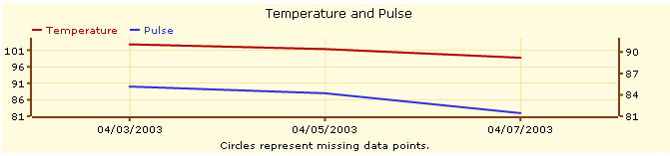

Figure 2 – Temperature and Pulse in one Chart

Data for the chart will be array with rows of the following values…

1. Date
2. Temp
3. Pulse

### X Axis

One point for each row of data, each point is a date.

### Y Axis

* Temperature is left Y axis, Pulse is right Y axis.
* Left Y is scaled from lowest plotted temperature to highest plotted temperature.
* Right Y is scaled from lowest plotted pulse to highest plotted pulse.

### Special Point Plotting Notes

* Plot the temperature line and points as red. Plot the pulse line and points as blue.
* Normally plot a solid circle for each point. If however, a row is **missing** a **Temperature** **value**, then plot an empty circle at the interpolation between the two existing points. If a row is **missing** a **Pulse** **value**, then plot an empty circle at the interpolation between the two existing points.

# Revision History

|  |  |  |
| --- | --- | --- |
| When | Who | What |
| 20140315 | FJF | Initial draft |
|  |  |  |
|  |  |  |