Department of Veterans Affairs

**Innovation 873**

**Telepathology Worklist**

Quick Start - User Guide



April 2015

Version *0.2*

Revision History

Note: The revision history cycle begins once changes or enhancements are requested after the document has been baselined.

| Date | Version | Description | Author |
| --- | --- | --- | --- |
| 8/1/2013 | 0.1 | Initial Draft of Quick Start User Manual for the VistA Imaging Telepathology Worklist | Amy m. foster |
| 04/24/2015 | 0.2 |  | Wesley Shyu |
|  |  |  |  |

Artifact Rationale

A User Guide is a technical communication document intended to give assistance to people using a particular system. It is usually written by a technical writer, although it can also be written by programmers, product or project managers, or other technical staff. Most user guides contain both a written guide and the associated images. In the case of computer applications, it is usual to include screenshots of the human-machine interface(s), and hardware manuals often include clear, simplified diagrams. The language used is matched to the intended audience, with jargon kept to a minimum or explained thoroughly. The User Guide is a mandatory, increment-level document, and should be updated to reflect the contents of the most recently deployed increment.

**Table of Contents**

1. Introduction 5

1.1. Purpose 5

1.2. Overview 5

1.3. Project References 5

1.3.1. Information/HelpDesk 5

1.4. Acronyms and Abbreviations 5

2. System Summary 7

2.1. User Access Levels 7

3. Getting Started 8

3.1. Telepathology Configurator 8

The Telepathology Configurator 8

3.2. Telepathology Worklist 9

3.3. Using Clinical Display to view Images 10

3.4. Exit System 10

4. Using the Telepathology Worklist 11

4.1. Reserve/Un-Reserve a Case 11

4.2. Reports 12

4.3. Images 14

4.4. Notes 14

4.5. Consultation 15

4.6. Default Health Summary 15

4.7. Health Summary List 16

4.8. Worklist Filter 17

5. Troubleshooting 18

# Introduction

The VistA Imaging TelePathology Worklist provides a com

## Purpose

The purpose of this document is to provide a guide for utilizing the VistA Imaging Telepathology Applications.

## Overview

The VistA Imaging Telepathology Application has two applications that a user will need to understand how to use.

* List and describe the major functions performed by the system
* Describe the architecture of the system in non-technical terms, (e.g., client/server, Web-based, etc.)
* User access mode, (e.g., graphical user interface)
* Responsible organization
* System name or title
* System code
* System category:
  + Major application: performs clearly defined functions for which there is a readily identifiable security consideration and need
  + support system: provides general computing or network support for a variety of users and applications
* Operational status:
  + Operational
  + Under development
  + Undergoing a major modification
* General description
* System environment or special conditions

## Project References

### Information/HelpDesk

For issues or questions about the Telepathology Configurator or the Telepathology Worklist please contact the National Service desk at 1-888-596-4357 -option 0 or visit <http://vaww.itsupportservices.va.gov/vasd_home.asp> to log a Remedy ticket.

## Acronyms and Abbreviations

| **Term** | **Definition** |
| --- | --- |
| CCOW | Clinical Context Object Workgroup |
| CPRS | Computerized Patient Record System |
| DFN | Data File Number |
| DICOM | Digital Imaging and Communication in Medicine |
| HDIG | Hybrid DICOM Image Gateway: An image gateway that combines the legacy DICOM Gateway and the new VISA Gateway. |
| HL7 | Health Level 7: ANSI-accredited standards for electronically defining clinical and administrative data in the healthcare industry from Health Level Seven International (www.hl7.org). HL7 provides standards for messaging, electronic records, decision support queries, medicine labels and the visual integration of data from different applications. |
| Laboratory package | A package in VistA, which automates the manual procedures used in these laboratory areas: Ordering of tests and procedures on both patient and non-patient specimens; collecting and accessioning of specimens into the Laboratory database; processing and analysis in appropriate department or work areas; review and verification of results; reporting of results and/or diagnoses for clinical health care treatment; analysis and reporting of quality control data used in generating results; providing management statistical data as well as requirements for accreditation by regulating bodies and agencies. |
| Pathology | The branch of medicine concerned with the cause, origin, and nature of disease, including the changes occurring as a result of disease. |
| Telepathology | The use of telecommunications technology to facilitate the transfer of image-rich pathology data between remote locations for the purposes of diagnosis, education, and research. |
| VistA Imaging Telepathology Configurator | A component of the VistA Imaging Telepathology Applications that allows administrators to configure components of the application. |
| VistA Imaging Telepathology Worklist | A component of the VistA Imaging Telepathology Applications that allows pathologists to view the list of cases at their site. |
| VI | VistA Imaging |
| VistA | Veterans Health Information Systems and Technology Architecture |
| VistA Imaging Telepathology Applications (VITA) | A telepathology solution that enables the viewing telepathology cases and reports at the local site using a graphical user interface. |
| VIX | VistA Imaging Exchange Server |

# System Summary

The VistA Imaging Telepathology Application provides a comprehensive worklist for Anatomic Pathology cases. The worklist has two major components, the Telepathology Configurator and the Telepathology worklist. The Telepathology Configurator is used by the system administrators and provides the ability to set parameters for the timeout period, and the rentention date for verified and released cases that are displayed on the worklist. The Telepathology worklist is comprised of two tabs, the Unread List and the Read List. Each tab provides Anatomic Pathology case information from the site the user is logged into providing a comprehensive list of the cases accessioned into the VistA Laboratory package. As these cases are updated, completed, verified and released the worklist provides information that the pathologist may use to track their daily workload. Image information has also been added into this application, which provides the ability to associate DICOM images from a vendor modality and associate it with a case that has a status of unread. Cases that contain a status of completed, verified/released are unable to participate in the image association process at this time.

## User Access Levels

|  |  |
| --- | --- |
| Application | Keys/Menu |
| Telepathology Configurator | MAG SYSTEM  LR LAB  Secondary menu :  MAGTP WORKLIST MGR |
| Telepathology Worklist | LR LAB  *MAG SYSTEM  Secondary menu :  MAGTP WORKLIST MGR |

*MAG SYSTEM allows a user access to the Telepathology worklist but provide no functionality.

# Getting Started

## Telepathology Configurator

The VistA Imaging Telepathology Application provides a comprehensive worklist for Anatomic xxxxxxtwo major components, the Telepathology Configurator and the

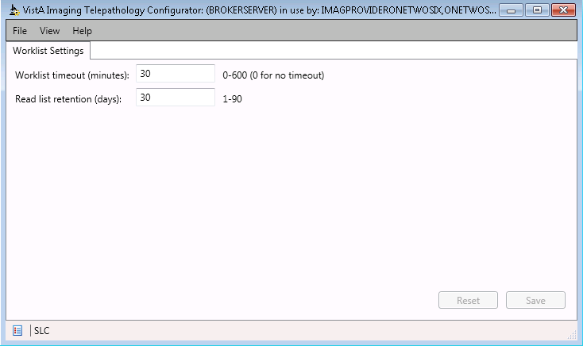

Figure 1 - Telepathology Configurator showing default settings.

## The Telepathology Configurator

## Telepathology Worklist

The VistA Imaging Telepathology Application provides a comprehensive worklist for Anatomic Pathology cases. The worklist has two major components, the Telepathology Configurator and the xxx

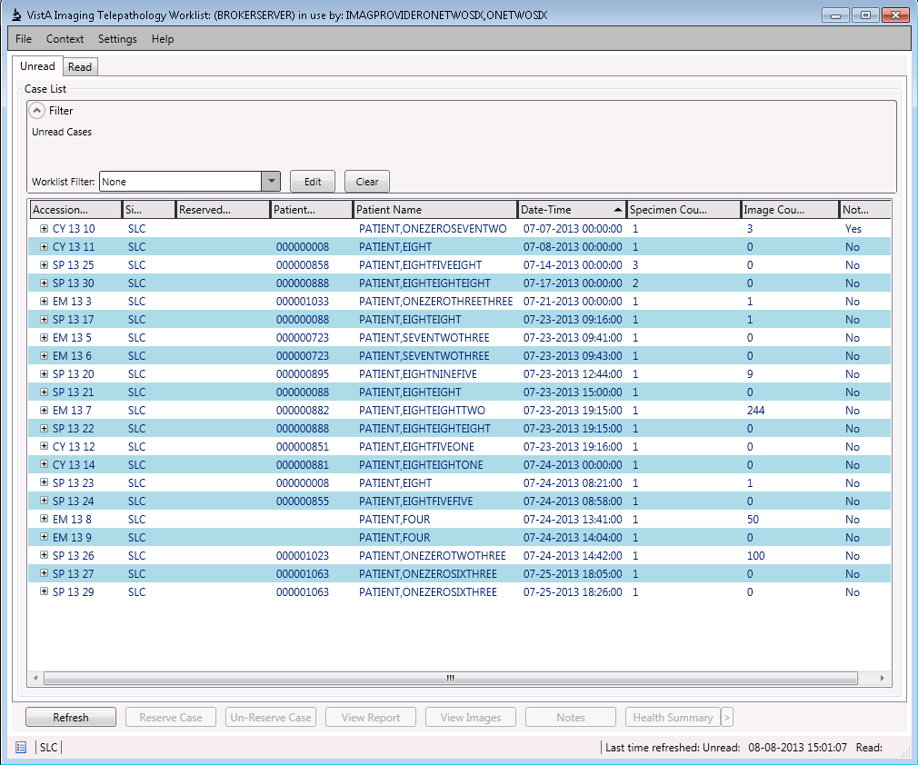

Figure 2 - Telepathology Worklist showing the Unread tab.

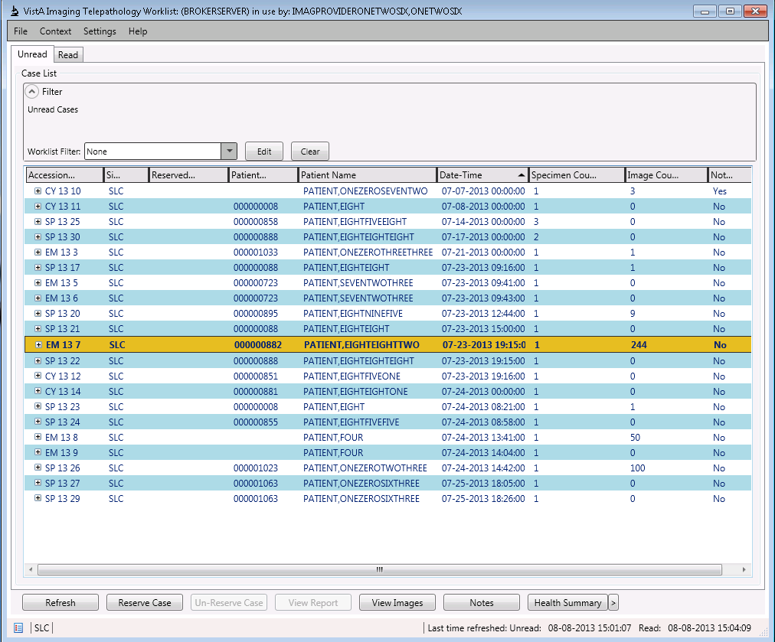

Figure 3 - Telepathology Worklist showing a case with images.

## Using Clinical Display to view Images

The Telepathology worklist has included functions that now allow for approved DICOM modalities to associate images with Laboratory Anatomic Pathology cases. Located on the Worklist (both Unread and Read tabs) is a button that reads View Images. When an image count is present that means there are images associated with a particular accession. In order to view those images the user may manually launch the Clinical Display application or the user may select the View Images button directly from the Worklist. When that button is clicked, the VistA Imaging Clinical Display application will launch displaying all images for the patient selected. (Note – CCOW must be actively running on the system in order for patient context to be maintained.)

## Exit System

Both the Telepathology Configurator and the Telepathology Worklist utilize the same mechanism to log off or exit the system. From the main menu select File and then LOG OFF or Exit. Done.

# Using the Telepathology Worklist

## Reserve/Un-Reserve a Case

Right a case on the case list to reserve a case. The Reserved By column should reflect the corresponding user.

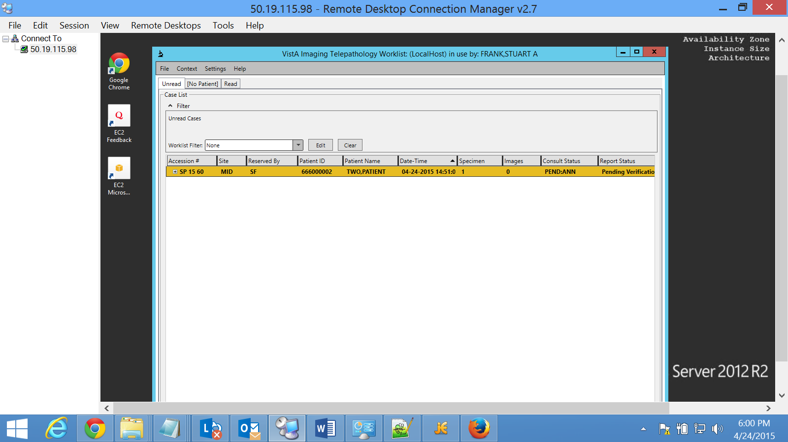

Right a case on the case list to un-reserve a reserved case.

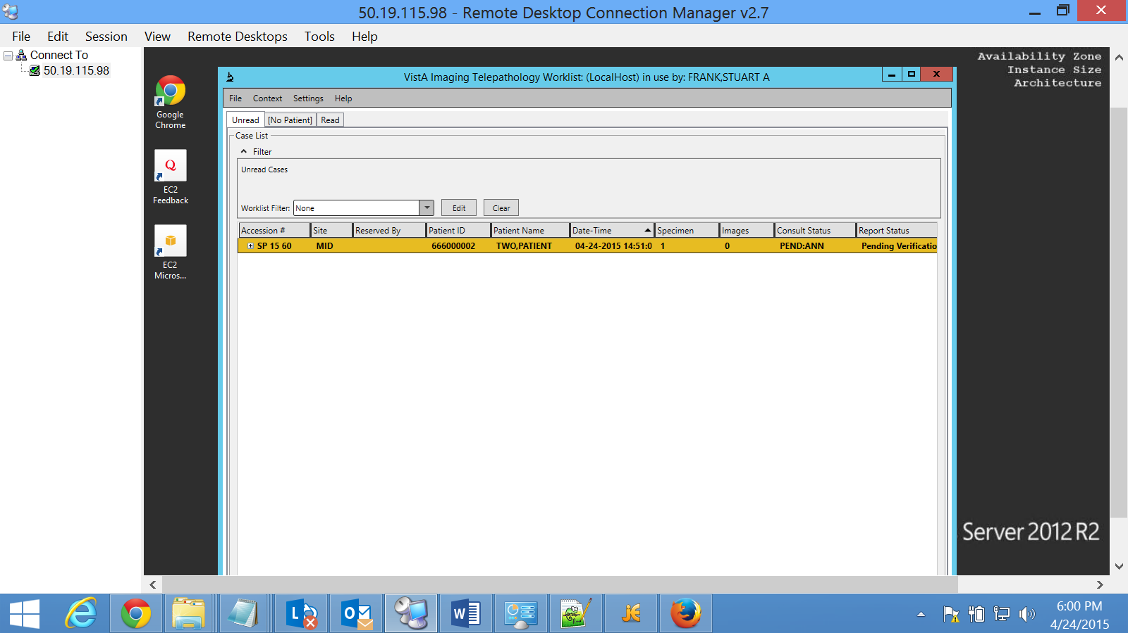

## Reports

Right a case on the case list and select View Report to view the report of the case.

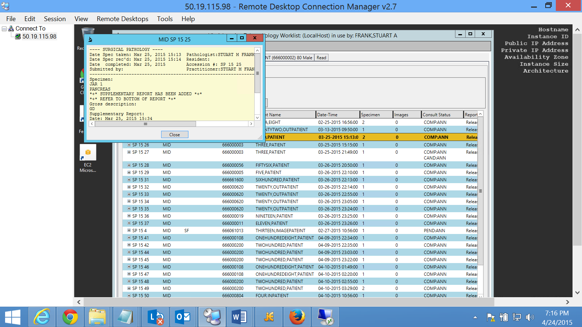

To edit a report, select Edit Report.

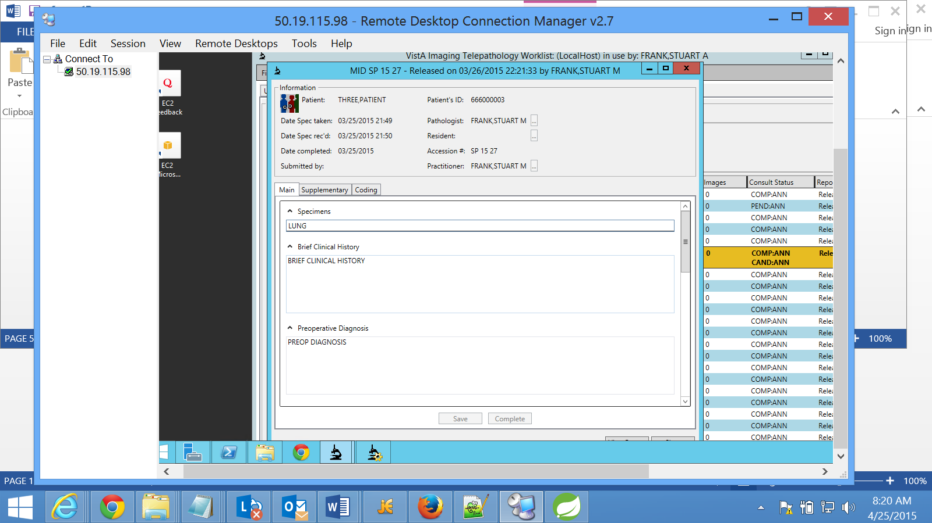

There are three tabs: Main, Supplementary, and Coding. For the Supplementary Report, the left pane is used to enter new information. And the right pane shows the information entered before. When the New button is clicked, the text entered in the left pane will be added to the right pane.

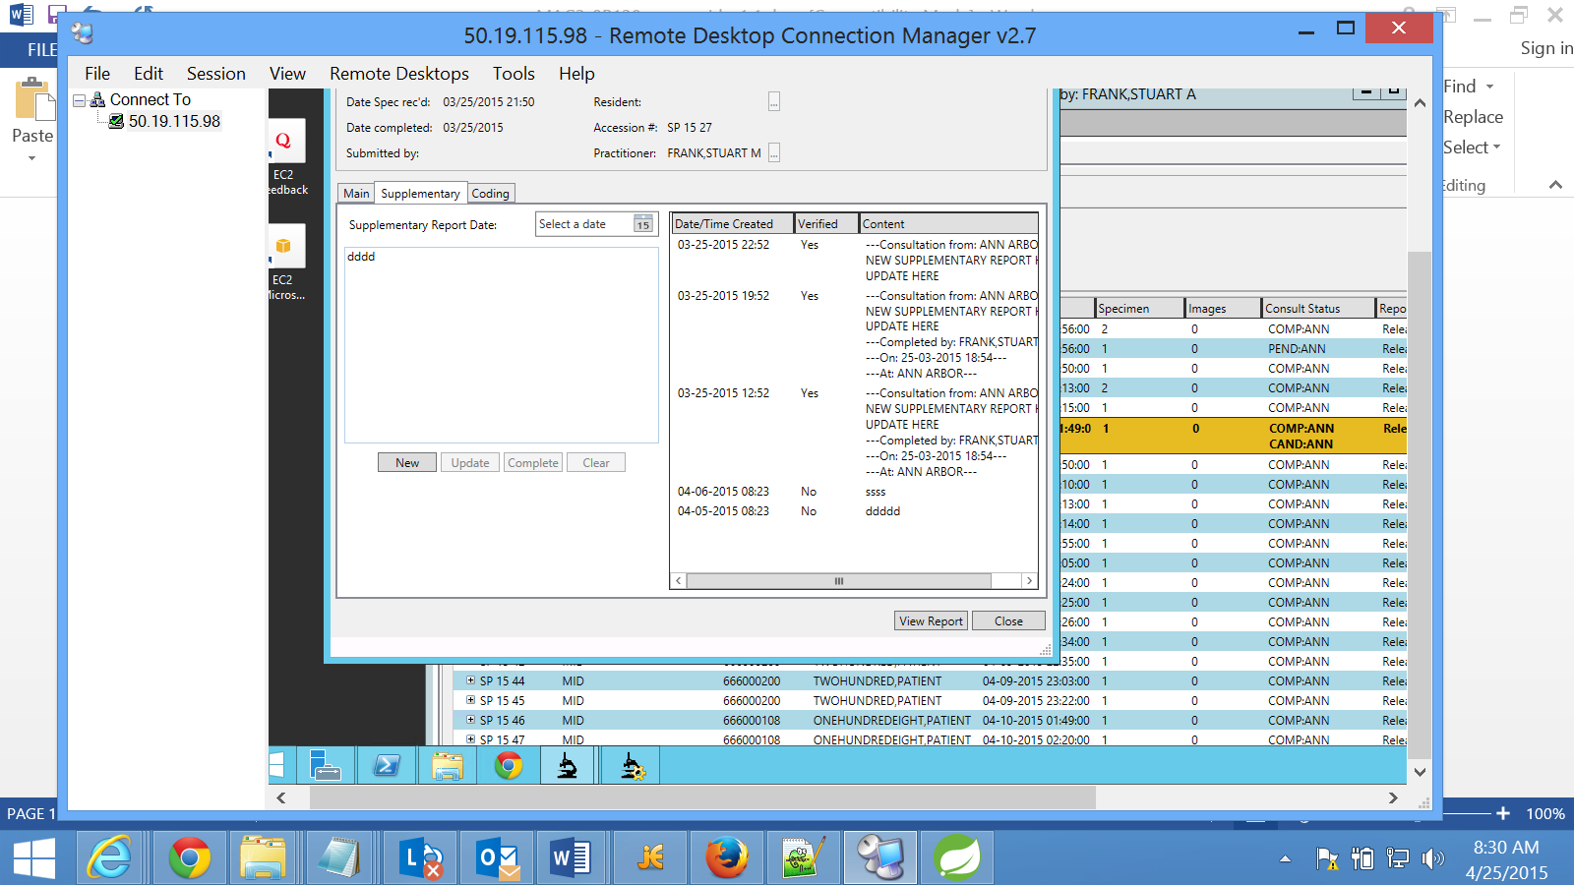

## Images

Right a case on the case list to and select View Images to view the images.

## Notes

Right a case on the case list and select View Notes to view the notes.

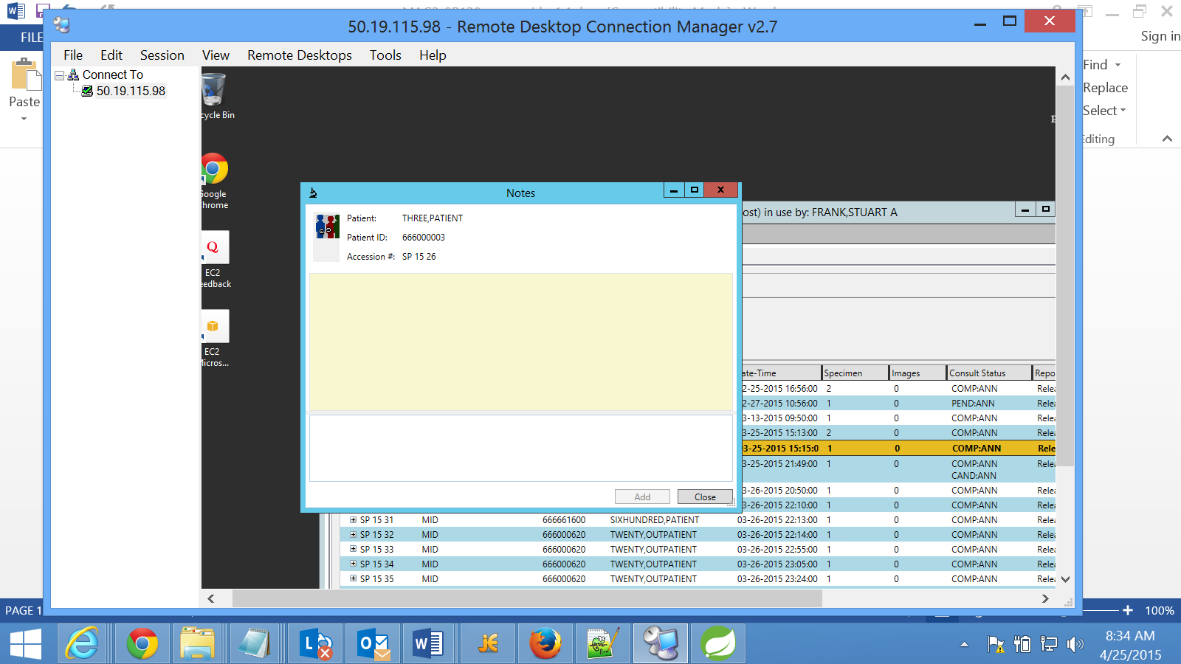

Click the Add button to add the newly entered text and it will be added to the upper display area.

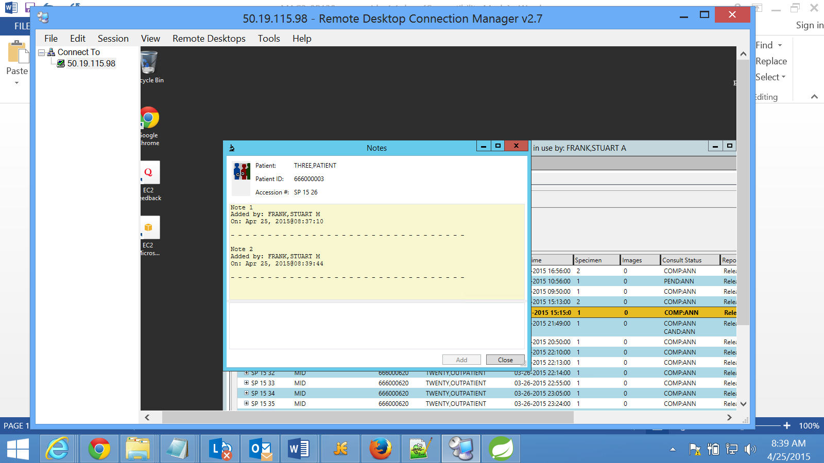

## Consultation

N/A

## Default Health Summary

Right a case on the case list select View Default Health Summary to view the Default Health Summary.

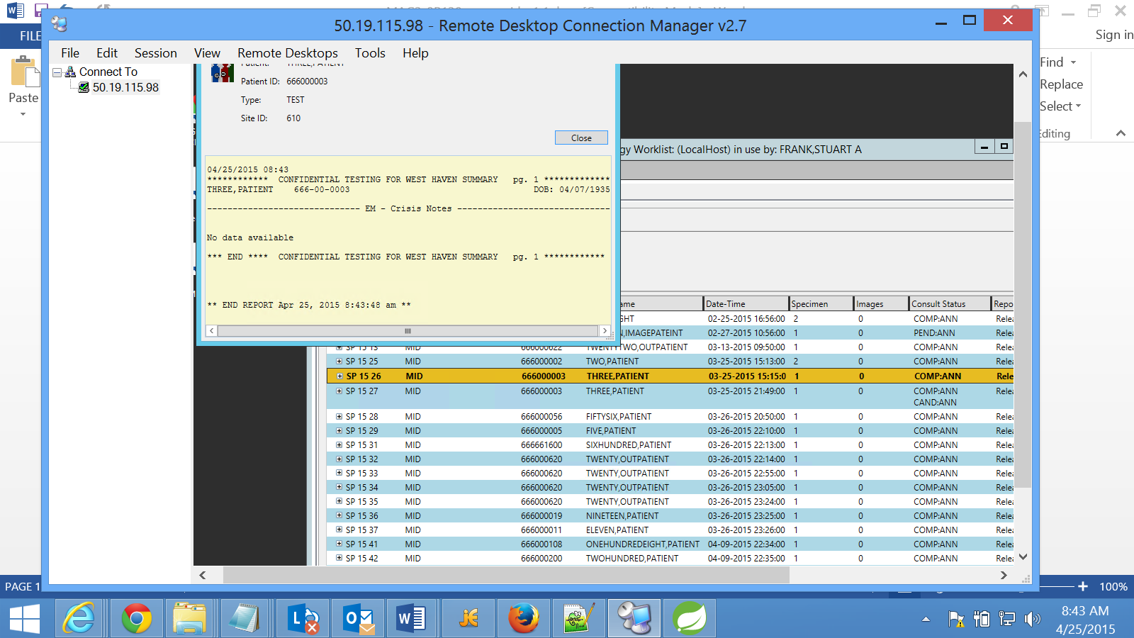

## Health Summary List

Right click a case on the case list and select Health Summary List to view the Health Summary List.

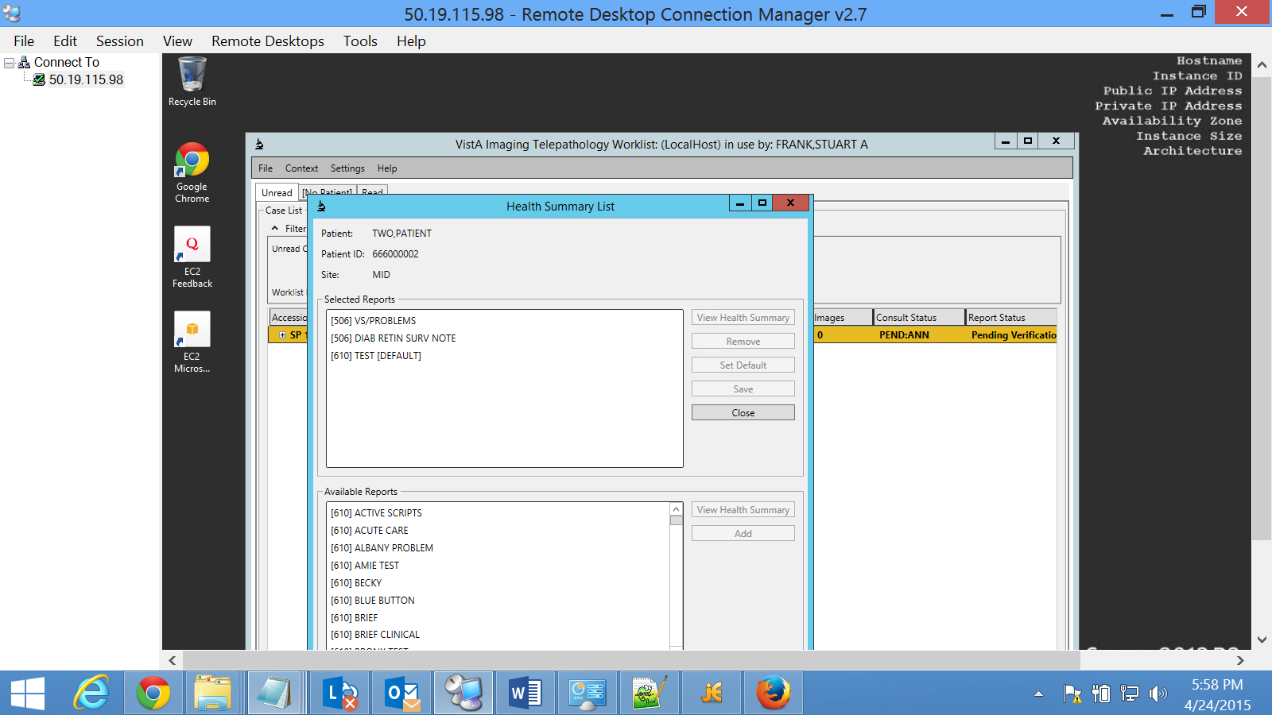

## Worklist Filter

A worklist filter can be used to limit the telepathology cases displayed in the case list.

To create a worklist filter, click the Settings on the menu bar and select Filter settings to bring up the Filter Settings dialog box. Click the New button to enter the constraints for the new filter.

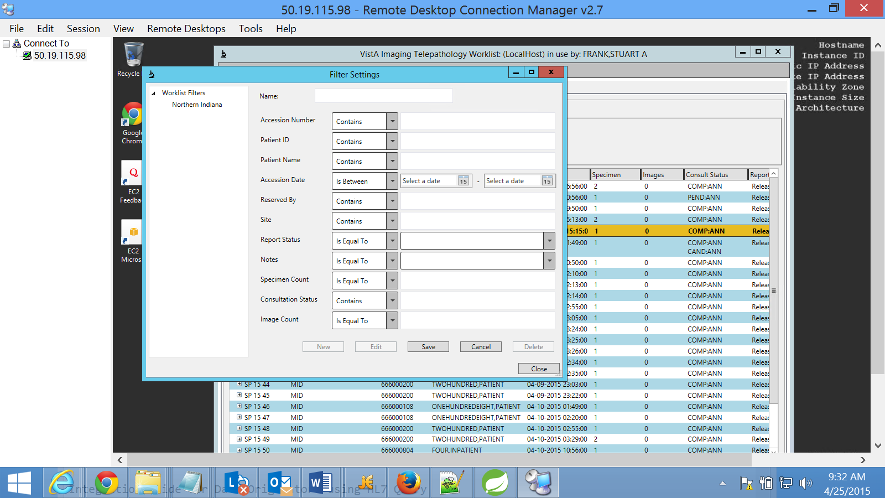

A worklist filter can be edited by clicking the Edit button on the upper panel of the case list.

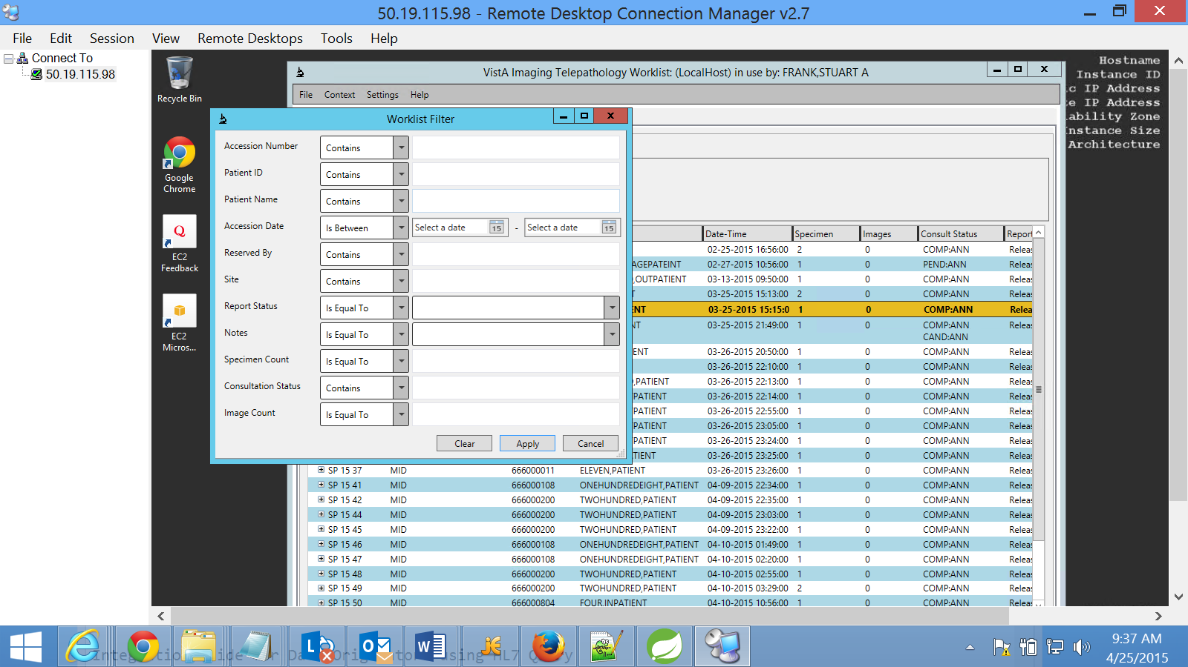

# Troubleshooting

For assistance or issues with the Telepathology Worklist please contac the National Helpdesk.

Template Revision History

| Date | Version | Description | Author |
| --- | --- | --- | --- |
| August 2008 | 0.1 | Initial Version | Amy M Foster |