Victor Harris

Assignment 3 – CIS225

**Chapter 6 Exercises**

6.1

6.2

They are extensions of type ‘Object’. They all have constructors.

6.3

They both return a boolean value. One takes a prefix string as an argument and returns if the string starts with that prefix, the other takes a string and an int as an argument and does the same, only it offsets the the ‘starting point’ to a specified index of the string / char[].

6.4

Yes, it is called ‘endsWith’, has a return type of boolean, and has a string parameter.

6.5

Yes, it is called ‘length’, it has no parameters and returns a value of type int.

6.6

I found them in the oracle documentation, and used the find utility to search for relevant keywords.

6.7

public String trim() | text.trim();

6.8

6.9

6.10

Its return type is boolean.

6.11

Removed ‘magic’ string as well.

6.12

It is in the java.util package, it creates an object capable of generating random values.

6.13

Done

6.14

6.15

0-99

6.16

6.17

6.18

6.19

6.20

**6.21**

They are important because they need to be random, while also being consistent. When generating a cryptographic value, it needs to be unpredictable. However, it also needs to be consistent in order to make decryption possible using the correct key.

6.22

6.23

It will work properly, because the random index used to select a response is generated based on the size of the ArrayList containing the available responses. \

6.24

Hashmaps are similar to ArrayLists, but utilize key-value pairs to store data.

6.25

Yes, the same types could be used for both parameters.

Hashmap.size();

6.27

6.28

It overwrites the existing value.

6.29

It saves the values separately.

6.30

6.31

It returns a boolean false value.

6.32

6.33

6.34

They are both collections, hash maps have rigid properties built around their key value pairs, where as array lists are much more flexible regarding what values can be inserted.

6.35

You can pass a string as an argument, which the split method will use as a delimiter.

6.36

split(“ “), split(“ “), split(“:”)

6.37

In a HashSet, you would be returning the key-value pairs, instead of just the value.

6.38

There is no problem if you use Regex (\\s+)

6.39

It utilizes a static list to essentially create a list to be used to clone itself into another ArrayList.

6.40

sort(), binarySearch(). copyOf(), etc.

6.41

6.42

6.43

6.44

**6.45**



**6.47**



**6.48**

**It inserts a value, only if the key is not assigned yet.**

**6.49**

**6.50**

**6.51**

It opens an HTML document with the details of the project. (really cool).

6.52

Multiple @versions are recorded in the same line, separated by a comma.

6.53

@ tags must have a fully qualified name, they include @author, @code, @docRoot, @deprecated, @param, @return, etc.

6.54

6.55

Constructor creates a new Canvas with a width / height of 500, 400.

drawSquare() instantiates a new pen, sets the color to blue, and then pens a square using the 320, 200 as a starting point.

drawWheel() instantiates a pen, sets its color to red, and then draws 36 lines, turning by 10 degrees each iteration.

drawSquare(Pen pen) takes a pen as an argument and draws 4 lines, 100 in length, turning by 90 every iteration.

colorScribble() instantiates a pen, chooses a random color and randomly wiggles it.

clear() erases the canvas using a public method of the Canvas object.

6.56

Done

6.57

Done.

6.58

Done.

6.59

Done.

6.60

Done.

6.61

Done

6.62

Done

6.63

6.64

6.65

6.66

**6.67**

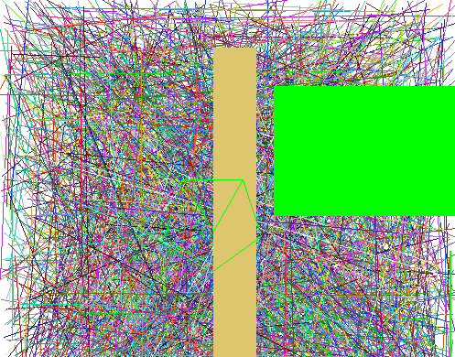

**6.68**

**6.69**

I used an array list, because I needed a container that was flexible, but did not need to access the balls based on any particular properties.

6.70



6.71

Pseudo solution: Instantiate a box object, which then instantiates boxBalls inside of it with the same methods as the bouncing balls with the move method that used the dimensions of the container box as limits rather than the dimensions of the canvas.

6.72

Pseudo solution: Generate 3 random floats to use as RGB values to instantiate a color object that can be passed as an argument when instantiating a new ball inside a for loop.

6.73

Higher gravity results in the balls falling faster and bouncing less.

6.74

6.75

6.76

So that it is easily identified by whoever ends up looking at the code later on, and so that the value is easy to investigate.

6.77



6.78

They are static methods because they are meant to be accessed from anywhere, and in the same way. Their return values are not based on the object they are attached to, but rather the values that are passed as arguments externally.

6.79

10,000 iterations took 0 milliseconds, UnitTest created by ChatGPT confirmed results. (that’s quick)

6.80

Yes, yes, and yes. So long as the static methods have a way of referencing the instanced class objects, either by a static instance or referenced arguments.

6.81

Done.

6.82

6.83

Done

6.84

Yes, it can be done using a static int that is incremented in the class constructor.

6.85

6.86

6.87

6.88

6.89

Because the values are only swapped locally.