RESULTS

The following represents the performance metrics of the system.

Performance of ML classifiers:

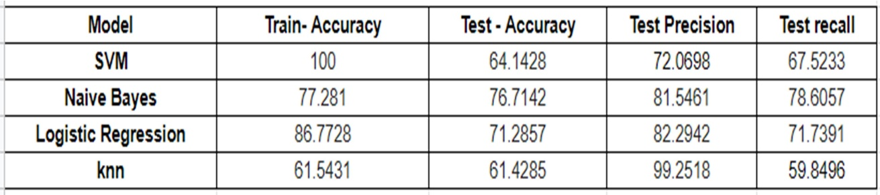

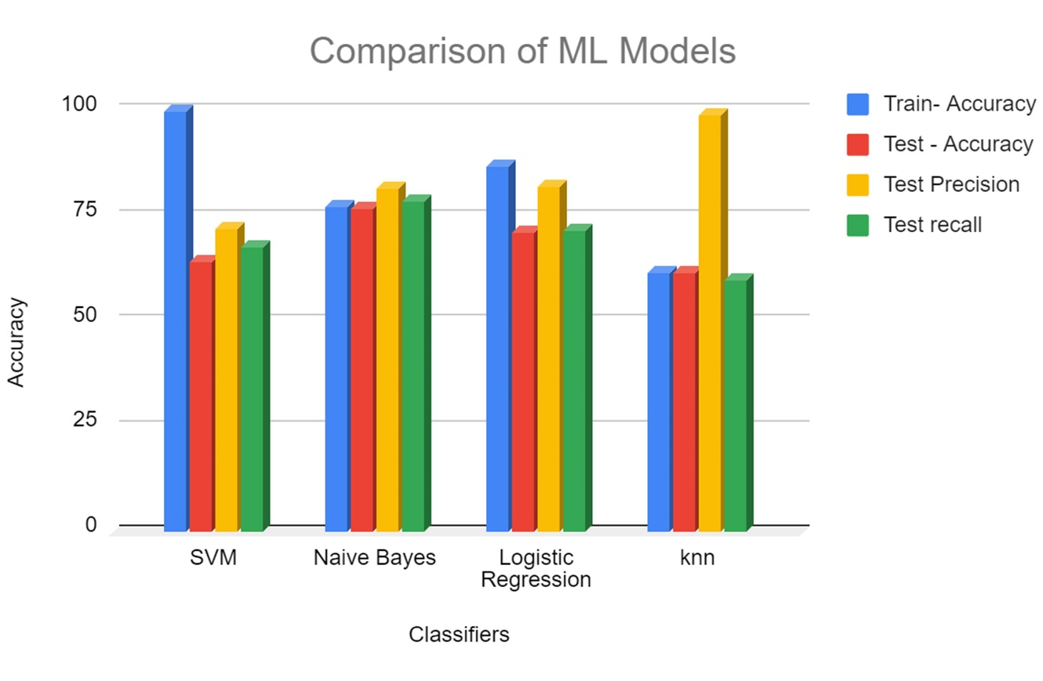

Fig 1.1: Comparison of ML Classifiers

Performance of Hybrid Models (DL+ML):

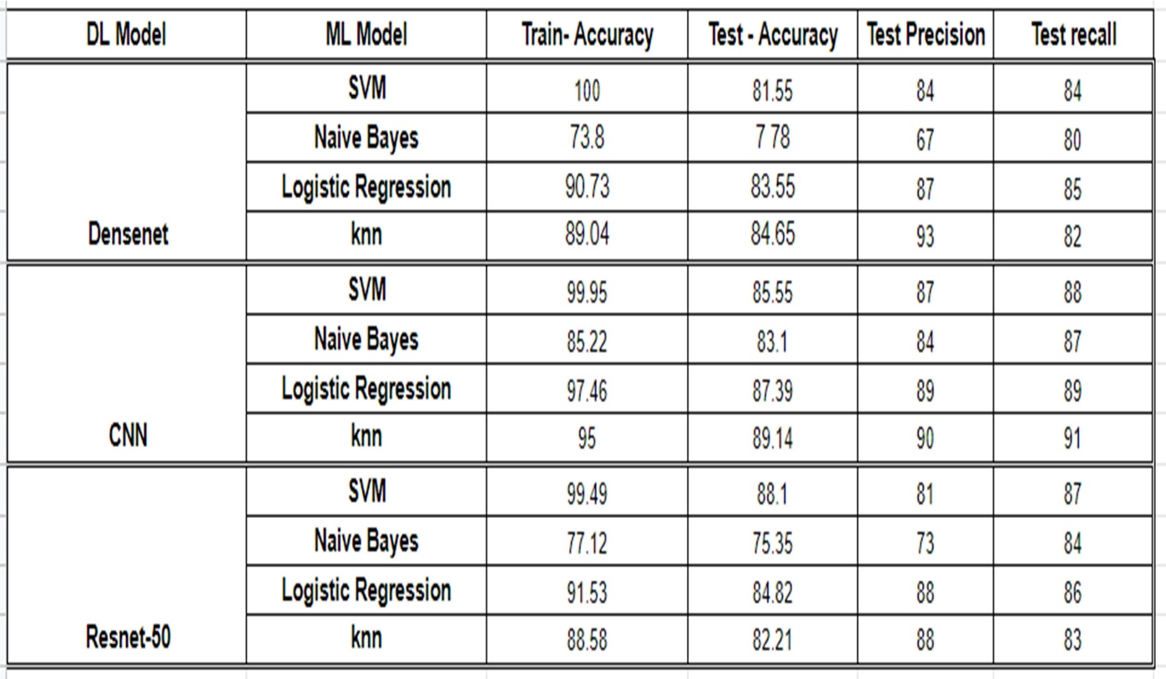

Performance of Hybrid Models with PCA:

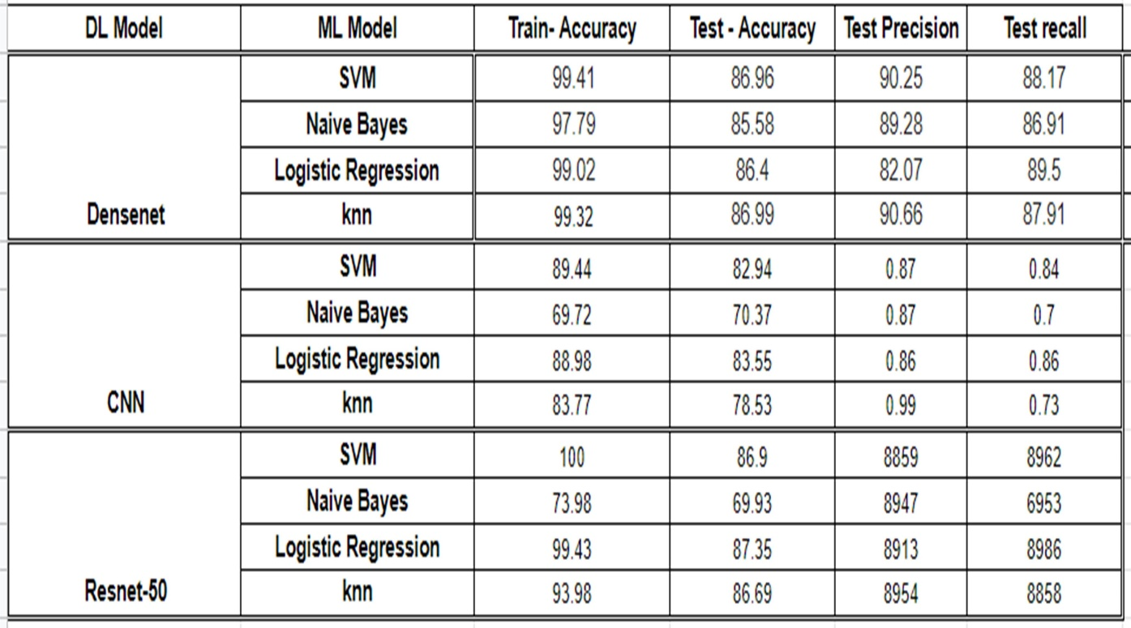

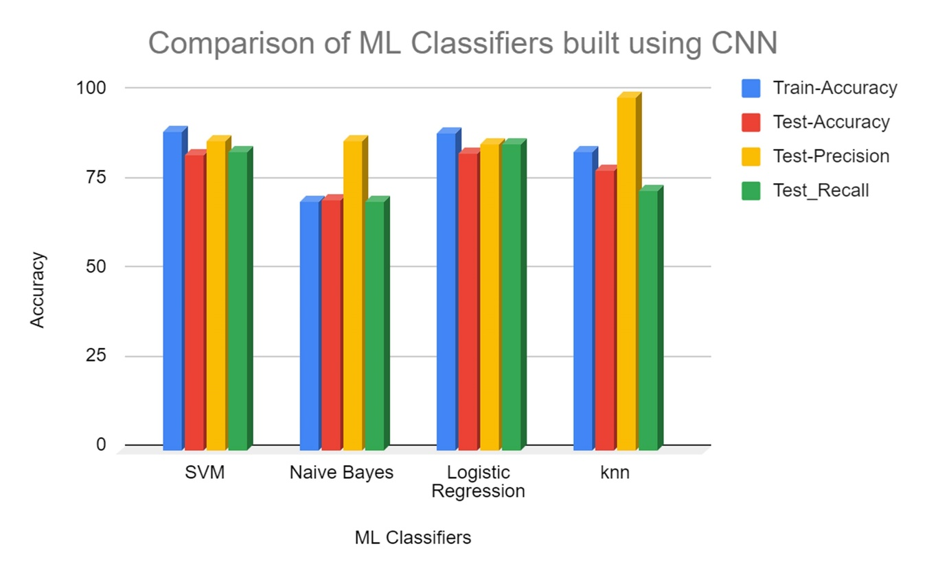

Fig 1.2: ML classifiers with CNN

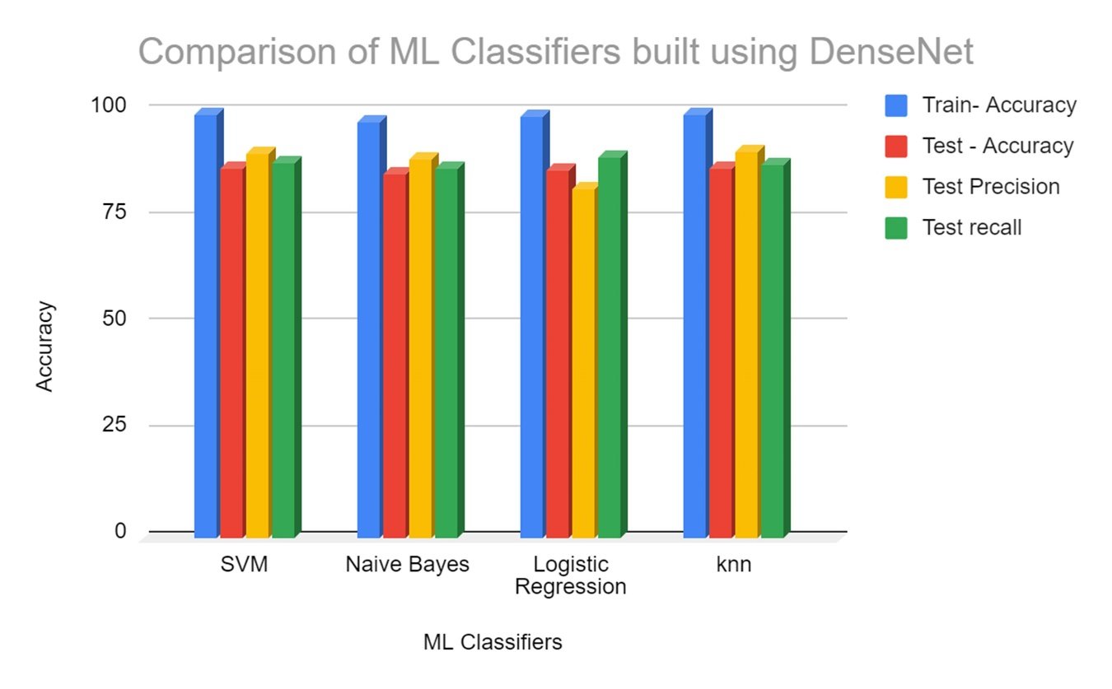

Fig 1.3: ML classifiers with DenseNet

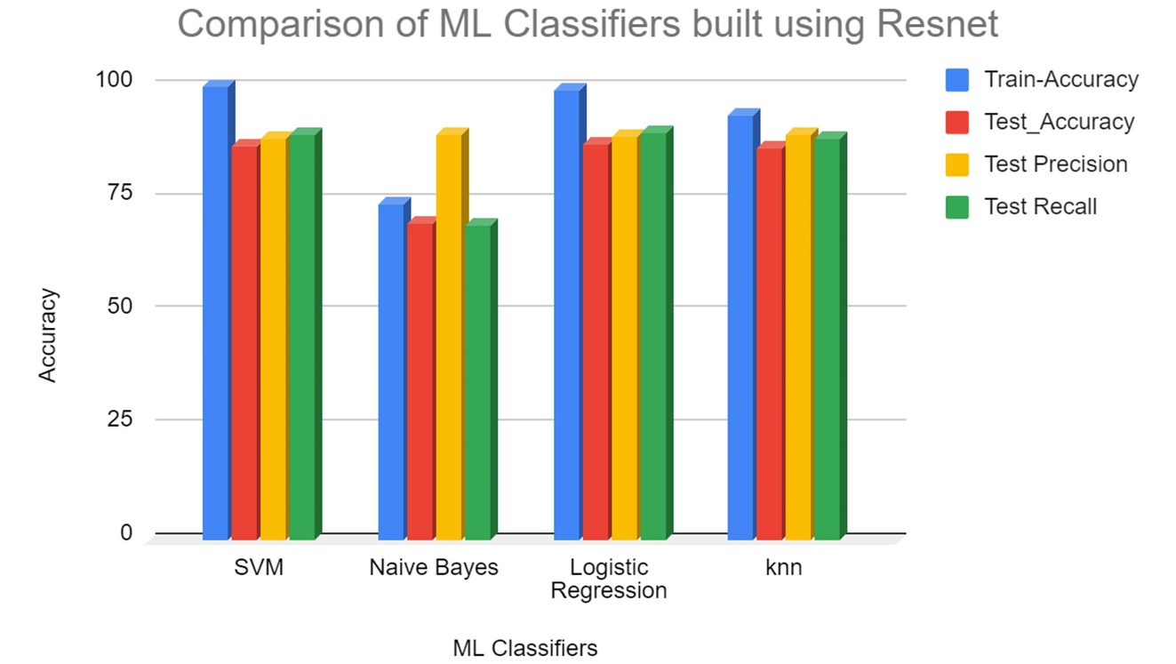

Fig 1.4: ML classifiers with ResNet

Comparison of SVM classifiers under different feature extractors:

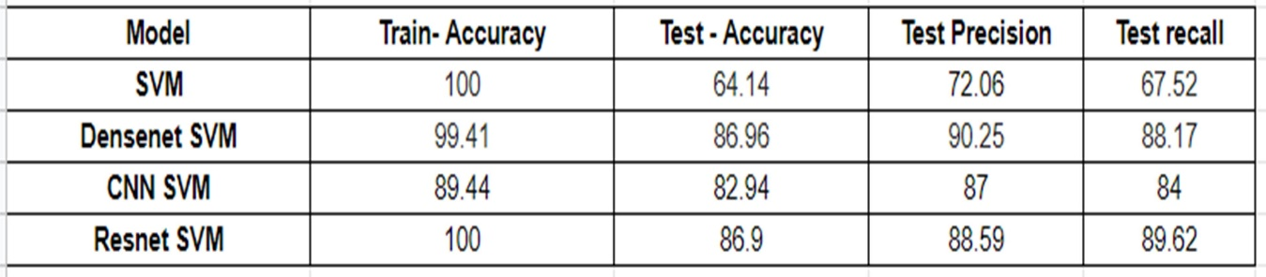

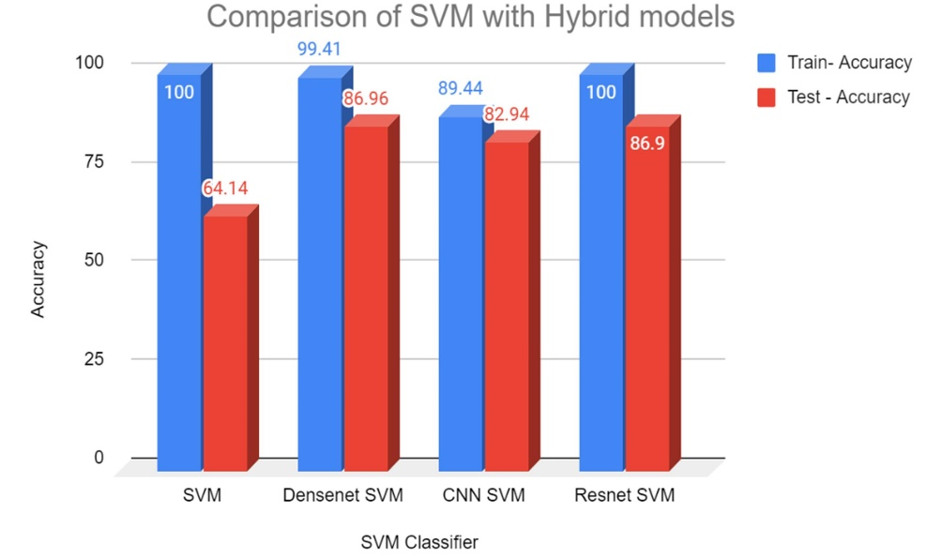

Fig 1.5: Comparison of SVM with hybrid models-1

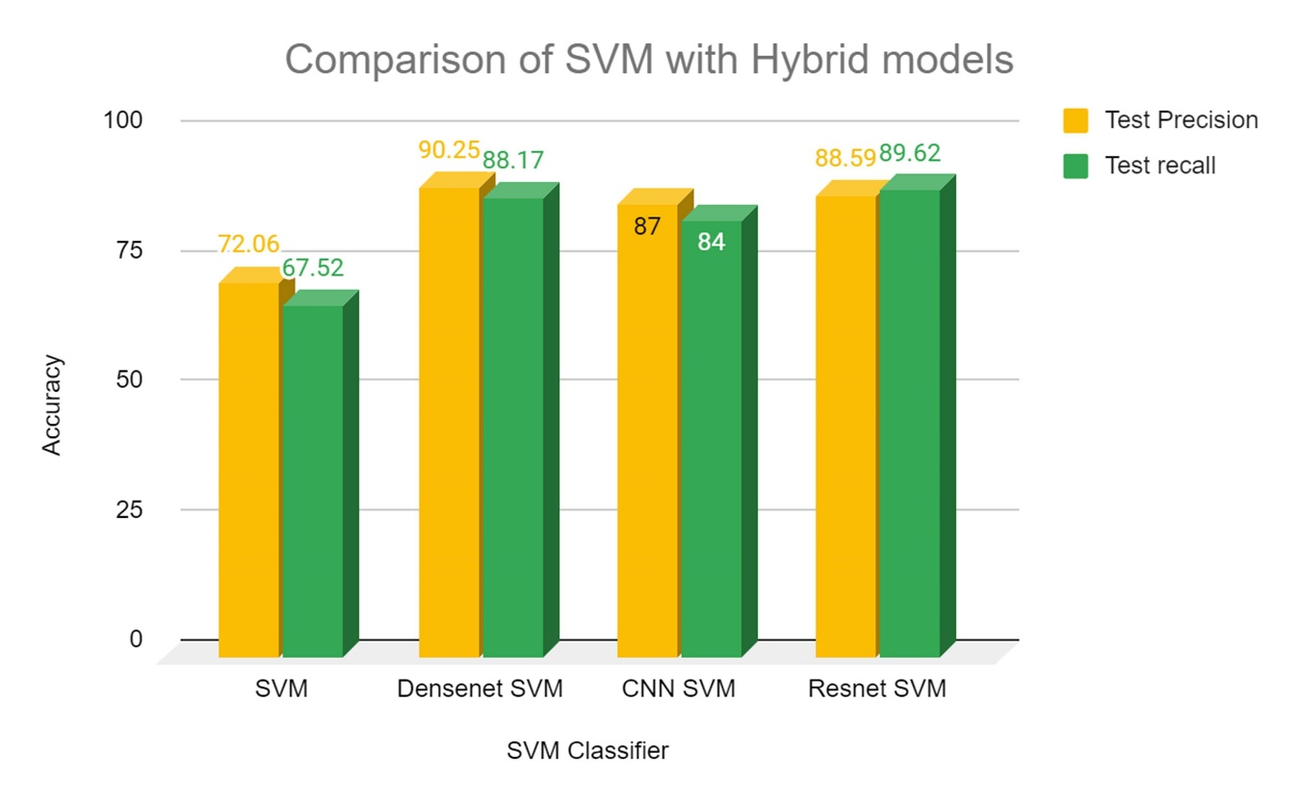

Fig 1.6.: Comparison of SVM with hybrid models-2

The test accuracy of the SVM classifier is improved from 64.14% to 86.96% with the DenseNet based hybrid model.

The following images represent the GUI of the system:

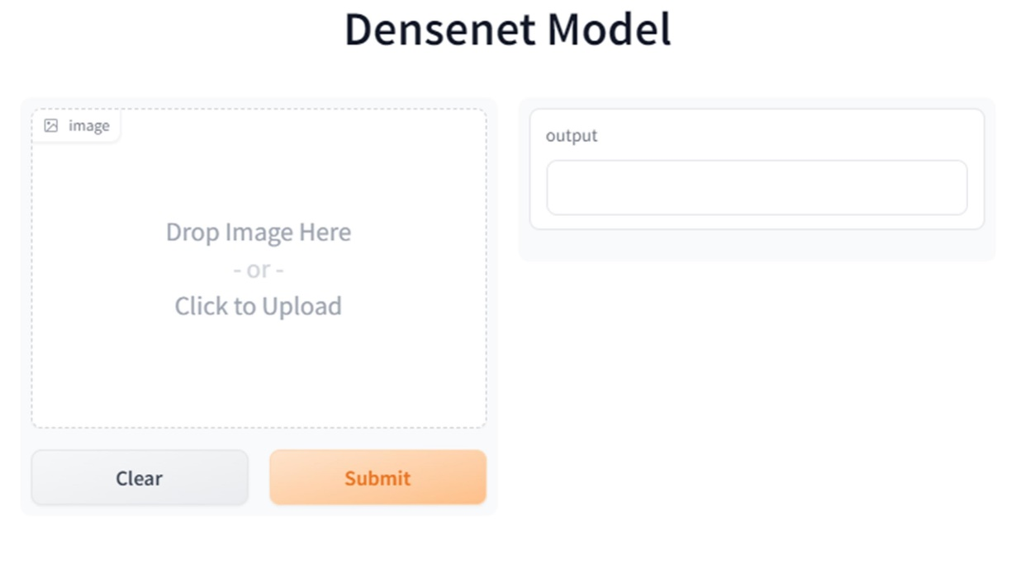

Fig 1.7: User Interface

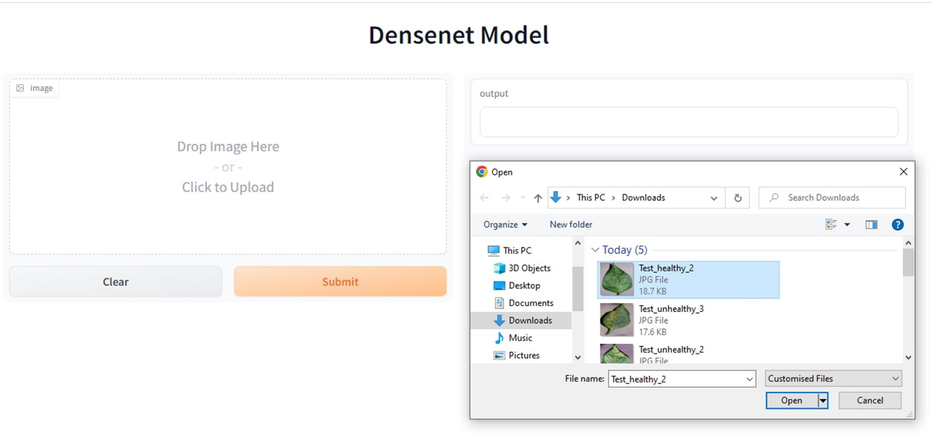

Fig 1.8: Input

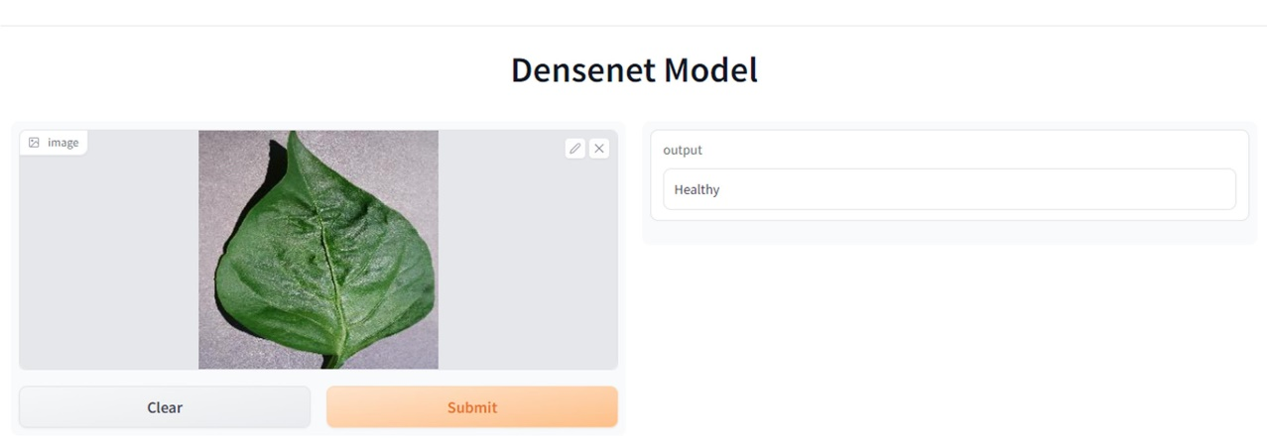

Fig 1.9: Output-1

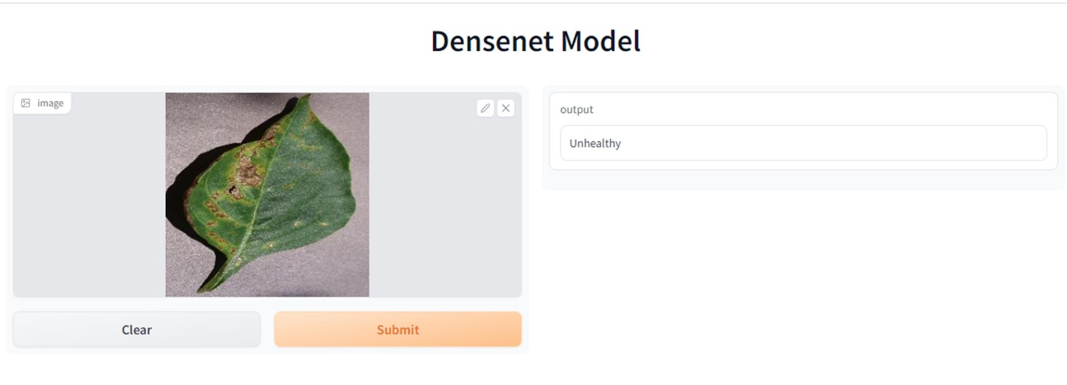

Fig 1.10: Output-2