B M S COLLEGE OF ENGINEERING
DEPARTMENT OF COMPUTER SCIENCE AND ENGINEERING
(Autonomous college under VTU)
P.O. Box No.: 1908, Bull Temple Road, Bangalore-560 019
2026-2027

AAT Report on
“SkyPulse: Drone-Based Emergency Medicine Delivery”
under the course Management and Entrepreneurship (23CS7PCMNE)
By
AAAA (1BM23CSxxx) BBBB (1BM23CSxxx)
CCCC (1BM23CSxxx) DDDD (1BM23CSxxx)
Work carried out at
Department of CSE, BMSCE
Faculty incharge
Prof. Radhika A D
Assistant Professor
Department of Computer Science and Engineering
CONTENTS
Sl. No. | Title | Page No.
1. | Introductory Page  Name and Address of the Business • Names and Addresses of the Principals • Nature of the Business • Statement of Financing Needed • Statement of Confidentiality | 1
2. | Executive Summary  The Problem • The Solution • Market Opportunity • Business Model • Financial Highlights • The Ask | 3
3. | Industry Analysis  Industry Overview, Future Outlook and Trends • Analysis of Competitors • Market Segmentation • Industry Forecasts and Market Size | 6
4. | Description of the Venture  Vision, Mission and Objectives • Services Offered • Unique Selling Proposition • Size of the Business • Office Equipment and Personnel • Background of the Entrepreneurs | 10
5. | Production Plan  Production Process and Subcontracting • Target Drone Specifications • Physical Plant • Machinery and Equipment • Suppliers of Materials and Services • Production Capacity | 12
6. | Operations Plan  Description of Operations • Flow of Orders • Technology Utilisation • Operating Schedule • Quality and Safety Management • Key Performance Indicators | 15
7. | Marketing Plan  Target Market and Positioning • Product • Pricing • Place (Distribution) • Promotion • Sales Forecast • Marketing Controls | 18
8. | Organizational Plan  Form of Ownership • Partners and Principal Shareholders • Authority of Principals • Management Team and Responsibilities • Organisation Structure • Advisory Board • Staffing Plan | 20
9. | Assessment of Risk  SWOT Analysis • Risk Register and Mitigation • Sensitivity Analysis • Contingency Plans | 22
10. | Financial Plan  Key Assumptions • Capital Requirement and Sources and Applications of Funds • Pro Forma Income Statement • Cash Flow Projections • Pro Forma Balance Sheet • Break-even Analysis • Investment Appraisal and Unit Economics | 24
11. | Conclusion | 29
12. | References | 30

1. Introductory Page

1.1 Name and Address of the Business
SkyPulse Aero Health Private Limited (proposed).
Registered office (proposed): Bengaluru, Karnataka – 560 019.
First operating hubs: District Hospital campuses at Chikkaballapur and Kolar, Karnataka.

1.2 Names and Addresses of the Principals
Sl. No. | Name | USN | Role in the venture
1 | AAAA | 1BM23CSxxx | Chief Executive Officer (CEO)
2 | BBBB | 1BM23CSxxx | Chief Technology Officer (CTO)
3 | CCCC | 1BM23CSxxx | Head of Flight Operations (COO)
4 | DDDD | 1BM23CSxxx | Head of Finance & Partnerships (CFO)
Table 1.1: Principals of SkyPulse (all students of the Department of CSE, BMSCE, Bengaluru)

1.3 Nature of the Business
SkyPulse is a drone-as-a-service medical logistics company. It flies blood units, anti-snake venom, life-saving drugs, vaccines and diagnostic samples between district hospitals, community health centres (CHCs), primary health centres (PHCs) and private hospitals. Its temperature-controlled drones replace road trips that take one to four hours with flights of 15 to 30 minutes. Hospitals and the State Health Department pay SkyPulse per delivery, by monthly subscription or through annual district contracts.

1.4 Statement of Financing Needed
SkyPulse needs total funding of ₹11.70 crore over the first two years:
- Founders' capital: ₹50 lakh (Year 1).
- Startup India Seed Fund Scheme (SISFS) grant: ₹20 lakh for proof of concept (Year 1).
- Seed equity round from angel / venture investors: ₹5 crore (Year 1).
- Pre-Series A equity round: ₹6 crore (Year 2) to expand from 4 to 7 hubs.

1.5 Statement of Confidentiality
This business plan is confidential. It is the property of SkyPulse Aero Health Pvt. Ltd. and was prepared as an Alternative Assessment Tool (AAT) for the course Management and Entrepreneurship (23CS7PCMNE) at B.M.S. College of Engineering. It may not be reproduced or shared with third parties without the written permission of the founders. The financial projections are estimates based on the assumptions stated in Section 10 and are not guarantees of future performance.

2. Executive Summary

2.1 The Problem
In a medical emergency the first hour, the 'golden hour', decides whether a patient lives. In rural Karnataka the medicine a patient needs is often not in the building. A PHC treating a woman with post-partum haemorrhage may have no blood bank. A taluk hospital treating a snakebite may run out of anti-snake venom (ASV) after a single patient, because one bite can need up to 10 vials. The nearest stock is usually 40 to 120 km away by road.
Karnataka recorded 13,235 snakebite cases and 100 deaths in 2024, and India loses an estimated 50,000 people a year to snakebite. A CAG audit of Karnataka's 108 ambulance service found the 30-minute response target was met in only 72% of cases, with individual delays of 56 to 80 minutes. Every hour spent fetching blood or medicine by road reduces the patient's chance of survival.

2.2 The Solution
SkyPulse runs a hub-and-spoke drone network. Each hub sits at a district hospital with a blood bank and pharmacy and serves every PHC, CHC and private hospital within a 40 km radius. A doctor places an order through the SkyPulse app, WhatsApp or a toll-free number. The hub packs the item into a temperature-logged cold-chain pod and a VTOL drone flies it to the facility's landing pad, typically in 15 to 30 minutes.
There is strong evidence that this works. In Rwanda, drone delivery cut median blood delivery time to 41 minutes against more than two hours by road, and reduced blood wastage by about two-thirds (Nisingizwe et al., Lancet Global Health, 2022). ICMR's i-Drone trials in India have delivered vaccines in the North-East, blood units in Delhi NCR and tissue samples between Karkala and Manipal in Karnataka (37 km in 15–20 minutes against 50–60 minutes by road).

2.3 Market Opportunity
India's drone market is valued at USD 0.47 billion in 2025 and is projected to reach USD 1.39 billion by 2030 (CAGR 24.4%). The delivery-drone segment is the fastest growing, at a projected 50.4% CAGR to 2030. Government policy actively supports the sector: the liberalised Drone Rules 2021 opened about 90% of Indian airspace as a green zone, a ₹120 crore PLI scheme supports domestic manufacturing, the Drone Shakti mission promotes drones-as-a-service, and a BVLOS certification framework is expected by the end of 2026. Karnataka alone has 2,138 PHCs across 31 districts, each a potential delivery point.

2.4 Business Model
- Per-delivery fees: ₹1,400 for an emergency delivery and ₹500 for a scheduled one in Year 1.
- Hospital subscriptions at ₹25,000 per month for a guaranteed dispatch SLA and a live tracking dashboard.
- Annual district contracts with the State Health Department / NHM at ₹36 lakh per district for routine PHC resupply.

2.5 Financial Highlights
Revenue is projected to grow from ₹221.4 lakh in Year 1 to ₹2,977.7 lakh (₹29.78 crore) in Year 5 as the network grows from 2 to 14 hubs and from 12 to 84 drones. EBITDA turns positive in Year 2 and net profit in Year 3. Year 5 net profit is ₹695.4 lakh (23.4% net margin). The fully loaded cost of one SkyPulse delivery falls from ₹1,644 to ₹740, against ₹2,902 for a road round trip. The project has an enterprise value of ₹1,227.7 lakh and an IRR of 74.1% including terminal value, and cumulative free cash flow turns positive in Year 5.
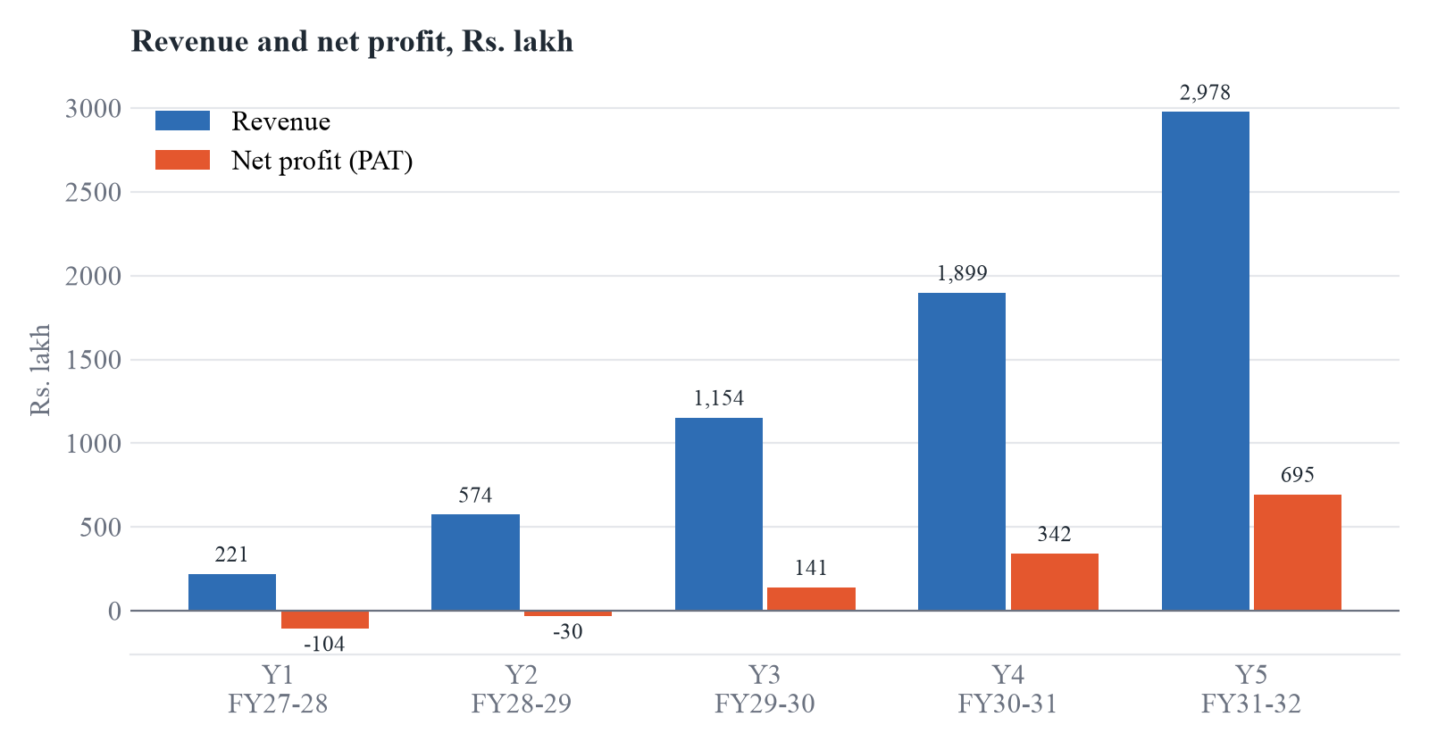
Figure 2.1: Projected revenue and net profit (Source: SkyPulse Financial Model)

2.6 The Ask
SkyPulse is raising a ₹5 crore seed round to launch two hubs in Chikkaballapur and Kolar districts and prove the model with 12 drones. Together with founders' capital, the SISFS grant and a ₹6 crore Pre-Series A round in Year 2, total funding of ₹11.70 crore takes the company to profitability with a cash buffer above ₹2 crore in every year.

3. Industry Analysis

3.1 Industry Overview, Future Outlook and Trends
Drone medical logistics sits where three industries meet: unmanned aerial systems (UAS), healthcare supply chains and last-mile logistics. Globally, the medical drone market is estimated at USD 0.43 billion in 2025 and is expected to exceed USD 1.18 billion by 2030 (CAGR 22.2%, Mordor Intelligence). Zipline, the global leader, has flown blood and medical products in Rwanda since 2016 and later expanded to Ghana, Nigeria, Kenya and the USA.
India is now one of the most drone-friendly regulatory environments in the world. The following trends shape the industry:
- Liberalised regulation: Drone Rules 2021 cut approvals to 5 forms and 4 fee types and shrank the yellow zone around airports from 45 km to 12 km. Green-zone flights up to 400 ft need no prior permission. Registration (UIN), Remote Pilot Certificates and type certification all run online through the DGCA Digital Sky platform.
- BVLOS opening up: the Ministry of Civil Aviation has said it will introduce a certification framework for beyond-visual-line-of-sight (BVLOS) operations by the end of 2026. Long-range medical corridors depend on this.
- Make in India: the import of foreign drones has been banned since February 2022. The PLI scheme (₹120 crore outlay) supports Indian manufacturers, and its extension with an R&D link is under consideration.
- Government as an early adopter: ICMR's i-Drone programme has run vaccine, blood and tissue delivery trials in Manipur, Nagaland, Himachal Pradesh, Delhi NCR and Karnataka. The Drone Shakti mission (Budget 2022-23) promotes drones-as-a-service through startups.
- Private capital and hospital adoption: Bengaluru's Airbound raised US$8.65 million in 2025 and US$37 million in 2026 and has completed more than 1,000 flights for Narayana Health. Narayana's new Banashankari hospital was designed without an on-site lab or blood bank because it relies on drones.
- Falling costs: battery and airframe prices keep falling, and in Indian studies drones cost ₹5–10 per km for critical deliveries.

3.2 Analysis of Competitors
The Indian medical drone market is early and fragmented. No player yet runs a state-wide emergency network in Karnataka. The table below compares SkyPulse with the main players and with the substitute (road transport).
Competitor | Focus | Strengths | Gaps SkyPulse targets
Airbound (Bengaluru) | Urban diagnostic-sample transfer for Narayana Health | Well funded (US$37M), low-cost tail-sitter drones, 13,000+ flights | Urban, intra-network focus; not public-health or emergency ASV / blood to rural PHCs
Skye Air Mobility | Drone delivery-as-a-service, e-commerce and healthcare | Funding from Chiratae Ventures; multi-city operations | Mainly commercial parcels; no cold-chain emergency SLA for government facilities
TSAW Drones | Urban medical logistics | Demonstrated 16-minute tissue transfer between Karnataka hospitals | Pilot-scale; no subscription or district contract model
Redwing Labs | Long-range medical transport, North-East India | Experience in difficult terrain | Not active in Karnataka
Garuda Aerospace | Drone manufacturer and services | Manufacturing scale; sample transport with Narayana Health | Diversified across agriculture and defence; healthcare is not its core
Road ambulance / courier (substitute) | 108 / private vehicles, bike couriers | Existing contracts, high payload | 1–4 hours on rural roads, costly per round trip (₹2,902), affected by traffic and floods
Table 3.1: Competitor analysis
Porter's Five Forces
Force | Intensity | Reasoning
Threat of new entrants | Medium | Low capital barrier for small pilots, but DGCA type certification, BVLOS approvals and hospital trust take years to build.
Bargaining power of suppliers | Medium | The ban on imported drones limits sourcing to Indian OEMs, but several now compete and PLI is expanding supply.
Bargaining power of buyers | High | Government buyers procure through tenders; private hospitals compare drones with road couriers.
Threat of substitutes | Medium | Roads, motorbike couriers and better stock at PHCs are substitutes, but none matches drone speed in an emergency.
Competitive rivalry | Low–Medium | The market is young, no player dominates Karnataka emergency delivery, and early movers can secure district contracts.
Table 3.2: Porter's five forces analysis

3.3 Market Segmentation
Segment | Customers | What they need flown | Buying behaviour
Public health (B2G) | District hospitals, CHCs, 2,138 PHCs, NHM Karnataka | Blood, ASV, oxytocin, vaccines, TB / HIV samples | Annual contracts through tenders / GeM; price-sensitive
Private hospitals (B2B) | Multi-speciality hospital chains, nursing homes | Blood components, rare drugs, inter-branch samples | Monthly subscriptions; value speed and reliability
Diagnostics (B2B) | Labs and collection centres | Patient samples to central labs | Scheduled per-delivery runs; value turnaround time
Blood banks & NGOs | Red Cross, Rashtrotthana and similar blood banks | Blood redistribution before expiry | Per delivery; cut wastage
Table 3.3: Market segmentation

3.4 Industry Forecasts and Market Size
SkyPulse sizes its market bottom-up for Karnataka:
- Total Addressable Market (TAM): about 2,500 public facilities (2,138 PHCs plus CHCs and taluk / district hospitals) and around 1,000 private hospitals and labs. At an average of two time-critical deliveries per facility per day for 330 days at ₹700 each, this is about 2.3 million deliveries, or ₹160 crore a year.
- Serviceable Available Market (SAM): the facilities within 40 km of the 14 planned hubs, about half of the TAM, or ₹80 crore a year.
- Serviceable Obtainable Market (SOM): 2,77,200 deliveries and ₹2,977.7 lakh of revenue by Year 5, about 37% of SAM. This is realistic for the first mover that holds the district contracts.
Market estimates from research firms vary widely because definitions differ. SkyPulse's financial plan therefore relies on its own bottom-up volumes (Section 10), not on top-down market shares.

4. Description of the Venture

4.1 Vision, Mission and Objectives
Vision: no patient in Karnataka should die waiting for blood or medicine.
Mission: to deliver blood, medicines and diagnostic samples to any health facility in the state within 30 minutes, safely, at a lower cost than road transport.
- Launch two hubs and 12 drones and complete 19,800 deliveries in Year 1.
- Sign the first NHM district contract and 8 private hospital subscriptions in Year 1.
- Reach 14 hubs, 84 drones and over 2.7 lakh deliveries a year by Year 5.
- Keep the dispatch-to-delivery time under 30 minutes for 95% of emergency orders.

4.2 Services Offered
Service | Description | Price (Year 1)
SkyPulse Emergency | On-demand flight of blood units, ASV, oxytocin, adrenaline and other life-saving drugs, dispatched within 10 minutes, 24×7 | ₹1,400 per delivery
SkyPulse LabLink | Scheduled pick-up of diagnostic samples from PHCs / labs to district labs | ₹500 per delivery
SkyPulse Resupply | Routine replenishment of vaccines and essential drugs for PHCs under a district contract | ₹36 lakh per district per year
SkyPulse Priority | Hospital subscription with guaranteed SLA, priority queue and live dashboard | ₹25,000 per month
SkyPulse Command (software) | Ordering app, WhatsApp / IVR ordering, live tracking, temperature logs and audit trail | Included in all plans
Table 4.1: SkyPulse services

4.3 Unique Selling Proposition
- Speed: 15–30 minute delivery against 1–4 hours by road. The Meghalaya ICMR study measured a 50-minute drone round trip against 240 minutes by road.
- Cold chain with proof: every pod logs temperature (2–8 °C for blood and vaccines) and the log is attached to the delivery record for blood-bank compliance.
- Cheaper than road: the fully loaded cost per delivery falls to about ₹740 by Year 5, against ₹2,902 for a road round trip.
- Built for public health: ordering by WhatsApp and toll-free IVR, so a PHC nurse needs no new device, and integration with 108 ambulance dispatch.
- Greener: about 0.016 kg of CO₂ per drone trip against 18.76 kg for a vehicle trip.

4.4 Size of the Business
Parameter | Year 1 | Year 3 | Year 5
Hubs | 2 | 7 | 14
Drones | 12 | 42 | 84
Deliveries per year | 19,800 | 1,10,880 | 2,77,200
Employees (approx.) | 26 | 61 | 108
Revenue (₹ lakh) | 221.4 | 1,153.8 | 2,977.7
Table 4.2: Scale of operations

4.5 Office Equipment and Personnel
Head office: a 600 sq. ft co-working or incubator space in Bengaluru with laptops, a flight-monitoring wall (3 displays), a networked storage server and video-conferencing equipment. Each hub has a ground control station (GCS) workstation, a backup 4G/satellite link, an inverter power backup and a pharmacy-grade refrigerator.
Each hub has 3 remote pilots (DGCA Remote Pilot Certificate holders), 2 drone technicians and 1 hub manager. The corporate team covers leadership, software engineering, sales, compliance and finance (Section 8).

4.6 Background of the Entrepreneurs
The founding team are final-year Computer Science and Engineering students at B.M.S. College of Engineering, Bengaluru. Between them they cover software engineering (mobile and web apps, cloud back-ends), embedded systems and IoT (telemetry and temperature sensing), data science (demand forecasting and route optimisation) and business development. The team will add an advisory board with a public-health physician, a DGCA-certified flight instructor and a chartered accountant (Section 8.6).

5. Production Plan
SkyPulse is a service business. Its 'production' is the readiness of the drone fleet, the hubs and the software that together generate deliveries. This section covers what is made in-house, what is bought or subcontracted, the physical plant, equipment and suppliers.

5.1 Production Process and Subcontracting
Component | Make / Buy | Details
VTOL drone airframe & avionics | Buy (subcontract) | Bought from DGCA type-certified Indian OEMs, in line with the 2022 import ban. Each drone has its own UIN and is NPNT compliant.
Cold-chain payload pod | Make (in-house assembly) | Insulated 5 kg pod with phase-change gel packs, an IoT temperature logger, a tamper seal and a parachute-drop release
SkyPulse Command software | Make (in-house) | Ordering app, dispatch engine, route optimiser, hospital dashboard and API for 108 / HMIS
Hub civil works | Subcontract | 6 m × 6 m landing pad, charging room and weather shelter, built by local contractors
Maintenance (A-checks) | Make | In-house technicians at every hub
Overhaul (C-checks) | Subcontract | OEM service centre under an annual maintenance contract (AMC)
Table 5.1: Make-or-buy decisions

5.2 Target Drone Specifications
Parameter | Specification
Type | Hybrid VTOL fixed-wing (vertical take-off, efficient forward flight)
Payload | Up to 5 kg (about 10 blood units or 50 ASV vials)
Range | Up to 100 km round trip; operating radius 40 km
Cruise speed | 80–100 km/h
Delivery method | Parachute drop or landing on the PHC pad
Safety | Geofencing, return-to-home, emergency parachute, redundant GNSS
Compliance | DGCA type certificate, UIN, NPNT, Remote ID
Weather limits | Light rain, winds up to 35 km/h
Table 5.2: Target drone specifications

5.3 Physical Plant
Each hub sits on a district hospital campus next to the blood bank and pharmacy, under a lease or MoU with the State Health Department. A hub has:
- Two landing / take-off pads (6 m × 6 m) with wind socks and safety fencing.
- A charging and battery room with fire-rated storage for 30 battery packs.
- A packing bay with a pharmacy-grade refrigerator (2–8 °C) and a freezer for gel packs.
- A ground control station room for remote pilots, with displays, radios and backup internet.
- A store for spares and maintenance tools.
Each receiving PHC gets a painted 3 m × 3 m drop zone, a QR-coded marker and staff trained to receive packages. This costs about ₹15,000 per site and is covered by the marketing and onboarding budget.

5.4 Machinery and Equipment
Item | Quantity (Year 1) | Unit cost (₹ lakh) | Total (₹ lakh)
VTOL drone with cold-chain pod | 12 | 14.0 | 168.0
Hub setup (pads, charging, cold storage, GCS) | 2 | 22.0 | 44.0
Technology platform development | 1 | 60.0 | 60.0
Total Year 1 capital expenditure |  |  | 272.0
Table 5.3: Machinery and equipment (Year 1)

5.5 Suppliers of Materials and Services
Input | Proposed supplier type | Reason
Drones and spares | DGCA type-certified Indian drone OEMs | Import ban; PLI-supported supply
Li-ion battery packs | Indian battery pack assemblers | Local service and short lead time
Cold-chain boxes and gel packs | Medical cold-chain packaging firms | WHO-PQS-style insulation
Temperature loggers / IoT | Indian IoT hardware vendors | 4G / LoRa logging
Connectivity | Telecom operators (4G IoT SIMs) | Telemetry coverage on routes
Cloud hosting | Indian data-centre region of a major cloud provider | Data localisation under the DPDP Act 2023
Insurance | General insurers offering drone third-party and hull cover | Mandatory third-party insurance
Table 5.4: Suppliers

5.6 Production Capacity
A 45-minute round trip including loading and battery swap lets one drone fly up to 12 sorties in a 10-hour shift. The plan assumes a conservative 5 deliveries per drone per day in Year 1, rising to 10 by Year 5 as demand builds. This gives 19,800 deliveries in Year 1 and 2,77,200 in Year 5, so spare capacity is kept for demand surges such as monsoon floods and snakebite season.

6. Operations Plan

6.1 Description of Operations
SkyPulse runs a hub-and-spoke model. A hub at each district hospital serves every facility within a 40 km radius, which covers 60–90 PHCs and CHCs in a typical Karnataka district. Expansion follows demand and terrain: districts with poor road access and high snakebite or maternal-emergency rates come first, starting with Chikkaballapur and Kolar (Year 1) and then Tumakuru, Chitradurga, Raichur and Kodagu.

6.2 Flow of Orders
- Order: a doctor or nurse orders through the SkyPulse app, WhatsApp bot or toll-free IVR, selecting the item, quantity and urgency (Emergency / Scheduled).
- Verification: the hub pharmacist or blood-bank officer verifies the prescription or requisition and confirms stock (target: 3 minutes).
- Packing: the item is packed in the cold-chain pod, sealed and scanned. The temperature logger starts.
- Pre-flight: the remote pilot runs the checklist. The system checks weather and the airspace zone on Digital Sky (NPNT) and plans the route.
- Flight: the drone takes off vertically, cruises at 80–100 km/h along an approved corridor and is monitored live on the GCS.
- Delivery: the pod is dropped by parachute or landed at the drop zone. The receiver confirms with an OTP, and the temperature log is uploaded.
- Return: the drone returns to the hub, the battery is swapped, a post-flight inspection is done and the drone is ready for the next sortie.
- Billing and records: the delivery is invoiced automatically and recorded in the hospital's dashboard and the state HMIS.
Target time from order to delivery: 10 minutes for dispatch plus 15–25 minutes of flight, under 35 minutes in total.

6.3 Technology Utilisation
- DGCA Digital Sky: UIN registration, Remote Pilot Certificates, NPNT flight permissions and airspace maps.
- SkyPulse Command: a cloud dispatch engine that assigns the nearest available drone and optimises multi-drop routes.
- Demand forecasting: machine-learning models on historical orders, season (snakebite peaks in the monsoon) and disease surveillance (IHIP) data, used to pre-position stock.
- IoT telemetry: 4G modules stream position, battery health and payload temperature every second.
- Integration: APIs to the 108 emergency service, e-Raktkosh (blood bank network) and hospital HMIS.
- Cyber-security: encrypted command links, role-based access and audit logs, with data stored in India under the DPDP Act 2023.

6.4 Operating Schedule
Hubs run two shifts from 6 am to 10 pm on 330 days a year. A remote pilot is on call at night for critical emergencies, depending on DGCA approval for night operations. During the monsoon, flights are re-planned around weather windows and the road courier fallback is activated (Section 9).

6.5 Quality and Safety Management
- Standard operating procedures (SOPs) for packing, flight, handover and incident reporting.
- Pre-flight and post-flight checklists logged digitally for every sortie.
- Preventive maintenance after a fixed number of flight hours, with battery health tracking.
- Temperature excursion alarms: any pod outside 2–8 °C is flagged and the product is quarantined.
- Quarterly safety audits and an annual third-party compliance audit.

6.6 Key Performance Indicators
KPI | Target
Order-to-delivery time (emergency) | < 35 minutes for 95% of orders
Flight success rate | > 99.5%
Cold-chain compliance | 100% of pods within 2–8 °C
Fleet availability | > 90%
Customer satisfaction (NPS) | > 60
Blood-unit wastage at partner hospitals | Reduced by at least 30%
Table 6.1: Operational KPIs

7. Marketing Plan

7.1 Target Market and Positioning
SkyPulse's primary customer is the public health system in Karnataka (district health officers, NHM and the State Blood Transfusion Council), because that is where the need and the scale are greatest. Private hospital chains and diagnostic labs are the secondary customers. They pay faster, adopt sooner and supply the case studies that win government contracts.
Positioning statement: for hospitals and health departments that cannot afford to lose the golden hour, SkyPulse is the medical drone network that delivers blood and life-saving medicines in under 30 minutes with a verified cold chain, at a lower cost than road transport.

7.2 Product
Four service tiers (Emergency, LabLink, Resupply and Priority, Table 4.1) sit on one software platform. The service is packaged so that a district can start with a single route and grow.

7.3 Pricing
Offering | Y1 | Y2 | Y3 | Y4 | Y5 | Pricing logic
Emergency delivery (₹) | 1,400 | 1,400 | 1,450 | 1,500 | 1,550 | Value-based: below the ₹2,902 road cost; about 3–4% annual increase
Scheduled delivery (₹) | 500 | 500 | 525 | 550 | 575 | Cost-plus over a ₹240 variable cost
Hospital subscription (₹/month) | 25,000 | 25,000 | 25,000 | 25,000 | 25,000 | Guaranteed SLA; stable to aid adoption
District contract (₹ lakh/yr) | 36 | 36 | 36 | 36 | 36 | Fixed retainer for routine PHC resupply
Table 7.1: Pricing strategy

7.4 Place (Distribution)
- Direct sales to private hospitals and diagnostic chains in Bengaluru Rural, Chikkaballapur, Kolar and Tumakuru.
- Government procurement through NHM Karnataka tenders and the Government e-Marketplace (GeM). DPIIT-recognised startups are exempt from prior turnover and experience criteria in public procurement.
- Partnerships with blood-bank networks (e-Raktkosh, Indian Red Cross Society) and with the 108 ambulance operator.

7.5 Promotion
- Live demonstration flights for District Health Officers, Deputy Commissioners and hospital administrators.
- Presentations at Continuing Medical Education (CME) events and at meetings of the Indian Medical Association and nursing associations.
- Case studies and short videos of real deliveries (patient consent taken), shared on LinkedIn, YouTube and the website.
- Press coverage around milestones such as the first ASV delivery and the 1,000th blood unit.
- Applications to government innovation programmes (Startup Karnataka Elevate, the ICMR i-Drone partnership).
- Onboarding kits for PHC staff, with a WhatsApp ordering guide in Kannada and English.

7.6 Sales Forecast
Driver | Y1 | Y2 | Y3 | Y4 | Y5
Deliveries | 19,800 | 55,440 | 1,10,880 | 1,78,200 | 2,77,200
Partner hospitals (subscriptions) | 8 | 20 | 40 | 65 | 95
District contracts | 1 | 2 | 4 | 6 | 8
Revenue (₹ lakh) | 221.4 | 573.9 | 1,153.8 | 1,899.0 | 2,977.7
Marketing budget (₹ lakh) | 17.7 | 40.2 | 69.2 | 94.9 | 148.9
Table 7.2: Sales forecast and marketing budget

7.7 Marketing Controls
Each month the team reviews customer acquisition cost against contract value, deliveries per partner, the NPS survey and repeat-order rate. A partner whose order volume falls by more than 20% gets an account review. Marketing spend falls from 8% of revenue in Year 1 to 5% by Year 4 as referrals and contracts take over.

8. Organizational Plan

8.1 Form of Ownership
SkyPulse will be incorporated as a Private Limited Company under the Companies Act, 2013. This form:
- limits the founders' liability,
- allows equity fundraising from angel and venture investors and an ESOP pool,
- is eligible for DPIIT startup recognition, giving access to SISFS grants, a three-year income-tax holiday under Section 80-IAC (subject to approval) and relaxed public procurement norms,
- carries the credibility hospitals and government departments expect in a vendor.

8.2 Partners and Principal Shareholders
Shareholder | At incorporation | After Seed (₹5 Cr at ₹20 Cr pre-money) | After Pre-Series A (₹6 Cr at ₹40 Cr pre-money)
Four founders (equal) | 100.0% | 72.0% | 62.6%
ESOP pool | – | 8.0% | 7.0%
Seed investors | – | 20.0% | 17.4%
Pre-Series A investors | – | – | 13.0%
Table 8.1: Indicative shareholding pattern

8.3 Authority of Principals
The Board of Directors has the CEO, the CTO and one nominee of the seed investor, plus one independent director with healthcare experience from Year 2. The CEO has authority over strategy, fundraising and government relations. Spending above ₹10 lakh, new hubs and equity issues need Board approval. Flight safety decisions rest with the Head of Flight Operations, who can ground the fleet at any time.

8.4 Management Team and Responsibilities
Role | Team member | Key responsibilities
Chief Executive Officer | AAAA | Strategy, fundraising, government and hospital partnerships, investor relations
Chief Technology Officer | BBBB | SkyPulse Command software, drone integration, IoT pod, cyber-security
Head of Flight Operations | CCCC | Hubs, pilots, DGCA compliance, safety management, maintenance
Head of Finance & Partnerships | DDDD | Accounts, pricing, tenders, billing, customer success, legal
Table 8.2: Management team

8.5 Organisation Structure
SkyPulse has a flat functional structure at headquarters and a standard structure at every hub:
- Board of Directors → CEO.
- CEO → CTO (software engineers, IoT engineer), Head of Flight Operations (hub managers → remote pilots and drone technicians; safety and compliance officer), Head of Finance & Partnerships (sales executives, accounts, customer success).

8.6 Advisory Board
- A public-health physician or retired District Health Officer, for clinical protocols and government navigation (to be appointed).
- A DGCA-certified flight instructor or aviation safety expert, for safety management (to be appointed).
- A chartered accountant, for statutory compliance and audits (to be appointed).
- A faculty mentor from BMSCE, for technology and research partnerships.

8.7 Staffing Plan
Category | Y1 | Y2 | Y3 | Y4 | Y5
Hub staff (6 per hub) | 12 | 24 | 42 | 60 | 84
Corporate team (incl. founders) | 14 | 16 | 19 | 21 | 24
Total employees | 26 | 40 | 61 | 81 | 108
Table 8.3: Staffing plan

9. Assessment of Risk

9.1 SWOT Analysis
Strengths | Weaknesses
• 15–30 minute delivery against 1–4 hours by road  • Verified cold chain with temperature logs  • Lower cost per delivery than road transport  • Strong software and IoT skills in the team | • Young founding team with no aviation track record  • Payload limited to 5 kg per flight  • Depends on weather and on regulatory approvals  • High upfront capital per hub
Opportunities | Threats
• BVLOS framework expected by end of 2026  • NHM / state health budgets for last-mile delivery  • Drone Shakti, PLI and DPIIT benefits  • Expansion to other states and to organ / vaccine logistics | • Delays in BVLOS or night-flight approvals  • Well-funded competitors entering Karnataka  • Accidents damaging public trust  • Slow payments from government customers
Table 9.1: SWOT analysis

9.2 Risk Register and Mitigation
Risk | Likelihood | Impact | Mitigation
Regulatory: BVLOS / corridor approvals delayed | Medium | High | Start with VLOS routes and DGCA-approved trial corridors; join ICMR / state pilot programmes; keep a compliance officer from day one
Drone crash or technical failure | Low | High | Type-certified drones, parachutes, geofencing, redundant GNSS, preventive maintenance and full insurance
Monsoon / bad weather grounds flights | High | Medium | Weather-aware scheduling, 330 operating days in the plan, road-courier fallback contract
Cold-chain breach damages blood or vaccines | Low | High | Validated pods, live temperature alarms, quarantine SOP, product-loss insurance
Cyber-attack or data breach | Low | High | Encrypted links, India-hosted data, DPDP Act 2023 compliance, annual penetration test
Slow government payments | High | Medium | Mix of private subscriptions (cash flow) and government contracts; milestone billing; cash buffer above ₹2 crore
Competition from funded players | Medium | Medium | Lock in multi-year district contracts early; focus on rural emergency, which urban players ignore
Battery fire at hub | Low | High | Fire-rated battery room, charging protocols, extinguishers and staff training
Public resistance (noise, privacy) | Low | Low | Community meetings, no cameras recording on routes, flights at 120 m altitude
Table 9.2: Risk register

9.3 Sensitivity Analysis
Each major risk was tested by changing the inputs in the financial model and recalculating. In every case the company stays cash-positive and profitable from Year 3, although payback can slip beyond Year 5:
Scenario | Y5 revenue (₹ lakh) | Y3 PAT (₹ lakh) | Y5 PAT (₹ lakh) | Lowest cash (₹ lakh) | Enterprise value (₹ lakh)
Base case | 2,977.7 | 140.9 | 695.4 | 248.3 | 1,227.7
Utilisation -20% | 2,496.8 | 29.2 | 452.5 | 228.2 | 412.7
Prices -15% | 2,617.0 | 17.8 | 438.4 | 226.1 | 359.4
Drone cost +30% | 2,977.7 | 108.0 | 642.4 | 197.9 | 860.9
Govt contracts delayed 1 yr | 2,905.7 | 75.6 | 644.1 | 215.2 | 991.0
Table 9.3: Sensitivity analysis (computed with the SkyPulse Financial Model)

9.4 Contingency Plans
- If BVLOS approval is delayed by more than 12 months, SkyPulse will stay with VLOS routes using relay pilots and pause hub expansion, extending runway by about 9 months.
- If utilisation falls 20% below plan, it will add private lab routes (LabLink) to fill idle flight hours and delay drone purchases.
- If a serious incident occurs, it will ground the fleet immediately, run an independent investigation, notify DGCA and restart only after root-cause fixes.
- If funding is delayed, it will apply for SIDBI / Karnataka Startup Cell debt and cut corporate hiring by one quarter.

10. Financial Plan
All estimates were prepared with a formula-driven Microsoft Excel model (SkyPulse_Financial_Model.xlsx, submitted with this report). Every figure is linked to a single Assumptions sheet, so any assumption can be changed and the full plan recalculates. All amounts are in ₹ lakh unless stated. Year 1 is FY 2027-28.

10.1 Key Assumptions
Assumption | Value | Basis
Hubs (Y1 → Y5) | 2, 4, 7, 10, 14 | District roll-out plan
Drones per hub | 6 | 4 active + 2 standby
Deliveries per drone per day | 5, 7, 8, 9, 10 | Conservative vs 12 possible
Operating days | 330 | Weather and maintenance losses
Emergency share of deliveries | 35% → 30% | Rwanda: 40% emergency
Variable cost per delivery | ₹240 | Energy, battery wear, packaging, maintenance, telecom
Drone unit cost | ₹14 lakh | Indian VTOL listings ₹3.6–18 lakh
Hub setup cost | ₹22 lakh | Pads, chargers, cold storage, GCS
Depreciation | Straight line, 5 years
Tax rate | 25% | Sec. 115BAA, after loss set-off
Discount rate | 18% | Venture-stage hurdle rate
Table 10.1: Key assumptions

10.2 Capital Requirement and Sources and Applications of Funds
Sources of funds | ₹ lakh | Applications of funds | ₹ lakh
Founders' capital | 50.0 | Drones (fleet of 24) | 336.0
Startup India Seed Fund grant | 20.0 | Hub setup (4 hubs) | 88.0
Seed round (Y1) | 500.0 | Technology platform | 75.0
Pre-Series A round (Y2) | 600.0 | Less: net operating cash generated (Y1 loss, Y2 profit) | (20.4)
 |  | Reserve for Y3 expansion to 7 hubs | 691.4
Total sources | 1,170.0 | Total applications | 1,170.0
Table 10.2: Sources and applications of funds (Year 1 + Year 2)

10.3 Pro Forma Income Statement
Particulars (₹ lakh) | Y1 | Y2 | Y3 | Y4 | Y5
Emergency delivery fees | 97.0 | 256.1 | 482.3 | 801.9 | 1,289.0
Scheduled delivery fees | 64.4 | 185.7 | 407.5 | 686.1 | 1,115.7
Hospital subscriptions | 24.0 | 60.0 | 120.0 | 195.0 | 285.0
Government contracts | 36.0 | 72.0 | 144.0 | 216.0 | 288.0
Total revenue | 221.4 | 573.9 | 1,153.8 | 1,899.0 | 2,977.7
Less: variable costs | 47.5 | 133.1 | 266.1 | 427.7 | 665.3
Gross profit | 173.9 | 440.8 | 887.7 | 1,471.3 | 2,312.4
Less: fixed operating costs | 223.5 | 370.8 | 578.0 | 780.9 | 1,062.5
EBITDA | (49.7) | 70.0 | 309.7 | 690.3 | 1,249.9
EBITDA margin | -22.4% | 12.2% | 26.8% | 36.4% | 42.0%
Less: depreciation | 54.4 | 99.8 | 166.4 | 234.0 | 322.8
Profit before tax | (104.1) | (29.8) | 143.3 | 456.3 | 927.1
Less: tax | 0.0 | 0.0 | 2.4 | 114.1 | 231.8
Net profit (PAT) | (104.1) | (29.8) | 140.9 | 342.3 | 695.4
Net margin | -47.0% | -5.2% | 12.2% | 18.0% | 23.4%
Table 10.3: Projected income statement

10.4 Cash Flow Projections
Particulars (₹ lakh) | Y1 | Y2 | Y3 | Y4 | Y5
Opening cash | 0.0 | 248.3 | 691.4 | 665.7 | 903.9
Cash from operations (PAT + depreciation) | (49.7) | 70.0 | 307.3 | 576.3 | 1,018.2
Capital expenditure | (272.0) | (227.0) | (333.0) | (338.0) | (444.0)
Founders' capital + grant | 70.0 | 0.0 | 0.0 | 0.0 | 0.0
Equity raised | 500.0 | 600.0 | 0.0 | 0.0 | 0.0
Closing cash | 248.3 | 691.4 | 665.7 | 903.9 | 1,478.1
Table 10.4: Projected cash flow statement

10.5 Pro Forma Balance Sheet
Particulars (₹ lakh) | Y1 | Y2 | Y3 | Y4 | Y5
Cash & bank | 248.3 | 691.4 | 665.7 | 903.9 | 1,478.1
Gross fixed assets | 272.0 | 499.0 | 832.0 | 1,170.0 | 1,614.0
Less: accumulated depreciation | 54.4 | 154.2 | 320.6 | 554.6 | 877.4
Net fixed assets | 217.6 | 344.8 | 511.4 | 615.4 | 736.6
Total assets | 465.9 | 1,036.2 | 1,177.1 | 1,519.3 | 2,214.7
Share capital | 550.0 | 1,150.0 | 1,150.0 | 1,150.0 | 1,150.0
Capital reserve (grant) | 20.0 | 20.0 | 20.0 | 20.0 | 20.0
Retained earnings | (104.1) | (133.8) | 7.1 | 349.3 | 1,044.7
Total equity & liabilities | 465.9 | 1,036.2 | 1,177.1 | 1,519.3 | 2,214.7
Table 10.5: Projected balance sheet (balances in every year)

10.6 Break-even Analysis
Break-even deliveries = (fixed operating costs + depreciation − subscription and contract revenue) ÷ contribution per delivery, where contribution per delivery = average delivery fee − variable cost per delivery (₹240).
Particulars (₹ lakh) | Y1 | Y2 | Y3 | Y4 | Y5
Contribution per delivery (₹) | 575 | 557 | 562 | 595 | 628
Fixed costs to recover (₹ lakh) | 217.9 | 338.6 | 480.4 | 603.9 | 812.3
Break-even deliveries | 37,897 | 60,785 | 85,410 | 1,01,504 | 1,29,448
Actual deliveries | 19,800 | 55,440 | 1,10,880 | 1,78,200 | 2,77,200
Margin of safety | -91.4% | -9.6% | 23.0% | 43.0% | 53.3%
Table 10.6: Break-even analysis
SkyPulse operates below break-even in Years 1 and 2, which is expected while the network is being built. It crosses break-even in Year 3, when actual deliveries (1,10,880) exceed the break-even level (85,410) by a 23.0% margin of safety, rising to 53.3% in Year 5.
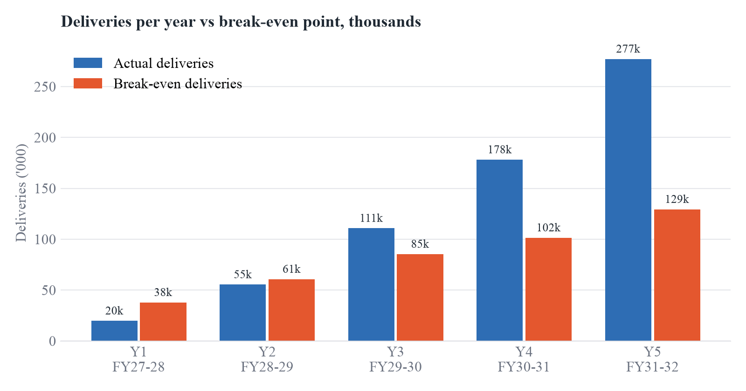
Figure 10.1: Actual vs break-even deliveries

10.7 Investment Appraisal and Unit Economics
Measure | Value
NPV of 5-year free cash flows @ 18% | ₹(27.1) lakh
Terminal value (5× Year 5 FCF, discounted) | ₹1,254.8 lakh
Enterprise value (NPV + terminal value) | ₹1,227.7 lakh
IRR (including terminal value) | 74.1%
Payback (cumulative FCF turns positive) | Y5 FY31-32
Cost per delivery, Year 1 → Year 5 | ₹1,644 → ₹740
Table 10.7: Investment appraisal
The five-year free cash flows alone give a small negative NPV, because the first three years are spent building the network. Once terminal value is included, the venture creates substantial value: an enterprise value of about ₹12.3 crore against ₹11.7 crore invested, and an IRR well above the 18% hurdle rate. Unit economics improve steadily as fixed costs are spread over more flights.
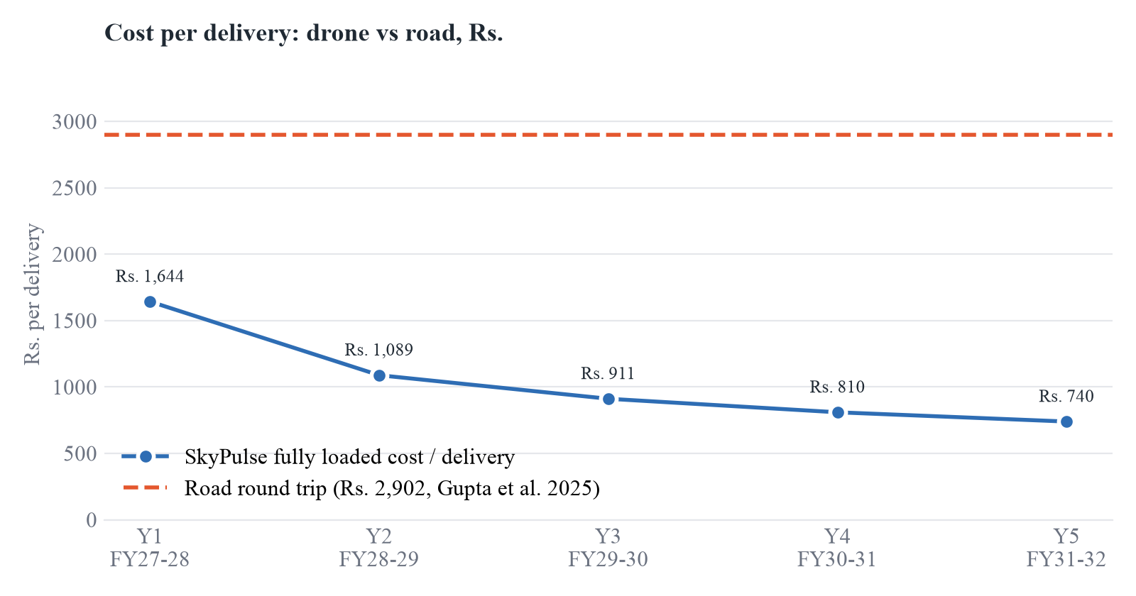
Figure 10.2: Fully loaded cost per delivery vs road transport

Conclusion
SkyPulse addresses a problem that costs lives every day in rural Karnataka: the time it takes to get blood, anti-snake venom and other life-saving medicines to the patient. Evidence from Rwanda and from ICMR's i-Drone trials in India shows that drones can cut delivery time by over 70% and reduce blood wastage. India's liberalised Drone Rules, the PLI scheme, Drone Shakti and the coming BVLOS framework make this the right time to build the service at scale.
The business plan is technically feasible, commercially viable and socially valuable. A hub-and-spoke network grows from 2 to 14 district hubs, with revenue rising from ₹221.4 lakh to ₹2,977.7 lakh in five years. The company is profitable from Year 3 and cash-positive throughout, and in every risk scenario tested the company stays solvent. With ₹11.70 crore of funding, SkyPulse can become Karnataka's medical air-bridge, and a model that other states can adopt.

References
- Hisrich R. D., Peters M. P., Shepherd D. A., Entrepreneurship, McGraw-Hill Education (business plan outline).
- Nisingizwe M. P. et al., "Effect of unmanned aerial vehicle (drone) delivery on blood product delivery time and wastage in Rwanda", The Lancet Global Health, 2022. doi:10.1016/S2214-109X(22)00048-1.
- Gupta P., Bhatia R., Choudhury R. K., Kotwal A., "Leveraging drone technology in health systems strengthening: a cost-effectiveness analysis from Northeast India", J Family Med Prim Care, 14(11):4712–4721, 2025.
- ICMR i-Drone programme. https://idrone.icmr.org.in/
- Ministry of Civil Aviation, Government of India, Drone Rules, 2021; DGCA Digital Sky platform. https://digitalsky.dgca.gov.in/
- Ministry of Civil Aviation, PLI Scheme for Drones and Drone Components, notified 30 September 2021.
- Comptroller and Auditor General of India, Performance Audit of 108 Emergency Ambulance Services, Karnataka.
- Deccan Herald, "Karnataka has a poisonous urban problem: snakebite cases, deaths surge as cities expand", 2025.
- TechCrunch, "India's Airbound bags $8.65M…" (Oct 2025) and "India's Airbound bags $37M…" (Aug 2026).
- MarketsandMarkets, India Drone (UAV) Market Report 2025–2030.
- Grand View Research, India Delivery Drones Market Outlook 2023–2030.
- Mordor Intelligence, Medical Drones Market Report 2025–2030.

