Pizza of the Future

Revenue Insights

- Total Revenue: ₹363,406
- Average Order Value: ₹726.81
- Created a new revenue column (price × quantity) for accurate analysis.

Product Performance
- Top Selling Pizza (by quantity): Margherita
- Most Profitable Pizza Size: Large (L)
Large size contributes the highest revenue overall.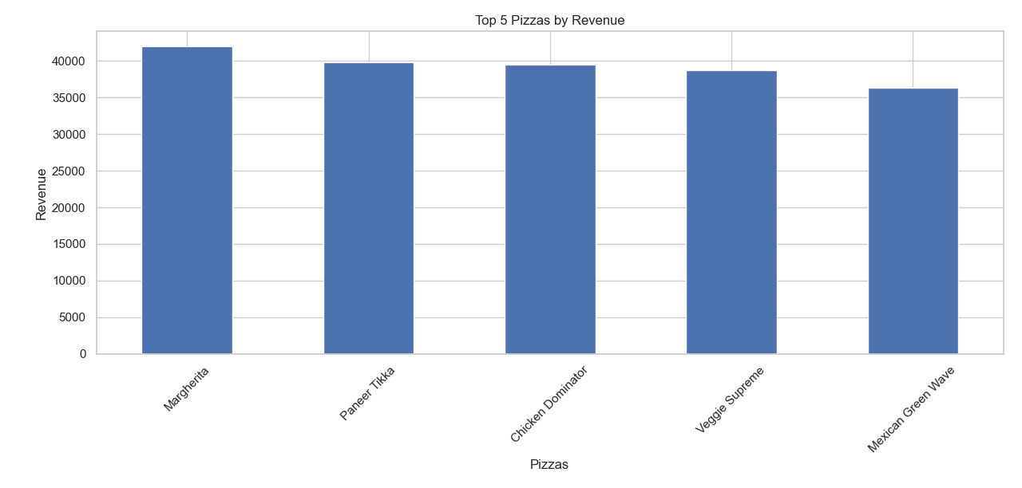

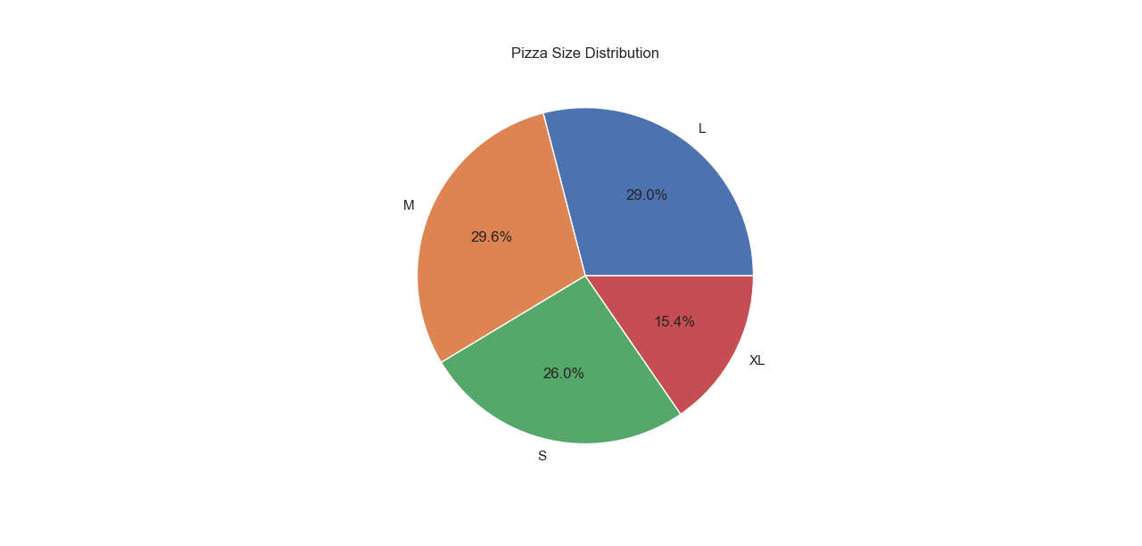

City Insights
- Highest Average Customer Rating: Mumbai
Suggests strong customer satisfaction and potential expansion opportunity.
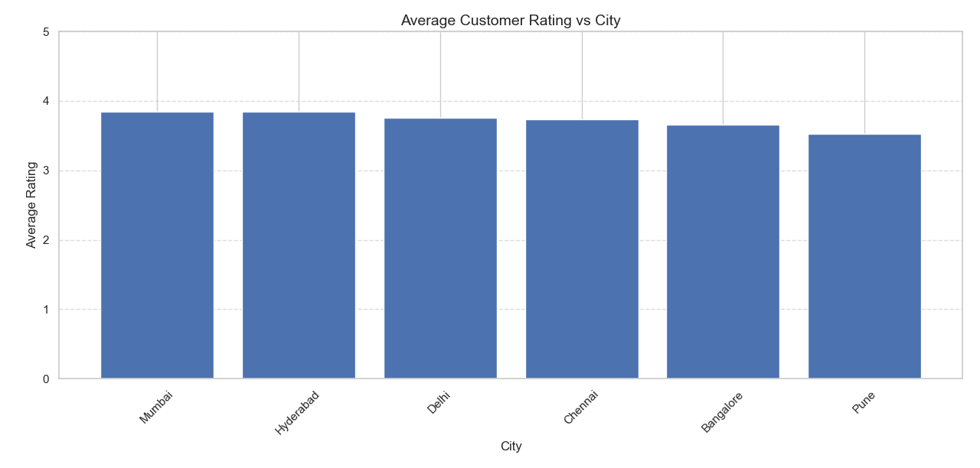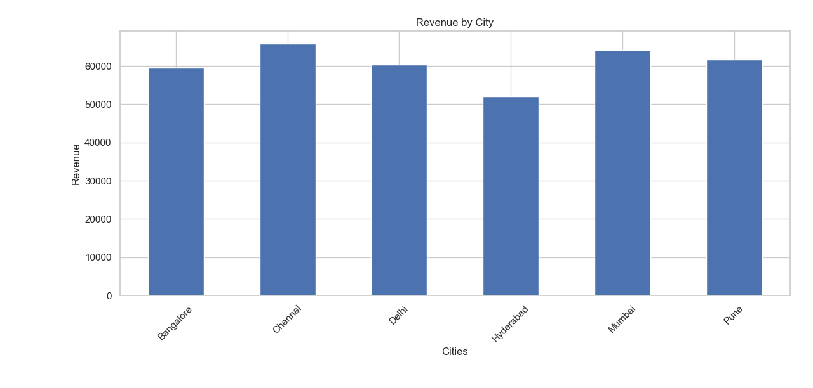

Sales Pattern Insights

- Above-Average Sales Days: Friday, Saturday, Tuesday
- Best Marketing Day: Friday (highest total revenue)
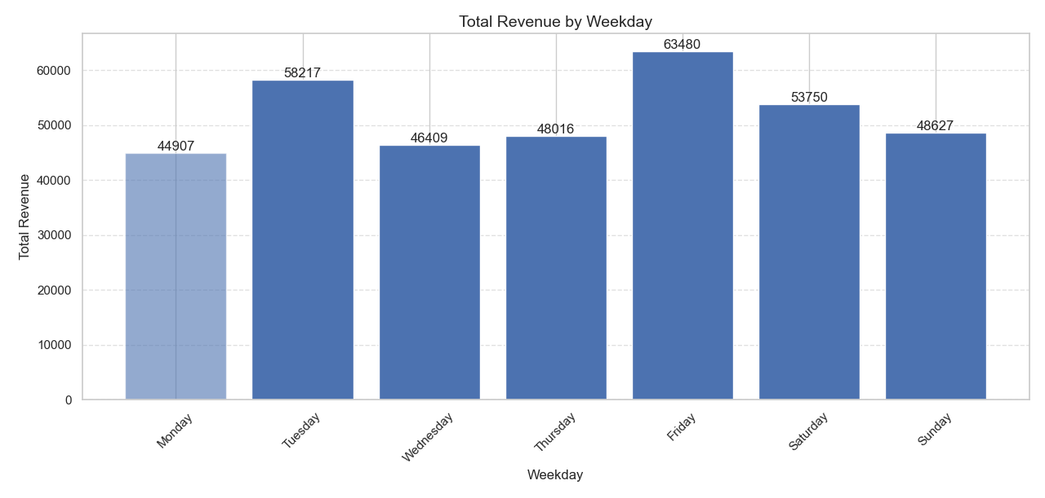

Weekend demand trend observed.

Strategic Recommendations
- Focus promotional campaigns on Fridays.
- Promote Large-size pizzas (highest revenue driver).
- Expand marketing efforts in Mumbai.
- Launch a Premium XL Margherita with added toppings & combo offers.
“Pizza of the Future” Idea
Name: Margherita Max Supreme XL
Based on high popularity + strong revenue + good ratings.
Premium positioning can increase profit margins.

Code URL:
https://github.com/VICKYBHAAI/ProjectDataVisualisationGL/blob/main/pizzalytics.py

