n8n Installation and Configuration Guide (with Docker and Ngrok)
Prepared by: Vicky Patil
Department: Data Science
Created Date: 26-10-2025

Overview
This document provides a detailed guide on installing and configuring n8n — a powerful open-source workflow automation tool — using Docker and Ngrok for secure and accessible remote execution.
n8n allows users to automate repetitive tasks by connecting APIs, applications, and databases visually. Running n8n locally with Docker provides a controlled environment, while Ngrok exposes the local instance securely over HTTPS, enabling webhook-based integrations with external services.

Purpose
When n8n runs locally on your computer (via http://localhost:5678), it cannot receive external webhooks because your local machine is not publicly accessible.
Ngrok solves this problem by creating a secure HTTPS tunnel from a public URL to your local port. This allows external services to send and receive data to your local n8n instance.

Prerequisites
Before starting, ensure the following are installed on your system:
- Docker Desktop
- Ngrok
- Stable Internet Connection
Create an empty folder (e.g., C:\n8n_data) to persist n8n workflow data. This folder will be mapped to /home/node/.n8n inside Docker.

1. Setting Up Ngrok Steps
1. Visit https://ngrok.com/download/windows
2. Sign up or log in to your Ngrok account.
3. Install Ngrok (via Microsoft Store or direct download).
4. Open CMD and run your Ngrok authtoken command (from dashboard):
Ngrok config add-authtoken <your-authtoken>
5. Verify by running: Ngrok http 5678
It will display a forwarding URL like https://example.ngrok-free.dev — save it.

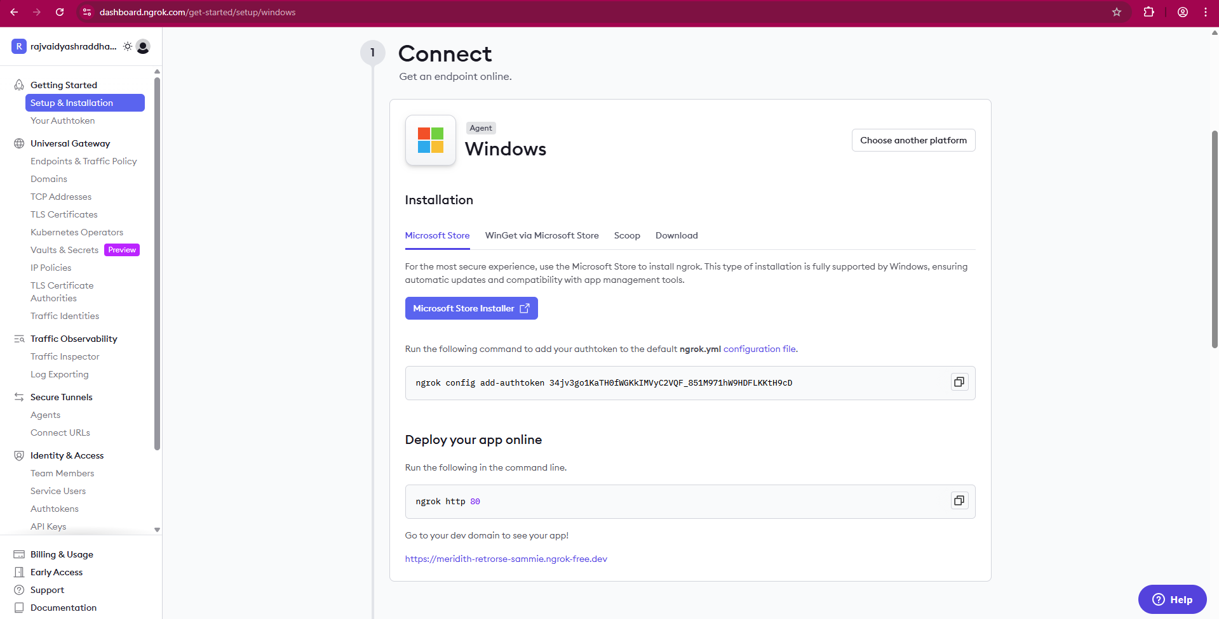
Fig 1.1


Fig 1.2


Fig 1.3

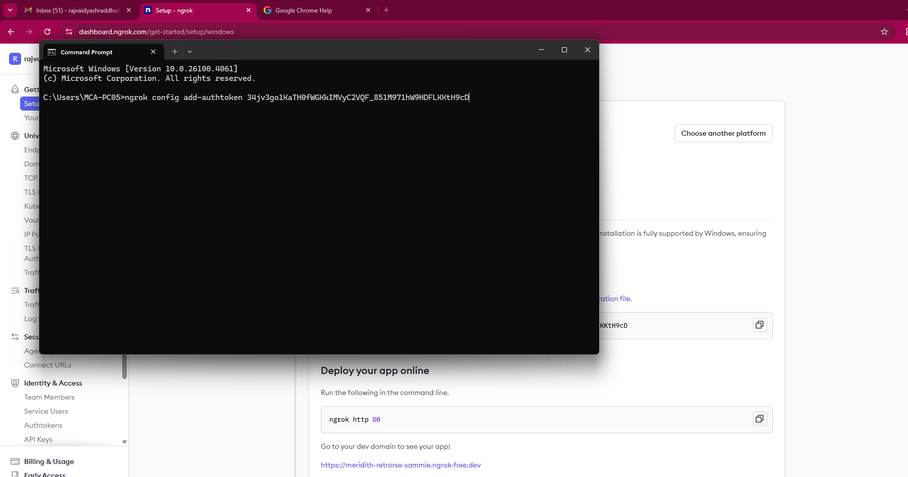
Fig 1.4

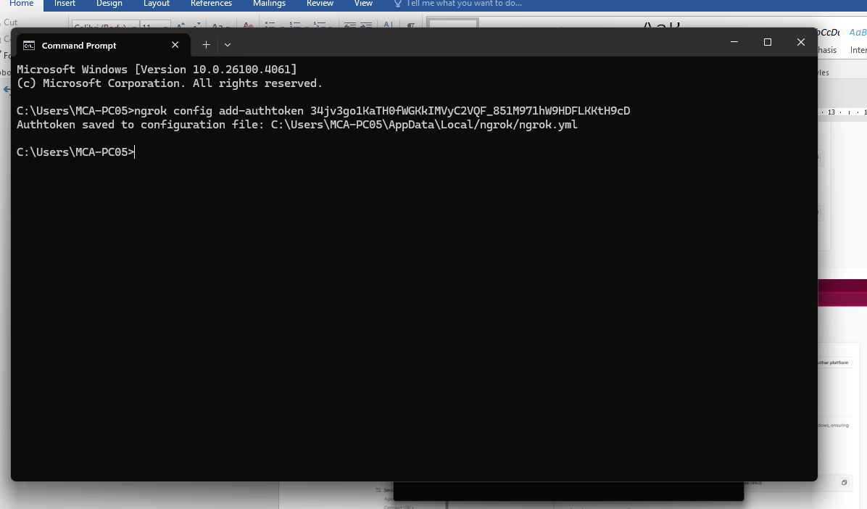
Fig 1.5


Fig 1.6

2. Running the n8n Docker Container
1. Open Docker Desktop.
2. Pull the latest n8n image:
docker pull n8nio/n8n
3. Create a container mapping:
Volumes Host Path: C:\n8n_data
Container Path: /home/node/.n8n

Variable Name | Value
N8N_COMMUNITY_PACKAGES_ALLOW_TOOL_USAGE | true
N8N_EDITOR_BASE_URL | https://<your-ngrok-domain>
WEBHOOK_URL | https://<your-ngrok-domain>
N8N_DEFAULT_BINARY_DATA_MODE | filesystem

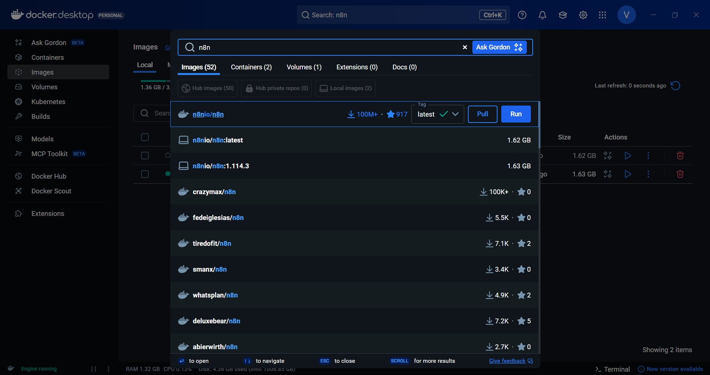
Fig 2.1



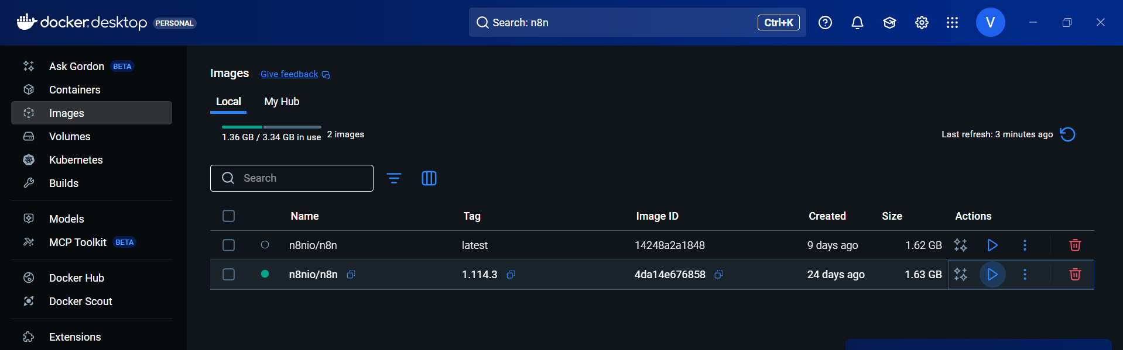
Fig 2.
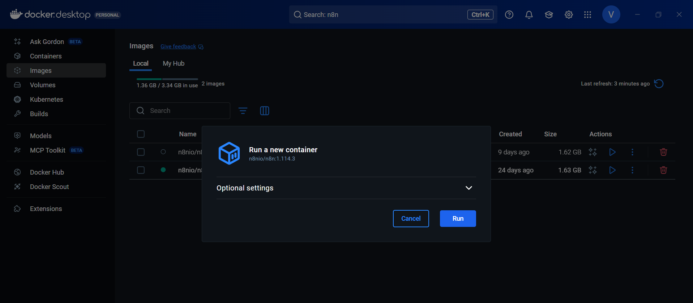
Fig 2.3

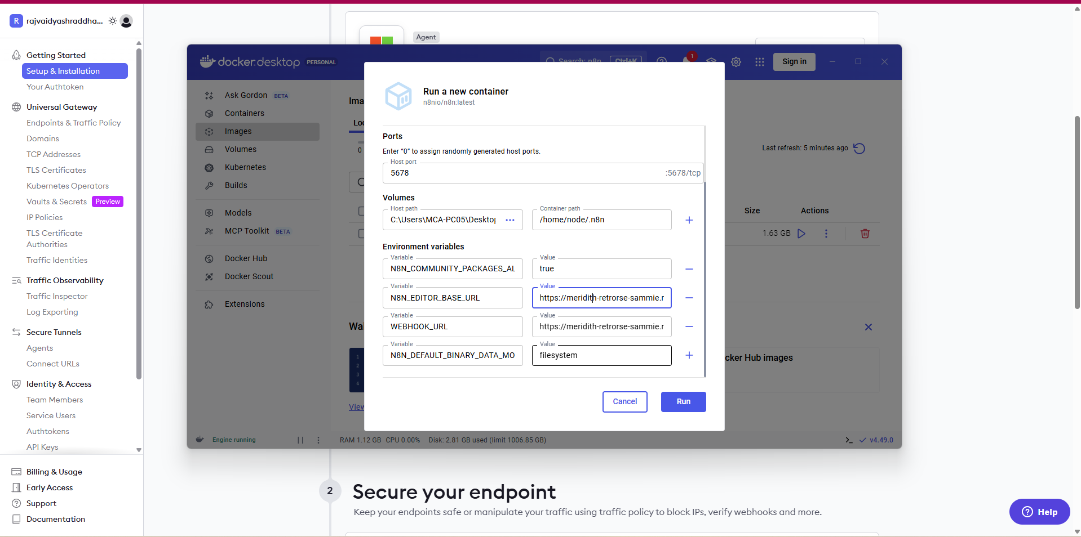
Fig 2.3

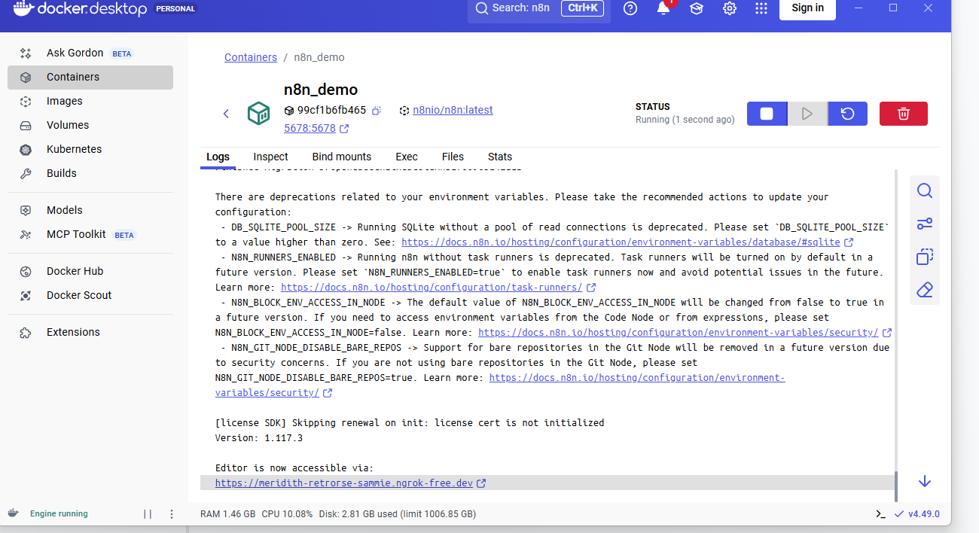
Fig 2.4

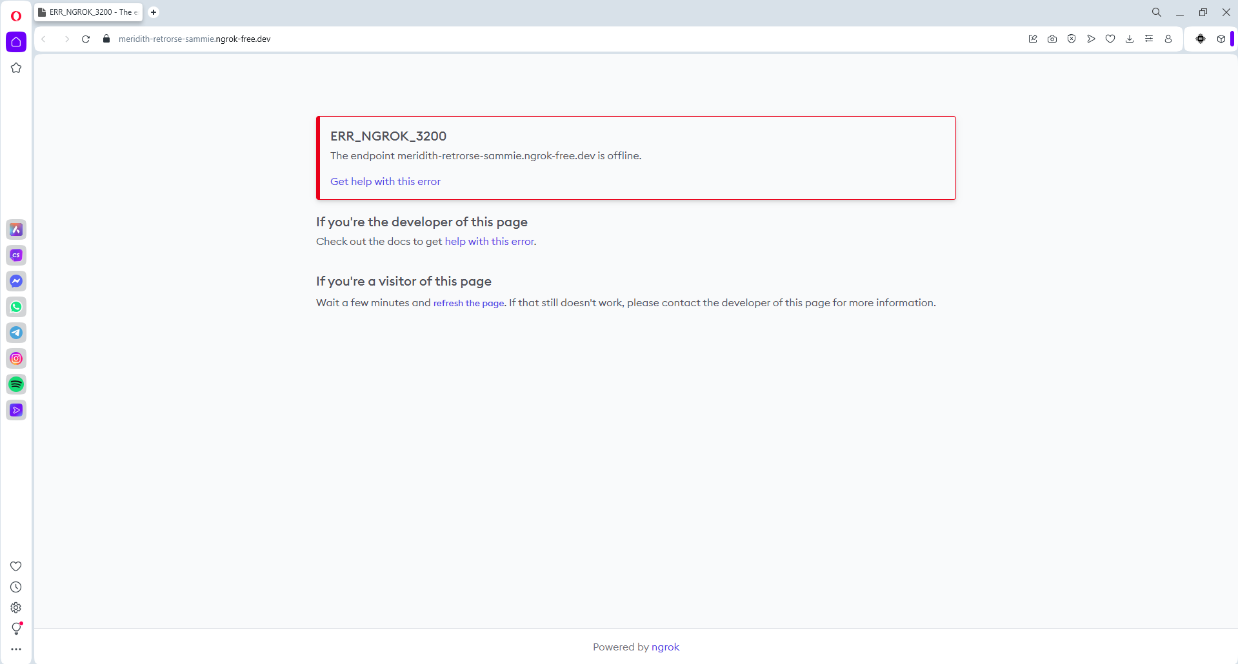
Fig 2.5

3. Starting n8n with Port Forwarding
Every time you restart your PC:
1. Start Docker Desktop
2. Run in CMD:
ngrok http 5678
3. Copy the forwarding URL and open it in your browser to access n8n securely or we can just click and navigate to the URL we get after running the docker image of n8n
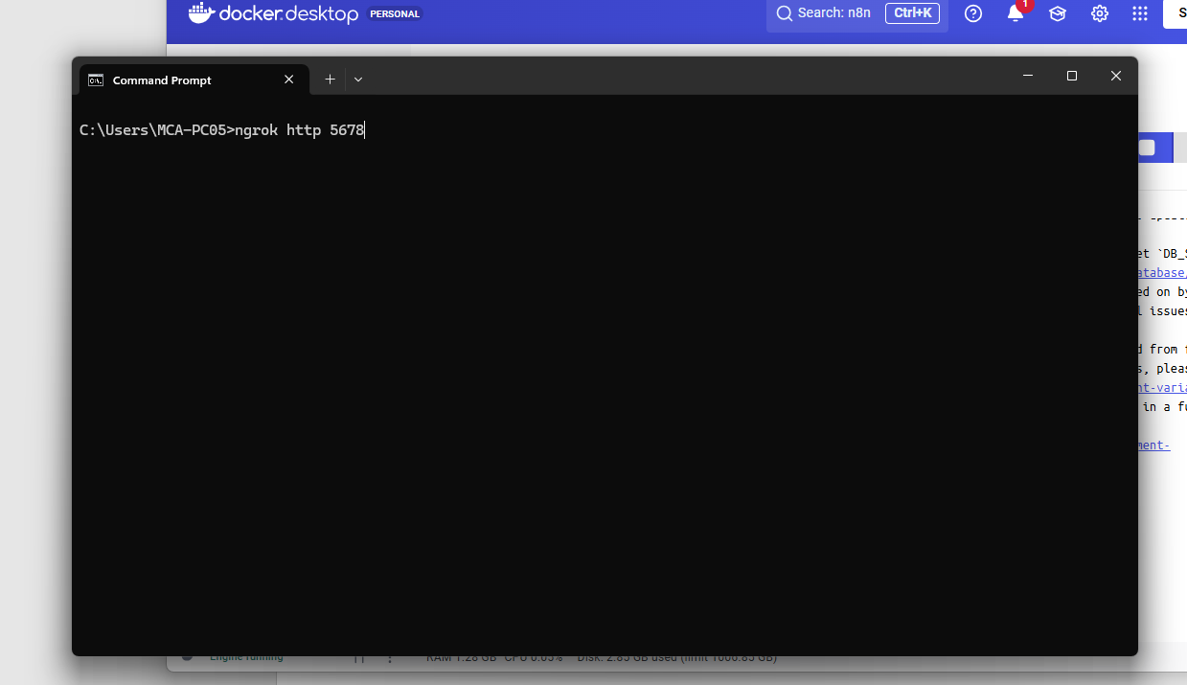
Fig 3.1
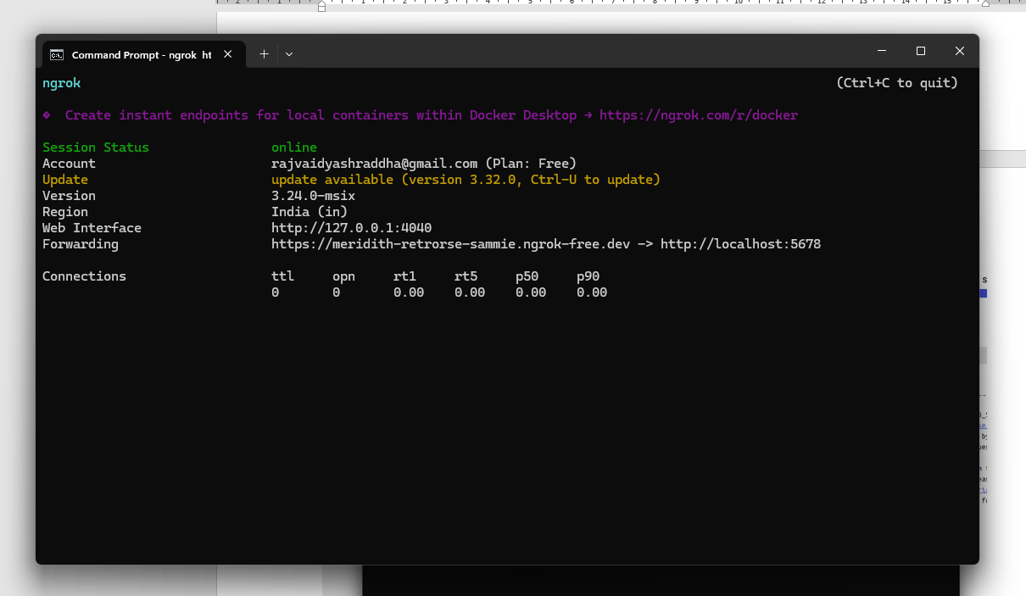
Fig 3.2
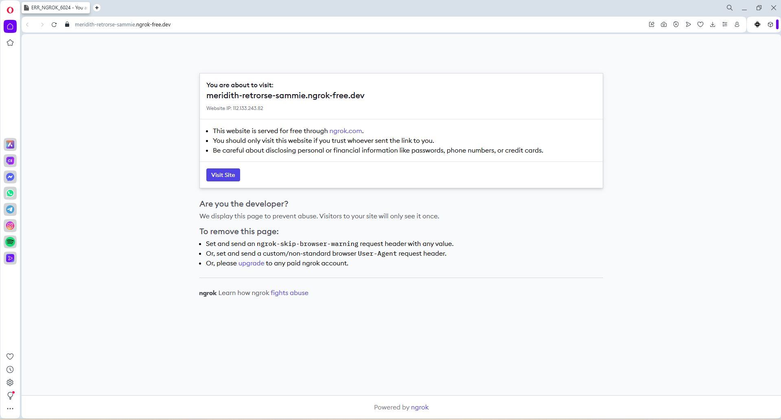
Fig 3.3

Why Ngrok is Used
When n8n runs on your computer, it works only on localhost (example: http://localhost:5678).
This means only your own device can access it, and no other system or API on the internet can communicate with your n8n workflows.
However, many workflows need data from external services — for example:
- Google Drive sending a file to n8n
- GitHub sending a push event
- A chatbot sending user messages
- An API calling your n8n webhook
These services cannot access your computer directly because it is not publicly available.
The Problem
Your local machine is behind:
- NAT
- Router
- Firewall
And it doesn’t have a public domain.
So external APIs cannot reach your webhook URL.

4. n8n Access and First Workflow Guide
Once n8n is running, simply enter the email and password you configured earlier to log in.
After signing in, n8n will ask for a few basic details—fill these out, and you will be taken to the main n8n Dashboard in your browser.
From this dashboard, you can create, manage, and monitor all your workflows.
To build your first automation:
1. Click “Start from Scratch.”
2. You will be taken to the workflow canvas, which is the main working area of n8n.
3. Here, you can drag and drop nodes, connect APIs, use AI agents, store credentials securely, and design complete automation pipelines.
The canvas supports everything from simple test workflows to enterprise-level automation.
Below are some sample screenshots of workflows to show the types of automations you can build.
n8n is extremely flexible—you can create basic “Hello World” flows or highly complex, multi-step processes involving APIs, databases, AI models, and more.

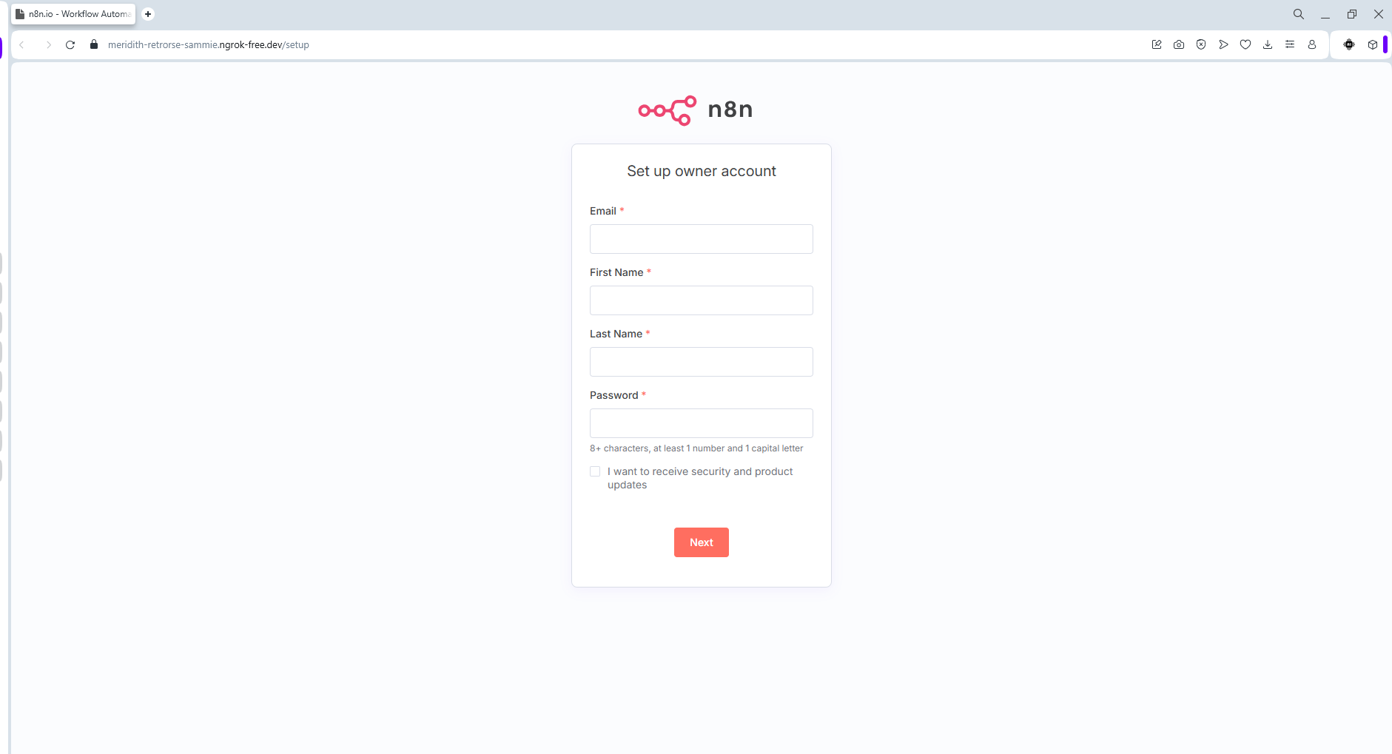
Fig 4.1
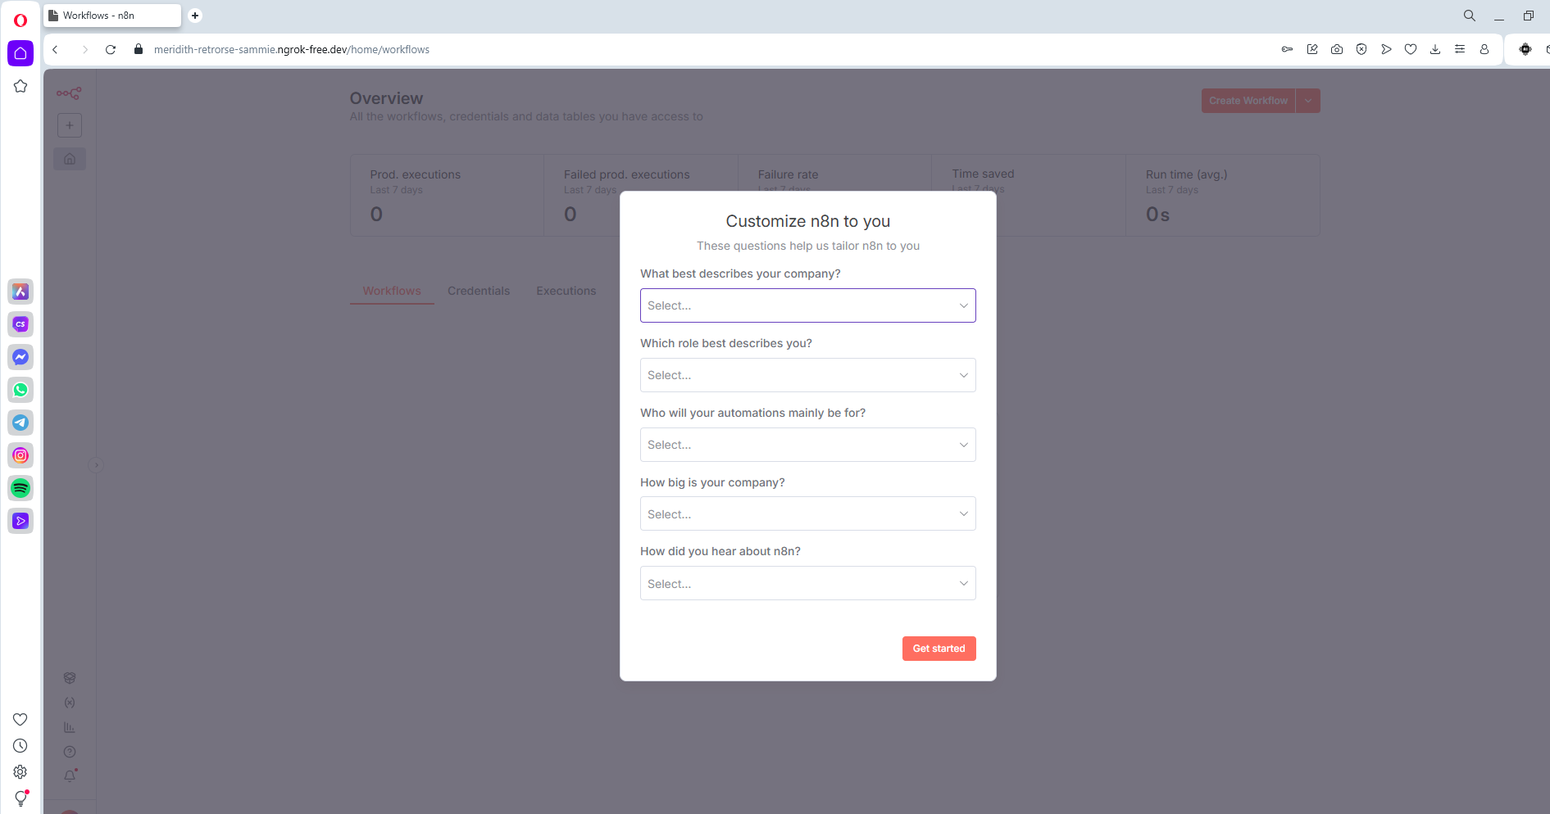
Fig 4.2

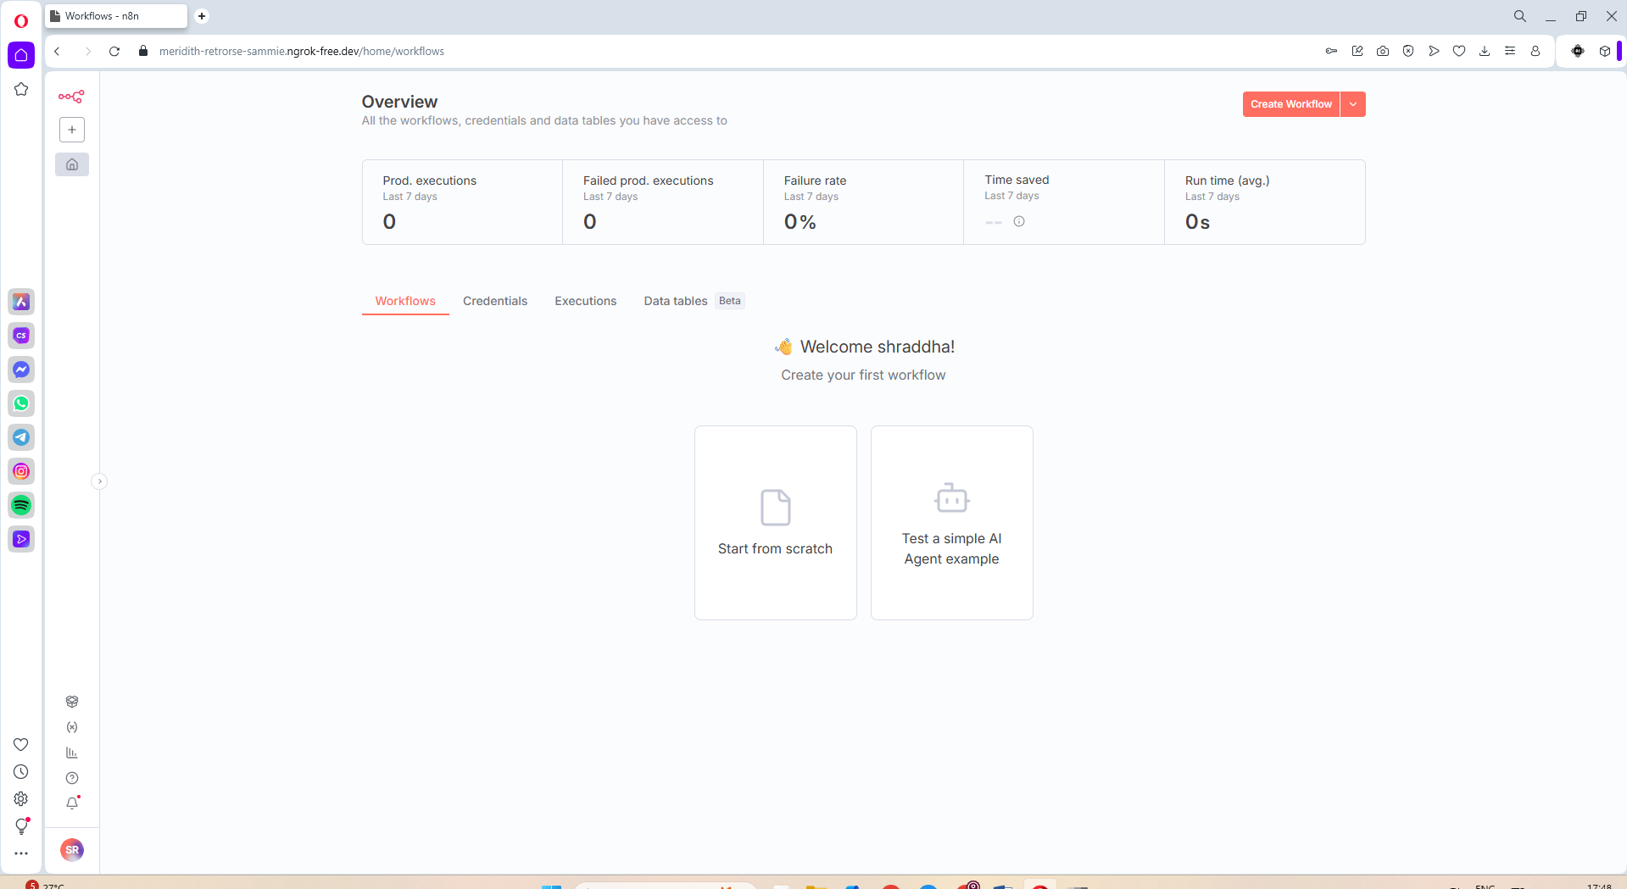
Fig 4.3

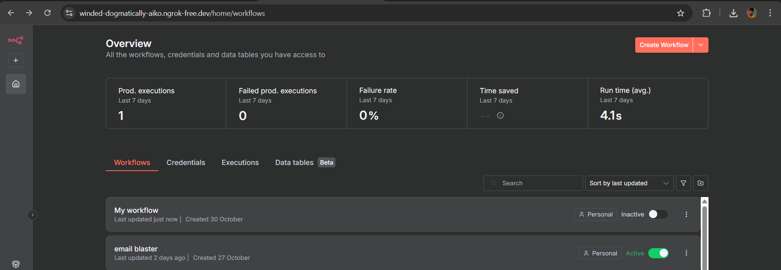
Fig 4.4

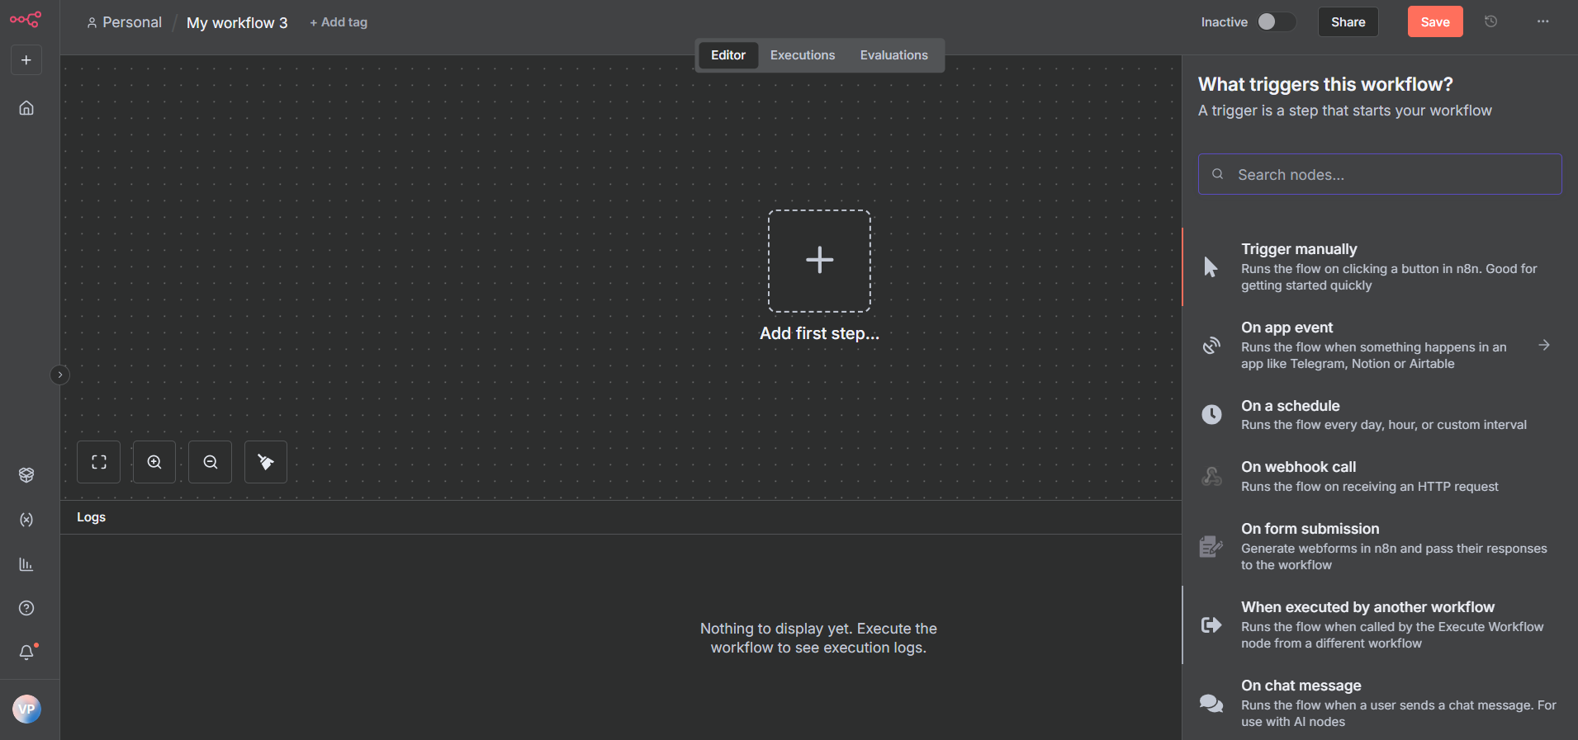
Fig 4.5

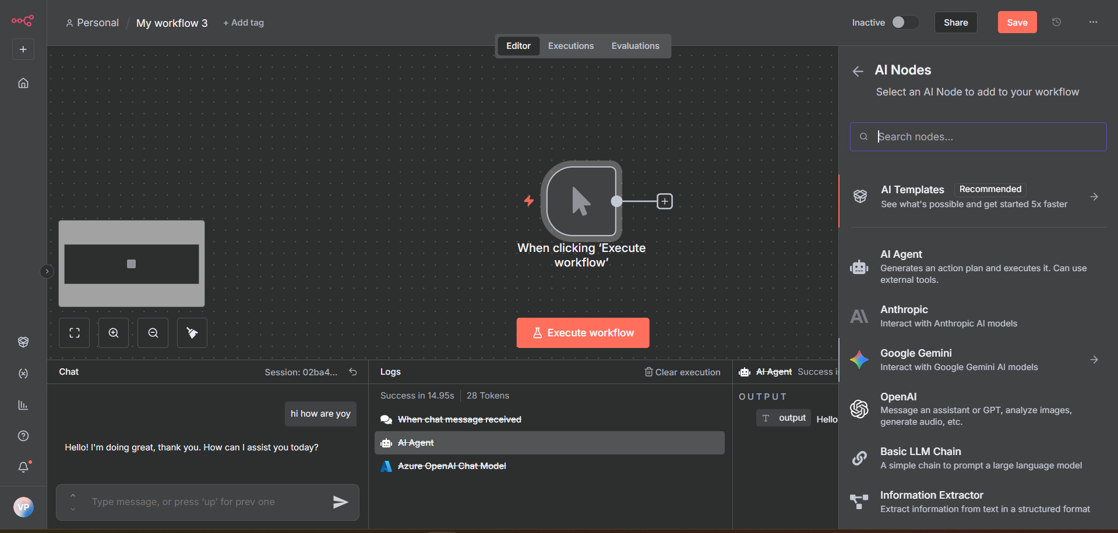
Fig 4.6
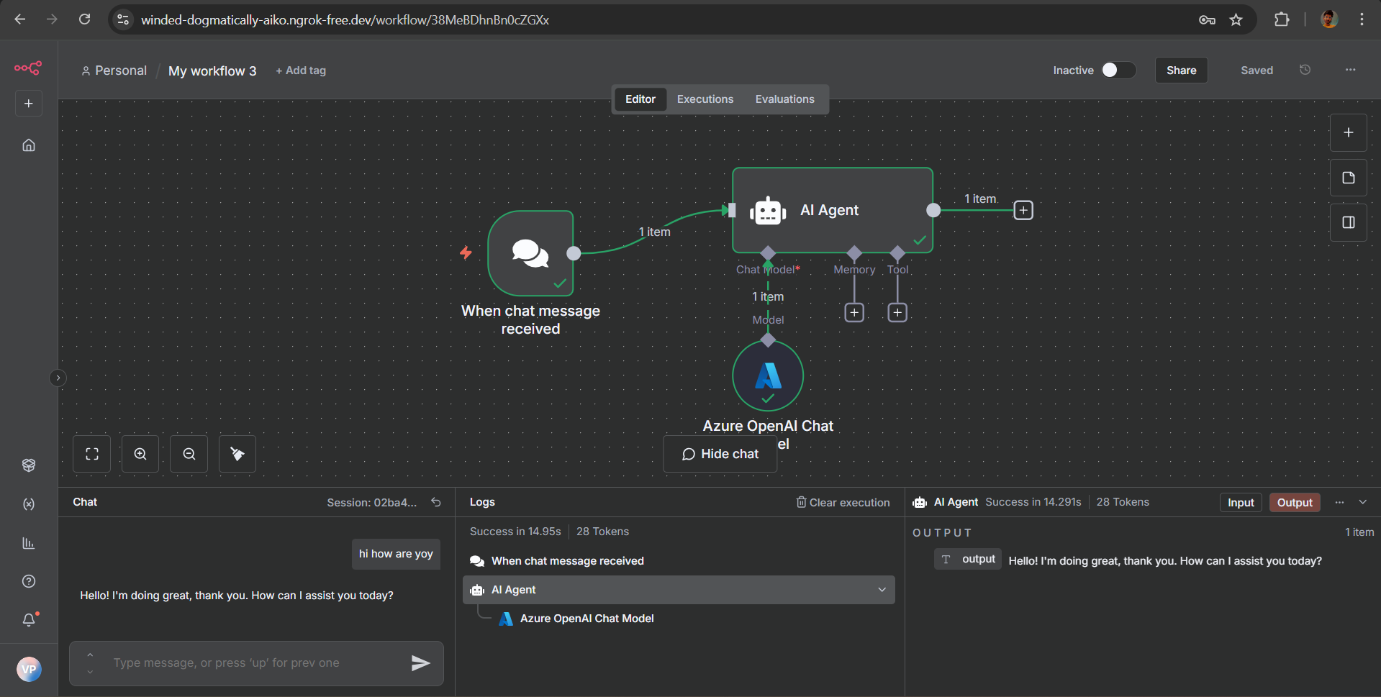
Fig 4.7

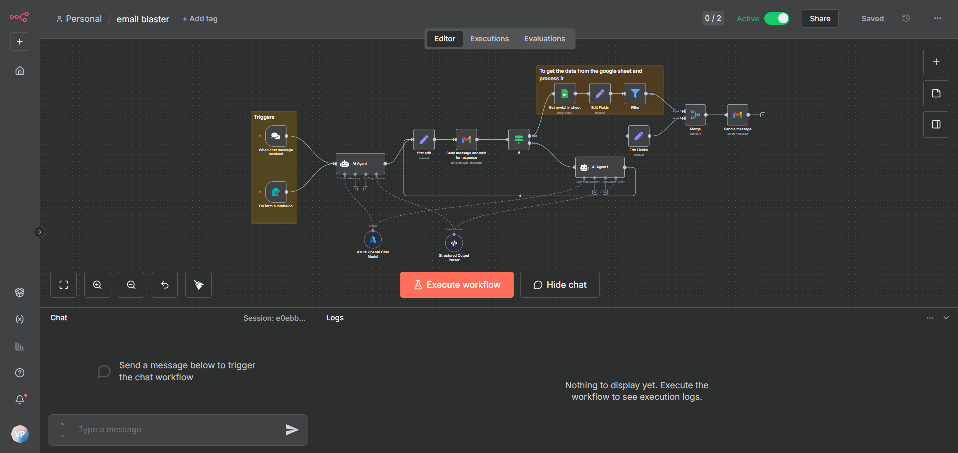
Fig 4.8

