Electrobot Ultra Gaming Tower PC - Intel 11th Gen i7 11700K, B560 Chipset, RTX 3060 12GB, 16GB (8GBx2) RAM,512GB Nvme SSD, 360mm Liquid Cooler

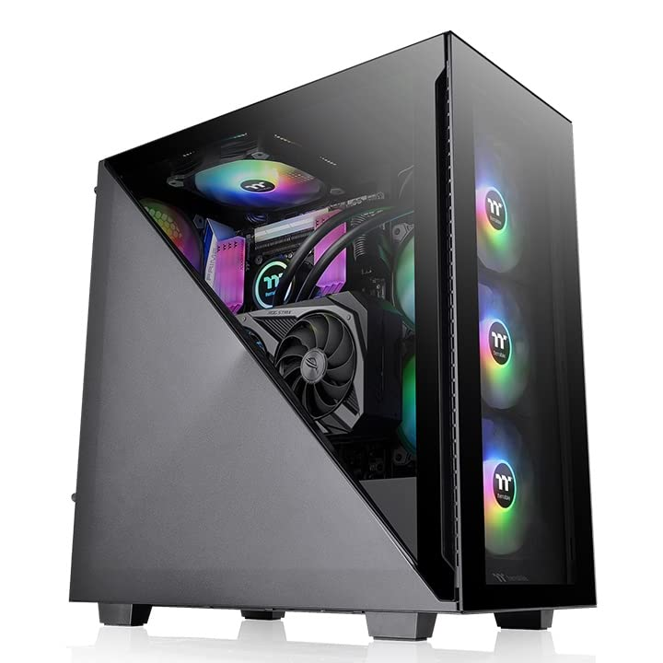

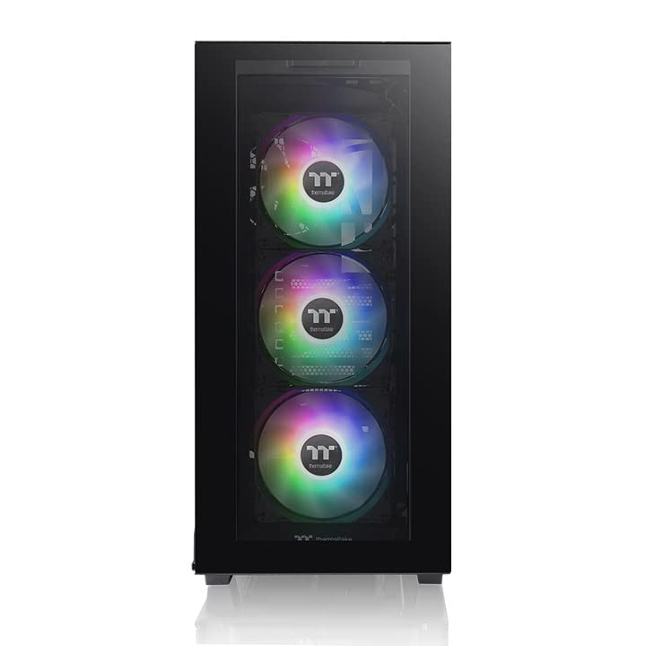

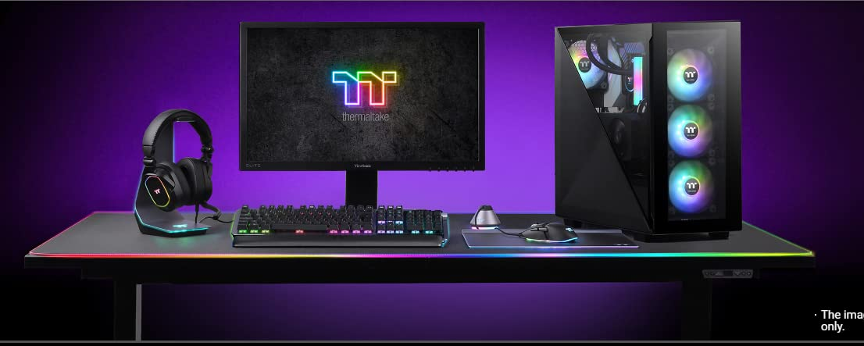

|  |  |
| --- | --- |
| M.R.P.: | ₹1,80,000 |
| Deal of the Day: | ₹99,999  Ends in 4 days |
| You Save: | ₹80,001 (44%) |
|  | Inclusive of all taxes |
| Specific Uses For Product | Gaming |
| Brand | Electrobot |
| Personal computer design type | Computer Tower |
| Operating System | DOS |
| Memory Storage Capacity | 512 GB |
| RAM Memory Installed Size | 16 GB |
| Included Components | Computer |
| CPU Model | Intel Core i7 |
| CPU Manufacturer | Intel |
| CPU Speed | 3.8 GHz |