Cougar MX440 Mesh RGB Powerful Airflow and Compact Mid-Tower Case with Tempered Glass and 3X ARGB Fans

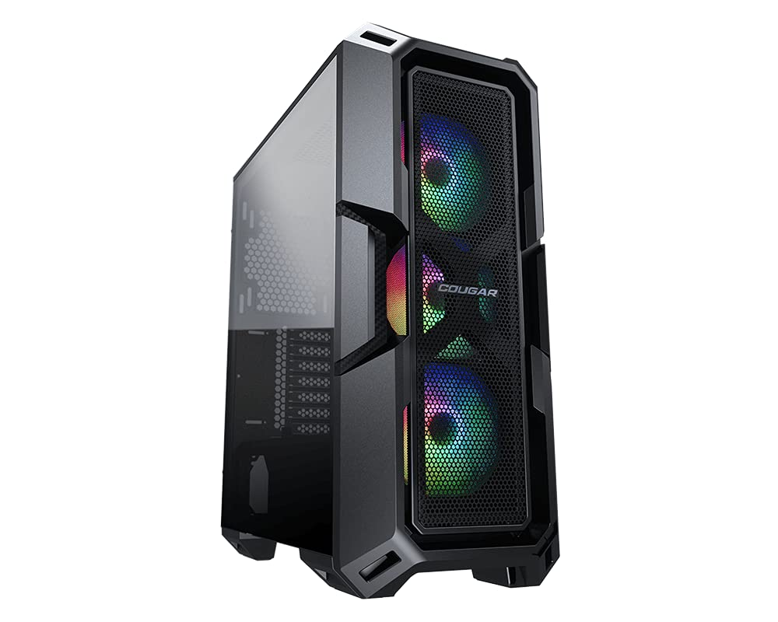

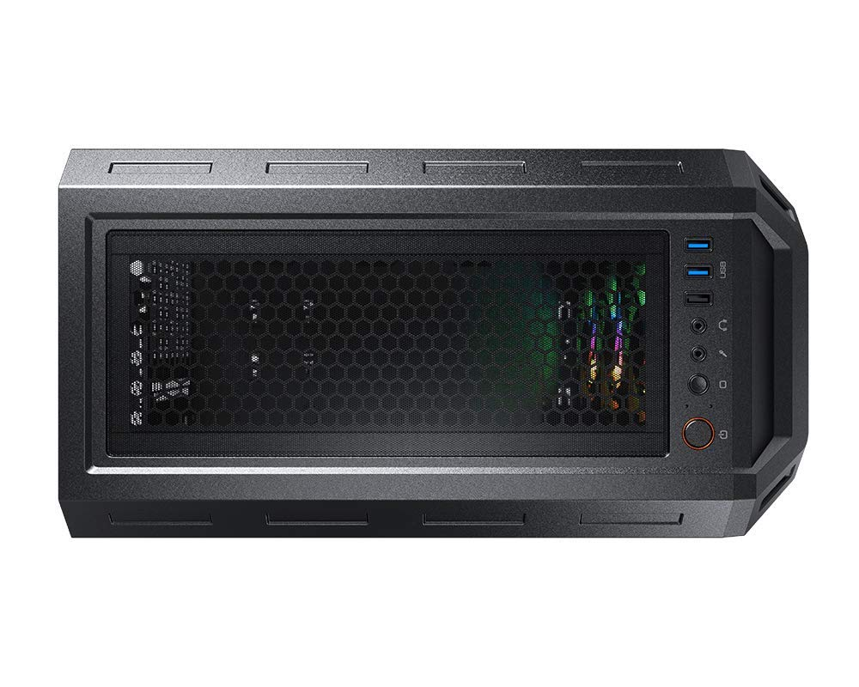

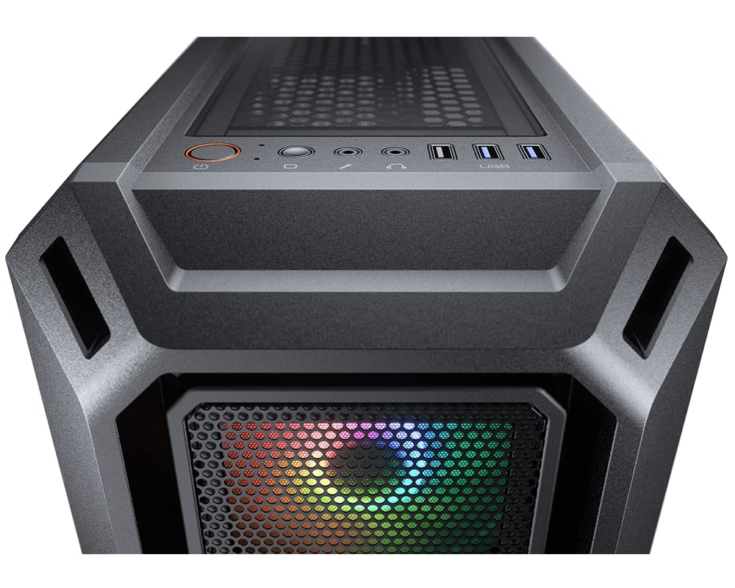

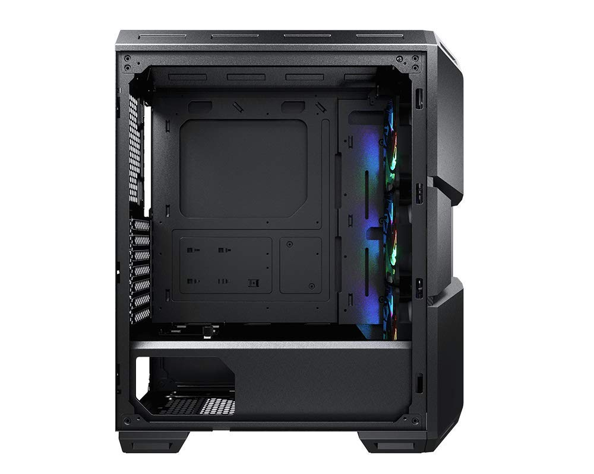

₹5,270

Inclusive of all taxes

**Product details**

|  |  |
| --- | --- |
| Brand | Cougar |
| Colour | Black |
| Material | Tempered Glass |
| Item Dimensions LxWxH | 42.4 x 21.5 x 50.5 Centimeters |
| Model Name | MX440 Mesh RGB |

* Strength, Sturdy, and Superior Airflow
* Incredible RGB Lighting
* Massive Tempered Glass Left Panel
* Wider but More Compact and Powerful
* Sufficient for Multiple USB Devices
* Strong Cooling Performance