Galax PC Case (REV-05) Revolution 05 Black

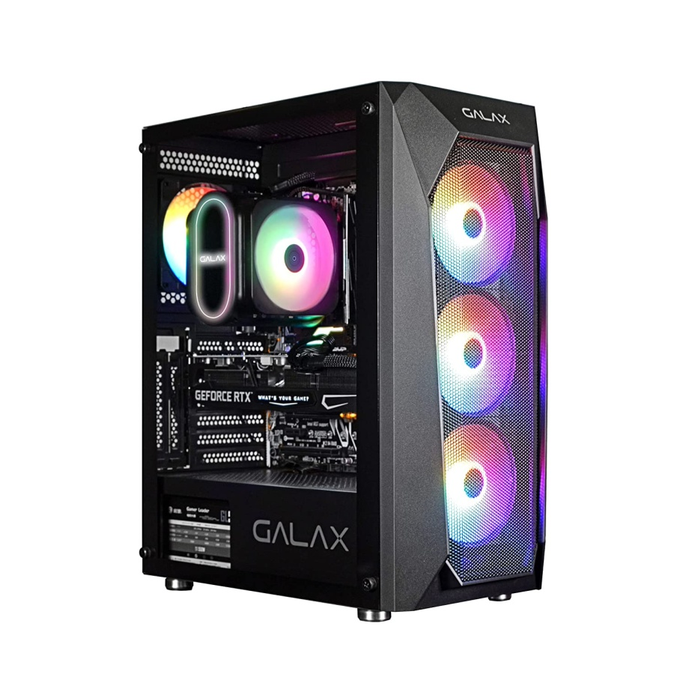

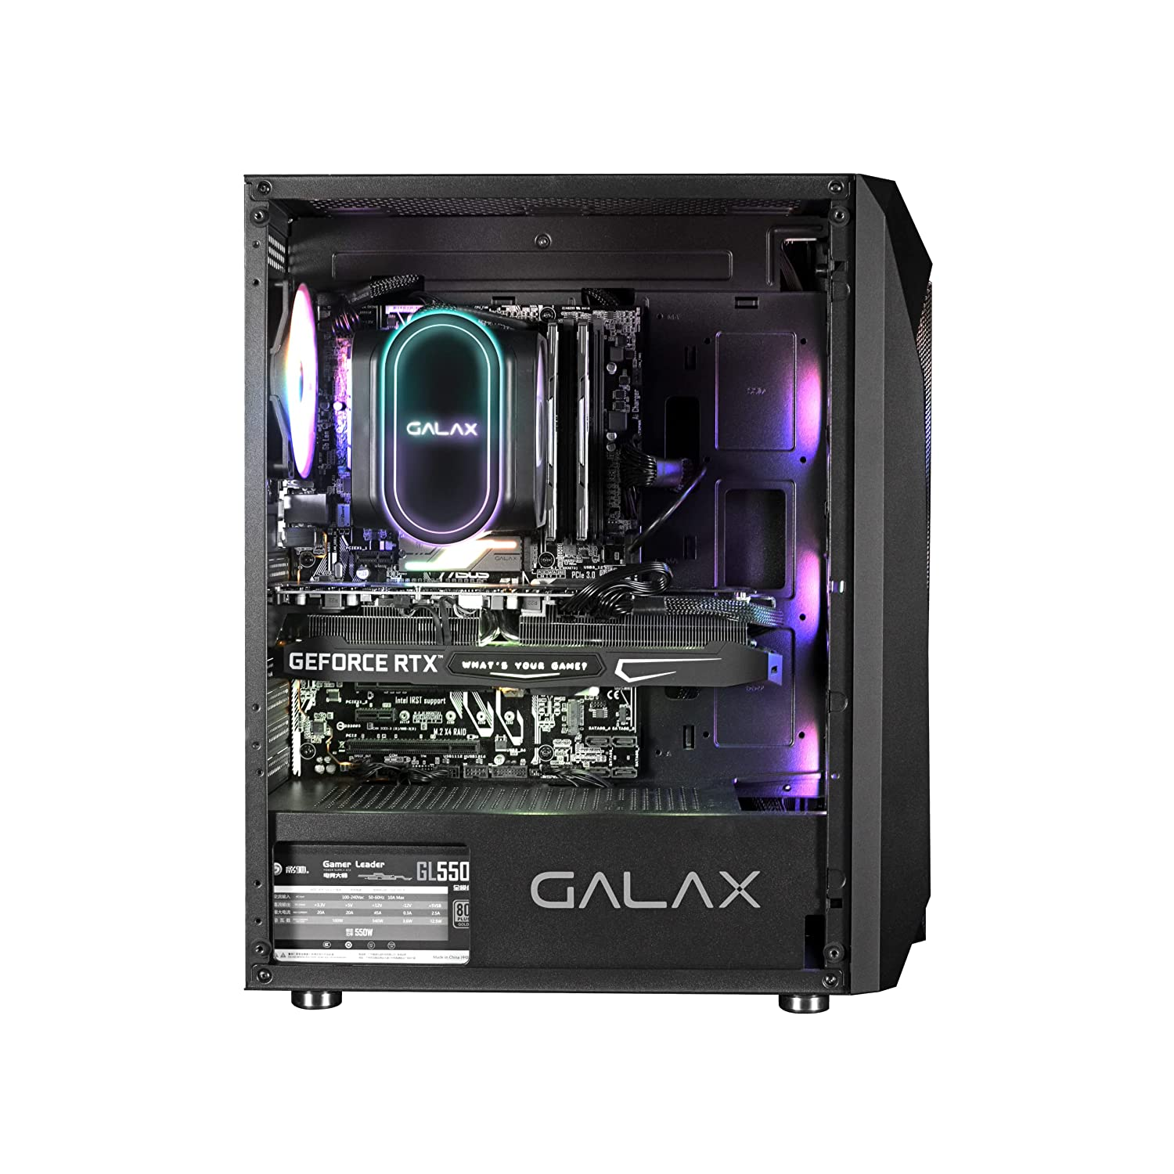

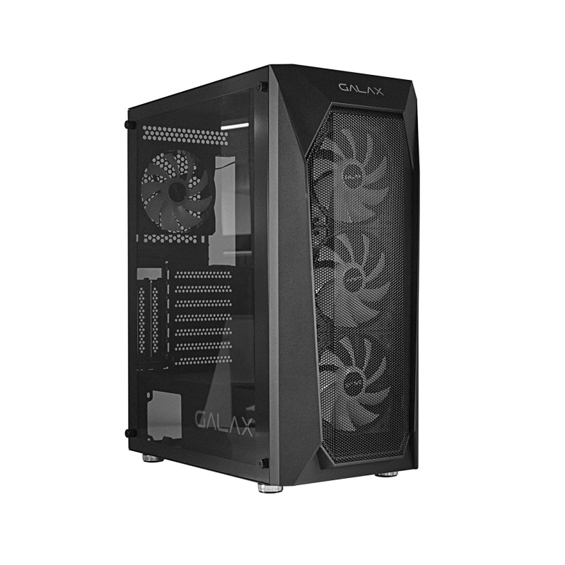

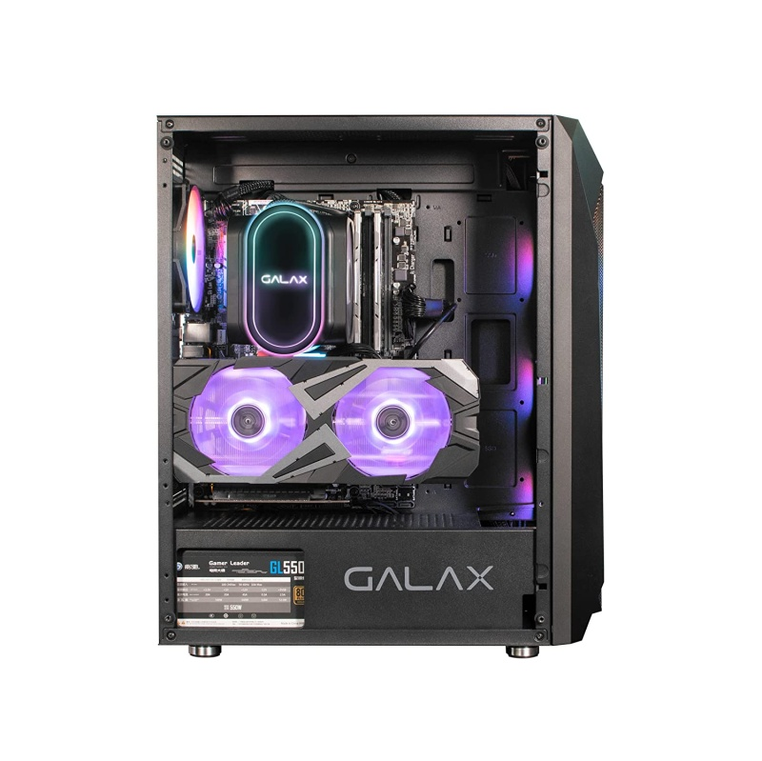

-41% ₹4,099

M.R.P.: ₹7,000

Inclusive of all taxes

### Product details

|  |  |
| --- | --- |
| Brand | Galax |
| Colour | Black |
| Material | Alloy Steel |
| Item Weight | 3 Kilograms |
| Item Dimensions LxWxH | 50 x 30 x 30 Centimeters |

* Compatible with ATX, M-ATX, ITX motherboards
* REV-05 is by far the tallest PC case in the Revolution family