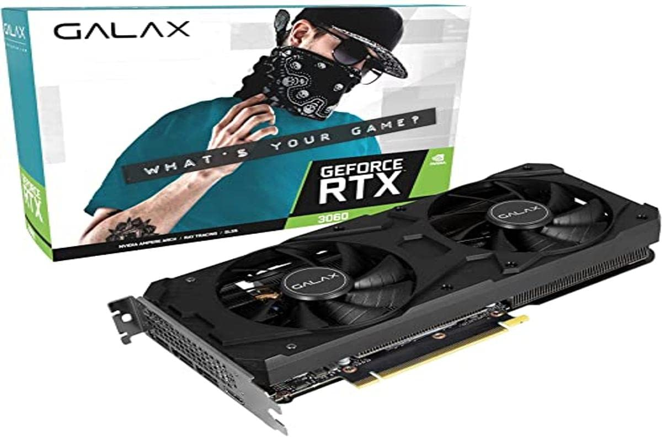

Inner

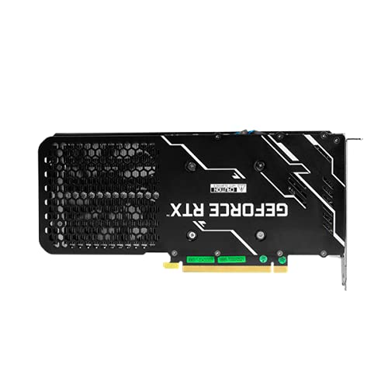

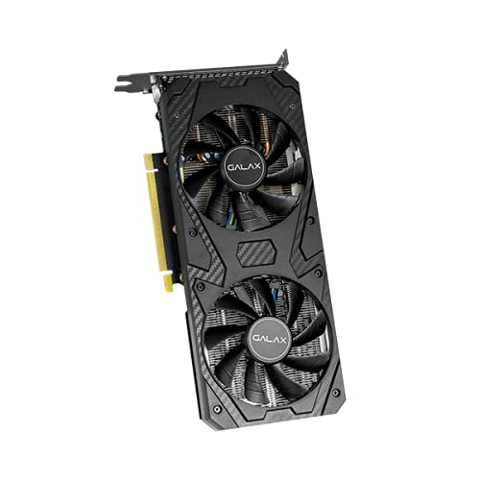

Galax GeForce RTX 3060 (1-Click OC) 12GB GDDR6 192-bit DP*3/HDMI Graphics Card

-51% ₹34,650₹34,650

M.R.P.: ₹70,000₹70,000

|  |  |
| --- | --- |
| Graphics Coprocessor | Nvidia |
| Brand | Galax |
| Graphics RAM Size | 12 GB |
| GPU Clock Speed | 1777 MHz |
| Video Output Interface | DisplayPort, HDMI |

# About this item

* CUDA Cores 3584
* Boost Clock (MHz) 1777
* Memory Interface Width 192-bit GDDR6