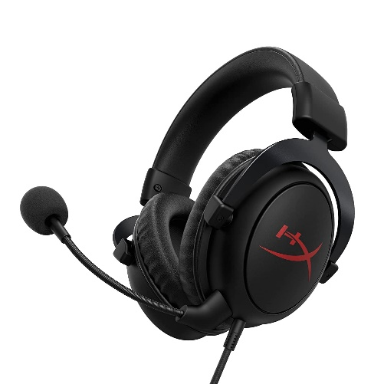

Inner

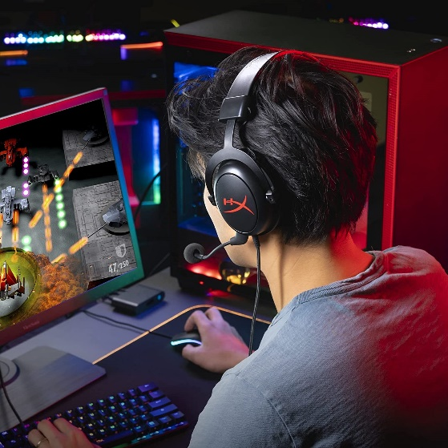

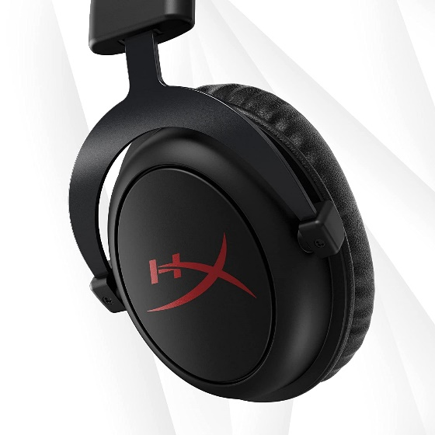

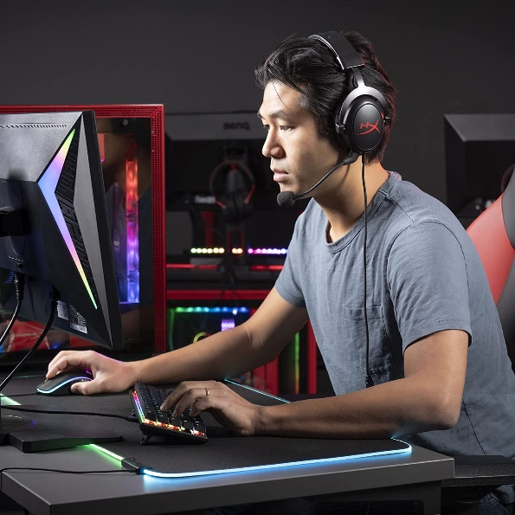

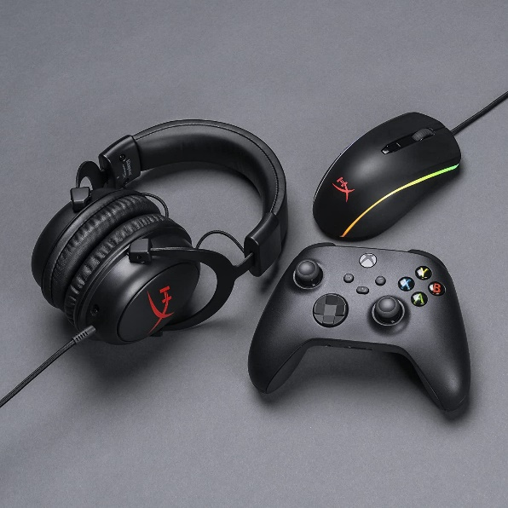

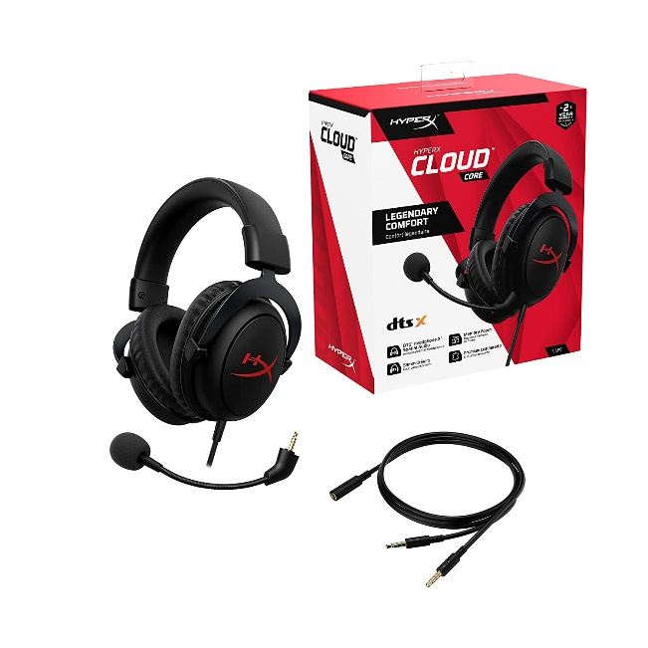

HyperX Cloud Core – Gaming Headset for PC, DTS Headpone:X

|  |  |
| --- | --- |
| M.R.P.: | ₹8,437.00₹8,437.00 |
| Deal of the Day: | ₹4,490.00₹4,490.00 |
| **Brand** | HyperX |
| **Model Name** | HyperX Cloud Core + 7.1 Gaming Headset for PC, PS4, Xbox One, Nintendo Switch, and Mobile Devices (HX-HSCC-2-BK/WW)HyperX Cloud Core + 7.1 Gaming Headset for PC, PS4, Xbox One, Nintendo Switch, and Mobile Devices (HX-HSCC-2-BK/WW) [See more](javascript:void(0)) |
| **Colour** | Black |
| **Form Factor** | On Ear |
| **Connector Type** | Wired |

**About this item**

* Virtual 7.1 surround sound - Hear positional audio better and get a more immersive audio experience thanks to virtual 7.1 surround sound delivered through the Cloud Core’s digital signal processing sound card.
* Advanced audio control box - The USB audio control box is powerful and easy-to-use. Conveniently access mic volume, headset volume, and mute the mic without having to dig into system menus, Battery life - 30 hours
* Signature HyperX comfort with Durable aluminum frame - Game longer and more comfortably thanks to the comfort provided by HyperX memory foam. Built tough with a sturdy aluminum frame so it is better equipped to handle the wear and tear of daily use. Sound pressure level -104dBSPL/mW at 1kHz
* Detachable noise-cancelling mic and Multi-platform compatibility - The flexible, detachable, noise-cancelling mic is Discord and TeamSpeak certified, and will give you a clear line of communication with your squadmates. The USB audio control box is compatible with PC and PS4, and you can connect via 3.5mm cable to Xbox One, Nintendo Switch, and Mobile and VR systems that support the connection