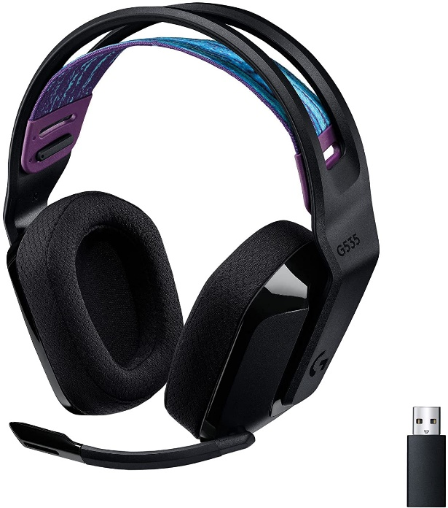

Inner

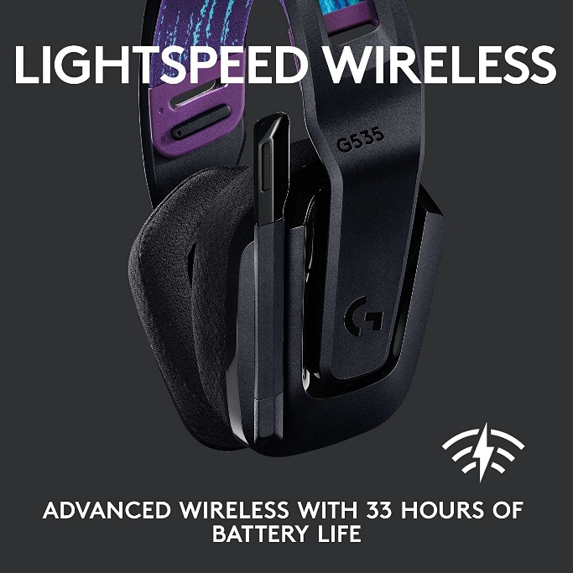

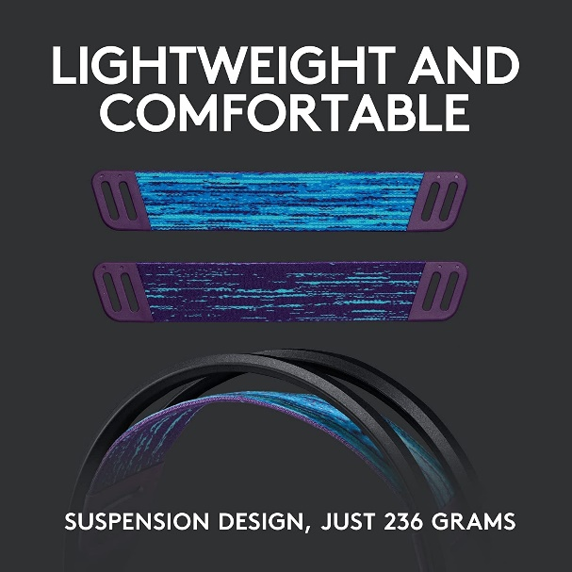

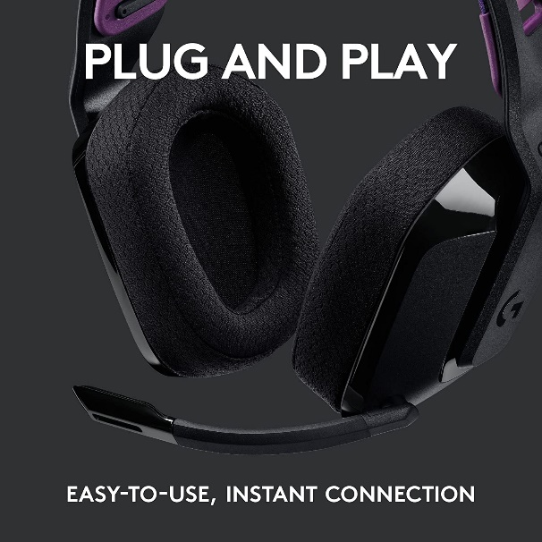

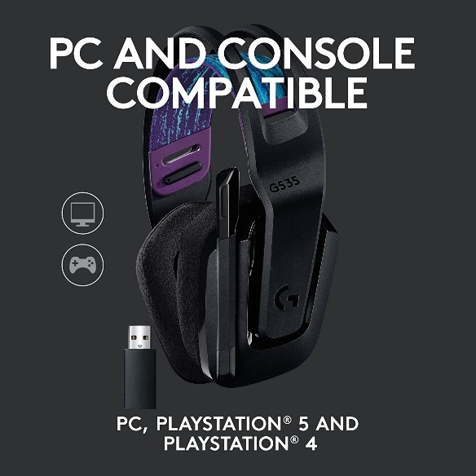

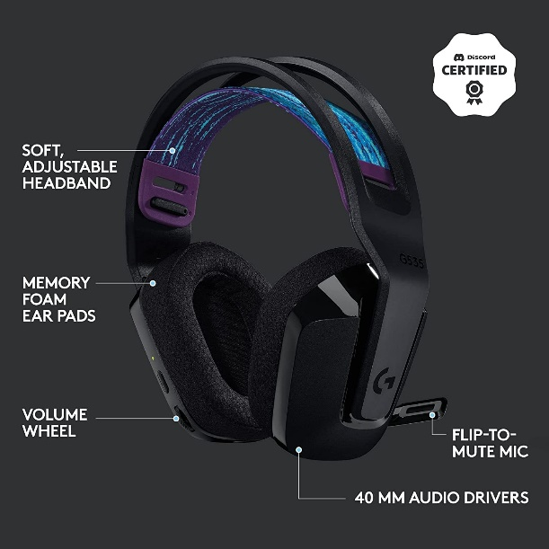

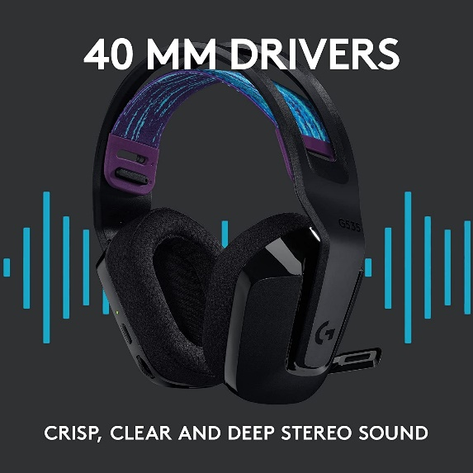

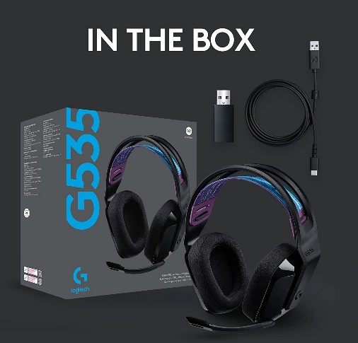

Logitech G535 Lightspeed Wireless Gaming Headset - Lightweight on-Ear Headphones, flip to Mute mic, Stereo, Compatible with PC, PS4, PS5, USB Rechargeable -...

|  |  |
| --- | --- |
| M.R.P.: | ₹14,995.00₹14,995.00 |
| Deal of the Day: | ₹11,495.00₹11,495.00 |
| **Brand** | Logitech G |
| **Series** | G535 wireless gaming headset |
| **Colour** | Black |
| **Form Factor** | Over Ear |
| **Connectivity Technology** | Wireless |

**About this item**

* LIGHTSPEED Wireless: Pro-grade LIGHTSPEED wireless technology provides 33 hours of battery life(1) and up to 12 meters of reliable wireless freedom
* Lightweight and Comfortable: At only 236 grams, G535 is smaller and lighter than the G733; reversible suspension headband helps distribute weight and is adjustable for a customized fit
* Plug and Play: Optimize your game time with an easy-to-use plug-and-play gaming headset; G535 uses a USB connection compatible with PC and PlayStation gaming devices
* On-Ear Controls: Volume roller is located directly on the ear cup, to quickly turn up your game, music or comms; simply flip up microphone to mute and get it out of the way
* 40 mm Drivers: With 40 mm neodymium drivers, this wireless gaming headset delivers crisp, clear, and deep stereo sound that makes your game come alive