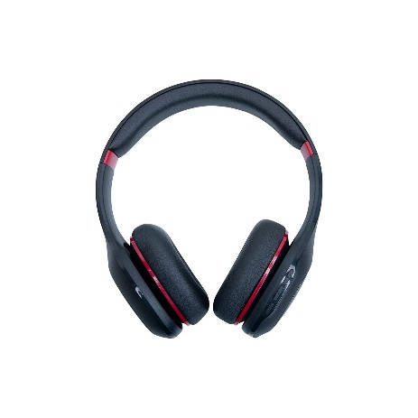

Inner

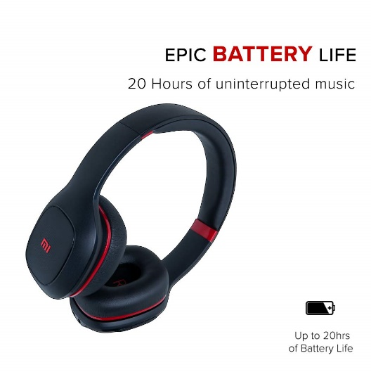

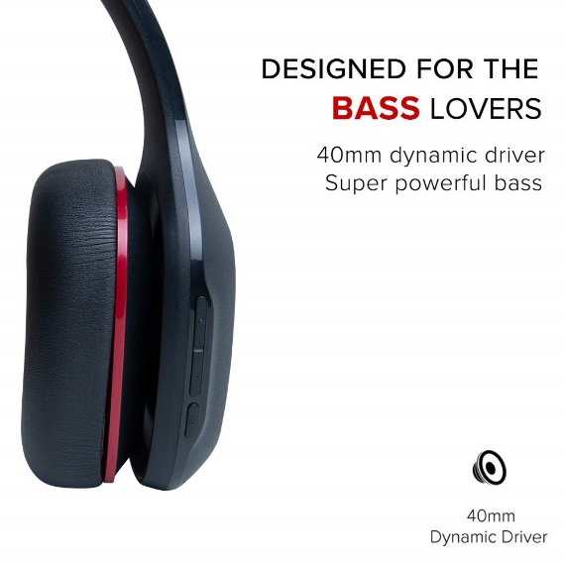

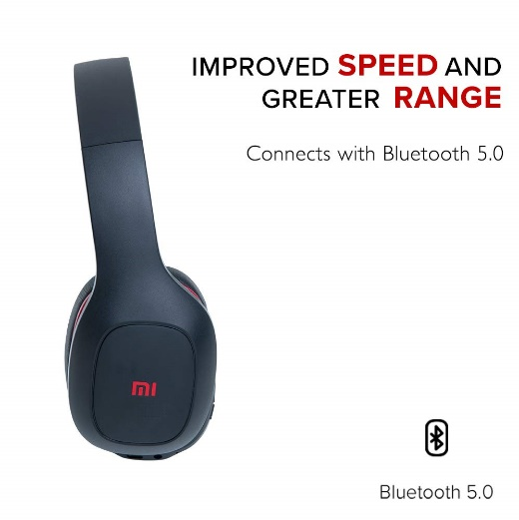



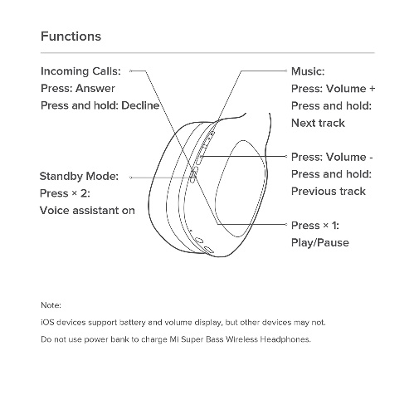

MI Super Bass Bluetooth Wireless On Ear Headphones with Mic (Black and Red)

|  |  |
| --- | --- |
| M.R.P.: | ₹2,199.00₹2,199.00 |
| Deal of the Day: | ₹1,599.00₹1,599.00 |

Top of Form

Colour: **Black and Red**

Bottom of Form

|  |  |
| --- | --- |
| **Brand** | MI |
| **Model Name** | Headphones |
| **Colour** | Black and Red |
| **Form Factor** | On Ear |
| **Connector Type** | Wireless |

**About this item**

* BreaktheWire : Up to 20 hours battery life | Super powerful Bass | 40mm dynamic driver | Pressure less ear muffs | Bluetooth 5.0 | Voice control
* Battery backup : 20 hours and charging time : 2 hours. Speaker Impedence : 32Ω
* Equipped with Bluetooth 5.0 with up to 10 m coverage
* Items included in the package – Headphones, User Manual, Charging cable, Aux cable
* Warranty : 6 months warranty for manufacturing defects
* The headphones are built with large 40mm drivers that create deep and impactful bass output
* Versatile in its conception, the Mi Super Bass Wireless Headphones can be used both wired or wirelessly