inner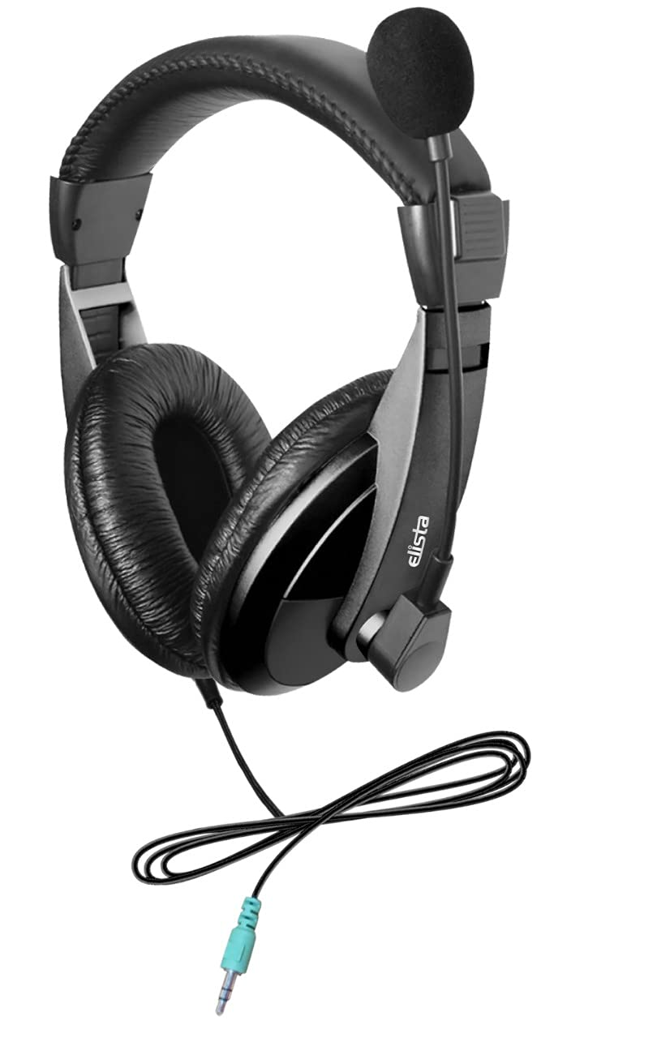

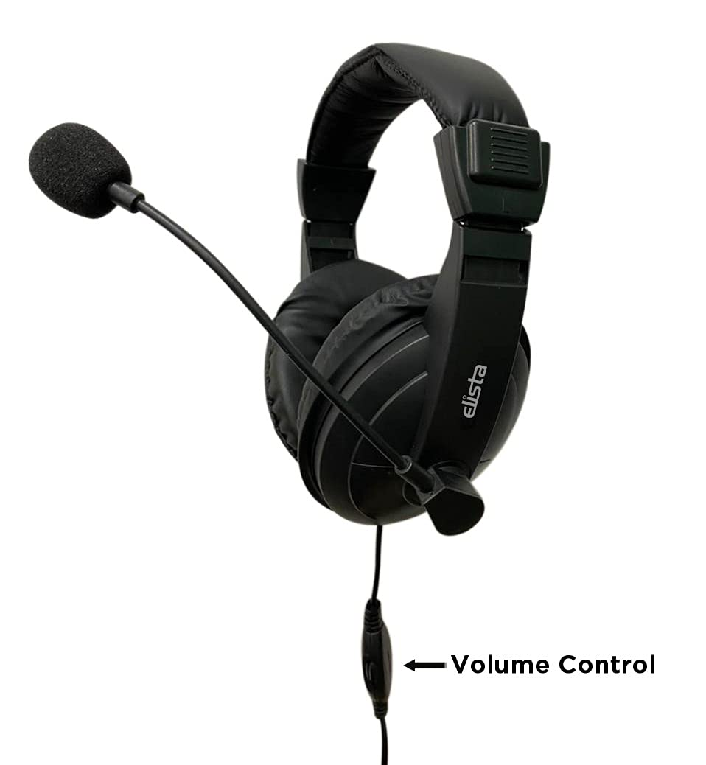

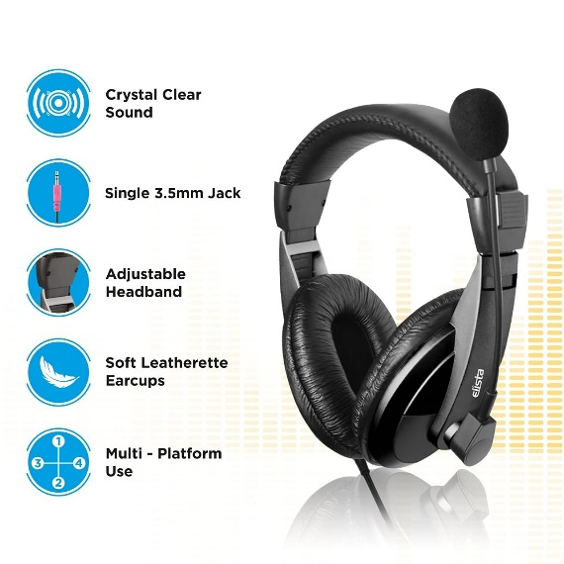

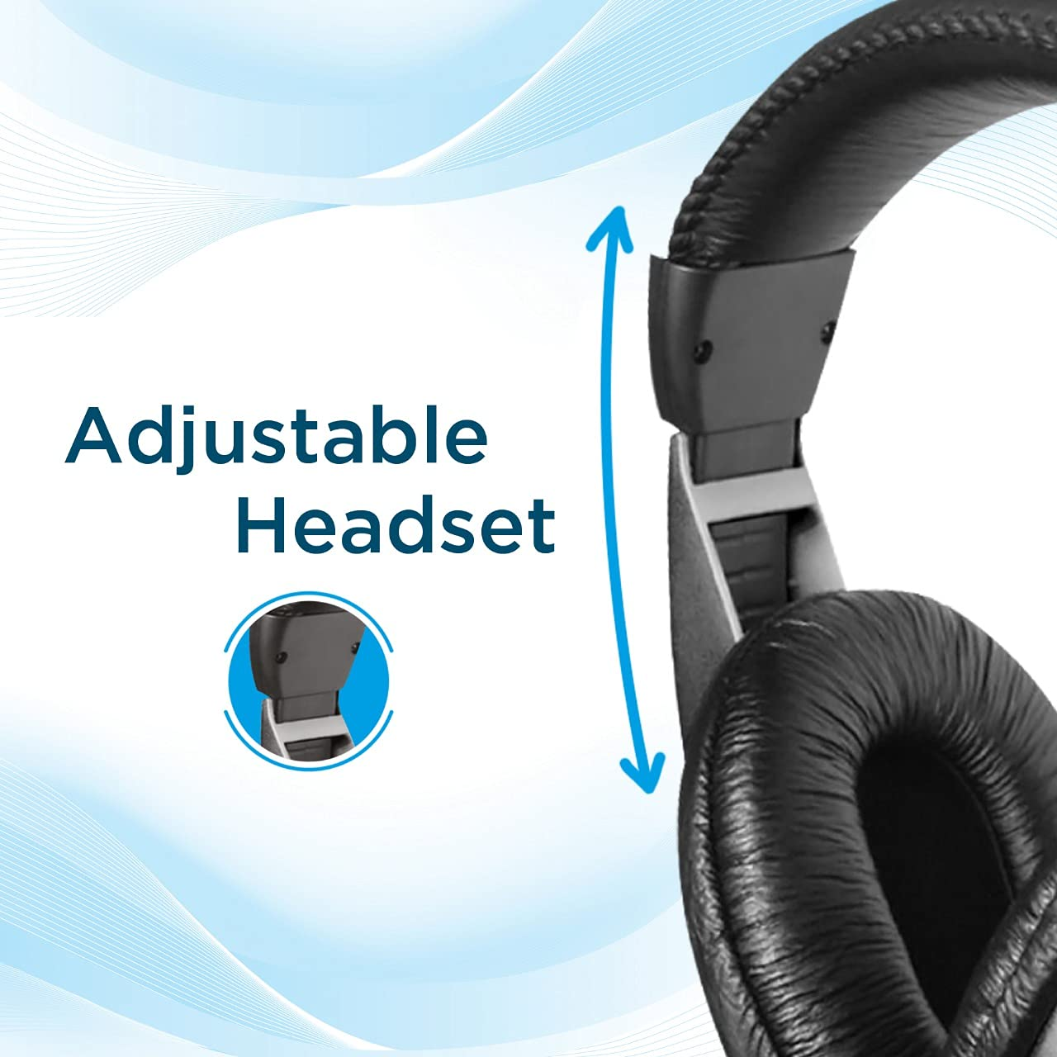

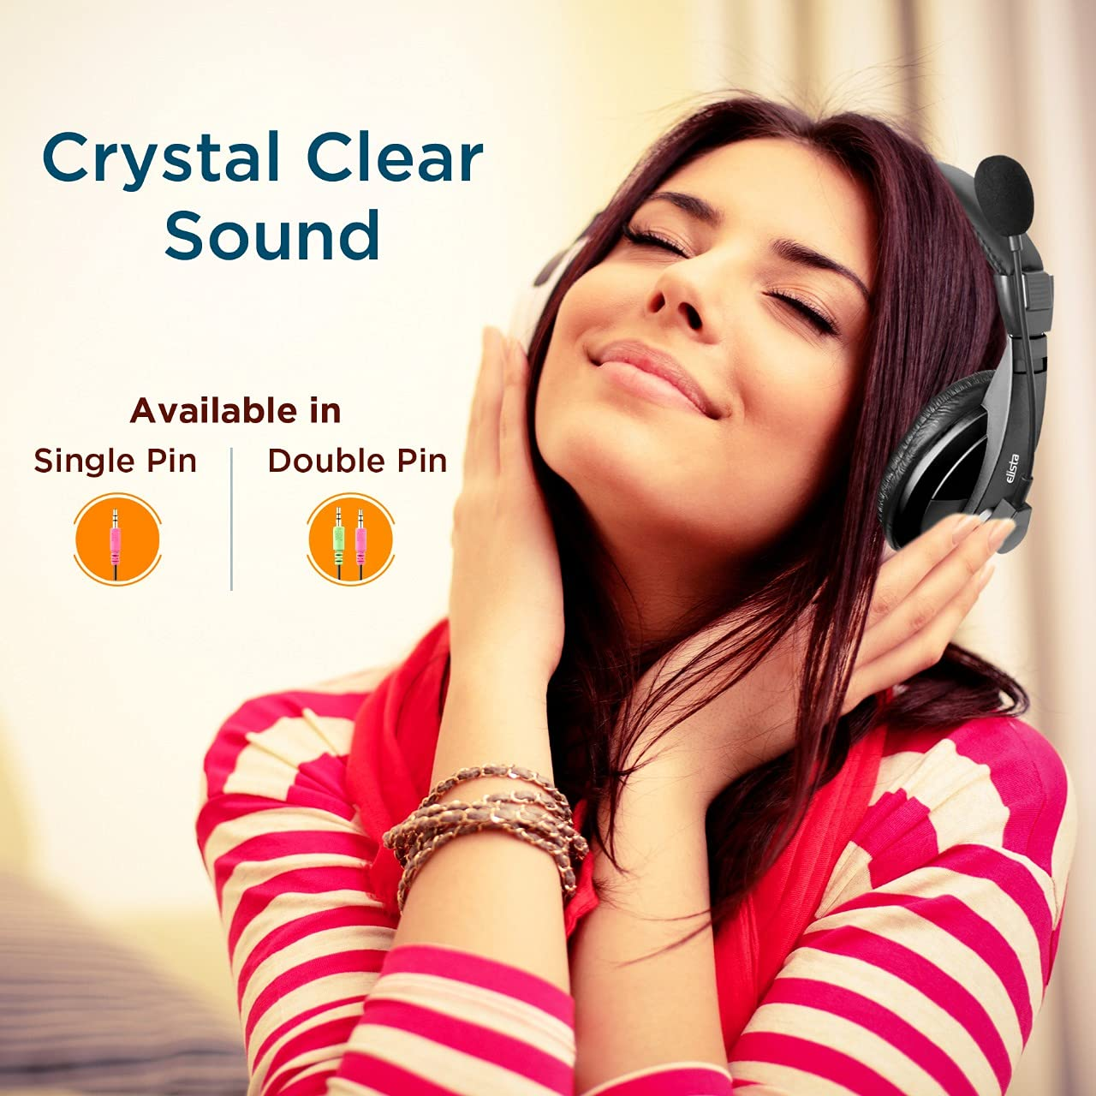

Elista Multimedia Headphone Crown EW100CM with Mic, Adjustable Headband for PC/Laptop/Mobile (Single Pin Connector), Black

-37% ₹475.00₹475.00

M.R.P.: ₹750.00₹750.00

|  |  |
| --- | --- |
| **Brand** | Elista |
| **Model Name** | Crown |
| **Colour** | Black |
| **Form Factor** | Over Ear |
| **Connector Type** | 3.5 mm Simgle Connector | Suports Mobile/Tablets/Ipad/PC&Laptop with single Mic and Audio out port | |

**About this item**

* Single Pin Connector - Suitable for use in Mobile/Ipad/Tablets and PC/ Laptop having single Mic and Audio Out option
* Side Mic
* Adjustable Headband
* Soft Leatherette Earcups
* Multi-Platform Use- Can be used in Mobile/Ipad/Tablets/PC/Laptop
* Crystal Clear Sound