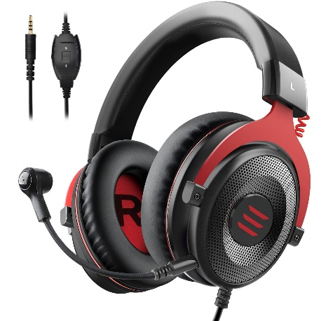

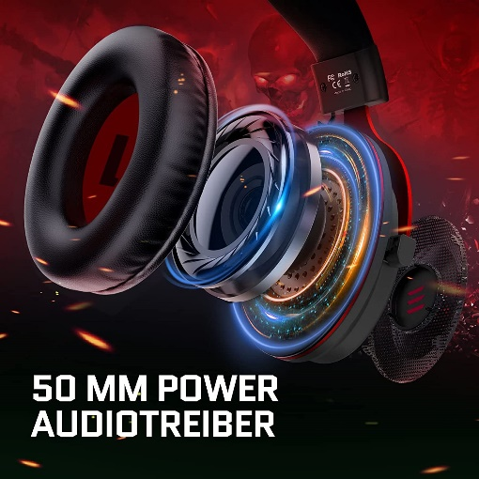

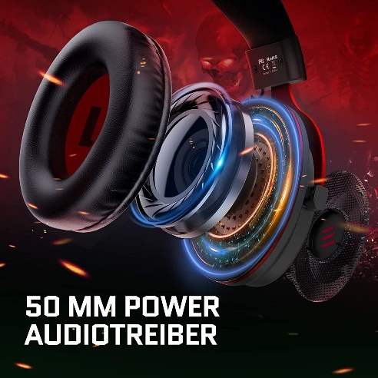

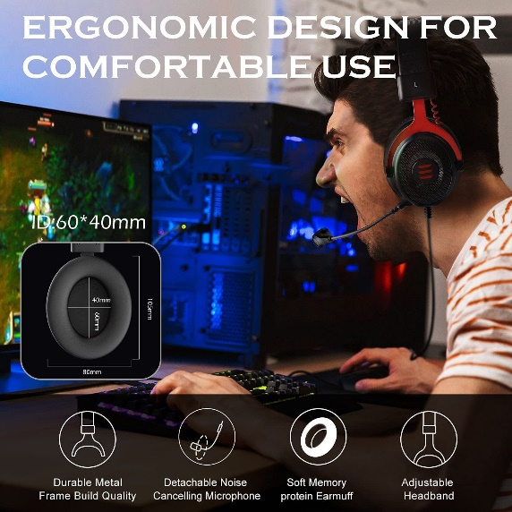

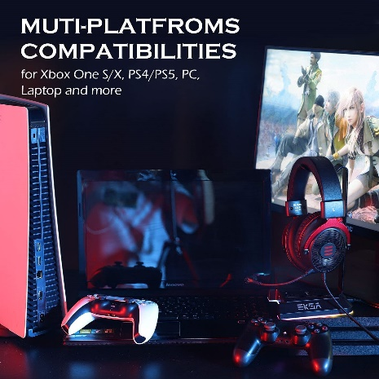

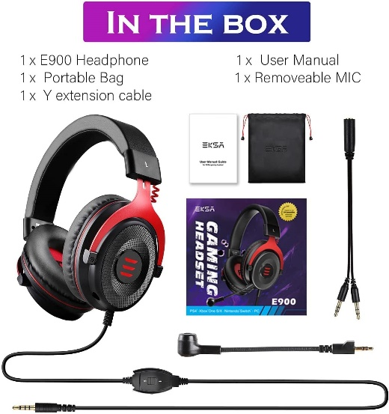

EKSA E900 Wired Stereo Gaming Headset-Over Ear Headphones with Noise Canceling Mic, Detachable Headset Compatible with PS4, PS5, PC, Laptop (Red)

|  |  |
| --- | --- |
| M.R.P.: | ₹2,999.00 |
| Deal of the Day: | ₹1,599.00   |  |  | | --- | --- | | **Brand** | EKSA | | **Model Name** | E900 Red | | **Colour** | Red | | **Form Factor** | Over Ear | | **Connector Type** | Wired |   **About this item**   * DETACHABLE NOISE-CANCELLING MICROPHONE: High sensitive microphone with omnidirectional noise reduction tech, reduces distracting background noise, to collect your voice clearly. Easy to use volume adjustment and one key mic mute switch, easy for your game operation. And noise-canceling microphone guarantee loud & high-quality voice talks in-game or online chat. [Note: The microphone without a sponge cover is an upgraded version, it will not affect the use, it is still genuine] * HIGH-QUALITY 50MM SPEAKERS: To bring you an immersive gaming experience in PUBG, Overwatch, Battlefield 1, Call of Duty, Destiny 2, Red Dead Redemption II, and other games, the E900 gaming headset has 50 mm over-ear speakers that produce clear treble and shocking bass. Also, the E900 gaming headset can accurately identify the location of various sounds, whether it is a weak footstep or an enemy gunshot. * HUMANIZED & COMFORTABLE DESIGN: The E900 gaming headset has a sturdy construction, an adjustable metal headband, flexible microphone, thick memory foam cushion pads, big & soft earmuffs, accord with human body engineering for a longer period of wearing. Allows you to find the perfect fit without constraint and provide excellent durability, suits all gamers at any age no matter what size your head is. * CONVENIENCE & LIGHTWEIGHT: The one key mute on-off and volume adjustment switch is located on the cable of the headset, giving you easy access to microphone mute and adjust the volume. At the same time, this gaming headset is lightweight, no matter if you go out to work or travel, it is very convenient to carry. * MULTI-PLATFORM COMPATIBILITY: E900 gaming headset with a 3.5mm audio jack is compatible with PlayStation 4, PlayStation 5, Xbox One Controller, PC, Nintendo Switch, Laptop, PSP, Tablet, iMac, Computer, Mobile Phone. Please note that you need an extra adapter (Not Included) when connecting with an old version Xbox One controller. this headset is great for gaming, working, studying, Chatting and Skype using, etc. |