Wireless Bluetooth Multi-Device Keyboard for Windows, Apple iOS Android or Chrome, Compact Space-Saving Design, for PC/Mac/Laptop/Smartphone/Tablet (Black)

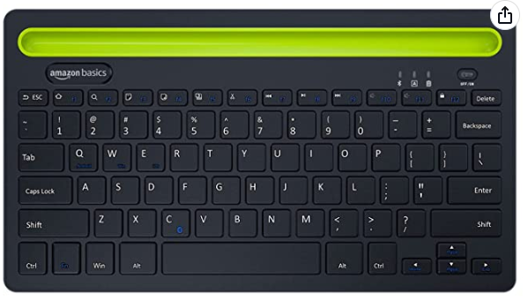

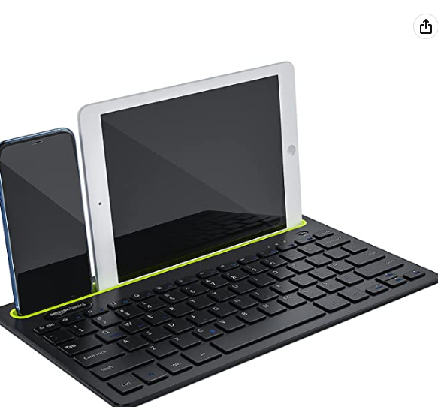

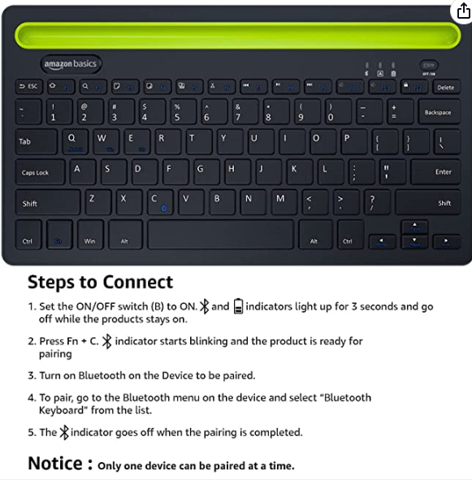

|  |  |
| --- | --- |
| M.R.P.: | ₹3,690₹3,690 |
| Deal of the Day: | ₹1,199₹1,199 |
| You Save: | ₹2,491₹2,491 (68%) |
|  | Inclusive of all taxes |

### Product details

|  |  |
| --- | --- |
| Brand | AmazonBasics |
| Compatible Devices | Laptop, Tablet, Smartphone |
| Connectivity Technology | Bluetooth |
| Keyboard Description | Wireless |
| Special Feature | Bluetooth |
| Colour | Black |

* Wireless Multi-Device Keyboard with enhanced efficiency
* Extremely durable and spill-resistant surviving any minor accidents
* Versatile feature that allows you to connect with any Bluetooth-enabled device with external keyboard support
* Integrated cradle to hold your phone while you type
* Easy-Switch Dial for absolute convenience
* Compatible with most PCs, smartphones, iPhones, Tablets, etc.