Lenovo 510 Wireless Keyboard and Mouse Combo, 2.4 GHz Nano USB Receiver, Full Size, Island Key Design, Left or Right Hand, 1200 DPI Optical Mouse, GX30N81775, Black

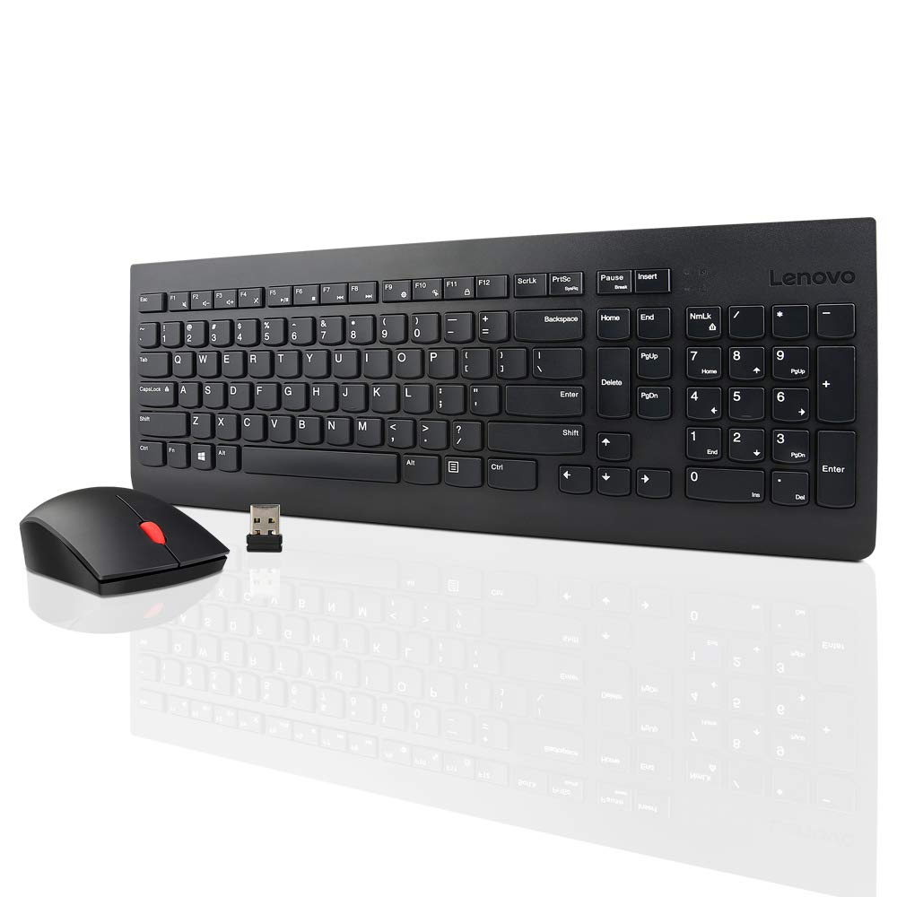

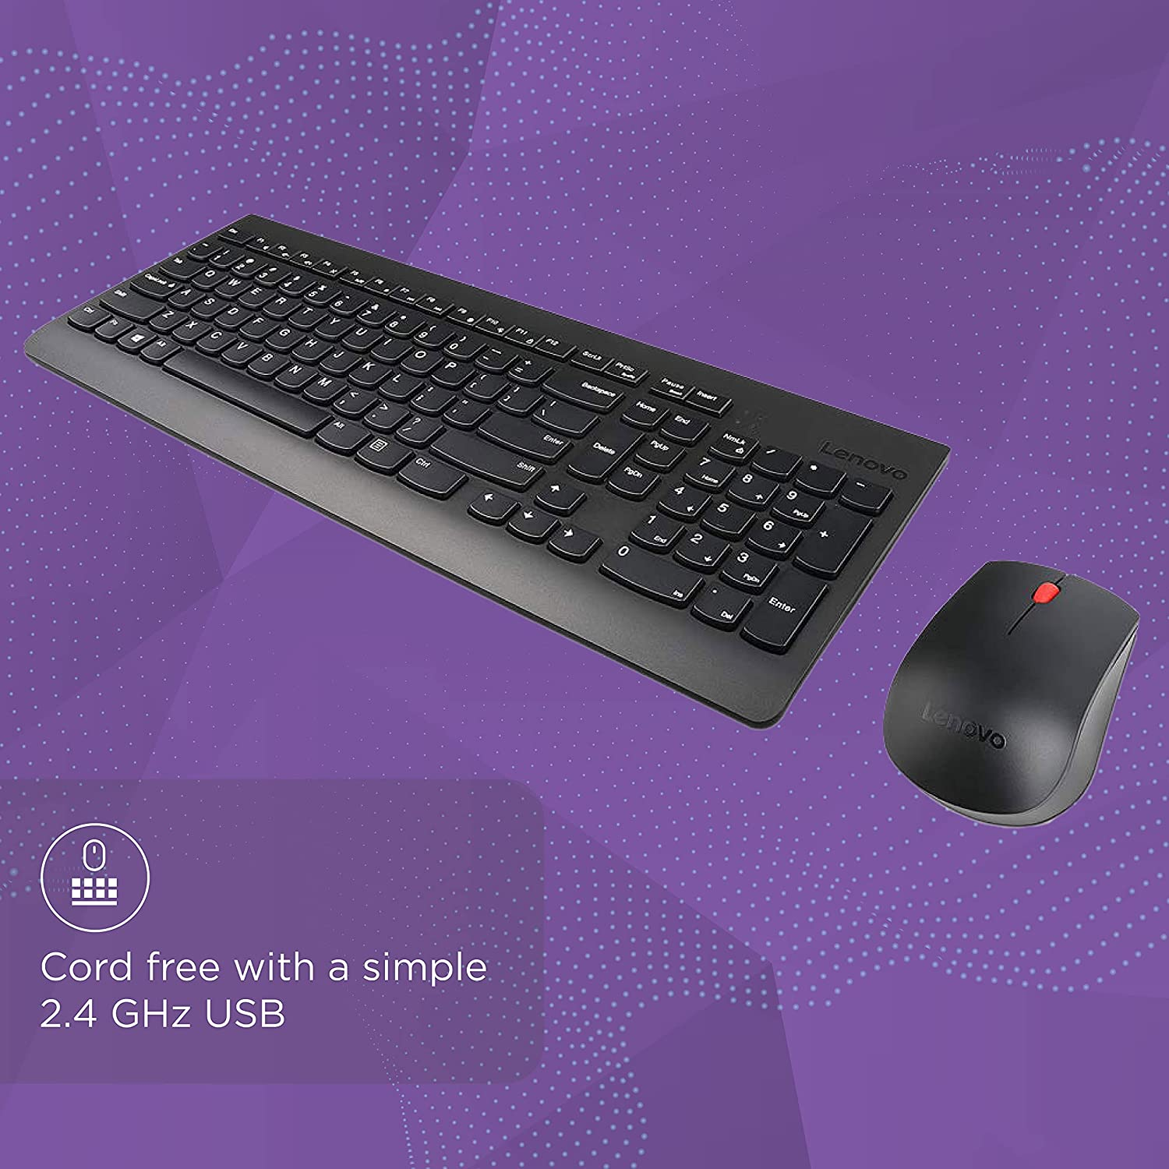

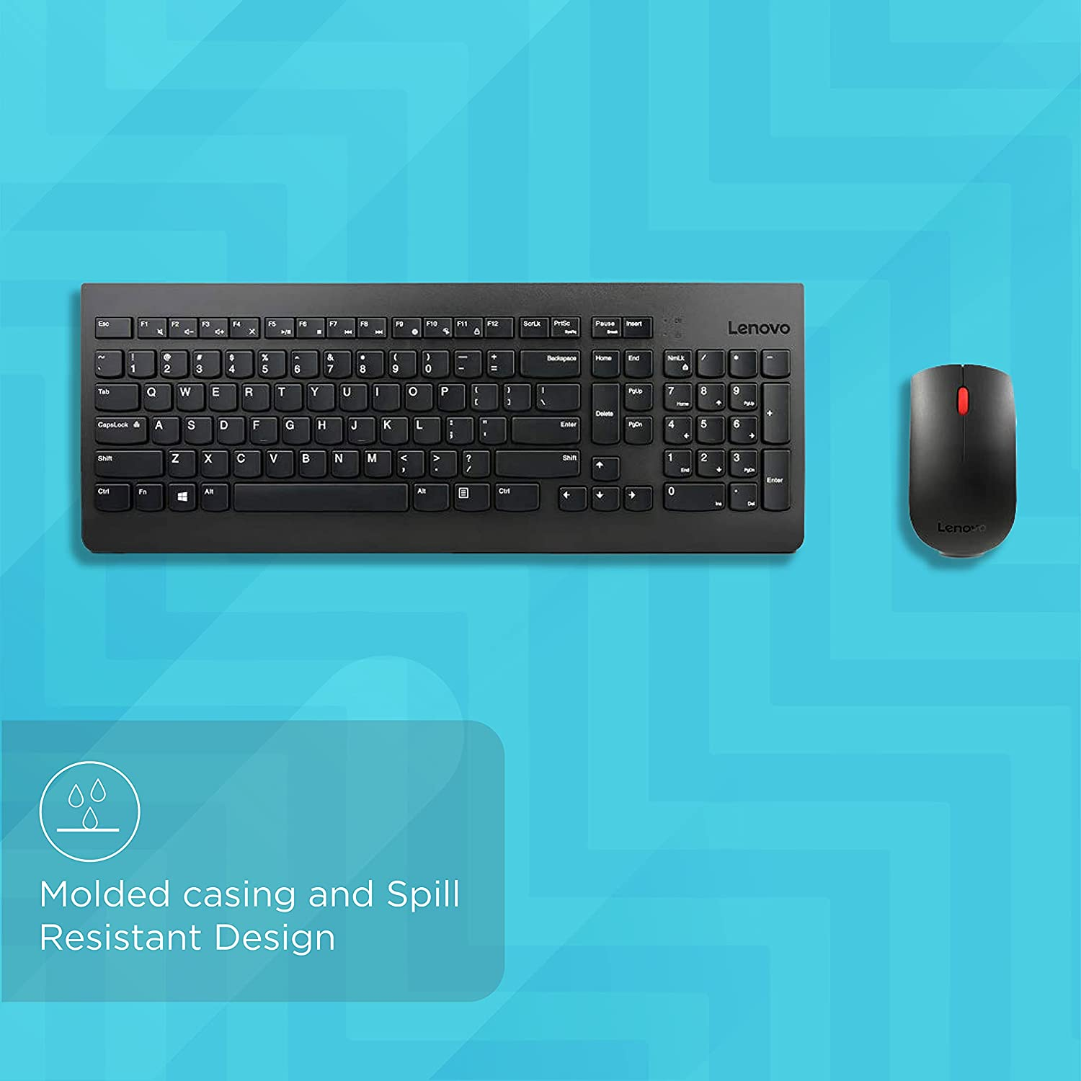

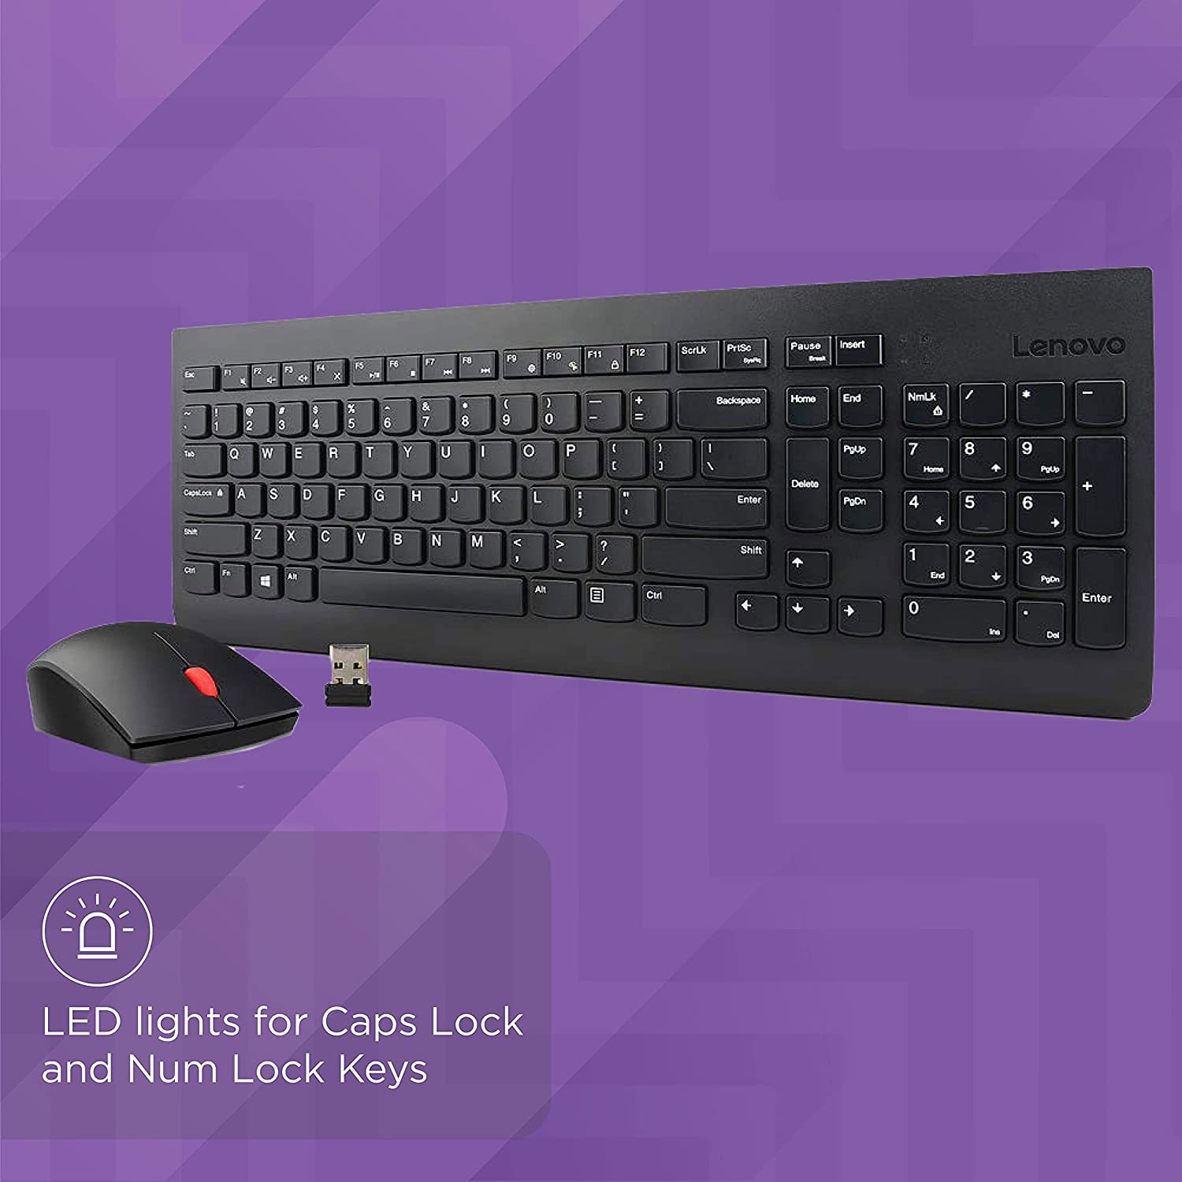

-25% ₹2,800.00

M.R.P.: ₹3,750.00

|  |  |
| --- | --- |
| Brand | Lenovo |
| Colour | Black |
| Connector Type | Wireless,Usb |
| Special Feature | Wireless |
| Keyboard Description | Multimedia |

# About this item

* Complete control of both your wireless keyboard & mouse combo with a simple 2.4 GHz dongle. Spill resistant keyboard
* With a liquid-resistant, molded casing, your keyboard won’t mind sharing a cup of your morning joe
* With LED indicators on the Caps Lock and Num Lock keys, easily avoid password typos
* Country of Origin: China
* Complete control of both your wireless keyboard & mouse combo with a simple 2.4 GHz dongle. Spill resistant keyboard
* With LED indicators on the Caps Lock and Num Lock keys, easily avoid password typos
* With a liquid-resistant, molded casing, your keyboard wonâ€t mind sharing a cup of your morning joe
* Country of Origin: China