Dell KB216 Wired Multimedia USB Keyboard with Super Quite Plunger Keys with Spill-Resistant – Black

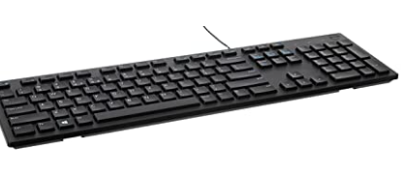 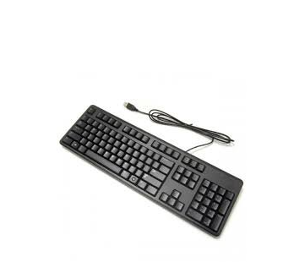

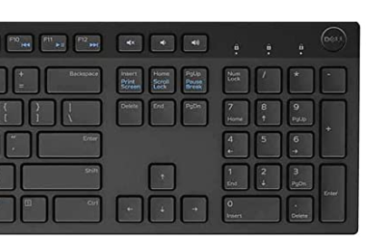

-61% ₹699

M.R.P.: ₹1,799₹1,799

### Product details

|  |  |
| --- | --- |
| Brand | Dell |
| Compatible Devices | PC |
| Connector Type | Wired |
| Keyboard Description | QWERTY |
| Special Feature | Multimedia |
| Colour | Black |

* DEVICE TYPE: Keyboard
* CONNECTIVITY TECHNOLOGY: Wired
* INTERFACE: USB
* HOT KEYS FUNCTION: Volume, Mute, Play/Pause, Backward, Forward
* KEYS STYLE: Chiclet