Corsair K60 RGB PRO SE Aluminum Frame Mechanical USB 3.0 or 3.1 Type-A Gaming Keyboard with Cherry Mechanical Keyswitches - Black

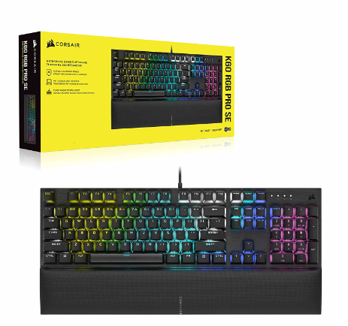

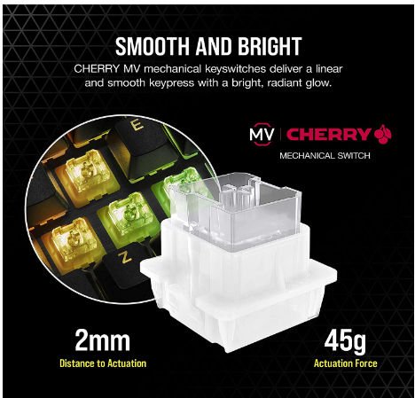

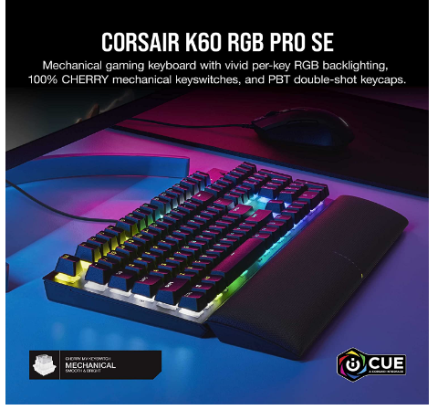

|  |  |
| --- | --- |
| M.R.P.: | ₹14,000 |
| Deal of the Day: | ₹7,999  Ends in 2 days |
| You Save: | ₹6,001 (43%) |

starts at ₹382. No Cost EMI available [EMI options](javascript:void(0))

### Product details

|  |  |
| --- | --- |
| Brand | Corsair |
| Compatible Devices | PC |
| Connector Type | USB 3.0 or 3.1 Type-A |
| Keyboard Description | Gaming |
| Special Feature | Backlit |
| Colour | Black |

* A sturdy brushed aluminum frame with black anodization delivers a stylish, modern look and years of battle-tested durability.
* 100% German-made CHERRY VIOLA mechanical keyswitches offer smooth linear travel with fast and precise inputs.
* Precision-molded PBT double-shot keycaps with a standard bottom row layout resist wear, fading, and shine, with 1.5mm thickness for rigid stability.
* Illuminate your desktop with dynamic, per-key RGB backlighting fully customizable with near-limitless colors and effects, enhanced by keyswitches that create an ultra-bright underglow.
* A magnetic, detachable soft-textured leatherette palm rest easily slides into place, cushioned by memory foam for theplush comfort to breeze through hours of gaming.
* Powerful CORSAIR iCUE software enables dynamic RGB lighting control, key remaps and custom macro programming, and full-system lighting synchronization across all iCUE-compatible CORSAIR devices.
* Experience an unparalleled level of immersion when playing iCUE-integrated games, as your RGB lighting dynamically reacts to in-game actions and events in real-time.
* Full N-key rollover (NKRO) with 100% anti-ghosting ensures that every keypress registers, no matter how fast you play.
* Activate Windows Key Lock mode to guarantee that you’ll never accidentally interrupt your game at critical moments.
* Convenient keyboard shortcuts let you control media playback, volume, and onboard lighting on-the-fly.