CORSAIR K60 PRO TKL RGB Tenkeyless Optical-Mechanical Gaming Keyboard - OPX Switches - Brushed Aluminum Frame - Detachable USB Type-C Cable - Per-Key RGB

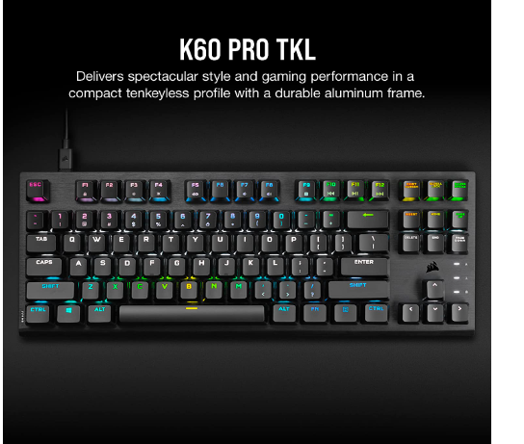

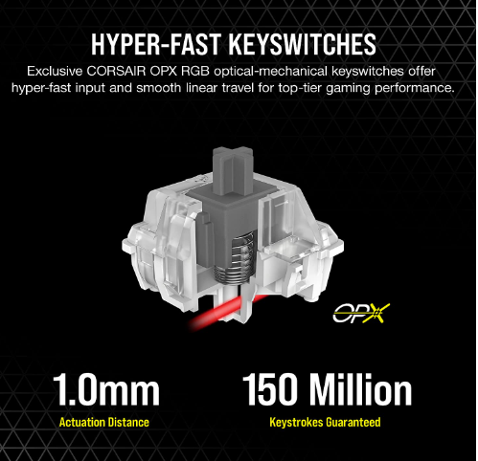

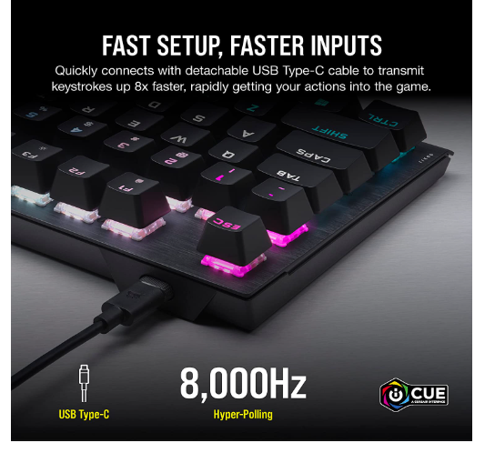

₹19,999.00

Inclusive of all taxes

|  |
| --- |
|  |

**EMI** starts at ₹955. No Cost EMI available [EMI options](javascript:void(0))

### Product details

|  |  |
| --- | --- |
| Brand | Corsair |
| Connector Type | USB-C |
| Keyboard Description | Gaming |
| Special Feature | Backlit |
| Colour | Black |
| Number of Keys | 87 |

* Exclusive CORSAIR OPX RGB Optical-Mechanical Keyswitches: Hyper-fast input with 1.0mm actuation distance and smooth linear travel, guaranteed for 150 million keystrokes.
* Compact Tenkeyless Size: Space-saving form-factor omits the numpad to deliver a compact tenkeyless size that saves desktop space and is easy to position for comfortable gaming.
* Durable Brushed Aluminum Frame: Brushed aluminum frame with black anodization delivers compact styling, combined with lightweight and rugged durability built to withstand a lifetime of gaming.
* Detachable USB Type-C Cable: Detachable USB Type-C cable enables you to quickly set up the keyboard with easy cable management, and can be quickly unplugged and taken on the go for simplified portability.
* Game Integrated Lighting Effects: Turn your keyboard into an extension of the game with iCUE game integrations, as your RGB lighting dynamically reacts to in-game events and takes the action beyond your screen.