E-Yooso USB 81 Keys True RGB Backlit 60% Mechanical Gaming Keyboard for PC Laptop, Gold (Red Switch)

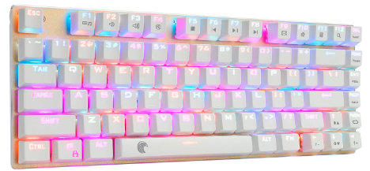

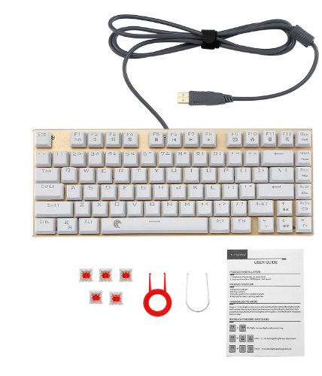

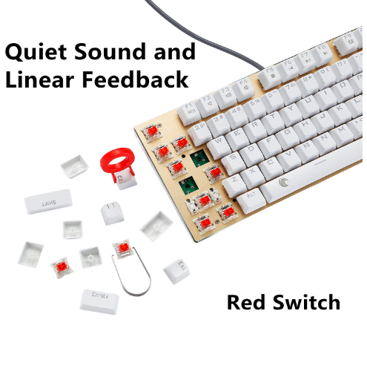

-48% ₹4,399

M.R.P.: ₹8,399

### Product details

|  |  |
| --- | --- |
| Brand | E-Yooso |
| Compatible Devices | Laptop |
| Connector Type | USB |
| Keyboard Description | Gaming |
| Special Feature | Lighting |
| Colour | Red Switch |

* [ Outemu DIY Red Switches ] This keyboard owns quiet click sound, and linear feedback. You can replace mechanical switches with brown, blue, silver switches, designed for responsiveness, and durability. It will bring you mechanical sense and excitement and offer a life span of over 50 million keystrokes.
* [ 21 RGB Backlight Modes Computer Keyboard ] You can play 14 RGB backlit modes with Fn+PgDn and 7 solid light modes by Fn+-/=. Double-shot injection molded key caps provide you with the colorful light effect.
* [ 81 Keys Anti-ghosting Gaming Keyboard ] Each key is controlled by independent switch, reducing the input error of key pressing and making you enjoy wonderful gaming experience.
* [ Tenkeyless Compact Design Keyboard ] Only 81 keys own convenient Multi-media Function Keys with Fn+F1~F12, Windows Key lock, email and calculator. Easy to carry, an ideal input partner for typing, office, entertainment, gaming.