Corsair K70 RGB MK.2 LED Backlit Wired Mechanical Gaming Keyboard (Cherry MX Blue, Black)

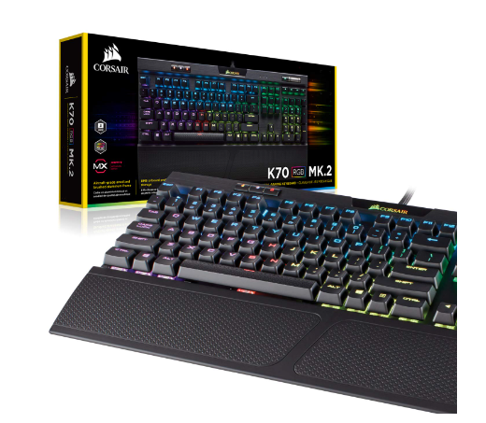

|  |  |
| --- | --- |
|  |  |
|  |  |
|  |  |
|  |  |

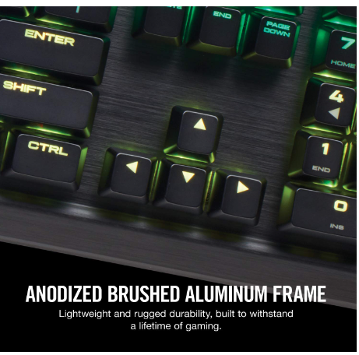

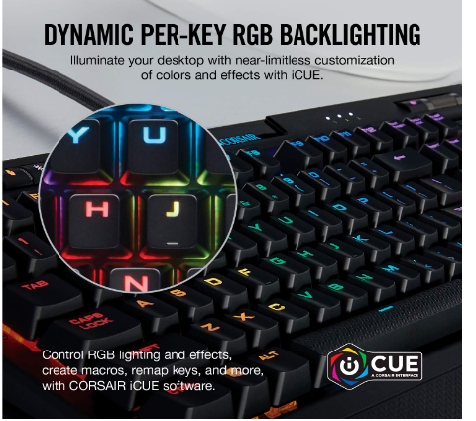

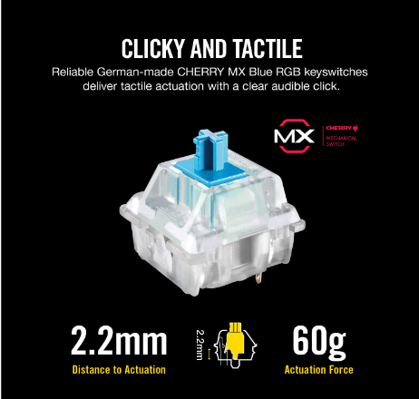

|  |  |
| --- | --- |
| M.R.P.: | ₹19,000 |
| Deal Price: | ₹13,499 |
| You Save: | ₹5,501 (29%) |
|  | Inclusive of all taxes |

### Product details

|  |  |
| --- | --- |
| Brand | Corsair |
| Compatible Devices | PC |
| Connectivity Technology | Wired |
| Keyboard Description | Gaming |
| Special Feature | Backlit, Mechanical |
| Colour | Cherry Mx Blue |

* Aircraft-grade anodized brushed aluminium frame, built to withstand a lifetime of gaming
* 8mb profile storage with hardware macro and lighting playback allow access to up to three stored profiles on the go, independent of external software
* Per-key dynamic multi-colour rgb backlighting offers near unlimited colour customization and control
* 100 percent cherry mx mechanical key switches provide the reliability and accuracy you demand
* Usb pass-through port provides convenient access to an additional usb port for your mouse or headset