Redragon K596 Vishnu 2.4G Wireless/Wired RGB Mechanical Gaming Keyboard, 87 Keys TKL Compact Keyboard with 3000 mAh Battery, 10 Onboard Macro Keys & Wrist Rest, 10H Play Time, Red Switches

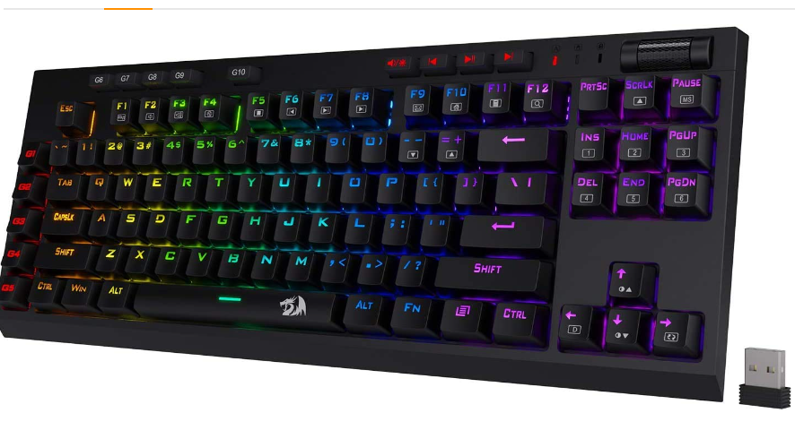

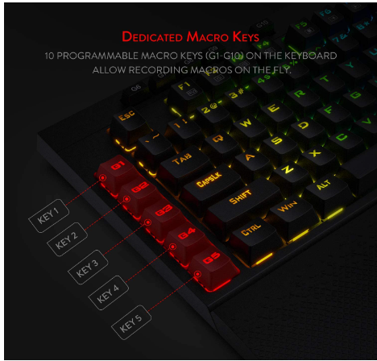

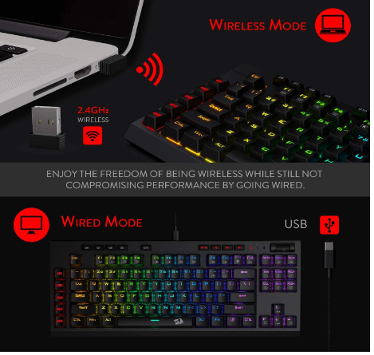

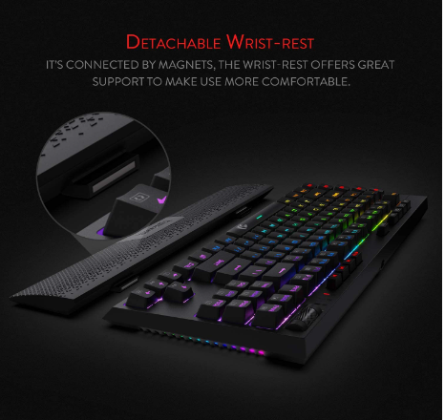

|  |  |
| --- | --- |
| M.R.P.: | ₹6,999 |
| Deal Price: | ₹5,599 |
| You Save: | ₹1,400 (20%) |
|  | Inclusive of all taxes |

### Product details

|  |  |
| --- | --- |
| Brand | Redragon |
| Connector Type | Bluetooth |
| Keyboard Description | Gaming |
| Colour | Black |
| Number of Keys | 92 |
| Item Dimensions LxWxH | 43.2 x 17.8 x 5.1 Centimeters |

* Wireless and Wired Mode - Featuring dual wired and wireless modes. Easy wireless setup with an included dongle that allows for low latency connection without interference up to 10 meters. Switch to a wired connection with a type-c cable. Enjoy the freedom of being wireless while still not compromising performance by going wired.
* Abundant Battery - Enjoy the wirelessness longer with the upgraded 3000mAh battery. Allows for usage up to 10 hours.
* Made for Gamer - 10 key-less design with added macro keys and dedicated media keys makes the keyboard ultra-compact and portable. Saves space in any setup and ideal for minimalistic desk setups. Included wrist-rest supports the wrist during long gaming marathons and clips to the keyboard with magnets.
* Linear Red Switches - Equipped with Redragon Red Linear switches. 40cN force allows for easy strokes and is light on the fingers. 2mm actuation point allows for fast responsiveness. Great for FPS and MOBAs.