Lenovo K200 KB-USWW GX30P93887 Keyboard (Black)

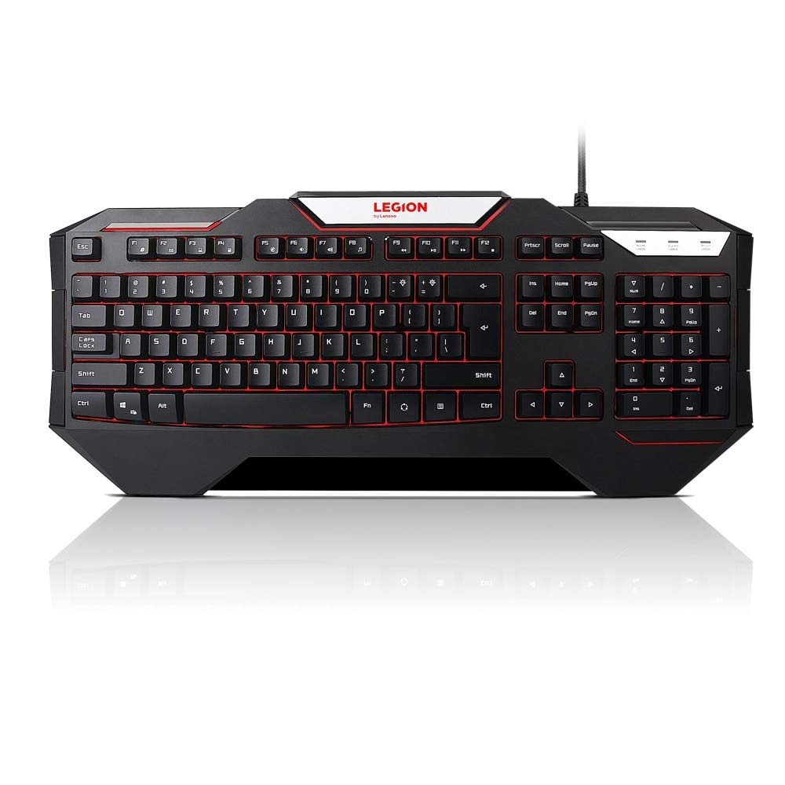

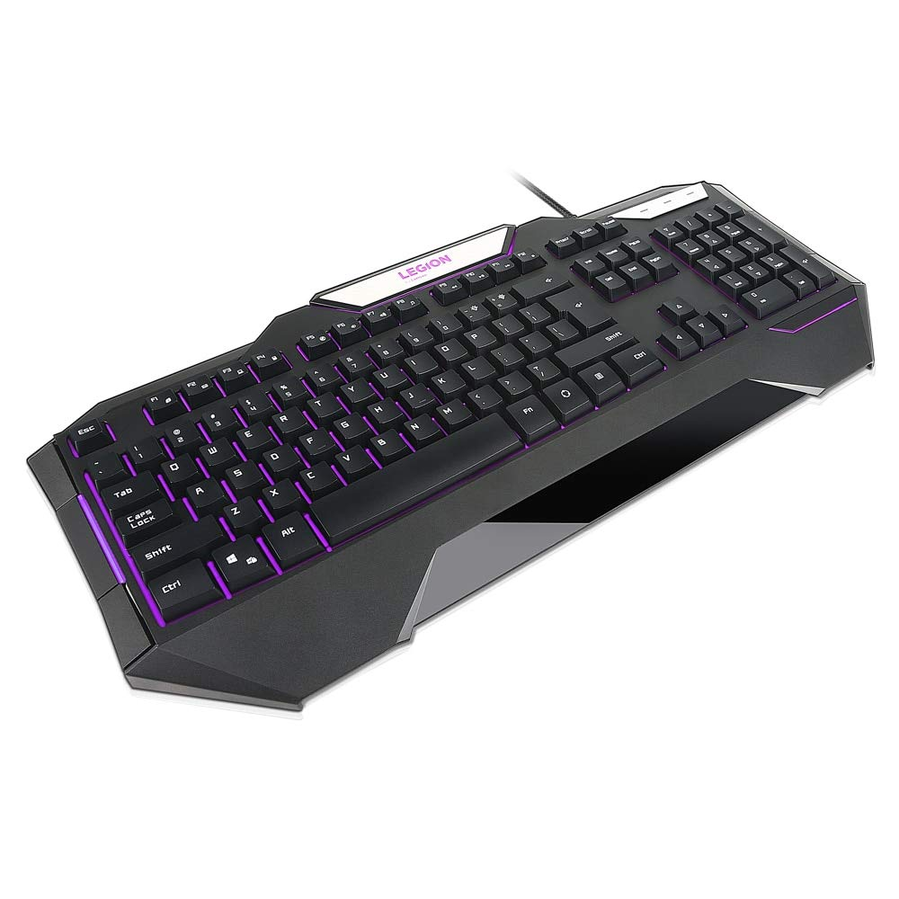

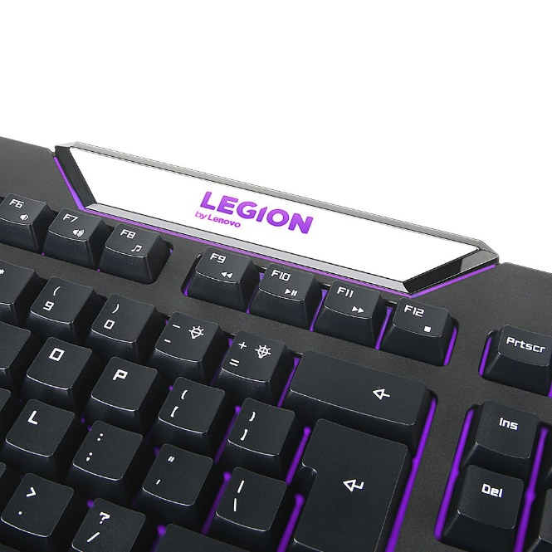

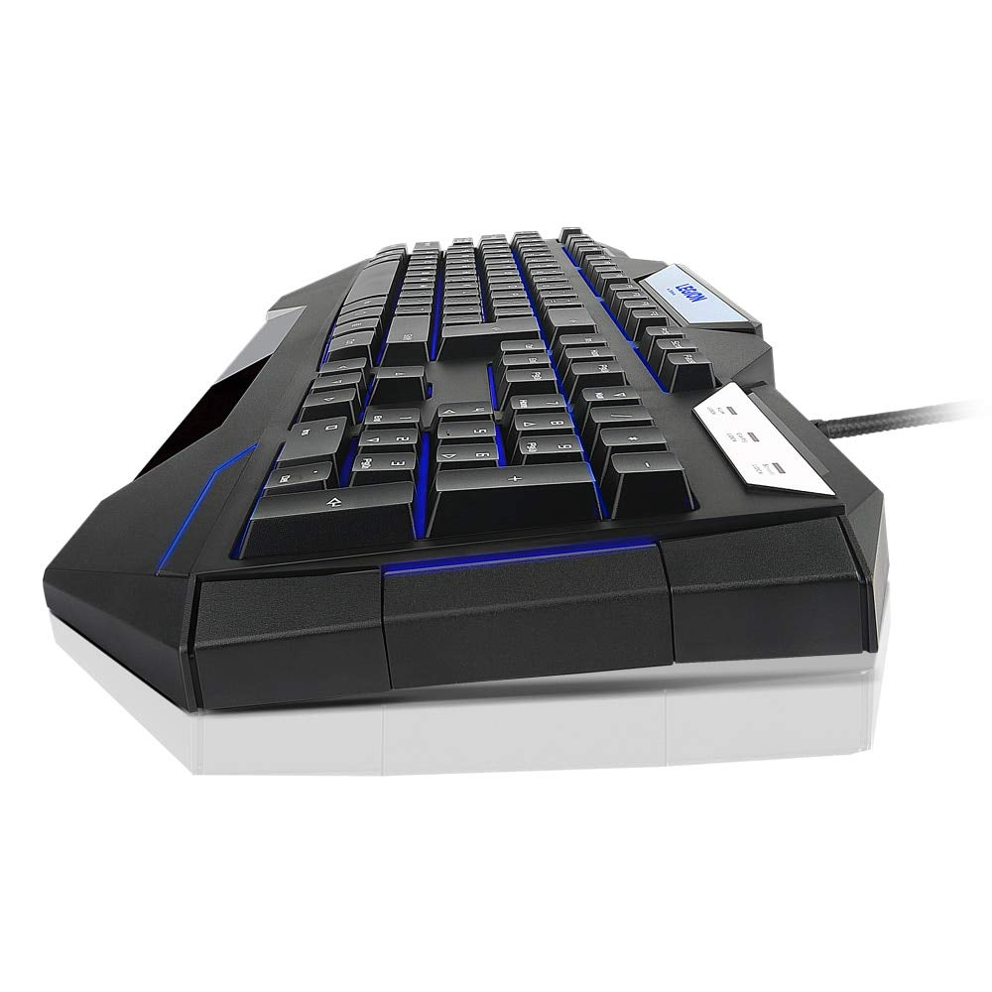

-8% ₹2,760.00

M.R.P.: ₹2,999.00

|  |  |
| --- | --- |
| Brand | Lenovo |
| Compatible Devices | PC |
| Keyboard Description | Gaming |
| Special Feature | Backlit |
| Colour | Black |

# About this item

* Play without breaking your bank - affordable gaming keyboard for beginner or casual PC gamers
* Level-up your game - enrich your game with three options of backlight and 12 anti-ghosting keys
* Intuitive and easy to set-up - enjoy a full gaming keyboard experience with intuitive functionality requiring no complicated specialized software
* Country of Origin: China

+