Lenovo ThinkPad Compact USB US English Keyboard with TrackPoint

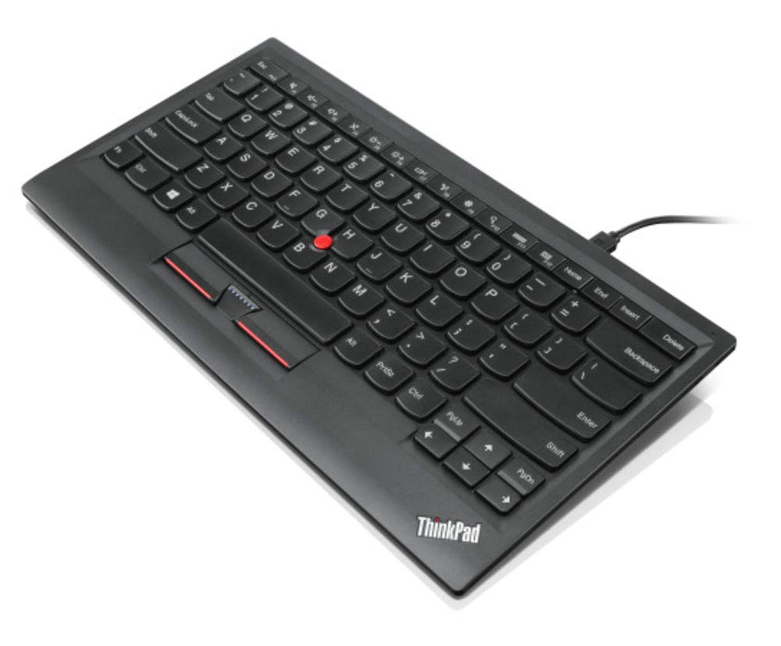

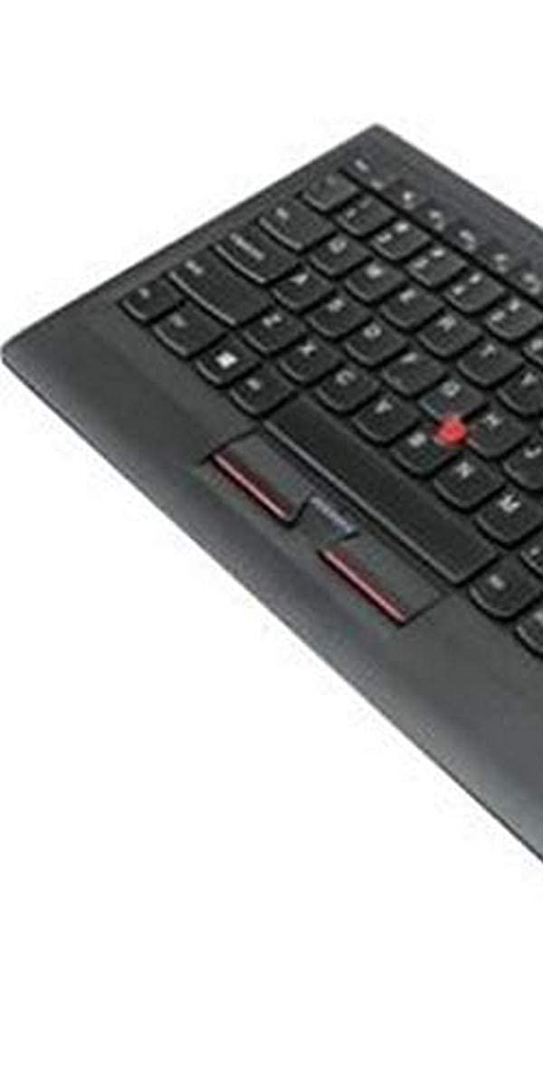

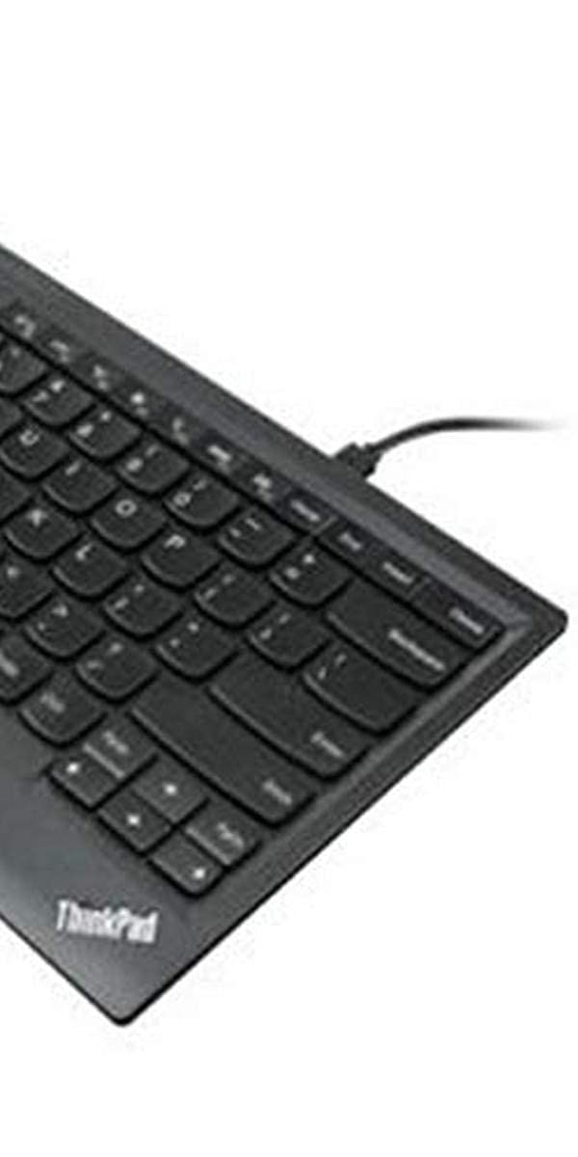

-55% ₹13,709.00

M.R.P.: ₹30,300.00

|  |  |
| --- | --- |
| Brand | Lenovo |
| Compatible Devices | Laptop |
| Connectivity Technology | USB |
| Number of Keys | 166 |
| Item Dimensions LxWxH | 30.6 x 16.4 x 1.4 Centimeters |

# About this item

* Device Type: Keyboard
* Connectivity Type: Cable
* island style keys design.To provide a seamless user experience, this new Island style keyboard is mirroring the same design, functions and technical specifications of the ThinkPad. The ThinkPad Compac