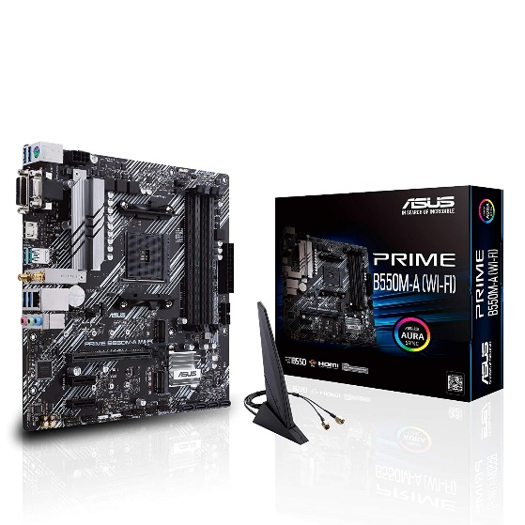

Inner

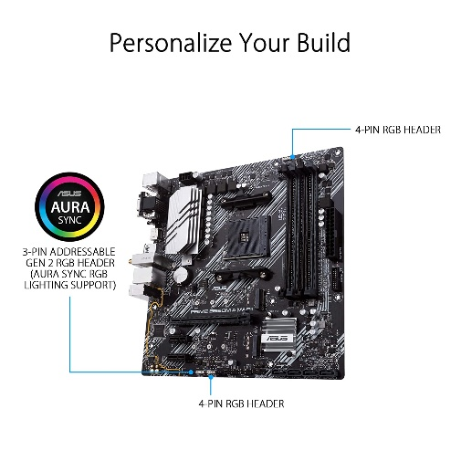

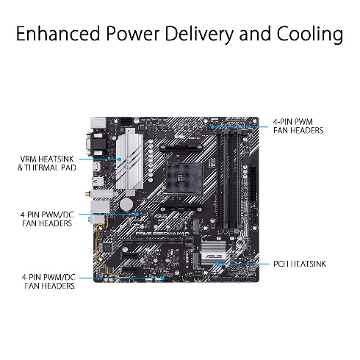

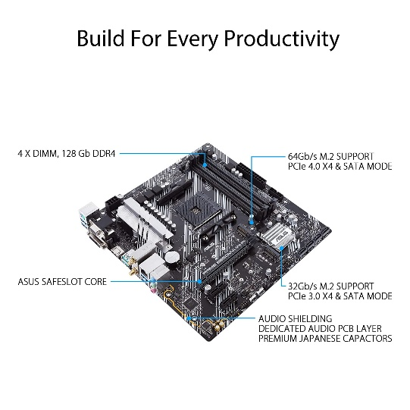

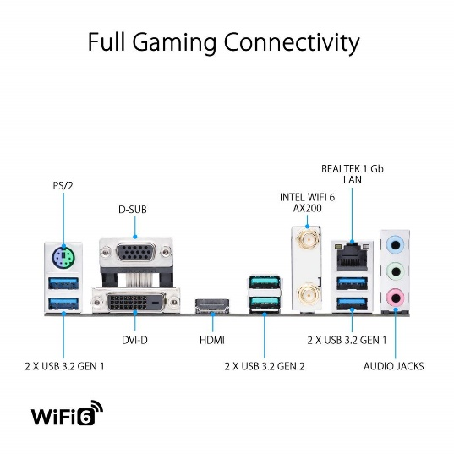

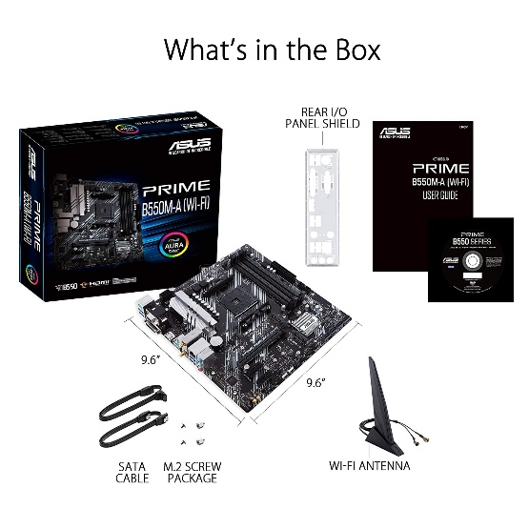

ASUS Prime B550M-A WiFi AMD AM4 (3rd Gen Ryzen Micro ATX Motherboard (PCIe 4.0, WiFi 6, ECC Memory, 1Gb LAN, HDMI 2.1/D-Sub, 4K@60HZ, Addressable Gen 2 RGB..

-17% ₹14,979₹14,979

M.R.P.: ₹17,990₹17,990

|  |  |
| --- | --- |
| Brand | ASUS |
| Compatible Devices | Personal Computer |
| Compatible Processors | AMD 3rd Generation Ryzen |
| Chipset Type | AMD B550 |
| Memory Clock Speed | 4400 MHz |