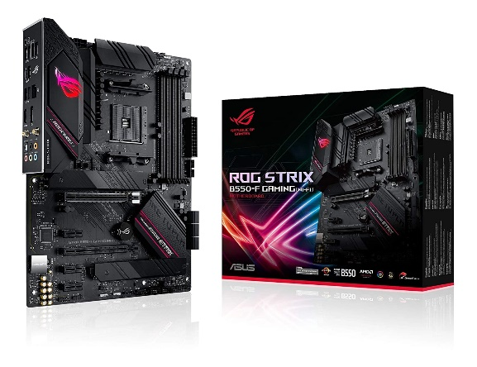

Inner

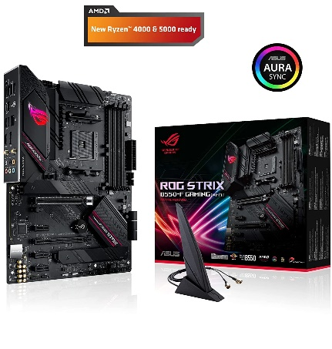

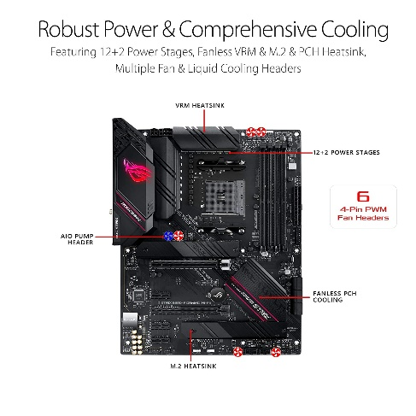

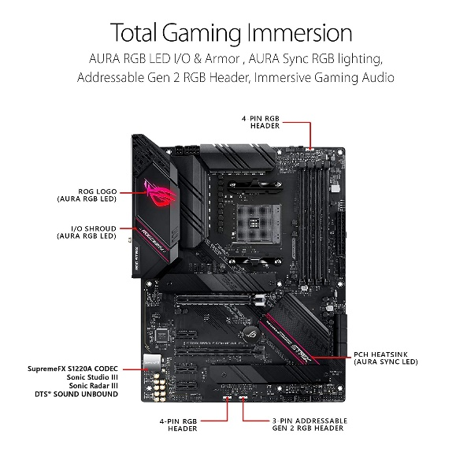

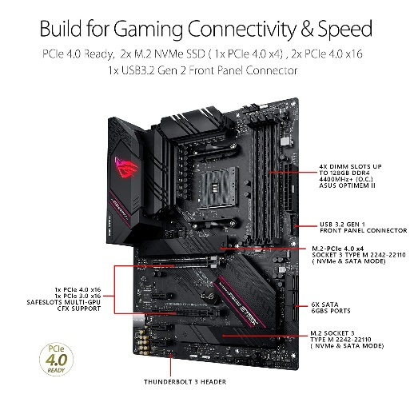

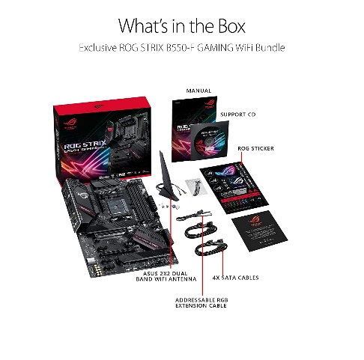

ASUS ROG Strix B550-F Gaming WiFi 6 (AMD AM4 Socket for 3rd Gen AMD Ryzen) ATX Gaming Motherboard with PCIe 4.0, teamed Power Stages, BIOS Flashback, Dual M...

-25% ₹23,999₹23,999

M.R.P.: ₹32,000₹32,000

|  |  |
| --- | --- |
| Brand | ASUS |
| CPU Socket | Socket AM4 |
| RAM Memory Technology | DDR4 |
| Compatible Processors | AMD 3rd Generation Ryzen |
| Chipset Type | AMD B550 |

**About this item**

* AMD AM4 Socket and PCIe 4. 0: The perfect pairing for 3rd Gen AMD Ryzen CPUs
* Robust Power Design: 12+2 DrMOS power stages with high-quality alloy chokes and durable capacitors to provide reliable power for the latest high-core-count AMD CPUs
* Optimized Thermal Solution: Fanless VRM and chipset heatsinks with ASUS Stack Cool 3+ design keep your system running reliably under heavy load by enhancing passive cooling capacity for critical onboard components. Supports channel bandwidth: HT20/HT40/HT80/HT160
* High-performance Gaming Networking: On-board WiFi 6 (802. 11ax), Bluetooth V5. 1 and 2. 5 Gb LAN with ASUS LANGuard
* Best Gaming Connectivity: Supports HDMI 2. 1 (4K@60HZ) and DisplayPort 1. 2 output, plus dual M. 2 slots (NVMe SSD)—one with PCIe 4. 0 x4 connectivity, USB 3. 2 Gen 2 Type-C port and Thunderbolt 3 header
* AMD AM4 Socket and PCIe 4. 0: The perfect pairing for 3rd Gen AMD Ryzen CPUs
* Robust Power Design: 12+2 DrMOS power stages with high-quality alloy chokes and durable capacitors to provide reliable power for the latest high-core-count AMD CPUs