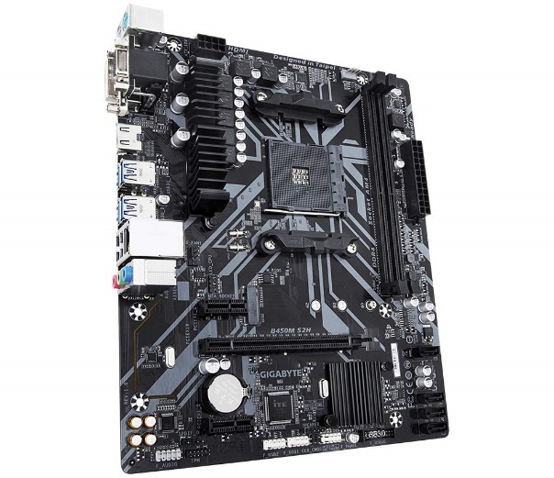

Inner

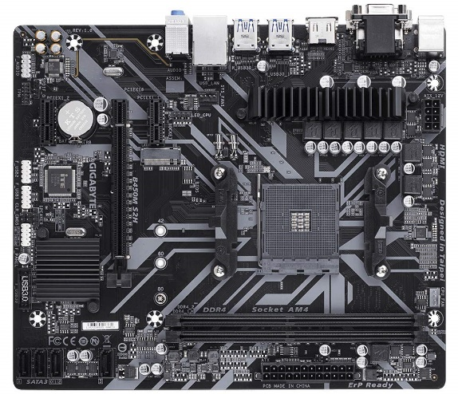

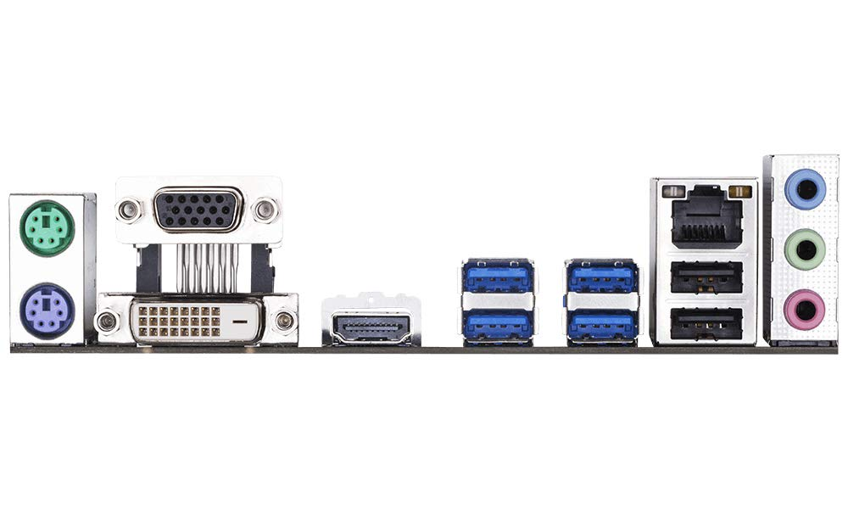

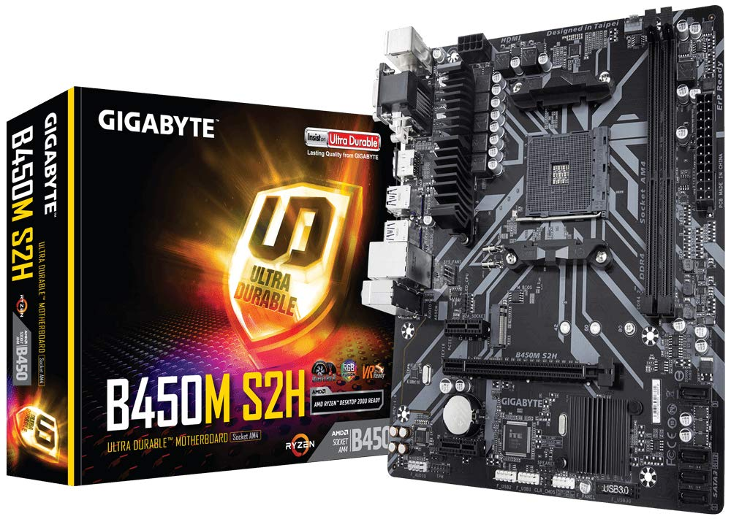

GIGABYTE AMD B450M S2H Ultra Durable Motherboard with Realtek GbE LAN with cFosSpeed, PCIe Gen3 x4 M.2,

-35% ₹6,499₹6,499

M.R.P.: ₹9,990₹9,990

|  |  |
| --- | --- |
| Brand | GIGABYTE |
| CPU Socket | Socket AM4 |
| Compatible Devices | Personal Computer, CPU |
| RAM Memory Technology | DDR4 |
| Compatible Processors | AMD 1st Gerenration Ryzen, AMD Athlon, AMD 2nd Gerenration Ryzen |

**About this item**

* Supports AMD Ryzen 2nd Generation/Ryzen with Radeon Vega Graphics/Athlon with Radeon Vega Graphics/Ryzen 1st Generation Processors
* Dual Channel Non-ECC Unbuffered DDR4, 2 DIMMs
* HDMI, DVI-D, D-sub Ports for Multiple Display
* Ultra-Fast PCIe Gen3 x4 M.2 with PCIe NVMe and SATA mode support
* GIGABYTE Exclusive 8118 Gaming LAN with Bandwidth Management