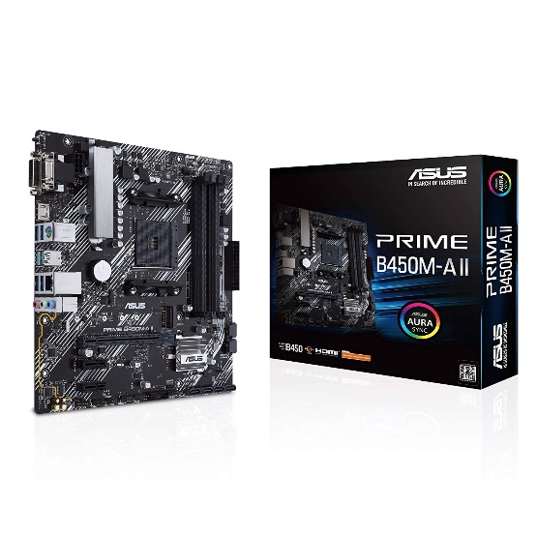

Inner

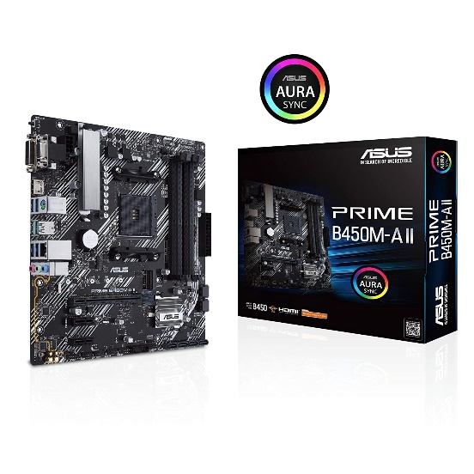

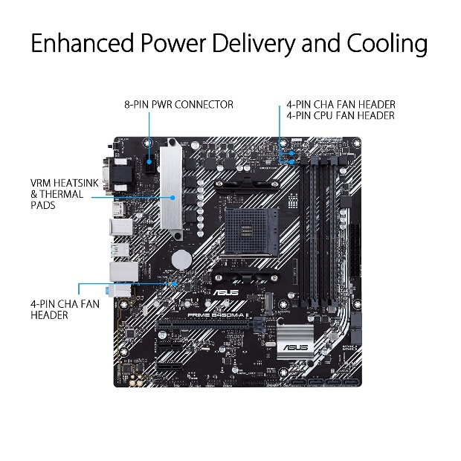

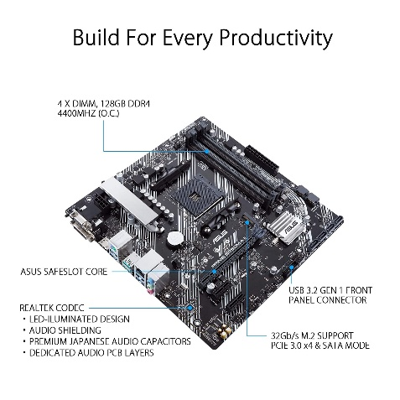

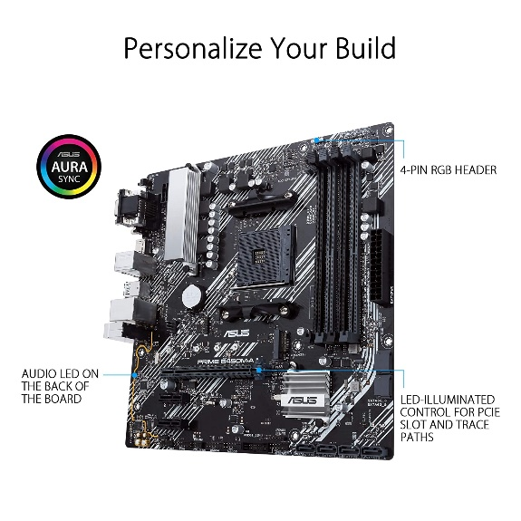

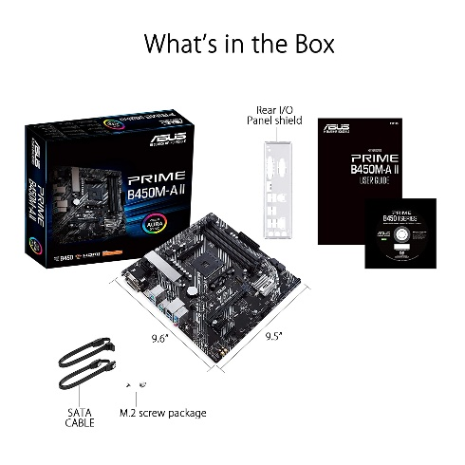

ASUS Prime B450M-A II (AMD AM4 Socket for Ryzen 5000/4000/G/ 3rd/2nd/1st Gen AMD Ryzen) DDR4 Micro ATX Motherboard with M.2 Support HDMI/DVI-D/D-Sub 1Gb...

-22% ₹8,595.00₹8,595.00

M.R.P.: ₹10,990.00₹10,990.00

|  |  |
| --- | --- |
| Brand | ASUS |
| CPU Socket | Socket AM4 |
| Compatible Devices | Personal Computer, Gaming Console |
| RAM Memory Technology | DDR4 |
| Compatible Processors | AMD 1st Gerenration Ryzen |

**About this item**

* AMD AM4 Socket : Compatible to Ryzen 5000, 3rd/2nd/1st Gen AMD Ryzen CPUs
* Designed for Productivity: USB 3.2 Gen 2 with 10Gbps ultra-fast transfer speed, onboard M.2 support, 4xDIMMs support up to 128GB DDR4 with 4400 (O.C.) performance, HDMI 2.0b/DVI/D-Sub
* Optimized Cooling: VRM & PCH heatsink with extensive surface, thermal pads help transfer heat from the inductor and phase array to the heatsink. Flexible fan controls for ultimate cooling and quietness with ASUS exclusive Fan Xpert 2+
* Built to Last: all-round protection with LANGuard, DRAM overcurrent protection, overvoltage protection, SafeSlot Core safeguards and stainless-steel back I/O, 1000+ compatible devices, 8000+ Validation Hours
* PC DIY Friendly: With BIOS Flashback and ASUS exclusive UEFI BIOS