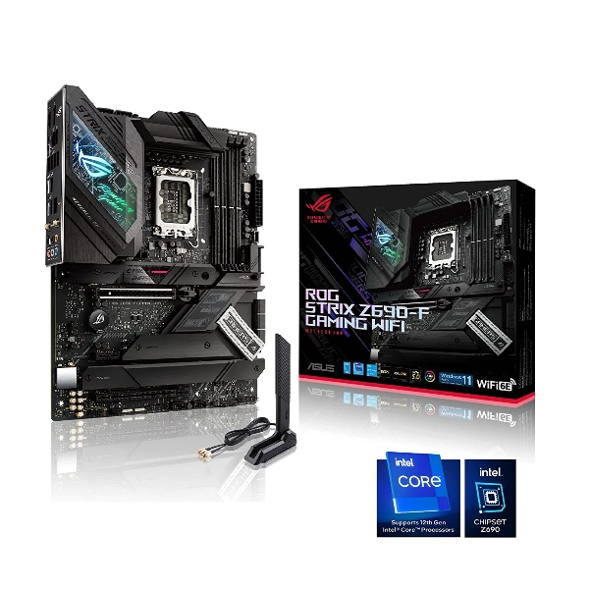

Inner

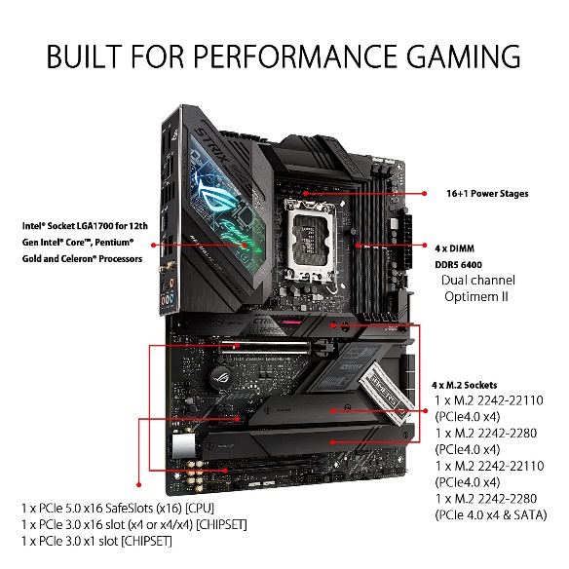

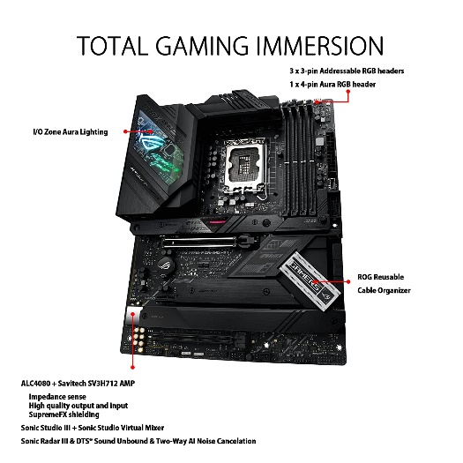

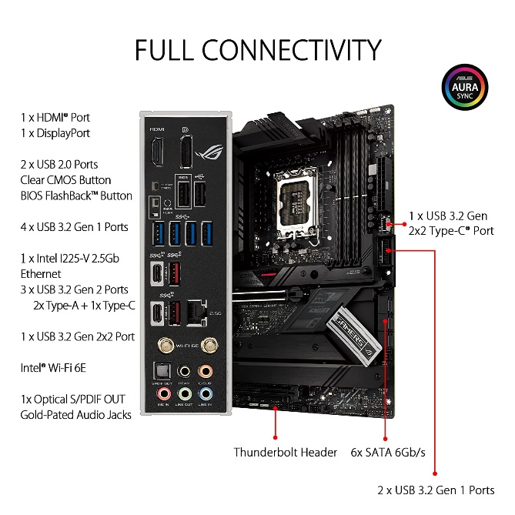

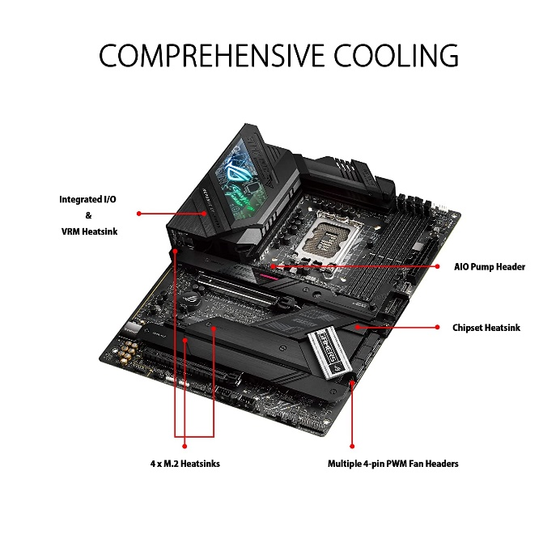

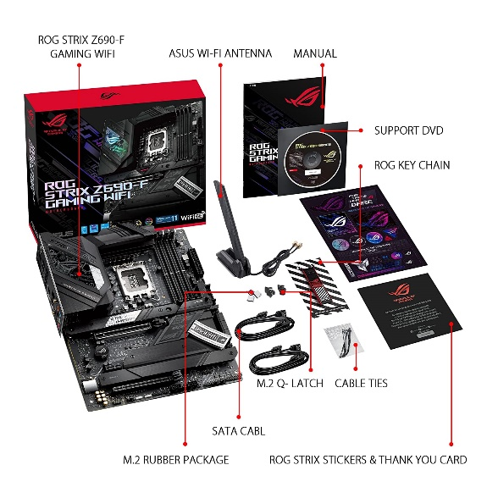

ASUS ROG Strix Z690-F Gaming WiFi LGA 1700 (12th Gen Intel Core) ATX Motherboard with DDR5, PCIe 5.0, WiFi 6E, 2.5 Gb LAN, Four M.2 with Backplate heatsinks...

-24% ₹37,982.00₹37,982.00

M.R.P.: ₹49,999.00₹49,999.00

|  |  |
| --- | --- |
| Brand | ASUS |
| CPU Socket | LGA 1700 |
| Compatible Devices | Personal Computer |
| RAM Memory Technology | DDR5 |
| Compatible Processors | Intel Celeron, Intel Pentium Gold |

**About this item**

* ASUS ROG STRIX Z690-F WIFI Gaming motherboard is designed to support latest 12th Gen Intel CPU's with LGA 1700 socket, Pentium Gold and Celeron Processors.
* The board is built with the PCIe 4.0 Ready supporting 4 x DIMM, up to 128GB DDR5 6400MHz(OC) of memory and Intel Turbo Boost Technology to push your experience to its peak. The board support next gen PCIe 5.0 video-cards making it future proof.
* Equipped with next-gen technology of WIFI 6E, PCIe 5.0, Realtek 2.5Gb Ethernet, USB 3.2 Gen 2x2 Type-C, front panel USB 3.2 Gen 2 Type-C, Four M.2 slots(PCIe 4.0),PCIe Slot Q-Release and Thunderbolt 4 header support.
* Comes with extensive cooling options like VRM heatsink, Thermal pads, M.2 Heatsink, M.2 backplate and hybrid fan headers. This motherboard offers rock-solid and stable performance for marathon gaming.
* ASUS ROG STRIX Z690-F Gaming WiFi features latest AI-powered enhancements span four pillars of performance, including overclocking, cooling, networking and onboard audio. Intelligent software solutions help ensure that your system performs at its best.