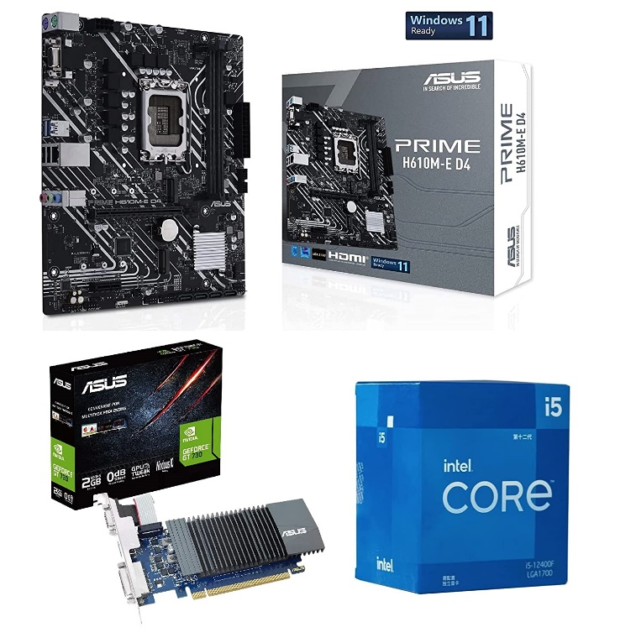

inner

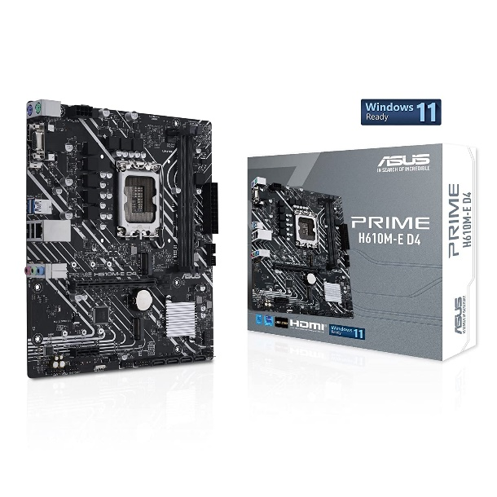

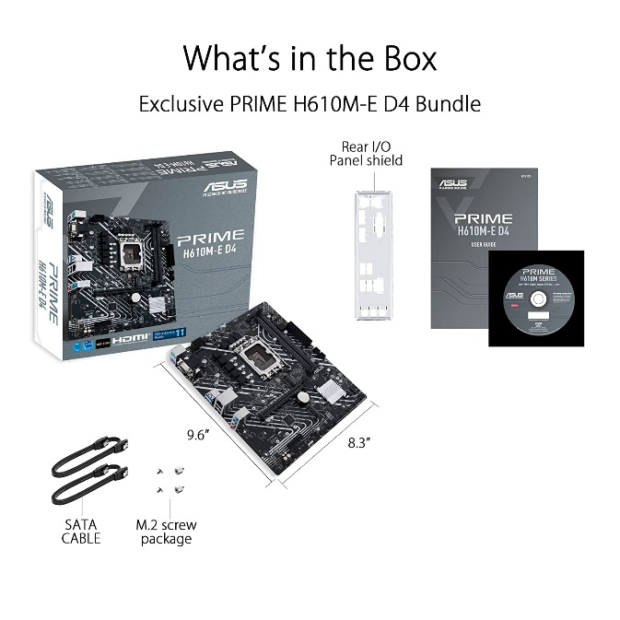

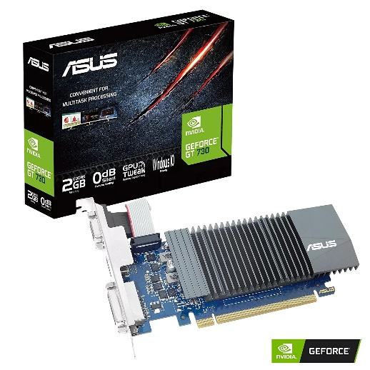

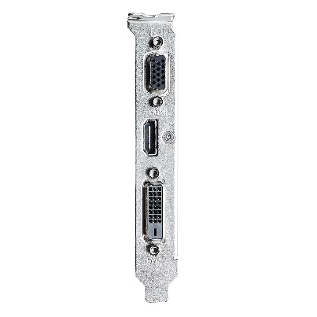

Intel Core i5 12400F 12th Gen Desktop Processor 18 MB ASUS Prime H610M-E D4 Motherboard and Asus GT 730 Graphic Card Combo 3 Years Warranty Gaming Editing...

-21% ₹31,499.00₹31,499.00

M.R.P.: ₹39,999.00₹39,999.00

|  |  |
| --- | --- |
| Specific Uses For Product | Gaming |
| Brand | Intel |
| Operating System | Windows 11, Windows 10 |
| RAM Memory Installed Size | 8 GB |
| Mounting Hardware | 1 Unit GPU, 1 Unit Processor with Fan, 1 Unit Motherboard |
| CPU Model | Core i5 |
| CPU Manufacturer | Intel |
| CPU Speed | 4.4 GHz |
| RAM Memory Technology | DDR4 |
| Graphics Coprocessor | NVIDIA GeForce GT 730 |

[See more](javascript:void(0))

**About this item**

* Intel Core i5 12400F 12th Gen Desktop Processor 18 MB Cache and Asus PRIME-H610M-E-D4 Motherboard and Asus GT 730 2GB Graphic Card is made for ultimate Desktop Computing.
* Motherboard Features - ASUS Prime H610M-E D4 Intel H610 (LGA 1700) micro-ATX motherboard with DDR4, PCIe 4.0, dual M.2 slots, Realtek 1 Gb Ethernet, DisplayPort, HDMI, D-Sub, USB 3.2 Gen 1 ports, SATA 6 Gbps, COM header, RGB header, Intel LGA 1700 socket: Ready for 12th Gen Intelprocessors. Ultrafast connectivity: 32Gbps M.2 slot, Realtek 1 Gb Ethernet and USB 3.2 Gen 1. 3 Years Warranty
* Processor Features - Intel Core i5 12400F 12th Gen Desktop Processor 18 MB Cache 4.40 Ghz Clock Speed with 6 Cores and 12 Threads, has 3 Years Warranty with Fan LGA 1700 Socket.
* Graphics Card Features - The ASUS GeForce GT 730 2GB GDDR5 Graphics Card comes with 384 CUDA cores, a Base clock speed of 902 MHz and operates across a 64-bit wide bus interface And Equipped with multiple Display Connectors like D-Sub Output, DVI Output x 1, HDMI x 1 which helps you to have multiple displays
* Other components required to complete your PC build are Power supply recommended 500W, DDR4 RAM 8GB – 16GB is enough, and M2 NVME SSD like Samsung Evo 970 Plus or 980 pro is recommended for unbelievable speeds.