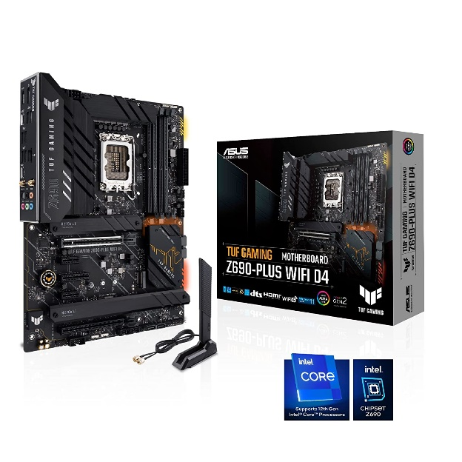

Inner

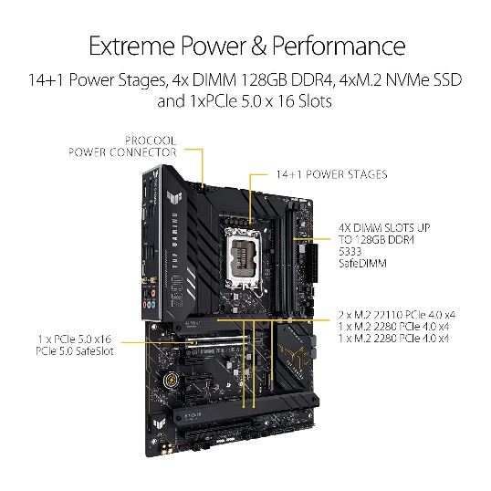

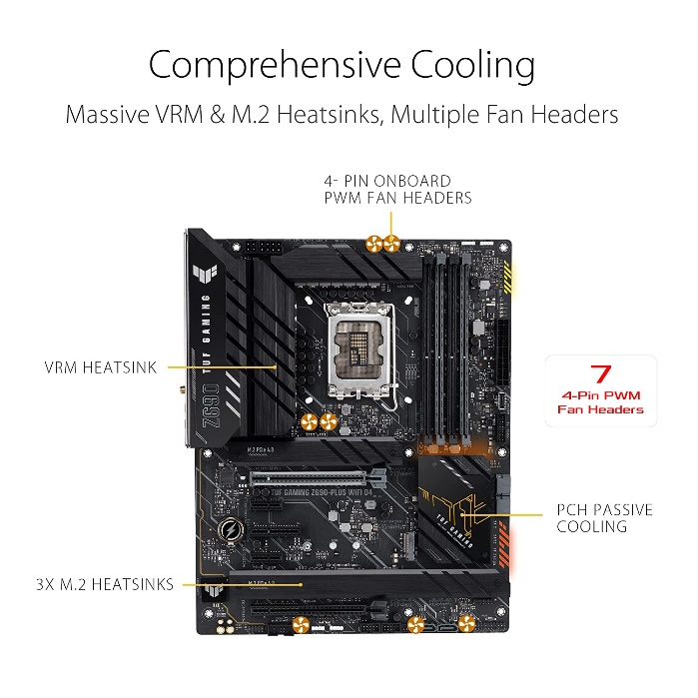

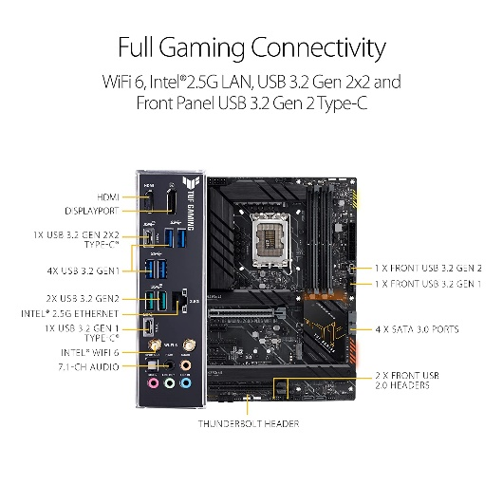

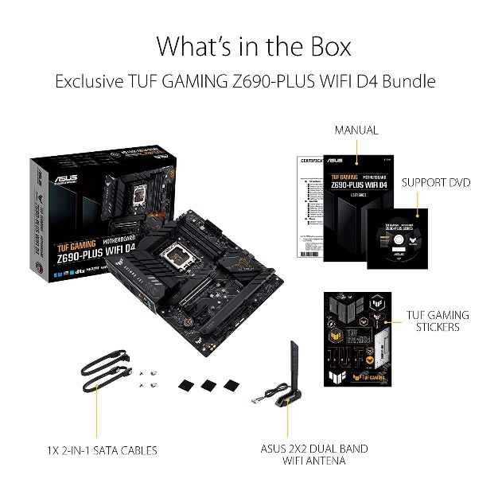

ASUS TUF Gaming Z690-PLUS WiFi D4 LGA 1700(12th Gen Intel Core Processors) ATX Motherboard with PCIe 5.0, DDR4 RAM, Four M.2 Slots, 2.5Gb Ethernet, USB-C,...

|  |  |
| --- | --- |
| M.R.P.: | ₹35,000.00₹35,000.00 |
| Deal of the Day: | ₹27,117.00₹27,117.00 |
| Brand | ASUS |
| CPU Socket | LGA 1700 |
| RAM Memory Technology | DDR4 |
| Compatible Processors | 12th Gen Intel Core, Pentium Gold and Celeron Processors |
| Chipset Type | Intel Z690 Chipset |

**About this item**

* The ASUS TUF GAMING Z690-PLUS WIFI D4 ATX motherboard is designed to support latest 12th Gen Intel CPU's with LGA 1700 socket, Pentium Gold and Celeron Processors.
* The board is built with the PCIe 5.0 Ready supporting 4 x DIMM, up to 128GB DDR4 5333MHz(OC) of memory and Intel Turbo Boost Technology to push your experience to its peak.
* Equipped with next-gen technology of WIFI 6, PCIe 5.0, Realtek 2.5Gb Ethernet, USB 3.2 Gen 2x2 Type-C, front panel USB 3.2 Gen 2 Type-C, Four M.2 slots(PCIe 4.0) and Thunderbolt 4 header support.
* Comes with extensive cooling options like VRM heatsink, PCH fanless heatsink, M.2 Heatsink and hybrid fan headers. This motherboard offers rock-solid and stable performance for marathon gaming.
* ASUS TUF GAMING Z690-PLUS features Two-Way AI Noise-Cancelation which reduces background noise from the microphone and audio output for crystal-clear communication in games or video conferences