Dell MS3320W-Black Dual Connectivity 3-Button Bluetooth 5.0 & Wireless 2.4Ghz Mouse with 3 Years Advance Exchange Warranty & 36M Battery Life.

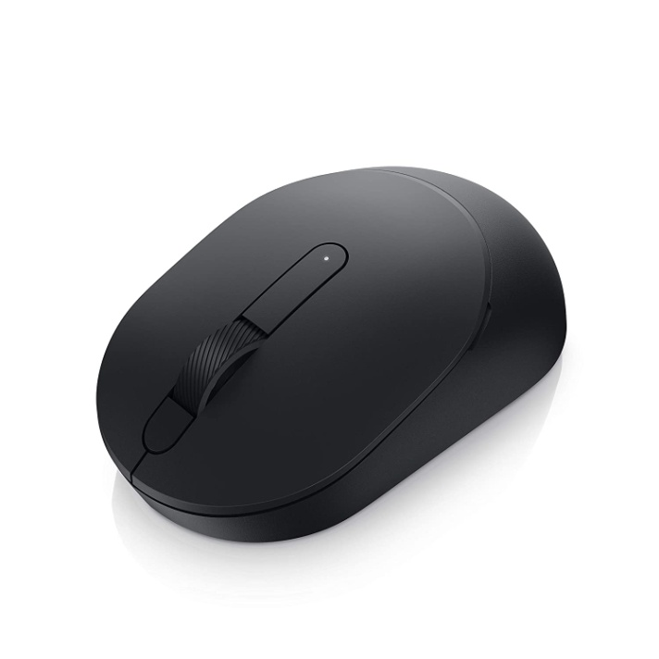

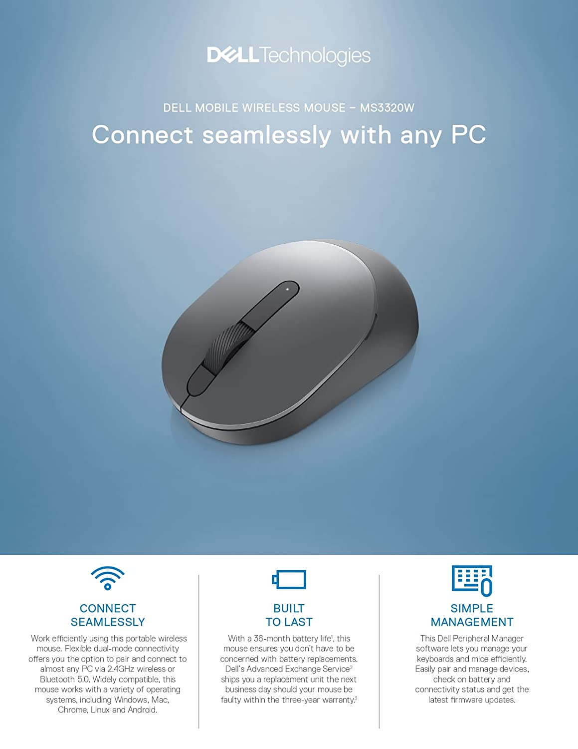

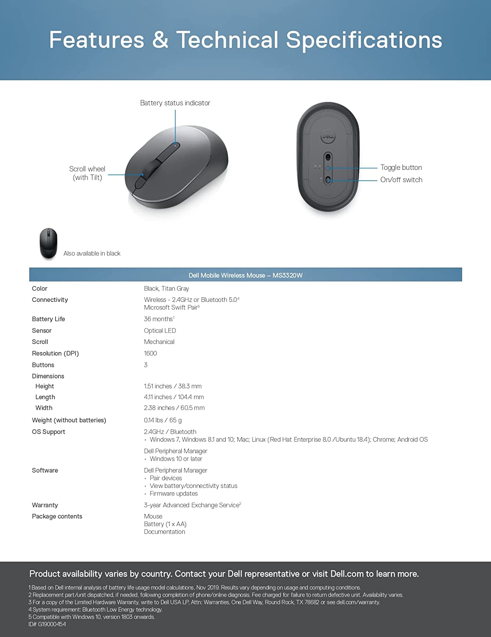

-64% ₹1,049

M.R.P.: ₹2,899

### Product details

|  |  |
| --- | --- |
| Brand | Dell |
| Colour | Black |
| Connectivity Technology | Wireless |
| Special Feature | Wireless, Bluetooth, Optical |
| Movement Detection Technology | Optical |
| Number of Buttons | 3 |

* DEVICE TYPE: Mouse
* CONNECTIVITY TECHNOLOGY: Wireless
* INTERFACE: 2.4 GHz, Bluetooth 5.0
* MOVEMENT DETECTION TECHNOLOGY: Opticle
* BUTTON QTY: 3
* MOVEMENT RESOLUTION: 16000 dpi
* FEATURES: Swift Pair