Anker CE100 Ergonomic Optical USB Wired Vertical Mouse 1000 / 1600 Dpi, 5 Buttons

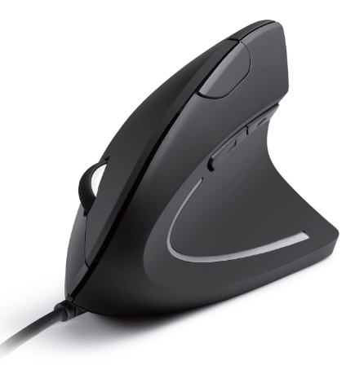

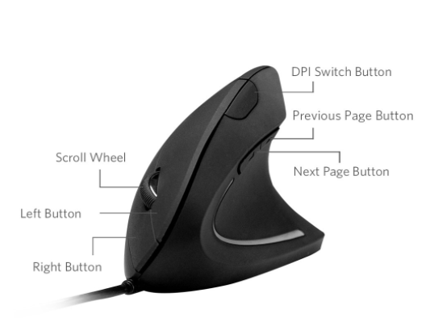

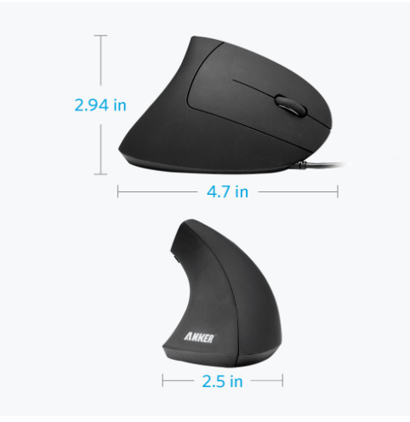

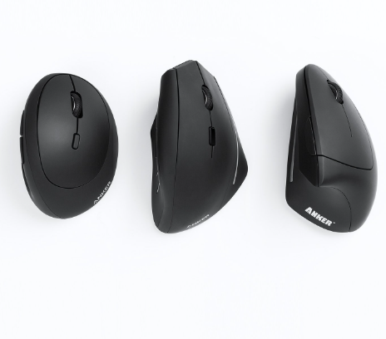

-24% ₹7,567

M.R.P.: ₹10,000

### Product details

|  |  |
| --- | --- |
| Brand | Anker |
| Connectivity Technology | USB |
| Special Feature | Ergonomic Design |
| Movement Detection Technology | Optical |
| Number of Buttons | 5 |
| Compatible Devices | Personal Computer |

* Scientific Ergonomic Design Encourages Healthy Neutral "Handshake" Wrist And Arm Positions For Smoother Movement And Less Overall Strain.
* 1000 Dpi Resolution Optical Tracking Technology Provides More Sensitivity Than Standard Optical Mice For Smooth And Precise Tracking On A Wide Range Of Surfaces. Added Next/Previous Buttons Provide Convenience When Webpage Browsing.
* The Superior Choice For Internet Surfers, Gamers And People Who Work At Length At The Computer. 4.8 Ft Usb Cable Length, Product Dimensions: 101 X 82 X 80 Mm
* Product Weight: 4.5 Oz.
* Package Includes: 1 Anker Vertical Ergonomic Optical Mouse (With 4.8 Ft Cable), 1 Instruction Manual. Includes 18 Month Warranty And Lifetime Technical Support Guarantee.